MINISTRY OF EDUCATION AND SCIENCE OF THE REPUBLIC OF KAZAKHSTAN

International Information Technology University
Faculty of Information Technologies
Specialty of Information Systems

Coursework

theme “IT Infrastructure of “Morrison Code” LLP”

for discipline “IT Infrastructures”

Senior lecturer, master: Auezova A.S.
Students: Kuralay Makhmetova
Asemai Toichieva
Group: IS-1811k

Almaty 2021
Content

Part I

1.1. Introduction
1.2. Description of “Morrison Code” LLP

Part II

2.1. Computer Enterprise Software:
2.1.1. Software components
2.1.2. ERP system
2.1.3 CRM system
2.2. Computer hardware platforms
2.3. Computer Servers

Part III

3.1. Cloud computing technologies
3.2. Computer Consulting Systems&Integration Services

Part IV

4.1. Economic impact
4.2. Perspectives of growth

Part V

5.1. Conclusion
5.2. References

1.1. Introduction

Infrastructure is the physical hardware used to interconnect computers and users. Infrastructure includes the transmission media, including telephone lines, cable television lines, satellites antennas, routers, and other devices that control transmission paths. Infrastructure also includes the software used to send, receive, and manage the signals that are transmitted in IT.
IT(Information Technology) is the integrated framework upon which digital networks operate. This infrastructure includes data centers, computers, computer networks, Database Management devices, and a regulatory system.
IT infrastructure can be viewed as a collection of four groups of services:
- technological services
- collaboration services
- messaging services
- services to ensure security.
The IT infrastructure of an organization can be divided into 2 parts - basic and additional.
The underlying infrastructure meets the basic service needs of an organization to operate and provides a platform for supporting and deploying services and applications critical to a company's business. Base unit components:
- physical network (passive and active LAN equipment)
- basic network services and services (technological services)
- security assurance
- file server and file services.
Complementary infrastructure provides the services and services required to meet specific business needs. These services are optional and are deployed based on the needs of the organization itself. The functioning of these services is directly dependent on the quality of the infrastructure core. This may include:
- collaboration services
- messaging services.
This covers the following processes:
- network printing services
- corporate email and anti-spam service
- intracorporate communication services
- collaboration service
- centralized update management service
- data backup and recovery service
- centralized storage and database management service
- IT infrastructure monitoring and management services
- services for managing and configuring security settings using group policies
- network certificate assignment services and much more
1.2. Description of “Morrison Code” LLP

“Morrison Code” LLP is online programming organization in Almaty, which covers the entire CIS.



Picture 1 – Holding’s picture

The goal is to make IT Infrastructure project for “Morrison Code” LLP. We analysed the problems of the enterprise. “Morrison Code” needs to control the work between and within the company, organize and plan it.

Our project will help to solve problems such as:
- Receive a common standardized database of contacts (clients, contractors) for the company.
- Effectively to exercise control over the quality of work at any point in time.
- Get performance statistics and Analytics.
- Plan to improve the quality of work and develop a business development strategy.

Advantages of the project:
- Data availability. Once entered, the data becomes available within the whole system, without the need for reconciliation, additional approvals and verification.
- Data consistency. The use of a common database allows to avoid the stages of verification and reconciliation.
- Control of employees ' work. In the case when one of the divisions makes data, the other division immediately receives information about it, and after the actual receipt of the listed positions puts it to itself on arrival.
- A ready-made set of combined tools. For example, if the sales Department creates an invoice, it is the basis for the automatic creation of accounting documents, and after payment-expense documents from the warehouse.

2.1. Computer Enterprise Software

Enterprise Application Software (EAS) addresses the needs of large organizations, whether Fortune 500 companies or large charities. In addition to scale (and often outdated design), such tools have several defining characteristics that set them apart from your typical B2C application:

- High efficiency. The corporate program must deal with the stress of the entire organization and is used daily.
- Fully owned by the company, no need to share the app with thousands of other users, helps with lightning-fast requests.
- High customization - probably tailor-made for your business processes.
- High scalability and extensibility. The system grows with your business.
- Large number of integrations - multiple systems work together to perform different tasks.
- Data portability. You can retrieve the data stored on the system for other purposes.
- High reliability and reliability. Enterprise software systems are typically equipped with multiple levels of security (for example, two-factor authentication, multiple user roles, and encryption).

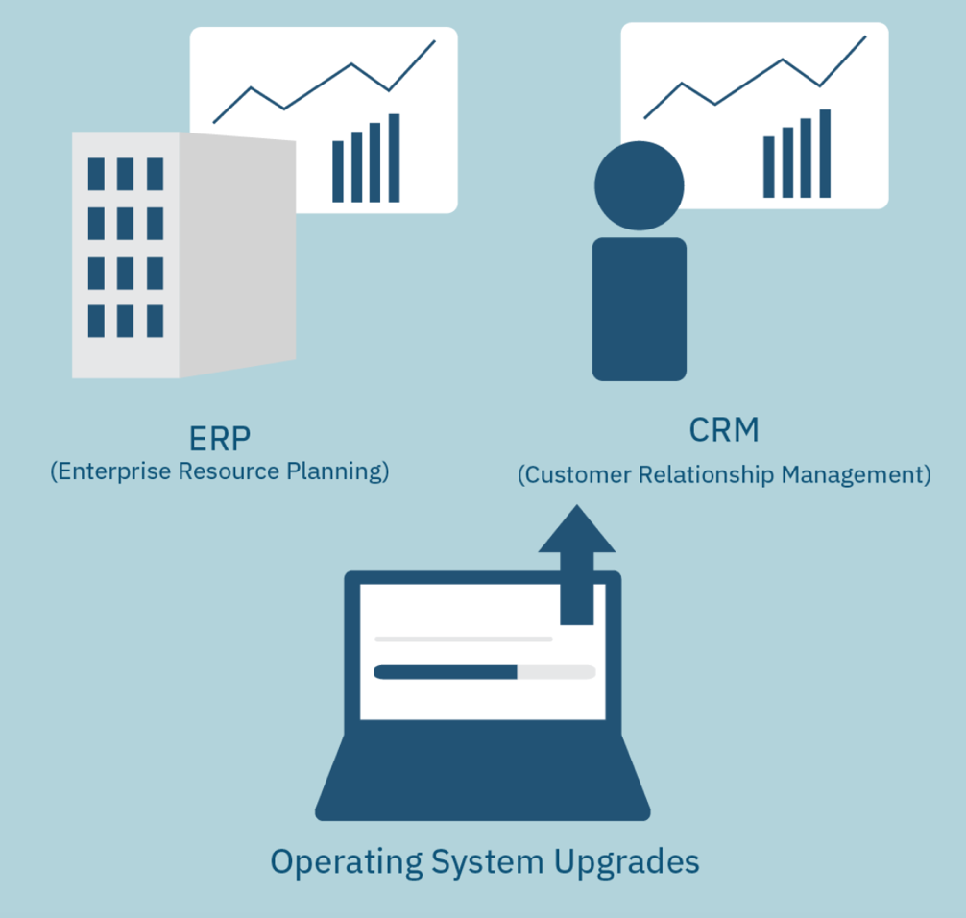

Picture 2 - Computer Enterprise Software system
2.1.1. Software components

The system of enterprise has three main types of software: applications, device drivers, and operating systems. Each type of software does a completely different job, but all three work closely together to do a useful job. Although some special-purpose programs do not fit into any of these classes, most programs do. Programs run on part of the system's memory. During operation, programs are known as processes or tasks. The following illustration shows the relationship between different software programs and hardware.

Applications
Applications are the top level of software. You can perform certain tasks with these programs, such as using a word processor for writing, a spreadsheet for accounting, or a computer-aided design program for drawing. The other two levels, device drivers and the operating system, play an important support role. Your system can run one application at a time, or it can run many at once.

Device drivers
Device drivers are a set of highly specialized programs. Device drivers help applications and the operating system perform their tasks. Device drivers (especially adapters) do not interact with you. They interact directly with computer hardware and protect applications from computer hardware.

Operating System
An operating system is a collection of programs that control the execution of programs and organize the resources of a computer system. These resources are hardware components of the system, such as keyboards, printers, monitors, and drives. Your AIX operating system comes with programs called commands or utilities that support your files, send, and receive messages, provide various information about your system, and more.

Table 1. Operating System of enterprise: Microsoft Windows

Core function | The Microsoft Windows kernel provides basic low-level operations such as scheduling threads or routing hardware interrupts. It is the heart of the operating system and all tasks it performs must be fast and simple.  Microsoft windows uses Hybrid Kernel Architecture.  It combine aspects and benefits of micro kernel and monolithic kernel architectures.
Security | Compared to other operating systems, Microsoft security is weak. According to their own developers, their products "just aren't engineered for security." The result is that Windows computers are more likely than other systems to be hijacked and used to distribute everything from spam to hate mail.
Components | Configuration and maintenance, User interface, Applications and utilities, Windows Server components, File systems, Core components, Services, DirectX, Networking, Scripting and command-line, Kernel, NET Framework, Security, Deprecate, components and apps, APIs
Advantages and disadvantages | Advantages  The Microsoft Windows operating system is the most popular choice and currently has a stronghold over the market. The Windows system is highly compatible, feature-rich and has a much larger selection of software applications.  Software support: Windows platform is best suited for game and software developers. Windows have large number audience so developers prefer to make utilities, games and software for windows OS. Linux users cannot make windows apps so it is better to use windows for developing apps.  Plug and play feature: Most hardware can be detected automatically by plug and play feature. You do not need to manually install the hardware but it is ready to use when attached e.g. webcam, keyboard, mouse, mobile device etc.  Desktop and touch screen: Windows 10 is made for both touch screen devices and desktop computers. The user interface of Windows 10 is made in such a way that it works better for any type of windows device  Disadvantages  High resource requirements. As opposed to the makers of other operating systems, Microsoft requires its customers to invest the most in their computer hardware: a faster processor (the CPU), more internal memory and a larger hard disk.  Closed Source. Troubleshooting problems with Windows would be so much easier for users and support personnel if only they knew what was actually going on. Unfortunately, only Microsoft has full access to its software's source code, and since no log files are generated its users are left to try and deduce what causes their problems by trial and error alone.  Outrageous license agreements. Most people never bother to read the EULA, or End User License Agreement, that must be agreed to before any Microsoft product − including service packs and security updates − can be used or installed.  Additional expenses. After setting up a series of Microsoft computers, or even a single one for that matter, sooner or later customers invariably find themselves in need of additional software.
Performance | 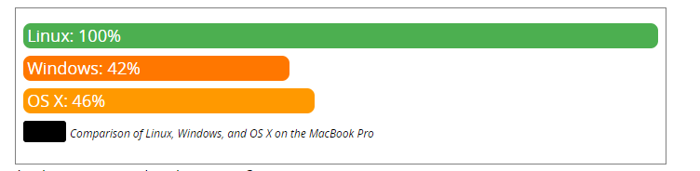
Compatibility | As windows OS is used by 95% of users so most of the hardware vendors make drivers for windows.
CLI&GUI | Cmd  - Handle User Input  - Accept input from devices including keyboard, mouse, touch, pen, etc.  - Handle App Output:  - Accept text output from a connected Command-Line app/tool  - Update the display as required  - Handle System Interactions:  - Launch when requested  - Manage resources  PowerShell is an object-oriented Shell, unlike the file/stream-based shells typically found in the *NIX world: Rather than handling streams of text, PowerShell processes streams of objects, giving PowerShell script writers the ability to directly access and manipulate objects and their properties, rather than having to write and maintain a lot of script to parse and manipulate text (e.g. via sed/grep/awk/lex/etc.)

The application program relies on the operating system to perform many detailed tasks related to the internal workings of the computer. The operating system also accepts commands directly from you for file management and security. There are many extensions for the AIX operating system that allow you to customize the environment.

Root user processes
Root user processes are programs that can only be run by a user with root authority. The system administrator has root authority for all processes.

Root user processes include:
- Read or write any object
- Call any system function
- Perform certain subsystem control operations

If you are not allowed to execute a command, the system displays a message stating that you do not have the correct permissions or that you are not allowed to execute this command. The system administrator may be the only person who can log in as root on your system. The system administrator can also configure you to use certain commands, giving you some control over the processes.

2.1.2. ERP system

The Enterprise Resource Planning (ERP) system is the heart and brain of a modern enterprise. It creates a single database that reduces the number of errors. The data is entered once and can be used by all departments. The system usually consists of several modules, each of which is responsible for digitizing another area of ​​your business:

- Accounting;
- Inventory management;
- Customer service;
- Business process management;
- Order management;
- Human resources;
- E-commerce;
- Delivery, etc.

Most companies maintain a database of customers, manage their inventory, process orders, and keep the books using outdated tools like Excel or pen and paper. There is little to no data flowing between different systems. Such an approach is very dependent on the human factor. The data might come with delays, frequent errors lead to revisions and financial losses. You might have lots of waste, warehouse surplus, or failures to deliver on time. As your business grows and its processes become more complex, it gets much harder to coordinate various systems used by different branches and manufacturing units.

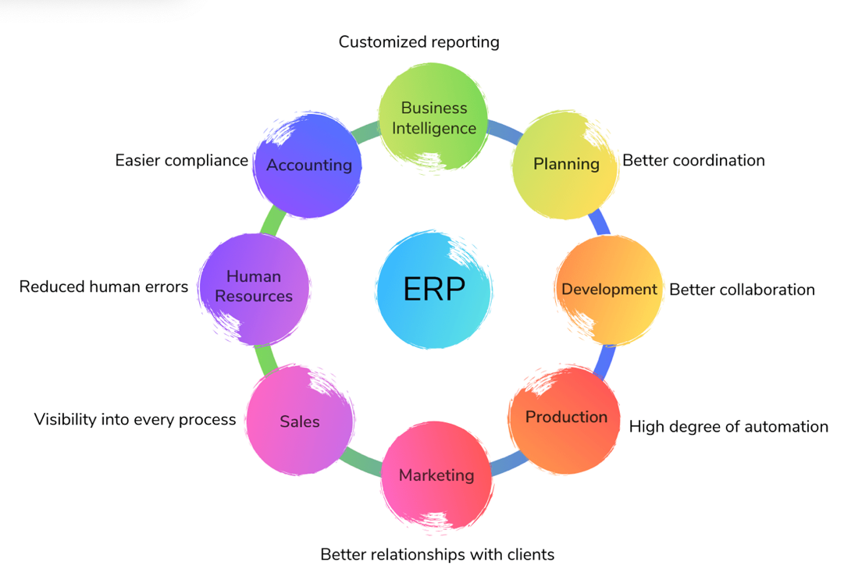

Picture 3 – ERP system
2.1.3 CRM system

The Customer Relationships Management (CRM) system ensures that your team knows every customer. This is a contact list that contains a detailed overview of your relationship with each client.

Sales and customer relations are the key to any business. If your sales representatives do not have a supernatural focus, they will lose some opportunities to cross-sell, sell new services to existing customers, or close deals.

It allows you to keep track of how and when you interacted with a customer (in person, by phone, email, social media, etc.), and ensures that no potential customers disappear.

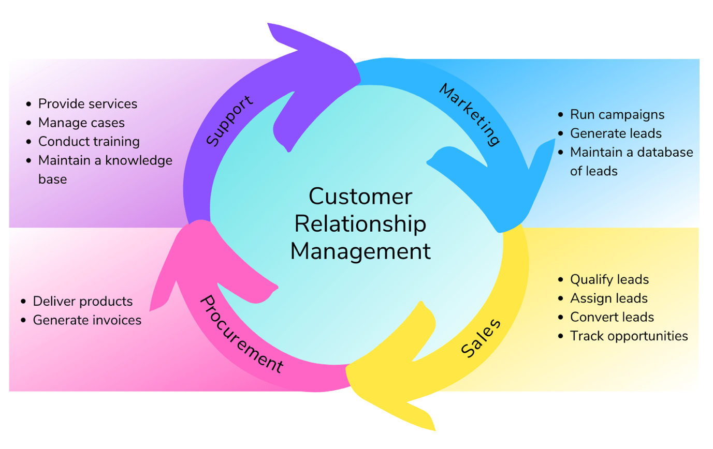

Picture 4 – CRM system

Most CRM systems allow you to track potential customers, manage orders, communicate with customers, track their status, plan advertising campaigns and evaluate their effectiveness. One of our clients asked us to develop our own management system for members of Norwegian associations. With hundreds of organizations across the country with different needs and structures, it was not possible to combine them into one ready-made CRM.

Over time, the system we created has evolved into a full-fledged CRM that manages a large number of members, companies and departments. Associations can now charge a subscription fee and sell tickets to various courses, meetings and conferences through a single system. Because each association has unique needs and workflows, we have created a number of special modules tailored to their requirements. Now every organization enjoys improved automation and increased revenue.

In addition to key CRM features such as lead management, invoicing and task management, the system now has:

- BankID for secure login and single login;
- Special modules that meet the needs of individual associations;
- Integration of the register of population and business, which provides important information about the members of the association;
- Customizable reports to help administrators manage their organizations;
- Integration of financial and accounting systems to support invoicing;
- Facebook Messenger chatbot for easy login; and
- Integration of e-mail for communication in the application between administrators and participants.

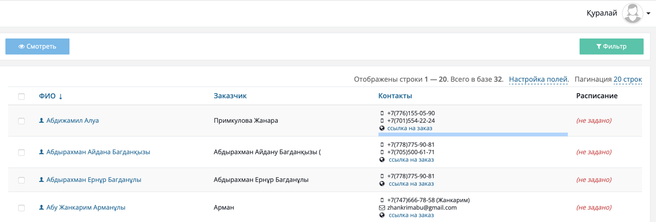

Picture 5 – The CRM system of enterprise

2.2. Computer hardware platforms

In an organization, hardware platform refers to the architecture of a computer or processor. For example, x86 and x86-64 processors are the most common computer architectures.

These machines usually run a version of Microsoft Windows, although you can also run other operating systems such as Linux, NetBSD, Mac OS X, and FreeBSD. However, ARM architecture dominates smartphones and tablets running Android, iOS and other mobile operating systems. It is a Microsoft microcontroller programming platform developed by Secret Lab LLC based on an idea from Arduino.

We took an Atmel processor (the same manufacturer as the Arduino processors) with 32 bits and 48 MHz.
It designed an Arduino compatible board along with the NET Micro Framework.
This is neither more nor less than a very stripped down version of the NET platform that we all know.
This idea brings .NET developers into the world of microcontroller programming. Using a board compatible with all sensors and devices that already exist for the Arduino.

What are the advantages of the hardware platform?
- Promotes that the equipment can be of high quality, with open standards and cheaper.
- Improve the safety and proper functioning of the structure by working in the most extensive test workshop in existence.
“It helps companies save on design costs and time in their work.
What are the disadvantages of the hardware platform?
- The physical design is unique. Sharing depends on ease of reproduction of the design and its reproducibility.
- Component availability
- Obtaining patents
- Equipment manufacturing model.

2.3. Computer Servers

Today, computers are used to process data in all areas of an enterprise: product design and development, manufacturing, inventory management and distribution, quality control, sales and marketing, service data, accounting, and personnel management. They are also used in the Morrison Code.

The most common uses of computer systems in business are database management, financial management and accounting, and word processing. Financial and accounting systems are used for various mathematical calculations with large amounts of numerical data, whether in the core functions of financial services companies. Meanwhile, computers equipped with spreadsheet or database management software are used by payables and receivables and payroll departments to process and tabulate financial data and analyze cash flow situations. Finally, word processing is ubiquitous and is used to create a wide variety of documents, including internal memos, correspondence with external organizations, public relations materials, and products (in the publishing, advertising and other industries).

Databases can also be used to make strategic decisions using artificial intelligence software. The database system can include - in addition to records and statistics of products, services, customers, etc. - information about past human experience in a particular area. This is called the knowledge base. Examples of the use of expert systems include business forecasting such as investment analysis, financial planning, insurance underwriting, and fraud risk prediction. Expert systems are also used in activities related to regulatory compliance, contract bidding, complex manufacturing controls, customer support and training.

3.1. Cloud computing technologies

The company currently uses a private cloud and hybrid cloud.

A private cloud is a secure IT infrastructure controlled and operated for a single organization. The organization can manage the private cloud on its own or outsource the task. Infrastructure can be located either at the customer's premises, or with an external operator, or partially at the customer and partially at the operator. An ideal private cloud is a cloud that is deployed on the premises of an organization, maintained and controlled by its employees.

A hybrid cloud is an IT infrastructure that uses the best qualities of a public and private cloud to solve a given problem. Often this type of cloud is used when the organization has seasonal periods of activity, in other words, as soon as the internal IT infrastructure cannot cope with the current tasks, part of the capacity is transferred to the public cloud (for example, large amounts of statistical information that, in their raw form, are not valuable for the enterprise ), as well as to provide users with access to enterprise resources (to the private cloud) through the public cloud.

The security:

Confidentiality must be ensured throughout the chain, including the cloud provider, the consumer, and the communications that link them.
The supplier's task is to ensure both physical and software integrity of data from third-party attacks. It is no coincidence that "cloud" data centers are usually designed based on the latest security standards (including encryption issues, as well as the aforementioned anti-virus protection and protection against hacker attacks).

The consumer must put in place appropriate policies and procedures "on their territory" to exclude the transfer of access rights to information to third parties. In this sense, the objective advantages of "clouds" should not be confused with relieving the customer of any efforts to ensure the security of their own information perimeter.
The solution to security problems includes traditional and well-known solutions, although it contains a number of specific solutions that, in the process of performing traditional tasks, must be optimized to save the performance of the virtual environment while adding security.
Serious hardware failures are already occurring, even for large cloud providers. In the world practice of "cloud" computing, there are cases when a consumer could not access applications for a long time. And the banal "disconnection of the Internet" due to the fault of the provider (not necessarily the provider directly serving the customer, the backbone operator may also be to blame) can make work with "cloud" resources impossible in principle.
Obviously, before starting projects related to the transfer of certain IT services to the "clouds", customers should assess such risks, conduct a thorough inventory of applications (fixing a list of critical for the business), and only then make decisions on how to build its "cloudy" IT future.
An alternative ISP on a “hot standby”, an alternative provider of a “cloud” solution, transparent management of maintaining data archives, insurance, strict liability conditions in agreements with suppliers are mandatory elements of security in the “clouds”.
The tasks of ensuring the integrity of information in the case of using individual "cloud" applications can be solved - thanks to modern database architectures, backup systems, integrity check algorithms and other industrial solutions. But that's not all. New challenges can arise when it comes to integrating multiple cloud applications from different vendors.
Virtualization can be secure and compliant with information protection regulations. However, customer security demands are still often ahead of vendors' capabilities.

In my opinion, in the future, cloud computing will become more accessible for users and companies. This will be caused by several factors:

- hardware virtualization - increasing the performance of cloud computing;
- reduction of power consumption of hardware - reduction of power consumption;
- higher speeds - the bandwidth of network equipment is constantly increasing, which increases productivity and reduces the amount of equipment on the same channel.

3.2. Computer Consulting Systems & Integration Services

4.1. Economic impact

The education industry must develop. Just as other industries are updating technologies and processes to stay competitive, the trillion dollar education industry needs a major overhaul.

Research firm IDC expects IT spending to exceed $ 2 trillion in 2013, driving business demand for scalable online learning solutions that add value to the business. What's more, a recent poll by Randstad, the world's second largest staffing company, names IT professionals and software developers among its top five most in-demand jobs in 2013, and the Bureau of Labor Statistics predicts that software developer employment will rise 30 percent. from 2010 to 2020, much faster than the average for all occupations. Candidates with proficiency in major programming languages ​​such as Java and .Net are becoming an increasingly sought-after commodity as the demand for computer software grows.

New programs for teaching children to program are beginning to appear. Morrison Code offers training programs aimed at the younger generation. Even for-profit institutions like Pluralsight are releasing free coding courses for kids along with programs designed for teachers and parents that can be used in school computer clubs and at home to learn the new coding craft.
The industry is changing and the online education market has already been created by opinion leaders who have taken responsibility for defusing tensions in the educational space. This is just the beginning of a trillion dollar industry that requires even more attention from major educational institutions. Online education alone can meet the enormous needs of students and professionals around the world.

Online education providers are already developing tailor-made courses to enable people to acquire specific skills needed in the workplace. By dramatically changing the way we teach, we are closing the gap between what businesses need from their employees and what the traditional education industry teaches, improving training and making a positive impact on the global economy.

4.2. Perspectives of growth

The separation of learning and teaching in higher education was based on two coexisting but increasingly contradictory reasons: allowing mass access to education (pushing priorities in favor of society) and marketization (bringing the sector closer to the interests of the free market). The idea of ​​open mass access has been reinforced by the emergence of digital technologies that have fueled the global growth of the open educational resource movement and the provision of online education through digital platforms. This provision can take the form of full degree programs, short-term credit-based courses, or massive open online courses, and the provision can be split. The concept of separation, originally referring to organizational changes in software and legislation, has recently entered higher education research and policy discourse, initially touching on quality assurance, research, infrastructure, and recreational opportunities. The disaggregation of the traditional university “package” began to influence other areas such as administration and management. Nowadays, private companies are increasingly performing various functions also related to the main activities of the university: developing curricula, delivering modules, evaluating students and issuing diplomas. The division of higher education was seen as offering cheaper, no-frills education and options for mixing and matching content. An example of split learning would be a degree program offered as separate stand-alone modules available for credit through an online platform to be taught at a learner's pace, in any order, in a pay-per-module model.

5.1. Conclusion

In conclusion, I want to say that IT infrastructure is a complex multicomponent integrated system, which is a complex of information technologies (software and hardware) and ensures the activities of an organization. Computer hardware, software, network services, services, e-mail, monitoring systems, information security policies, control systems, backup and data storage systems, office equipment, telephony, etc. - all these are components of the IT infrastructure of the enterprise. In addition, in my opinion, in the future, cloud computing will become more accessible for users and companies. This will be caused by a number of factors:
- hardware virtualization - increasing the performance of cloud computing;
- reduction of power consumption of hardware - reduction of power consumption;
- higher speeds
- the bandwidth of network equipment is constantly increasing, which increases productivity and reduces the amount of equipment on the same channel. In this coursework contained all main parts. We shared coursework to 4 parts. First par include introduction and description of “Morrison Code” LLP. Second part include computer enterprise software, software components, ERP system, CRM system, computer hardware platforms, and computer servers. Third part include economic impact and perspectives of growth. Fourth part about conclusion and references. We tried to do the best work and created IT Infrastructure of “Morrison Code” LLP.

5.2. References

1.https://sites.ualberta.ca/dept/chemeng/AIX43/share/man/info/C/a_doc_lib/aixuser/glossary/toc.html
// The AIX Version, First Edition. All about Computer Software System
2. https://www.ibm.com/ru-ru/topics/infrastructure
// The topic about IT Infrastructure
3. https://www.lankey.ru/kis/
// The article about IT Infrastructure
4. https://indevlab.com/ru/blog-ru/infrastruktura-informatsionnyh-tehnologij/
// The structure of IT Infrastructure
5. https://morrison.s20.online/profile/index
// My profile in CRM system
6. https://www.1cbit.kz/company/news-kz/369052/
// The topic about ERP system
7. https://g.co/kgs/i7dZuY
// Cloud computing technologies

