CLDV6212 ICE TASKS 1 AND 2

Lefa Makhubela ST10442096

Contents

1. Primary Benefits of Using Table Storage in Azure and When to Use It 2

Primary Benefits of Table Storage: 2

Particular situations in which table storage would be preferable: 2

2. Can you think of scenarios where Queue storage is a suitable solution for storing data in Azure? 2

3. Can you identify the most common use cases for Blob storage in cloud solutions? 3

# Primary Benefits of Using Table Storage in Azure and When to Use It

## Primary Benefits of Table Storage:

NoSQL key-value store: Azure Table Storage is very adaptable for situations that don't call for intricate joins or relational constraints because it saves data in a key-value format.  
  
Scalability: It can scale automatically without human configuration in response to demand and is designed to manage very large datasets.  
  
Cost-effective: When working with large amounts of straightforward, structured data, it provides a less expensive option than SQL-based databases.  
  
Schema-less flexibility: This is ideal for dynamic data because not every item has the same fields, and each entity (row) can have distinct properties.

Simple Data Model: Azure Table Storage makes use of an easy-to-understand and manipulate key-value data paradigm. It provides effective, organized data storage and retrieval without requiring intricate schemas.  
  
High durability and availability: It offers redundancy through automatic replication, ensuring that data is always available and not lost.

Particular situations in which table storage would be preferable:  
  
Data storage for the Internet of Things: Gathering millions of sensor readings from devices, where each record is straightforward and requires quick writes.  
  
Logs from audits; appending logs with timestamps and little metadata, where volume is big and querying is simple.  
  
person profile information is particularly helpful when it is varied; for example, one person may have a bio and links to social media, while another may only have their name and email.  
  
Product catalogs: Perfect for items with different characteristics, such as electronics with specifications, books with author details, and clothing with sizes.

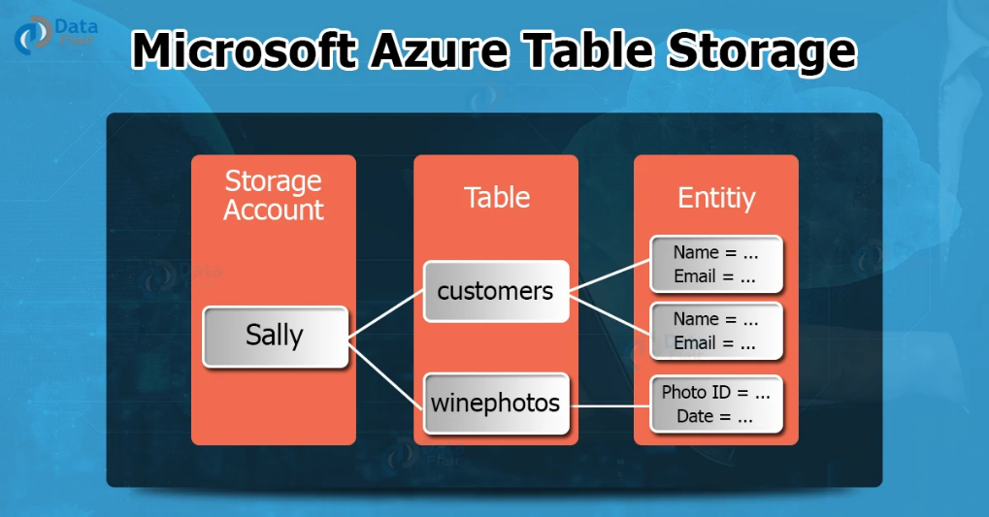

Figure 1: Architecture and Data Model for Azure Table Storage

# 2. Can you think of scenarios where Queue storage is a suitable solution for storing data in Azure?

Asynchronous processing: By enabling one component to deliver a message and another to process it later, queue storage enables systems to manage background operations. For instance, when a user uploads a file, a background service can resize it.  
  
Decoupling components allows two components of a system to function independently. For example, a back-end service can handle messages in the background without having to reply right away, while a front-end application can submit data to a queue.  
  
Systems for processing orders are helpful for managing client orders in the order that they were received. It is possible to queue up each order and process them in FIFO (first-in-first-out) order.  
  
Load leveling: Queue storage can absorb the rise in traffic and keep back-end systems from breaking while processing messages at a constant rate.

Task retry and failure treatment: To increase system reliability, failed tasks can be either moved to a poison queue for special handling or left in the queue.  
  
Email and notification systems: A message is sent to a queue following a user action (such as signing up), and a different service reads it to send out notifications or confirmation emails.

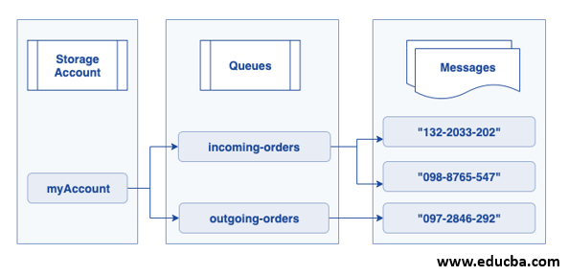

Figure 2: Azure Queue Storage Message Workflow

# 3. Can you identify the most common use cases for Blob storage in cloud solutions?

Storage for media files: Blob Storage is perfect for holding vast volumes of unstructured data, such as music, video, and picture files. It is frequently used to serve media content in apps like webpages and mobile apps.  
  
Document storage: It can hold Word, Excel, PDF, and other document formats. It also enables metadata tagging and safe access with Azure AD or SAS tokens.  
  
Application logs: For further analysis or auditing, logs from servers, apps, or diagnostic tools can be stored in blob storage.  
  
Backups and disaster recovery: Blob storage is ideal for long-term data backup at a reduced cost because it enables cool and archive access tiers.

Big Data and analytics: Azure Data Lake is built on blob storage, which makes it appropriate for storing enormous volumes of unprocessed data for reporting, analytics, and machine learning.  
  
Frontend SPAs (Single Page Applications) and static websites can benefit from the direct hosting of HTML, CSS, JavaScript, and picture files from Blob storage.  
  
Video streaming: Using Azure Media Services or directly through optimized blob access, Blobs can store and broadcast big video files effectively.

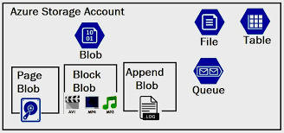

Figure 3: Types of Azure Blob Storage

# References

DataFlair. Redirect Notice. 2025. [www.google.com/url?sa=i&url=https%3A%2F%2Fdata-flair.training%2Fblogs%2Fazure-tables-and-table-storage%2F&psig=AOvVaw1kUzD8T1EHqybmLEy_V2u8&ust=1753960796625000&source=images&cd=vfe&opi=89978449&ved=0CBUQjRxqFwoTCMiW9KS75I4DFQAAAAAdAAAAABBR](http://www.google.com/url?sa=i&url=https%3A%2F%2Fdata-flair.training%2Fblogs%2Fazure-tables-and-table-storage%2F&psig=AOvVaw1kUzD8T1EHqybmLEy_V2u8&ust=1753960796625000&source=images&cd=vfe&opi=89978449&ved=0CBUQjRxqFwoTCMiW9KS75I4DFQAAAAAdAAAAABBR).

[Accessed 29 July 2025].

EDUCBA. 2023. Azure Queue Storage [cdn.educba.com/academy/wp-content/uploads/2020/07/Azure-Queue-Storage-architecture.png.](https://cdn.educba.com/academy/wp-content/uploads/2020/07/Azure-Queue-Storage-architecture.png)

[Accessed 29 July 2025].

CloudDesktopOnline. 2020. Azure Storage Types for Windows Virtual Desktop (WVD). [www.clouddesktoponline.com/blog/wp-content/uploads/2020/01/Azure-storage.jpg](http://www.clouddesktoponline.com/blog/wp-content/uploads/2020/01/Azure-storage.jpg).

[Accessed 29 July 2025].

Jain, Sonali. 2024. Azure Table Storage: Everything You Need to Know. [cloudkeeda.com/azure-table-storage/.](https://cloudkeeda.com/azure-table-storage/) [Accessed 29 July 2025].

Swetha Mudunuri. 2023. Choosing the Right Azure Storage Service: Blob, File, Queue, or Table Storage. <https://iamswetha7.medium.com/choosing-the-right-azure-storage-service-blob-file-queue-or-table-storage-d41003de9556>

[Accessed 29 July 2025].

Microsoft. nd. Queue Storage | Microsoft Azure. <https://azure.microsoft.com/en-us/products/storage/queues>

[Accessed 29 July 2025].

Microsoft. 2022. Introduction to Blob (Object) Storage - Azure Storage. <https://learn.microsoft.com/en-us/azure/storage/blobs/storage-blobs-introduction>

[Accessed 30 July 2025].