Movie Ticket (javascript project)

Teammates: Xiaoran Xie, How YunJi

Page1 - HomePage

Page2 - SelectedMoviePage

Page3 - SeatedMap

Page4 - CheckedOutPage

### Page1 - HomePage

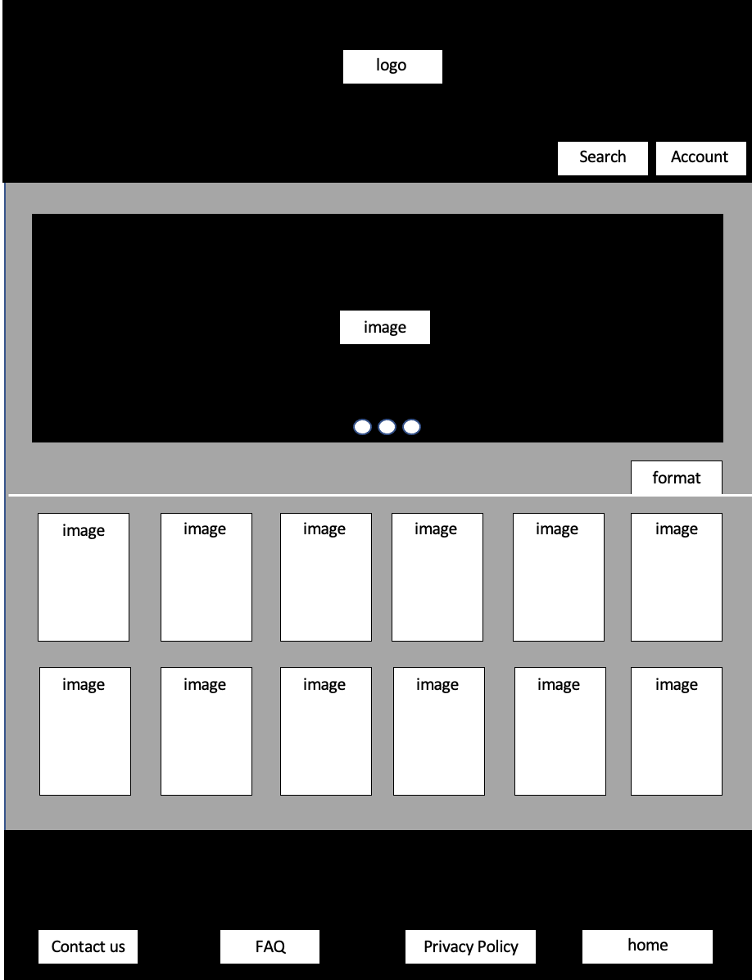

1. Search bar, which users can input the movie name and go to selectedMoviePage.
2. Account button, which users need to log in their account or they can’t buy the tickets.
3. There is a movie poster board which has around 12 movies pictures here, users can click on the pictures and go to selectedMoviePage.
4. Footer has four buttons, which covers the IT support and some policy.

### Page2 - SelectedMoviePage

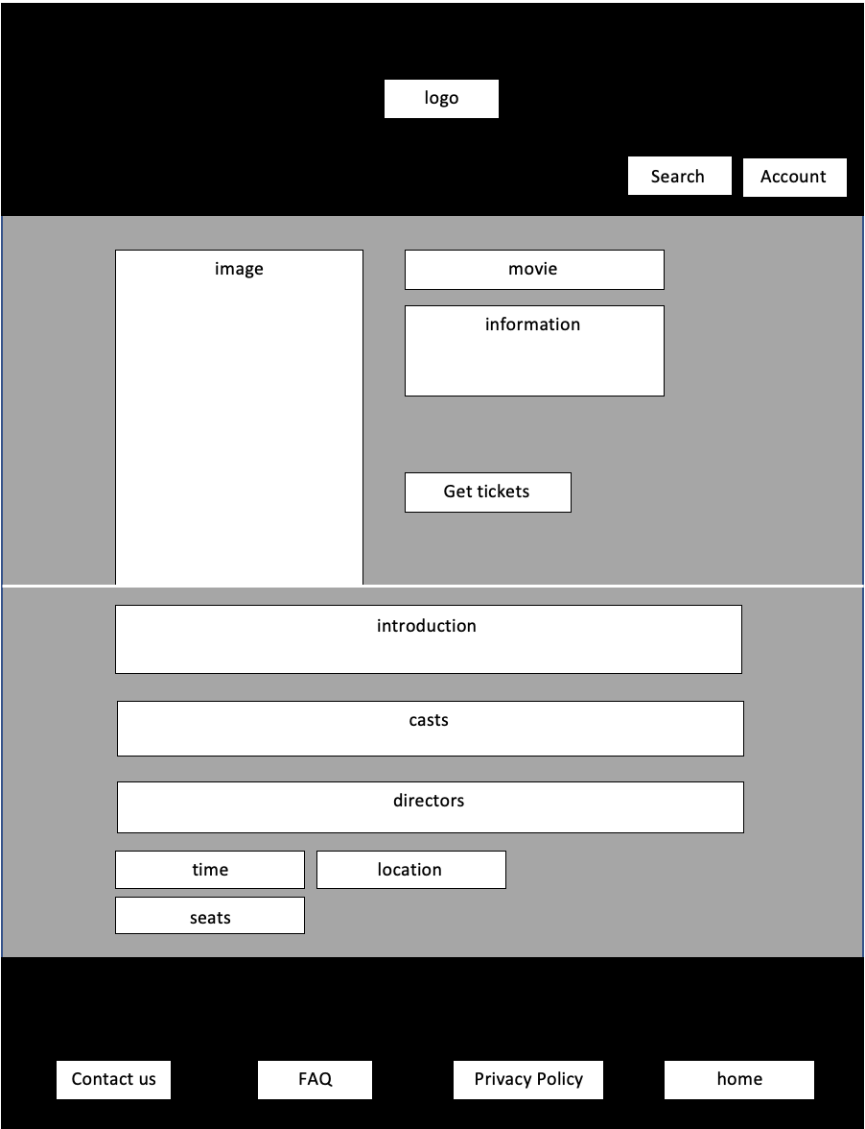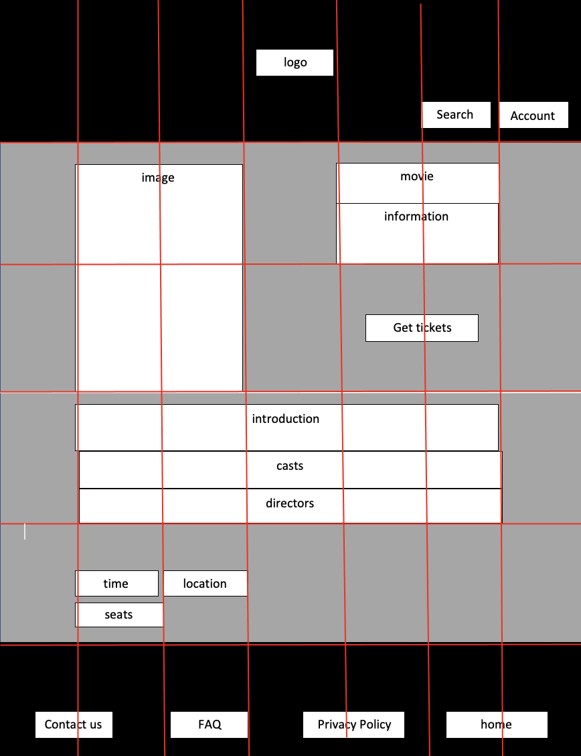

1. First part is the large movie poster and some details of this movie arrangement. Get tickets button can make users go to the SeatedMap if the scheduled showing time for this movie exists.
2. Second part is more details of this movie, such as movie description, casts, directors.
3. There also has the time button which shows all showing times, but in first version we only give users one scheduled time.
4. Location button will not be used in the first version.
5. Seats button, which users can go to seatedMap.

### Page3 - SeatedMap

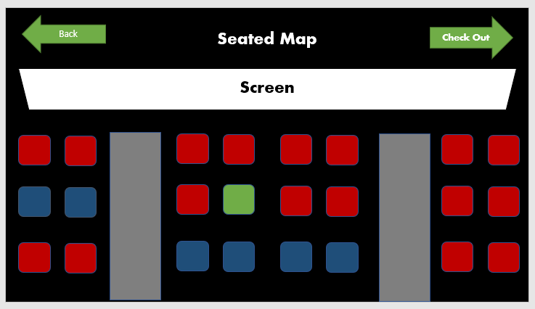

Function

1. We have seats in the theatre, red is empty , green is occupied.

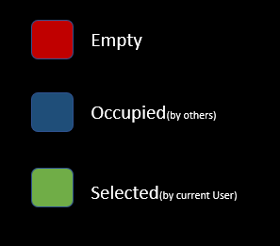

1. Click on the seat in the picture to select the seat.
   1. Click on an empty(red) seat to select the seat , the seat turns into a selected(green) seat.
   2. To unselect , just click on the selected(green) seat again to deselect it. The deselected seat turns into an empty(red) seat.

### Page4 - CheckOutPage

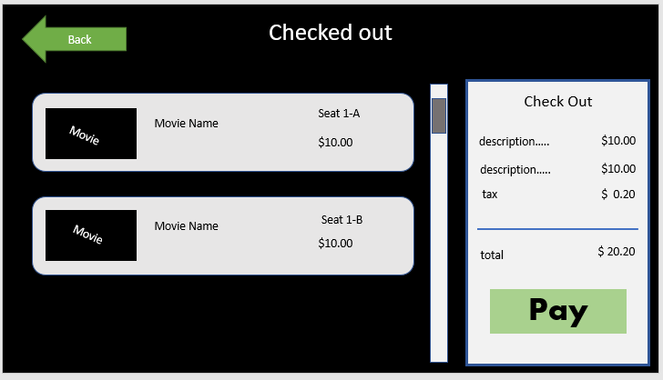

This page shows the movie users have selected on the left. And the total price includes calculation on the right.