Basic Instructions

1. Ensure that onlineBookSales.API is the start up project
2. Run the dbscript script in db folder
3. Create an IIS folder and host the app web project
4. Start the client by right-clicking on Index and then run in your browser
5. Launch the backend by running Visual Studio

Register a new user

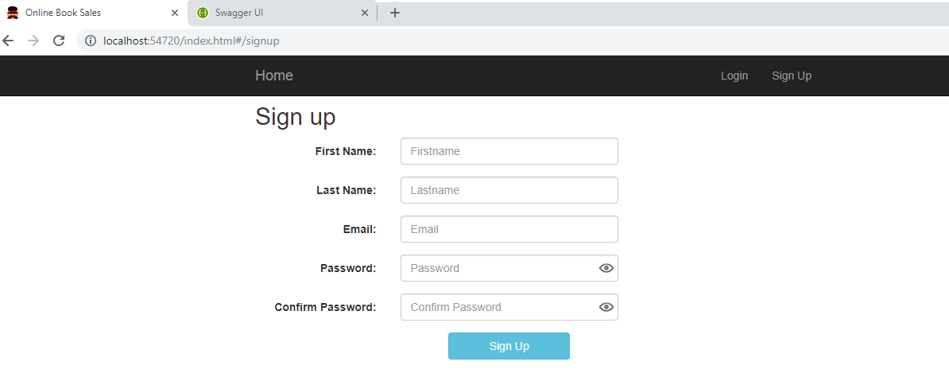

Login Screen

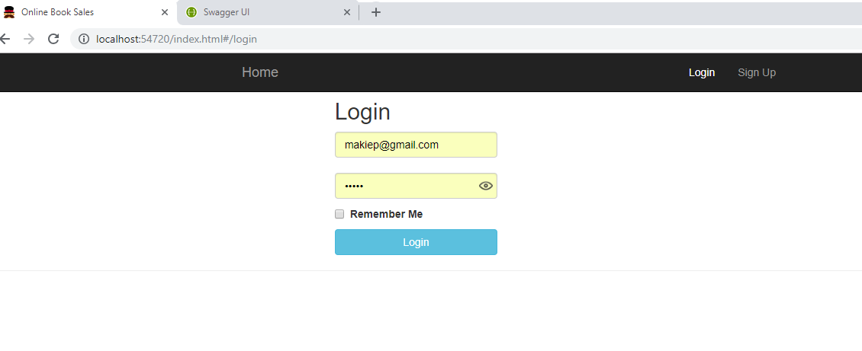

Subscription Page

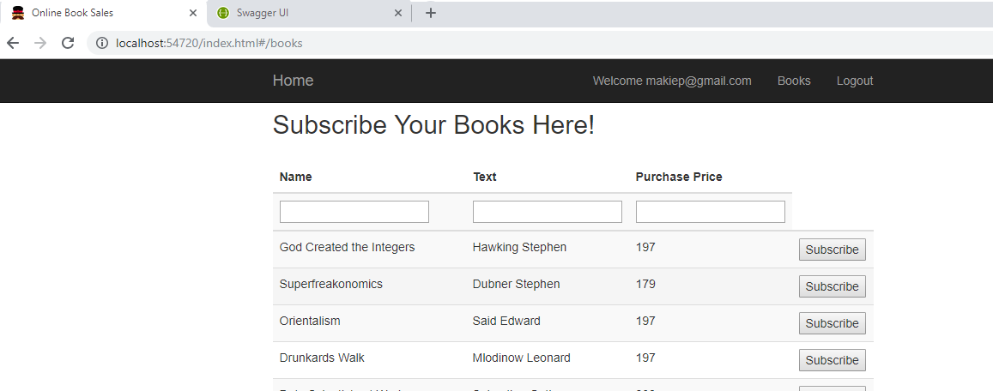

Subscribed Books

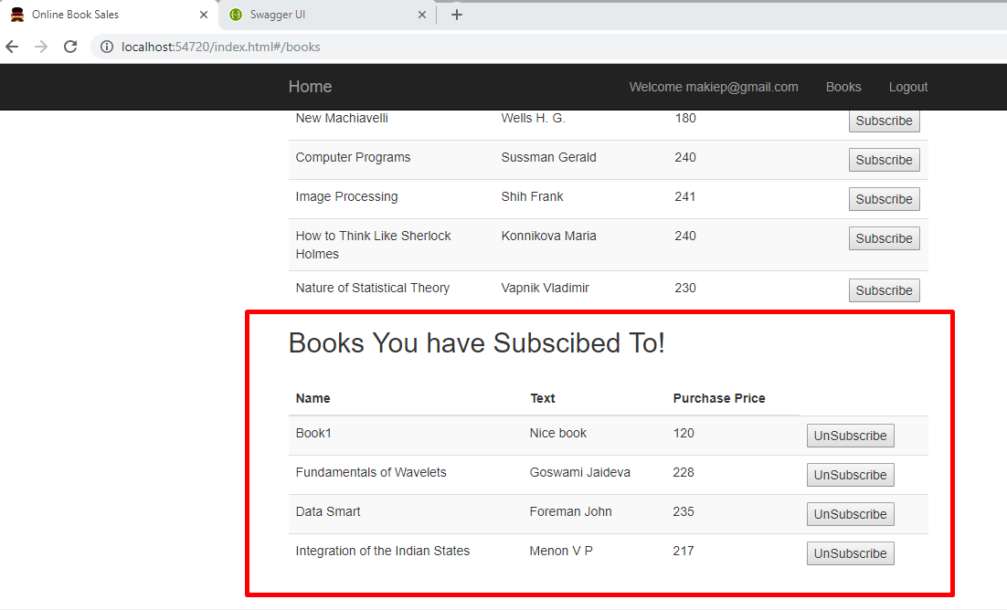

Search fields

