**Using Software**

**Visual Studio**

**DB Browser**

**MVC Format**

|  |  |
| --- | --- |
| |  | | --- | | UNICOMTIC MANAGEMENT SYSTEM | |

|  |  |  |
| --- | --- | --- |
| **Models** | **Controllers** | **Views** |
| User  Course  Subject  Student  Timetable  Room  Timetable | UserController  CourseController  SubjectController  StudentController  TimetableController  ExamController  Mark.Controller | AddStudentForm  AttendanceForm  CourseForm  ExamForm  LoginForm  Main  MarkForm  StudentForm  TimetableForm  UserForm |

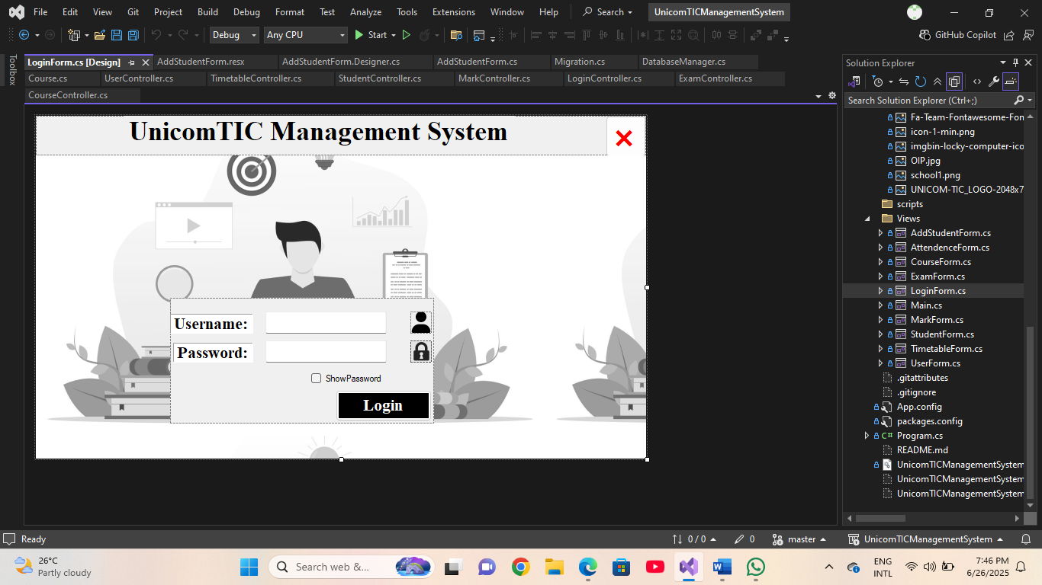

**Login System**

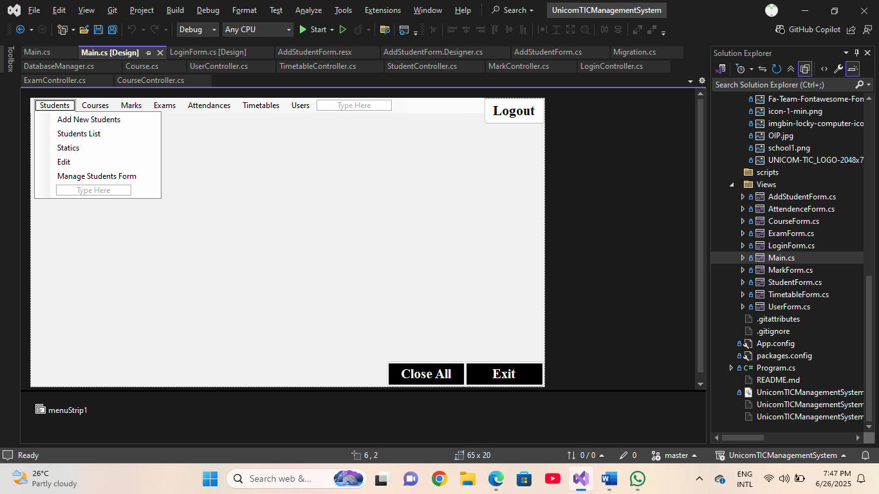

**MainForm**

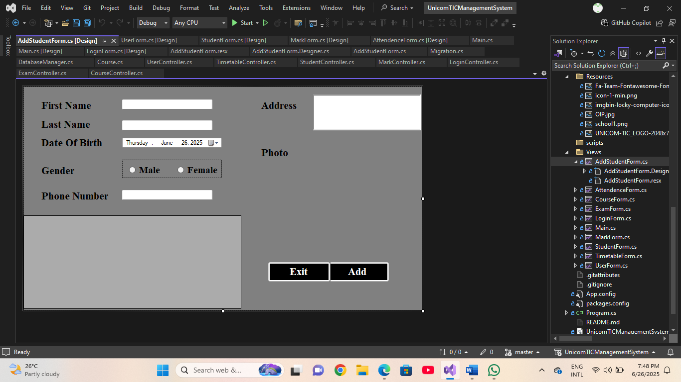

**Addstudent Form**

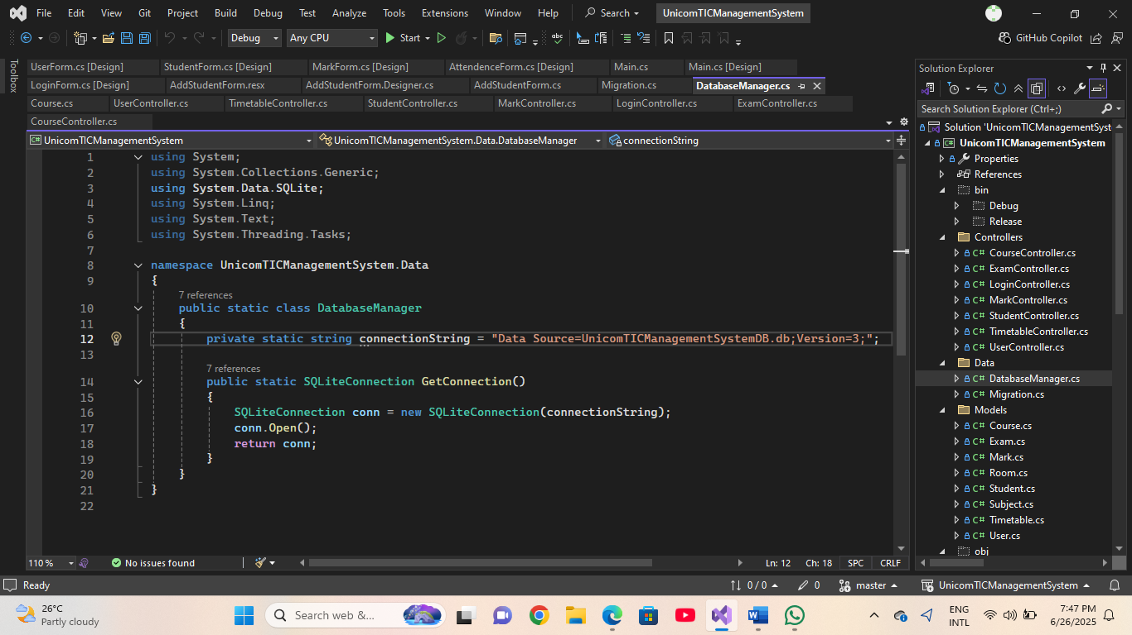

**Data Connection**

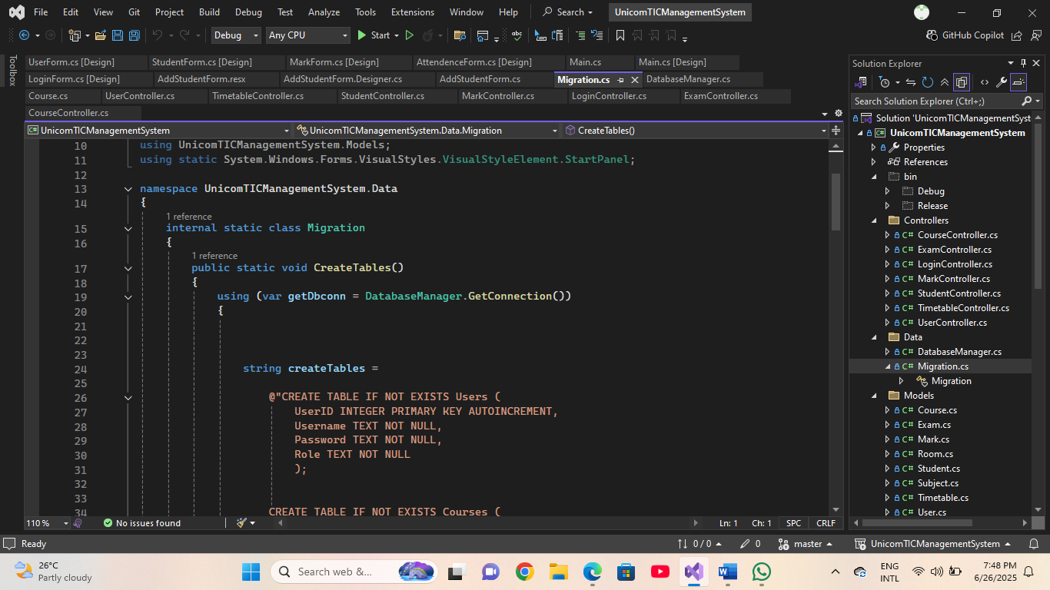

**Create Tables**

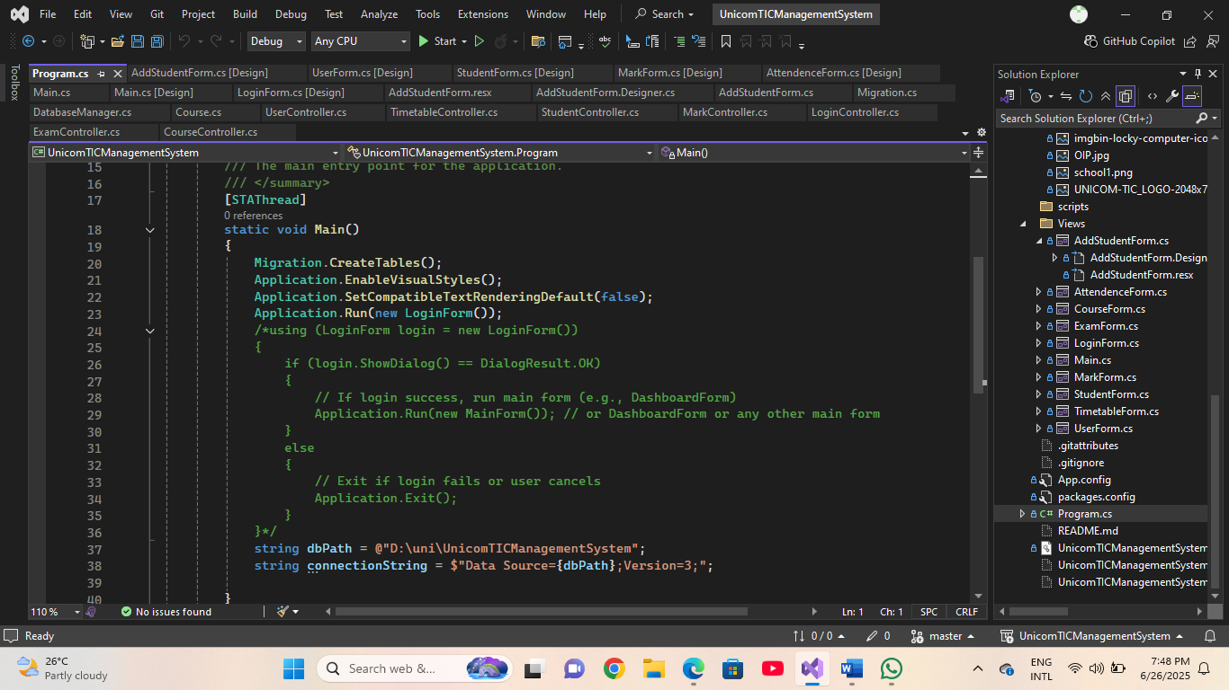

**MainForm Coding**

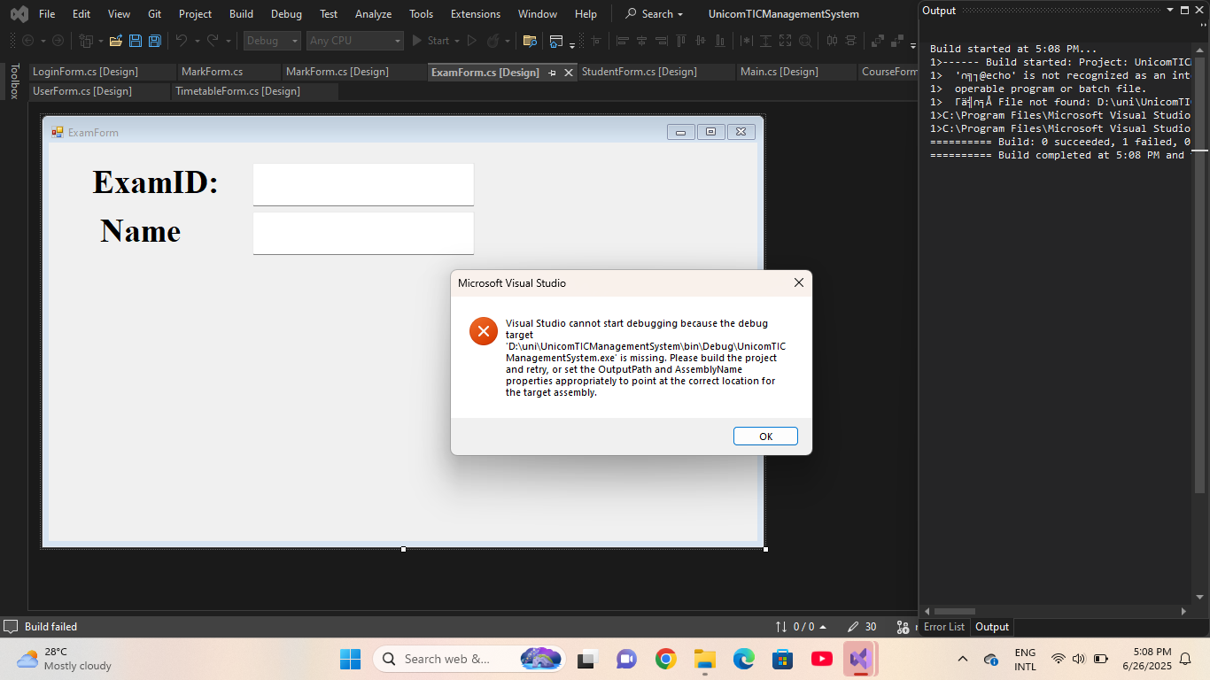

**My Errors**