Data Acquisition & Exploratory Data Analysis
Universal Diagnostic Model for the Big Six West African Staples
Team Architects | ML/DL Research Paper Assignment | ICT 324

1. Data Acquisition
Six crop-specific image datasets were sourced from three distinct repositories to support the “Universal Diagnostic Model for the Big Six West African Staples” research objective. Table 1 summarizes the source, class structure, and volume for each crop.
Crop | Source | Classes | Images
Cassava | Kaggle (Cassava Leaf Disease Classification) | 5 | 21,397
Maize | Kaggle (aggregated multi-source) | 4 | 4,188
Taro | Mendeley Data (West African-collected; substituted for Yam) | 5 | 21,220
Tomato | PlantVillage (Kaggle) | 10 | 16,011
Pepper | PlantVillage (Kaggle) | 2 | 2,475
Potato | PlantVillage (Kaggle) | 3 | 2,152
Total |  | 29 | 67,443
Table 1. Summary of acquired datasets by crop, source, class count, and image volume.

1.1 Note on Yam Substitution
No publicly available, sufficiently large yam (Dioscorea spp.) leaf disease dataset was identified during the literature and data-sourcing search. Taro (cocoyam) was substituted as it is a comparable West African root/tuber staple, with a recent (2025), regionally-collected, and well-documented public dataset available via Mendeley Data. This substitution is itself a documented finding regarding the current data-availability gap for yam-specific disease research in the region, and is discussed further in the Limitations section of this paper.

2. Data Validation
All 67,443 acquired images were programmatically verified for file integrity using Python's PIL library (Image.verify()). One corrupted, non-image artifact file (filename: svn-r6Yb5c, likely a packaging remnant from the source repository) was identified within the Tomato_YellowLeaf_Curl_Virus class and removed. The final validated dataset comprises 67,442 images across 29 classes.

3. Class Distribution
Figure 1 presents the class distribution for each of the six crops. Distribution reveals substantial imbalance both between crops and within individual crops.
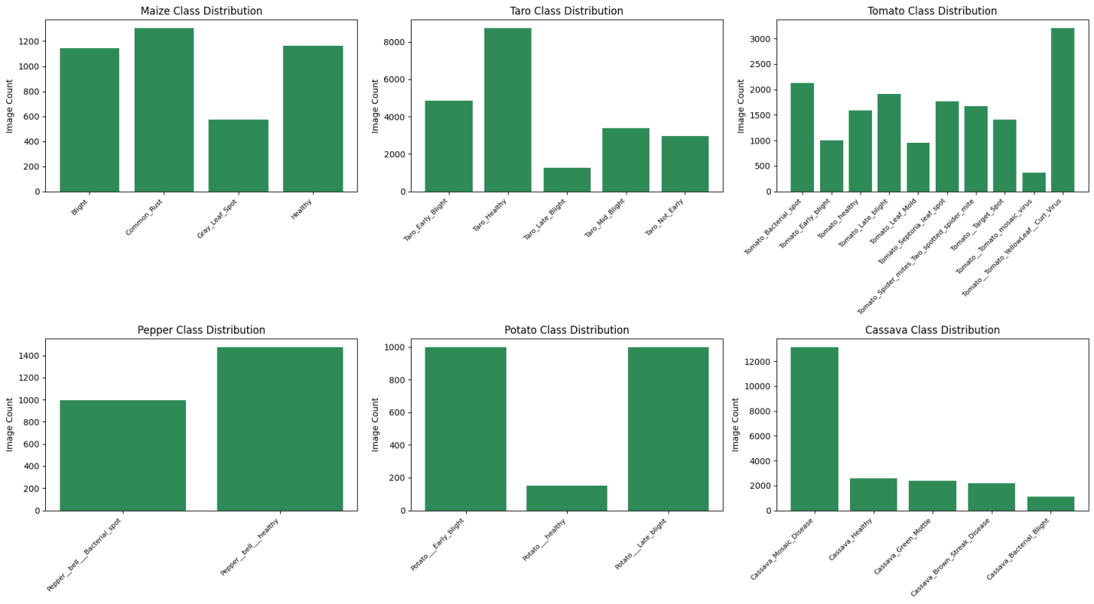
Figure 1. Class distribution across all six crops (Maize, Taro, Tomato, Pepper, Potato, Cassava).
Key observations:
- Between-crop imbalance: Cassava, Taro, and Tomato each contribute 16,000–21,000+ images, while Pepper and Potato contribute only ~2,000–2,500 images each.
- Within-crop imbalance (Cassava): Cassava_Mosaic_Disease (13,158 images) vastly outweighs Cassava_Bacterial_Blight (1,087 images), a ratio of roughly 12:1.
- Within-crop imbalance (Potato): Potato___healthy (152 images) is dramatically underrepresented relative to its two disease classes (~1,000 images each).
- Within-crop imbalance (Taro): Taro_Healthy (8,744 images) is disproportionately high relative to its four disease-stage classes.
- This imbalance will be addressed during preprocessing via class weighting in the loss function and/or targeted augmentation of minority classes.

4. Sample Verification
A representative sample image was drawn from each of the 29 classes to visually confirm correct labeling and inspect image characteristics (Figure 2).
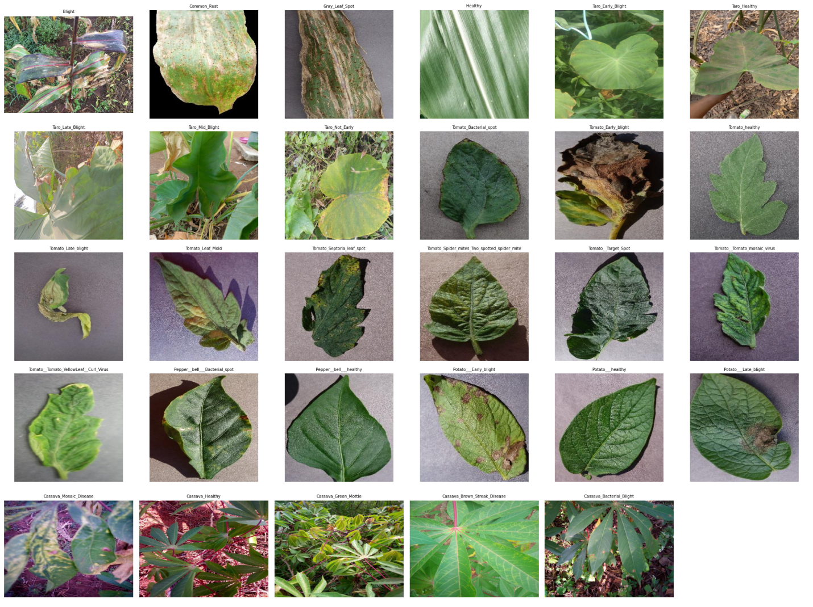
Figure 2. Representative sample image from each of the 29 disease/health classes across all six crops.
Visual inspection confirmed correct labeling across all classes. Notably, the three PlantVillage-sourced crops (Tomato, Pepper, Potato) share a consistent grey lab-background aesthetic, while Taro and Cassava consist of natural field photographs with varied backgrounds (soil, foliage, and in some cases a hand holding the leaf). This domain-shift between lab-controlled and field-collected imagery is flagged as a methodological consideration for the Discussion and Limitations sections, as a model trained on this combined set may partially learn background-associated features rather than purely disease-relevant features.

5. Image Resolution Audit
Image dimensions were sampled and audited across all six crops to inform the preprocessing pipeline (Table 2).
Source | Resolution
PlantVillage (Tomato, Pepper, Potato) | Uniform 256 x 256
Taro | Uniform 640 x 640
Cassava | Uniform 800 x 600
Maize | Variable (188px to 1920x1080), reflecting multi-source aggregation
Table 2. Native image resolution by data source.
Given the resolution inconsistency across and within sources, all images will be resized to a standardized 224 x 224 during preprocessing, matching the input requirements of the Vision Transformer architecture (Dosovitskiy et al., 2021).

6. Summary
- Total validated images: 67,442 across 29 classes and six crops.
- Zero corrupted files remaining after validation and cleanup.
- Significant class imbalance identified and documented, both between and within crops — to be addressed via class weighting / augmentation.
- Resolution inconsistency identified across all three data sources — to be resolved via standardized resizing to 224 x 224.
- Domain-shift risk identified between lab-background (PlantVillage) and field-collected (Taro, Cassava) imagery — flagged for Discussion/Limitations.
- Yam data-scarcity finding documented; Taro (cocoyam) substituted as the sixth staple crop.

Team Contribution Statement
- Makinde Ayomide Daniel (2023/12127) - Team Lead and Head Project Research
- Sanni Smaiat Ajoke ()

