

Gouri Sankar Das | Emp ID : 00368235 Email Id : gouri.das@wipro.com

Location : MANIKONDA, HYDERABAD, Andhra Pradesh,India



EXPERIENCE SUMMARY

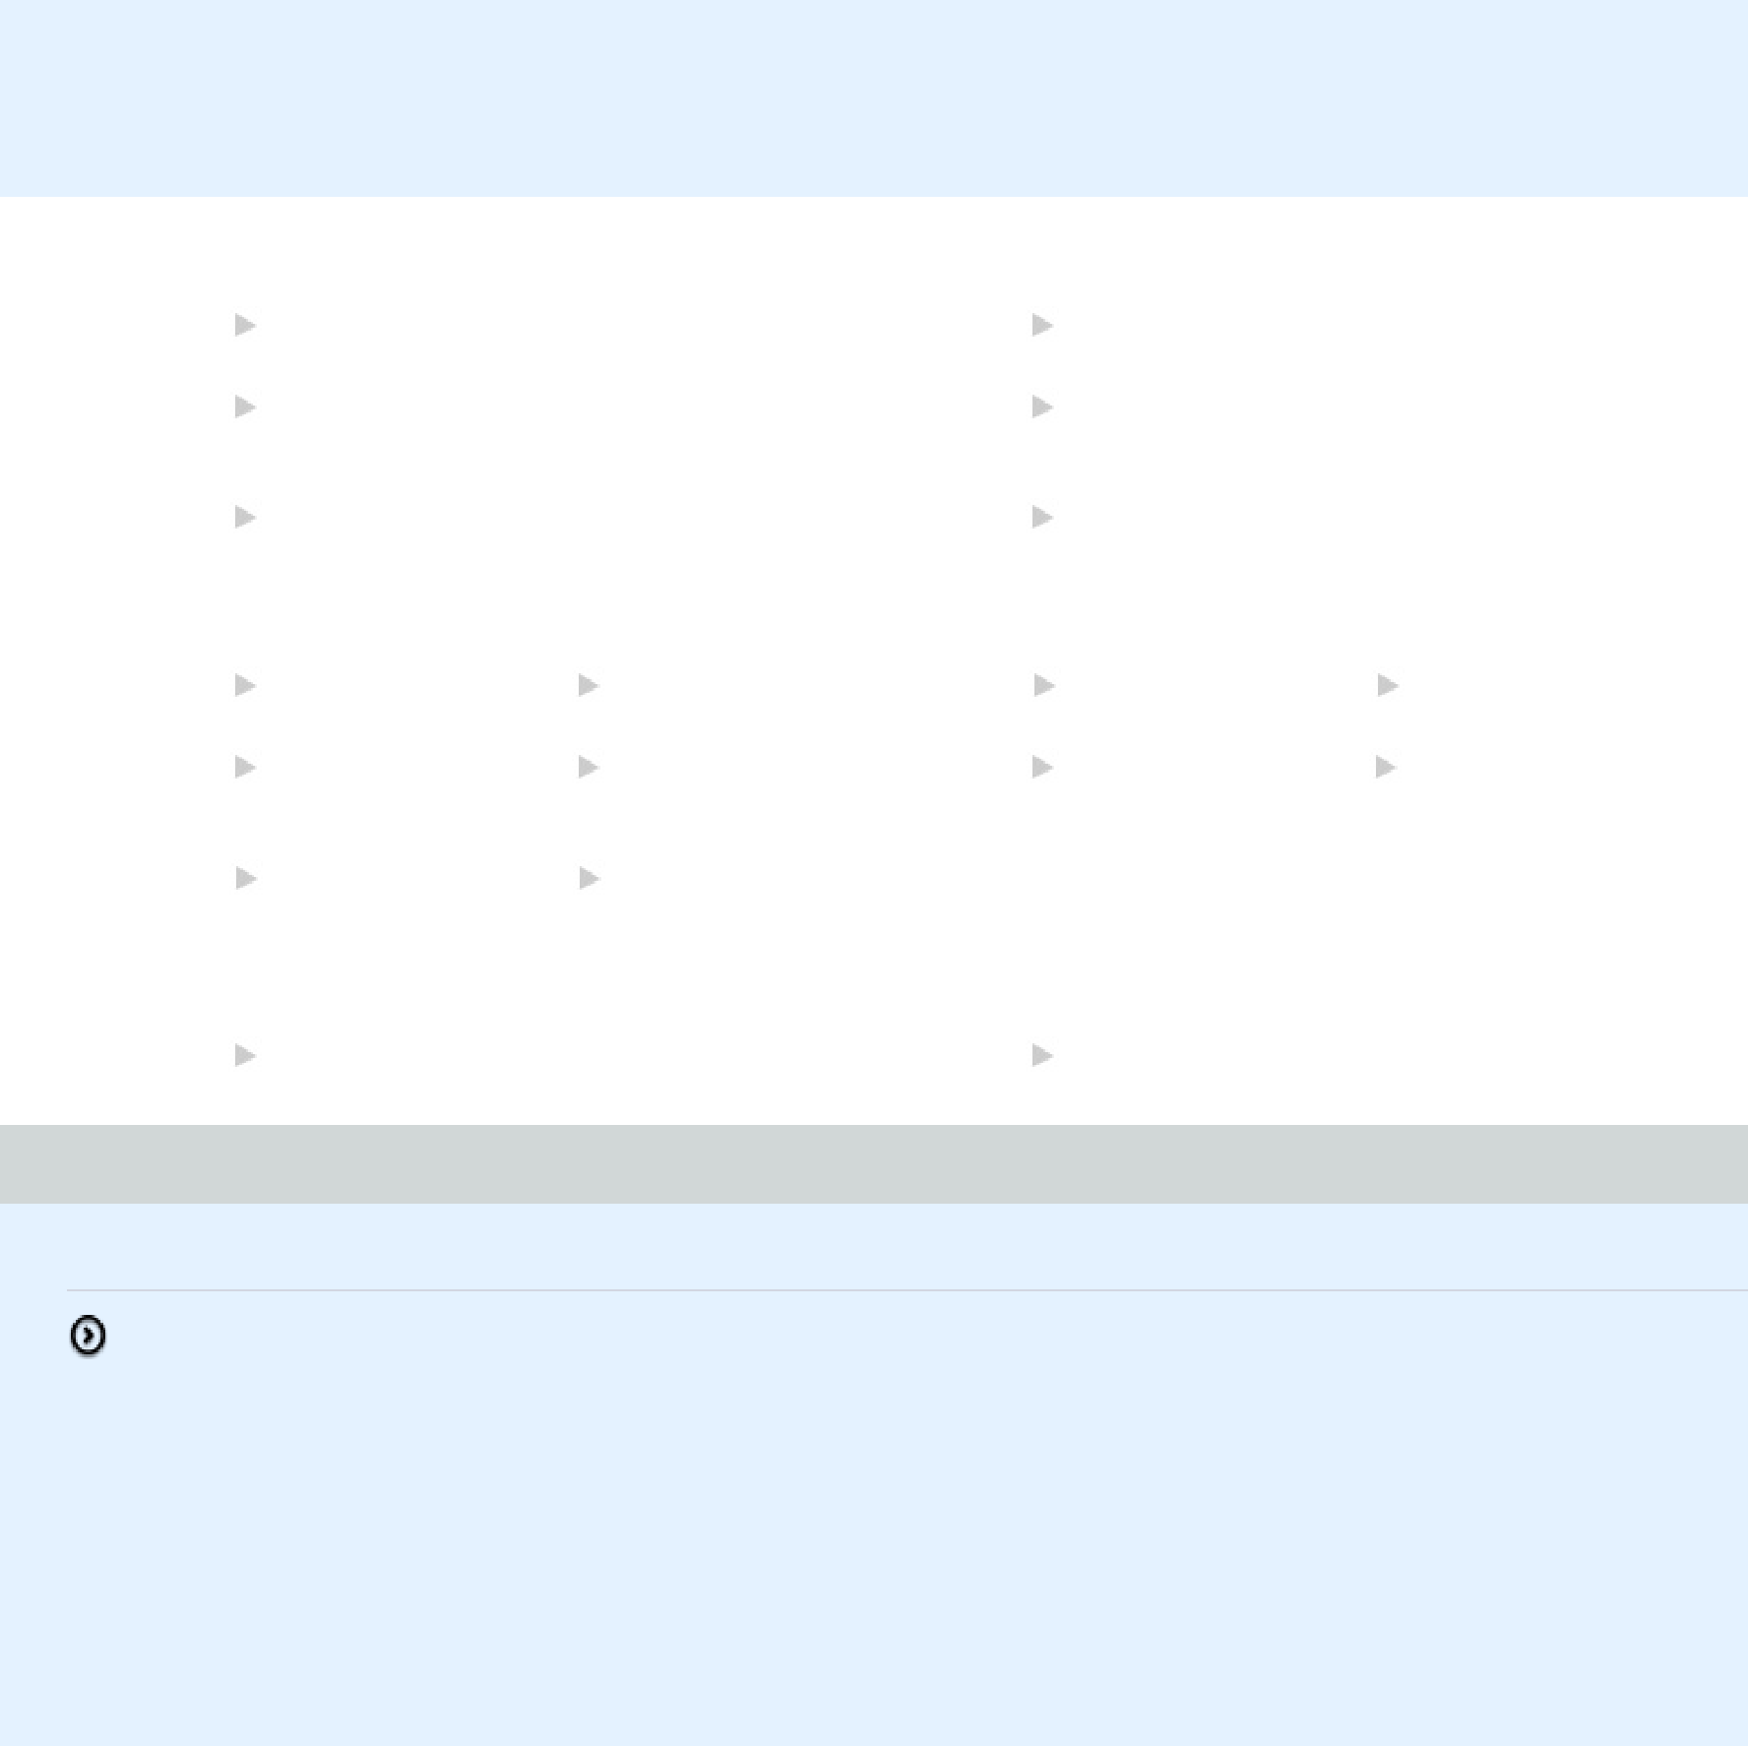

Have been in this project for about a year now and have had a fair share of exposure in different components under MS WP Testing. Have worked in Manual Testing for approx six months and have been involved in Device Health Semi Automation testing for around eight months now in different device types like Phi, QRD, LowCost and Fluid V2. Indeed it has been a pleasant experience so far with project work and WASE going on in the right direction.

SKILL SET

|  |  |  |
| --- | --- | --- |
| Jun-2019 | Windows OS | 4Month(s) |
|  |  |  |
| Jun-2019 | Windows Phone | 9Month(s) |
|  |  |  |
| Jun-2016 | WinForms | 1Year(s) |
|  |  |  |

|  |  |  |
| --- | --- | --- |
| Jun-2019 | Product Testing | 2Year(s) 10Month(s) |
|  |  |  |
| Oct-2017 | Windows Platform | 4Month(s) |
|  | Testing |  |
| Jun-2016 | Application Testing | 1Year(s) |
|  |  |  |

TRAINED SKILLS

|  |  |  |
| --- | --- | --- |
| Apr-2018 | Cloud-Microsoft Azure | L1 |
|  |  |  |
| Jul-2016 | Unix Shell Scripting | L2 |
|  |  |  |
| Mar-2015 | Perl Programming | L1 |
|  |  |  |

|  |  |  |
| --- | --- | --- |
| Aug-2016 | Selenium | L2 |
|  |  |  |
| Oct-2015 | STAF - Software Testing | L1 |
|  | Automation Framework |  |

DOMAIN

|  |  |  |  |  |  |  |
| --- | --- | --- | --- | --- | --- | --- |
| Jun-2016 | MANUFACTURING | 5Year(s) 10Month(s) |  | Jul-2013 | MOBILE APPLICATION 6Month(s) |  |
|  |  |  |  |  | / PLATFORM |  |
|  |  |  |  |  |  |

WORK EXPERIENCE

Total Experience - 06 years and 11 months

**25-10-2017 - 10-06-2019 (PSP-MIC-PJ-WDG_ENGSRVS)**

|  |  |  |  |  |
| --- | --- | --- | --- | --- |
| **Role:** | | TEST ENGINEER-L3 | **Domain:** MANUFACTURING | |
| **Team Size:** | | 30 |  |  |
|  |  |  |  |  |
|  | **Skills** |  |  | **Duration** |
|  |  |  |  |  |
|  | Windows OS |  |  | 4Month(s) |
|  |  | |  |  |
|  | Windows Phone | |  | 4Month(s) |
|  |  | |  |  |
|  | Product Testing | |  | 10Month(s) |
|  |  |  |  |  |

**Description:**

"As a Senior Test Engineer you should able to devise Test Strategy, review test plan, traceability matrix and ensure usage of tools for optimization. You should be able to ensure the availability test environment, design test and defect reporting formats and manage the team. You should update project related data as required in applicable systems and ensure timely reporting and response to stakeholders."

**Responsibility:**

Experience in developing test cases, preparation of test data, creating Test Plans, performing manual testing, analyzing the scope of optimization through automations, effective defect tracking and reporting active failures. Involved in Maintenance and Support for Microsoft Projects.

Experience on usage of MS tools, Windows Testing Tools (WTT), ATLAS, TREX, VSO.

Experience in Performance Testing and Code Coverage testing.

|  |  |  |  |  |
| --- | --- | --- | --- | --- |
| **01-07-2016 - 24-10-2017 (PSP-MIC-PJ-MS OSG TEX)** | | |  |  |
| **Role:** | | TEST ENGINEER-L2 | **Domain:** MANUFACTURING | |
| **Team Size:** | | 30 |  |  |
|  |  |  |  |  |
|  | **Skills** |  |  | **Duration** |
|  |  | |  |  |
|  | Windows Phone | |  | 5Month(s) |
|  |  | |  |  |
|  | Windows Platform Testing | |  | 4Month(s) |
|  |  | |  |  |
|  | Product Testing | |  | 6Month(s) |
|  |  |  |  |  |

**Description:**

"As a Senior Test Engineer you should able to devise Test Strategy, review test plan, traceability matrix and ensure usage of tools for optimization. You should be able to ensure the availability test environment, design test and defect reporting formats and manage the team. You should update project related data as required in applicable systems and ensure timely reporting and response to stakeholders."

**Responsibility:**

NATest Execution monitoring, executions and log triage on the failures in Calendar system and ABS system and reporting to customers. Identifying risks, bottlenecks and painpoints in the system and get them fixed with proper follow-ups with internal customers. Frequent check with teams on daily deliverable with proper checks on system. Frequent meetings with customer and different stakeholders to understand scope changes and updating team accordingly. providing solutions to problem statements in the system and also providing value ads to customers at regular intervals.

|  |  |  |  |  |
| --- | --- | --- | --- | --- |
| **27-07-2013 - 30-06-2016 (MS WP TEST ENGINEERING)** | | |  |  |
| **Role:** | | TEST ENGINEER - L1 | **Domain:** MANUFACTURING | |
| **Team Size:** | | 20 |  |  |
|  |  |  |  |  |
|  | **Skills** |  |  | **Duration** |
|  |  |  |  |  |
|  | WinForms |  |  | 1Year(s) |
|  |  | |  |  |
|  | Application Testing | |  | 1Year(s) |
|  |  | |  |  |
|  | Product Testing | |  | 1Year(s) |
|  |  |  |  |  |

**Description:**

Test environment preparatoin and manual test case execution was the primary objective in this project.Test environment preparation includes instaling latest

windows phone build on the devices using powershell scripting. We used to execute test cases mostly on application such as messaging, email, wallet, nfc etc

written in WTT, a micosoft proprietory tool and log bugs in product studio, also a MS tool.

It was a semi automation project where the health of the windows phone device was getting measured with the help of different parameters called health

metrics.A set of automated tests, which run on a daily basis on different devices define the health of the particular

device. These tests cover the

responsiveness, Battery life, Memory and reliability of the device under test. Device health provides a set of health tests, it will provide a lightweight

method of verifying and automating tasks such as a) quickly verifying that the feature does not hold the system from entering a lower power states or b)

verifying that you are not introducing any major regressions in the amount of time your feature spends low power states. Since this library is merely a way

of detecting problems, but not diagnosing (unlike the health tests which would diagnose the issue), we will also preserve the logs taken so that further

offline analysis is possible. The scope was to deal with failures by analyzing the log files or crash dumps generated during the test progression and

resolve the failures with an appropriate bug (or create a new bug with justifiable stack trace, if no existing bug is found and intimate the test owner

about the exception), So that the exception can be handled. The health tests are authorized using WTT jobs and run on Tshell using the Powershell. The

health execution PowerShell script takes a wtq query file as input, passes it into the Tshell along with the predefined templates for starting the test run.

The predefined template would perform most of the infrastructure related work and the WTT job would contain the tasks related to executing the test scenario

on the device. The template would also contain tasks to post process the results and upload them into the health database.

**Responsibility:**

Prime responsibility of this role is to complete Test Execution for a defined module or a product. Develop test cases and identifynd report bugs. This role has three levels. L1 is entry level position, incumbent is responsible for Test Execution. Developing test cases ( manual/ automated) as per defined guidelines and escalate the blocking issues appropriately to the lead or test manager.

**04-02-2013 - 26-07-2013 (MICROSOFT_WINDOWS_PHONE)**

|  |  |  |  |  |  |
| --- | --- | --- | --- | --- | --- |
| **Role:** | | TEST ENGINEER - L1 | **Domain:** MOBILE APPLICATION / PLATFORM | | |
| **Team Size:** | | 9 |  |  |  |
|  |  |  |  |  |  |
|  | **Skills** |  |  | **Duration** |  |
|  |  | |  |  |  |
|  | Product Testing | |  | 6Month(s) |  |
|  |  |  |  |  |  |

**Description:**

Manual testing was the primary role and responsibility of this project

**Responsibility:**

Prime responsibility of this role is to complete Test Execution for a defined module or a product. Develop test cases and identifynd report bugs. This role has three levels. L1 is entry level position, incumbent is responsible for Test Execution. Developing test cases ( manual/ automated) as per defined guidelines and escalate the blocking issues appropriately to the lead or test manager.