EE 371 HW1

01/1

10/1

1)

11/1

xy/S

01/0

10/0

00/0

00/1

11/0

Q = 1

Q = 0

fullAdder.sv

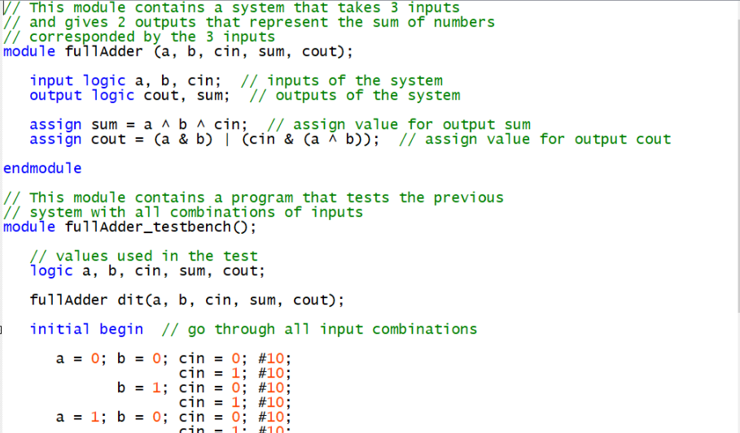

flipFlopAdder.sv

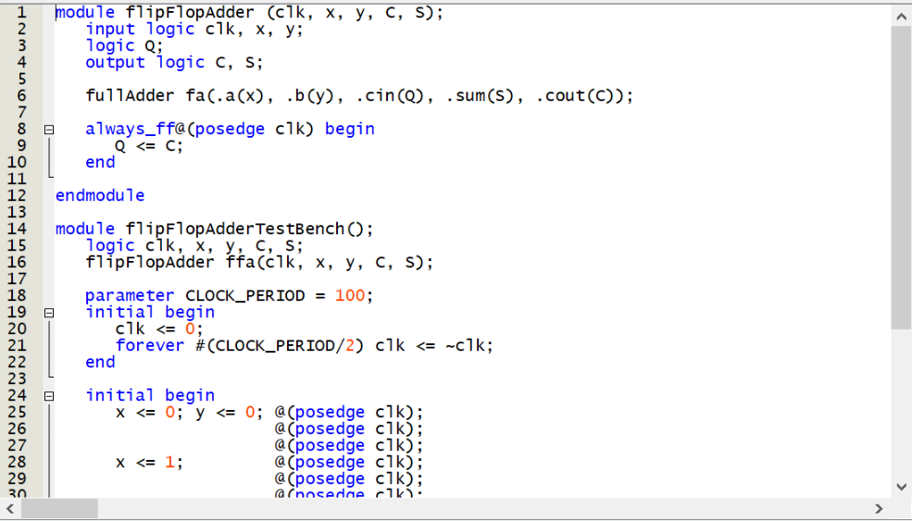

Simulation

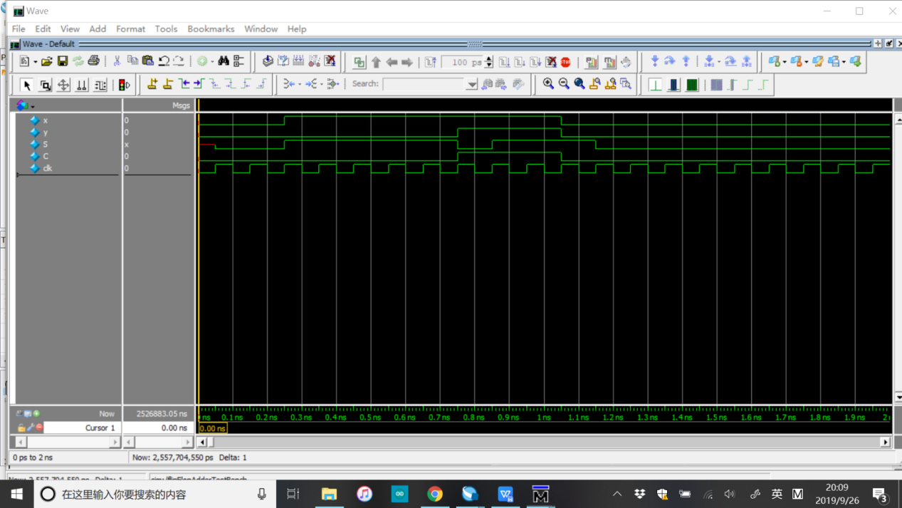

2)

fsm.sv

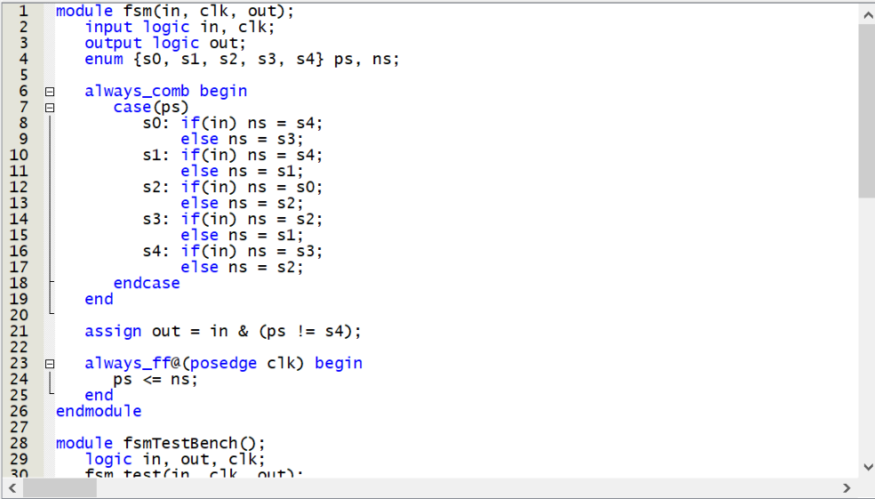

Simulation

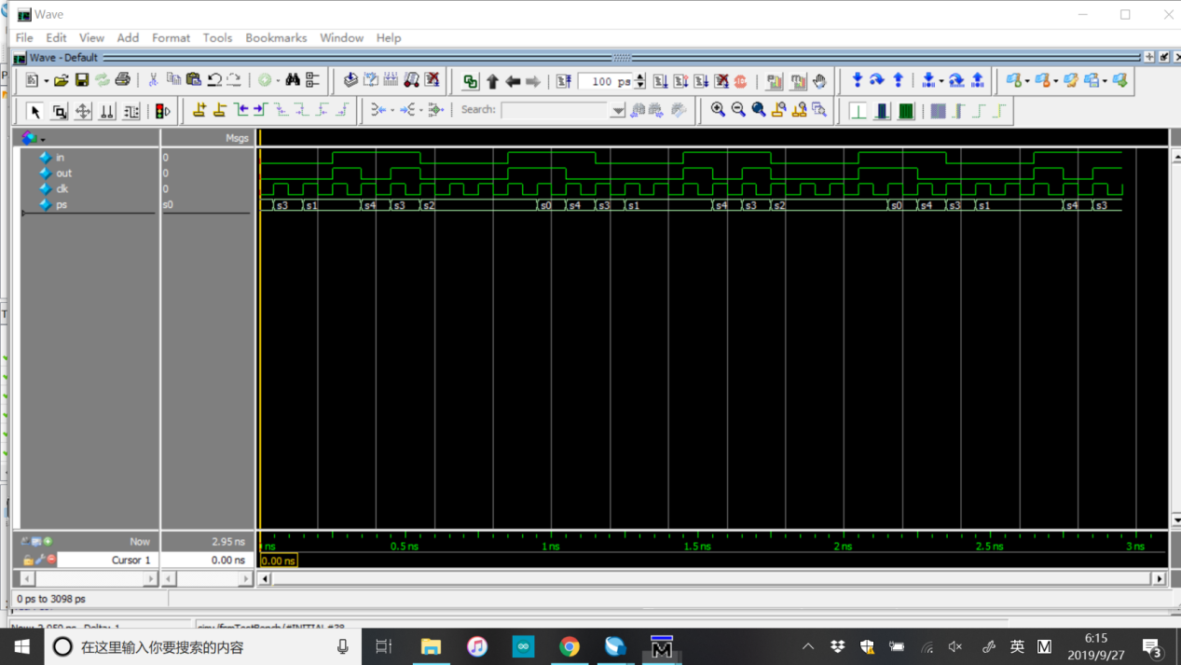

3)

00/0

ab/y

10/0

01/0

11/0

00/0

00/1

01/1

10/1

11/1

10/1

01/1

00/1

10/0

11/1

11/0

01/0

11

10

01

00

4)

Code1:

<=:

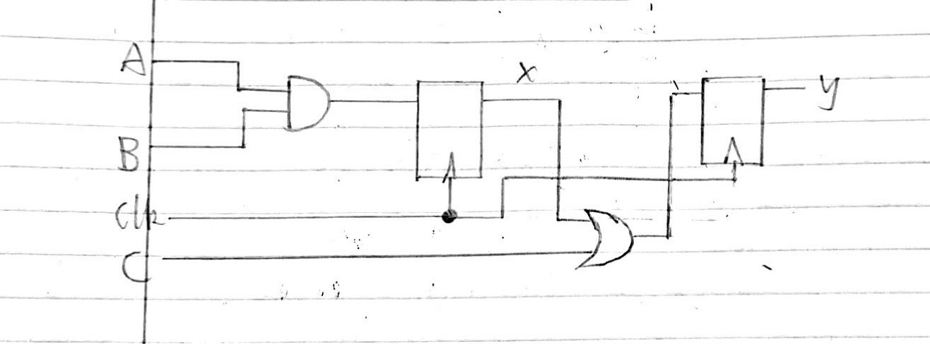

=:

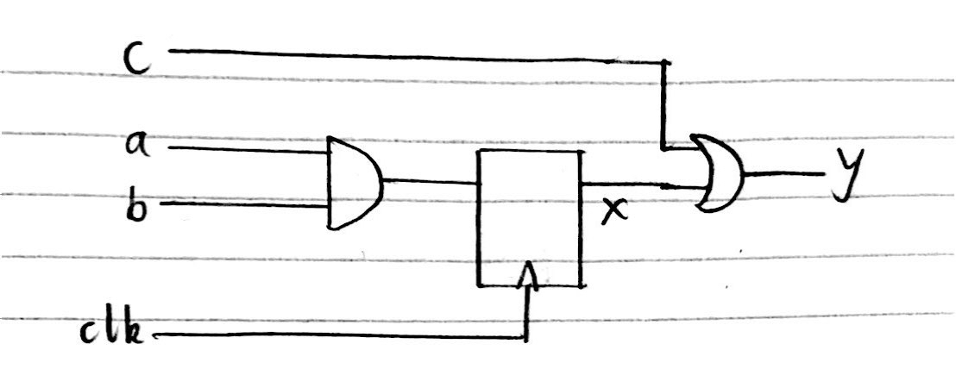

Code2:

<=:



=:

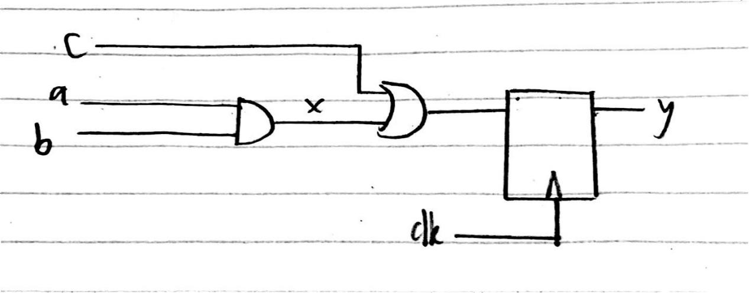

The two modules would have the same function when non-blocking assignment is used because in non-blocking assignment values are assigned simultaneously. However, they would have different functions under blocking assignment because in blocking assignment values are assigned immediately after the statement.

Feedback & Comment

I had some trouble writing the SystemVerilog codes because I kinda forget how to write them. And I also found that I can write finite state machines with logic rather than enum. I also struggled with problem 4 because I am not used to using blocking assignment with in always_ff.