1. a.

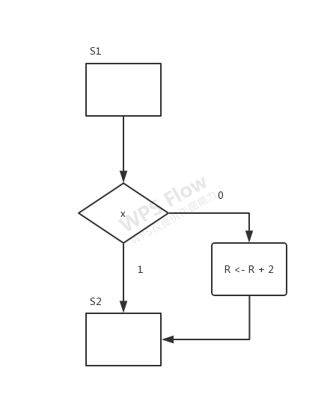

b.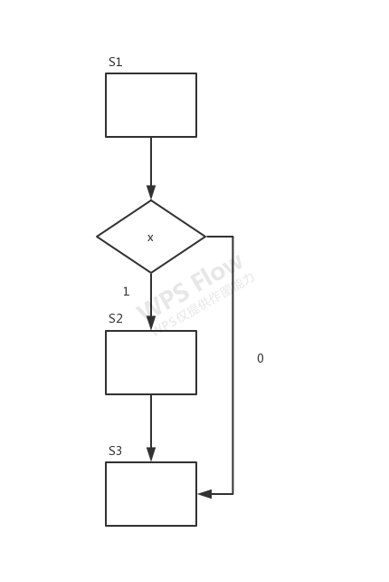c.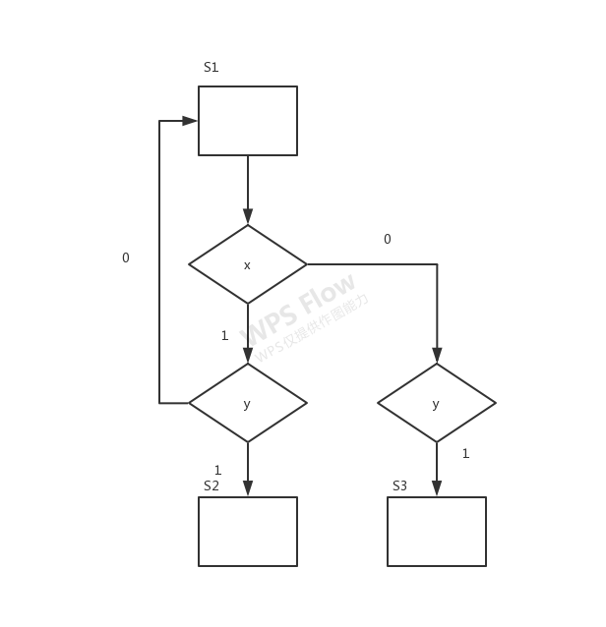

2.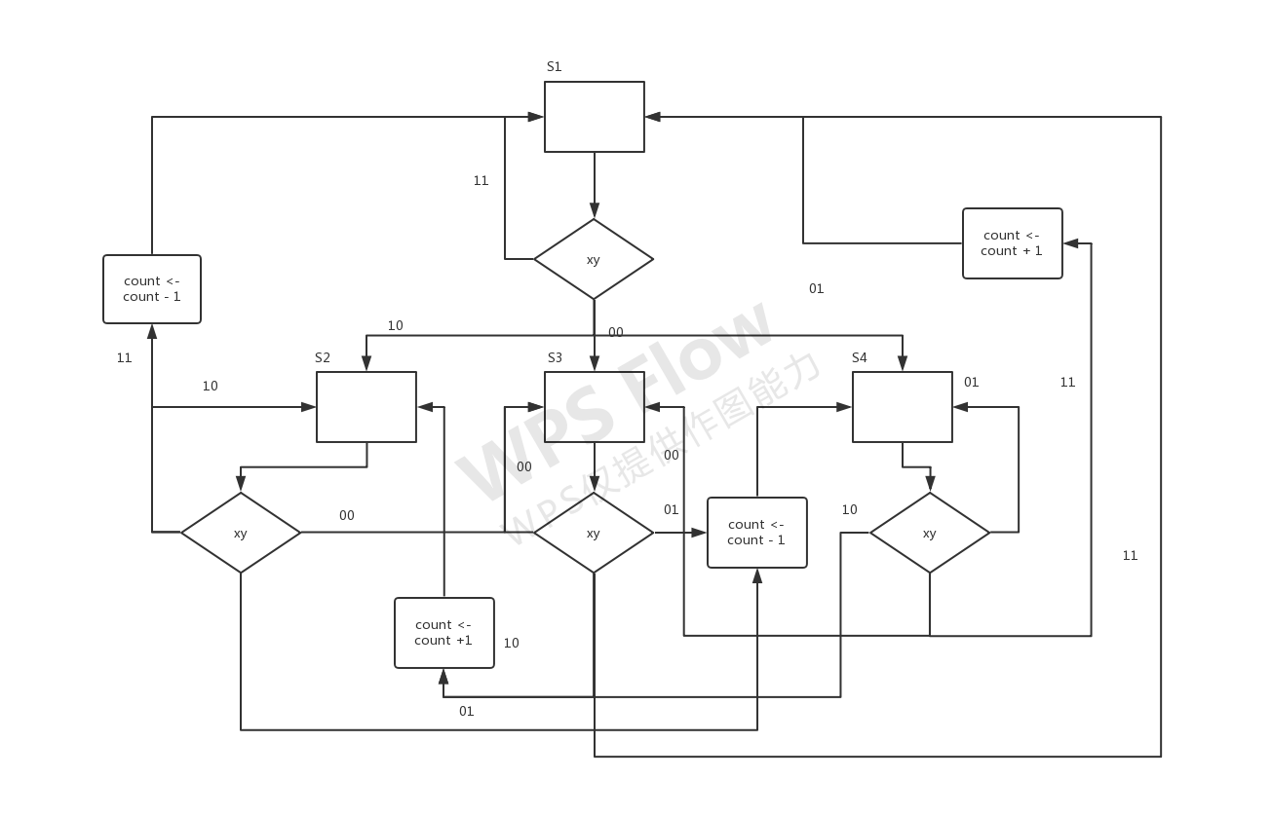

ASMD

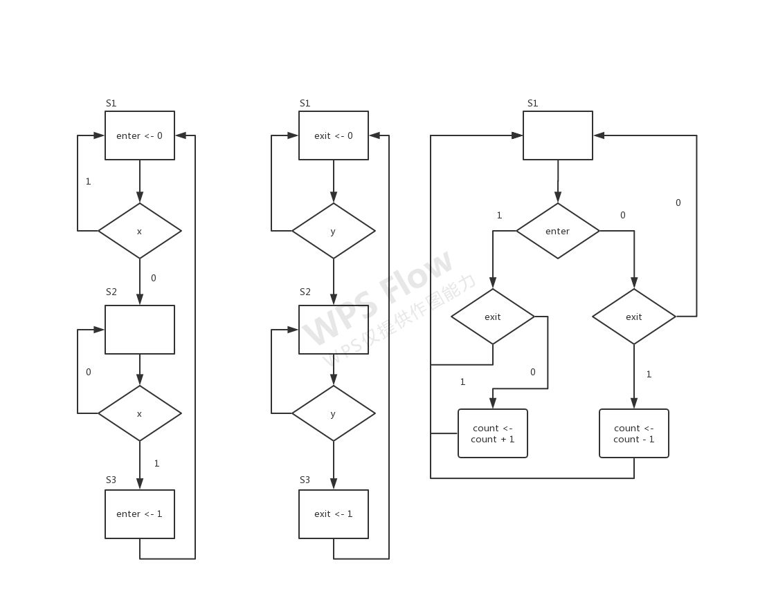

Flow chart of each module

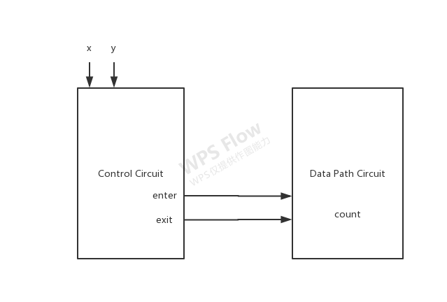

Block Diagram

3.

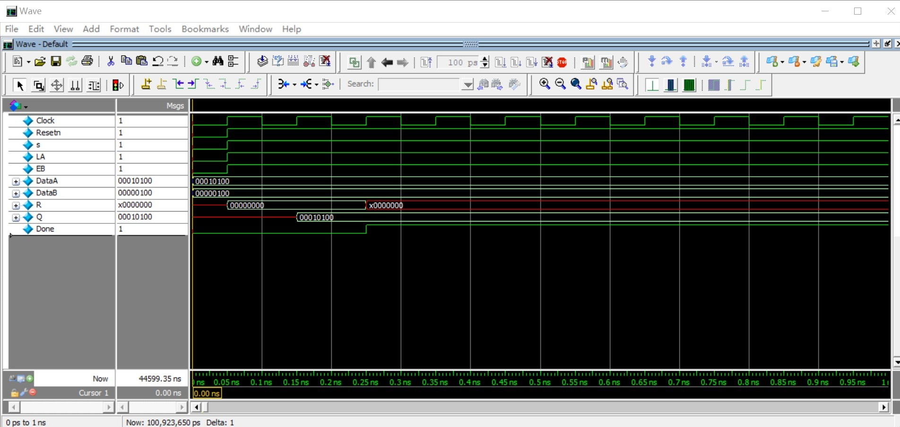

Simulation Before Modification



Simulation After Modification

Feedback

I had some confusion on question 2 because there are two sensors and they each is a finite state machine, but finally I managed to put them all into one ASMD diagram.

I could not get question 3 done. The best I could do was to write one divider myself. I spent 7 hours on this homework, with 5 hours on question 3.