

ESTONIAN UNIVERSITY OF LIFE SCIENCES

Institute of Forestry and Engineering

**Tarkvararakendus „Birdfeeders“**

**Console Application “Birdfeeders”**

Software application

Curriculum in Software design, programming and Data Management

teacher Mait Lang , PhD

Tartu 2024

**TABLE OF CONTENTS :**

**Title page…………………………………………………………..1**

**Table of contents…………………………………………….…….2**

**Purpose of Application…………………………………………... 3**

**Short guide of using the program ……………………………….4 The Source………………………………………………………...5**

**Rules for input……………………………………………….…….8**

**License information……………………………………………...10**

**References…………………………………………………….…..15**

**Application “Birdfeeders in Forest”**

**Purpose of the Application.**

**Figure 1**

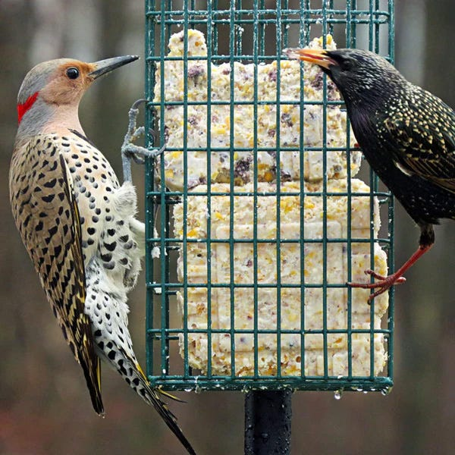

The purpose of the console application “Birdfeeders” is to determine the impact of presence of humanmade birdfeeders in the forest subject of study on the ecosystem health which would be expressed in survival rate of birds in the forest and on the increased attractiveness of such a forest in the eyes of human visitors with children, who would be attracted by birds chirping and would enjoy bird feeding as a form of entertainment and as a way to experience outdoors.

As scientific studies by Millikin University in the US showed, “the individual health of birds improved with the presence of humanmade feeders with supplemental feeding, including increased antioxidant levels, reduced stress (heterophil-to-lymphocyte ratio) and more rapid feather growth. In some species, there was improved body condition index scores and innate immune defence” **(Wilcoxen E, et al 2015**). In general, with the presence of birdfeeders with grains, there were observed consistent patterns of birds being in greater overall health . Besides that, survival rates for birds and their offspring were 38 percent higher in areas where bird feeders were present, and places with bird feeders have a higher percentage of young birds recruited into the breeding population than places without. Besides, bird feeders provide food during cold, barren months, give birds energy for migration, supplement natural food resources. As for humans, they offer relaxation and decrease stress. In a world overwhelmed with technology, the joyful chirping of wild birds provides for visitors a soothing source of natural beauty and a nice escape to unwind from daily stressors.[1]

**Figure 2:**

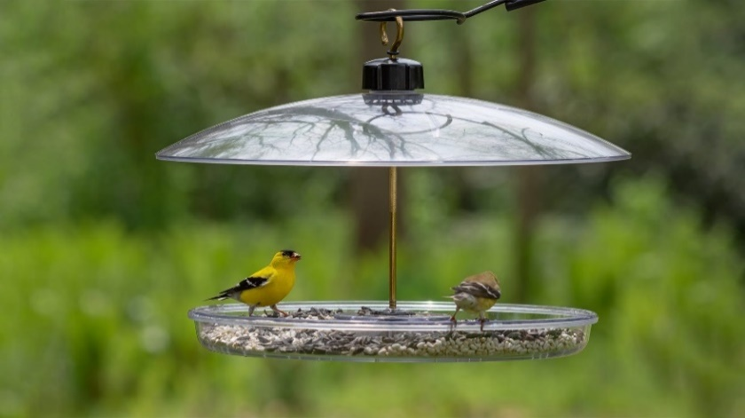

**Short guide for using the program**

To run this program, you need a Python a version at least 3.12.

To test my application, go to my Github (<https://github.com/Makintosh24/BirdfeedersForest>), download the file.

Go to the repository, click the green button “CODE”, Download Zip.

Download repository as a zip file ans unpack in in th=e fo=lder =of =your ch=oice.

( need to have a Pyhton )

You

I take this ZIP to my desktop. Extract it from zip, “Birdfeeders” . We go to the source .

Download Python 3.12 or higher on the computer.

Open the folder, run the command src\main.py

I go to the source, I open the main.py and I run it in Python and test it.

I have a fully open license.

In the shell –

Open the shell- find the folder with **the source**.

**The source.**

# Birdfeeder app

#

# to start go to folder birdfeeders and type

# python.exe .\src\main.py

#

# Copyright (c) by

#

Something is inherently nedodelano here... If I have 60 % initial surviaval rate , then with the presence of the feeders I believe it becomes

If it was 100, it becomes 138... what is this survival rate?

There were 60 birds, we inserted HOW many birdfeeders that it became 98?

במילים אחרות, האם זה מבוסס? Conclusion – I Must read the 2 articles.

יש בזה משהו, אי אפשר להתכחש. אנחנו לא ילדים קטנים. צריך לעמוד מאחורי מה שאנחנו אומרים.

**Rules for input**

In this application, we solve two problems:

1) determine the extent of attractiveness of the forest in the eyes of the human visitors as a function of the number of birdfeeders, implying that a greater amount of birdfeeders attract more birds, which attract more human visitors as a result.

2) Calculate the survival rate of birds in a forest containing birdfeeders , based on the study by Millikin University which stated that presence of feeders affects the birds population to be higher by 38% than in a forest without birdfeeders

Inside the application, I declared the following variables -

BIRDFEEDERS – for number of birdfeeders in the forest,

SURVIVALRATE – the input that we give to the program

BIRDSURVIVALRATE - the calculated survival rate as a function of the number of birdfeeders

FOREST ATTRACTIVENESS – a statement which describes the extent of attractiveness of the forest as a recreation site for visitors as a function of the number of the feeders

As for the first problem, To activate the Forest Attractiveness calculator, we insert the number of birdfeeders in the forest subject of study and determine the extent of its attractiveness in the eyes of the visitors, if a number under 0 is inserted, the system gives an error, if the number of feeders is less then 3, the forest is not considered attractive, the threshold is 6, below it when greater then 3 the forest is considered moderately attractive, while a value greater then 6 returns a high scale of subjective attractiveness.

Regarding the second problem, to determine the survival rate of birds under the existence of birdfeeders, the user must insert an existing survival rate of birds in the input area (prior to the installation of the birdfeeders), and the function multiplies it by 1.38 to get the final survival rate of birds.

If upon those two procedures and subsequent solutions we desire to continue with our calculations, aca inserting new input, to the question that follows “ new calculation yes or no?” we should insert y for yes, and then the cycle continues, otherwise we answer n for “NO”, and the process halts and we get eventually to the end.

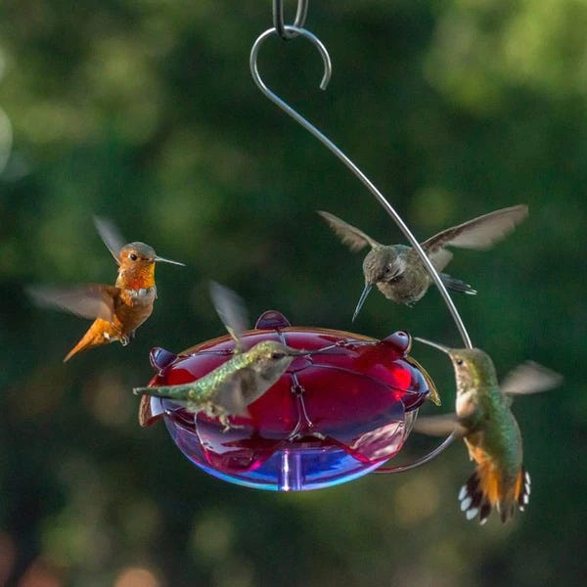

**Figure 3**

***License information :***

Creative Commons Legal Code

CC0 1.0 Universal

CREATIVE COMMONS CORPORATION IS NOT A LAW FIRM AND DOES NOT PROVIDE

LEGAL SERVICES. DISTRIBUTION OF THIS DOCUMENT DOES NOT CREATE AN

ATTORNEY-CLIENT RELATIONSHIP. CREATIVE COMMONS PROVIDES THIS

INFORMATION ON AN "AS-IS" BASIS. CREATIVE COMMONS MAKES NO WARRANTIES

REGARDING THE USE OF THIS DOCUMENT OR THE INFORMATION OR WORKS

PROVIDED HEREUNDER, AND DISCLAIMS LIABILITY FOR DAMAGES RESULTING FROM

THE USE OF THIS DOCUMENT OR THE INFORMATION OR WORKS PROVIDED

HEREUNDER.

Statement of Purpose

The laws of most jurisdictions throughout the world automatically confer

exclusive Copyright and Related Rights (defined below) upon the creator

and subsequent owner(s) (each and all, an "owner") of an original work of

authorship and/or a database (each, a "Work").

Certain owners wish to permanently relinquish those rights to a Work for

the purpose of contributing to a commons of creative, cultural and

scientific works ("Commons") that the public can reliably and without fear

of later claims of infringement build upon, modify, incorporate in other

works, reuse and redistribute as freely as possible in any form whatsoever

and for any purposes, including without limitation commercial purposes.

These owners may contribute to the Commons to promote the ideal of a free

culture and the further production of creative, cultural and scientific

works, or to gain reputation or greater distribution for their Work in

part through the use and efforts of others.

For these and/or other purposes and motivations, and without any

expectation of additional consideration or compensation, the person

associating CC0 with a Work (the "Affirmer"), to the extent that he or she

is an owner of Copyright and Related Rights in the Work, voluntarily

elects to apply CC0 to the Work and publicly distribute the Work under its

terms, with knowledge of his or her Copyright and Related Rights in the

Work and the meaning and intended legal effect of CC0 on those rights.

1. Copyright and Related Rights. A Work made available under CC0 may be

protected by copyright and related or neighboring rights ("Copyright and

Related Rights"). Copyright and Related Rights include, but are not

limited to, the following:

i. the right to reproduce, adapt, distribute, perform, display,

communicate, and translate a Work;

ii. moral rights retained by the original author(s) and/or performer(s);

iii. publicity and privacy rights pertaining to a person's image or

likeness depicted in a Work;

iv. rights protecting against unfair competition in regards to a Work,

subject to the limitations in paragraph 4(a), below;

v. rights protecting the extraction, dissemination, use and reuse of data

in a Work;

vi. database rights (such as those arising under Directive 96/9/EC of the

European Parliament and of the Council of 11 March 1996 on the legal

protection of databases, and under any national implementation

thereof, including any amended or successor version of such

directive); and

vii. other similar, equivalent or corresponding rights throughout the

world based on applicable law or treaty, and any national

implementations thereof.

2. Waiver. To the greatest extent permitted by, but not in contravention

of, applicable law, Affirmer hereby overtly, fully, permanently,

irrevocably and unconditionally waives, abandons, and surrenders all of

Affirmer's Copyright and Related Rights and associated claims and causes

of action, whether now known or unknown (including existing as well as

future claims and causes of action), in the Work (i) in all territories

worldwide, (ii) for the maximum duration provided by applicable law or

treaty (including future time extensions), (iii) in any current or future

medium and for any number of copies, and (iv) for any purpose whatsoever,

including without limitation commercial, advertising or promotional

purposes (the "Waiver"). Affirmer makes the Waiver for the benefit of each

member of the public at large and to the detriment of Affirmer's heirs and

successors, fully intending that such Waiver shall not be subject to

revocation, rescission, cancellation, termination, or any other legal or

equitable action to disrupt the quiet enjoyment of the Work by the public

as contemplated by Affirmer's express Statement of Purpose.

3. Public License Fallback. Should any part of the Waiver for any reason

be judged legally invalid or ineffective under applicable law, then the

Waiver shall be preserved to the maximum extent permitted taking into

account Affirmer's express Statement of Purpose. In addition, to the

extent the Waiver is so judged Affirmer hereby grants to each affected

person a royalty-free, non transferable, non sublicensable, non exclusive,

irrevocable and unconditional license to exercise Affirmer's Copyright and

Related Rights in the Work (i) in all territories worldwide, (ii) for the

maximum duration provided by applicable law or treaty (including future

time extensions), (iii) in any current or future medium and for any number

of copies, and (iv) for any purpose whatsoever, including without

limitation commercial, advertising or promotional purposes (the

"License"). The License shall be deemed effective as of the date CC0 was

applied by Affirmer to the Work. Should any part of the License for any

reason be judged legally invalid or ineffective under applicable law, such

partial invalidity or ineffectiveness shall not invalidate the remainder

of the License, and in such case Affirmer hereby affirms that he or she

will not (i) exercise any of his or her remaining Copyright and Related

Rights in the Work or (ii) assert any associated claims and causes of

action with respect to the Work, in either case contrary to Affirmer's

express Statement of Purpose.

4. Limitations and Disclaimers.

a. No trademark or patent rights held by Affirmer are waived, abandoned,

surrendered, licensed or otherwise affected by this document.

b. Affirmer offers the Work as-is and makes no representations or

warranties of any kind concerning the Work, express, implied,

statutory or otherwise, including without limitation warranties of

title, merchantability, fitness for a particular purpose, non

infringement, or the absence of latent or other defects, accuracy, or

the present or absence of errors, whether or not discoverable, all to

the greatest extent permissible under applicable law.

c. Affirmer disclaims responsibility for clearing rights of other persons

that may apply to the Work or any use thereof, including without

limitation any person's Copyright and Related Rights in the Work.

Further, Affirmer disclaims responsibility for obtaining any necessary

consents, permissions or other rights required for any use of the

Work.

d. Affirmer understands and acknowledges that Creative Commons is not a

party to this document and has no duty or obligation with respect to

this CC0 or use of the Work.

**References:**

In this work, I used the following web resources:

The Benefits of Bird Feeding - https://www.perkypet.com/articles/the-benefits-of-bird-feeding

**Wilcoxen E. (Biology dep., Millikin University) Horn D. et al,** Effects of Birdfeeding activities on the population of wild birds (2015) - Conservation Psychology. Vol 3. *www.ncbi.nlm.nih.gov/pmc/articles/PMC4778448/pdf/cov058.pdf*

1. Benefits of birth feeding [website]<https://www.perkypet.com/articles/the-benefits-of-bird-feeding> (10/02/2024)