**COMPILER DESIGN LAB**

NAME: M. Kesava Reddy

ROLL NO: 21010141

BRANCH: CSE

**1. Write a program to implement three address code**

#include <stdio.h>

int temp_counter = 1;

char* generate_temp() {

static char temp[5];

snprintf(temp, sizeof(temp), "t%d", temp_counter++);

return temp;

}

void generate_code(char* op, char* arg1, char* arg2, char* result) {

printf("%s = %s %s %s\n", result, arg1, op, arg2);

}

int main() {

// Example expression: a = b + c * d

char* a = "a";

char* b = "b";

char* c = "c";

char* d = "d";

char* temp1 = generate_temp();

char* temp2 = generate_temp();

generate_code("*", c, d, temp1);

generate_code("+", b, temp1, temp2);

generate_code("=", temp2, NULL, a);

return 0;

}

**OUTPUT :**

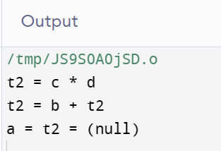S