

Object-Oriented Programming

LAB #1
Topic: Classes and Objects. Vehicle Fleet (Variant 6)

Student’s name: Maksims
Student’s surname: Karnakovs
St. code: st93166
Group: 4502BDA
Lecturer: Dmitrijs Gavrilovs

RIGA 2026

TABLE OF CONTENTS
1. PROBLEM DESCRIPTION 4
1.1. Task 4
1.2. Required functionality 4
1.3. Input and output 4
1.4. How to build and run 5
2. SOLUTION DESIGN 6
2.1. Structure 6
2.2. How the classes interact 7
2.3. Design decisions 7
2.4. OOP principles 8
3. UML DIAGRAMS 9
3.1. Overview 9
3.2. Vehicle — the class of variant 6 10
3.3. Ground transport 11
3.4. Air transport 13
3.5. Water transport 15
3.6. Application and user interface 16
4. IMPLEMENTATION 17
4.1. Vehicle: drive and refuel 17
4.2. Ground transport 17
4.3. Electric car 18
4.4. Flight planning 18
4.5. Voyage planning 19
4.6. Console interface 20
4.7. Quick tests 21
5. ADDITIONAL IMPROVEMENTS 22
6. PROGRAM VERIFICATION 23
6.1. Method 23
6.2. Console output 25
6.3. Automated tests 31
7. CONCLUSIONS 33
8. AI USAGE 34
8.1. Tools 34
8.2. What AI was used for 34
8.3. Parts influenced or generated by AI 34
8.4. Verification and corrections by the student 35
8.5. Explanation pages (artifacts) 35
8.6. Prompt log 36

PROBLEM DESCRIPTION

Task
This laboratory work is variant 6 of the individual variants (student code 93166, 93166 mod 20 = 6). The task is to describe a vehicle as a class. A vehicle is identified by its registration number, has a brand and a model, carries some fuel and has a mileage. Two operations change its state: driving a distance, which burns fuel and increases the mileage, and refuelling, which adds fuel to the tank.
The solution is a C# console application on .NET 10. Because the exact assignment gives at most 70 % of the grade, the vehicle was developed further into a small fleet and trip-planning program: ground, air and water vehicles share the Vehicle base class, and every trip (a drive, a flight or a voyage) is checked against the fuel on board before it starts.

Required functionality
Table 1. Requirements of variant 6 and where they are implemented
Requirement | Implementation
Registration number | Vehicle.RegistrationNumber. It is checked and normalized (2–10 letters, digits or "-", upper case) by NormalizeRegistrationNumber and is unique in the fleet (Fleet.Add).
Brand, model | Vehicle.Brand, Vehicle.Model; they cannot be empty.
Fuel level | Vehicle.FuelLevel in litres with a private setter, together with TankCapacity. An electric car keeps its energy in a battery (ElectricCar.BatteryCharge, kWh).
Mileage | Vehicle.Mileage in km with a private setter.
Drive | Vehicle.Drive(distance) burns FuelConsumption(distance) and adds the distance to the mileage. It refuses the trip if the fuel is not enough and then changes nothing.
Refuel | Vehicle.Refuel(amount, pricePerUnit) adds fuel up to the tank capacity and returns the cost.

Input and output
- Input comes from the keyboard through a numbered console menu. Every value is checked: a wrong value is explained and asked again, it never stops the program. Decimal numbers can be typed with "." or ",", dates as 2027-03-15 or 15.03.2027, and in some questions just Enter keeps the offered default.
- Output: the list and the details of the vehicles, a plan of every trip (distances, time, fuel needed) and the result of every operation. Results are green, warnings yellow and errors red.
- At the start the program offers 15 demo vehicles, one of each type, so every function can be tried without typing the data in.
- When the input ends (for example, when it is redirected from a file), the program says so and finishes normally.

How to build and run
The .NET 10 SDK is required; no NuGet packages are used. The solution file OOPLAB1.slnx contains two projects: OOPLAB1 (the program) and OOPLAB1.Tests (quick tests). From the solution folder:
dotnet run --project OOPLAB1
dotnet run --project OOPLAB1.Tests
In Visual Studio open OOPLAB1.slnx; OOPLAB1 is the startup project. The tests are a second console program: right-click OOPLAB1.Tests → Debug → Start New Instance. The test program returns exit code 1 if a test fails. The file Program_original.cs in the solution folder is the student’s original single-file version, kept for reference; it is not part of the build.

SOLUTION DESIGN

Structure
The code is split into three layers, and every folder is a namespace:
- Model — OOPLAB1.Vehicles (with the Ground, Air and Water namespaces) and OOPLAB1.Fuel: the vehicles, their rules and calculations. The model never reads from or writes to the console, so it can be used and tested without the user interface.
- Application — OOPLAB1: Program (entry point), Fleet (the collection of vehicles) and DemoData.
- User interface — OOPLAB1.UI: the menus and dialogs that ask the user and call the model.
The program has 42 source files; the model contains 21 vehicle classes, 6 of them abstract. Table 2 lists the classes and their responsibilities.
Table 2. Classes and their responsibilities
Class | Responsibility
Vehicle (abstract) | The class of variant 6: identity, fuel, mileage, Drive, Refuel; passengers and cargo for all vehicles; checks of the data.
GroundVehicle (abstract) | Technical inspection, road type, speed limit and travel time, road gradient.
Automobile (abstract) | A ground vehicle with a steering wheel on the left or on the right.
Car, ElectricCar, Truck, Motorcycle | Ground vehicles: doors and seats; a battery; cargo and a trailer; a sidecar.
AirVehicle (abstract) | Flight planning (climb, cruise, descent), wind, fuel reserve, altitude limit.
Airplane (abstract), PassengerAirplane, CargoAirplane, LightAirplane | Airplanes; only they can also drive on the ground (taxi). Reserve by passengers, consumption by cargo, altitude limit.
Balloon, Airship, Helicopter, CargoHelicopter | Other aircraft with their own flight rules.
WaterVehicle (abstract) | Voyage planning with a current, the draft and the depth of the route.
MotorBoat, Sailboat, CargoShip, PassengerLiner | Vessels: sails, cargo and draft, lifeboats.
FlightPlan, VoyagePlan (records) | Immutable results of planning a flight or a voyage.
FuelType, RoadType, SteeringSide (enums) | Fixed sets of values.
VehicleException | An operation that is impossible in the current state of a vehicle.
FuelPrices, Wind | Settings the user can change: the price of every fuel, the default wind.
Fleet | The vehicles of the program; registration numbers are unique.
Menu, MenuItem | A reusable console menu.
FleetMenu | The main menu.
VehicleCreator, VehicleActionsMenu, DriveDialog, FlightDialog, VoyageDialog | Dialogs: creating a vehicle, special actions, a drive, a flight, a voyage.
InputReader, ConsolePrinter | Checked input, coloured output.
Program, DemoData | Start of the program, demo vehicles.

How the classes interact
Program creates the Fleet, FuelPrices and Wind objects and passes them to FleetMenu. FleetMenu builds the main menu from Menu items; each item is a method that selects a vehicle from the fleet and calls a dialog. The dialogs read values with InputReader, call the model and print the result with ConsolePrinter.
Most of the menu works only with the Vehicle base class. The exact type is checked in a few places where a different dialog is needed: "Drive / fly / sail" opens a flight dialog for an AirVehicle, a voyage dialog for a WaterVehicle and a road trip dialog for a GroundVehicle, and "Refuel / charge" charges an ElectricCar:
private void DriveOrFly()
{
Vehicle? vehicle = SelectVehicle();
if (vehicle is AirVehicle aircraft)
FlyOrTaxi(aircraft);
else if (vehicle is WaterVehicle vessel)
VoyageDialog.Run(vessel, _wind);
else if (vehicle is GroundVehicle groundVehicle)
DriveDialog.Run(groundVehicle);
else if (vehicle != null)
Drive(vehicle);
}
Vehicles do not know fuel prices: the menu takes the price from FuelPrices and passes it to Refuel, so the price is a setting of the program, not a property of a car.

Design decisions
- Vehicle is abstract. A "vehicle in general" cannot be driven or refuelled in a meaningful way, and every type has to name itself (the abstract property TypeName). The five properties and the two methods of the assignment are all in Vehicle; objects are created through its subclasses.
- Three branches by environment. GroundVehicle, AirVehicle and WaterVehicle collect what is common to vehicles on roads, in the air and on water, so the concrete classes contain only their own differences.
- Shared behaviour goes up. Passengers and cargo are needed by unrelated types (car, motorcycle, passenger airplane, liner; truck, cargo airplane, cargo ship, cargo helicopter), so BoardPassengers and LoadCargo are in Vehicle, and each type only sets MaxPassengers or MaxCargo. This follows the rule agreed at the start: subclasses should not get too many unique extras, or the Vehicle class would lose its meaning.
- Template methods. The base class runs an algorithm and the subclasses override only the step that differs: GroundVehicle.FuelConsumption → FlatRoadConsumption; AirVehicle.PlanFlight → ClimbDistance, DescentDistance, GroundSpeed, FuelReserve; WaterVehicle.PlanVoyage → SpeedThroughWater, Draft, FuelReserve.
- Plan first, then act. PlanFlight and PlanVoyage calculate without changing the vehicle and return an immutable record. Fly and Sail use the same plan, check the fuel and only then change the fuel and the mileage. The user sees the plan and decides.
- Two kinds of errors. Wrong arguments (a negative distance, an empty brand) throw ArgumentException; operations impossible in the current state (not enough fuel, the cargo does not fit) throw VehicleException. The menu catches both, prints the message and goes on. A failed operation changes nothing.
- The electric car has its own battery (BatteryCharge, BatteryCapacity in kWh); its inherited fuel tank is 0 L of 0 L, and Drive and Refuel are overridden to use the battery.
- No third-party libraries. The program and its tests use only the .NET base library.

OOP principles
Table 3. OOP principles in the solution
Principle | Where it is used
Encapsulation | The state has private setters (FuelLevel, Mileage, Passengers, CurrentCargo, BatteryCharge, …) and changes only through methods that check the rules. Constructors check all data, so an invalid object cannot exist. Fleet gives out only a read-only list.
Inheritance | 21 vehicle classes; the longest chain is Vehicle → GroundVehicle → Automobile → Car → ElectricCar.
Polymorphism | Virtual members are overridden by the types: FuelConsumption, Drive, Refuel, FuelReserve, GroundSpeed, SpeedThroughWater, GetInfo, TypeName and others. The list, the details and the trips work through Vehicle references, and every object behaves by its own type.
Abstraction | Abstract classes Vehicle, GroundVehicle, Automobile, AirVehicle, Airplane, WaterVehicle; the abstract property TypeName. The user interface works with these abstractions.
Aggregation and composition | Fleet holds the vehicles; a Menu consists of MenuItems; FleetMenu works with the Fleet, FuelPrices and Wind objects given to its constructor.

UML DIAGRAMS
The diagrams were generated from the submitted source code. A script reads the declaration of every class (its base class, properties and methods with their visibility and modifiers) and draws them, so the diagrams show the real code. Notation:
- + public, # protected; underlined — static; italic — abstract; /Name — a derived (computed) property;
- {readOnly} — set only in the constructor; {private set} — everyone can read it, only the class can change it; {leaf} — sealed;
- hollow triangle — inheritance; hollow diamond — aggregation; filled diamond — composition; dashed arrow — dependency («create», «call», «use», «throws»);
- constants, constructors and private members are not shown; every class shows only the members it declares or overrides.

Overview
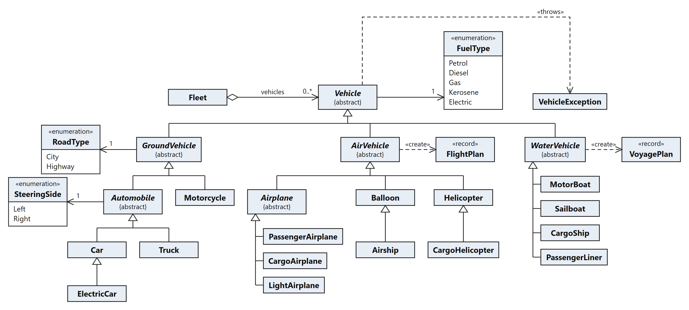
Fig. 1. Class diagram of the whole model (names only)

Vehicle — the class of variant 6
The central class with all members (Fig. 2). The five properties of the assignment are at the top of the attribute list; Drive and Refuel are the first operations after FuelConsumption.
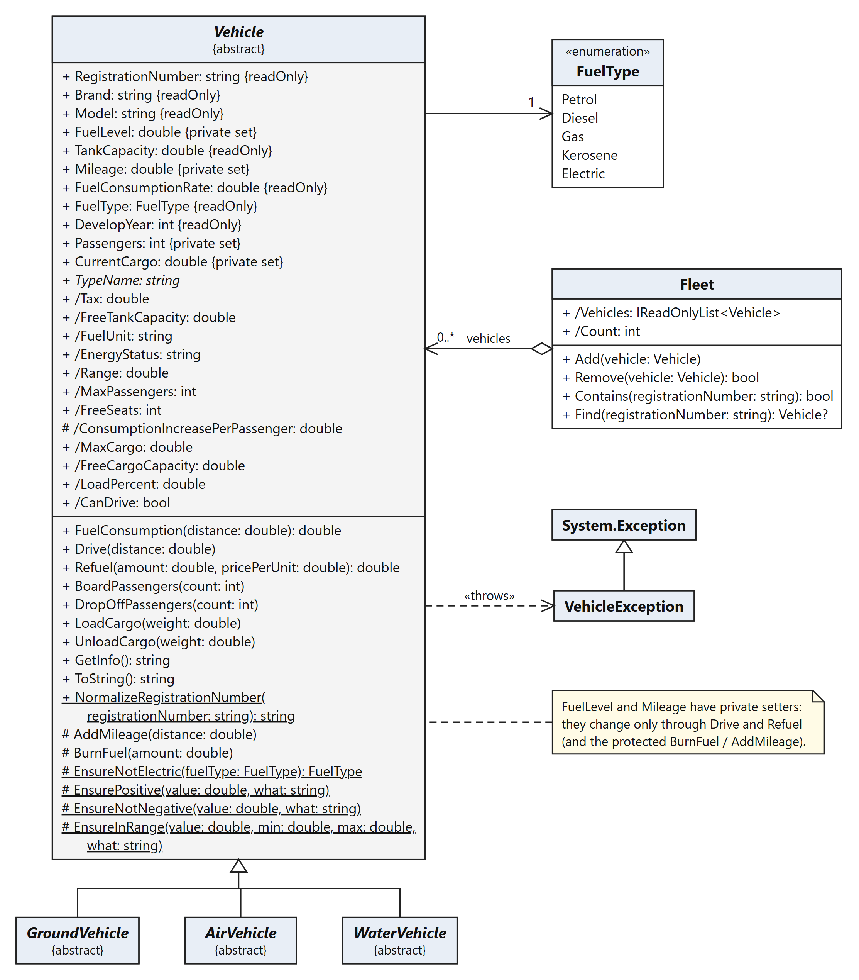
Fig. 2. Class Vehicle, the fleet and the exception

Ground transport
GroundVehicle adds the inspection, the road and the gradient; Automobile adds the steering side (Fig. 3). The concrete ground vehicles are shown in Fig. 4.
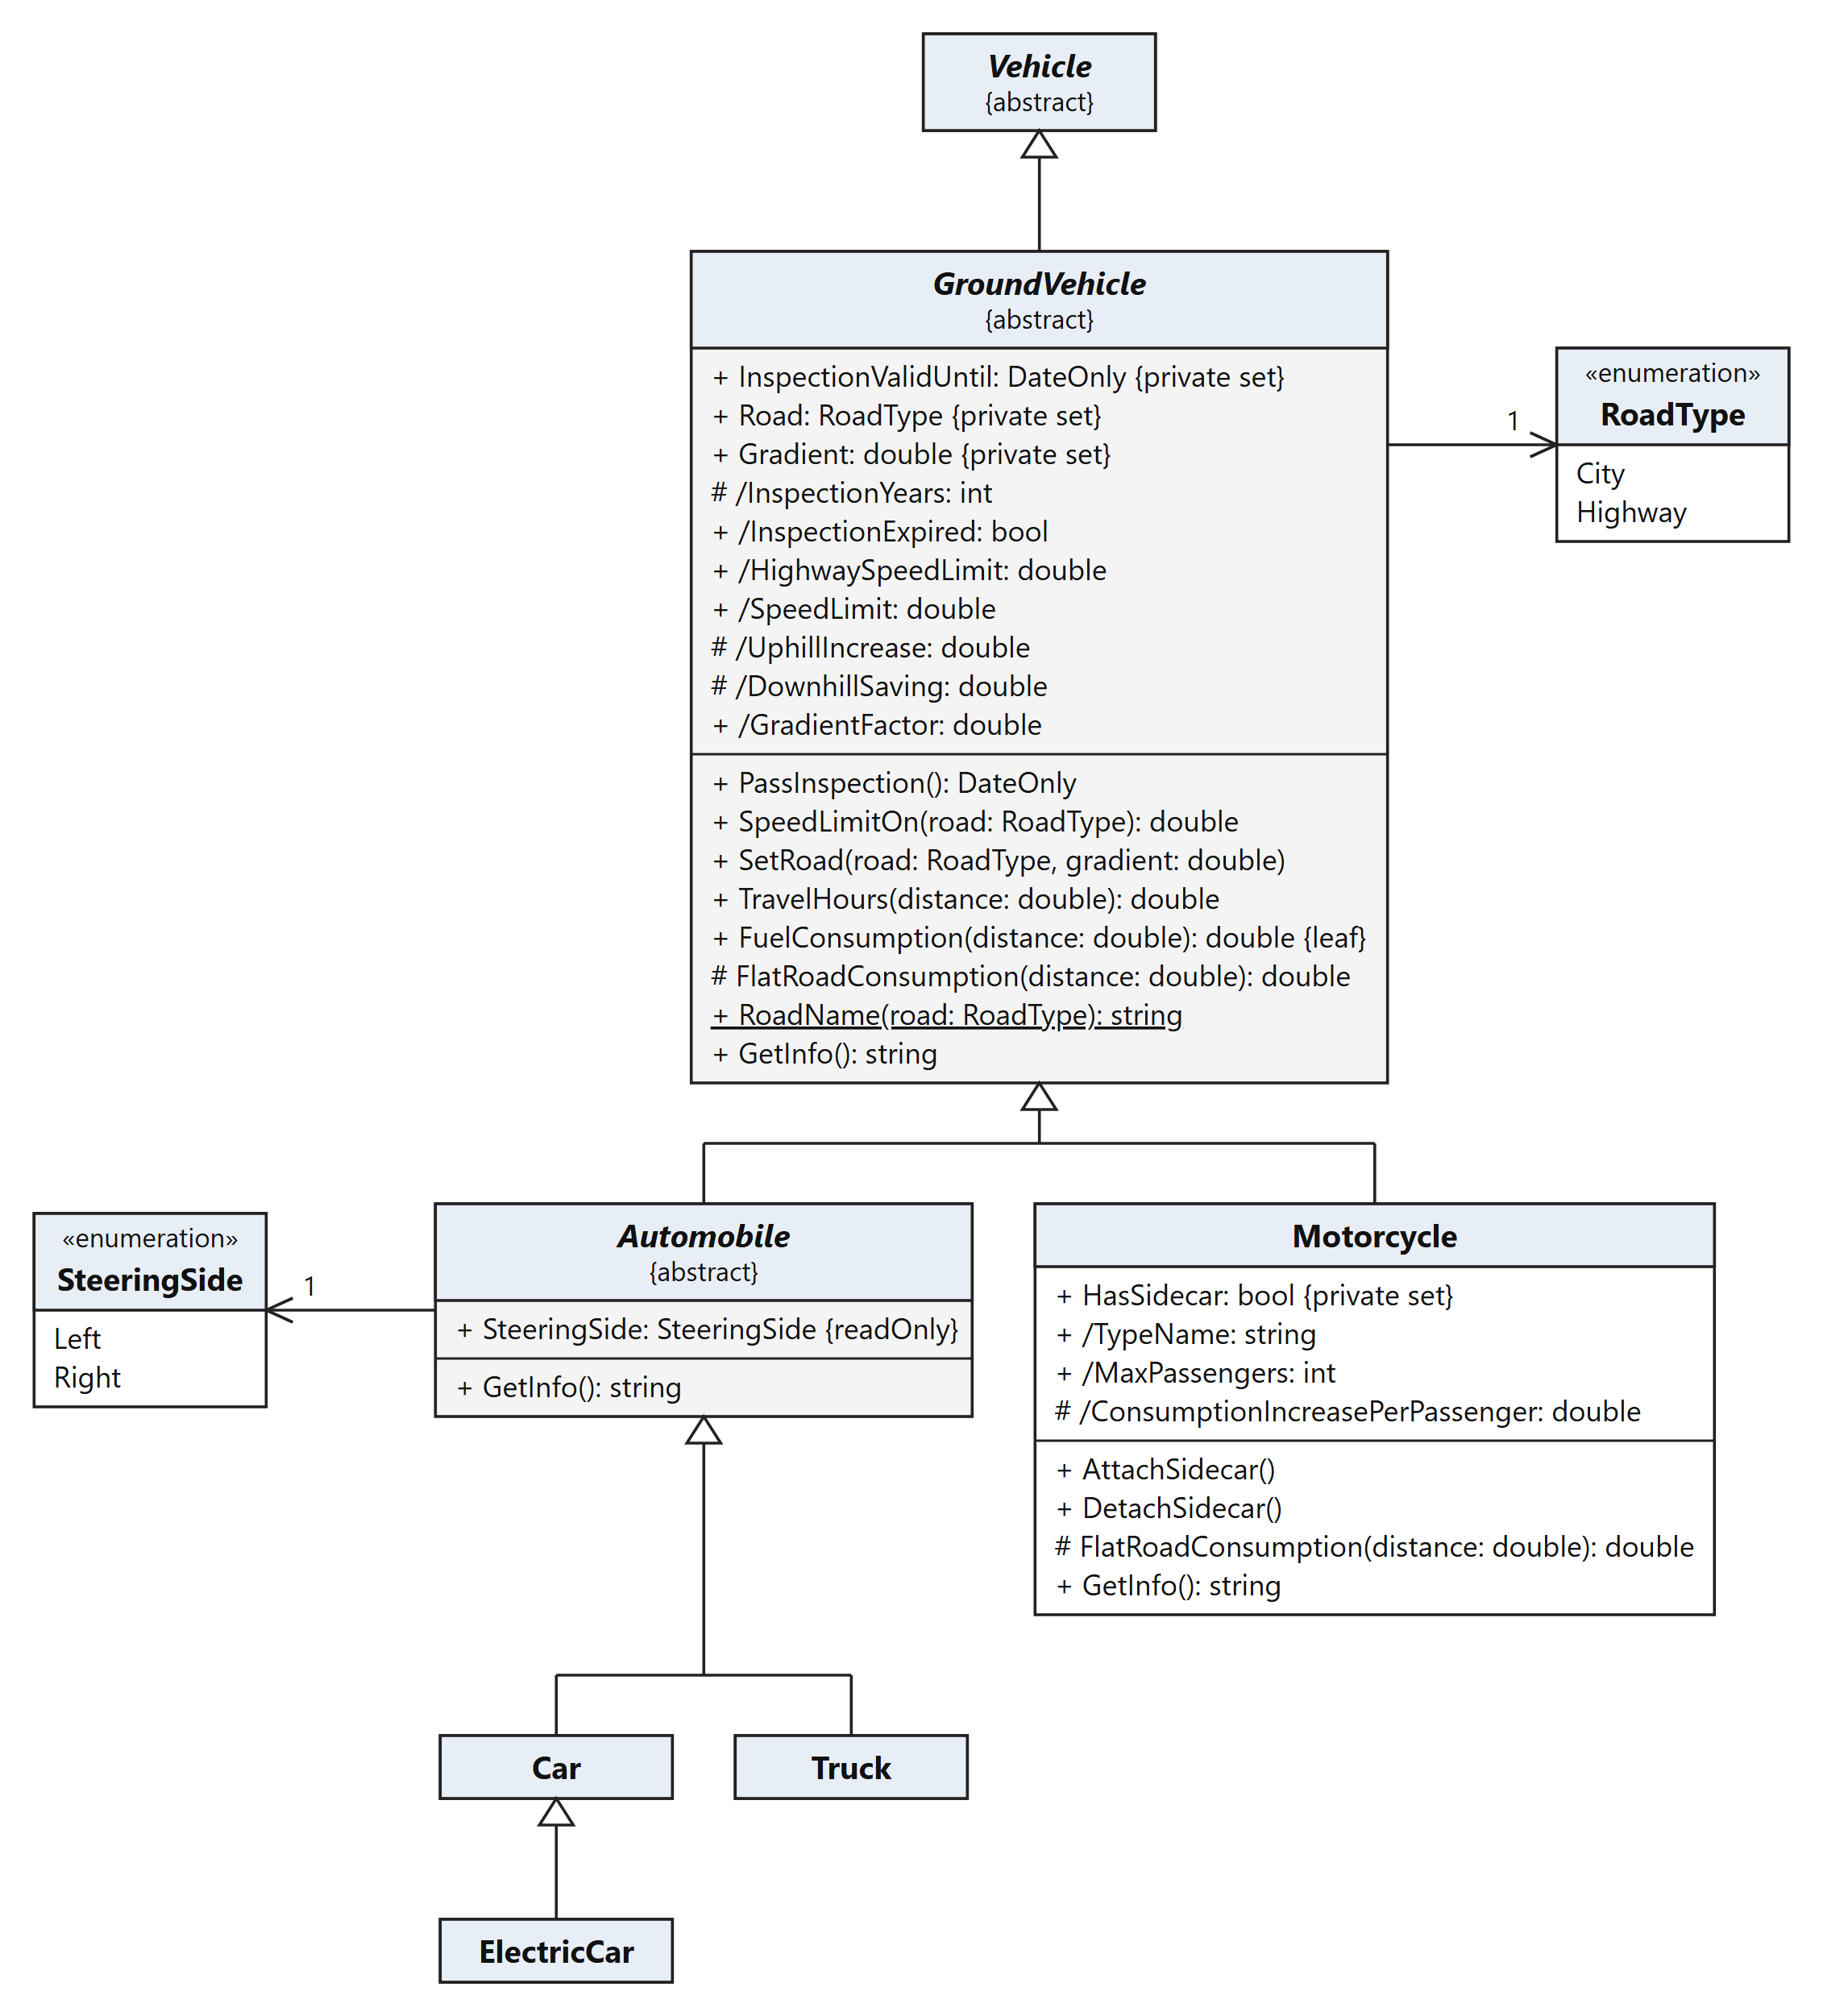
Fig. 3. GroundVehicle, Automobile and Motorcycle
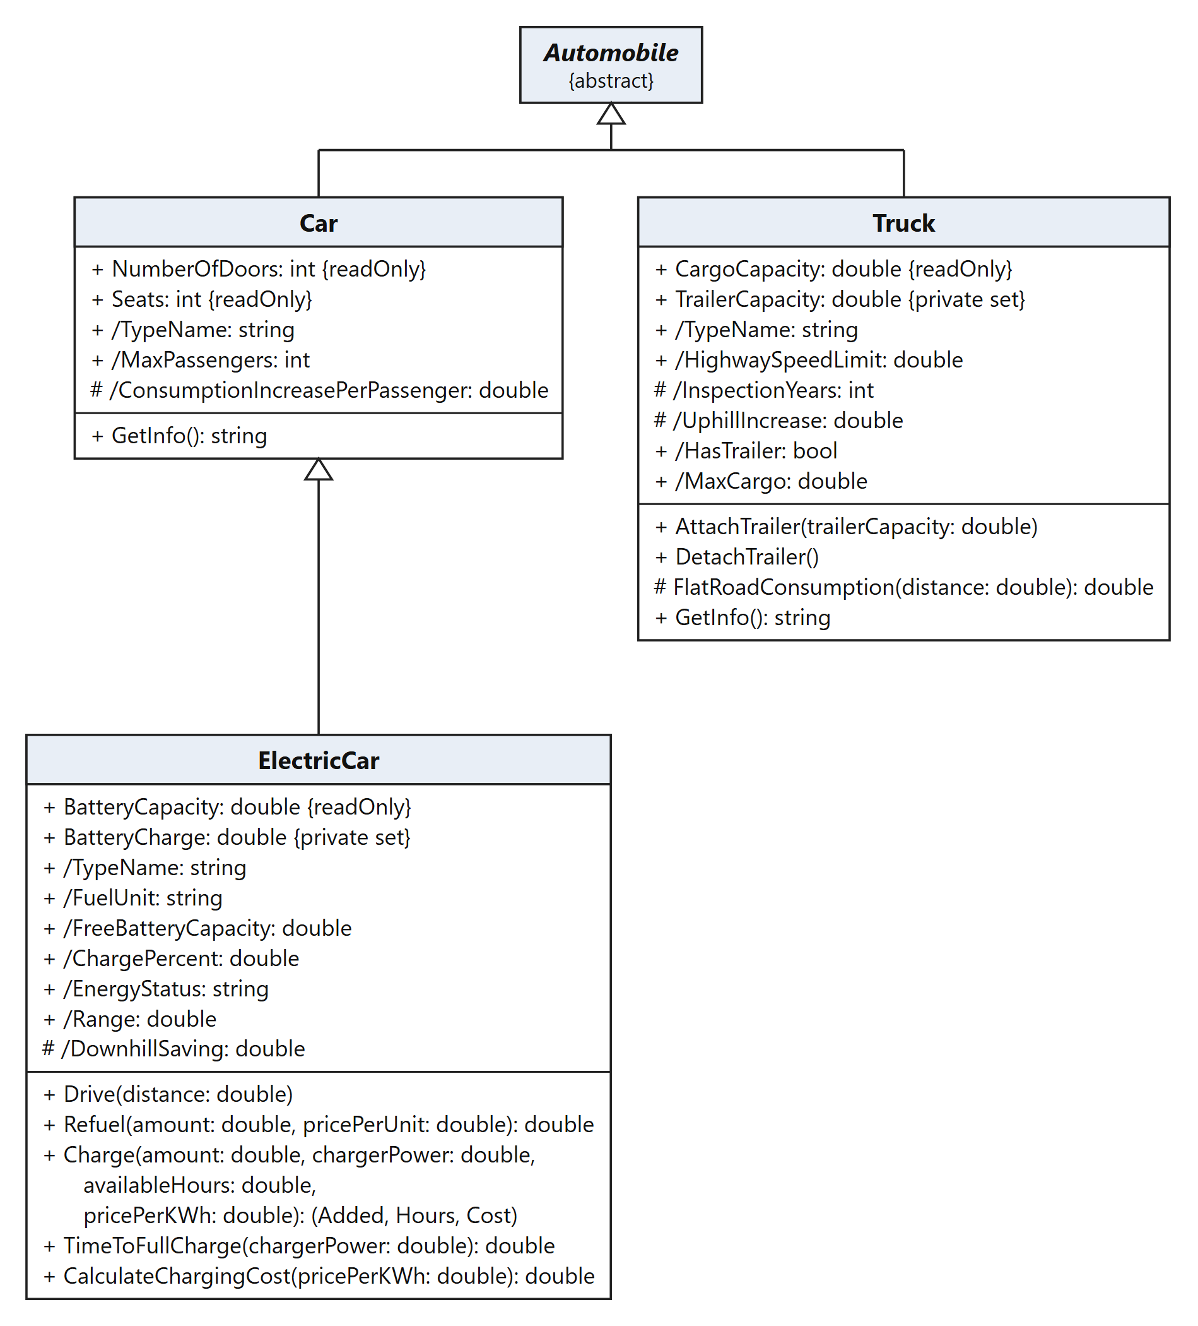
Fig. 4. Car, ElectricCar and Truck

Air transport
AirVehicle contains the flight algorithm and creates a FlightPlan (Fig. 5); the balloons and helicopters are in Fig. 6.
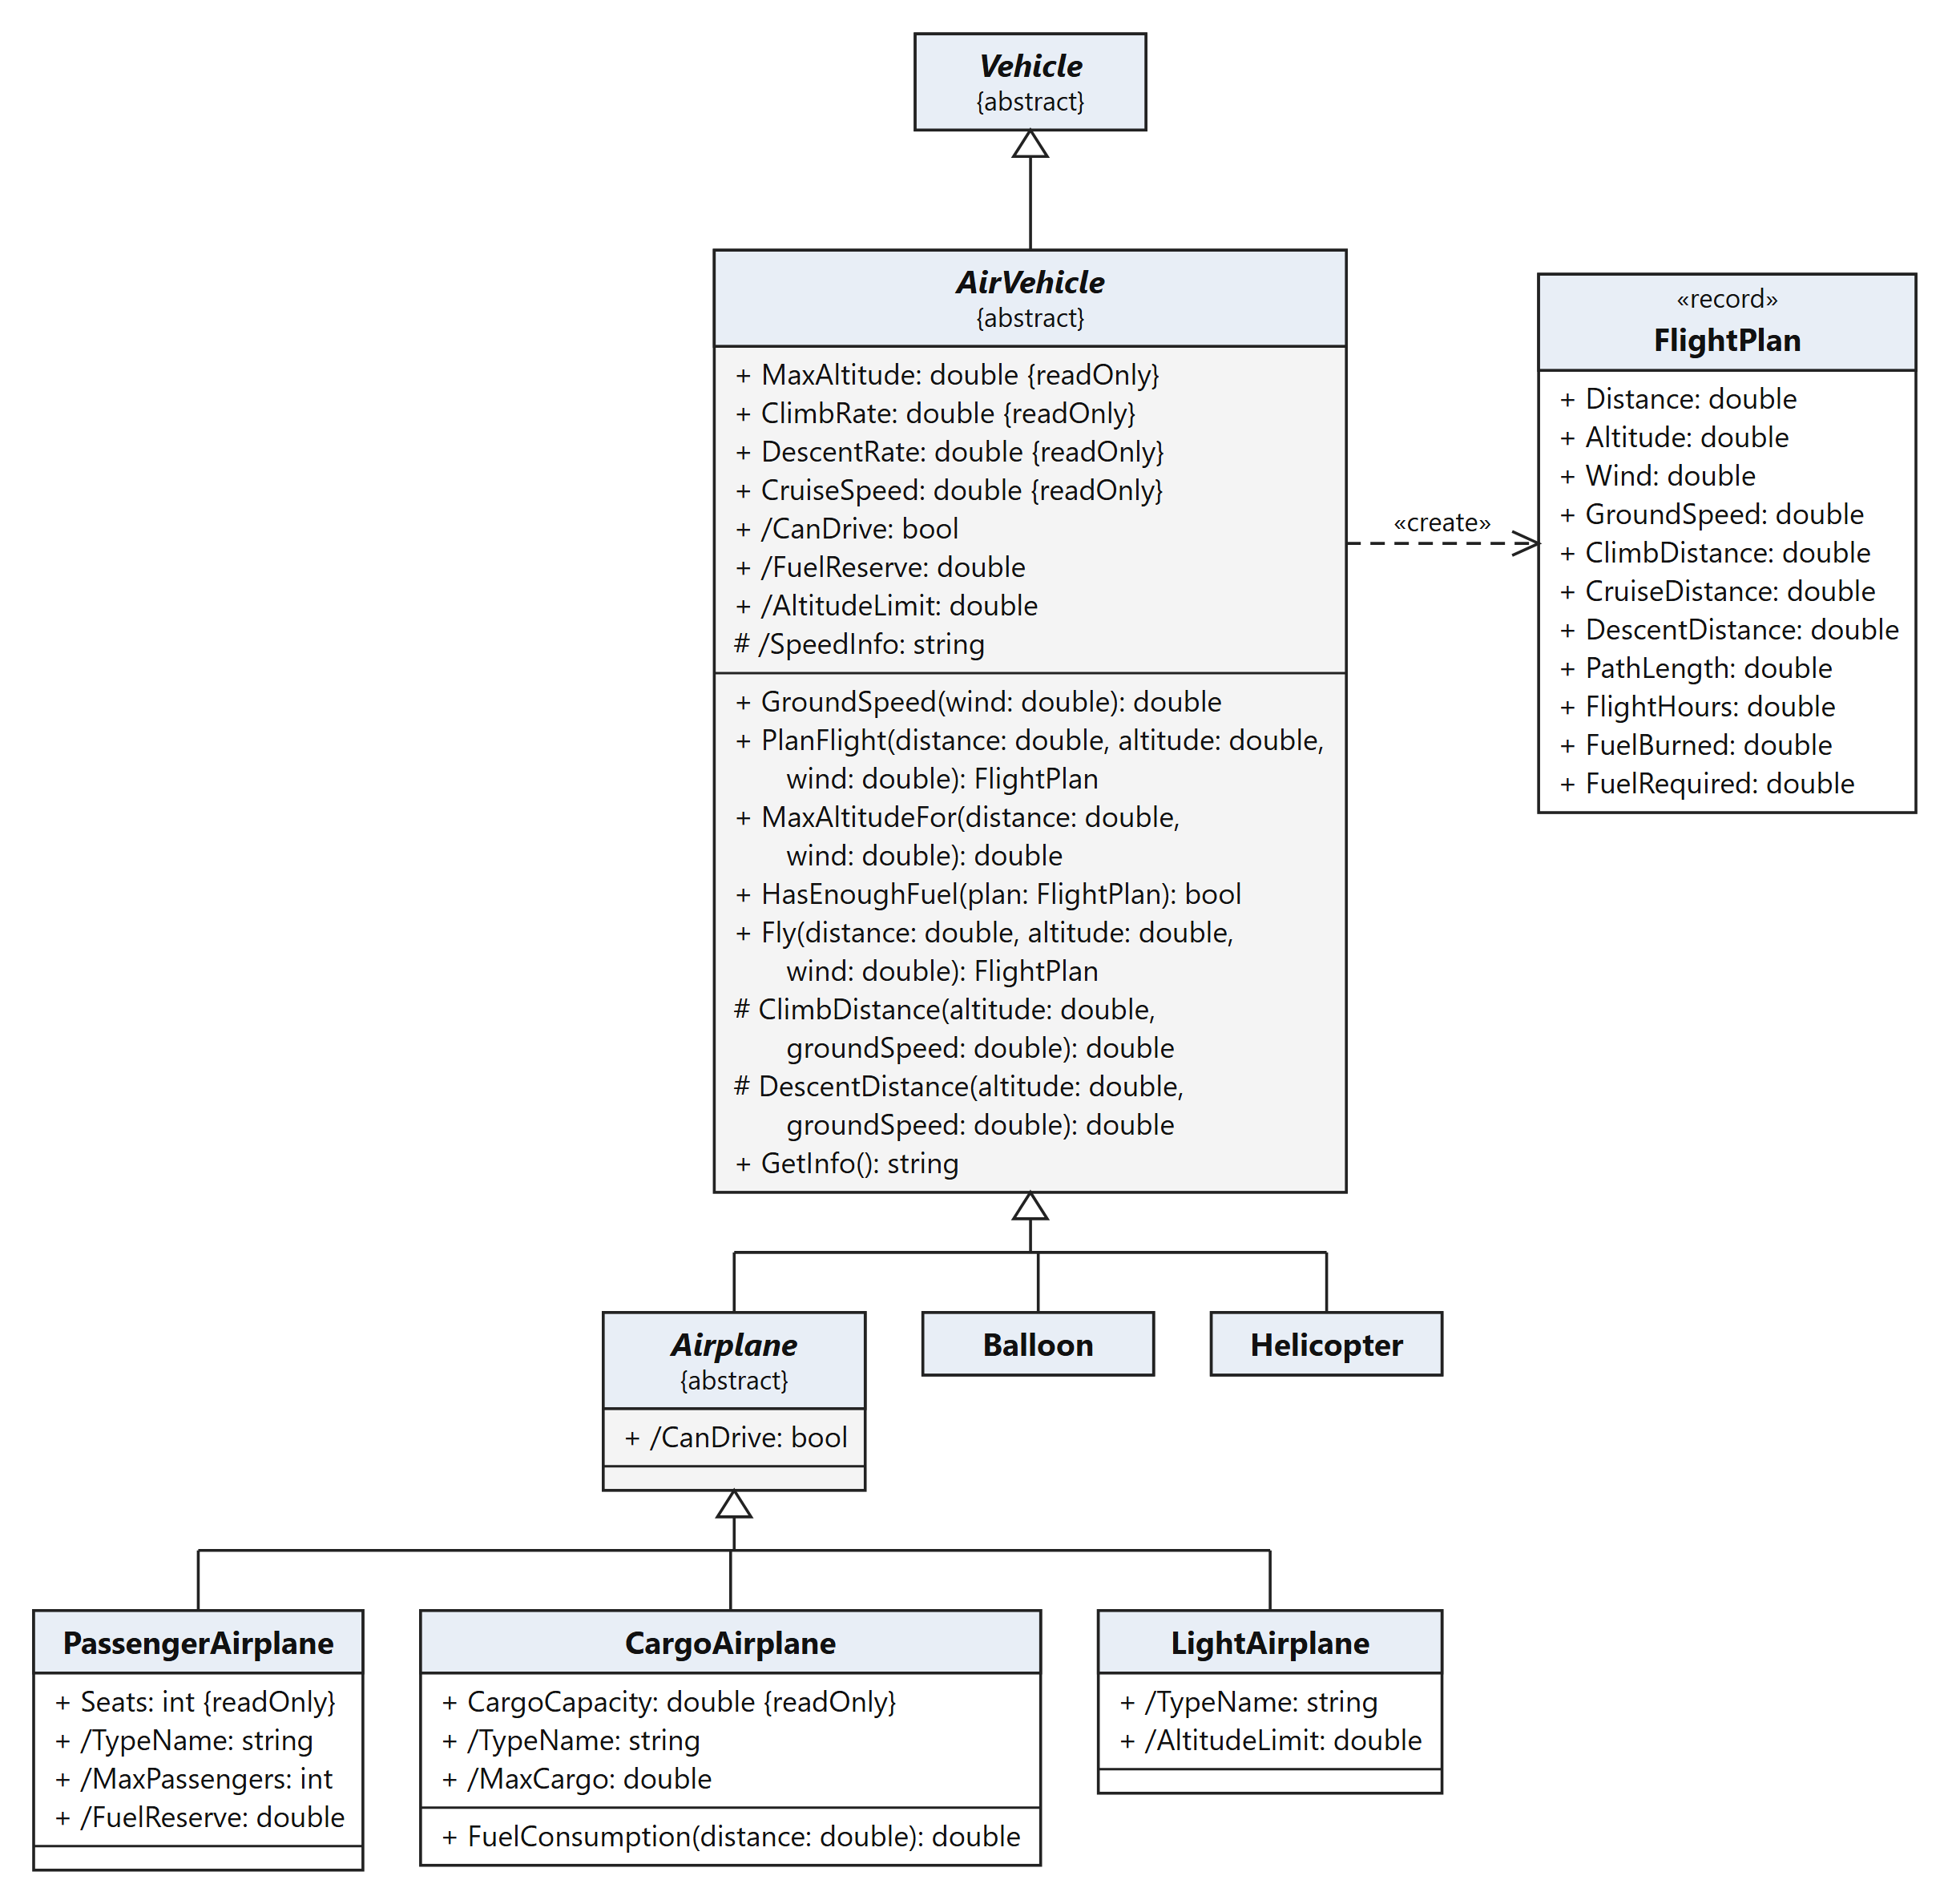
Fig. 5. AirVehicle, FlightPlan and the airplanes
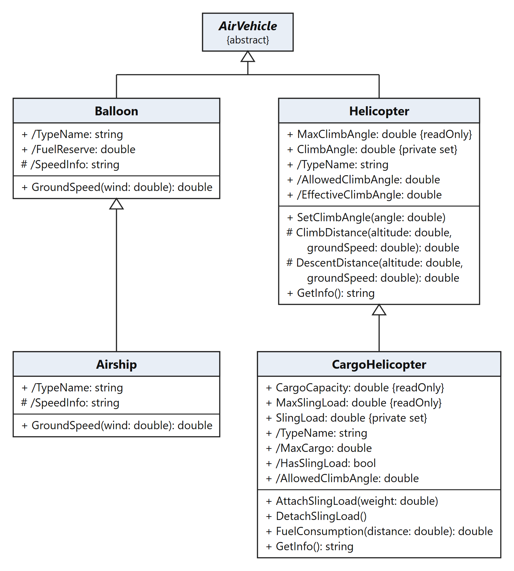
Fig. 6. Balloon, Airship, Helicopter and CargoHelicopter

Water transport
WaterVehicle plans voyages and creates a VoyagePlan; the four vessels are drawn as a column under it (Fig. 7).
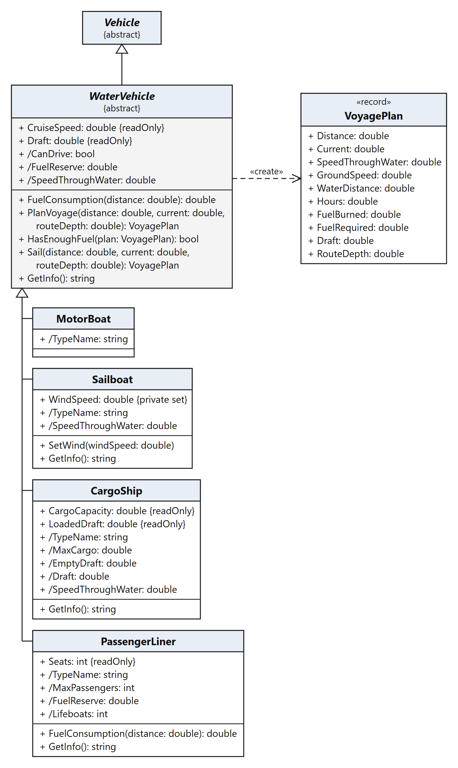
Fig. 7. WaterVehicle, VoyagePlan and the vessels

Application and user interface
Fig. 8 shows how the program is started and how the user interface calls the model (public members only; parameter types are omitted here).
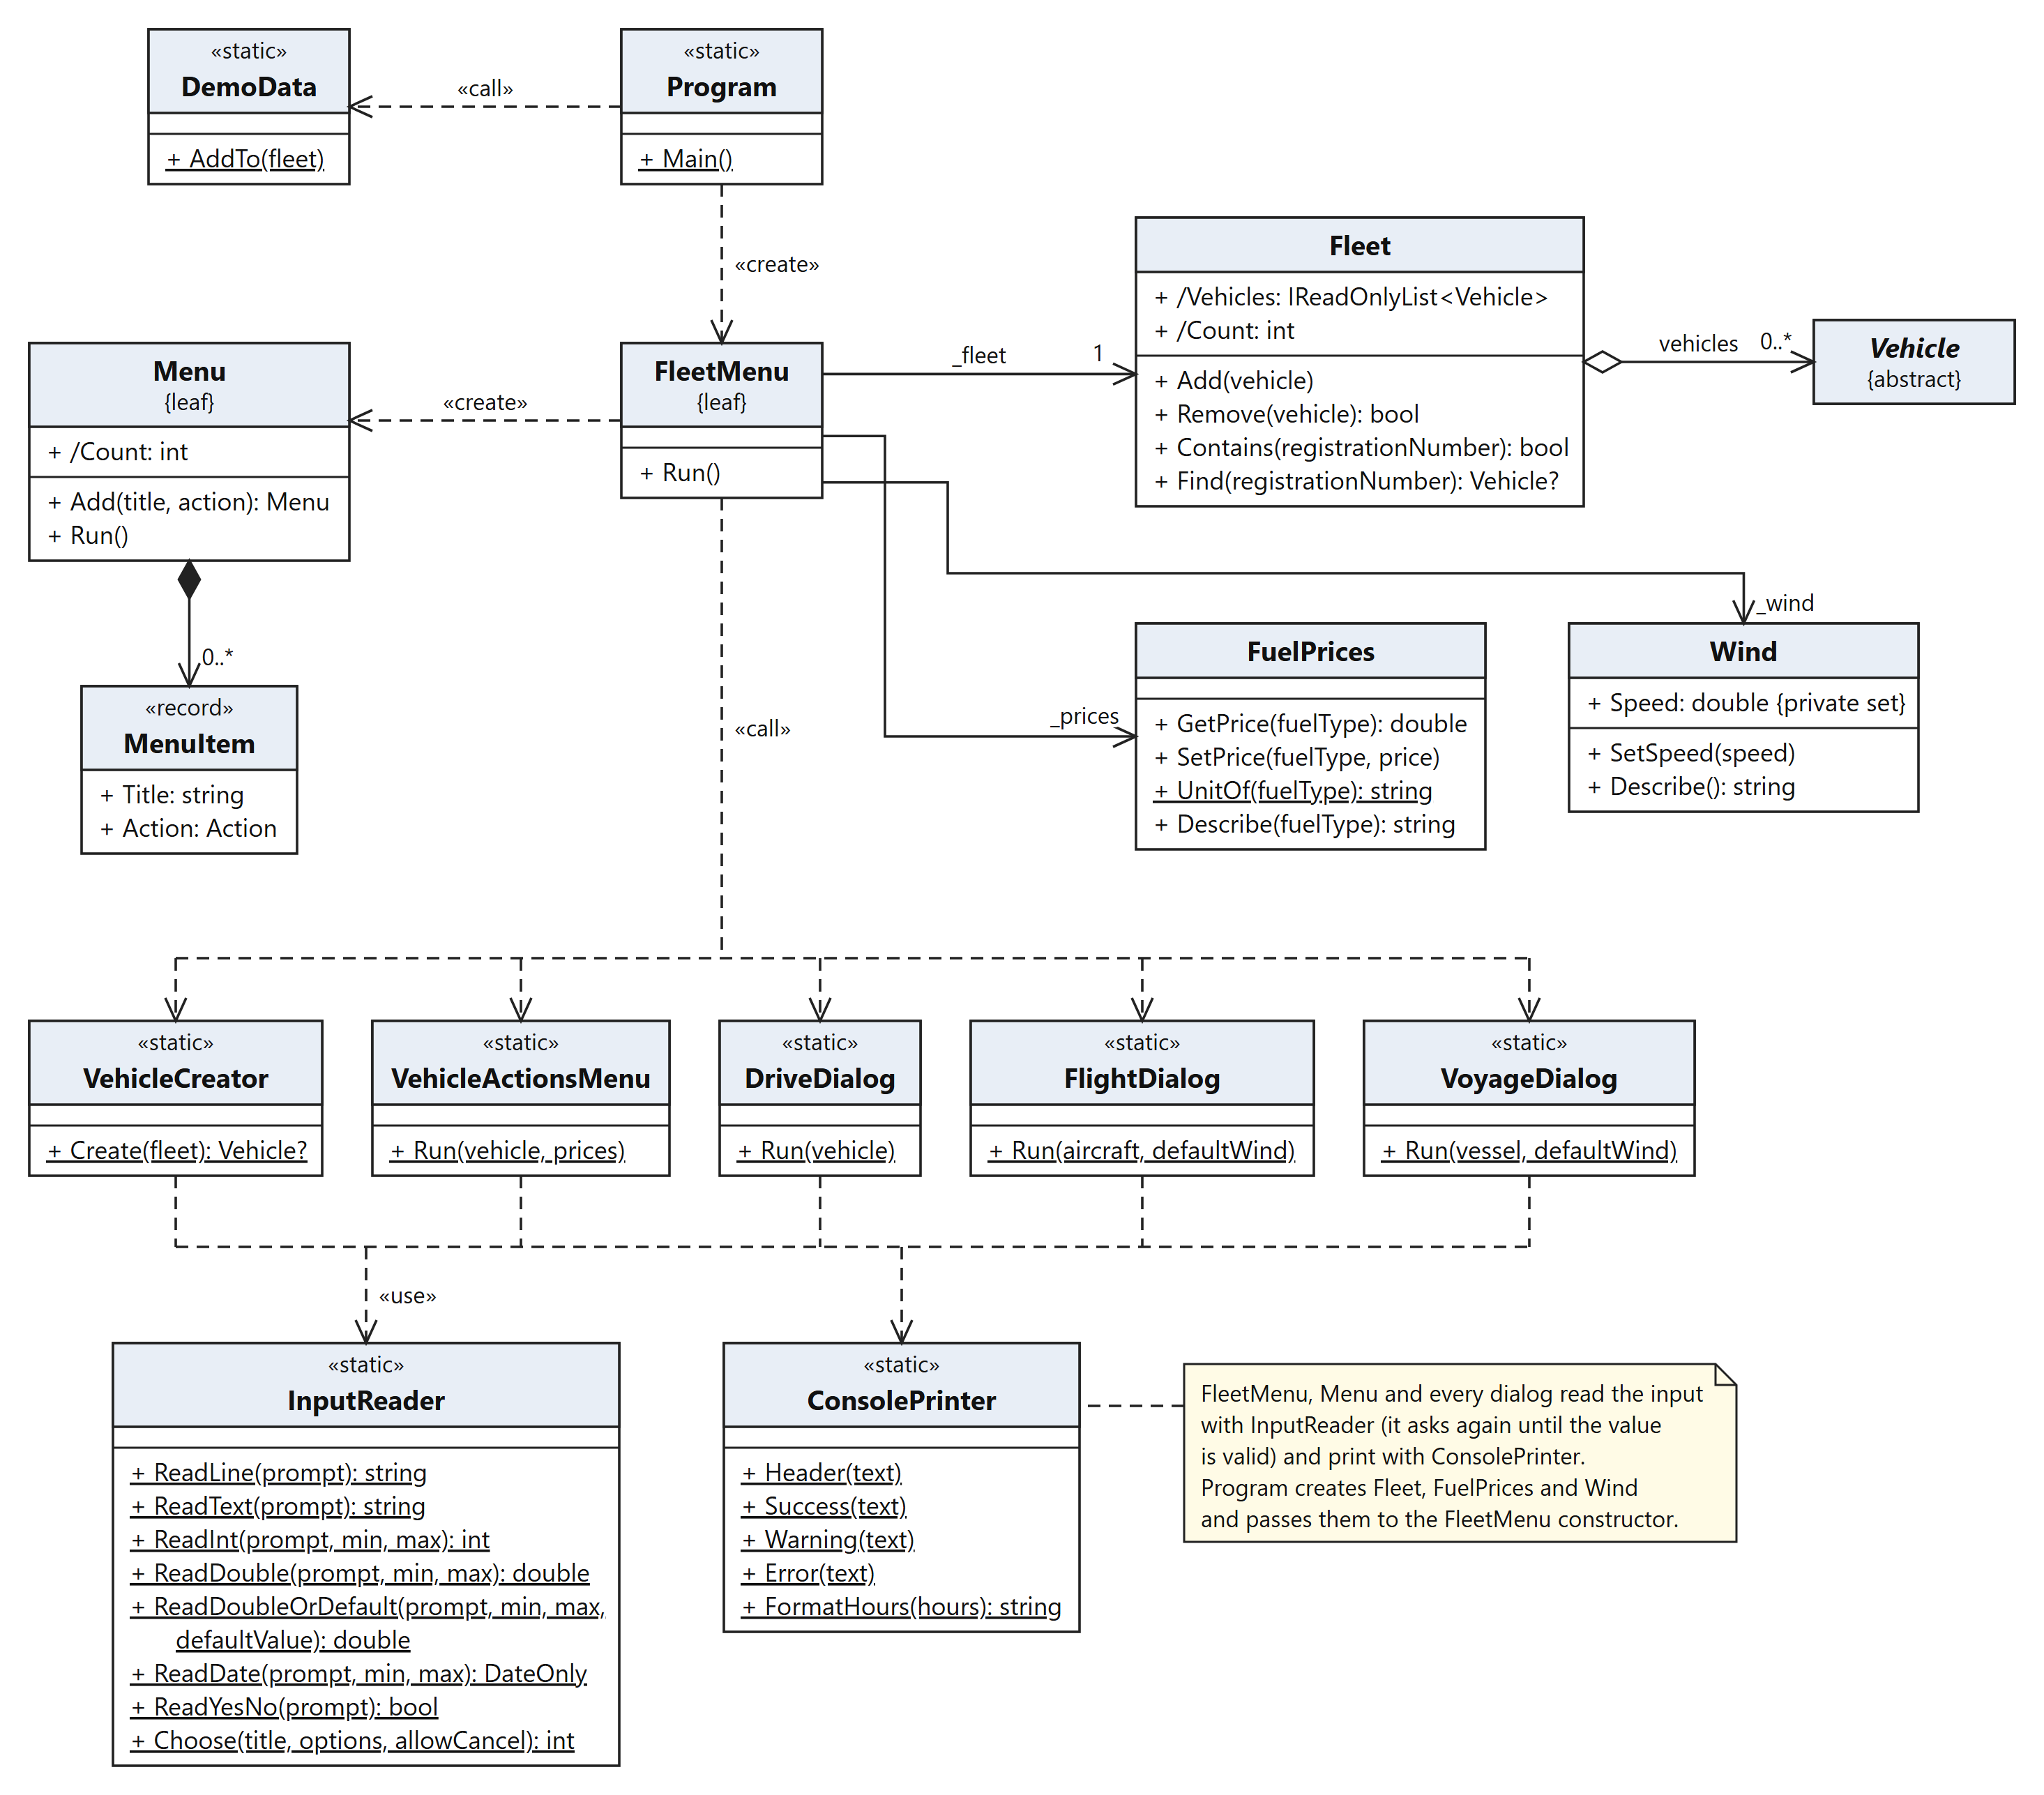
Fig. 8. Program, fleet, settings and the user interface

IMPLEMENTATION

Vehicle: drive and refuel
Consumption rates are stored in L/100 km (kWh/100 km for the electric car), as in real vehicle data. The base consumption grows with the load: every passenger adds a share that depends on the type (car +2 %, motorcycle +5 %). Drive calls the virtual FuelConsumption, so it automatically uses the rules of the concrete type:
Program code (Vehicle.cs):
public virtual void Drive(double distance)
{
if (!CanDrive)
throw new VehicleException($"{TypeName} cannot drive on the ground.");
EnsurePositive(distance, "Distance");
double fuelNeeded = FuelConsumption(distance);
if (fuelNeeded > FuelLevel + Tolerance)
throw new VehicleException(
$"Not enough fuel: {fuelNeeded:F1} L needed, {FuelLevel:F1} L in the tank " +
$"(enough for {Range:F0} km).");

BurnFuel(fuelNeeded);
AddMileage(distance);
}

// Adds fuel to the tank and returns how much it cost.
public virtual double Refuel(double amount, double pricePerUnit)
{
EnsurePositive(amount, "Amount of fuel");
EnsureNotNegative(pricePerUnit, "Price");
if (amount > FreeTankCapacity + Tolerance)
throw new VehicleException($"Only {FreeTankCapacity:F1} L fits into the tank.");

FuelLevel = Math.Min(TankCapacity, FuelLevel + amount);
return amount * pricePerUnit;
}
The comparison uses a small tolerance (1e-9), because a double such as 24.1 may be stored as 24.0999…, and without it the last litre could not be used. The original version divided the initial fuel by two (fuelLevel / 2) and its truck formula gave 500 L per 100 km for 500 kg of cargo; both errors were fixed.

Ground transport
GroundVehicle adds a technical inspection date (an expired inspection is only a warning; a new one is valid for 2 years, for a truck 1 year), the road of the trip — city 50 km/h, highway 90 km/h, truck 80 km/h, as in Latvia — which gives the travel time, and the average gradient from −10 to +10 %. The gradient must apply to every ground vehicle, so FuelConsumption is sealed in GroundVehicle, and the subclasses override only the flat-road part:
Program code (GroundVehicle.cs):
// 1 on a flat road, more uphill, less downhill.
public double GradientFactor => Gradient >= 0
? 1 + UphillIncrease * Gradient
: 1 + DownhillSaving * Gradient;

public sealed override double FuelConsumption(double distance)
{
return FlatRoadConsumption(distance) * GradientFactor;
}

protected virtual double FlatRoadConsumption(double distance) => base.FuelConsumption(distance);
Uphill every 1 % adds 10 %, downhill every 1 % saves 5 %. The electric car saves 8 % per 1 % downhill (recuperation), and a truck pays 2 % more per 1 % uphill for every tonne of cargo. The truck adds its cargo (+1 L/100 km per 500 kg) and a trailer (+5 L/100 km) in FlatRoadConsumption, the motorcycle a sidecar (×1.15). Drive itself did not change: it asks FuelConsumption, and FuelConsumption knows the road.

Electric car
ElectricCar.Charge(amount, chargerPower, availableHours, pricePerKWh) adds energy only for the available time: added = min(amount, power × hours). It returns a tuple (Added, Hours, Cost), so the dialog can warn that the time was not enough. Refuel is overridden as charging with a usual 11 kW charger. TimeToFullCharge and CalculateChargingCost reject a zero or negative value; the original version divided by zero there.

Flight planning
The flight algorithm was specified by the student (Fig. 9): a flight is a trapezoid. The aircraft climbs (the left triangle), flies at one altitude and descends (the right triangle). The horizontal leg of a triangle is the ground speed multiplied by the time needed to change the altitude (altitude / ClimbRate or DescentRate).
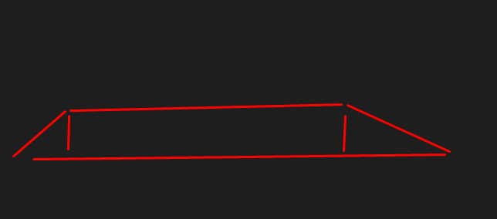
Fig. 9. The student’s sketch of the flight profile from the prompt: climb, cruise, descent
Fuel is counted on the real path (the two hypotenuses and the cruise): climb ×2, cruise ×1, descent ×0.5, and then the reserve is added (10 % by default). If the tank holds less than the fuel plus the reserve, the flight is cancelled. The wind changes the ground speed; the engines burn fuel by time, so the fuel is multiplied by CruiseSpeed / groundSpeed:
Program code (AirVehicle.PlanFlight, shortened):
double groundSpeed = CheckedGroundSpeed(wind); // CruiseSpeed + wind
double climbDistance = ClimbDistance(altitude, groundSpeed);
double descentDistance = DescentDistance(altitude, groundSpeed);
double cruiseDistance = distance - climbDistance - descentDistance;
// ... too short for this altitude -> VehicleException
double altitudeKm = altitude / 1000;
double climbPath = Math.Sqrt(climbDistance * climbDistance + altitudeKm * altitudeKm);
double descentPath = Math.Sqrt(descentDistance * descentDistance + altitudeKm * altitudeKm);

double windFactor = CruiseSpeed / groundSpeed;
double fuel = (FuelConsumption(climbPath) * ClimbFuelFactor
+ FuelConsumption(cruiseDistance)
+ FuelConsumption(descentPath) * DescentFuelFactor) * windFactor;
// ... time of the three parts
return new FlightPlan(/* ... */ fuel, fuel * (1 + FuelReserve));
The subclasses change only single steps of this algorithm:
- PassengerAirplane: the reserve is 10 % up to 50 passengers, +5 % for every started 100 more, at most 40 %;
- CargoAirplane: +1 % consumption per tonne of cargo; the reserve stays 10 %;
- LightAirplane: no pressurized cabin, so it flies at most 3000 m;
- the three airplanes can also drive on the ground (taxi); other aircraft cannot drive;
- Balloon: flies with the wind (ground speed = wind), needs no reserve because it descends safely; Airship: a balloon with engines — its own speed plus the wind;
- Helicopter: the climb angle is chosen for every flight up to MaxClimbAngle; the climb leg is altitude / tan(angle), and the landing is vertical (DescentDistance returns 0);
- CargoHelicopter: +1 % consumption per 100 kg inside and on the sling; with a sling load the climb angle is at most 15°.
protected override double ClimbDistance(double altitude, double groundSpeed)
{
double radians = EffectiveClimbAngle * Math.PI / 180;
return altitude / 1000 / Math.Tan(radians);
}

// Vertical landing: the descent has no horizontal part.
protected override double DescentDistance(double altitude, double groundSpeed) => 0;

Voyage planning
A current changes the way through the water. With the speed v through the water and the current c (+ with the current, − against it) the ground speed is v + c, the time is distance / (v + c), and the way through the water is v × time. The fuel is counted for this way:
Program code (WaterVehicle.PlanVoyage, shortened):
if (Draft > routeDepth + Tolerance)
throw new VehicleException(/* ... */ "would run aground.");

double speed = SpeedThroughWater;
double groundSpeed = speed + current;
if (groundSpeed <= 0)
throw new VehicleException(/* ... */ "it cannot move forward.");

double hours = distance / groundSpeed;
double waterDistance = speed * hours;
double fuel = FuelConsumption(waterDistance);
- CargoShip: the cargo makes the draft deeper (from the empty to the loaded draft) and the ship up to 20 % slower. The first idea, "cargo weakens the current", was replaced, because a current carries a ship regardless of its mass;
- PassengerLiner: reserve 15 %, one lifeboat for every started 50 passengers, +0.25 % consumption each;
- Sailboat: the sails add 0.5 × wind speed to the engine speed, so every km costs less fuel;
- MotorBoat: the plain vessel.

Console interface
Menu is a reusable class: items are added as (title, action) pairs by method chaining, and Run repeats "print → read a number → execute". An error inside an action does not close the program:
Program code (Menu.cs):
private static void Execute(MenuItem item)
{
try
{
item.Action();
}
catch (VehicleException e)
{
ConsolePrinter.Error(e.Message);
}
catch (ArgumentException e)
{
ConsolePrinter.Error(e.Message);
}
}
The special actions menu is built for the selected vehicle, so it shows only what this vehicle can do (a trailer for a truck, a sidecar for a motorcycle, a sling for a cargo helicopter). InputReader asks again until the value is valid, and ReadDoubleOrDefault accepts just Enter for the default. VehicleCreator keeps one table of (type name, create method); a new vehicle type needs one line in this table and one Create… method. When the input ends, InputReader throws EndOfStreamException, and Program catches it to finish normally.

Quick tests
OOPLAB1.Tests is a separate console project with its own small test runner instead of a test framework, because the program must not use third-party packages. A test is a public static method marked [Test]; the runner finds them by reflection, runs each one, prints PASS or FAIL and returns exit code 1 if any test fails. Assert has Equal, Near (with a tolerance), True, False, Contains and Throws<T>. Every test builds fresh demo vehicles, so the tests do not affect each other.
Program code (VehicleTests.cs):
[Test]
public static void Drive_BurnsFuelAndAddsMileage()
{
Car car = NewCar();
car.Drive(100);
Assert.Near(24, car.FuelLevel, "fuel after 100 km at 6 L/100 km", 1e-9);
Assert.Near(15100, car.Mileage, "mileage", 1e-9);
}

ADDITIONAL IMPROVEMENTS
The assignment asks for one Vehicle class with five properties and two methods. Everything in Table 4 was implemented beyond it.
Table 4. Improvements beyond the minimum requirements
Area | Improvement
Object model | A hierarchy of 21 classes in three branches (ground, air, water) with abstract base classes and template methods; records for the plans; enumerations instead of strings; a separate exception type.
Validation | All constructors and methods check their data (NaN and infinity too); the format and normalization of the registration number; unique numbers in the fleet; allowed ranges in the dialogs.
Fuel and costs | Consumption in L/100 km; default fuel prices that can be changed in the menu; Refuel returns the cost; charging an electric car with a given power, time and price.
Load | Passengers and cargo for all types with limits and an effect on consumption; a truck trailer; a motorcycle sidecar; a sling load of a cargo helicopter.
Ground transport | Technical inspection (date, warning, passing it again), left or right steering wheel, road type with speed limit and travel time, road gradient with recuperation and the truck load effect.
Air transport | Flight plan (climb, cruise, descent), fuel reserve and cancellation, wind, altitude limits, a reserve that grows with the passengers but has a cap, a balloon, an airship, a helicopter with a climb angle and a vertical landing.
Water transport | Current, draft and route depth, a cargo ship that sits deeper and slows down, a liner with a reserve and lifeboats, a sailboat.
Settings | A default wind of 15 km/h that can be changed in the menu; Enter keeps the default.
User interface | A reusable menu, checked input with clear messages, colours, special actions for the selected vehicle, demo data, a normal end when the input ends.
Quality | No console calls in the model; a build without warnings; the .NET code analyzers (Recommended set) report only one intentional message; 71 automated tests.

PROGRAM VERIFICATION

Method
The program was checked in three ways:
- Scenarios through the menu with the demo vehicles. The expected values were calculated by hand from the formulas; the actual values were copied from the console output. The same scenarios include wrong and unusual input.
- Automated tests: 71 quick tests in OOPLAB1.Tests fix the same numbers and the reactions to wrong data.
- The build: 0 warnings; the .NET code analyzers (Recommended set) report only one intentional message (CA1859: the Create… methods of VehicleCreator return Vehicle to fit one table).
Table 5 lists the scenarios. In the figures the typed answers are bold white; the repeated main menu and the list of 15 vehicles are shortened to one grey line.
Table 5. Verification scenarios: input, expected and actual result
# | Input or action | Expected result | Actual result | OK
1 | Start with demo data; menu 2 "Show all vehicles" | 15 vehicles, one of each type, with fuel and mileage | 15 vehicles listed (Fig. 10) | yes
2 | Details of AB-1234 (Toyota Corolla) | Number, brand, model, fuel 32.0 / 50.0 L, mileage 15000 km | Shown as expected (Fig. 11) | yes
3 | Drive AB-1234 100 km, highway, gradient Enter (0 %) | 100 / 100 × 6 = 6.00 L; fuel 32 → 26.0 L; mileage 15100 km; 100 / 90 h = 1 h 7 min | "Drove 100 km in 1 h 7 min and used 6.00 L. Fuel: 26.0 / 50.0 L, mileage 15100 km." | yes
4 | Refuel AB-1234 with 20 L of petrol | 20 × 1.65 = 33.00 EUR; fuel 46.0 / 50.0 L | "Added 20.0 L for 33.00 EUR. Fuel: 46.0 / 50.0 L." | yes
5 | Drive AB-1234 1000 km with 32 L | Needs 60 L → refused, nothing changes | "Error: Not enough fuel: 60.0 L needed, 32.0 L in the tank (enough for 533 km)." Fuel stays 32.0 L (Fig. 12) | yes
6 | Refuel 30 L when 18 L is free, then 18 L | 30 rejected; 18 L cost 29.70 EUR | "The value must be at most 18." then "Added 18.0 L for 29.70 EUR." | yes
7 | Main menu: "99", then "abc" | Asked again, the program goes on | "Enter a number from 0 to 8.", "'abc' is not a whole number." | yes
8 | Add a car: number AB-1234 (exists), "A B", year 1850, fuel 60 L in a 50 L tank, "30,5", date 2027-13-01 | Every wrong value is explained and asked again; "30,5" is accepted as 30.5; the car is added with the number LV-2024 | All messages as expected; "Car LV-2024 added to the fleet." (Fig. 13) | yes
9 | AB-1234: highway +3 %, 120 km; then city, 30 km | 6 × 1.3 = 7.80 L/100 km, 9.36 L, 1 h 20 min; city: 1.80 L, 30 / 50 h = 36 min | "7.80 L/100 km", "Drove 120 km in 1 h 20 min and used 9.36 L"; "Drove 30 km in 36 min and used 1.80 L" | yes
10 | Truck TR-7700: trailer 3000 kg, cargo 4000 kg, highway +2 %, 80 km | Flat: 12 + 4000/500 + 5 = 25 L/100 km; ×(1 + (0.10 + 0.02 × 4) × 2) = 34.00; 27.20 L; 80 km at 80 km/h = 1 h | "consumption 25.00", "34.00 L/100 km", "Drove 80 km in 1 h and used 27.20 L" (Fig. 14) | yes
11 | Electric car: 20 kWh, 11 kW charger, 1 h available | Only 11 kWh in 1 h, 2.75 EUR; warning: 20 kWh take 1 h 49 min | "Charged 11.0 kWh in 1 h for 2.75 EUR", "Not enough time: … takes 1 h 49 min." | yes
12 | Cessna 172: 300 km, wind +25 km/h, 1000 m | Ground speed 251 km/h; fuel 43.9 L + 10 % = 48.3 L; 1 h 12 min | "Fuel: 43.9 L + 10% reserve = 48.3 L", "Landed after 1 h 12 min" (Fig. 15) | yes
13 | Cessna again: 400 km, wind −40 km/h, 76.1 L in the tank | Needs 86.3 L → flight cancelled | "Error: Flight cancelled: not enough fuel, 10.3 L more is needed." | yes
14 | Robinson R44: 100 km, wind 0, angle 45°, then 30°, 1000 m | 45° rejected (max 30°); climb leg 1.7 km, vertical landing; 29.3 L + 10 % = 32.2 L; 39 min | "The value must be at most 30.", "Climb: 1.7 km at 30.0 deg", "Descent: vertical", "32.2 L", "39 min" | yes
15 | Balloon with wind 0 | Cannot fly | "Balloon cannot move forward without wind." | yes
16 | Motor boat: 60 km, current −5 km/h, depth 3 m | Ground speed 40 km/h, 1 h 30 min; way through water 45 × 1.5 = 67.5 km; 67.5 × 0.67 = 45.2 L | "Way through the water: 67.5 km", "Fuel: 45.2 L", "Arrived after 1 h 30 min" (Fig. 16) | yes
17 | Cargo ship fully loaded, route depth 5 m | Draft 3.0 + 2.5 = 5.5 m, speed 22 × 0.8 = 17.6 km/h → runs aground | "Draft 5.5 m is deeper than the route (5.0 m): … would run aground." | yes
18 | The input ends in the middle of a dialog | The program finishes normally | "The input has ended." "Goodbye!" | yes
19 | dotnet run --project OOPLAB1.Tests | All tests pass, exit code 0 | "71 tests: 71 passed, 0 failed", exit code 0 (Fig. 17) | yes

Console output
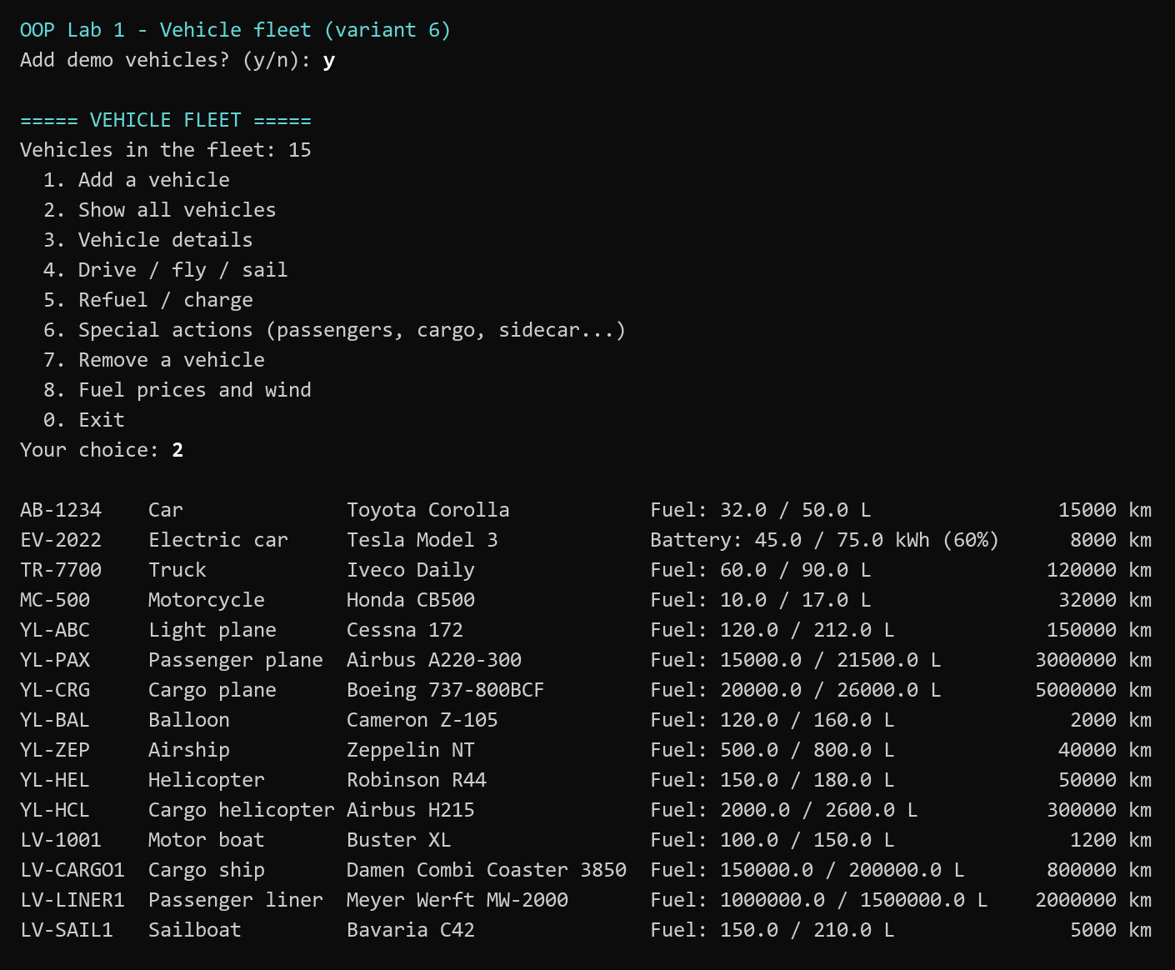
Fig. 10. Start of the program and the list of the demo vehicles
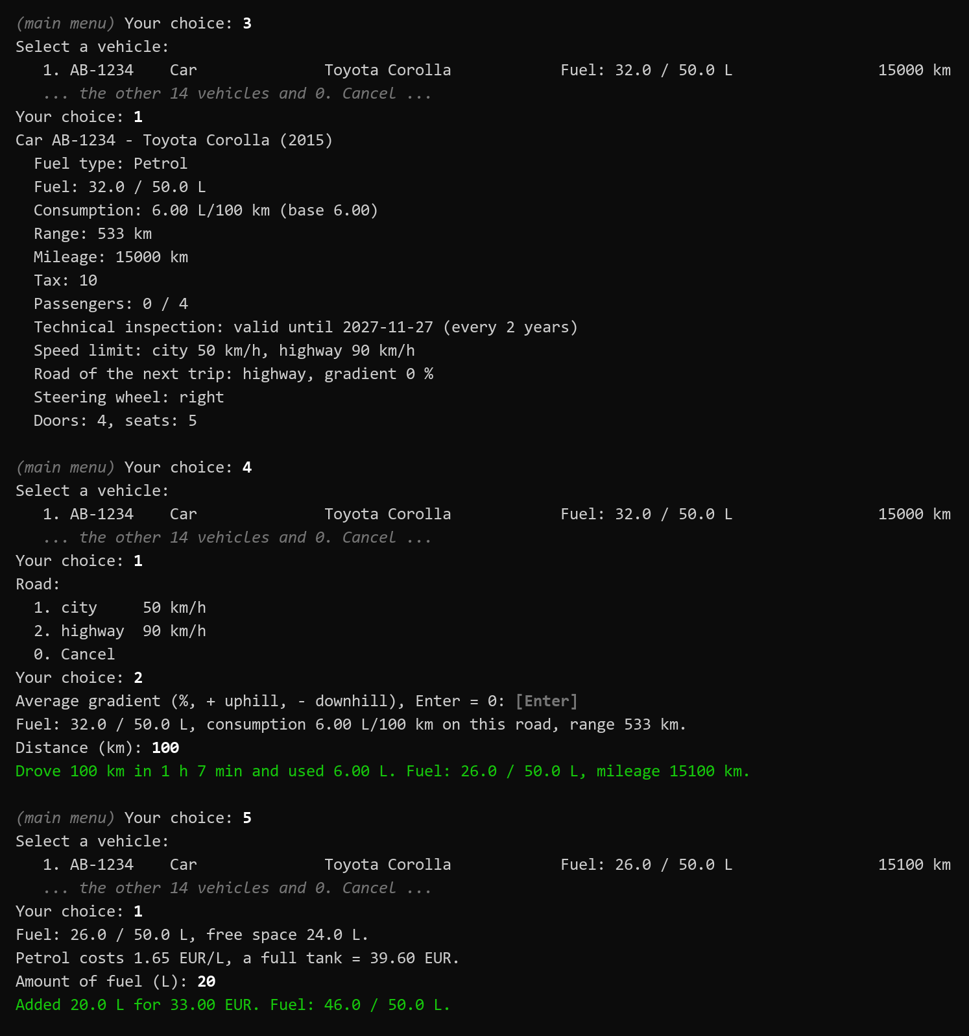
Fig. 11. Variant 6 task: details, drive and refuel of the Toyota
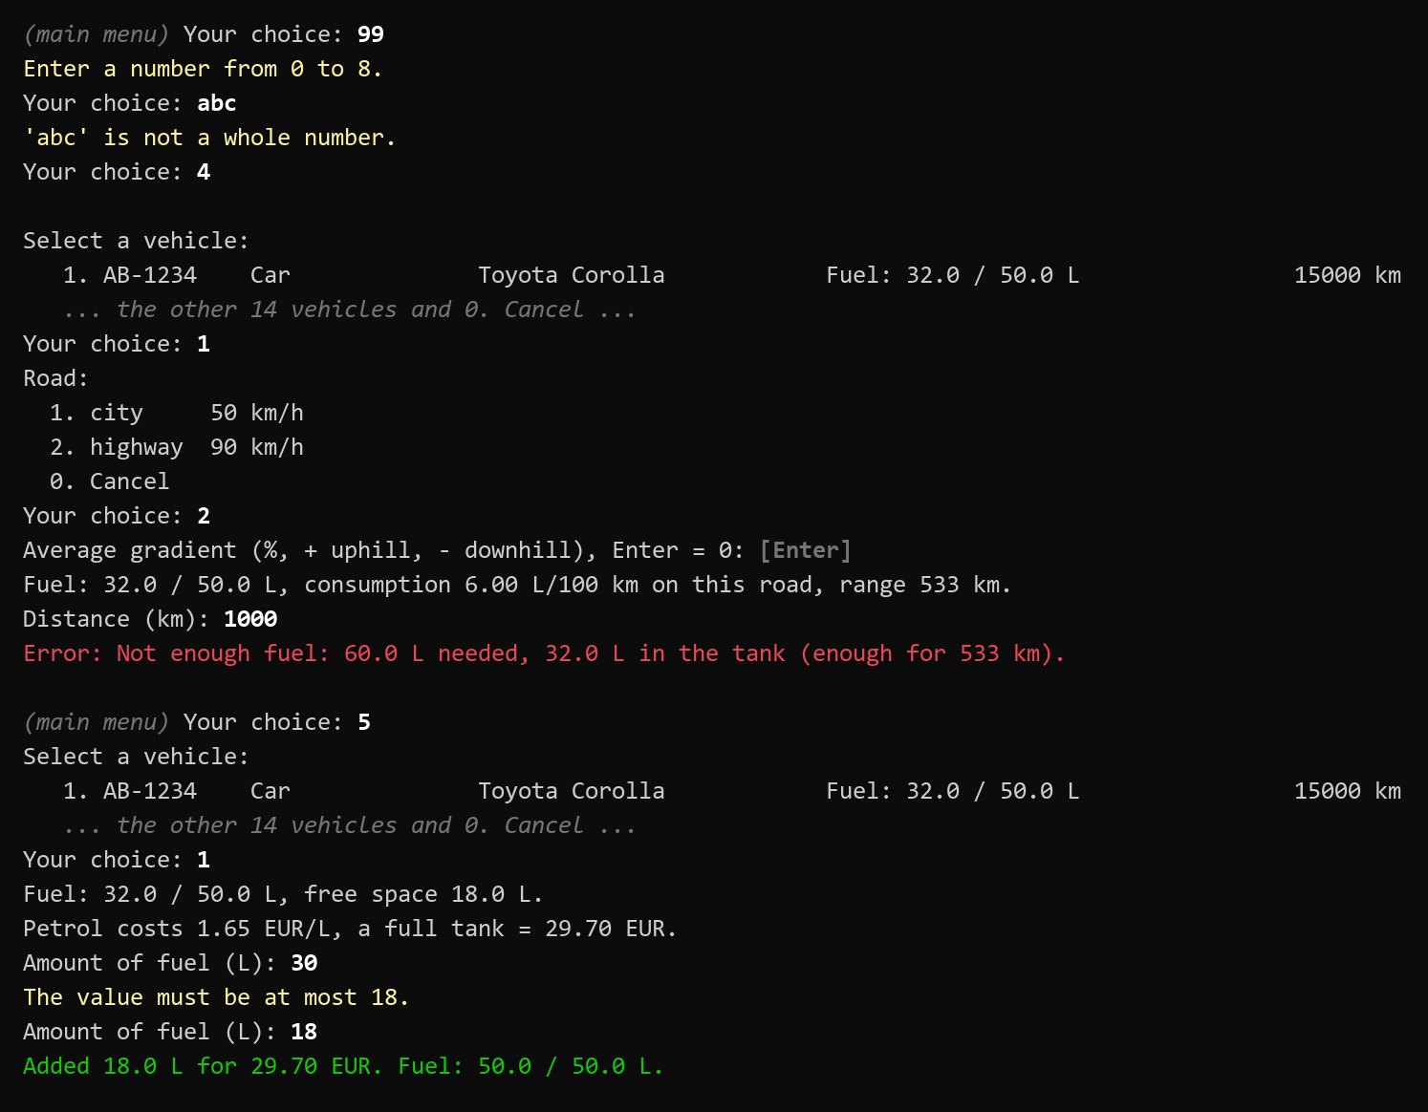
Fig. 12. Wrong input: menu number, letters instead of a number, not enough fuel, too much fuel
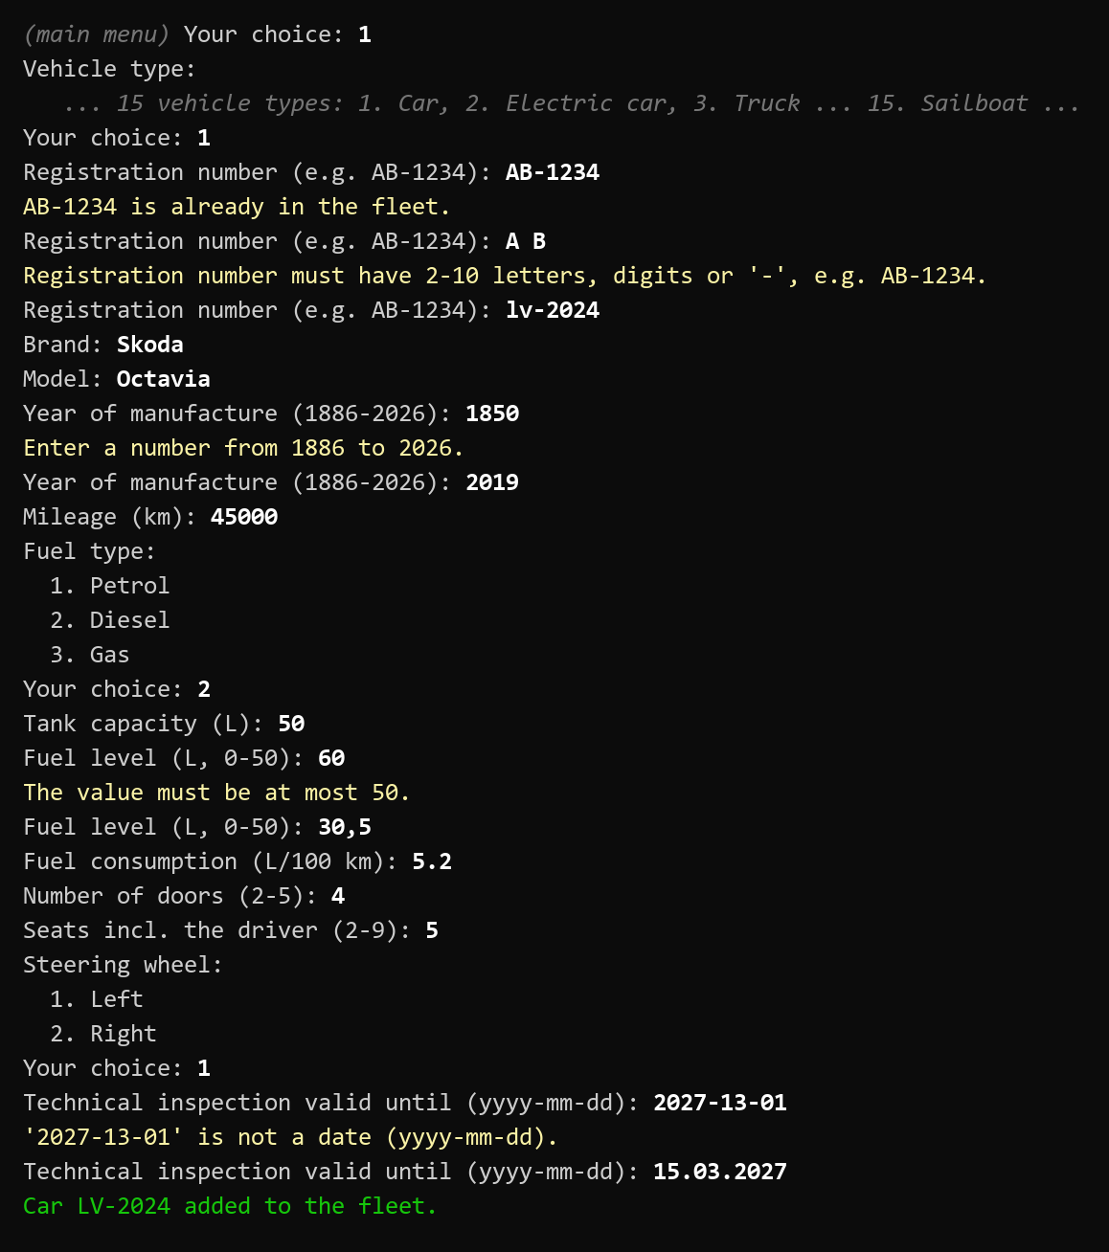
Fig. 13. Adding a car with mistakes on the way
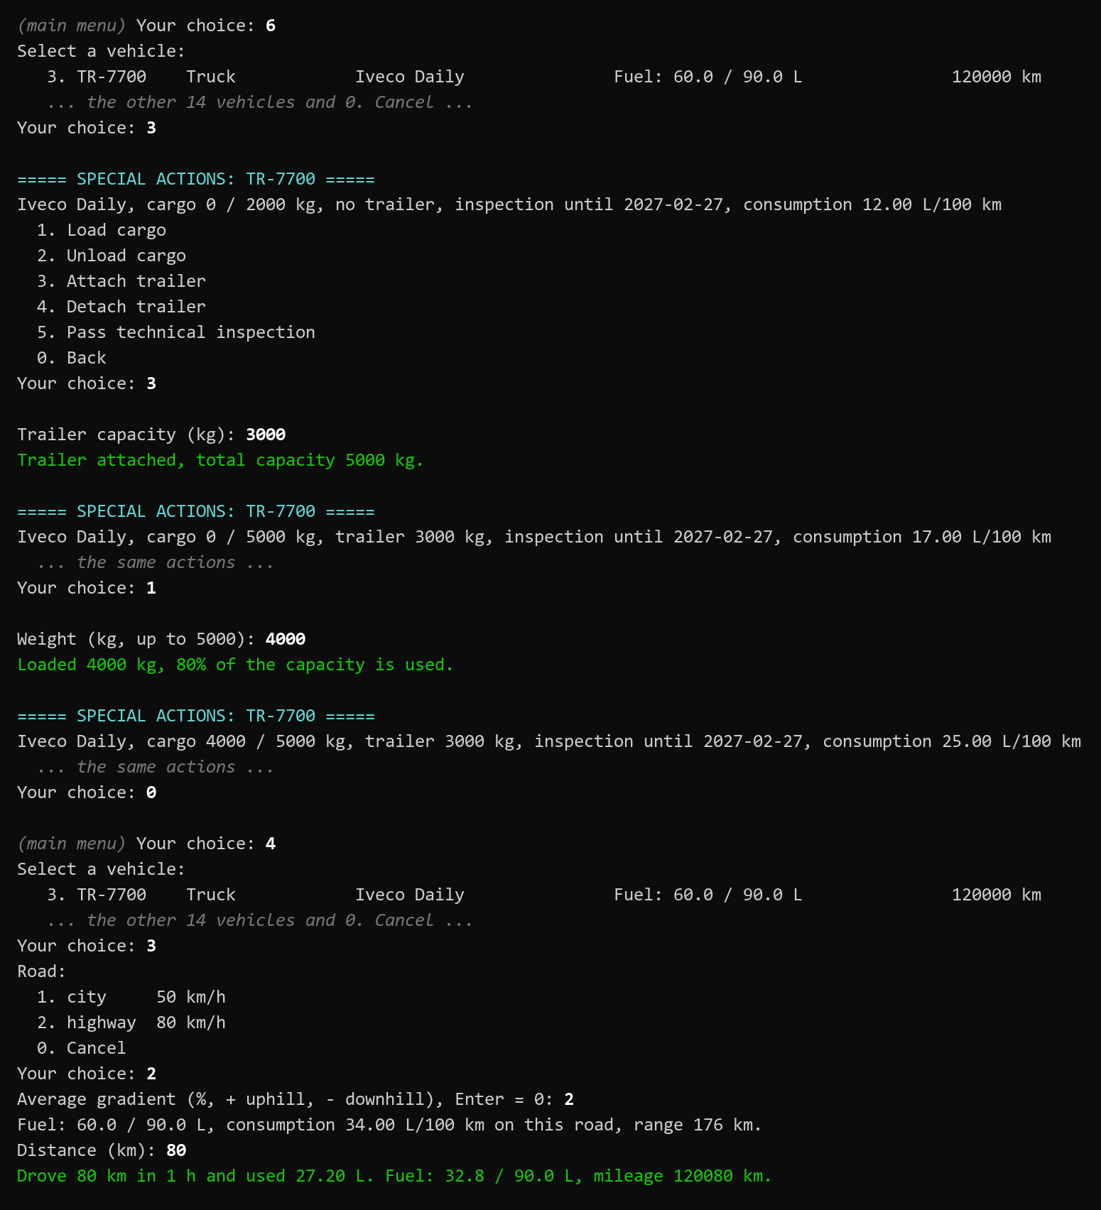
Fig. 14. Truck with a trailer and 4 t of cargo, 80 km uphill
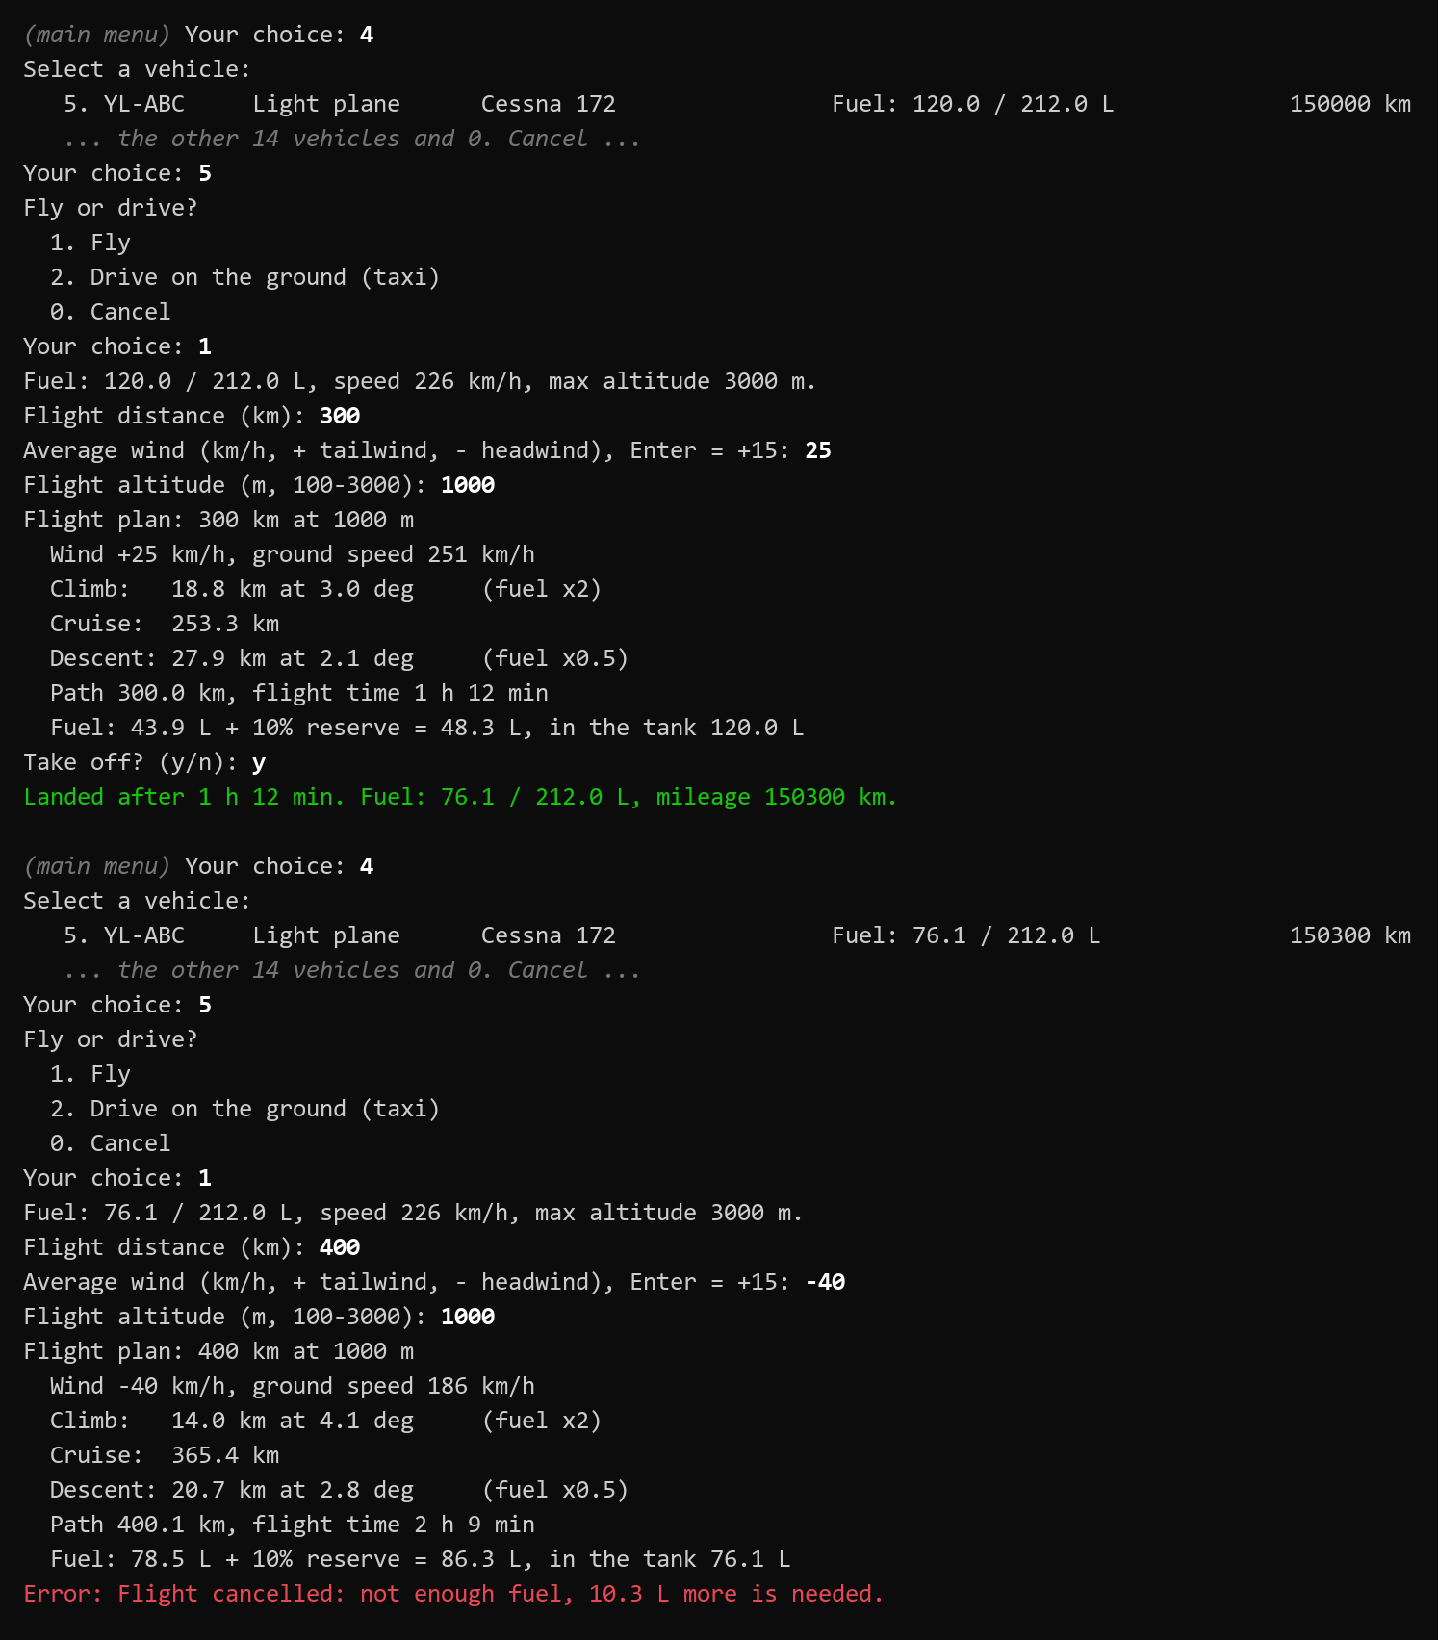
Fig. 15. Flight plans of the Cessna: a tailwind flight and a cancelled flight
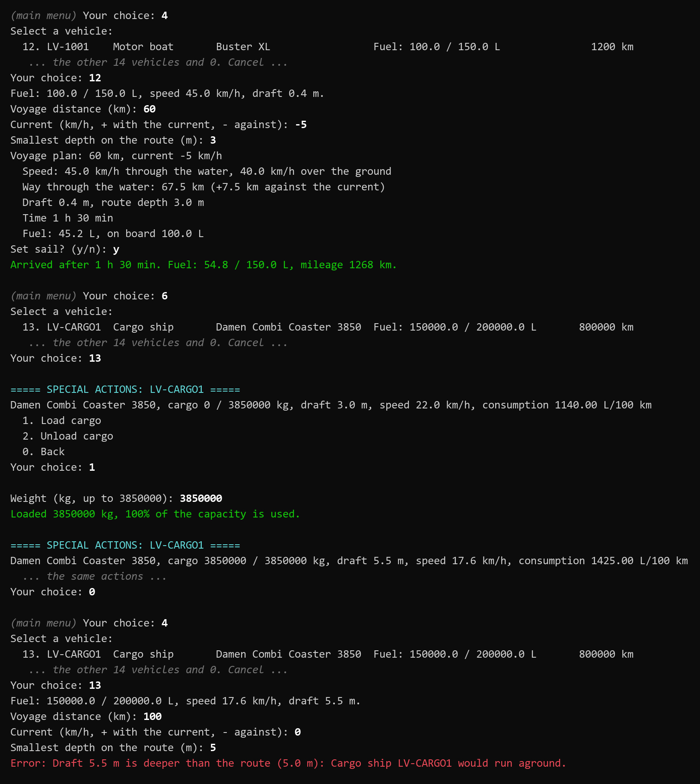
Fig. 16. Voyages: against the current; a loaded cargo ship on a shallow route

Automated tests
The tests are grouped by topic: the variant 6 task (13 tests), ground vehicles (14), the electric car (6), aircraft (15), vessels (8), prices, wind and fleet (7) and console input (8). The input tests replace the console input with prepared lines. Run from the solution folder:
dotnet run --project OOPLAB1.Tests
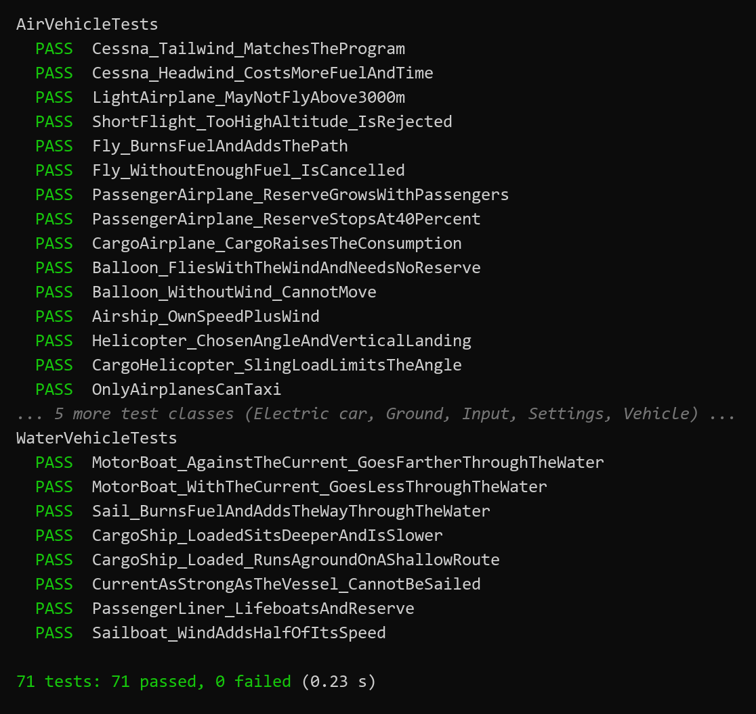
Fig. 17. Output of the quick tests (shortened)

CONCLUSIONS
The assignment of variant 6 was implemented completely: the Vehicle class keeps the registration number, brand, model, fuel level and mileage and changes the fuel and the mileage only through Drive and Refuel, which check the fuel and the tank. On top of it the program models 15 kinds of ground, air and water vehicles with their own rules, plans every trip before it starts, has a console menu with checked input and is covered by 71 automated tests.
The main difficulty was to keep every rule in one place while the hierarchy grew. For example, the road gradient had to work for all ground vehicles without touching Drive; the solution was a sealed FuelConsumption in GroundVehicle with a protected step FlatRoadConsumption for the subclasses. Other difficulties were the electric car, which does not fit the fuel tank model and got its own battery; physical simplifications that had to stay consistent (engines burn fuel by time, so the wind and the current change the fuel through the time); comparisons of doubles; and decimal separators, which depend on the language of Windows and were fixed with the invariant culture.
The work showed in practice how abstract classes and template methods remove duplicated code, how private setters protect the state of an object, and why separating the model from the user interface makes the code testable. It also showed how a small test runner can be written with reflection when no test library may be used.
Possible improvements: saving and loading the fleet to a file (for example JSON); separate types for units, so that litres and kWh cannot be mixed; an interface such as IChargeable if more electric vehicles are added; a standard test framework (xUnit or MSTest) if packages are allowed; more realistic models of speed and consumption on different roads.

AI USAGE

Tools
Claude by Anthropic (model Claude Opus 5.5) was used through Claude Code in the Claude desktop application, from 24 to 27 September 2026, in one conversation. Claude Code can read and edit the files of a chosen folder and run commands such as dotnet build and dotnet run; it worked only in the project folder OOPLAB1. No other AI tools were used.

What AI was used for
- splitting the student’s single-file program into classes and folders and fixing its errors;
- implementing the functionality specified by the student (algorithms, rules, extensions) and offering options for the student to choose from;
- the console user interface;
- checking the requirements and the code quality, and writing the quick tests;
- explanation pages (Table 7) that the student used to study the code;
- drafting this report: the text, the UML diagrams generated from the code, the verification runs and the prompt log.

Parts influenced or generated by AI
The starting point was the student’s own single-file program (Program_original.cs, included in the archive). It already had the classes Vehicle, Car, Truck, Motorcycle and ElectricCar with the properties of variant 6, the tax by year of manufacture, cargo for the truck, charging with a charger power and time, and an empty menu loop.
Most of the final C# code — roughly 90 % of the lines — was written by Claude according to the student’s instructions. The rules of the domain and the algorithms came from the student or were chosen by the student from options offered by Claude (Table 6).
Table 6. Main decisions and who made them
Decision | By whom
Extending the model beyond the assignment; "do not overdo the uniqueness of subclasses" | Student
Flight as a trapezoid (climb, cruise, descent), +10 % reserve, cancellation (Fig. 9) | Student (algorithm and sketch)
Climb rate in m/s together with a cruise speed; climb ×2, descent ×0.5 fuel | Claude’s proposal, accepted by the student
Three airplane types and their features; the balloon as the third aircraft; the reserve in steps with a 40 % cap | Student
Helicopter: maximum climb angle, a new angle for every flight, vertical landing | Student
Cargo helicopter, airship, water transport with a current, liner with lifeboats, sailboat with wind | Student
Cargo ship: the idea "cargo weakens the current" replaced by draft, running aground and slowing down | Claude explained the physics; the student chose the new behaviour
Wind with a default value in the fuel prices menu | Student
GroundVehicle: technical inspection, steering side, road gradient, 50 km/h in a Latvian city; speed and travel time | Student (the last one chosen from Claude’s list)
Folder structure with plural names and a separate Fuel folder | Student
Truck cargo coefficient lowered to 1 L/100 km per 500 kg | Student
Own test runner without packages | Student (chosen from Claude’s options)

Verification and corrections by the student
- wrote the original program, gave the specifications and made the decisions listed above;
- corrected Claude’s proposals: the truck coefficient, the cap of the reserve, the Latvian speed limit, the names of the folders, the behaviour of the cargo ship;
- ran the program and checked the menu, the drives, flights and voyages;
- read and studied the code, with the help of the explanation pages, to be able to explain it at the defense.
Claude checked every change by building the project (0 warnings), running console scenarios and, at the end, the 71 tests.

Explanation pages (artifacts)
During the work Claude also created six public web pages (claude.ai artifacts, in Russian and English) that explain the code. They are learning material, not a part of the solution; the solution is fully contained in the archive.
Table 7. Explanation pages created by Claude
Page | Link | Content
Structure | https://claude.ai/artifact/SmiTfEVaqBdAo2v6zm3GYa | File tree of the solution: every file with its namespace, purpose and number of lines, including the test project.
Class hierarchy | https://claude.ai/artifact/224Ezp8nZrJ21KBaKMJF95 | Inheritance tree of the 21 vehicle classes, which members every class overrides, OOP principles.
Interface | https://claude.ai/artifact/Gspa4sxUc4C4ZexfFe5QXH | Every menu item with the real console output, how Menu, InputReader and the dialogs work.
Ground transport | https://claude.ai/artifact/2NWEfFFmrZv2GqRaSARyGe | Car, electric car, truck, motorcycle; inspection, road type, gradient chart.
Air transport | https://claude.ai/artifact/2vYNkjw5FaU9y3V3rxV8MS | Flight profile of every aircraft, a calculator with the same formulas as PlanFlight, checked flights.
Water transport | https://claude.ai/artifact/P7XFGWBfq6JTbCrEKHZK5V | Current, draft and route depth, a voyage calculator, checked voyages.

Prompt log
The main prompts of the chat in chronological order (dates of 2026). The prompts were written in Russian; each is given in the original (line breaks shown as " / ") and in an English translation. "Choices" are the student’s answers to Claude’s clarifying questions. Service messages (continue after an interruption, short confirmations) and messages about the version control set-up are not listed; […] marks omitted parts.
Table 8. Prompts and what Claude did
# | Prompt of the student | Done by Claude
1  24.09 | RU: Работай только в OOPLAB1. Все остальные файлы вспомогательные и только для прочтения. / это лабораторная работа по ООП. Цель расписана во вариантах работы. Есть некоторые противоречия в заданиях( к примеру где-то написано сделать 1 класс где-то два) выбор варианта сделан при помощи 93166 mod 20 = 6. Так как по новой системе надо делать сверх меры указанного в задание. Если выполнить чисто задание будет 7/10. / Не используй сторонние библиотеке без моего разрешения / Раздели код на отдельные файлы с классами / Исправь логику у электрокаров я её не доделал / так же подготовь архитектуру для воздушного транспорта наброском без конкретики я его до делаю / Сделай интерфейс для меню(в консоли) / предложи для каждого подкласса уникальные методы я выберу из них / отчёт пока что не делаем после программы к ней перейдём / уточняй в спорных моментах  EN: Work only in OOPLAB1. All other files are auxiliary and read-only. / This is an OOP laboratory work. The goal is described in the variants. There are some contradictions in the tasks (in one place it says to make 1 class, in another two). The variant was chosen as 93166 mod 20 = 6. Under the new system you have to do more than the task says; the task alone gives 7/10. / Do not use third-party libraries without my permission. / Split the code into separate files with classes. / Fix the logic of the electric cars, I did not finish it. / Also prepare a draft architecture for air transport without details, I will finish it. / Make an interface for the menu (in the console). / Suggest unique methods for every subclass, I will choose from them. / No report yet, we will get to it after the program. / Ask about disputable points.  Choices: the electric car keeps its own battery; fuelLevel / 2 is a bug; consumption in L/100 km with linear cargo; Vehicle abstract; Car: passengers ("do not overdo the uniqueness of subclasses, so the Vehicle class keeps its meaning"); Truck: unloading and a trailer; Motorcycle: sidecar and passenger; ElectricCar: charging cost ("then Refuel must return the cost too"). | Split the single Program.cs into classes; fixed the electric car (own battery, Charge with power and time, no division by zero), removed fuelLevel / 2, fixed the truck formula; added FuelType, validation, VehicleException, Fleet, demo data; console menu (Menu, InputReader, VehicleCreator, VehicleActionsMenu, ConsolePrinter); a draft of the air classes; the chosen methods.
2  24.09 | RU: уменьши Truck.ExtraConsumptionPer500Kg, например до 1–2. / Переменные у самолёта / Скорость подъёма / Скорость спуска / Максимальная высота / у самолёта нужен алгоритм с подсчётам к требованием необходимого запаса бензина на полёт. Пользователь вводит Самолёт, высоту и длину полёта / Два треугольника и расстояние / Скорость подъёма влияет на прямой треугольнику слева / Скорость спуска справа / самолёт обычно после подъёма держит одну высоту / С помощью этого мы можем получить примерное расстояние и добавить +10% топлива для страховки / Если не хватит топлива отменна полёта  EN: Reduce Truck.ExtraConsumptionPer500Kg, for example to 1–2. / Variables of the airplane: climb rate, descent rate, maximum altitude. / The airplane needs an algorithm that calculates the fuel required for the flight. The user enters the airplane, the altitude and the length of the flight. / Two triangles and a distance. The climb rate affects the right triangle on the left, the descent rate the one on the right; after the climb an airplane usually keeps one altitude. / With this we get the approximate distance and add +10 % fuel for safety. If the fuel is not enough, the flight is cancelled. (A sketch was attached, see Fig. 9.)  Choices: climb/descent rate in m/s plus a cruise speed; climb ×2 and descent ×0.5 fuel; the helicopter stays a draft. | ExtraConsumptionPer500Kg = 1; AirVehicle.PlanFlight with the trapezoid, the FlightPlan record, +10 % reserve and cancellation; FlightDialog (distance, altitude, plan, take-off).
3  25.09 | RU: у тебя есть возможность в отдельный файлик вернуть ту версию программы которая была до первого сообщения хотябы просто текст  EN: Can you put the version of the program from before the first message into a separate file, at least as plain text? | Restored the original Program.cs as Program_original.cs in the solution folder, outside the project, so that it is not compiled.
4  25.09 | RU: Вертолётам надо запретить drive только полёт / надо что бы у топлива были условные цены по умолчанию и возможность изменить цену конкретного топлива на выбор  EN: Helicopters must not drive, only fly. / Fuels need conventional default prices and a way to change the price of a chosen fuel. | Helicopter cannot drive (VehicleException); FuelPrices with default prices and the menu item "Fuel prices"; refuelling and charging take the price from it.
5  25.09 | RU: Надо самолёту дать выбор лететь или ехать / Надо самолёту дать уникальные элементы / два разных класса надо / пассажирский самолёт: фишка количество людей которые будут требовать больше лимита для безопасности / грузовой: будет требовать больше бензина на полёт, но не виде резерва. в зависимости от тяжести груза / гражданский самолёт: ограничение на высоту полёта / Нужен третий вид воздушного транспорта: / На выбор шар(не нужна страховка топливом есть безопасный спуск), дельтаплан(тут совершенно другая функция на дистанцию полёта и нет топлива), дрон(нет возможности человека посадить, топливо это электричество)(проблема это не совсем транспорт)  EN: The airplane must be able to choose to fly or to drive. / The airplane needs unique features, separate classes: passenger airplane — the number of people requires a bigger reserve for safety; cargo airplane — needs more fuel for the flight depending on the cargo weight, but not as a reserve; civil airplane — a limit of the flight altitude. / A third kind of air transport is needed, to choose from: a balloon (no fuel reserve needed, it descends safely), a hang glider (a completely different flight function and no fuel), a drone (cannot carry a person, runs on electricity; the problem is that it is not really transport).  Choices: the civil airplane is a third class, a light private airplane; the balloon; the reserve grows in steps "but at most +40 %, without a limit the reserve can become insane"; the cargo code goes into Vehicle like the passengers. | CanDrive in Vehicle (aircraft cannot drive, airplanes can taxi); abstract Airplane with PassengerAirplane (reserve steps, max 40 %), CargoAirplane (+1 % per tonne), LightAirplane (3000 m); Balloon; LoadCargo/UnloadCargo moved to Vehicle.
6  26.09 | RU: надо вертолёт доделать / У него полёт надо сделать последующему принципу / можно конечно сделать вертикальный взлёт чисто но это слишком просто / вертолёты могут подниматься под наклоном. / Надо дать вертолёту атрибут максимального угла под которым он может подниматься / посадку вертикальный спуск так как не безопасно приземлятся под углом  EN: The helicopter must be finished. Its flight must follow this principle: a purely vertical take-off is possible, but too simple; helicopters can climb at an angle. / The helicopter needs an attribute of the maximum climb angle. / Landing is a vertical descent, because landing at an angle is not safe.  Choices: the climb angle is chosen for every flight. | Helicopter with MaxClimbAngle and ClimbAngle per flight, climb leg = altitude / tan(angle), vertical landing; the time on a slope is the slower of the vertical and the horizontal movement; Robinson R44 in the demo data.
7  26.09 | RU: […] сделай артефакты и распредели по подпапкам файлы классов / Снизу схематичное описание архитектуры папок спроси если будет не понятно / /Vehicles{Vehicle.cs;Fuel.cs}/Ground{/Car{/Car.cs;/ElectricCar.cs};Truck.cs; и тд};/Air{/Plane{PasssengerAirPlane.cs; и тд};/Balloon{...};/Helicopter{...}} / 1. артефакт со структурой файлов / 2. Артефакт полёта вертолёта/шара/вертолёта / 3. Артефакт с описанием наземного трансопрта / 4. Артефакт со схемой иерархией классов  EN: […] make artifacts and distribute the class files into subfolders. / Below is a schematic description of the folder architecture, ask if something is unclear: (folder scheme) / 1. an artifact with the file structure; 2. an artifact of the flight of the helicopter / balloon; 3. an artifact describing ground transport; 4. an artifact with the class hierarchy.  Choices: plural folder names (a namespace must not be equal to a class name); a separate folder for fuel outside Vehicles. | Moved the files into folders (namespace = folder); created four explanation pages: structure, flight profile, ground transport, class hierarchy.
8  26.09 | RU: расширение классов / Helicopters: Нужен грузовой вертолёт который может цеплять прицеп / Baloons: Дирижабль он имеет свою скорость в отличие от шара / Водный транспорт: фишка течение которое потенциально увеличивает/уменьшает расстояние / Катер - просто транспорт водный / Грузовой корабль - можно загрузить груз уменьшает влияние течения(если это так работает если нет надо другое придумать) / Пассажирский лайнер - резерв топлива и количество шлюпок которые увеличивают вес от количества пассажиров / Парусник - увеличивает скорость в зависимости от ветра  EN: Class extension. / Helicopters: a cargo helicopter that can hang a load (a "trailer"). / Balloons: an airship, it has its own speed unlike a balloon. / Water transport: the feature is a current that can increase or decrease the distance. Motor boat — just water transport. Cargo ship — cargo can be loaded, it reduces the influence of the current (if it works like that; if not, something else is needed). Passenger liner — a fuel reserve and a number of lifeboats that add weight depending on the passengers. Sailboat — its speed grows with the wind.  Choices: the sling load increases consumption and limits the climb angle; cargo ship: "draft, running aground and slowing down"; liner: reserve 15 %, lifeboats from the passengers; the wind is used by the aircraft and the sailboat. | Explained that cargo cannot weaken a current; CargoHelicopter (+1 % per 100 kg, 15° with a sling load), Airship : Balloon, WaterVehicle with current, draft and route depth, MotorBoat, Sailboat, CargoShip (draft, up to −20 % speed), PassengerLiner (15 %, lifeboats); average wind for every flight; menu "Drive / fly / sail".
9  26.09 | RU: ветер можно добавить в тип топлива и он должен иметь значение по умолчанию и возможность отредактировать / надо сделать английскую версию артефактов  EN: The wind can be added to the fuel types; it must have a default value and a way to edit it. / An English version of the artifacts is needed.  Choices: the wind is a line in the fuel prices menu; Enter keeps the default; one page with a RU/EN switch. | Wind class (default 15 km/h, 0–150) in "Fuel prices and wind"; InputReader.ReadDoubleOrDefault; flights and voyages offer the wind as the default; all pages bilingual, a fifth page about water transport.
10  26.09 | RU: […] сделай артефакт про ui  EN: […] make an artifact about the UI. | The "Interface" page with the real console output of every menu item; found and fixed shifted numbers in lists of 10 and more items.
11  27.09 | RU: надо сделать общий класс для всего ground Vahicle и надо дать всему общею уникальность. drive нельзя трогать он и так у всех уникальный(Хотя можно сделать наклон дороги, но тогда обычный drive останеца только у самолётов). Можно добавить атрибут тех осмотр, атрибут левосторонний автомобиль или правосторонний(у мотоциклов этого нет). / Предложи что-то ещё для уникальности наземного транспорта  EN: A common class for all ground vehicles is needed, and all of them need a common uniqueness. Drive must not be touched, it is already unique for everyone (a road gradient could be added, but then the plain Drive stays only for airplanes). An attribute "technical inspection" can be added, and an attribute "left-hand or right-hand drive" (motorcycles do not have it). / Suggest something else for the uniqueness of ground transport.  Choices: inspection by date, an expired one is only a warning; the steering side is only an attribute; "in Latvia 50 km/h in the city", road gradient, speed and travel time; update the pages. | GroundVehicle and Automobile base classes; inspection date with a warning and "Pass technical inspection"; SteeringSide; road type, speed limits and travel time; gradient −10…+10 % through the sealed FuelConsumption and FlatRoadConsumption; updated the demo data and the pages.
12  27.09 | RU: делаем контроль качества проверь требования / добавляем быстрые тесты в отдельную папку с отдельным запуском / в следующем сообщение займёмся ворд документам  EN: Now quality control: check the requirements. / Add quick tests in a separate folder with a separate run. / In the next message we will work on the Word document.  Choices: an own test runner without packages; the test project is part of the solution. | Checked the variant and the general requirements; fixed two analyzer remarks; the OOPLAB1.Tests project with its own runner and 71 tests; checked a build from a clean copy.
13  27.09 | RU: Я сделал все артефакты публичными в отчёте об использование ии надо добавить их в пункт об использование ИИ / Maksims Karnakovs st93166 group:4502BDA Lecture:Dmitrijs Gavrilovs университет TSI / Для шаблонов стилей лежит файл PcLab5.docx / Весь отчёт на английском / Так же надо собрать главные сообщения в этом чате как промт свои ответы коротко отметь что было сделано тобой. […] / ссылки на артефакты: […] / Не бойся уточнять что-то  EN: I made all artifacts public; add them to the AI usage section of the report. / Maksims Karnakovs st93166 group: 4502BDA Lecturer: Dmitrijs Gavrilovs, university TSI. / PcLab5.docx is the style template. / The whole report is in English. / Also collect the main messages of this chat as prompts and briefly note your answers: what was done by you. […] / Links to the artifacts: […] (see Table 7). / Do not be afraid to ask.  Choices: prompts in the original and in translation; the student ran the program and read and studied the code; the original program is mentioned and included in the archive. | Drafted this report in the style of PcLab5.docx: the text, the UML diagrams generated from the code, the verification runs and this prompt log.

