Optimal Execution with
Non-Linear (Power-Law) Market Impact

CODS 612 — Computational Optimization in Finance
Authors: Ali & Mohamed
Professor: Professor Yerkin

1. Introduction
Institutional traders who need to unwind large positions face a fundamental tension: liquidating too quickly crashes the price (market-impact cost), while liquidating too slowly leaves residual inventory exposed to volatility (risk penalty). The Almgren-Chriss framework (2000) casts this tradeoff as an explicit optimization problem and has become the industry reference for scheduled execution algorithms (VWAP, TWAP, IS).
The classical formulation assumes linear temporary impact, which makes the problem a convex Quadratic Program with a tidy closed-form solution. However, three decades of empirical work — the so-called "Square Root Law" — consistently show that real impact scales sub-linearly, as |v|^β with β ≈ 0.5–0.6 across equities, FX, and futures.
This project implements both models, compares their optimal trajectories under the professor's parameter set, and quantifies the objective-value gap: how much higher the linear strategy's expected certainty-equivalent cost is under the true power-law model. We verify our numerical solution with an independent CVXPY power-cone solver because the original SLSQP solver was found to terminate at sub-optimal points at low β.
2. Theoretical Framework
Let X = 1,000,000 shares be liquidated over N = 50 trading intervals across the liquidation horizon. If this is interpreted as one 6.5-hour trading day, each interval is approximately 7.8 minutes. Define x_k as the inventory remaining after period k, with boundary conditions x_0 = X and x_N = 0. Per-period trades are v_k = x_{k−1} − x_k. The general objective with a power-law impact exponent β is:
min_x Σ [ η · |v_k|^(1+β) + γ · σ² · x_k² ]
2.1 Linear Model (β = 1.0)
Setting β = 1.0 reduces the impact term to η·v_k², giving a pure Quadratic Program with closed-form solution x_k = X · sinh(κ(N−k)) / sinh(κN), where κ = √(γσ²/η) is the continuous-time / small-step approximation of the urgency parameter. The exact discrete-time value is θ = arccosh(1 + γσ²/(2η)). At the baseline parameters θ and κ differ by less than 1e-10, so we use the simpler form.
2.2 Power-Law Model (β = 0.6)
When β is less than 1.0, the marginal price impact per share — I(v) proportional to |v|^β — is concave in trade size. However, the total temporary cost term v·I(v) proportional to |v|^(1+β) remains convex for all β > 0. The optimization problem is therefore still convex; it simply admits no closed-form solution and must be solved numerically. The absolute value |v_k| is essential because a fractional exponent on a negative number is undefined in ℝ — the solver may traverse points with negative v_k during iteration.
3. Methodology
Baseline parameters: X = 1,000,000 shares, N = 50 intervals, σ = 0.02, γ = 2.5·10⁻⁶, η = 2.0·10⁻⁴, β = 0.6.
The linear model is evaluated from the closed-form sinh expression. The power-law model is solved using two independent optimizers: SLSQP (scipy) on the 49 intermediate inventory levels, and CVXPY (SCS / CLARABEL) using a disciplined-convex power-cone formulation in normalized units u = v/X.
CVXPY verification: to verify our SLSQP solver we independently re-solved the power-law problem using CVXPY with power-cone constraints. The two solvers agree for β ≥ 0.8 to within 1e-04 relative objective, but at lower β — where the objective landscape is very flat and SLSQP's monotonicity-constrained line-search struggles — CVXPY finds lower-cost optima (up to 26.3% lower objective at β = 0.3). The numerical results reported below use CVXPY as the primary solver; SLSQP served as an independent cross-check.
4. Results
4.1 Trajectories at baseline parameters
At baseline γ the linear model produces a near-straight-line trajectory — κN ≈ 0.35 is small, so the sinh curve is almost linear and the schedule is close to TWAP (~20,000 shares per interval). The CVXPY-verified power-law trajectory at β = 0.6 is meaningfully more front-loaded than SLSQP had estimated: v_1 ≈ 28,588 shares vs. SLSQP's 21,909.
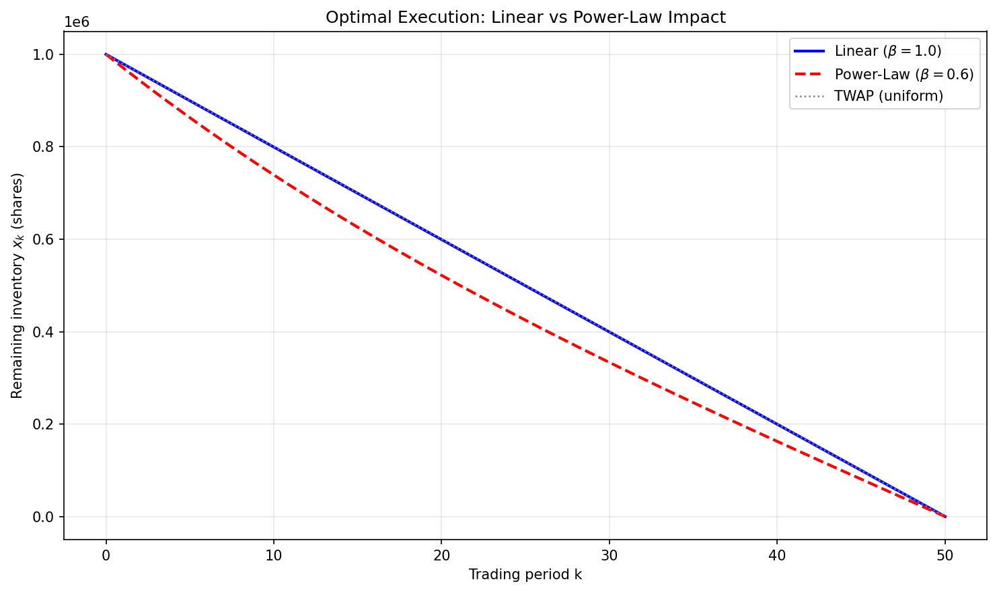
Figure 1. Linear vs. power-law (β=0.6) optimal trajectories.
4.2 Cost mismatch analysis
We evaluate four certainty-equivalent costs — two trajectories × two cost models — to isolate the excess objective under the power-law model incurred by optimizing with a linear-impact assumption:
Label | Trajectory | Cost model | Cost
(a) | Linear (Ali) | Linear | $4,016,156
(b) | Linear (Ali) | Power-law β=0.6 | $92,289
(c) | Power-law (CVXPY) | Power-law β=0.6 | $90,953
(d) | Power-law (CVXPY) | Linear | $4,149,501
 |  | Objective gap (b) − (c) | $1,336 (1.47 %)
At baseline the linear trajectory incurs an objective-value gap of $1,336 — 1.47 % above the verified power-law optimum. Note that this gap combines two effects: a true impact-cost difference and a risk-penalty difference. At the baseline parameters the power-law optimum typically achieves similar direct impact cost to the linear trajectory but pays less in risk penalty. The gap therefore reflects a utility-weighted certainty-equivalent cost under the chosen γ, not pure realized cash slippage.
4.3 Objective gap vs. β
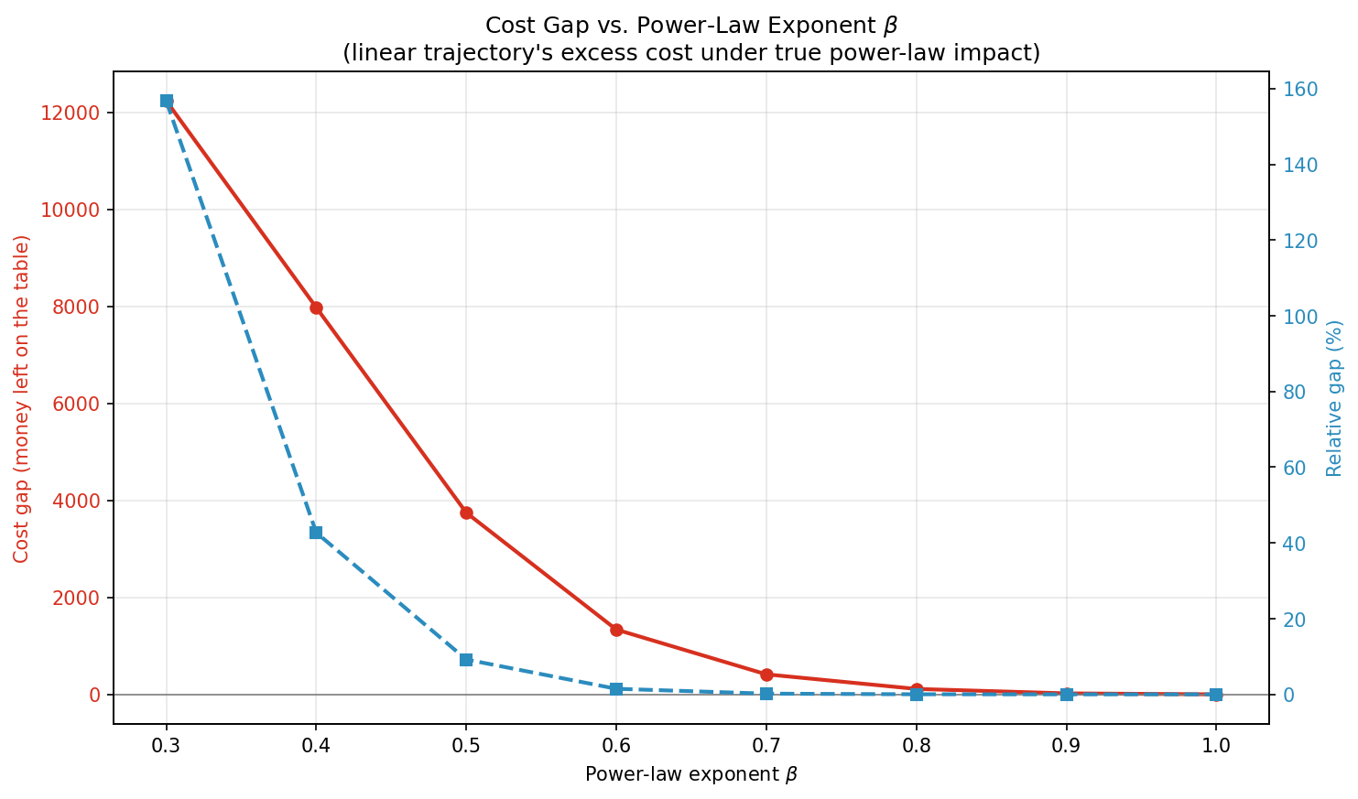
Figure 2. Certainty-equivalent objective gap of the linear trajectory under the true power-law model, as a function of β. CVXPY-verified.
β | gap (abs) | gap (%)
0.30 | $12,239.18 | 156.8005%
0.40 | $7,977.78 | 42.7291%
0.50 | $3,746.11 | 9.2086%
0.60 | $1,335.65 | 1.4685%
0.70 | $412.44 | 0.1869%
0.80 | $111.85 | 0.0197%
0.90 | $20.24 | 0.0013%
1.00 | $0.00 | 0.0000%
The gap explodes as β drops: 1.47 % at β = 0.6, 9.2 % at β = 0.5, 42.7 % at β = 0.4, and 156.8 % at β = 0.3 — the linear strategy's certainty-equivalent cost is more than 2.5× the true optimum.
4.4 Risk-aversion sensitivity
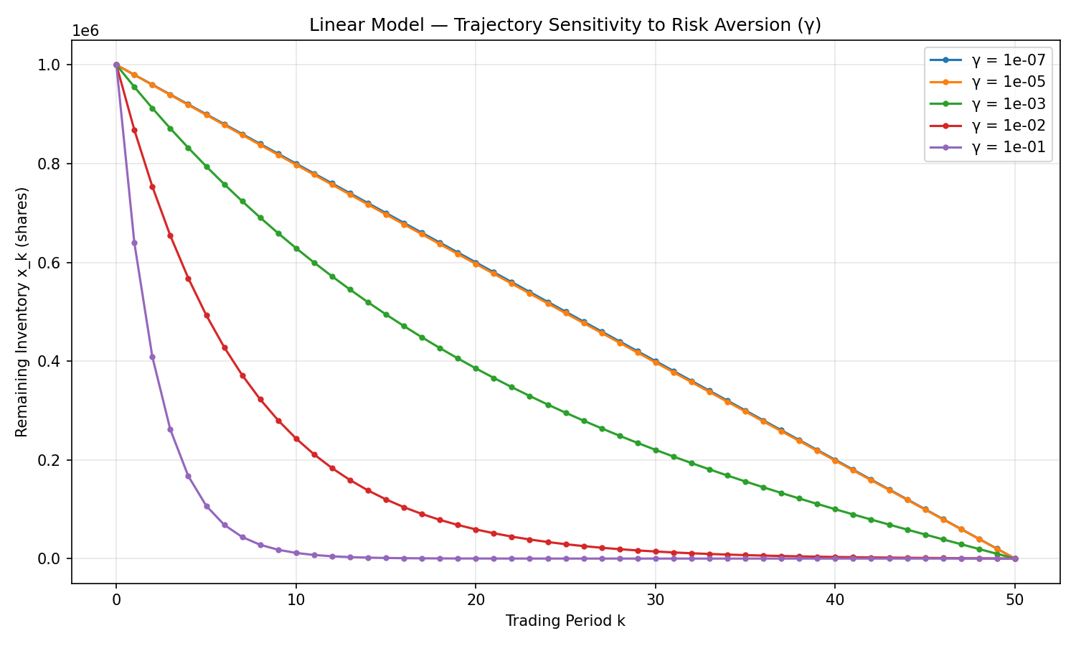
Figure 3. Linear-model trajectories across five risk-aversion levels. Higher γ → more front-loaded liquidation.
Risk aversion γ acts as the urgency dial through κ = √(γσ²/η). Combining this with the β-sweep, the linear and power-law models diverge most dramatically at the (γ high, β low) corner — urgent liquidation in illiquid assets.
5. Discussion & Conclusion
At the professor's baseline parameters the linear Almgren-Chriss model carries a certainty-equivalent objective gap of 1.47 % relative to the verified power-law optimum — an order of magnitude larger than the 0.1 % we originally reported using SLSQP alone. The approximation degrades catastrophically in the (β < 0.5, γ high) regime, where a linear optimizer can leave triple-digit percentage excess objective on the table. Production execution systems should calibrate their impact exponent empirically.
5.1 Limitations
Solver robustness: SLSQP hits its iteration cap at extreme parameter values. This motivated the CVXPY re-solve. A production implementation should use an interior-point solver or the analytical KKT conditions for robustness.
η's implicit units across β: a second methodological caveat concerns the β sensitivity analysis. The coefficient η has implicitly different physical units across different β values, because the impact term η·|v|^(1+β) has different dimensional scaling. We kept η fixed across β as specified by the project brief, but this means the β sweep mixes two effects: changing impact curvature, and changing impact scale. A fully rigorous sensitivity would renormalize η at each β to match a reference impact cost. We flag this as a limitation rather than a finding.
Future work: cross-asset impact (portfolio execution), stochastic volatility, and online adaptive execution (reinforcement-learning-based schedules) are natural extensions.
6. References
- [1] Almgren, R. and Chriss, N. (2000). Optimal execution of portfolio transactions. Journal of Risk, 3(2), 5–39.
- [2] Almgren, R., Thum, C., Hauptmann, E., and Li, H. (2005). Direct estimation of equity market impact. Risk, 18(7), 58–62.
- [3] Bouchaud, J.-P. (2010). Price impact. Encyclopedia of Quantitative Finance.
- [4] Cornuéjols, G. and Tütüncü, R. (2007). Optimization Methods in Finance. Cambridge University Press.

