|  |  |  |
| --- | --- | --- |
| **Assignment # 2** | **BSiT 6th** | **BSIT-023R17-51** |

Economics

**Instructions**

|  |
| --- |
| The purpose of this assignment is to give your hand on practice. It is   expected that students will solve the assignments themselves.   It should be clear that your assignment will not get any credit if:   o Cheating from any source will result in zero marks in the   assignment.   o Any student found cheating in any of the two assignments submitted   will be awarded "F" grade in the course.   o No assignment after due date will be accepted   o The submitted assignment does not open or file is corrupted.    **Question No. 1 (5 Points)**  Write a few lines on comparison of GDP and GNP.    Ans:    GNP and GDP both reflect the national output and income of an economy. The main difference  is that GNP (Gross National Product) takes into account net income receipts from abroad. |
| • GDP (Gross Domestic Product) is a measure of (national income = national output =   national expenditure) produced in a particular country.  • GNP (Gross National Product) = GDP + net property income from abroad. This net   income from abroad includes dividends, interest and profit.  • GNI (Gross National Income) = (similar to GNP) includes the value of all goods and   services produced by nationals – whether in the country or not. |

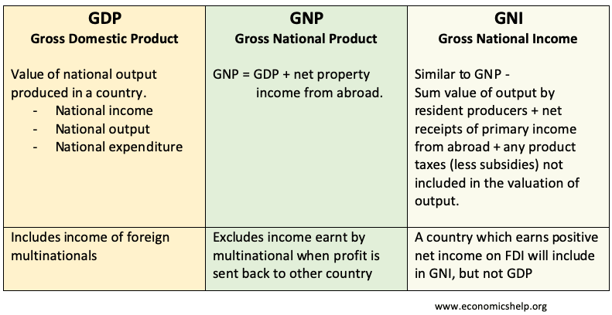

|  |  |  |
| --- | --- | --- |
| **Assignment # 2**  **Question No. 2 (5 Points)**  Write a short note on depreciation. | **BSiT 6th** | **BSIT-023R17-51** |

Ans:

|  |
| --- |
| Depreciation, i.e. a decrease in an asset's value, may be caused by a number of other factors as  well such as unfavorable market conditions, etc. Machinery, equipment, currency are some  examples of assets that are likely to depreciate over a specific period of time. Opposite of  depreciation is appreciation which is increase in the value of an asset over a period of time. |
| Accounting estimates the decrease in value using the information regarding the useful life of the  asset. This is useful for estimation of property value for taxation purposes like property tax etc.  For such assets like real estate, market and economic conditions are likely to be crucial such as in  cases of economic downturn. |