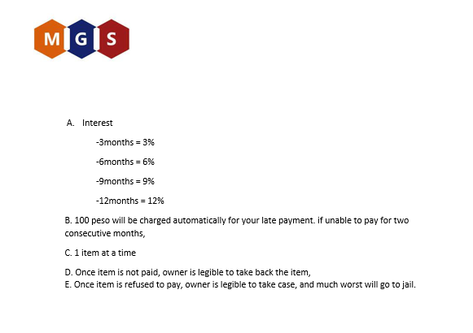

____________________________

CREDITOR NAME AND SIGNATURE