Timothy Quintana

February 24, 2020

Foundations of Programming: Python

Assignment 05

# Introduction

For this Assignment the task is to modify code that has been supplied by Dirk. We must review and Modify the 2D Data Structure to use dictionaries as the inner data type.

Again, this week the assignment is difficult. Mainly due to the fact my 2 year old got pinkeye and i'm travelling to Canada for work so I was only able to half listen to the lecture and watch the posted video when able. Python is awesome and I need to dedicate the time I truly want to it but the lack of time currently means that my code and tracking isn't as good as I would like it to be.  
We were required to modify the code to load dictionaries and add functionality of loading existing data. Additionally we were required to use dictionaries as a 2D table.   
Running and verifying the script seemed like it worked halfway. Not what I wanted but not completely wrong. I still need to work on it to get it the way that I want.   
As for Step 5.4 which is verifying correct functionality. I believe that I can get there soon. As Dirk mentioned in the notes the modification of another's code isn't as easy as it seems. it's almost as if it's another dialect when someone else codes compared to what you have in your mind.

*CODE:  
  
# ------------------------------------------#*

*# Title: CDInventory.py*

*# Desc: Starter Script for Assignment 05*

*# Change Log: (Who, When, What)*

*# DBiesinger, 2030-Jan-01, Created File*

*# TQuintana, 2020-Feb-23, Modified #1, and #TODO Functionilating of loading data*

*# TQuintana, 2020-Feb-24, Modified #3 to print return*

*# ------------------------------------------#*

*# Declare variables*

*strChoice = '' # User input*

*lstTbl = [] # list of lists to hold data*

*dict_row = {"id": '', "CD Title": "", "Artist": ""} # list of data row (Changed to a Dict)*

*strFileName = 'CDInventory.txt' # data storage file*

*objFile = None # file object*

*# Get user Input*

*print('The Magic CD Inventory\n')*

*while True:*

*# 1. Display menu allowing the user to choose:*

*print('[l] load Inventory from file\n'*

*'[a] Add CD\n'*

*'[i] Display Current Inventory\n'*

*'[d] delete CD from Inventory\n'*

*'[s] Save Inventory to file\n'*

*'[x] exit')*

*strChoice = input('l, a, i, d, s or x: ').lower() # convert choice to lower case at time of input*

*print()*

*if strChoice == 'x':*

*# 5. Exit the program if the user chooses so*

*print("Now Exiting...")*

*break*

*if strChoice == 'l':*

*# TODO Add the functionality of loading existing data*

*objFile = open(strFileName, 'r')*

*keys = []*

*values = []*

*items = dict_row.items()*

*for items in objFile:*

*print("keys : ", str(keys))*

*print("values : ", str(values))*

*pass*

*elif strChoice == 'a': # no elif necessary, as this code is only reached if strChoice is not 'exit'*

*# 2. Add data to the table (2d-list) each time the user wants to add data*

*strID = input('Enter an ID: ')*

*strTitle = input('Enter the CD\'s Title: ')*

*strArtist = input('Enter the Artist\'s Name: ')*

*intID = int(strID)*

*dict_row = {"Id": intID, "CD Title": strTitle, "Artist": strArtist}*

*lstTbl.append(dict_row)*

*elif strChoice == 'i':*

*# 3. Display the current data to the user each time the user wants to display the data*

*print('ID, CD Title, Artist')*

*for row in lstTbl:*

*print(row, sep=" ")*

*objFile = open(strFileName, 'r')*

*for row in objFile:*

*lstRow = row.strip().split(",")*

*dict_row ={"ID": int(lstRow[0]), "Title":lstRow[1],"Artist":lstRow[2]}*

*lstTbl.append(dict_row)*

*objFile.close()*

*elif strChoice == 'd':*

*del_choice = input("Input number you would like to delete")*

*del_num = int(del_choice)*

*if del_num in dict_row:*

*del dict_row[del_num]*

*print("\n Okay, its been deleted")*

*else:*

*print("\n That is not a valid choice. Goodbye")*

*# TODO Add functionality of deleting an entry*

*pass*

*elif strChoice == 's':*

*# 4. Save the data to a text file CDInventory.txt if the user chooses so*

*objFile = open(strFileName, 'w')*

*for row in lstTbl:*

*strRow = ''*

*for item in row:*

*strRow += str(item) + ','*

*strRow = strRow[:-1] + '\n'*

*objFile.write(strRow)*

*objFile.close()*

*else:*

*print('Please choose either l, a, i, d, s or x!')*

# 

# This picture shows the menu and what happens when you enter a. You can add a CD by ID, Title and Artist.

This will save it to a file, and we can call it later.

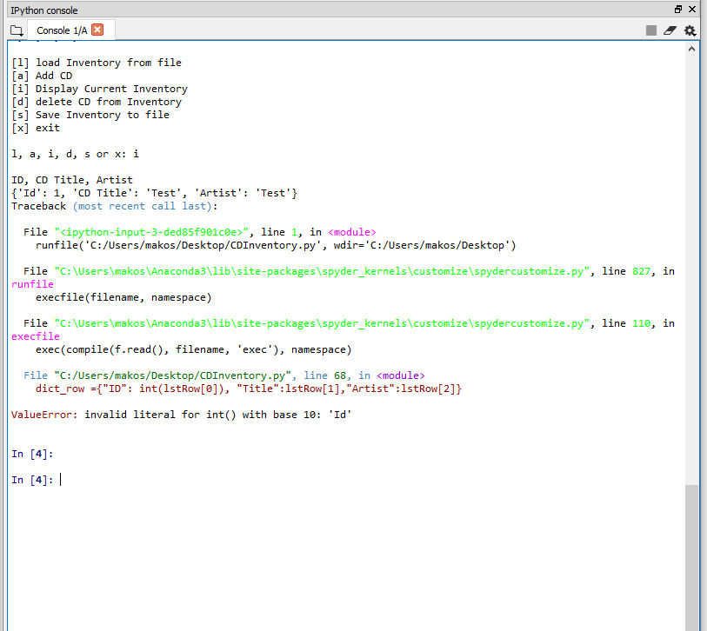

I was having some issues with spyder generating errors.

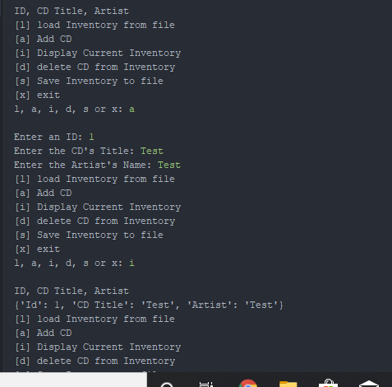  
I tried it in Pycharm since I like the feel of Pycharm better than Spyder and it kind of worked. I need to figure out how to modify the Key/ID to line up as expected. I believe a sort or split is needed for this part

# Summary

Overall, this lab killed me. I wish that I could concentrate as expected and apologize for the documentation as my O365 license just expired. I purchased a new one through the Veterans Network but it won't be in until Wed. I believe that I'm on the right track for the project but not there yet and need a few more days as expected.   
There were quite a few errors that I had in my code that I will try to rectify and pay more attention to during the lecture portion of this. I will be in Canada for work so maybe I can read up in my hotel room. Again apologies for the shoddiness of what I have produced.

## Appendix

[Python Programming for the Absolute Beginner, 3rd Edition](https://www.amazon.com/gp/product/1435455002/ref=ppx_yo_dt_b_asin_title_o05_s00?ie=UTF8&psc=1)

Dawson, Michael

<https://realpython.com/python-lists-tuples/>

<https://realpython.com/python-dicts/>

<https://www.geeksforgeeks.org/file-handling-python/>