**1.Collect and analyse feedback:**

* 1. **Listening to Employees**

We can use the ADKAR template model to get information about the satisfactions of employees and get feedbacks.

* 1. **Auditing Compliance**
* Observation
* Performance report
* Use of new system (cf: excel metrics)
  1. **Analyzing Effectiveness**
* Employees performances (use monthly reports)
* Global performances of project (cf: excel metrics)

**2. Diagnose gaps and manage resistance:**

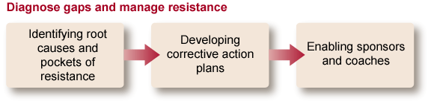

With the information get in step one we can develop corrective action plan to get success on the project.

* If **awareness** was the root cause, examine past communications and messages to this group. Create messages that address any gaps in building awareness around why the change is needed.
* If **desire** was the root cause, then assess the incentives or consequences that would create motivation to change. Are these incentives or consequences sufficient? Do adjustments to the incentives or consequences need to be made? Are these incentives and consequences understood? Have your coaching plans and resistance management plans been effective?
* If **knowledge** was the root cause, examine the education programs that are available as well as the attendance and effectiveness of these programs. Is additional work needed? Do current programs need to be redesigned? Are there gaps in the knowledge and skills being taught to employees?
* If **ability** was the root cause, personal coaching plans and/or personal assistance may be required. What on-the-job assistance is offered? Can employees get immediate help? What happens when a situation arises that does not strictly match what they were taught?
* If **reinforcement** was the root cause, what systems, values or reward systems reinforce the change? Do the systems allow employees to do the process both ways? Do reports and performance evaluations encourage following the new processes, systems and job roles? Are consequences in place for not following the new processes, systems or job roles?

**3. Celebrate success and reinforce the change:**

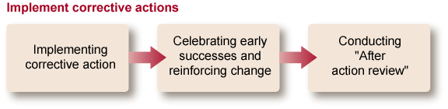

Organization of a **final event** to present the results to all partners and collaborators:

**List of guests**:

All SWAT Employees,

Town Hall employees,

The Wayne Entreprise members who funded and monitored the changes

**Objective of the event**:

represent the desired objectives,

present the results of the change,

publicly congratulate the teams,

present the upcoming objectives for the future