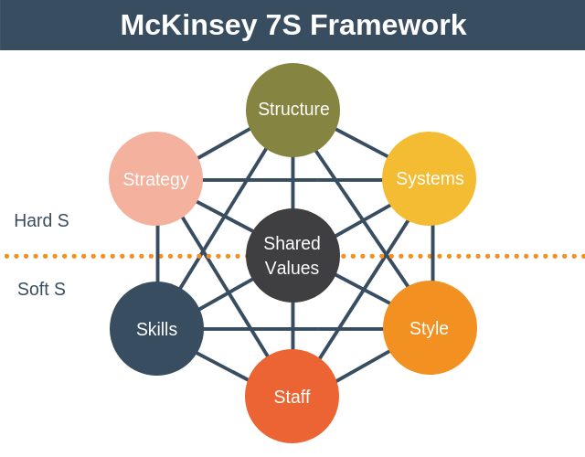

McKinsey 7S

# Overview & Purpose

The McKinsey 7s model is a tool that analyzes a firm's organizational design by looking at 7 key internal elements: strategy, structure, systems, shared values, style, staff and skills, in order to identify if they are effectively aligned and allow the organization to achieve its objectives.

# 

# 7s factors

In the McKinsey model, the seven areas of organization are divided into the ‘soft’ and ‘hard’ areas. Strategy, structure and systems are hard elements that are much easier to identify and manage when compared to soft elements. On the other hand, soft areas, although harder to manage, are the foundation of the organization and are more likely to create the sustained competitive advantage.

# Hard S

1. Strategy
2. Structure
3. Systems

# Soft S

1. Style
2. Staff
3. Skills
4. Shared Values

# 5-Step Process

1. Understand the current situation.
2. Determine the situation
3. Determine your action plan to reach the desired situation
4. Execute the action plan
5. Perform a periodic review of the situation

# Advantages:

* It shows the wider impacts of any changes
* It helps an organization work out what needs to do to where it wants to be
* It helps align departments, processes, and softer issues

# Disadvantages:

* It can be complicated to use
* It needs the support of senior management
* It is an internal focused

page break