

**Cat On Run**

**Thank you for purchasing the asset , if you have any question please contact me at** [**madfireongames@gmail.com**](mailto:madfireongames@gmail.com)

**Project Structure**

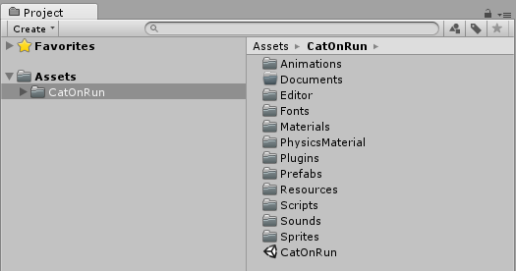

**Animations folder**: There is stored animations used in game.

**Editor Folder**: There is stored Game Design window script (Dont edit anytging in this folder).

**Fonts folder**: There is stored fonts used in GameScene.

**Texture2D**: There is stored all sprites and textures used in game.

**Materials:** There is store material of GameObjects used in game.

**Prefabs Folder**: There is stored Game Objects spawned in game.

**Resources Folder**: There is stored resources for Game Design (Dont edit anytging in this folder).

**Scripts Folder**: There is stored Script files used in game.

**Sounds Folder**: There is stored Musics and Sound effects used in game.

**Scripts**

1. GameManager:- This script controls the game , its saves and loads data from the device eg:- Best Score , musics status ,etc.

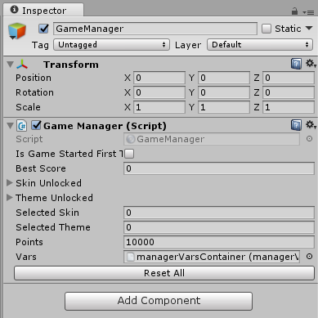

1. Leaderboard:- Scripts which control leaderboard of play store and app store.

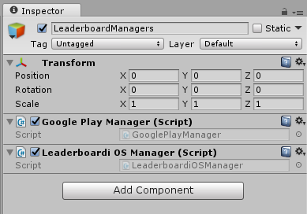

1. Unity IAP:- This script controls the Unity IAP for android and iOS. It controls the remove ads function.

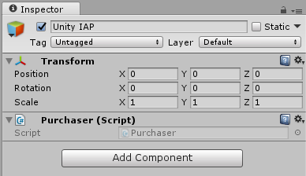

1. GuiManager:- This script controls the game menu , is assigns the functions to the buttons and updates the text like score , best score , etc;

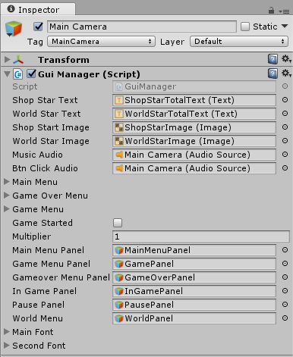

1. ShopManager:- This script controls the shop menu , is assigns the functions to the buttons and updates the character , etc.

Note:- Click on Reset button of GameManager after changing the shop.

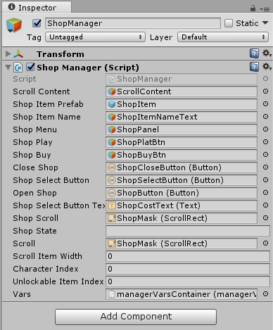

1. WorldShopManager:- This script controls the world shop menu , is assigns the functions to the buttons and updates the theme , etc..

Note:- Click on Reset button of GameManager after changing the shop.

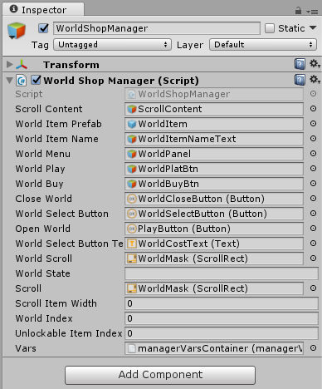

1. ObjectPooling:- This script created the required clone of objects which are used again and again and it the make them active when required , helps in game optimization.

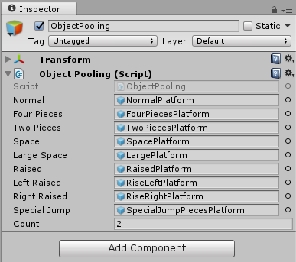

1. ScreenShot:- This script helps player to take the screen shot of their game and share it on the social platforms like facebook , whatsapp , etc.

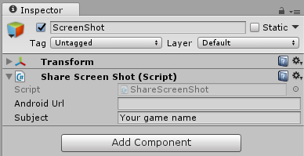

1. PlatformSpawner:- This script controls the spawning of platform , there path , theme and much more.

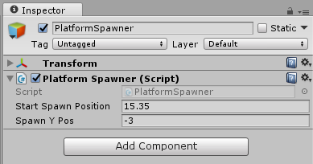

How To Reskin?

Go to Editor -> Click on GameDesign.

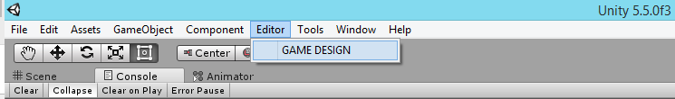

GameDesign window will open.

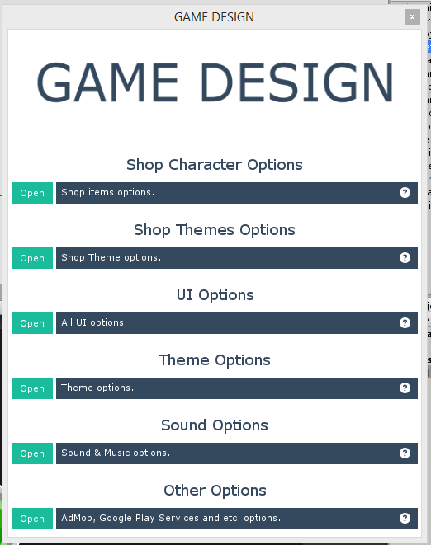

Open any section and you will find fields to change.

**Game Design: UI Options**

You can easily edit all UI Elements like Button sprites, Text colors.

All available configurations is listed bellow:

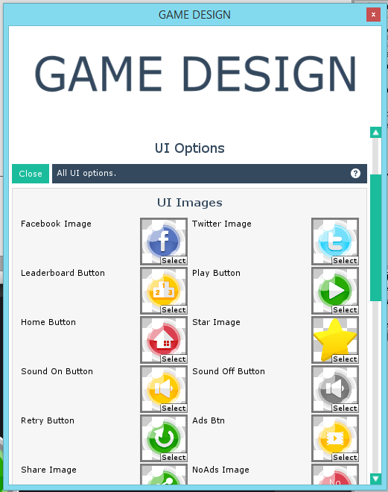

**Game Design: Sound Options / Other Options**

You can easily edit all sounds and musics like characters sound effects, buttons click , admob settings , Leaderboard for iOS and Android , and much more.

[Note] Import Sdk Before Activating Admob and Play Service

All available configurations is listed bellow:

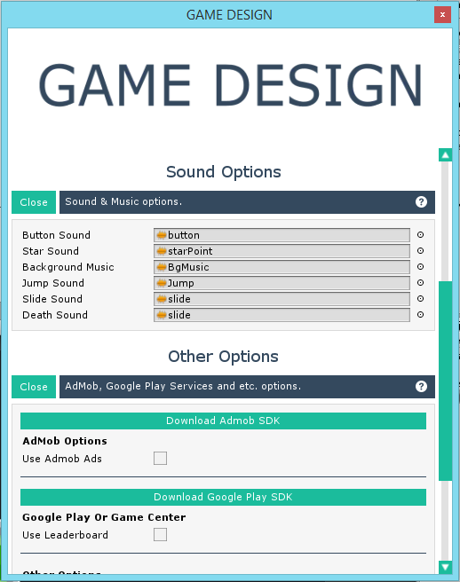

**Game Design: Shop Options**

You can easily add or remove the character by editing the shop options. The shop menu is update by its own.

All available configurations is listed bellow:

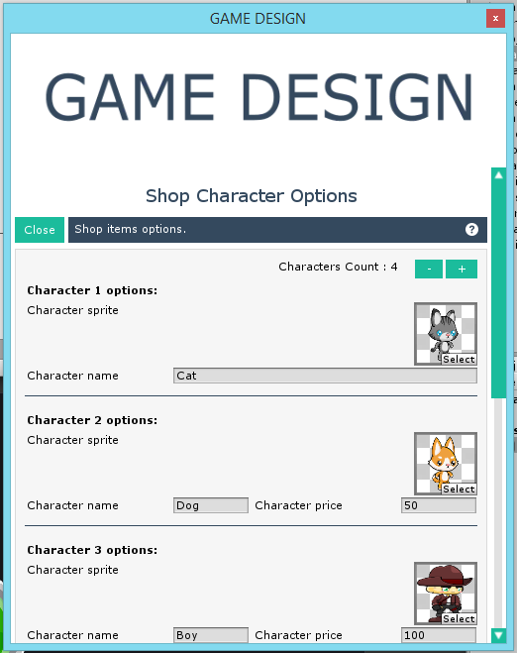

**Game Design: Shop Theme Options**

You can easily add or remove the theme here. The shop theme menu is update by its own.

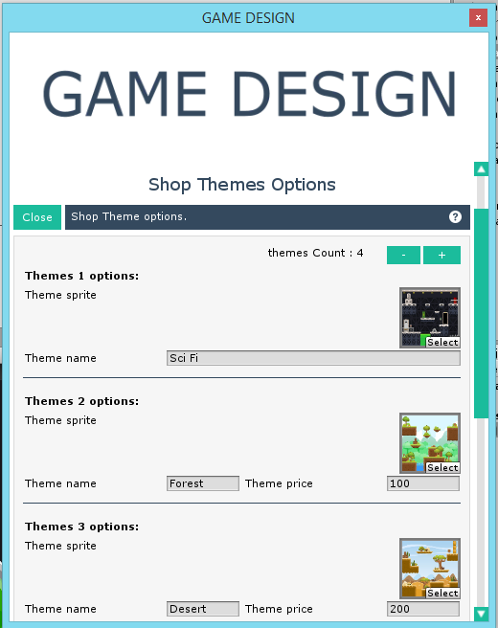

**Game Design: Theme Options**

You can easily add or remove the platform theme here.

The game will update , no need to change sprite manually.

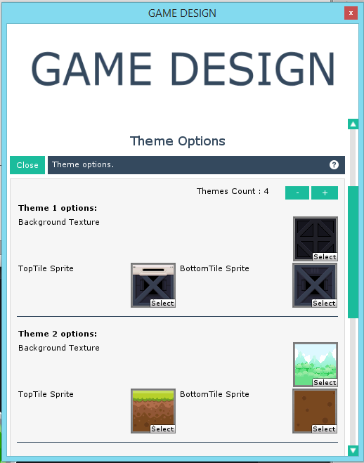

**Adding New Character**

Step 1 :- Update the Shop menu from GameDesign.

Step 2 :- Now Drag any player gameobject into scene from Prefabs-> Player folder (eg: Boy , Cat).

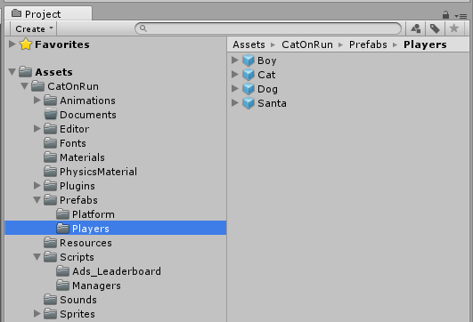

Step 3 :- Create a new folder in Animation and give it name(eg:- Robot).

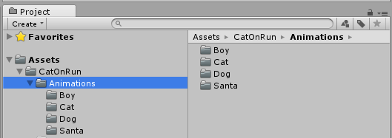

Step 4:- Copy and Paste the animation and animator from other folder, let say Boy folder.

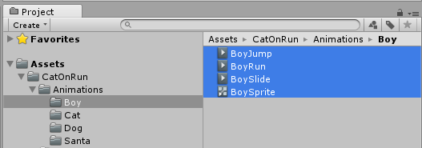

Step 5 :- Rename them eg:- RobotJump , RobotRun , RobotSlide , RobotSprite.

Step 6 :- Go to the prefab you dragged to scene in Step 2 and rename it to eg: Robot.

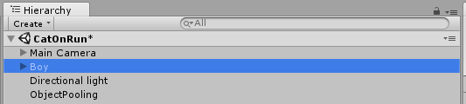

Step 7 :- Drag the gameobject to Prefabs-> Player folder to create new prefabs.

Step 8 :- Now select the Child sprite of the gameobject which is in the scene and open Animation Window (Window -> Animation).

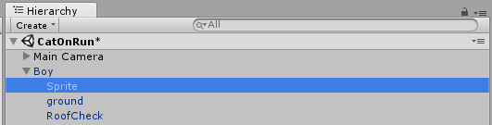

Step 9 :- Select Child sprite and drag animator (RobotSprite ) on the Animator field.

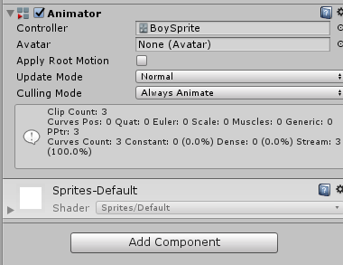

Step 10 :- Now in Animation window replace the sprite for each anim with your and adjust the animation.

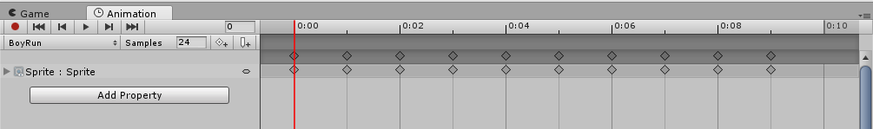

Step 11:- Click on gameobject (Robot) and press Apply.

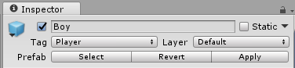

Step 12 :- Drag the prefab to PlayerSpawner and assign it in same manner as the Shop is assigned.

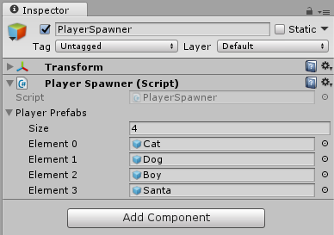

Note:- Click on Reset Button of GameManager after adding or removing character