Business Template

Subject areas
DB_Makpal_Chuinusheva_HW_diagram

Contents
1 Business Description 3
1.1 Business background 3
1.2 Problems. Current Situation 3
1.3 The benefits of implementing a database. Project Vision 3
2 Model description 3
2.1 Definitions & Acronyms 3
2.2 Logical Scheme 3
2.3 Objects 3

Business Description

Business background
The mountaineering club organizes climbing activities for its members.
The club manages information about climbers, climbs, mountains, guides, and equipment.
Currently, this data is stored in separate files or manually, which makes it difficult to track participation, manage resources, and ensure data consistency.

Problems. Current Situation
The current system has several issues:
- Data is scattered across different files and is not centralized.
- It is difficult to track which climbers participated in specific climbs.
- There is no clear relationship between climbs, guides, and equipment.
- Data redundancy and inconsistencies may occur.
- Reporting and analysis (e.g., most popular mountains or active climbers) is difficult.

the Benefits of implementing a database. Project Vision
Implementing a database will:
- Centralize all information in one system.
- Ensure data consistency and integrity.
- Allow efficient querying and reporting.
- Support many-to-many relationships (e.g., climbers participating in multiple climbs).
- Improve decision-making and planning.

The goal of this project is to design a logical data model in 3NF that accurately represents the mountaineering club operations.

Model description

Definitions & Acronyms
PK – Primary Key (unique identifier of a table)
FK – Foreign Key (reference to another table)
3NF – Third Normal Form (no transitive dependencies)
M:N – Many-to-Many relationship

Logical Scheme

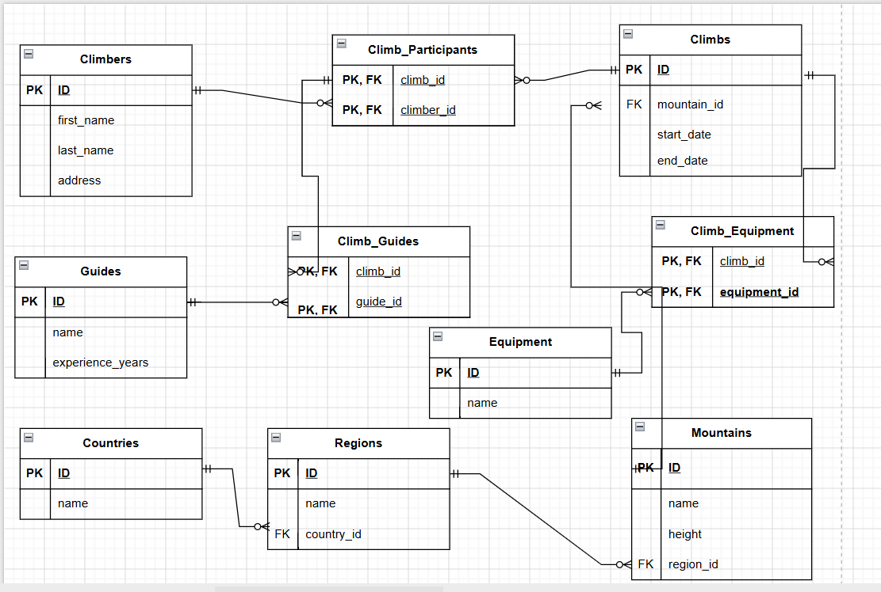

Objects

Table Description
The database consists of the following main entities:
- Climbers
- Climbs
- Mountains
- Countries
- Regions
- Guides
- Equipment
And junction tables:
- Climb_Participants
- Climb_Guides
- Climb_Equipment

Table Name | Field name | Field Description | Data Type
Climbers | ID | < Unique identifier >, PK | Int
 | first_name | < Climber first name > | VARCHAR
 | last_name | < Climber last name > | VARCHAR
 | address | < Climber address > | VARCHAR

Table Name | Field name | Field Description | Data Type
Climbs | ID | Unique identifier (PK) | INT
Climbs | mountain_id | Reference to Mountains (FK) | INT
Climbs | start_date | Climb start date | DATE
Climbs | end_date | Climb end date | DATE

Table Name | Field name | Field Description | Data Type
Mountains | ID | Unique identifier (PK) | INT
Mountains | name | Mountain name | VARCHAR
Mountains | height | Height of mountain | INT
Mountains | country_id | Reference to Countries (FK) | INT
Mountains | region_id | Reference to Regions (FK) | INT

Table Name | Field name | Field Description | Data Type
Climb_Participants | climb_id | FK to Climbs, PK | INT
Climb_Participants | climber_id | FK to Climbers, PK | INT

Comments on table relationships
- A climber can participate in many climbs, and a climb can include many climbers (M:N), implemented via Climb_Participants.
- A climb can involve multiple guides (M:N via Climb_Guides).
- Equipment can be used in multiple climbs (M:N via Climb_Equipment).
- Each mountain belongs to one region and one country (1:N).

EXAMPLE WITH DATA
ID | first_name | last_name | address
1 | Ali | Khan | Almaty
2 | Dana | Nur | Astana

