3DMA Final Project Asset List– Max in the Office

Max – techniques: modelling, sculpting, rigging, texture painting
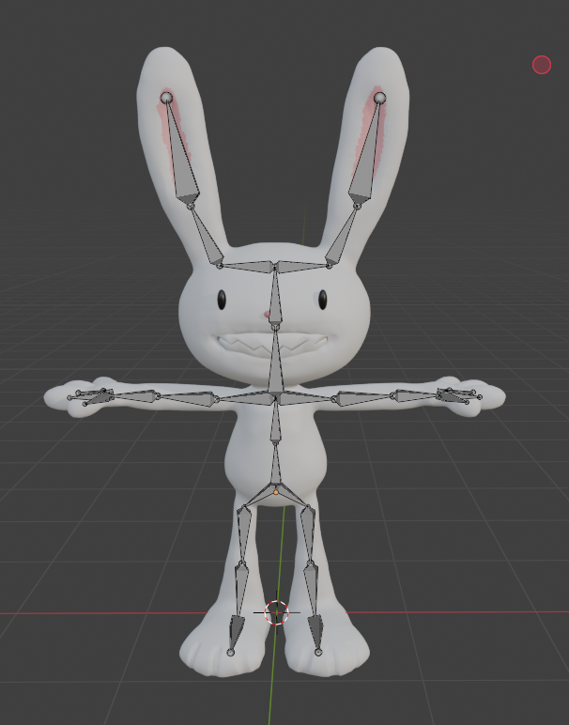
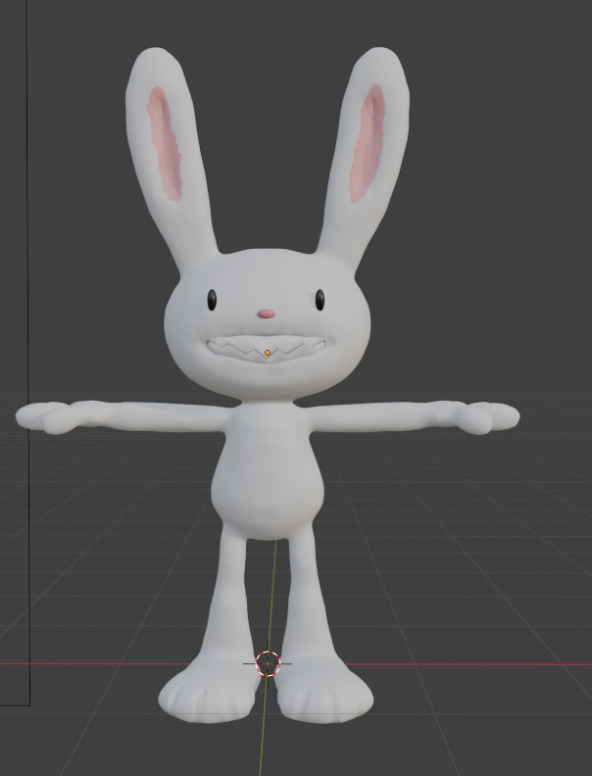

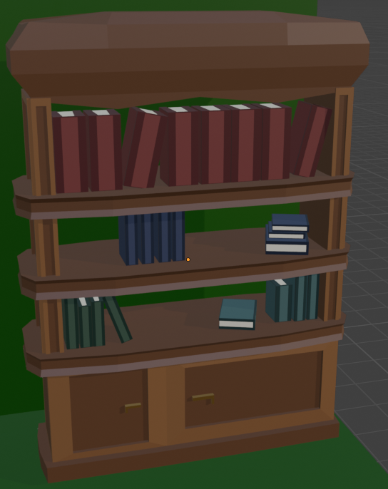
Bookshelf + Books = modelling

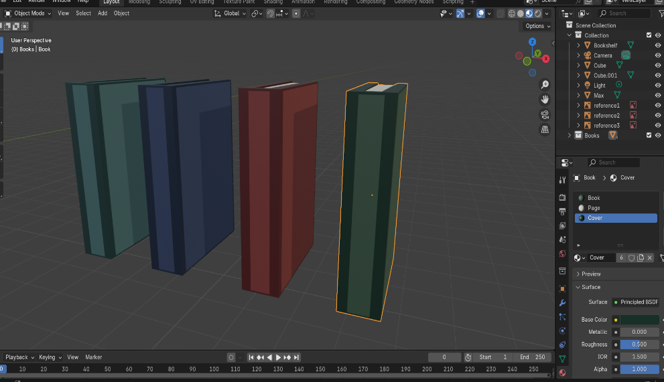

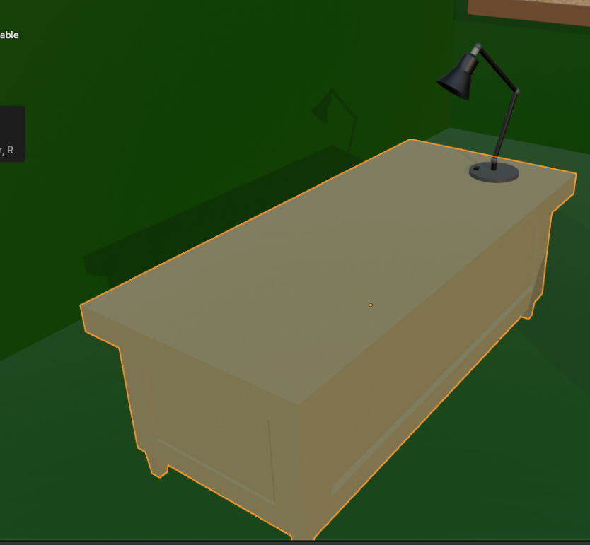
Table + chair + lamp = modelling, modifiers, animation(lamp)
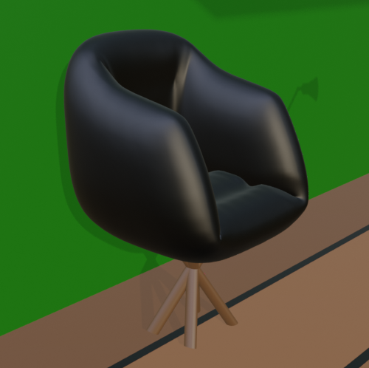

Billboard + Pins + Photos = modelling, texturing (cork texture)
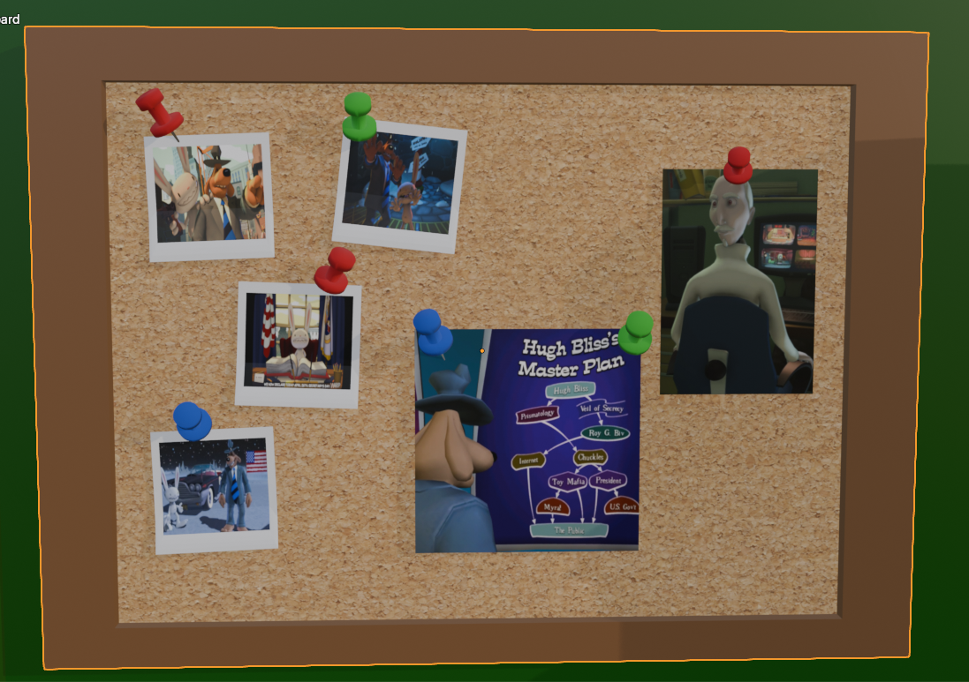

Ceiling fan – modelling, animation (with cycles modifier)
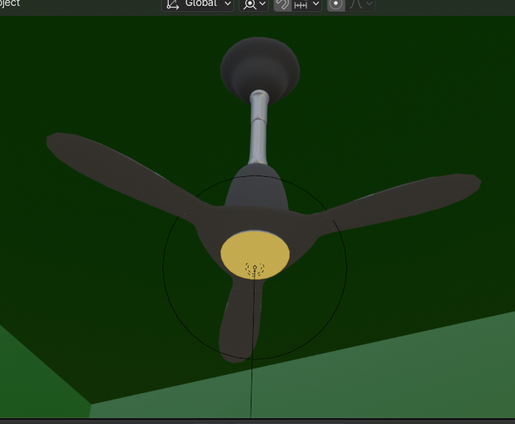

Scene Lighting – fan spotlight, lamp spotlight + animation
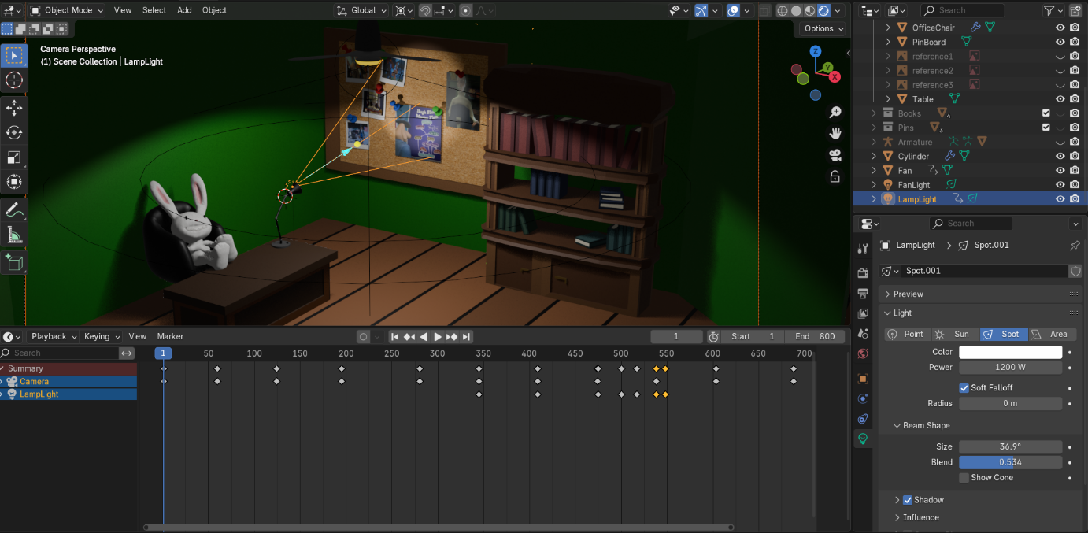

Camera – moving through the scene via keyframes animation

