**Data Analytics - BAN-357-BOS1**

**Mid-Term Assignment 1**

By- Maksat Mametjumayev

Dear Karen Payne,

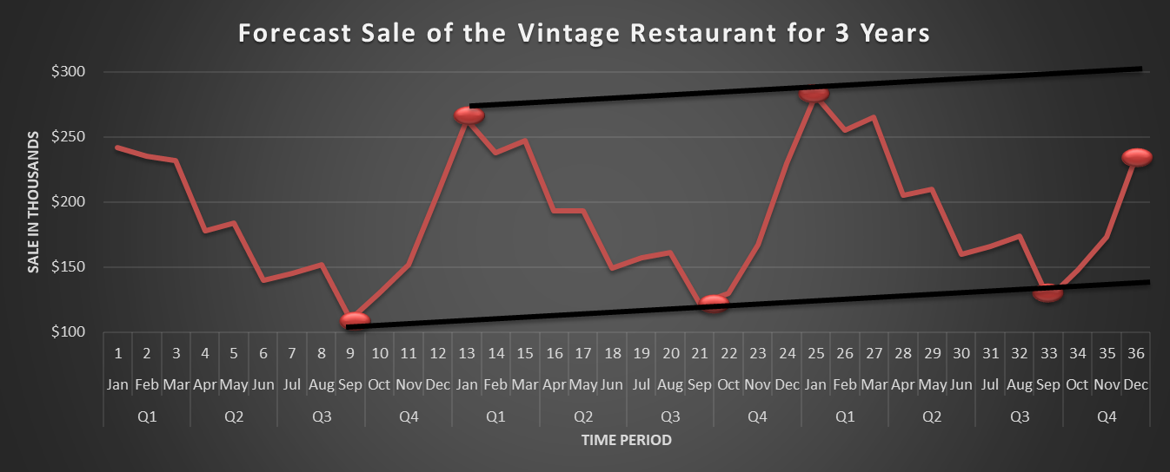This report talks about my findings and recommendations about sales of the Vintage Restaurant, on Captiva Island near Fort Myers, Florida. Firstly, the restaurant needs to implement a system that will enable forecast food and beverage sales by month for up to one year in advance. Based on collected sales data for three years, I was able to build the time series plot as it was shown below:

The time series plot of the Vintage Restaurant illustrates that each year sales are lowest at the end of Q3 and the beginning of Q4, specifically in September and October months. In contrast, the time series plot shows that each year the sales are highest at the end of Q4 and the entire Q1, particularly, the highest sales include December, January, February, and even March months. Accordingly, this proves the existence of a seasonal pattern. Furthermore, the time series plot has an upward slope that allows us to get accurate output from the dummy variable approach. Hence, using a dummy variable approach, I was able to conduct regression analysis forecasting of Vintage Restaurant for three years and predict the sales of the fourth year. Accordingly, the output of the forecast is accurate as the p-value is statistically significant, and the positive coefficient illustrates the positive correlation between the forecast result and actual sales for three years. Figure 2 also shows the low variance between actual sales and forecast for three years:

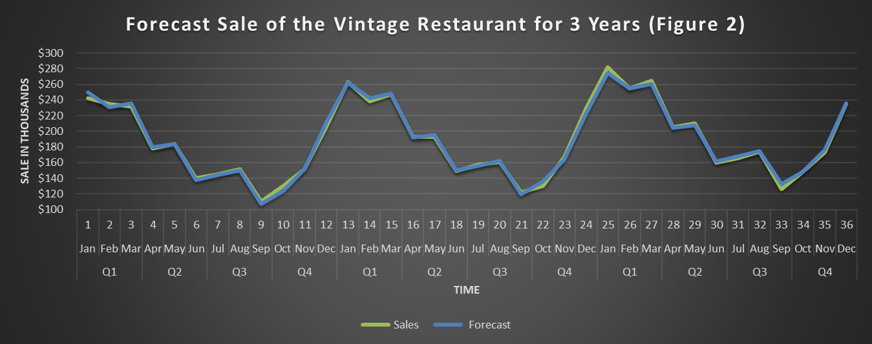Also, below I demonstrated the table of forecast sales for the fourth year which is output from a dummy variable approach and regression analysis.



The last graph shows the continuation of the seasonality pattern as the highest sale in the fourth year is still from the end of Q4 until the end of Q1 while the lowest sale is from the end of Q3 until the beginning of Q4:

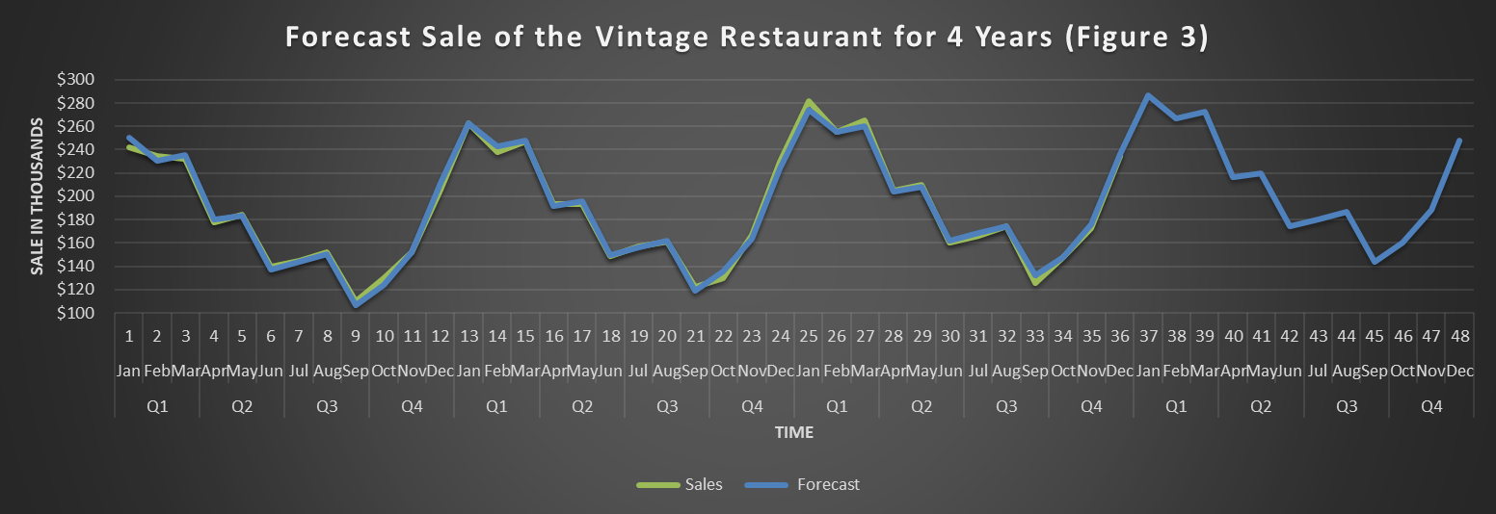

The last figure shows the positive linear trend as the slope is upward. I conducted a positive linear trend based on the total sale for three years from actual sale information while it also includes the total sale for the fourth year from forecast output. The turning the total sale into a percentage, I was able to identify that each year sales grew by 6%. In particular, the growth between the first year and second year was 6.84%, the growth between the second and third years was 6.62, and the growth between the third year and fourth years will be 6.07. This illustrates the gradual decrease in growth.

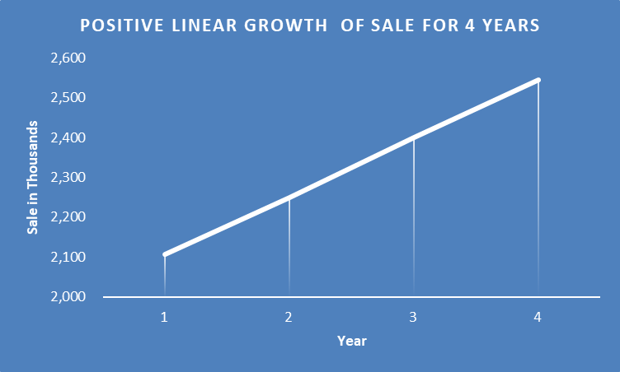

If the January sales for the fourth year are $295,000- the forecast error will be calculated by the following:

forecast error = (actual sale -forecast sale)/ actual sale

So,

Forecast errors for 4th yr Jan= (295,000-286,750)/295,000= 2.80%.

The forecast error is small, so you do not have to worry about it. However, if the forecast error was high, you would need to check her sale data several times to choose other suitable forecasting food and beverage sale.

**Recommendation:**  Based on 95% confidence, the variance between actual sales data and forecast output is low which proves the strong accuracy of prediction. Hence, I would recommend you increase supplies or inventories for the Vintage restaurant during the winter season, specifically, from the end of December until the end of February. In contrast, I would recommend decreasing supplies and inventories from Q2 until the middle of Q4 as the graphs and time series plot demonstrate the restaurant's lowest sales period.