ТДЗ8. Тесты единичного корня

Николаева В.Н. Достовалов М.Ю.

28 03 2024

library(openxlsx)  
library(aTSA)  
library(urca)  
library(haven)  
library(stats)  
library(tseries)  
library(forecast)  
library(zoo)  
library(xts)  
library(pander)  
library(lmtest)  
library(car)  
library(ggplot2)

data <- readxl::read_xls('WB_Russia.xls')  
  
population <- data$SP.POP.TOTL  
life_expectancy <- na.omit(data$SP.DYN.LE00.IN)  
emissions <- na.omit(data$EN.ATM.CO2E.PC)

Выбранные показатели: SP.POP.TOTL: Численность населения, общая SP.DYN.LE00.IN: Ожидаемая продолжительность жизни при рождении, общая (в годах) EN.ATM.CO2E.PC: Выбросы CO2 (в метрических тоннах на душу населения)

tsdisplay(population)

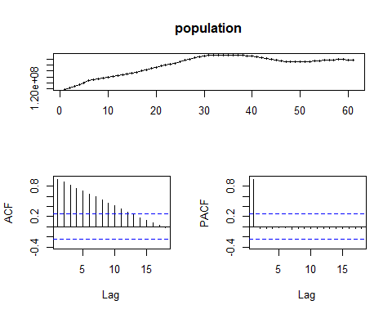

tsdisplay(life_expectancy)

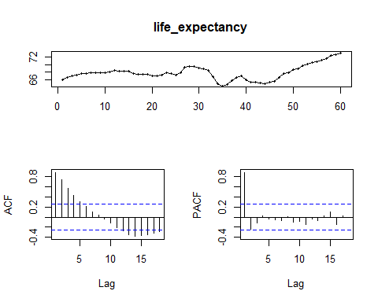

tsdisplay(emissions)

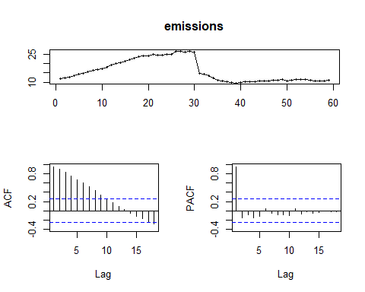 Тест Дики-Фуллера для исходного ряда

stationary.test(population, method = "adf")

## Augmented Dickey-Fuller Test   
## alternative: stationary   
##   
## Type 1: no drift no trend   
## lag ADF p.value  
## [1,] 0 4.672 0.990  
## [2,] 1 -0.529 0.487  
## [3,] 2 -0.409 0.524  
## [4,] 3 -0.207 0.581  
## Type 2: with drift no trend   
## lag ADF p.value  
## [1,] 0 -7.55 0.010  
## [2,] 1 -2.02 0.322  
## [3,] 2 -1.89 0.372  
## [4,] 3 -1.77 0.416  
## Type 3: with drift and trend   
## lag ADF p.value  
## [1,] 0 -1.99 0.573  
## [2,] 1 -1.79 0.655  
## [3,] 2 -1.58 0.741  
## [4,] 3 -1.27 0.870  
## ----   
## Note: in fact, p.value = 0.01 means p.value <= 0.01

stationary.test(life_expectancy, method = "adf")

## Augmented Dickey-Fuller Test   
## alternative: stationary   
##   
## Type 1: no drift no trend   
## lag ADF p.value  
## [1,] 0 1.572 0.969  
## [2,] 1 0.712 0.844  
## [3,] 2 0.846 0.882  
## [4,] 3 0.872 0.890  
## Type 2: with drift no trend   
## lag ADF p.value  
## [1,] 0 0.268 0.974  
## [2,] 1 -1.283 0.594  
## [3,] 2 -0.778 0.771  
## [4,] 3 -0.584 0.840  
## Type 3: with drift and trend   
## lag ADF p.value  
## [1,] 0 -0.120 0.990  
## [2,] 1 -1.577 0.742  
## [3,] 2 -1.042 0.924  
## [4,] 3 -0.809 0.956  
## ----   
## Note: in fact, p.value = 0.01 means p.value <= 0.01

stationary.test(emissions, method = "adf")

## Augmented Dickey-Fuller Test   
## alternative: stationary   
##   
## Type 1: no drift no trend   
## lag ADF p.value  
## [1,] 0 -0.411 0.523  
## [2,] 1 -0.465 0.508  
## [3,] 2 -0.512 0.493  
## [4,] 3 -0.619 0.454  
## Type 2: with drift no trend   
## lag ADF p.value  
## [1,] 0 -0.97 0.704  
## [2,] 1 -1.12 0.650  
## [3,] 2 -1.21 0.621  
## [4,] 3 -1.42 0.545  
## Type 3: with drift and trend   
## lag ADF p.value  
## [1,] 0 -1.86 0.626  
## [2,] 1 -1.99 0.569  
## [3,] 2 -2.07 0.536  
## [4,] 3 -2.23 0.473  
## ----   
## Note: in fact, p.value = 0.01 means p.value <= 0.01

Тест KPSS (Квятковского-Филлипса-Шмидта-Шина) для исходного ряда

stationary.test(population, method = "kpss")

## KPSS Unit Root Test   
## alternative: nonstationary   
##   
## Type 1: no drift no trend   
## lag stat p.value  
## 1 2.39 0.0186  
## -----   
## Type 2: with drift no trend   
## lag stat p.value  
## 1 0.663 0.0169  
## -----   
## Type 1: with drift and trend   
## lag stat p.value  
## 1 0.258 0.01  
## -----------   
## Note: p.value = 0.01 means p.value <= 0.01   
## : p.value = 0.10 means p.value >= 0.10

stationary.test(life_expectancy, method = "kpss")

## KPSS Unit Root Test   
## alternative: nonstationary   
##   
## Type 1: no drift no trend   
## lag stat p.value  
## 1 0.269 0.1  
## -----   
## Type 2: with drift no trend   
## lag stat p.value  
## 1 0.251 0.1  
## -----   
## Type 1: with drift and trend   
## lag stat p.value  
## 1 0.156 0.0419  
## -----------   
## Note: p.value = 0.01 means p.value <= 0.01   
## : p.value = 0.10 means p.value >= 0.10

stationary.test(emissions, method = "kpss")

## KPSS Unit Root Test   
## alternative: nonstationary   
##   
## Type 1: no drift no trend   
## lag stat p.value  
## 1 0.419 0.1  
## -----   
## Type 2: with drift no trend   
## lag stat p.value  
## 1 0.426 0.0659  
## -----   
## Type 1: with drift and trend   
## lag stat p.value  
## 1 0.128 0.0826  
## -----------   
## Note: p.value = 0.01 means p.value <= 0.01   
## : p.value = 0.10 means p.value >= 0.10

PP-тест Филлипса-Перрона для исходного ряда

stationary.test(population, method = "pp")

## Phillips-Perron Unit Root Test   
## alternative: stationary   
##   
## Type 1: no drift no trend   
## lag Z_rho p.value  
## 3 0.161 0.722  
## -----   
## Type 2: with drift no trend   
## lag Z_rho p.value  
## 3 -3.43 0.599  
## -----   
## Type 3: with drift and trend   
## lag Z_rho p.value  
## 3 -1.69 0.975  
## ---------------   
## Note: p-value = 0.01 means p.value <= 0.01

stationary.test(life_expectancy, method = "pp")

## Phillips-Perron Unit Root Test   
## alternative: stationary   
##   
## Type 1: no drift no trend   
## lag Z_rho p.value  
## 3 0.102 0.709  
## -----   
## Type 2: with drift no trend   
## lag Z_rho p.value  
## 3 -2.14 0.747  
## -----   
## Type 3: with drift and trend   
## lag Z_rho p.value  
## 3 -3.16 0.925  
## ---------------   
## Note: p-value = 0.01 means p.value <= 0.01

stationary.test(emissions, method = "pp")

## Phillips-Perron Unit Root Test   
## alternative: stationary   
##   
## Type 1: no drift no trend   
## lag Z_rho p.value  
## 3 -0.406 0.596  
## -----   
## Type 2: with drift no trend   
## lag Z_rho p.value  
## 3 -2.98 0.652  
## -----   
## Type 3: with drift and trend   
## lag Z_rho p.value  
## 3 -5.24 0.781  
## ---------------   
## Note: p-value = 0.01 means p.value <= 0.01

Тест Дики-Фуллера для первой разности

population_diff = diff(population)  
stationary.test(population_diff, method = "adf")

## Augmented Dickey-Fuller Test   
## alternative: stationary   
##   
## Type 1: no drift no trend   
## lag ADF p.value  
## [1,] 0 -1.82 0.0692  
## [2,] 1 -1.86 0.0637  
## [3,] 2 -1.92 0.0543  
## [4,] 3 -2.07 0.0403  
## Type 2: with drift no trend   
## lag ADF p.value  
## [1,] 0 -1.24 0.608  
## [2,] 1 -1.35 0.572  
## [3,] 2 -1.52 0.512  
## [4,] 3 -1.77 0.415  
## Type 3: with drift and trend   
## lag ADF p.value  
## [1,] 0 -1.50 0.772  
## [2,] 1 -1.63 0.720  
## [3,] 2 -1.93 0.597  
## [4,] 3 -2.48 0.374  
## ----   
## Note: in fact, p.value = 0.01 means p.value <= 0.01

life_expectancy_diff = diff(life_expectancy)  
stationary.test(life_expectancy_diff, method = "adf")

## Augmented Dickey-Fuller Test   
## alternative: stationary   
##   
## Type 1: no drift no trend   
## lag ADF p.value  
## [1,] 0 -4.00 0.01  
## [2,] 1 -4.14 0.01  
## [3,] 2 -3.79 0.01  
## [4,] 3 -3.15 0.01  
## Type 2: with drift no trend   
## lag ADF p.value  
## [1,] 0 -4.05 0.0100  
## [2,] 1 -4.22 0.0100  
## [3,] 2 -3.88 0.0100  
## [4,] 3 -3.25 0.0239  
## Type 3: with drift and trend   
## lag ADF p.value  
## [1,] 0 -4.17 0.0100  
## [2,] 1 -4.39 0.0100  
## [3,] 2 -4.10 0.0117  
## [4,] 3 -3.51 0.0481  
## ----   
## Note: in fact, p.value = 0.01 means p.value <= 0.01

emissions_diff = diff(emissions)  
stationary.test(emissions_diff, method = "adf")

## Augmented Dickey-Fuller Test   
## alternative: stationary   
##   
## Type 1: no drift no trend   
## lag ADF p.value  
## [1,] 0 -6.48 0.0100  
## [2,] 1 -4.45 0.0100  
## [3,] 2 -3.18 0.0100  
## [4,] 3 -2.58 0.0116  
## Type 2: with drift no trend   
## lag ADF p.value  
## [1,] 0 -6.43 0.0100  
## [2,] 1 -4.41 0.0100  
## [3,] 2 -3.16 0.0304  
## [4,] 3 -2.56 0.1158  
## Type 3: with drift and trend   
## lag ADF p.value  
## [1,] 0 -6.52 0.0100  
## [2,] 1 -4.49 0.0100  
## [3,] 2 -3.20 0.0963  
## [4,] 3 -2.57 0.3398  
## ----   
## Note: in fact, p.value = 0.01 means p.value <= 0.01

Тест KPSS (Квятковского-Филлипса-Шмидта-Шина) для первой разницы

stationary.test(population_diff, method = "kpss")

## KPSS Unit Root Test   
## alternative: nonstationary   
##   
## Type 1: no drift no trend   
## lag stat p.value  
## 1 0.13 0.1  
## -----   
## Type 2: with drift no trend   
## lag stat p.value  
## 1 0.136 0.1  
## -----   
## Type 1: with drift and trend   
## lag stat p.value  
## 1 0.116 0.1  
## -----------   
## Note: p.value = 0.01 means p.value <= 0.01   
## : p.value = 0.10 means p.value >= 0.10

stationary.test(life_expectancy_diff, method = "kpss")

## KPSS Unit Root Test   
## alternative: nonstationary   
##   
## Type 1: no drift no trend   
## lag stat p.value  
## 1 0.0743 0.1  
## -----   
## Type 2: with drift no trend   
## lag stat p.value  
## 1 0.157 0.1  
## -----   
## Type 1: with drift and trend   
## lag stat p.value  
## 1 0.0637 0.1  
## -----------   
## Note: p.value = 0.01 means p.value <= 0.01   
## : p.value = 0.10 means p.value >= 0.10

stationary.test(emissions_diff, method = "kpss")

## KPSS Unit Root Test   
## alternative: nonstationary   
##   
## Type 1: no drift no trend   
## lag stat p.value  
## 1 0.252 0.1  
## -----   
## Type 2: with drift no trend   
## lag stat p.value  
## 1 0.265 0.1  
## -----   
## Type 1: with drift and trend   
## lag stat p.value  
## 1 0.156 0.042  
## -----------   
## Note: p.value = 0.01 means p.value <= 0.01   
## : p.value = 0.10 means p.value >= 0.10

PP-тест Филлипса-Перрона для первой разницы

stationary.test(population_diff, method = "pp")

## Phillips-Perron Unit Root Test   
## alternative: stationary   
##   
## Type 1: no drift no trend   
## lag Z_rho p.value  
## 3 -3.39 0.282  
## -----   
## Type 2: with drift no trend   
## lag Z_rho p.value  
## 3 -3.09 0.639  
## -----   
## Type 3: with drift and trend   
## lag Z_rho p.value  
## 3 -6.29 0.699  
## ---------------   
## Note: p-value = 0.01 means p.value <= 0.01

stationary.test(life_expectancy_diff, method = "pp")

## Phillips-Perron Unit Root Test   
## alternative: stationary   
##   
## Type 1: no drift no trend   
## lag Z_rho p.value  
## 3 -25.1 0.01  
## -----   
## Type 2: with drift no trend   
## lag Z_rho p.value  
## 3 -26 0.01  
## -----   
## Type 3: with drift and trend   
## lag Z_rho p.value  
## 3 -26.6 0.01  
## ---------------   
## Note: p-value = 0.01 means p.value <= 0.01

stationary.test(emissions_diff, method = "pp")

## Phillips-Perron Unit Root Test   
## alternative: stationary   
##   
## Type 1: no drift no trend   
## lag Z_rho p.value  
## 3 -52 0.01  
## -----   
## Type 2: with drift no trend   
## lag Z_rho p.value  
## 3 -52 0.01  
## -----   
## Type 3: with drift and trend   
## lag Z_rho p.value  
## 3 -53.2 0.01  
## ---------------   
## Note: p-value = 0.01 means p.value <= 0.01

summary(ur.za(population, model = c("trend")))

##   
## ################################   
## # Zivot-Andrews Unit Root Test #   
## ################################   
##   
##   
## Call:  
## lm(formula = testmat)  
##   
## Residuals:  
## Min 1Q Median 3Q Max   
## -680412 -194094 9623 249735 596933   
##   
## Coefficients:  
## Estimate Std. Error t value Pr(>|t|)   
## (Intercept) 1.774e+07 3.176e+06 5.586 7.08e-07 ***  
## y.l1 8.607e-01 2.690e-02 31.995 < 2e-16 ***  
## trend 1.142e+05 2.881e+04 3.963 0.000212 ***  
## dt -1.471e+05 3.145e+04 -4.677 1.88e-05 ***  
## ---  
## Signif. codes: 0 '***' 0.001 '**' 0.01 '*' 0.05 '.' 0.1 ' ' 1  
##   
## Residual standard error: 332900 on 56 degrees of freedom  
## (1 пропущенное наблюдение удалено)  
## Multiple R-squared: 0.9982, Adjusted R-squared: 0.9981   
## F-statistic: 1.036e+04 on 3 and 56 DF, p-value: < 2.2e-16  
##   
##   
## Teststatistic: -5.1789   
## Critical values: 0.01= -4.93 0.05= -4.42 0.1= -4.11   
##   
## Potential break point at position: 27

stationary.test(life_expectancy, method = "adf")

## Augmented Dickey-Fuller Test   
## alternative: stationary   
##   
## Type 1: no drift no trend   
## lag ADF p.value  
## [1,] 0 1.572 0.969  
## [2,] 1 0.712 0.844  
## [3,] 2 0.846 0.882  
## [4,] 3 0.872 0.890  
## Type 2: with drift no trend   
## lag ADF p.value  
## [1,] 0 0.268 0.974  
## [2,] 1 -1.283 0.594  
## [3,] 2 -0.778 0.771  
## [4,] 3 -0.584 0.840  
## Type 3: with drift and trend   
## lag ADF p.value  
## [1,] 0 -0.120 0.990  
## [2,] 1 -1.577 0.742  
## [3,] 2 -1.042 0.924  
## [4,] 3 -0.809 0.956  
## ----   
## Note: in fact, p.value = 0.01 means p.value <= 0.01

stationary.test(life_expectancy_diff, method = "adf")

## Augmented Dickey-Fuller Test   
## alternative: stationary   
##   
## Type 1: no drift no trend   
## lag ADF p.value  
## [1,] 0 -4.00 0.01  
## [2,] 1 -4.14 0.01  
## [3,] 2 -3.79 0.01  
## [4,] 3 -3.15 0.01  
## Type 2: with drift no trend   
## lag ADF p.value  
## [1,] 0 -4.05 0.0100  
## [2,] 1 -4.22 0.0100  
## [3,] 2 -3.88 0.0100  
## [4,] 3 -3.25 0.0239  
## Type 3: with drift and trend   
## lag ADF p.value  
## [1,] 0 -4.17 0.0100  
## [2,] 1 -4.39 0.0100  
## [3,] 2 -4.10 0.0117  
## [4,] 3 -3.51 0.0481  
## ----   
## Note: in fact, p.value = 0.01 means p.value <= 0.01