MINISTRY OF SCIENCE AND HIGHER EDUCATION OF THE RUSSIAN FEDERATION

FEDERAL STATE AUTONOMOUS EDUCATIONAL INSTITUTION OF HIGHER EDUCATION

"NOVOSIBIRSK NATIONAL RESEARCH UNIVERSITY

STATE UNIVERSITY"   
(NOVOSIBIRSK STATE UNIVERSITY, NSU)

09.03.01 - Informatics and Computer Engineering

Focus (profile): Computer Science and System Design

**TEAM PAPER**

**Authors:**

**Kotenkov Maksim  
Yakovleva Valeria  
Zelenin Pavel**

**Job topic:**

**“Conway’s Game of Life”**

Novosibirsk, 2023

**TABLE OF CONTENTS**

**INTRODUCTION 3**

**1 PROBLEM STATEMENT 4**

**2 ANALOGUES 5**

**3 HARDWARE 6**

**4 SOFTWARE 14**

**5 SOFTWARE & HARDWARE 31**

**6 USER MANUAL 32**

**CONCLUSION 34**

**APPENDIX 1 35**

# 

# **INTRODUCTION**

Let us talk you through our project – “The Game of Life “. “Life” itself was made in 1970 by British mathematician John Horton Conway – it’s a game main feature of which is unnecessary for a player: he only sets the initial states of first cell generation on the plate. Plate consists of a grid of cells which, based on a few mathematical rules, can live, die or multiply. Depending on the initial conditions, the cells form various patterns throughout the course of the game.

1) For a space that is populated   
 a) Each cell with *one or no neighbors* **dies**, as if by solitude

b) Each cell with *two or three neighbors* **survives**

c) Each cell with *four or more neighbors* **dies**, as if by overpopulation

2) For a space that is empty or unpopulated

a) Each cell with *three neighbors* **becomes populated**

More specifically, it does mean *each* *dead cell with three neighbors* **becomes alive**, *each alive cell with less than two or more than three neighbors* **becomes dead**.

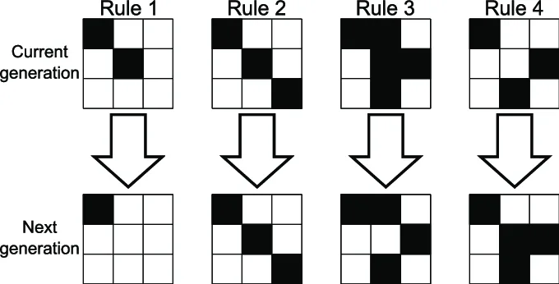

*Picture 1.1 – RULES*

So, we need to make a display showing our cells, which should change their condition according to the rules, while the game is on.

Also, due to the limited size of memory, as was told in the documentation, we need to handle edge cells. We have decided to make a toroidal plate – it means edge cells are neighbors to the opposite side cells, so the grid is cycled.

# **1 PROBLEM STATEMENT**

Out of the suggested projects, we found “Conway's game of life” to be the most interesting. After doing some research among already existing implementations of this game, we came to the conclusion that the classic version of the game cannot provide a good user experience. In this problem, we saw space for our own ideas and decided to develop the game in Logisim and Assembly, with significant modifications that in our opinion improve the game and make it more interesting.

# **2 ANALOGUES**

Comparing our game with classical version we can find out what makes us different:

1. Toroidal plate – our cells are neighbors and you can move through the border to another cell on the opposite side
2. Intuitive main scheme - we only have a display, buttons and a few subcircuits. That makes it easy understandable and not so awkward
3. Pattern buttons – using it you can simply and quickly put ready-made blocks on the plate. So there’s no reason to use cursor for placing every cell
4. System control – the possibility to pause and reset the game at every moment. Using relevant buttons you can control simulation

# **3 HARDWARE**

In our project we have 10 schemes including the main one:

* main
* Cell
* State manager
* Row of cells
* Rows plate
* Controller
* OutputLogic
* counter
* PressedCounter
* BUTTONS

Their interaction is illustrated on the block diagram below:

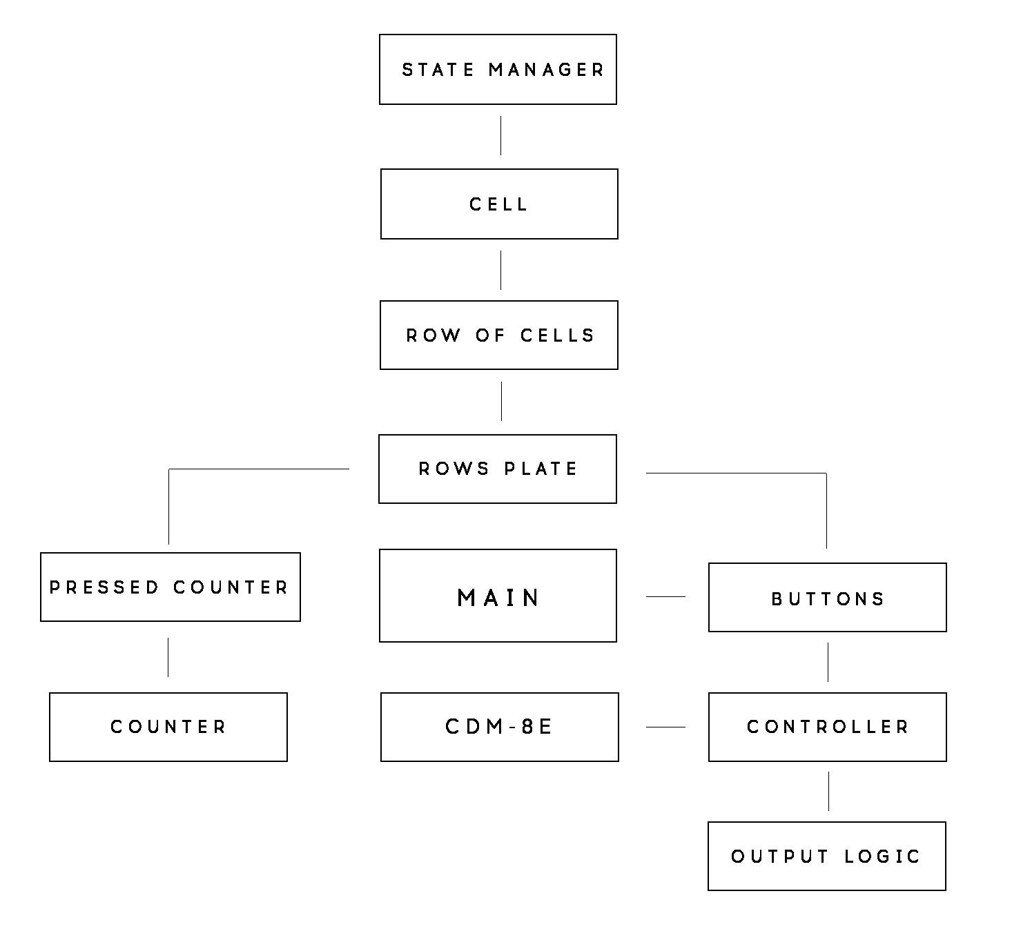

*Picture 2.1 – HARDWARE STRUCTURE*

THE MAIN SCHEME

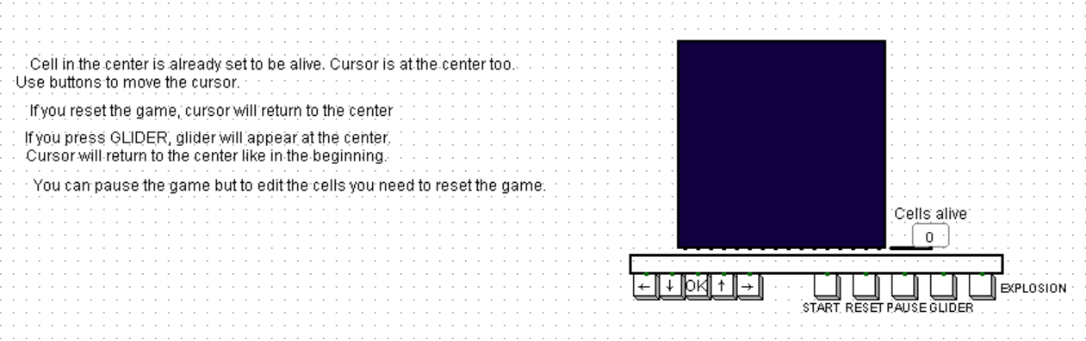

*Picture 2.2 – MAIN CIRCUIT*

***Main scheme*** in turn contains a display and the ***“BUTTONS”*** subcircuit (it is connected to 9 different buttons). Arrows – to move the cursor cell, ok – to change the state of the cell. Start button starts the game, reset returns us back to the only one cell on the plate – cursor, so it basically does delete all the other cells. Glider is a pattern button which places the glider in the middle of the grid, explosion works the same way – places an explosion on a grid. And the pause button, obviously, stops or continues the game.

***“BUTTONS”*** itself looks like this:

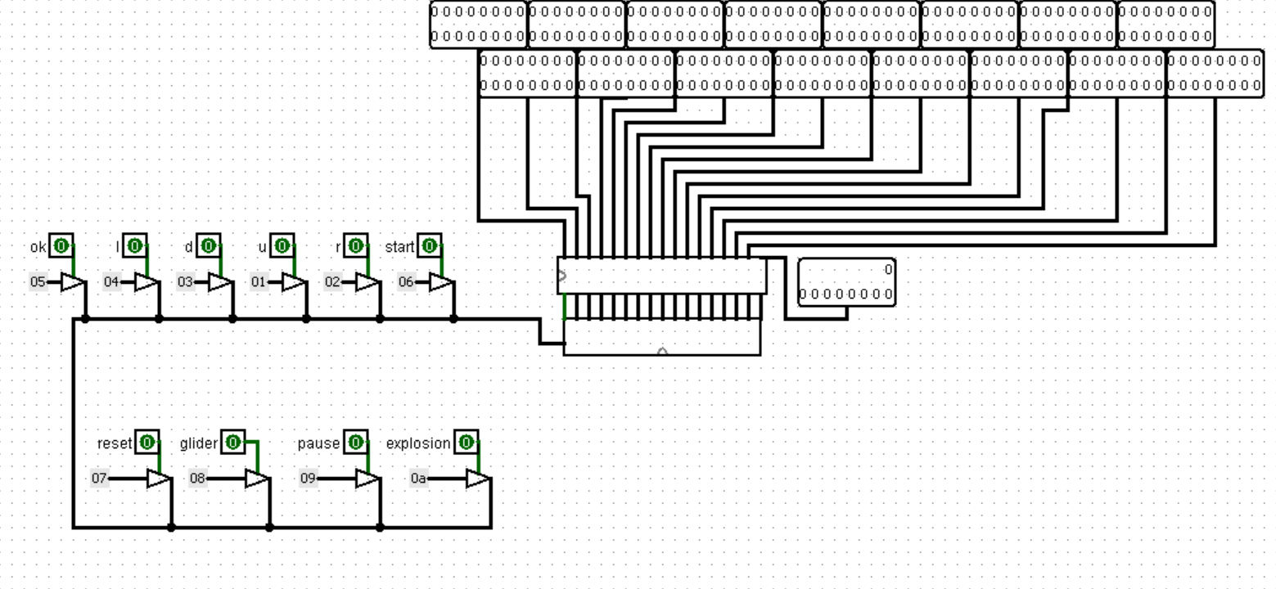

*Picture 2.3 – BUTTONS*

Each pin on the right side is connected to display – one pin is responsible for one row. Lower right one is for counting alive cells.

This scheme contains 2 more subcircuits – ***“Rows plate”*** and ***“Controller”.*** When the player presses some buttons – its code goes into ***“Controller”*** through the input tunnel (IOdat).

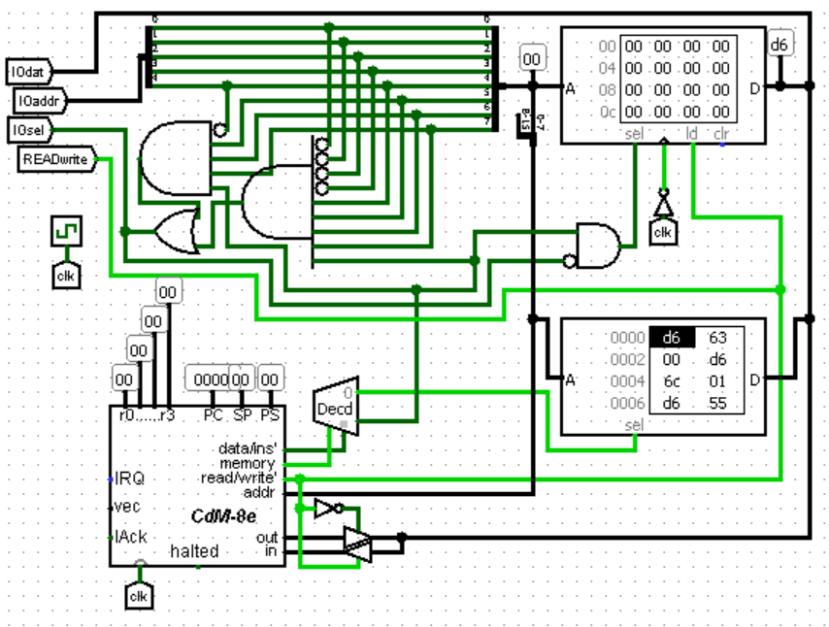

*Picture 2.4 – CONTROLLER*

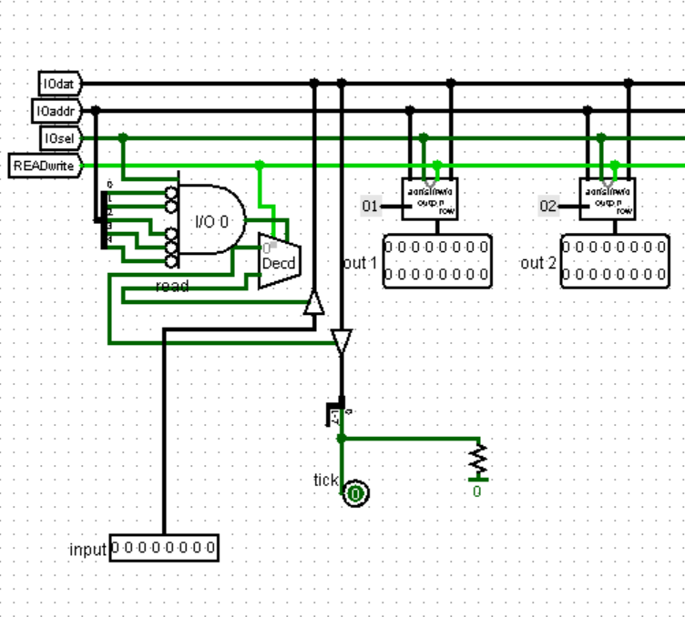

*Picture 2.5 – CONTROLLER*

By the end of one tick, we get 16 outputs (IO1 - IO16) which are forming our plate (1 output = 1 row). Each output is going from ***“OutputLogic”*** – that circuit will be considered in “SOFTWARE & HARDWARE”



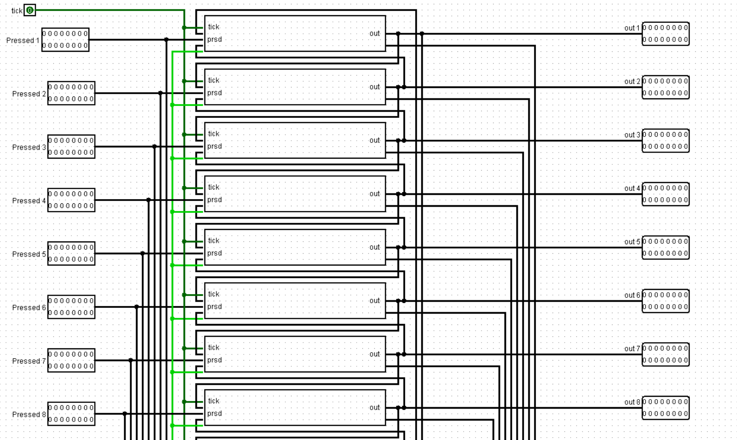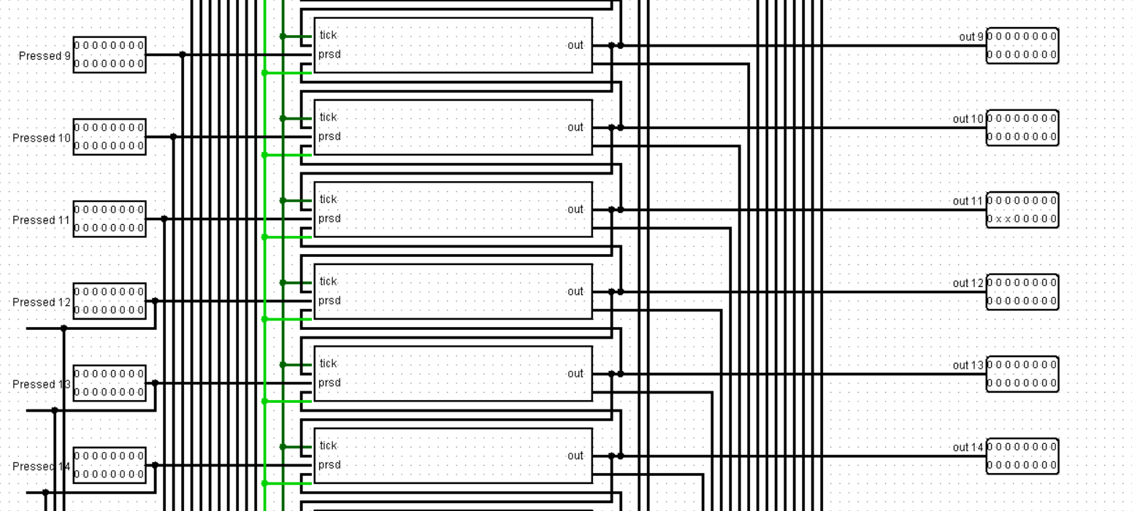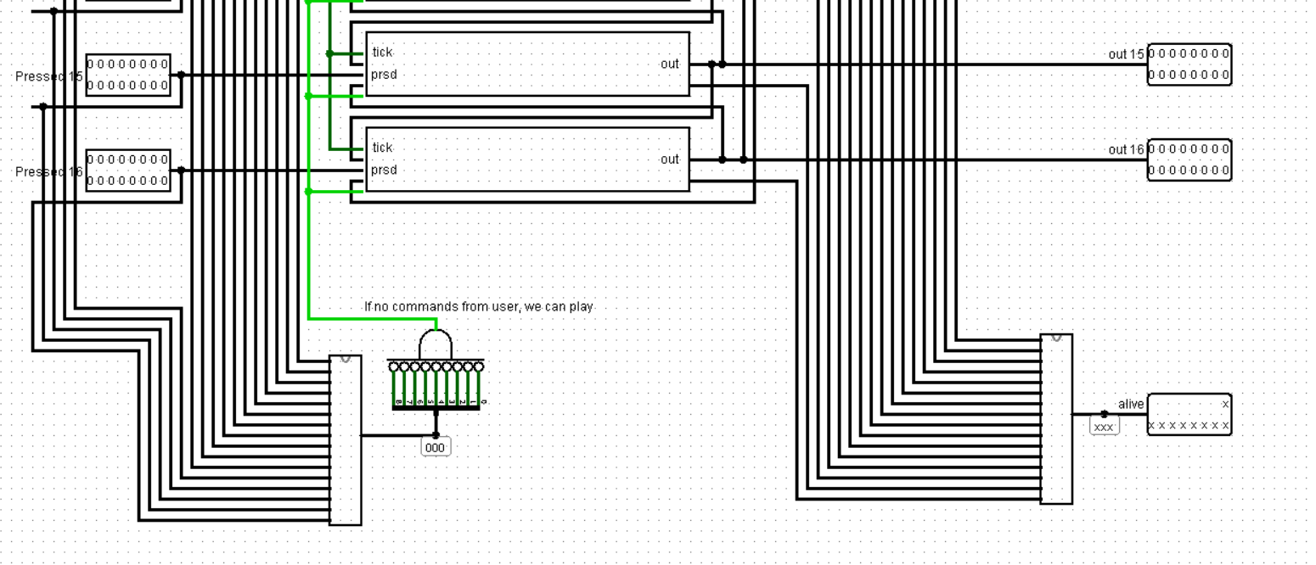

*Picture 2.6 – ROWS PLATE*

***“Rows plate”*** combines all the rows into the whole grid. It contains 16 ***“Row of cells”*** subcircuits.

***“Row of cell”*** itself is also made of 16 subcircuits called ***“Cell”***. This subcircuit is made of 11 contacts, 8 of which are showing the state of cell’ neighbors. There are also “can play”, “tick” and “pressed” contacts. “Can play” is for controlling placement of already placed cells – they should not change condition when we are putting another cell on a plate - it states 1 only when the user gives us no commands at all (all cells become not pressed when we press "start"). “Pressed” button is responsible for the condition of a cell in the sense of user’s intervention – did the player change the cell's condition or it changed due to the start of the game. “Tick” is tick, when it changes states 2 times, it means one iteration has happened.

In the bottom left we have a subcircuit calculating the number of pressed cells – and if that number is zero (so the user did not change the state of any cells), we set “can play” contact at 1 showing that player is glad with placing.   
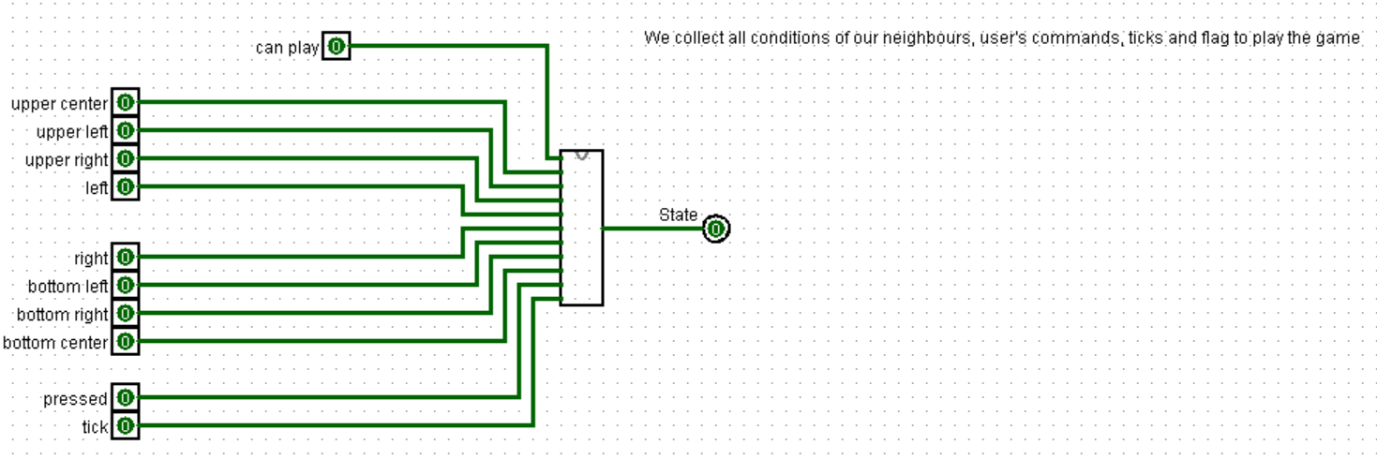

*Picture 2.7 – CELL*

All 11 contacts are connected to the ***“State manager”:***

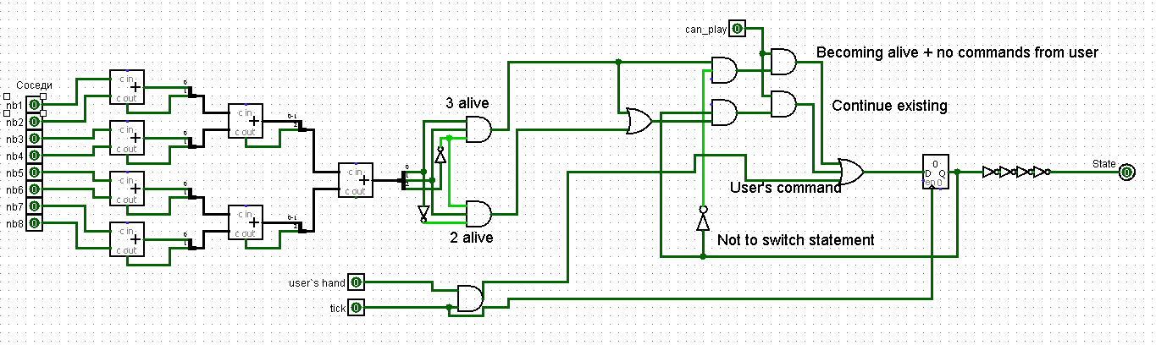

*Picture 2.8 – STATE MANAGER*

This circuit is calculating the state of the cell according to the rules. Using adders we get the final number of neighbors – if there are 3 or 2 alive cells around – the cell survives, otherwise – dies. If the cell was dead but now it has 3 neighbors – the cell becomes alive.

Turning now back to ***“Row of cells”*** :

We get 2 rows on input – the top row of neighbors and the bottom one. Each of them is sequentially connected to 16 ***“Cell”*** subcircuits.

Here’s a piece of ***“Row of cells”*** circuit, for instance

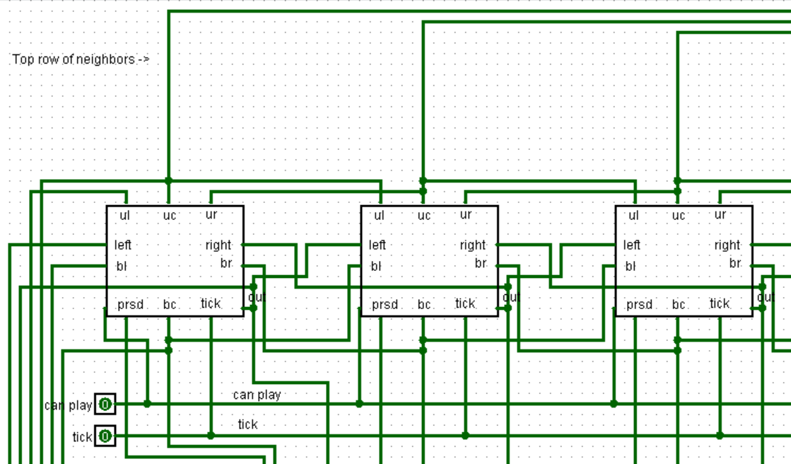

*Picture 2.9 – ROW OF CELLS*

The second cell is connected to its upper center neighbor, then its upper left neighbor (ul) connects to the first cell’s upper center, its upper right connects to the third one upper center, etc. So, it is clear that all cells which are neighbors to each other are connected. Because of that we connect each “Row of cells” subcircuit on the “Rows plate” scheme – any row has upper and down neighbors cells.

First row upper is the last row, last row down is, obviously, first row.

It also has a “Pressed” pin which is defining user’s impact on cells – each of its’ 16 wires are connected to cells “pressed” (prsd) contacts

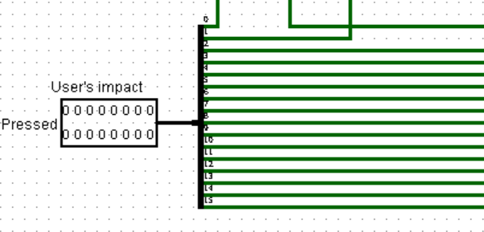

*Picture 2.10 – ROW OF CELLS*

At the end of the tick all cell outputs (their conditions) are going on display. “Alive_counter” pin also connects to it

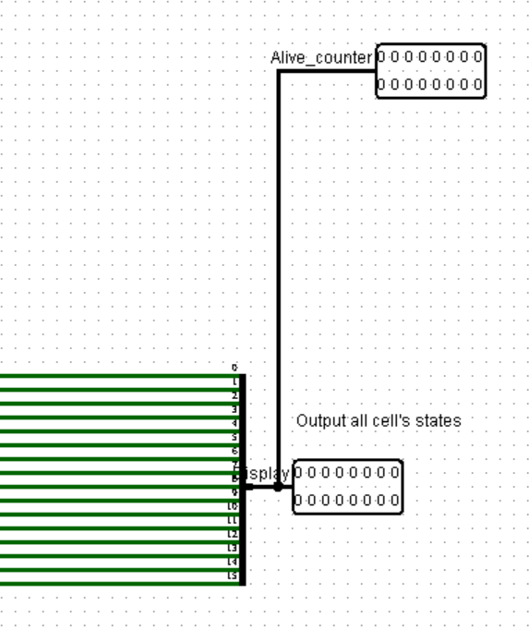

*Picture 2.11 – ROW OF CELLS*

Each alive_counter connects to ***“PressedCounter”*** on the ***“Rows plate”*** circuit. PressedCounter is made of 16 pins, each bit of whose is, going through splitter, added in ***“counter”***

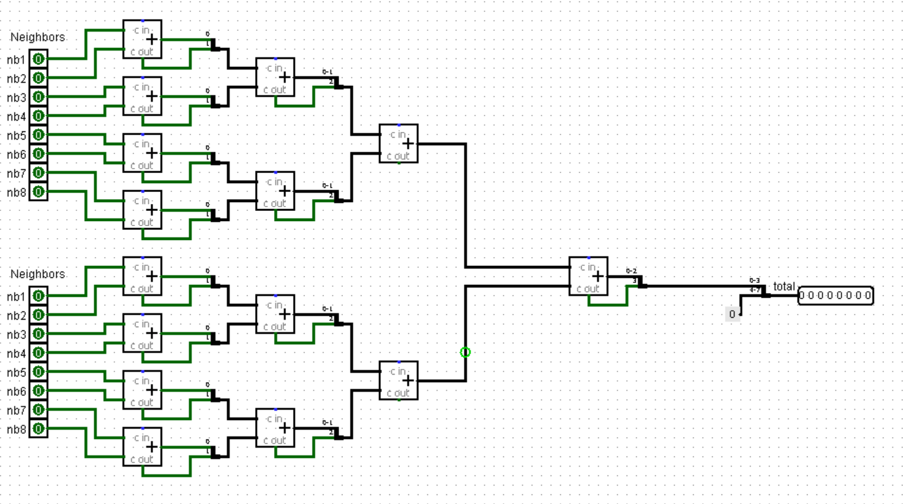

*Picture 2.12 – COUNTER*

Using adders we calculate the total number of alive cells. In ***“PressedCounter”*** we use 9 bits to determine this number – max number of alive cells is 256 (16x16), so 8 bits are not enough.

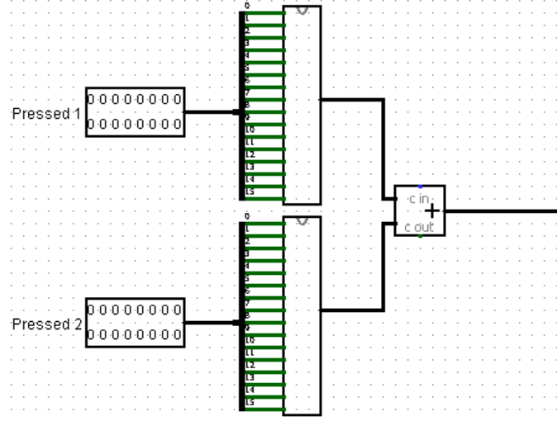

*Picture 2.13 – PRESSED_COUNTER*

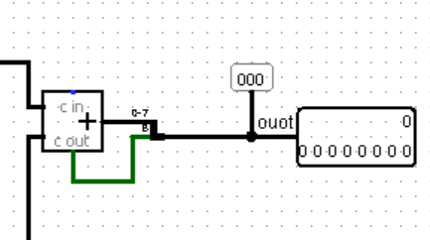

*Picture 2.14 – PRESSED_COUNTER*

# **4 SOFTWARE**

We have an assembly Controller Program which is basically responsible for all user`s commands. It consists the following subroutines:

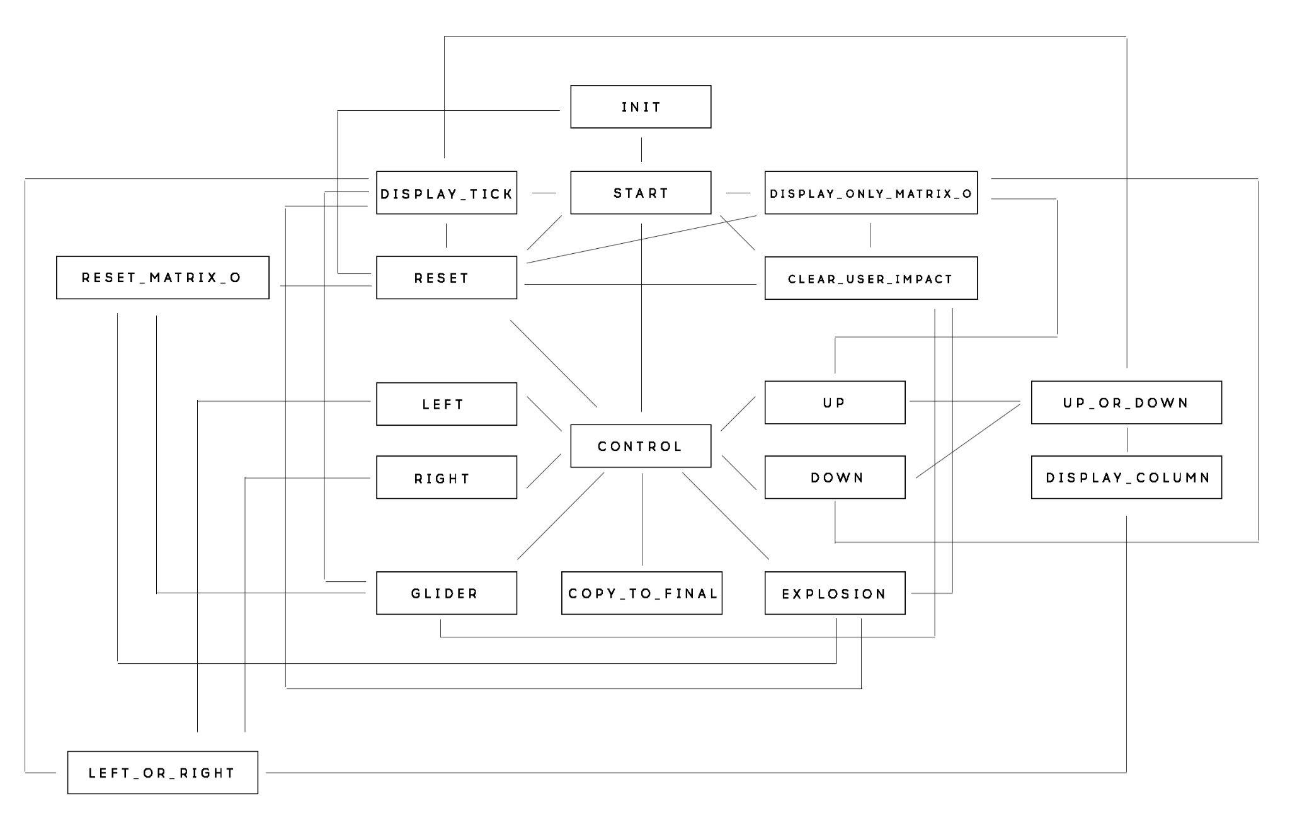

*Picture 3.1 – SOFTWARE STRUCTURE*

* start (actually is main and is never called)
* init
* reset
* clear_user_impact
* reset_matrix_o
* control
* copy_to_final
* display_only_matrix_o
* display_column
* right
* left
* left_or_right
* up
* down
* up_or_down
* display_tick
* glider
* explosion

How they all interact is shown on a block diagram above.

Firstly, we give symbolic names for different addresses:

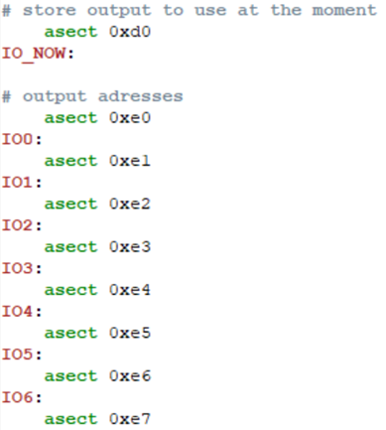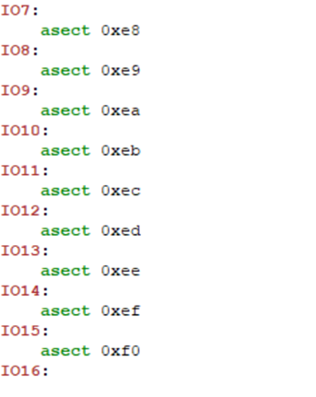

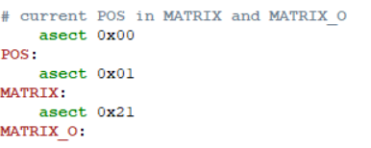

*Picture 3.2 – OUTPUT TO USE*

This is how all the labels are distributed in memory:

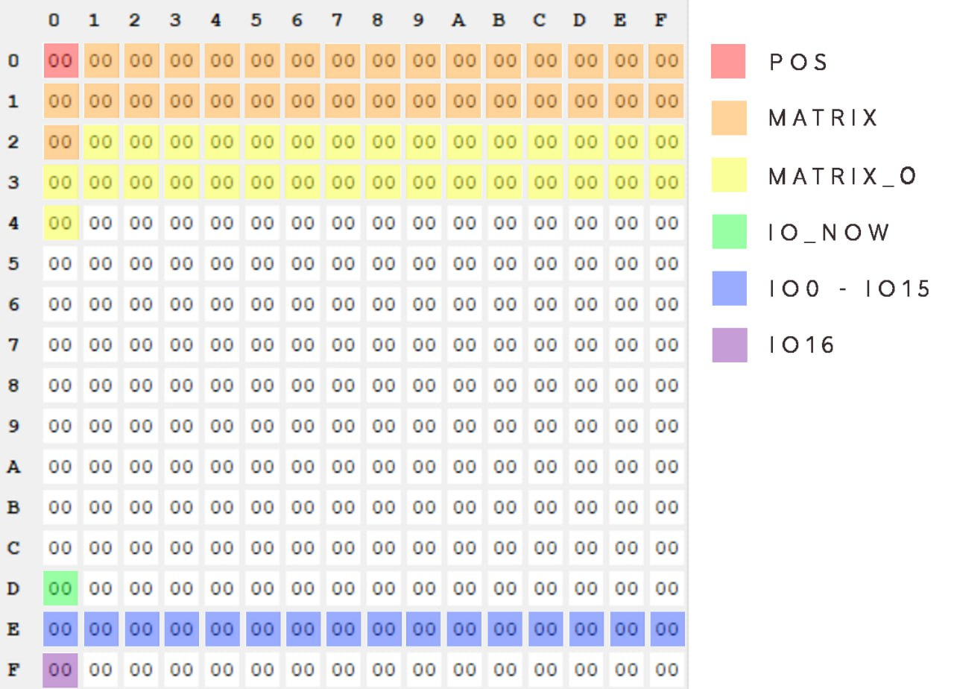

*Picture 3.3 – MEMORY ALLOCATION*

MATRIX and MATRIX_O are arrays of 32 halves of columns (the whole column is 16 cells, 16 bits, but we only can handle 8 bits in one register, so we split 16 bits into 8 and 8 bits and store these halves).

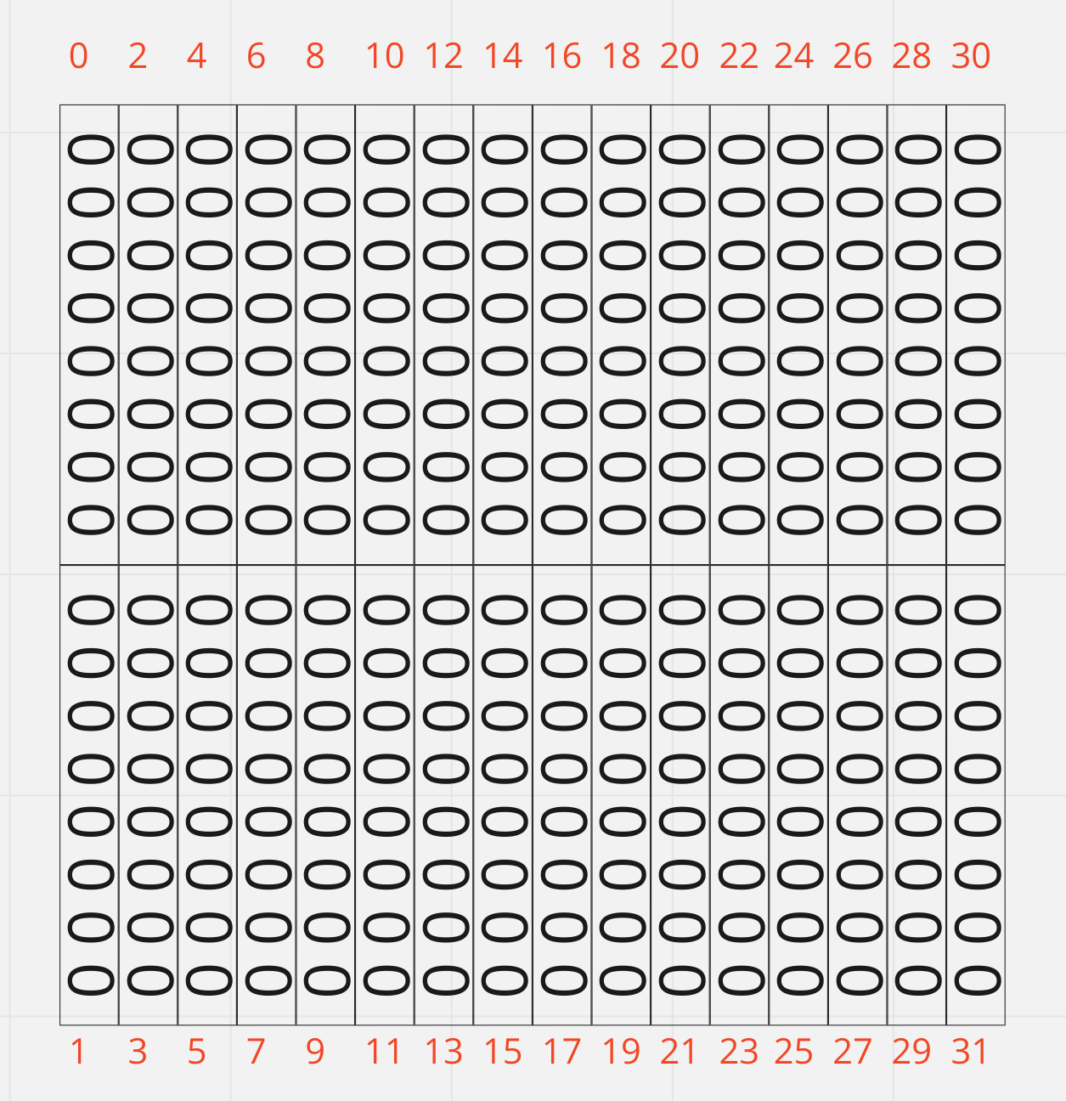

*Picture 3.4 – MATRIСES VISUALIZATION*

We use MATRIX only to determine the position of the cursor and to change its position by shifts in a row (shla and shr) or by copying the whole byte (half of full column, 8 cells) to another position in MATRIX. MATRIX_O is used for output – it contains cells that will go on display.

Then, after starting point – asect 0, we start our program:

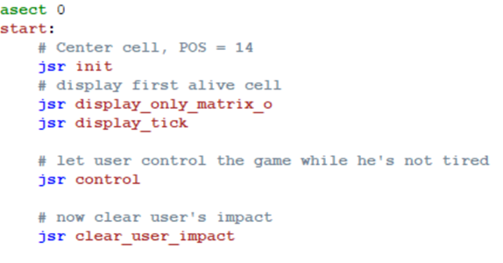

*Picture 3.5 – START OF THE PROGRAMM*

There’re a few subroutines from the list above – **init** (initialisation), **display_only_matrix_o**, **display_tick**, **control** and **clear_user_impact**.

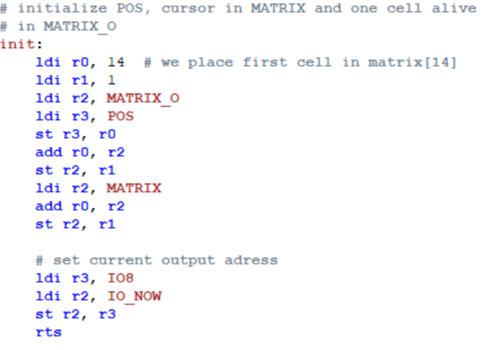

*Picture 3.6 – INIT*

We place the cell in the 14th half of column (first half of 8 column)– almost in the middle of MATRIX. Now we have 1 cell alive. Also, we set IO_NOW to IO8, where the cursor is, to display movements of the cursor faster.

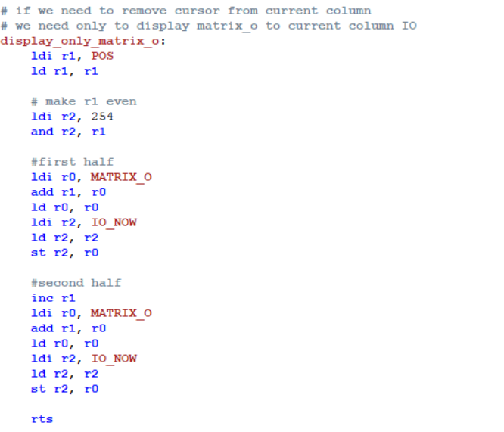

*Picture 3.7 – DISPLAY_ONLY_MATRIX_O*

***Display_only_matrix_o*** subroutine helps us save the row (column in our case - they are rotated) cells while removing the cursor.

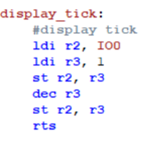

*Picture 3.8 – DISPLAY_TICK*

The subroutine above is just sequentially putting 1 and 0 in the IO0 address - so 1 tick is done and we update the screen.

Control subroutine processes the button code and according to that code starts other subroutines.

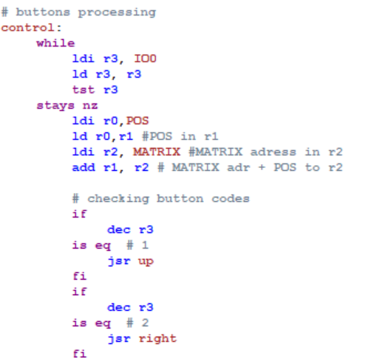

*Picture 3.9 – CONTROL*

Other calls are the same - we decrease the value by 1 and compare it to 0, if it is equal - we call the relevant subroutine. Only if code is 6 we do nothing but quitting the subroutine using rts.

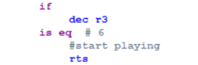

*Picture 3.10 – GAME START*

For called by control subroutines we’ll be using another one:

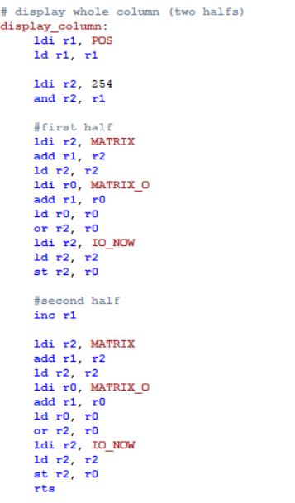

*Picture 3.11 – DISPLAY_COLUMN*

The subroutine above just refreshes a single row (2 halves of it) considering the cursor position.

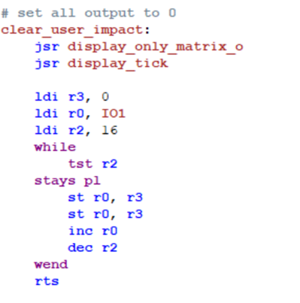

*Picture 3.12 – CLEAR_USER_IMPACT*

Here we’re showing the display state using the first subroutine. Then we clear all the rows – set them to 0.

Again, basically our rows are columns due to their connection, so we renamed our buttons - right is actually up, up - left, down - right and left - down. It is shown on Picture 3.4.

We just changed pin labels in BUTTONS to make control understandable.

Subroutine below - “right” - move cursor one position right using bitwise shift considering possible overflow - then we should move to another byte in MATRIX, so we call a subprogram that will be explained later.

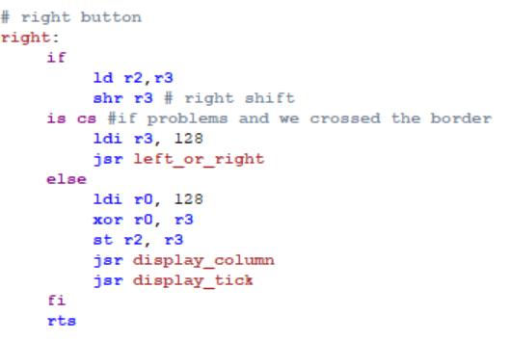

*Picture 3.13 – RIGHT*

With “left” button we do almost the same thing and if we cross the border between halves, we call the same subprogram - left_or_right:

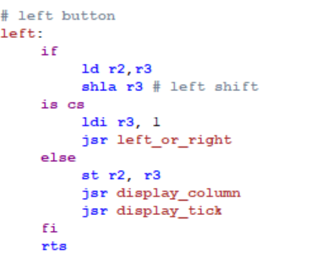

*Picture 3.14 – LEFT*

The difference between left and right is in the shift we use: shla and shr, and the value we put in r3: 128 and 1. If we have moved right and the overflow happened - which means we should go to another byte - we place 128 in r3. That’s because in the second byte that 1 will be in the 7th bit. With the left case and 1 there’s the same thing - we need to move to the next byte - in that byte our 1 will be in the 0 bit.

Also, in the “right” subroutine we xor r0 and our shifted r3. That was made to avoid possible issues with the 7th bit (sometimes it has a value of 1, sometimes of 0).

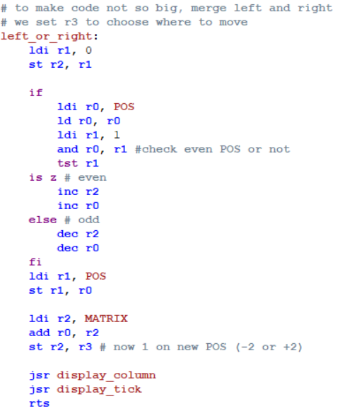

*Picture 3.15 – LEFT_OR_RIGHT*

In left and right subroutines we store a value into r3, which helps us determine what overflow happened - where we should move. At first we check even POS or odd to understand should we increase or decrease POS (at what half of the column we’ll move). Then we store in the MATRIX value of r3 - in the certain column determined by POS. Earlier, in “left” or “right” subroutines, r3 was loaded.

Here’s the “up” subroutine:

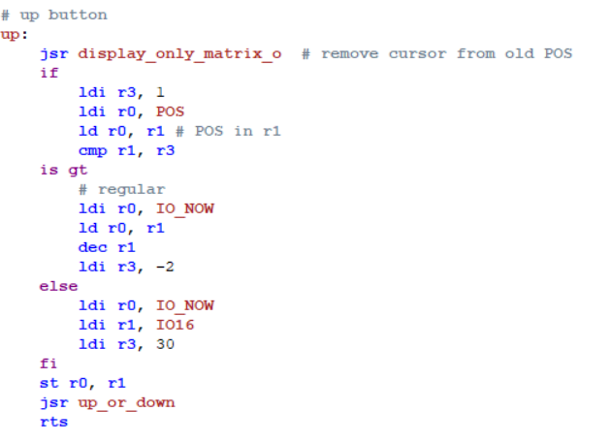

*Picture 3.16 – UP*

Firstly, we need to remove the cursor to another column saving all its cells. For that we use display_only_matrix_o. Then we compare POS with 1 and if it is greater - so we need to move in the left column (in our case) - we put (-2) into r3. That means we should “go up” in 2 bytes. And if it’s not greater than 1 - that means it’s the first column (0 and 1 bytes) - due to the fact we make a toroidal grid - we should go to the 16th column (bytes 30 and 31). That’s why in the second case we store 30 in r3 (we need to go up 30 bytes).

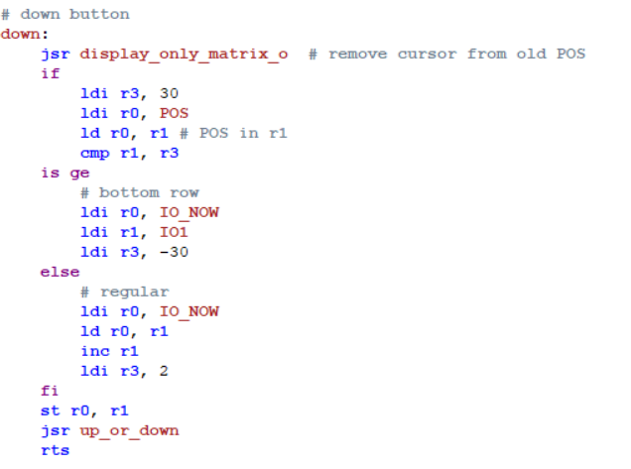

*Picture 3.17 – DOWN*

Down button does the opposite thing - if POS is the 16th column and we want to go down (in the right column) we’re supposed to be in the 1th column (bytes 0 and 1) - so we put (-30) in r3 . And in all other ways we just go down for a single column i.e. for 2 bytes.

In the end of up of down subroutines we call up_or_down:

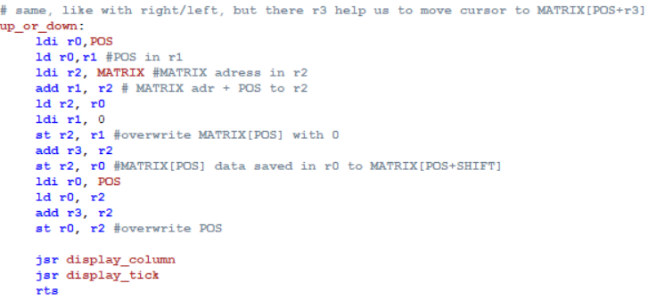

*Picture 3.18 – UP_OR_ DOWN*

Here we just shift MATRIX[POS] by adding the value in r3 (it was loaded in “up” or in “down”). Then overwrite MATRIX[POS] - because the cursor has moved. And lastly remember the final byte that POS points on.

When user is done with placing cells, the life itself starts:

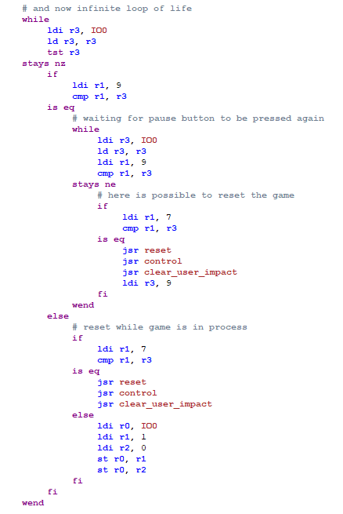

*Picture 3.19 – MAIN*

Code 9 is responsible for pause, so we stop the game until the user presses that button again. Then we check if the buttons’ code is 7 – it’s responsible for reset. In other cases, we put 1 and 0 in the IO0 address to refresh the display.

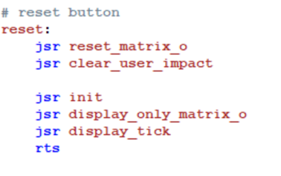

*Picture 3.20 – RESET*

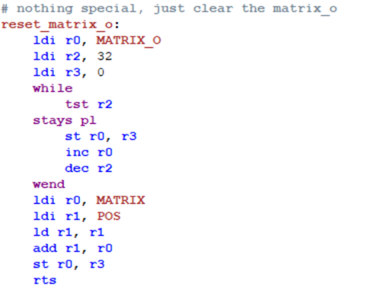

*Picture 3.21 – RESET_MATRIX_O*

Reset clears MATRIX_O, then all the rows. After it calls an initialization and places the cursor on the display (last 2 subroutines).

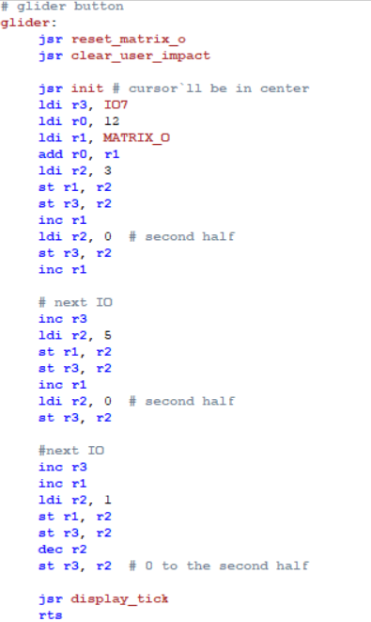

*Picture 3.22 – GLIDER*

That is just a hard-coded pattern of a glider - we put certain cells on a plate to make a diagonally moving game figure.

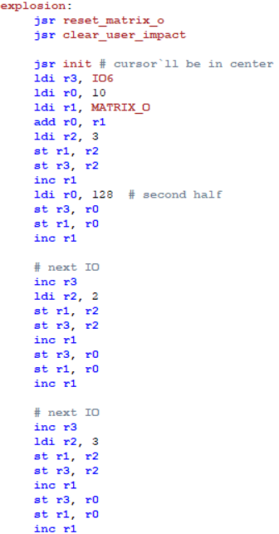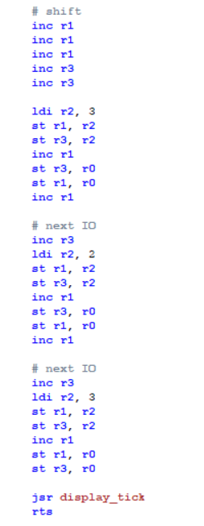

*Picture 3.23 – EXPLOSION*

This subroutine has a similar function - placing the pattern on the display. Now - the explosion pattern.

There’s the last of listed subroutines:

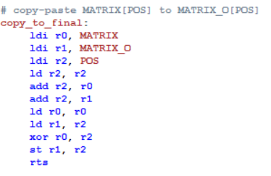

*Picture 3.24 – COPY_TO_FINAL*

All it does is copy the cursor from MATRIX to MATRIX_O. In the BUTTONS circuit it's the “OK” button (code 5). That’s how we save our placed cells.

# **5 SOFTWARE & HARDWARE**

**OutputLogic**

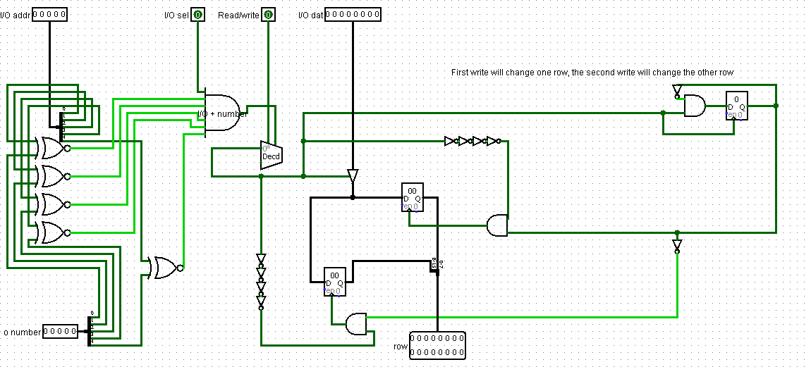

*Picture 4.1 – RESET_MATRIX_O*

This subcircuit forms a 16 bit row with two 8 bit outputs to the same IO that is possible because of the third register (let’s call it flag-register because it sets to 1 when we got the first half and to 0 when we got the 2nd half) . First storage command to this IO places content to the first 8 bit of output pin from OutputLogic and changes flag-register to 1. The next storage command places content to the second half because flag-register is 1 and then sets flag-register to 0. After two storage commands we have a full 16 bit row to display and flag-register set to 0.

**Controller**

In the picture 1.3 - “Controller” we have 2 AND gates connected to one OR (upper-left corner), which are used for bit masking. Left one is for masking all the 0xe* addresses (0xe0, 0xe1 and etc.). Right one - only for one address - 0xf0 - in which IO16 is placed.

# **6 USER MANUAL**

To run the game follow this steps:

1. Install Logisim.
2. Download and extract archive with our project.
3. Open TheLife.circ file in Logisim.
4. Enable the simulation. (Top bar -> Simulate -> Simulation Enabled (Ctrl+E)).
5. Enable ticks (Top bar -> Simulate -> Ticks Enabled (Ctrl+K)).
6. Enjoy!

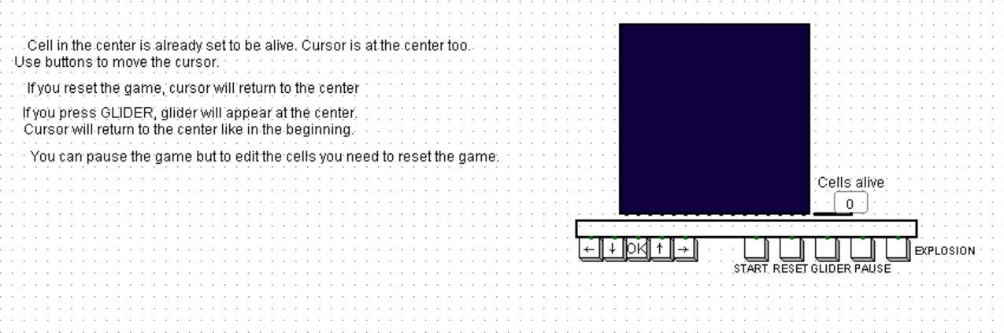

*Picture 5.1 – START SCREEN*

At the beginning of simulation, the cursor cell is going to appear:

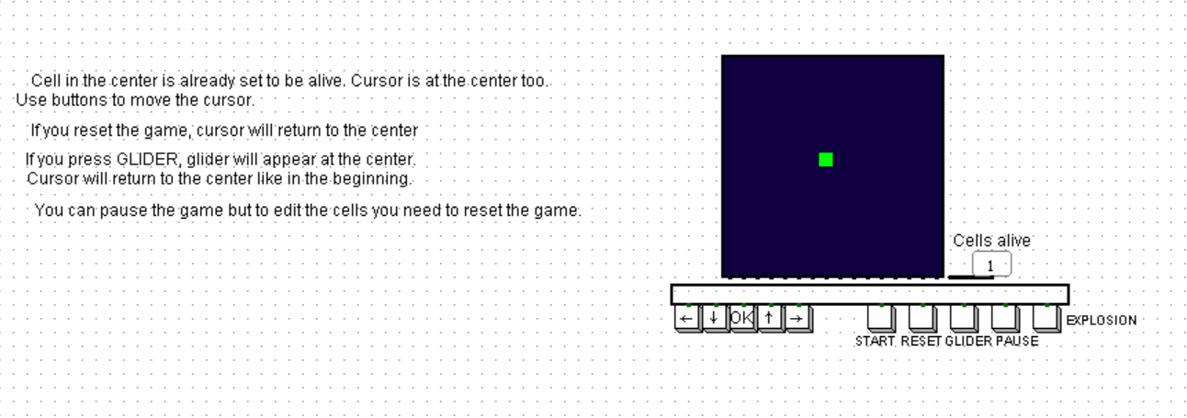

*Picture 5.2 – SIMULATION BEGINS*

Using arrows, the player can move it wherever he wants. To fix the position of a new cell or to change the condition of an already placed one – he presses the OK button. “START” button surprisingly starts the game. “RESET” was made for convenience – not to disable simulation every time. “PAUSE” stops or continues the game. “GLIDER” button places pattern of glider to the middle of grid, “EXPLOSION” places the explosion pattern.

# **CONCLUSION**

We have created a functional circuit and Assembly program that are connected and faithfully simulate the behavior of the game with additional features that distinguish our program from the classic version of the game.

Circuit includes 10 subcircuits in total. Program for CdM-8e is written in Assembly and has 572 lines.

# **APPENDIX 1**

# store output to use at the moment

asect 0xd0

IO_NOW:

# output adresses

asect 0xe0

IO0:

asect 0xe1

IO1:

asect 0xe2

IO2:

asect 0xe3

IO3:

asect 0xe4

IO4:

asect 0xe5

IO5:

asect 0xe6

IO6:

asect 0xe7

IO7:

asect 0xe8

IO8:

asect 0xe9

IO9:

asect 0xea

IO10:

asect 0xeb

IO11:

asect 0xec

IO12:

asect 0xed

IO13:

asect 0xee

IO14:

asect 0xef

IO15:

asect 0xf0

IO16:

# current POS in MATRIX and MATRIX_O

asect 0x00

POS:

asect 0x01

MATRIX:

asect 0x21

MATRIX_O:

#####################################################################

### main code

asect 0

start:

# Center cell, POS = 14

jsr init

# display first alive cell

jsr display_only_matrix_o

jsr display_tick

# let user control the game while he's not tired

jsr control

# now clear user's impact

jsr clear_user_impact

# and now infinite loop of life

while

ldi r3, IO0

ld r3, r3

tst r3

stays nz

if

ldi r1, 9

cmp r1, r3

is eq

# waiting for pause button to be pressed again

while

ldi r3, IO0

ld r3, r3

ldi r1, 9

cmp r1, r3

stays ne

# here is possible to reset the game

if

ldi r1, 7

cmp r1, r3

is eq

jsr reset

jsr control

jsr clear_user_impact

ldi r3, 9

fi

wend

else

# reset while game is in process

if

ldi r1, 7

cmp r1, r3

is eq

jsr reset

jsr control

jsr clear_user_impact

else

ldi r0, IO0

ldi r1, 1

ldi r2, 0

st r0, r1

st r0, r2

fi

fi

wend

# set all output to 0

clear_user_impact:

jsr display_only_matrix_o

ldi r3, 0

ldi r0, IO1

ldi r2, 16

while

tst r2

stays pl

st r0, r3

st r0, r3

inc r0

dec r2

wend

rts

# initialize POS, cursor in MATRIX and one cell alive in MATRIX_O

init:

ldi r0, 14 # we place first cell in matrix[14]

ldi r1, 1

ldi r2, MATRIX_O

ldi r3, POS

st r3, r0

add r0, r2

st r2, r1

ldi r2, MATRIX

add r0, r2

st r2, r1

# set current output adress

ldi r3, IO8

ldi r2, IO_NOW

st r2, r3

rts

# buttons processing

control:

while

ldi r3, IO0

ld r3, r3

tst r3

stays nz

ldi r0,POS

ld r0,r1 #POS in r1

ldi r2, MATRIX #MATRIX adress in r2

add r1, r2 # MATRIX adr + POS to r2

# checking button codes

if

dec r3

is eq # 1

jsr up

fi

if

dec r3

is eq # 2

jsr right

fi

if

dec r3

is eq # 3

jsr down

fi

if

dec r3

is eq # 4

jsr left

fi

if

dec r3

is eq # 5

jsr copy_to_final

fi

if

dec r3

is eq # 6

#start playing

rts

fi

if

dec r3

is eq # 7

jsr reset

fi

if

dec r3

is eq # 8

jsr glider

fi

if

dec r3

dec r3

is eq # 10

jsr explosion

fi

wend

rts

# nothing special, just clear the matrix_o

reset_matrix_o:

ldi r0, MATRIX_O

ldi r2, 32

ldi r3, 0

while

tst r2

stays pl

st r0, r3

inc r0

dec r2

wend

ldi r0, MATRIX

ldi r1, POS

ld r1, r1

add r1, r0

st r0, r3

rts

# reset button

reset:

jsr reset_matrix_o

jsr clear_user_impact

jsr init

jsr display_only_matrix_o

jsr display_tick

rts

# glider button

glider:

jsr reset_matrix_o

jsr clear_user_impact

jsr init # cursor`ll be in center

ldi r3, IO7

ldi r0, 12

ldi r1, MATRIX_O

add r0, r1

ldi r2, 3

st r1, r2

st r3, r2

inc r1

ldi r2, 0 # second half

st r3, r2

inc r1

# next IO

inc r3

ldi r2, 5

st r1, r2

st r3, r2

inc r1

ldi r2, 0 # second half

st r3, r2

#next IO

inc r3

inc r1

ldi r2, 1

st r1, r2

st r3, r2

dec r2

st r3, r2 # 0 to the second half

jsr display_tick

rts

# make pattern of explosion

explosion:

jsr reset_matrix_o

jsr clear_user_impact

jsr init # cursor`ll be in center

ldi r3, IO6

ldi r0, 10

ldi r1, MATRIX_O

add r0, r1

ldi r2, 3

st r1, r2

st r3, r2

inc r1

ldi r0, 128 # second half

st r3, r0

st r1, r0

inc r1

# next IO

inc r3

ldi r2, 2

st r1, r2

st r3, r2

inc r1

st r3, r0

st r1, r0

inc r1

# next IO

inc r3

ldi r2, 3

st r1, r2

st r3, r2

inc r1

st r3, r0

st r1, r0

inc r1

# shift

inc r1

inc r1

inc r1

inc r3

inc r3

ldi r2, 3

st r1, r2

st r3, r2

inc r1

st r3, r0

st r1, r0

inc r1

# next IO

inc r3

ldi r2, 2

st r1, r2

st r3, r2

inc r1

st r3, r0

st r1, r0

inc r1

# next IO

inc r3

ldi r2, 3

st r1, r2

st r3, r2

inc r1

st r1, r0

st r3, r0

jsr display_tick

rts

# copy-paste MATRIX[POS] to MATRIX_O[POS]

copy_to_final:

ldi r0, MATRIX

ldi r1, MATRIX_O

ldi r2, POS

ld r2, r2

add r2, r0

add r2, r1

ld r0, r0

ld r1, r2

xor r0, r2

st r1, r2

rts

# if we need to remove cursor from current column

# we need only to display matrix_o to current column IO

display_only_matrix_o:

ldi r1, POS

ld r1, r1

# make r1 even

ldi r2, 254

and r2, r1

#first half

ldi r0, MATRIX_O

add r1, r0

ld r0, r0

ldi r2, IO_NOW

ld r2, r2

st r2, r0

#second half

inc r1

ldi r0, MATRIX_O

add r1, r0

ld r0, r0

ldi r2, IO_NOW

ld r2, r2

st r2, r0

rts

# display whole column (two halfs)

display_column:

ldi r1, POS

ld r1, r1

ldi r2, 254

and r2, r1

#first half

ldi r2, MATRIX

add r1, r2

ld r2, r2

ldi r0, MATRIX_O

add r1, r0

ld r0, r0

or r2, r0

ldi r2, IO_NOW

ld r2, r2

st r2, r0

#second half

inc r1

ldi r2, MATRIX

add r1, r2

ld r2, r2

ldi r0, MATRIX_O

add r1, r0

ld r0, r0

or r2, r0

ldi r2, IO_NOW

ld r2, r2

st r2, r0

rts

# right button

right:

if

ld r2,r3

shr r3 # right shift

is cs #if problems and we crossed the border

ldi r3, 128

jsr left_or_right

else

ldi r0, 128

xor r0, r3

st r2, r3

jsr display_column

jsr display_tick

fi

rts

# left button

left:

if

ld r2,r3

shla r3 # left shift

is cs

ldi r3, 1

jsr left_or_right

else

st r2, r3

jsr display_column

jsr display_tick

fi

rts

# to make code not so big, merge left and right

# we set r3 to choose where to move

left_or_right:

ldi r1, 0

st r2, r1

if

ldi r0, POS

ld r0, r0

ldi r1, 1

and r0, r1 #check even POS or not

tst r1

is z # even

inc r2

inc r0

else # odd

dec r2

dec r0

fi

ldi r1, POS

st r1, r0

ldi r2, MATRIX

add r0, r2

st r2, r3 # now 1 on new POS (-2 or +2)

jsr display_column

jsr display_tick

rts

# up button

up:

jsr display_only_matrix_o # remove cursor from old POS

if

ldi r3, 1

ldi r0, POS

ld r0, r1 # POS in r1

cmp r1, r3

is gt

# regular

ldi r0, IO_NOW

ld r0, r1

dec r1

ldi r3, -2

else

ldi r0, IO_NOW

ldi r1, IO16

ldi r3, 30

fi

st r0, r1

jsr up_or_down

rts

# down button

down:

jsr display_only_matrix_o # remove cursor from old POS

if

ldi r3, 30

ldi r0, POS

ld r0, r1 # POS in r1

cmp r1, r3

is ge

# bottom row

ldi r0, IO_NOW

ldi r1, IO1

ldi r3, -30

else

# regular

ldi r0, IO_NOW

ld r0, r1

inc r1

ldi r3, 2

fi

st r0, r1

jsr up_or_down

rts

# same, like with right/left, but there r3 help us to move cursor to MATRIX[POS+r3]

up_or_down:

ldi r0,POS

ld r0,r1 #POS in r1

ldi r2, MATRIX #MATRIX adress in r2

add r1, r2 # MATRIX adr + POS to r2

ld r2, r0

ldi r1, 0

st r2, r1 #overwrite MATRIX[POS] with 0

add r3, r2

st r2, r0 #MATRIX[POS] data saved in r0 to MATRIX[POS+SHIFT]

ldi r0, POS

ld r0, r2

add r3, r2

st r0, r2 #overwrite POS

jsr display_column

jsr display_tick

rts

display_tick:

#display tick

ldi r2, IO0

ldi r3, 1

st r2, r3

dec r3

st r2, r3

rts

end