**UNIVERSITY OF ECONOMICS AND HUMAN SCIENCES**

**BRANCH OF STUDY: COMPUTER SCIENCE**



**REPORT FOR DATABASE PROJECT**

Student: Maksim Kez

Database L10   
full-time course

Index number: 54163

Warsaw, 2024

**INDEX**

Description 3

Scripts used 4

Conclusion 8

# **Description**

My project shows one possible database organization for a store. Picture 1.1 shows visual representation of the database, made with DBML.

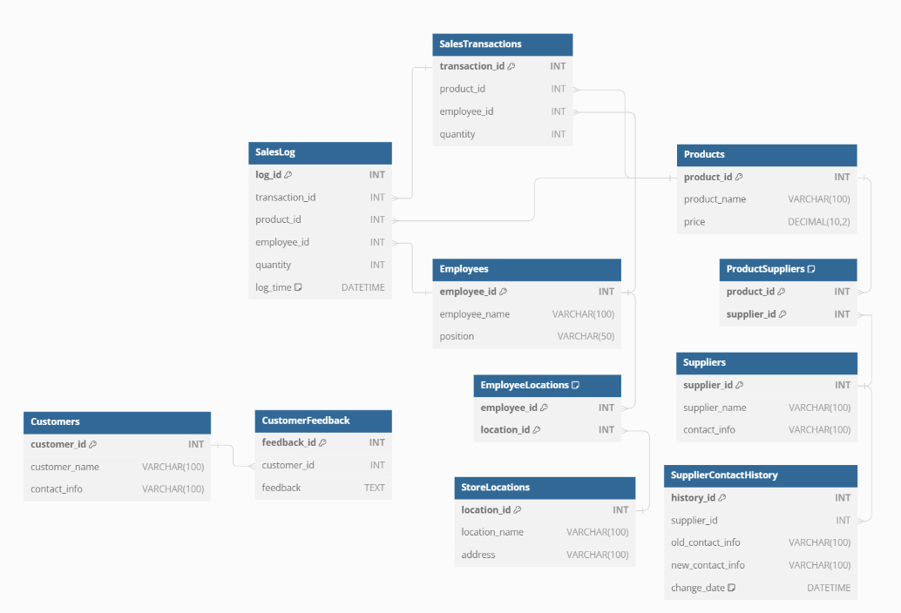

Picture 1.1 *–* Visual representation of the database

Description of tables and their relationships:

1. **SalesLog**: Linked to tables SalesTransactions, Products, and Employees via foreign keys transaction_id, product_id, and employee_id respectively.
2. **SupplierContactHistory**: Linked to the Suppliers table via foreign key supplier_id.
3. **SalesTransactions**: Linked to tables Products and Employees via foreign keys product_id and employee_id respectively.
4. **ProductSuppliers**: Linked to tables Products and Suppliers via foreign keys product_id and supplier_id respectively.
5. **EmployeeLocations**: Linked to tables Employees and StoreLocations via foreign keys employee_id and location_id respectively.
6. **CustomerFeedback**: Linked to the Customers table via foreign key customer_id.

# 

# **Scripts used**

All scripts used in the process of project execution in the file “scriptsProject.sql”. All scripts in the file are arranged in the order of their application.

Stored procedures:

1. sp_spaceused

Displays the number of rows, disk space reserved, and disk space used by a table, indexed view, or Service Broker queue in the current database. The result of the procedure is shown in picture 2.1.

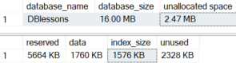

Picture 2.1

2) sp_help

Provides information about a database object, a user-defined data type, or a data type.

(not all information is provided on the screenshot because there is too much of it). The result of the procedure is shown in picture 2.2.

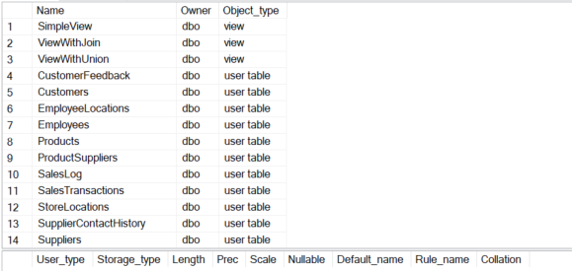

Picture 2.2

1. sp_helptext (on GetProductsAbovePrice)

Displays the definition (source code) of a user-defined object like a stored procedure, function, or view. The result of the procedure is shown in picture 2.3.

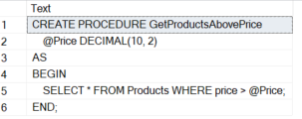

Picture 2.3

1. sp_configure

Displays (displays on the screenshop) or changes global configuration settings. The result of the procedure is shown in picture 2.4.

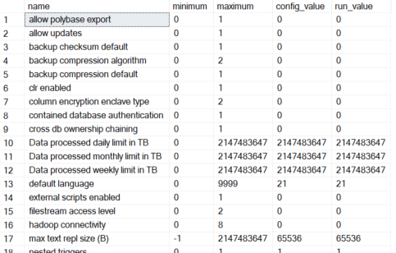

Picture 2.4

1. sp_helpindex (on Products)

Displays information about indexes on a table. The result of the procedure is shown in picture 2.5.



Picture 2.5

1. sp_depends (on Products)

Displays object dependency information. The result of the procedure is shown in picture 2.6.

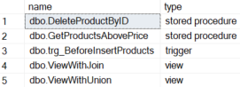

Picture 2.6

1. sp_who

Returns information about current users and processes. The result of the procedure is shown in picture 2.7.

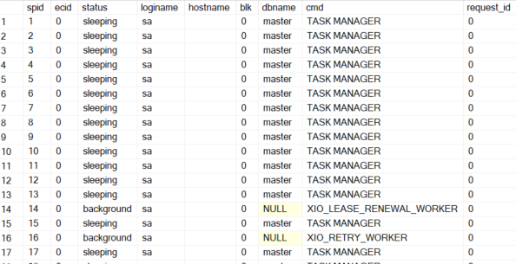

Picture 2.7

1. sp_lock

Returns information about currently active locks. The result of the procedure is shown in picture 2.8.

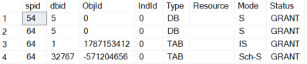

Picture 2.8

1. sp_server_info

Returns information about the SQL Server version and edition. The result of the procedure is shown in picture 2.9.

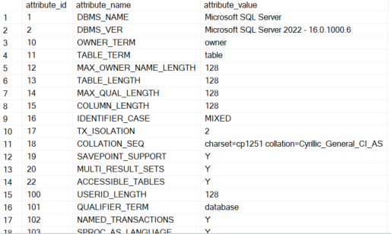

Picture 2.9

1. sp_tables

Lists all user-defined and system tables in the current database. The result of the procedure is shown in picture 2.10.

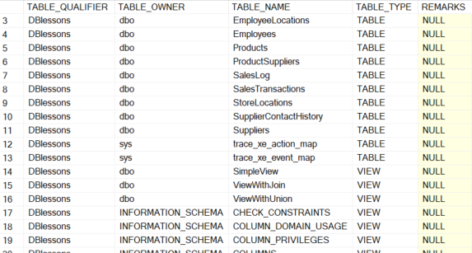

Picture 2.10

# **Conclusion**

There were no problems in the process of creating this project, as I already had a little experience with TSQL. However, the task to create automatic backups seemed difficult.

The project has many options for expansion: from adding new values to the table or adding new triggers for validation of data at the database layer to new tables. For example, table “Users” linked to “Customers” by key “customer_id”, with columns email, password, hashed by trigger, etc. to extend the “store” online.

In conclusion, making the project was interesting for me.