LABORATORY WORK 3 REPORT
Organization of the Development Process with Agile (Scrum)
for the project
ShopSphere — Online Store

Prepared by:
Maksym Ostrozhynskyi
Ivan Yevseiev
2026

Table of Contents
1. Introduction 3
1.1 Purpose of the Work 3
1.2 Input Documents 3
1.3 Results in Brief 3
2. Selected Tool and Board Setup 3
2.1 Choice of the Tool 3
2.2 Project and Board Configuration 4
3. Product Backlog 4
3.1 How the Backlog Was Formed 4
3.2 Backlog Structure by Epic 5
3.3 Backlog Structure by Priority 5
3.4 Coverage of Laboratory Works 1 and 2 5
4. Scrum Planning 6
4.1 Sprint Planning Meeting 6
4.2 Sprint 1 6
4.3 Definition of Done 7
4.4 Release Plan 7
5. Estimation 8
5.1 Scale and Method 8
5.2 Planning Poker 8
6. Assignment of Work 9
6.1 Distribution by Roles 9
6.2 Start of the Sprint 10
7. Conclusion 10
Appendix A. Full Product Backlog 12

1. Introduction

1.1 Purpose of the Work
The purpose of this laboratory work is to organize the development of ShopSphere according to the Agile methodology: to turn the requirements and the architecture designed in the previous laboratory works into a prioritized product backlog, to plan the first sprint, to estimate the work and to distribute it between the members of the team.

1.2 Input Documents
- Requirements Specification “ShopSphere — Online Store” (Laboratory Work 1) — 44 functional and 26 non-functional requirements with High, Medium and Low priorities, user roles and team roles (section 6).
- Software Architecture (Laboratory Work 2) — a modular monolith with ten business modules, the Web & Security Layer, a React single-page application and the AWS deployment; the architectural decisions became separate technical tasks.

1.3 Results in Brief
Item | Result
Tool | Jira Software Cloud, team-managed Scrum project “ShopSphere” (key SHOP)
Product backlog | 83 work items in 13 epics: 44 user stories (FR), 26 tasks (NFR), 13 architectural tasks
Total estimate | 321 story points
Sprint 1 | “Sprint 1 - Walking skeleton”, 05.10 – 16.10.2026, 11 items, 40 story points, active
Assignment | Maksym Ostrozhynskyi — 19 SP, Ivan Yevseiev — 21 SP in Sprint 1
Board | https://ostroginskiymaksim.atlassian.net/jira/software/projects/SHOP/boards/2

2. Selected Tool and Board Setup

2.1 Choice of the Tool
Three tools were considered: Jira Software, Trello and Asana. Jira Software Cloud was selected for the following reasons:
- Native Scrum support — product backlog, sprints with a goal and dates, a sprint board, story-point estimation and burndown and velocity reports are built in. In Trello, sprints and estimates require third-party Power-Ups.
- Hierarchy of work items — epics group the stories and tasks of one architectural module, so the backlog mirrors the module structure from Laboratory Work 2.
- Traceability — every work item has a description with acceptance criteria and a reference to the source requirement, labels (FR, NFR, architecture) and an epic, so the coverage of the specification can be checked with filters.
- Integration with GitHub — commits and pull requests that mention an issue key (e.g. SHOP-14) are shown in the issue, which supports the “CI and code review” requirement.
- Free plan for teams of up to 10 users, which is enough for the two-person team.

2.2 Project and Board Configuration
Setting | Value
Project | ShopSphere (key SHOP), team-managed software project, Scrum template
Board | SHOP board — backlog, active sprint board, reports
Link | https://ostroginskiymaksim.atlassian.net/jira/software/projects/SHOP/boards/2
Members | Maksym Ostrozhynskyi (project administrator, Team Lead), Ivan Yevseiev (member, QA Lead)
Work item types | Epic — architectural module; Story — functional requirement in user-story form; Task — non-functional requirement or architectural/technical work
Workflow | To Do → In Progress → Done (shown in the Russian interface of the site as «К выполнению», «В работе», «Готово»)
Priorities | Highest, High, Medium, Low
Estimation | Story points (field “Story point estimate”), Fibonacci scale 1, 2, 3, 5, 8, 13
Labels | FR — functional requirement; NFR — non-functional requirement; architecture — task derived from Laboratory Work 2
Sprint length | 2 weeks (10 working days)

Access for the teacher: the project is shared with the teacher by adding the teacher's account in Project settings → Access, or through the screenshots in this report.
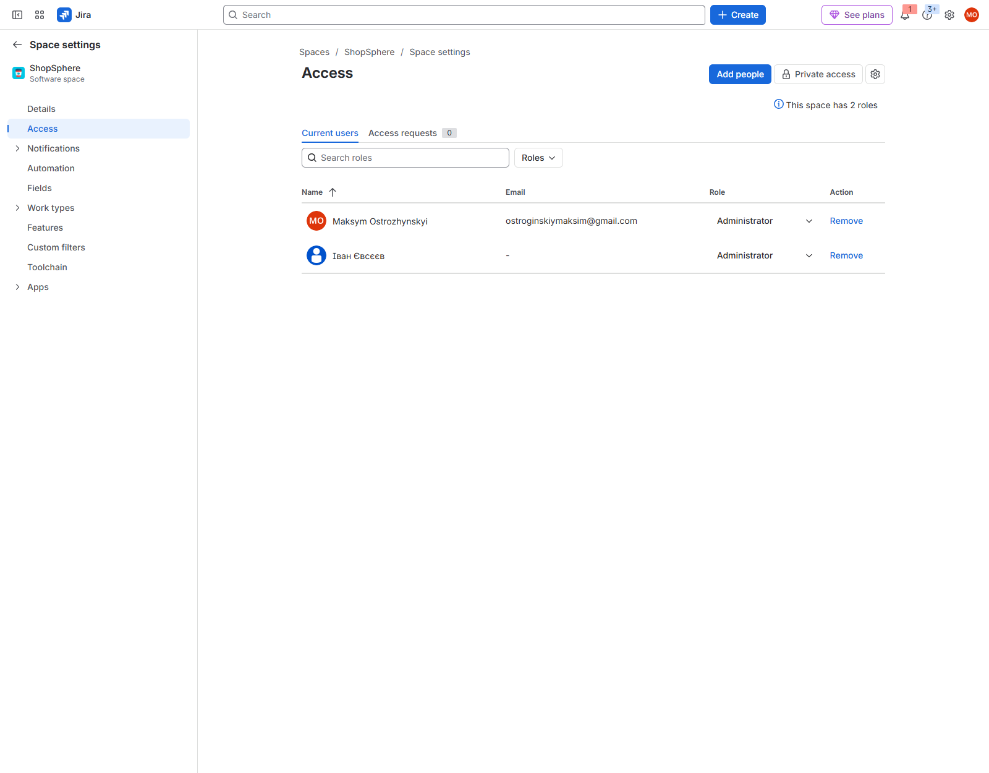
Figure 1 — Project members and board settings of the SHOP project

3. Product Backlog

3.1 How the Backlog Was Formed
- Epics from the architecture. Each of the ten business modules of the modular monolith (Laboratory Work 2, section 3.2) became an epic. Three more epics were added for cross-cutting work: Platform & Infrastructure, Web & Security Layer and SPA Foundation.
- Functional requirements → user stories. Every one of the 44 functional requirements of the Specification became one story written in the form “As a <role>, I want <goal>, so that <benefit>”. The measurable details of the requirement became the acceptance criteria. The story was placed in the epic of the module that implements it.
- Non-functional requirements → tasks. Every one of the 26 non-functional requirements became a task with the prefix “NFR:” and acceptance criteria that make it verifiable (load test, coverage threshold, configuration check). The task is placed in the epic where the architectural decision is implemented (Laboratory Work 2, section 6.2).
- Architectural decisions → technical tasks. 13 tasks implement the infrastructure designed in Laboratory Work 2 that is not covered by a single requirement: the module skeleton, the database with one schema per module, the shared kernel, the Web & Security Layer, the SPA skeleton, the transactional outbox, the Stripe, Nova Poshta and SMTP adapters, the order state machine, the AWS environment, the CD pipeline and the test infrastructure.
- Ordering. The backlog is ordered by execution: foundation first, then High-priority requirements in the order of the main usage scenario (catalog → cart → checkout → payment → notifications → order management), then Medium and Low priority.

3.2 Backlog Structure by Epic
Key | Epic (module) | Owner | FR | NFR | Arch. | SP
SHOP-1 | Platform & Infrastructure | Maksym Ostrozhynskyi | 0 | 11 | 6 | 56
SHOP-2 | Web & Security Layer | Ivan Yevseiev | 0 | 4 | 1 | 17
SHOP-3 | SPA Foundation (Storefront & Management Panel) | Maksym Ostrozhynskyi | 0 | 6 | 1 | 24
SHOP-4 | Identity | Ivan Yevseiev | 8 | 1 | 0 | 29
SHOP-5 | Catalog | Maksym Ostrozhynskyi | 10 | 1 | 0 | 52
SHOP-6 | Inventory | Maksym Ostrozhynskyi | 3 | 0 | 0 | 11
SHOP-7 | Cart | Maksym Ostrozhynskyi | 5 | 0 | 0 | 19
SHOP-8 | Ordering | Maksym Ostrozhynskyi | 9 | 2 | 1 | 52
SHOP-9 | Payment | Maksym Ostrozhynskyi | 1 | 1 | 1 | 17
SHOP-10 | Delivery | Maksym Ostrozhynskyi | 1 | 0 | 1 | 8
SHOP-11 | Reviews | Ivan Yevseiev | 2 | 0 | 0 | 6
SHOP-12 | Notification | Ivan Yevseiev | 1 | 0 | 2 | 11
SHOP-13 | Administration & Analytics | Ivan Yevseiev | 4 | 0 | 0 | 19
 | Total |  | 44 | 26 | 13 | 321
Table 1 — Work items and story points per epic

3.3 Backlog Structure by Priority
The priorities of the Specification were kept: High-priority requirements are needed for the first release, Medium — important improvements, Low — later releases. The Highest priority was given to the foundation tasks that block all other work (project skeleton, CI, database, security layer).
Priority | Items | FR | NFR | Arch. | SP
Highest | 4 | 0 | 1 | 3 | 16
High | 47 | 23 | 14 | 10 | 184
Medium | 24 | 14 | 10 | 0 | 94
Low | 8 | 7 | 1 | 0 | 27
Table 2 — Work items per priority

3.4 Coverage of Laboratory Works 1 and 2
All 44 functional and 26 non-functional requirements are present in the backlog — one work item per requirement, with the requirement name kept as the summary and the Specification section in the “Source” line of the description. The full list with keys is given in Appendix A. The JQL filter project = SHOP AND labels = FR returns 44 items and labels = NFR returns 26 items.
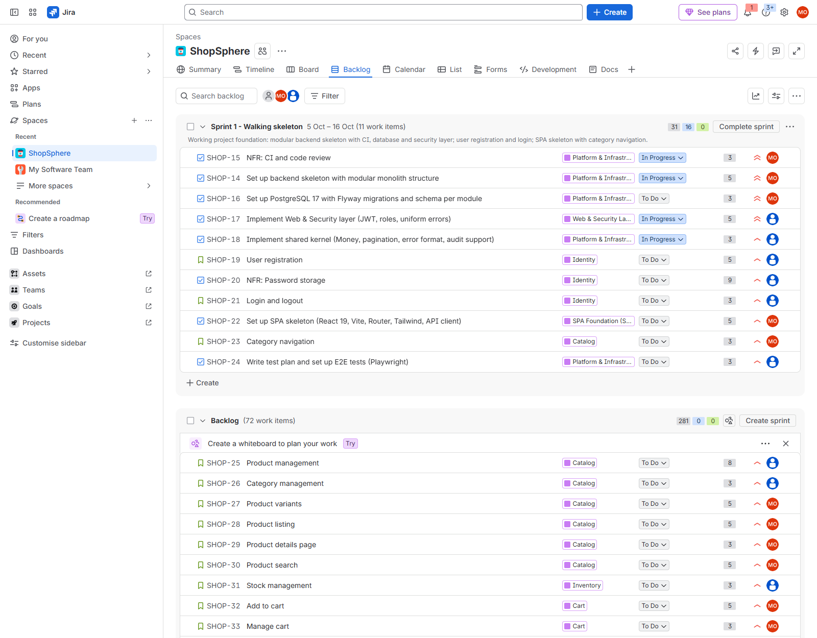
Figure 2 — Product backlog of the SHOP project
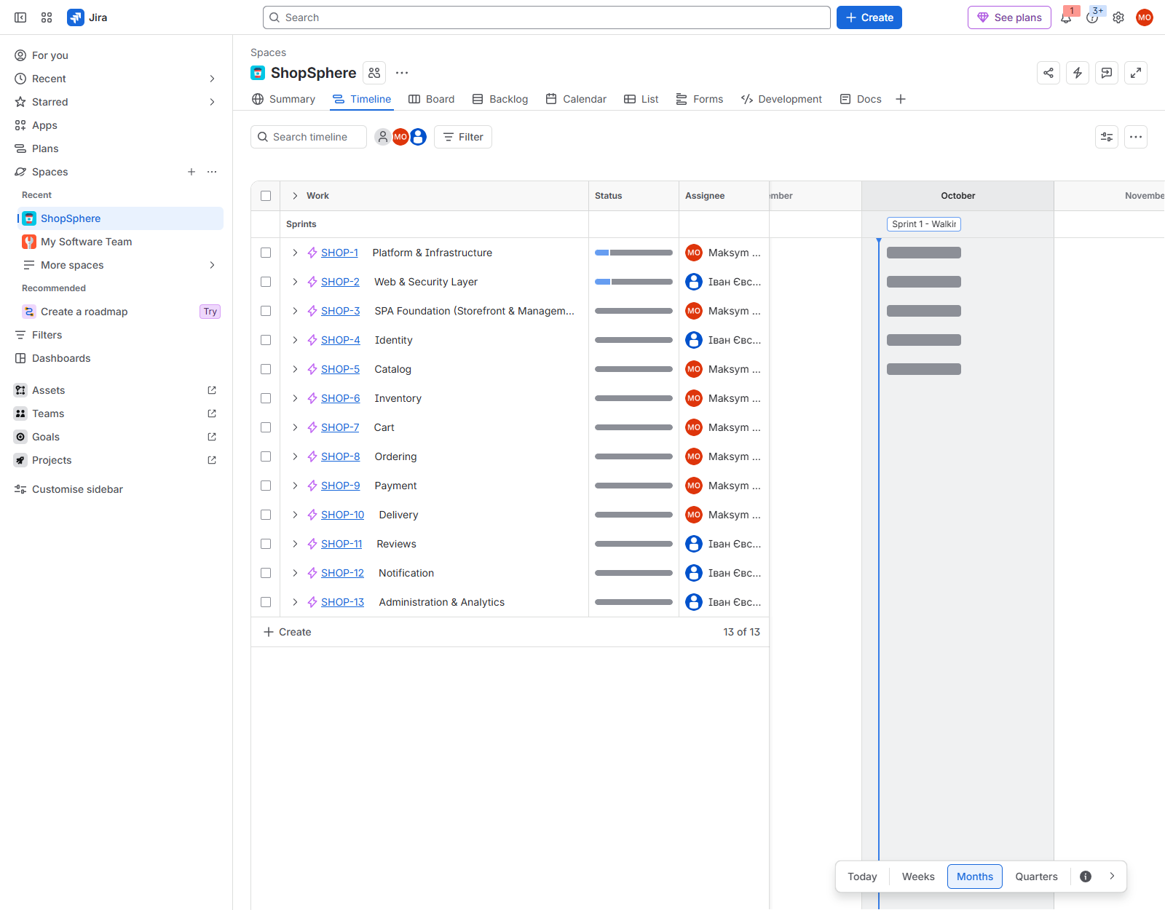
Figure 3 — Epics of the SHOP project

4. Scrum Planning

4.1 Sprint Planning Meeting
Item | Description
Date | 03.10.2026, about 1.5 hours, online
Participants | Maksym Ostrozhynskyi (facilitator, Team Lead), Ivan Yevseiev (QA Lead, represents the customer's requirements)
Input | Ordered product backlog, team capacity, Definition of Done
Steps | 1) review of the backlog order and priorities; 2) agreement on the sprint goal; 3) estimation of the candidate items (planning poker); 4) selection of items up to the capacity; 5) assignment; 6) start of the sprint

4.2 Sprint 1
Parameter | Value
Name | Sprint 1 - Walking skeleton
Dates | 05.10 – 16.10.2026 (2 weeks)
Goal | Working project foundation: modular backend skeleton with CI, database and security layer; user registration and login; SPA skeleton with category navigation.
Capacity | 2 developers × ~20 SP = 40 SP (first sprint, velocity not yet measured)
Commitment | 11 items, 40 SP

Why these items. Nothing can be implemented before the module skeleton, the CI pipeline, the database migrations and the security layer exist, so they received the Highest priority and were started first. Registration and login are the first High-priority stories, because almost every other feature depends on authenticated users and roles. The SPA skeleton and category navigation give the first visible part of the Storefront, so at the sprint review the customer can see a working vertical slice — from the browser through the REST API to the database.
Key | Summary | Type | Priority | SP | Assignee
SHOP-14 | Set up backend skeleton with modular monolith structure | Task (Arch.) | Highest | 5 | Maksym
SHOP-15 | NFR: CI and code review | Task (NFR) | Highest | 3 | Maksym
SHOP-16 | Set up PostgreSQL 17 with Flyway migrations and schema per module | Task (Arch.) | Highest | 3 | Maksym
SHOP-17 | Implement Web & Security layer (JWT, roles, uniform errors) | Task (Arch.) | Highest | 5 | Ivan
SHOP-18 | Implement shared kernel (Money, pagination, error format, audit support) | Task (Arch.) | High | 3 | Ivan
SHOP-19 | User registration | Story | High | 5 | Ivan
SHOP-20 | NFR: Password storage | Task (NFR) | High | 2 | Ivan
SHOP-21 | Login and logout | Story | High | 3 | Ivan
SHOP-22 | Set up SPA skeleton (React 19, Vite, Router, Tailwind, API client) | Task (Arch.) | High | 5 | Maksym
SHOP-23 | Category navigation | Story | High | 3 | Maksym
SHOP-24 | Write test plan and set up E2E tests (Playwright) | Task (Arch.) | High | 3 | Ivan
Table 3 — Sprint 1 backlog in execution order

4.3 Definition of Done
- The code is merged into master through a pull request approved by the other team member.
- The GitHub Actions build and all automated tests pass; new business logic is covered by tests.
- All acceptance criteria of the work item are met and checked by the team member who did not implement it.
- API changes are reflected in the OpenAPI documentation.

4.4 Release Plan
The remaining backlog (281 SP) was split into sprints of about 40 SP in backlog order. This is a forecast that will be corrected after the velocity of Sprint 1 is known.
Sprint | Dates | SP | Main epics
Sprint 1 | 05.10 – 16.10.2026 | 40 | Platform & Infrastructure, Web & Security Layer, Identity, SPA Foundation, Catalog
Sprint 2 | 19.10 – 30.10.2026 | 40 | Catalog, Inventory, Cart
Sprint 3 | 02.11 – 13.11.2026 | 34 | Ordering, Inventory, Delivery, Payment
Sprint 4 | 16.11 – 27.11.2026 | 38 | Payment, Ordering, Notification, Identity
Sprint 5 | 30.11 – 11.12.2026 | 39 | Web & Security Layer, Payment, Ordering, Platform & Infrastructure
Sprint 6 | 14.12 – 25.12.2026 | 40 | SPA Foundation (Storefront & Management Panel), Catalog, Cart, Ordering
Sprint 7 | 28.12 – 08.01.2026 | 40 | Ordering, Identity, Reviews, Administration & Analytics, …
Sprint 8 | 11.01 – 22.01.2027 | 39 | Platform & Infrastructure, SPA Foundation (Storefront & Management Panel), Web & Security Layer, Identity, …
Sprint 9 | 25.01 – 05.02.2027 | 11 | Catalog, Administration & Analytics, Platform & Infrastructure
Table 4 — Forecast of sprints
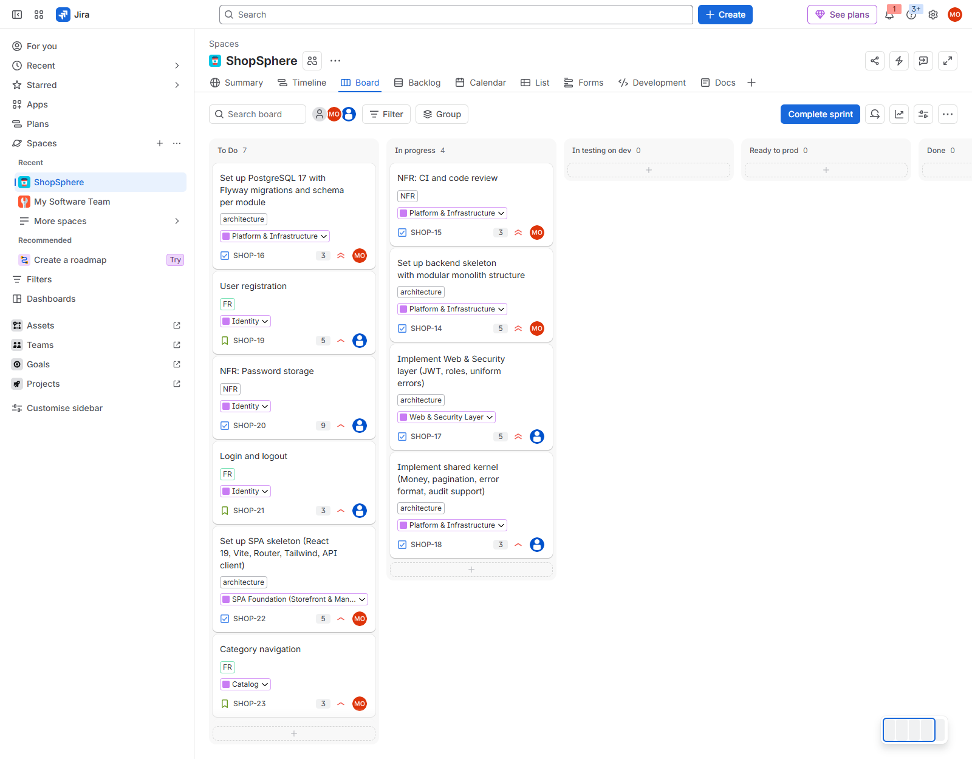
Figure 4 — Active Sprint 1 board

5. Estimation

5.1 Scale and Method
The work was estimated in story points on the Fibonacci scale. Story points measure the relative size of a work item — the amount of work, its complexity and its risk together — rather than hours. The growing gaps of the Fibonacci sequence reflect the growing uncertainty of large items. Items larger than 8 points are split before they enter a sprint.
SP | Meaning | Reference items from the backlog
1 | Trivial, configuration only | SHOP-64 Price and date format; SHOP-52 No card data stored
2 | Small, well understood | SHOP-20 Password storage; SHOP-41 Order confirmation
3 | Small feature with tests | SHOP-21 Login and logout; SHOP-23 Category navigation (reference story)
5 | Medium feature, several layers | SHOP-19 User registration; SHOP-14 Backend skeleton
8 | Large feature or external integration | SHOP-38 Checkout; SHOP-39 Stripe integration; SHOP-25 Product management
13 | Too large — must be split | not used
Table 5 — Story point scale

5.2 Planning Poker
The estimates were made together with planning poker. Category navigation (3 SP) was agreed as the reference story, because both members understand its scope: one entity, one REST endpoint, one page and tests. For every item both members first discussed the acceptance criteria, then showed their cards at the same time; if the estimates differed, the member with the higher estimate explained the risk and the item was estimated again. Examples of such discussions:
- User registration — the confirmation email with a 24-hour link, the uniqueness check and the password rules make it larger than login, so the team agreed on 5.
- Checkout — estimated 8 by both: three steps, guest contact data, the idempotency key and the transaction with the stock reservation (Laboratory Work 2, Figure 6).
- Payment methods and Stripe integration — 8 each because of the external API, webhooks and failure scenarios (Figure 7); the integration was separated from the user-facing story so that each stays within 8 points.
- Backend skeleton — 5 rather than 3, because the architecture test that protects module boundaries is a new technique for the team.
Estimates are based on the acceptance criteria taken from the Specification, the number of architectural layers affected (database, module service, REST API, UI), the dependency on external services and the experience of the team with the technology.

6. Assignment of Work

6.1 Distribution by Roles
The work was assigned according to the team roles defined in section 6 of the Specification. Both members are full-stack developers, so every module is owned by one person end to end (database, backend and UI), and the other person tests it.
Member | Roles | Owned epics | SP (Sprint 1 / total)
Maksym Ostrozhynskyi | Full-Stack Developer, Team Lead | Platform & Infrastructure, SPA Foundation, Catalog (storefront), Cart, Ordering (customer side), Payment, Delivery, Inventory (reservation) | 19 / 177
Ivan Yevseiev | Full-Stack Developer, QA Lead | Web & Security Layer, Identity, Reviews, Notification, Administration & Analytics, management panel (product, category, stock, promo code and order management), test plan and E2E tests | 21 / 144
Table 6 — Distribution of work between team members
Principles of the distribution:
- Module ownership follows the Specification: Maksym is responsible for the catalog, cart, checkout, payment and the integrations with Stripe and Nova Poshta and for the project setup, CI/CD and deployment; Ivan is responsible for user accounts, security, reviews, notifications, the management panel and administration.
- Non-functional requirements are assigned to the owner of the architectural decision that implements them: performance, availability and infrastructure — Maksym; security, testing, accessibility and localization — Ivan as the QA Lead.
- In Sprint 1 the load is balanced (19 and 21 SP) and the members work in parallel without blocking each other: Maksym builds the skeleton, the database and the SPA; Ivan builds the security layer and the identity stories on top of it.
- Cross-testing: every item is checked against its acceptance criteria and reviewed by the member who did not implement it (Definition of Done).

6.2 Start of the Sprint
After the planning meeting the sprint was started and three items were moved to In Progress to start the work:
Key | Summary | Assignee
SHOP-14 | Set up backend skeleton with modular monolith structure | Maksym Ostrozhynskyi
SHOP-15 | NFR: CI and code review | Maksym Ostrozhynskyi
SHOP-17 | Implement Web & Security layer (JWT, roles, uniform errors) | Ivan Yevseiev
Table 7 — Items in progress at the start of Sprint 1
The other items of the sprint stay in To Do and are taken in the order of the sprint backlog.
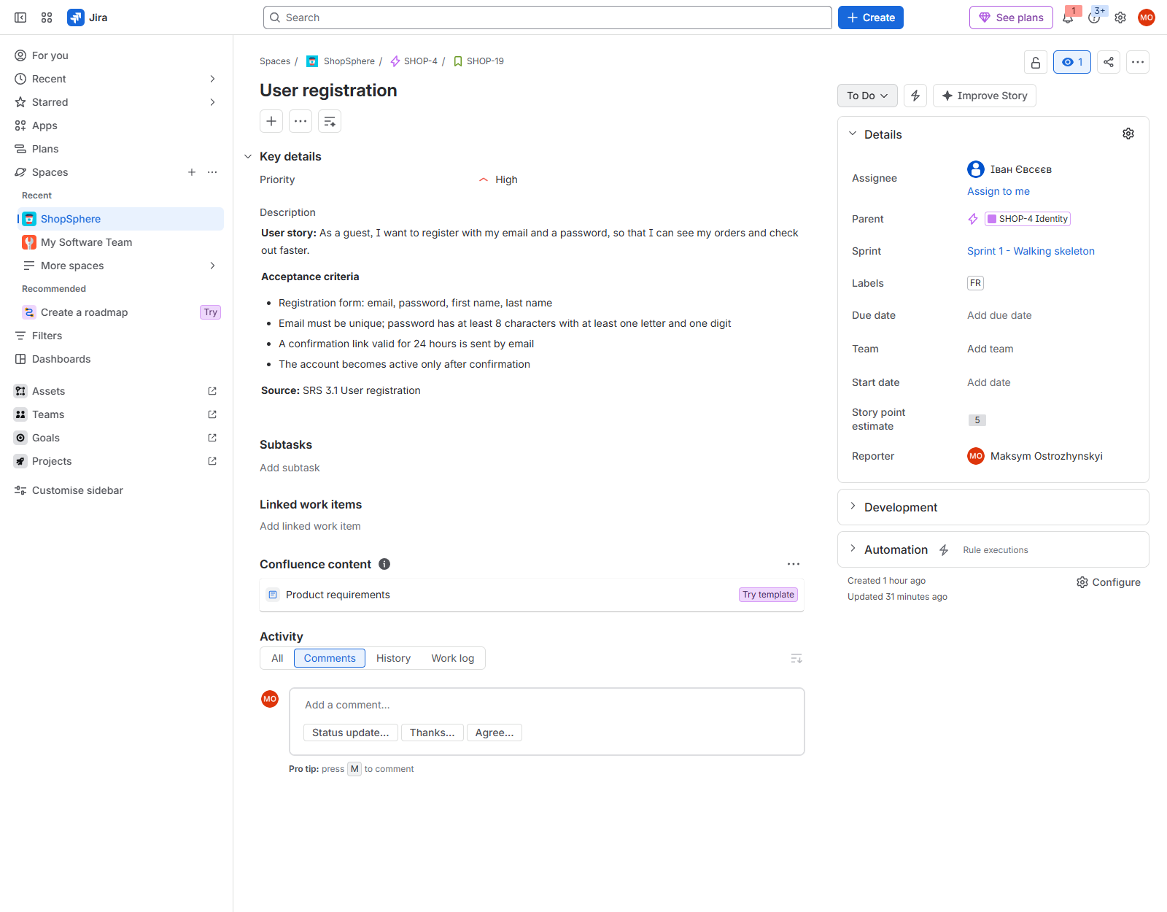
Figure 5 — Detail of a work item

7. Conclusion
In this laboratory work the development of ShopSphere was organized with the Scrum framework in Jira Software Cloud.
- The product backlog of 83 work items in 13 epics covers all 44 functional and 26 non-functional requirements of the Specification (Laboratory Work 1) and 13 technical tasks that implement the architecture (Laboratory Work 2). Epics correspond to the architectural modules, so the backlog and the code have the same structure.
- Functional requirements were written as user stories, and all requirements received verifiable acceptance criteria, a priority (Highest, High, Medium, Low) and a reference to their source.
- All items were estimated in story points with planning poker; the whole backlog is 321 SP, which at about 40 SP per sprint gives 9 two-week sprints.
- Sprint 1 “Walking skeleton” (40 SP) was planned with a clear goal, the work was assigned according to the roles from the Specification, and the sprint was started with three items in progress.
The next steps are daily synchronization of the team during the sprint, a sprint review with the customer and a retrospective on 16.10.2026, and correcting the release plan using the measured velocity.

Appendix A. Full Product Backlog
The list is given in backlog order. Type: Story — functional requirement; Task (NFR) — non-functional requirement; Task (Arch.) — architectural task. S1 — included in Sprint 1.
Key | Summary | Type | Priority | SP | Assignee | Epic
SHOP-14 | Set up backend skeleton with modular monolith structure (S1) | Task (Arch.) | Highest | 5 | Maksym | Platform & Infrastructure
SHOP-15 | NFR: CI and code review (S1) | Task (NFR) | Highest | 3 | Maksym | Platform & Infrastructure
SHOP-16 | Set up PostgreSQL 17 with Flyway migrations and schema per module (S1) | Task (Arch.) | Highest | 3 | Maksym | Platform & Infrastructure
SHOP-17 | Implement Web & Security layer (JWT, roles, uniform errors) (S1) | Task (Arch.) | Highest | 5 | Ivan | Web & Security Layer
SHOP-18 | Implement shared kernel (Money, pagination, error format, audit support) (S1) | Task (Arch.) | High | 3 | Ivan | Platform & Infrastructure
SHOP-19 | User registration (S1) | Story | High | 5 | Ivan | Identity
SHOP-20 | NFR: Password storage (S1) | Task (NFR) | High | 2 | Ivan | Identity
SHOP-21 | Login and logout (S1) | Story | High | 3 | Ivan | Identity
SHOP-22 | Set up SPA skeleton (React 19, Vite, Router, Tailwind, API client) (S1) | Task (Arch.) | High | 5 | Maksym | SPA Foundation (Storefront & Management Panel)
SHOP-23 | Category navigation (S1) | Story | High | 3 | Maksym | Catalog
SHOP-24 | Write test plan and set up E2E tests (Playwright) (S1) | Task (Arch.) | High | 3 | Ivan | Platform & Infrastructure
SHOP-25 | Product management | Story | High | 8 | Ivan | Catalog
SHOP-26 | Category management | Story | High | 3 | Ivan | Catalog
SHOP-27 | Product variants | Story | High | 5 | Maksym | Catalog
SHOP-28 | Product listing | Story | High | 5 | Maksym | Catalog
SHOP-29 | Product details page | Story | High | 3 | Maksym | Catalog
SHOP-30 | Product search | Story | High | 5 | Maksym | Catalog
SHOP-31 | Stock management | Story | High | 3 | Ivan | Inventory
SHOP-32 | Add to cart | Story | High | 5 | Maksym | Cart
SHOP-33 | Manage cart | Story | High | 3 | Maksym | Cart
SHOP-34 | Implement order aggregate and state machine | Task (Arch.) | High | 5 | Maksym | Ordering
SHOP-35 | Stock reservation | Story | High | 5 | Maksym | Inventory
SHOP-36 | Delivery methods | Story | High | 5 | Maksym | Delivery
SHOP-37 | Integrate Nova Poshta API with daily branch directory refresh | Task (Arch.) | High | 3 | Maksym | Delivery
SHOP-38 | Checkout | Story | High | 8 | Maksym | Ordering
SHOP-39 | Integrate Stripe Checkout Sessions and payment webhook | Task (Arch.) | High | 8 | Maksym | Payment
SHOP-40 | Payment methods | Story | High | 8 | Maksym | Payment
SHOP-41 | Order confirmation | Story | High | 2 | Maksym | Ordering
SHOP-42 | Implement domain event bus with transactional outbox | Task (Arch.) | High | 5 | Ivan | Notification
SHOP-43 | Implement SMTP email adapter and bilingual templates | Task (Arch.) | High | 3 | Ivan | Notification
SHOP-44 | Order status emails | Story | High | 3 | Ivan | Notification
SHOP-45 | Order history and tracking | Story | High | 3 | Maksym | Ordering
SHOP-46 | Order list for managers | Story | High | 5 | Ivan | Ordering
SHOP-47 | Order status update | Story | High | 3 | Ivan | Ordering
SHOP-48 | Password recovery | Story | High | 3 | Ivan | Identity
SHOP-49 | User management | Story | High | 3 | Ivan | Identity
SHOP-50 | NFR: Role-based access control | Task (NFR) | High | 3 | Ivan | Web & Security Layer
SHOP-51 | NFR: Protection from attacks | Task (NFR) | High | 5 | Ivan | Web & Security Layer
SHOP-52 | NFR: No card data stored | Task (NFR) | High | 1 | Maksym | Payment
SHOP-53 | NFR: Order and payment integrity | Task (NFR) | High | 5 | Maksym | Ordering
SHOP-54 | Provision AWS infrastructure (ALB, Auto Scaling, RDS, S3, CloudFront) | Task (Arch.) | High | 8 | Maksym | Platform & Infrastructure
SHOP-55 | Set up CD pipeline (Docker image, ECR, rolling deployment) | Task (Arch.) | High | 5 | Maksym | Platform & Infrastructure
SHOP-56 | NFR: Encrypted traffic | Task (NFR) | High | 2 | Maksym | Platform & Infrastructure
SHOP-57 | NFR: Secrets management | Task (NFR) | High | 2 | Maksym | Platform & Infrastructure
SHOP-58 | NFR: Availability 99.5% | Task (NFR) | High | 3 | Maksym | Platform & Infrastructure
SHOP-59 | NFR: Backups and recovery | Task (NFR) | High | 2 | Maksym | Platform & Infrastructure
SHOP-60 | NFR: Server response time | Task (NFR) | High | 3 | Maksym | Platform & Infrastructure
SHOP-61 | NFR: Page load time | Task (NFR) | High | 3 | Maksym | SPA Foundation (Storefront & Management Panel)
SHOP-62 | NFR: Responsive design | Task (NFR) | High | 3 | Maksym | SPA Foundation (Storefront & Management Panel)
SHOP-63 | NFR: Browser support | Task (NFR) | High | 2 | Ivan | SPA Foundation (Storefront & Management Panel)
SHOP-64 | NFR: Price and date format | Task (NFR) | High | 1 | Maksym | SPA Foundation (Storefront & Management Panel)
SHOP-65 | Product filtering | Story | Medium | 8 | Maksym | Catalog
SHOP-66 | NFR: Search speed | Task (NFR) | Medium | 5 | Maksym | Catalog
SHOP-67 | Promo codes | Story | Medium | 5 | Maksym | Cart
SHOP-68 | Promo code management | Story | Medium | 3 | Ivan | Cart
SHOP-69 | Order cancellation | Story | Medium | 5 | Maksym | Ordering
SHOP-70 | Order editing | Story | Medium | 5 | Ivan | Ordering
SHOP-71 | NFR: Peak order throughput | Task (NFR) | Medium | 3 | Maksym | Ordering
SHOP-72 | Return request | Story | Medium | 5 | Maksym | Ordering
SHOP-73 | Profile editing | Story | Medium | 2 | Ivan | Identity
SHOP-74 | Address book | Story | Medium | 3 | Ivan | Identity
SHOP-75 | Account deletion | Story | Medium | 3 | Ivan | Identity
SHOP-76 | Write a review | Story | Medium | 3 | Ivan | Reviews
SHOP-77 | Review moderation | Story | Medium | 3 | Ivan | Reviews
SHOP-78 | Audit log | Story | Medium | 5 | Ivan | Administration & Analytics
SHOP-79 | Store settings | Story | Medium | 3 | Ivan | Administration & Analytics
SHOP-80 | Sales dashboard | Story | Medium | 8 | Ivan | Administration & Analytics
SHOP-81 | NFR: Adding servers | Task (NFR) | Medium | 2 | Maksym | Platform & Infrastructure
SHOP-82 | NFR: Data volume | Task (NFR) | Medium | 3 | Maksym | Platform & Infrastructure
SHOP-83 | NFR: Ease of ordering (usability test) | Task (NFR) | Medium | 3 | Ivan | Platform & Infrastructure
SHOP-84 | NFR: Accessibility WCAG 2.1 AA | Task (NFR) | Medium | 5 | Ivan | SPA Foundation (Storefront & Management Panel)
SHOP-85 | NFR: Ukrainian and English | Task (NFR) | Medium | 5 | Ivan | SPA Foundation (Storefront & Management Panel)
SHOP-86 | NFR: Clear error messages | Task (NFR) | Medium | 2 | Ivan | Web & Security Layer
SHOP-87 | NFR: Test coverage 70% | Task (NFR) | Medium | 3 | Ivan | Platform & Infrastructure
SHOP-88 | NFR: API documentation | Task (NFR) | Medium | 2 | Ivan | Web & Security Layer
SHOP-89 | Sign in with Google | Story | Low | 5 | Ivan | Identity
SHOP-90 | Recently viewed products | Story | Low | 2 | Maksym | Catalog
SHOP-91 | Wishlist | Story | Low | 3 | Maksym | Cart
SHOP-92 | Invoice download | Story | Low | 3 | Maksym | Ordering
SHOP-93 | Back-in-stock alerts | Story | Low | 3 | Ivan | Inventory
SHOP-94 | Bulk import/export | Story | Low | 5 | Ivan | Catalog
SHOP-95 | Report export | Story | Low | 3 | Ivan | Administration & Analytics
SHOP-96 | NFR: Logging and monitoring | Task (NFR) | Low | 3 | Maksym | Platform & Infrastructure

