SOFTWARE ARCHITECTURE
for the project
ShopSphere — Online Store

Prepared by:
Maksym Ostrozhynskyi
Ivan Yevseiev

Table of Contents
1. Introduction 3
1.1 Purpose of the Document 3
1.2 Input Documents 3
1.3 Architectural Drivers 3
1.4 Notation and Tools 4
2. Architectural Approach 5
2.1 Considered Approaches 5
2.2 Selected Approach: Modular Monolith with a Single-Page Application 5
2.3 Design Principles 6
2.4 Trade-offs and Risks 7
3. High-Level Architecture 8
3.1 System-Level Component Diagram 8
3.2 Backend Module Structure 10
3.3 Interfaces and Protocols 11
3.4 Deployment Architecture 12
4. Interaction Between Components 14
4.1 Communication Styles 14
4.2 Request Processing Inside the Backend 14
4.3 Key Interaction Scenarios 14
4.4 Error Handling and Fault Tolerance 15
5. Detailed Design of Key Components 16
5.1 Selection of Key Components 16
5.2 Class Diagrams of the Ordering Component 16
5.3 Sequence Diagrams of Checkout with Online Payment 19
5.4 State Machine Diagram of an Order 20
6. Diagram Selection Rationale and Relation to Non-Functional Requirements 22
6.1 Summary of Diagrams 22
6.2 Relation to Non-Functional Requirements 22
7. Conclusion 25

1. Introduction

1.1 Purpose of the Document
This document describes the software architecture of ShopSphere, the online store specified in the Requirements Specification prepared in Laboratory Work 1. It contains the selected architectural approach and its justification, the high-level architecture diagrams, the detailed UML diagrams of the key component, the description of the interaction between components and the relation of the design to the non-functional requirements.
The document is intended for the development team and the customer. It is the basis for the next steps of the project: the database schema, the REST API specification and the implementation of the High-priority requirements.

1.2 Input Documents
- Requirements Specification “ShopSphere — Online Store” — 44 functional and 26 non-functional requirements, user roles, the technology stack (a constraint agreed with the customer) and priorities.
- Requirements Elicitation and Analysis — customer interviews and four usage scenarios, which are used here to check the interactions between components.
Requirements are referred to by their names in the Specification, written in italics (for example, Stock reservation), so that every design decision can be traced back to a requirement.

1.3 Architectural Drivers
Not all requirements influence the architecture equally. The requirements below have the largest effect on the structure of the system and were used as the main criteria for the design decisions.
Driver | Source requirements | Consequence for the architecture
Correct orders and payments | Order and payment integrity, Stock reservation, Payment methods, Order cancellation | An order, its stock reservation and its events are saved in one ACID transaction; repeated requests and repeated payment notifications are detected and ignored.
Performance under load | Server response time, Peak order throughput, Search speed, Page load time | Stateless backend instances, database indexes and full-text search, static files delivered through a CDN.
Availability and recovery | Availability 99.5%, Backups and recovery | At least two backend instances in two availability zones behind a load balancer; a managed database with a standby replica and daily backups.
Scalability | Adding servers, Data volume | No server-side session state, so capacity grows by adding instances; the data volume is handled by one indexed PostgreSQL database.
Security | Encrypted traffic, Password storage, No card data stored, Role-based access control, Protection from attacks, Secrets management | HTTPS on every external connection, card data entered only on the payment provider page, role checks on the server, secrets kept in a secrets store.
Small team and fixed launch date | Technology stack (section 5 of the Specification), a team of two developers, launch in December; CI and code review, Test coverage 70% | A single deployable application with strict internal module boundaries; one build and one deployment pipeline.
External integrations | Payment methods, Delivery methods, Order status emails, Sign in with Google | Each external service is used by exactly one module through an adapter, so a change of provider affects only that module.

1.4 Notation and Tools
All diagrams follow the UML 2.5.1 standard (OMG). They were created in PlantUML, a text-based UML modelling tool. The diagram sources (.puml) and the rendered images are stored in the docs/lab-2/diagrams folder of the project repository, so the diagrams are versioned together with the code and can be updated in the same code review as the implementation.

2. Architectural Approach

2.1 Considered Approaches
Four architectural approaches were compared against the architectural drivers from section 1.3.
Approach | Advantages for ShopSphere | Disadvantages for ShopSphere
Layered monolith  One application divided only into technical layers (controllers, services, repositories). | Simplest start; one database transaction covers the whole order; one deployment. | Business areas are mixed inside each layer, so with 44 functional requirements the code quickly becomes tightly coupled; it is hard for two developers to work in parallel; any part can be separated later only by a large refactoring.
Modular monolith  One application divided into business modules with explicit interfaces. | Keeps the simplicity of a monolith: one deployment, local ACID transactions, simple debugging. Clear module boundaries allow parallel work and separate testing. Scales horizontally by running identical instances. A module can be extracted into a separate service later. | All modules are deployed together; module boundaries must be protected by the code structure and code review; all modules scale together.
Microservices  Independent services with their own databases communicating over the network. | Independent deployment and scaling of each service; failure isolation. | Creating an order would need a distributed transaction (saga) across order, stock and payment services, which makes Order and payment integrity much harder to guarantee; many databases, pipelines and monitoring tools for a team of two; network calls add latency and new failure modes. The expected load (about 500 visitors a day, ten times more during sales) does not require independent scaling.
Service-oriented architecture (SOA)  Autonomous services integrated through an enterprise service bus and shared contracts. | Reuse of services by many enterprise applications. | Designed for integrating many existing enterprise systems; ShopSphere is a single application and the only enterprise integration (1C) is out of scope; the service bus is extra infrastructure to build and operate.

2.2 Selected Approach: Modular Monolith with a Single-Page Application
ShopSphere is designed as a three-tier client–server web application whose server part is a modular monolith:
- Client tier — a React 19 single-page application (SPA) with two areas: the Storefront for guests and customers and the Management Panel for managers and administrators. It is served as static files from Amazon S3 through the Amazon CloudFront CDN.
- Application tier — one Spring Boot 4.1 application (Java 25) divided into ten business modules. It exposes a REST API and runs as a Docker container on two or more Amazon EC2 instances behind an Application Load Balancer.
- Data tier — a PostgreSQL 17 database (Amazon RDS) for business data and Amazon S3 for product images.
Justification of the choice:
- Data consistency. Creating an order, reserving stock and recording the events for notifications happen in one local database transaction. This satisfies Order and payment integrity and Stock reservation without the distributed transactions that microservices would require.
- Sufficient performance. The required load — 1,000 concurrent users with 95% of responses within 500 ms (Server response time) and 50 orders per minute (Peak order throughput) — is moderate for a Spring Boot application with a connection pool and indexed PostgreSQL queries. Calls between modules are in-process method calls without network overhead.
- Horizontal scalability. The backend keeps no user session in memory (authentication uses JWT, carts are stored in the database), so any instance can serve any request. Capacity is increased by adding instances to the Auto Scaling group without changing the code (Adding servers).
- Fits the team and the schedule. Two full-stack developers and a December launch require one repository, one build, one CI/CD pipeline and one deployable artifact. The module boundaries also make it easy to divide the work between the two developers (section 6 of the Specification).
- Maintainability. Every module has a public interface and hidden internals, its own database schema and its own tests. This keeps the code understandable as the number of features grows and supports Test coverage 70% and CI and code review.
- Evolution path. Because modules communicate only through interfaces and events, a module can later be extracted into a separate service if it needs independent scaling or if the 1C integration is added in a future project.

2.3 Design Principles
The architecture applies the four design principles as follows.
Principle | How it is applied in ShopSphere
Modularity | The backend is divided into ten modules, each responsible for one group of functional requirements (section 3.2). A module consists of a public api package (interfaces, data transfer objects, events) and internal packages that other modules cannot use. Each module owns its tables in a separate database schema; other modules never read these tables directly. The SPA is divided into feature folders (catalog, cart, checkout, account, management) in the same way.
Reuse | Common building blocks are implemented once: a shared kernel on the backend (the Money value object, pagination, the error response format, audit support); one API client and one library of UI components (forms, tables, buttons) shared by the Storefront and the Management Panel; module interfaces used by several modules (for example, InventoryApi is used by Cart and Ordering).
Scalability | Stateless backend instances behind a load balancer; static files and images delivered by a CDN; pagination of all lists (24 products per page); database indexes and PostgreSQL full-text search; short database transactions; asynchronous sending of emails.
Fault tolerance | Idempotent order creation and payment handling; a transactional outbox, so that emails are retried until they are sent; timeouts on every call to an external service; scheduled jobs that cancel unpaid orders and release stock; health checks, so that the load balancer replaces failed instances; a standby database replica with automatic failover. Details are given in section 4.4.

2.4 Trade-offs and Risks
Risk of the selected approach | Mitigation
The whole application is deployed at once, so an error in one module can affect the whole store. | Every change passes automated tests in GitHub Actions and code review (CI and code review); deployments are rolling — instances are replaced one by one behind the load balancer, so the store stays available.
Module boundaries can erode over time (one module starts using internal classes of another). | Internal classes are package-private; dependencies between modules are allowed only on api packages; the rule is part of the code review checklist.
The single database is a shared resource and a potential bottleneck. | A managed Multi-AZ database with automatic failover; indexes and short transactions; static files and images are served by the CDN and do not load the backend or the database.
All modules scale together, even if only one of them is under load. | Acceptable for the expected load; if needed, a module (for example, search) can be extracted as described in section 2.2.

3. High-Level Architecture

3.1 System-Level Component Diagram
Figure 1 shows the system as a set of components: the client application, the backend, the data stores and the external services. For every connection the diagram shows the interface and the protocol. The backend provides two interfaces: the REST API used by the SPA and the webhook endpoint used by the payment provider. All connections that leave the AWS network are encrypted.
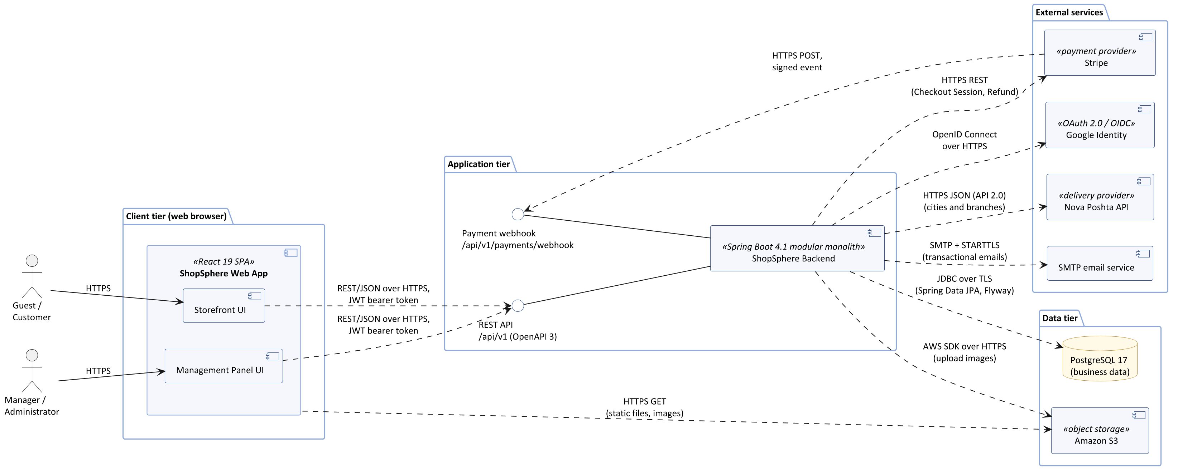
Figure 1 — System-level UML component diagram of ShopSphere

The responsibilities of the components are listed below.
Component | Responsibility | Technology
Storefront UI | Catalog, search, product pages, cart, checkout, customer account, order history, reviews | React 19, TypeScript, React Router, Tailwind CSS (part of the SPA)
Management Panel UI | Product, stock, promo code and order management for managers; users, settings, dashboard, reports and audit log for administrators; pages are available according to the user role | React 19 (part of the SPA)
ShopSphere Backend | All business logic, security and data access; REST API and webhook endpoint; scheduled jobs | Java 25, Spring Boot 4.1 (Spring Web MVC, Spring Security, Spring Data JPA), Flyway
PostgreSQL 17 | Business data of all modules (one schema per module), transactional outbox, audit log | Amazon RDS for PostgreSQL
Amazon S3 | SPA build (static files) and product images | Amazon S3 with Amazon CloudFront
Stripe | Hosted card payment page, payment notifications (webhooks) and refunds | Stripe API (Checkout Sessions)
Nova Poshta API | Directory of cities and branches for delivery to a Nova Poshta branch | Nova Poshta API 2.0 (JSON)
SMTP email service | Delivery of transactional emails | SMTP
Google Identity | Authentication for Sign in with Google | OAuth 2.0 / OpenID Connect

3.2 Backend Module Structure
Figure 2 shows the inside of the backend. The Web & Security Layer receives every HTTP request, authenticates it, checks the user role and calls the application service of the corresponding module. Modules depend on each other only through provided interfaces (shown in the lollipop notation). Reactions that do not have to happen immediately — emails and the audit log — use domain events published through the Domain Event Bus.
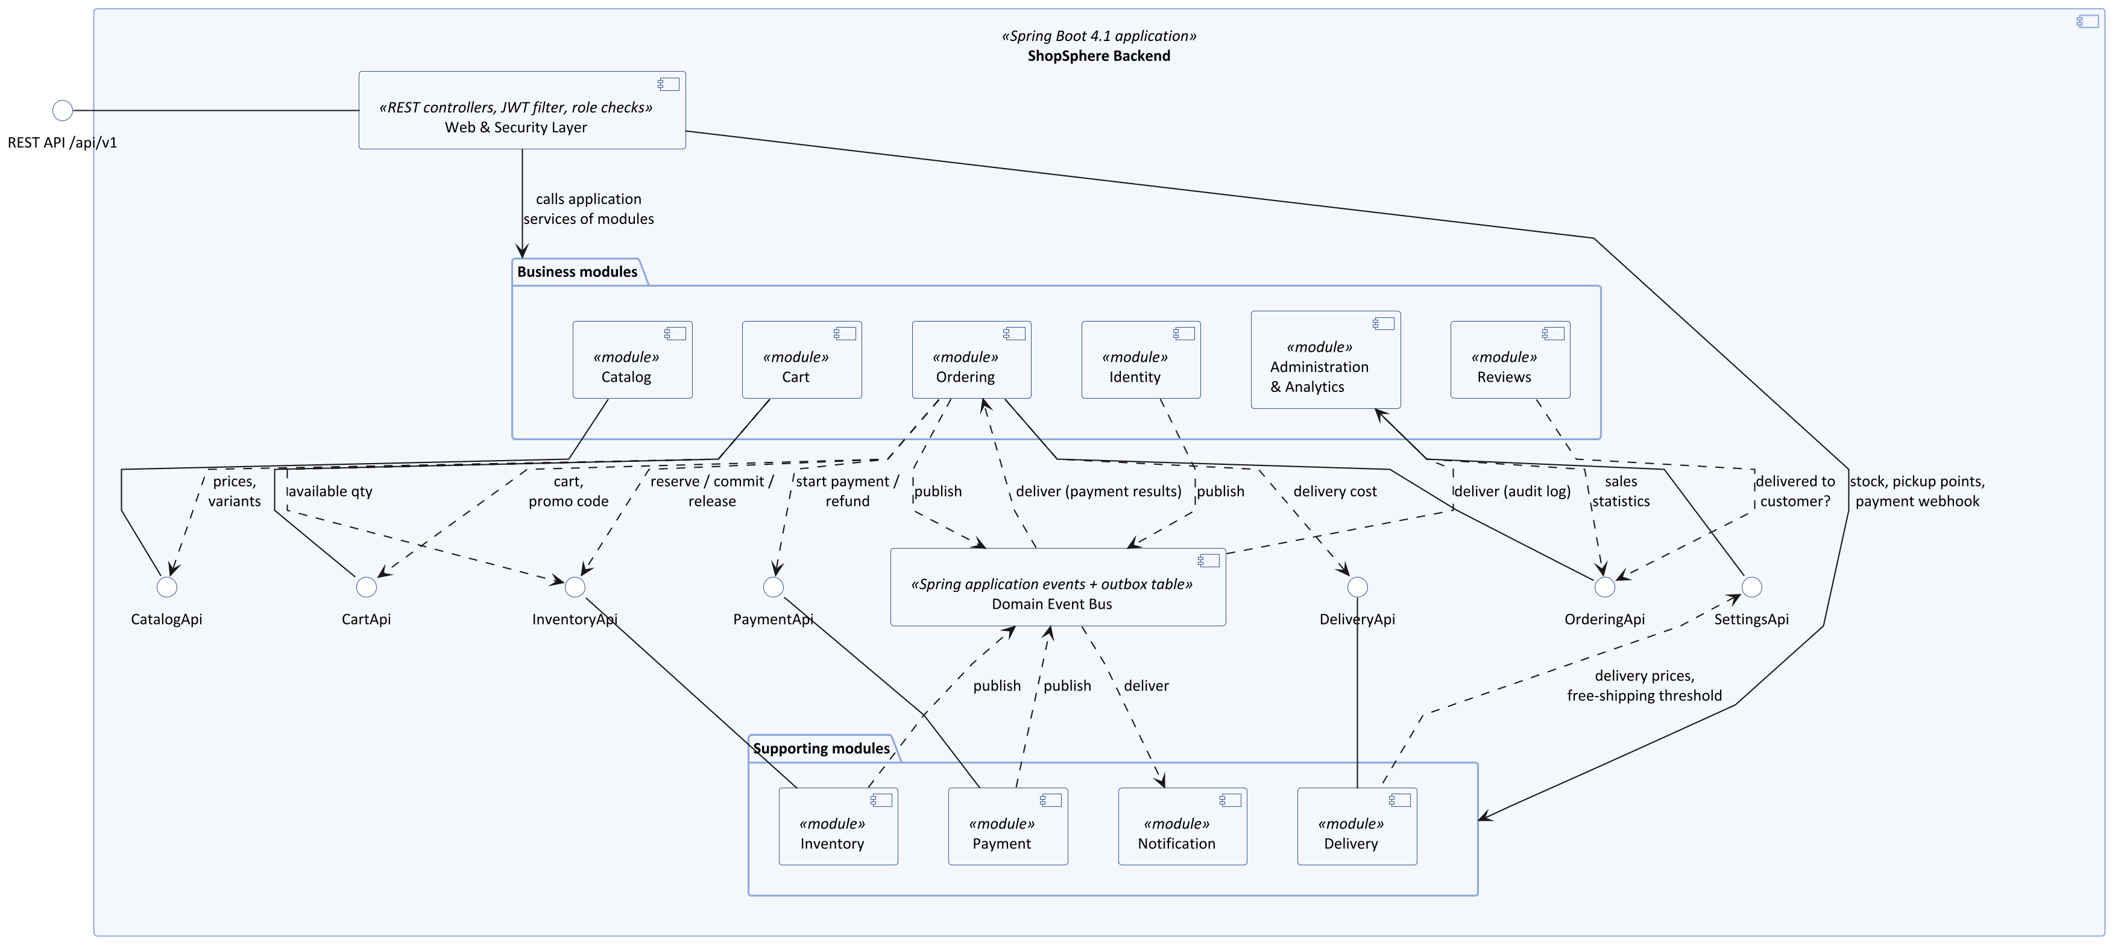
Figure 2 — UML component diagram of the backend modules

Every functional requirement of the Specification is assigned to exactly one module (or to a module and the Notification module that sends the related email).
Module | Responsibility | Requirements (Specification section)
Web & Security Layer | REST controllers, validation of requests, authentication with JWT, role checks, rate limiting of login and registration, uniform error responses, OpenAPI documentation | Role-based access control, Protection from attacks, Clear error messages, API documentation
Identity | Registration and email confirmation, login and logout, account locking after failed attempts, password recovery, profile, address book, account deletion and anonymization, Google sign-in, user and role management | 3.1; User management (3.9)
Catalog | Category tree, products, variants and attributes, product images, search with suggestions, filters and sorting, recently viewed products, CSV import/export | 3.2; Product management, Category management, Bulk import/export (3.7)
Inventory | Stock quantities of variants, reservations for orders, low-stock highlighting, back-in-stock subscriptions | Stock management (3.7), Stock reservation (3.4), Back-in-stock alerts (3.6)
Cart | Guest and customer carts, merge after login, wishlist, promo codes and their management | 3.3; Promo code management (3.7)
Ordering | Checkout, orders and their status history, order confirmation, cancellation, return requests, PDF invoices, order list, status update and order editing for managers | Checkout, Order confirmation, Order history and tracking, Order cancellation, Return request, Invoice download (3.4); 3.8
Payment | Online card payments through Stripe, processing of webhooks, refunds | Payment methods (3.4), Order and payment integrity
Delivery | Delivery methods and pickup points, delivery cost and free-shipping threshold, Nova Poshta branch directory | Delivery methods (3.4)
Reviews | Reviews and ratings, moderation by managers | 3.5
Notification | Email templates in Ukrainian and English, sending of emails from the outbox | 3.6; email part of Order confirmation
Administration & Analytics | Sales dashboard, report export (CSV, XLSX), audit log, store settings | Sales dashboard, Report export, Audit log, Store settings (3.9)

3.3 Interfaces and Protocols
The table lists every interface between the components and the way data is transferred through it.
Interface | Between | Protocol and format | Notes
REST API /api/v1 | SPA → Backend | HTTPS (TLS 1.2+), JSON; JWT in the Authorization: Bearer header | Resource-oriented endpoints (for example, GET /api/v1/products, POST /api/v1/orders), documented in OpenAPI 3; POST /api/v1/orders requires an Idempotency-Key header.
Static content | Browser → CloudFront → S3 | HTTPS GET | SPA files and product images are cached by the CDN and the browser.
Payment webhook /api/v1/payments/webhook | Stripe → Backend | HTTPS POST, JSON; Stripe-Signature header | The signature is verified with the endpoint secret; each event ID is processed only once.
Stripe API | Backend → Stripe | HTTPS REST; secret API key; Idempotency-Key header | Creates Checkout Sessions that expire after 30 minutes, expires sessions, creates refunds.
Nova Poshta API 2.0 | Backend → Nova Poshta | HTTPS POST, JSON; API key | Directory of cities and branches, refreshed daily and stored locally.
SMTP | Backend → email service | SMTP on port 587 with STARTTLS | Transactional emails.
OpenID Connect | Backend ↔ Google | OAuth 2.0 authorization code flow over HTTPS | Sign in with Google; after sign-in the backend issues its own JWT.
JDBC | Backend → PostgreSQL | PostgreSQL protocol over TLS, port 5432 | Connection pool; schema migrations with Flyway.
AWS SDK | Backend → S3, Secrets Manager, CloudWatch | HTTPS with the IAM role of the instance | Upload of product images (JPEG, PNG, WebP, up to 5 MB); reading secrets; logs and metrics. No access keys are stored on the servers.
Module interfaces (CatalogApi, InventoryApi, …) | Module → module | In-process Java method calls | Executed in the caller’s transaction when atomicity is needed.
Domain events | Module → module | Spring application events; events that must not be lost are also written to the outbox table | Used for notifications, the audit log and payment results.

3.4 Deployment Architecture
Figure 3 shows how the components are deployed in Amazon Web Services, region eu-central-1 (Frankfurt), close to the customers in Ukraine. The diagram shows the nodes, the artifacts deployed on them and the communication paths with protocols and ports.
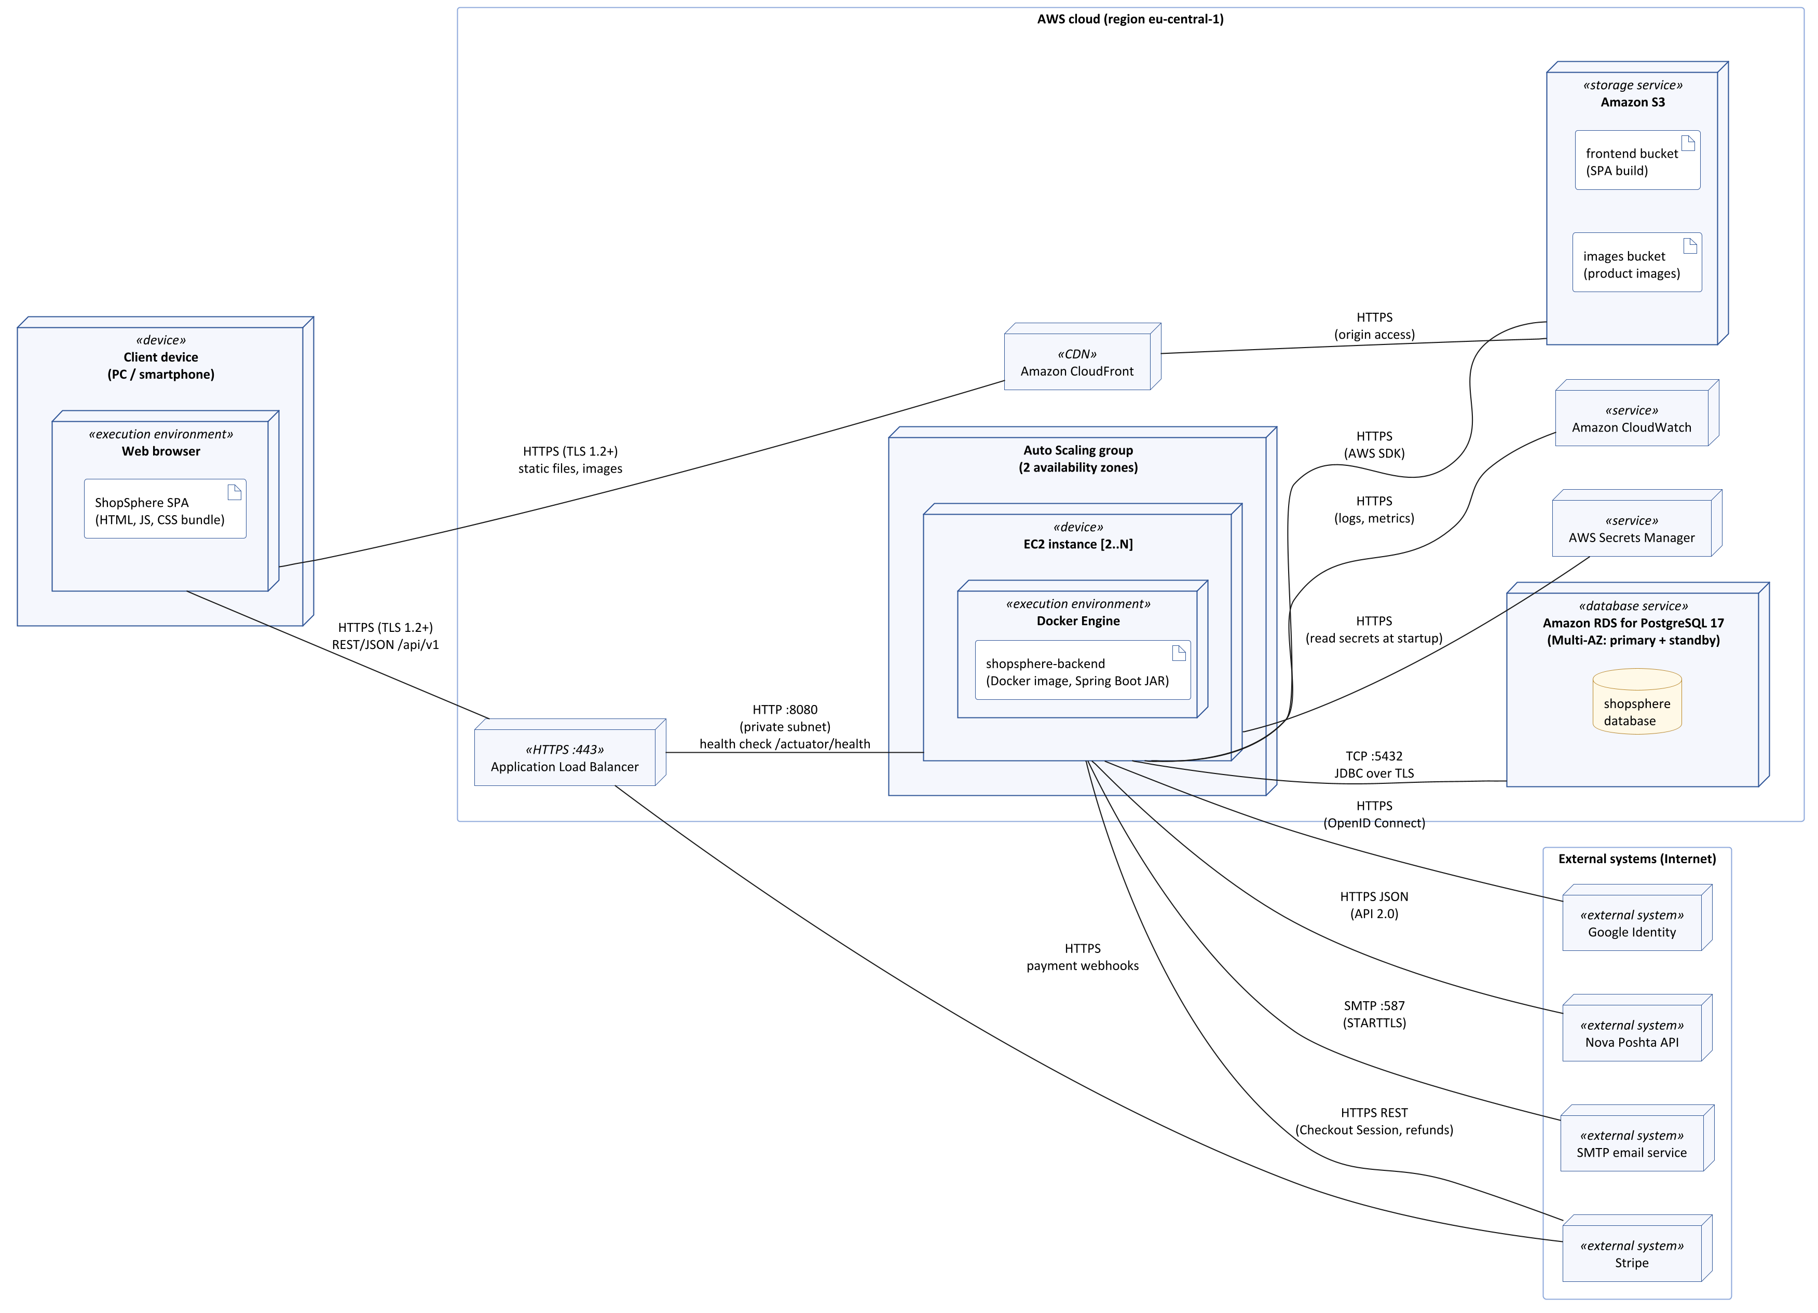
Figure 3 — UML deployment diagram of ShopSphere in AWS
Node | Purpose | Related requirements
Amazon CloudFront + S3 | Delivers the SPA and product images over HTTPS from edge locations close to users. | Page load time, Encrypted traffic
Application Load Balancer | Terminates HTTPS (TLS 1.2 or higher), distributes requests between instances, checks /actuator/health and stops sending traffic to unhealthy instances. | Encrypted traffic, Availability 99.5%
Auto Scaling group of EC2 instances | At least two instances in two availability zones run the backend Docker image. Instances are added when the CPU load is high and replaced automatically when they fail; deployments are rolling, without downtime. | Adding servers, Availability 99.5%, Peak order throughput
Amazon RDS for PostgreSQL 17 (Multi-AZ) | Primary database with a synchronous standby in another availability zone and automatic failover; automated daily backups kept for 30 days. | Backups and recovery, Availability 99.5%, Data volume
AWS Secrets Manager | Stores the database password, the JWT signing key, Stripe keys, SMTP and Nova Poshta credentials; the application reads them at startup. | Secrets management
Amazon CloudWatch | Collects logs and metrics; alarms notify the team when health checks fail. | Logging and monitoring

The Docker image is built and tested by GitHub Actions for every change of the main branch, pushed to a container registry (Amazon ECR) and rolled out to the Auto Scaling group. The backend instances are placed in private subnets and are reachable only through the load balancer; the database accepts connections only from the backend instances.

4. Interaction Between Components

4.1 Communication Styles
Style | Used for | Reason
Synchronous REST over HTTPS | SPA ↔ backend | The user waits for the result; simple and supported by all browsers; documented with OpenAPI 3.
In-process calls through module interfaces | A module needs a result immediately or in the same transaction (for example, Ordering → InventoryApi.reserve). | No network overhead; the operation is atomic.
Domain events with a transactional outbox | Reactions that may happen later and must not slow down or break the main operation: emails, audit log, back-in-stock alerts. | The event is saved in the same transaction as the business change, so it is never lost; a background job delivers it and retries on failure.
Webhooks | Payment results from Stripe. | The payment is completed outside ShopSphere; Stripe notifies the backend and retries the notification if it is not acknowledged.
Scheduled jobs | Cancelling unpaid orders (every minute), sending outbox events (every 10 seconds, so that emails are sent within 1 minute as required by Order confirmation), anonymizing deleted accounts (after 30 days), removing audit records older than 1 year, refreshing the Nova Poshta branch directory (daily). | Time-based requirements. Several instances can run the same job safely, because each job locks the rows it processes (SELECT … FOR UPDATE SKIP LOCKED).

4.2 Request Processing Inside the Backend
Inside every module a request passes through the same layers:
- Controller (Web & Security Layer) — maps the HTTP request to a command, validates the input and checks the role; returns JSON or a list of field errors.
- Application service — implements one use case (for example, CheckoutService.placeOrder) and defines the transaction boundary.
- Domain model — entities and value objects that enforce the business rules (for example, Order.cancel() refuses cancellation after the order has been shipped).
- Repository — reads and writes the module’s tables with Spring Data JPA.
Cross-cutting functions — authentication, authorization, the audit of data changes made by managers and administrators, logging and error handling — are implemented once in the Web & Security Layer and the shared kernel and apply to all modules.

4.3 Key Interaction Scenarios
The table traces the four usage scenarios from the Requirements Elicitation document through the components.
Scenario | Interaction between components
1. A guest buys a product | Storefront → REST API → Catalog (search, filters, product page) → Cart (add the variant, apply the promo code through CartApi) → Ordering (CheckoutService) → Delivery (cost), Inventory (reservation), Payment → Stripe (hosted payment page) → webhook → Payment → event → Ordering (order paid, stock committed) → Notification → SMTP. Shown in detail in Figures 6 and 7.
2. A customer cancels an order | Storefront → REST API → Ordering (OrderService.cancelOrder, allowed until the order is shipped) → Inventory (restock or release) → Payment (refund for a paid order) → event OrderCancelled → Notification (email).
3. A manager adds a product and processes an order | Management Panel → Catalog (product and variants; images uploaded to S3) → Inventory (stock of each variant) → Ordering (changeStatus to Shipped with a tracking number) → event OrderStatusChanged → Notification (email with the tracking number) and Administration (audit log entry with the manager and time).
4. The owner reviews monthly sales | Management Panel → Administration & Analytics (dashboard for September compared with August) → OrderingApi (sales statistics) → export to XLSX.

4.4 Error Handling and Fault Tolerance
Situation | Handling
The customer clicks “Place order” twice or the network repeats the request | The SPA sends the same Idempotency-Key; the backend finds the existing order and returns it instead of creating a second one. A unique constraint on the key also protects against two simultaneous identical requests.
Stripe delivers the same webhook more than once | The event ID is stored in processed_webhook_event with a unique constraint; a repeated event is acknowledged and ignored.
A payment arrives after the order was cancelled for non-payment | The Stripe session is expired when the order is cancelled; if a payment still arrives, it is refunded automatically.
Two customers buy the last item at the same time | The reservation is a conditional update (on_hand − reserved ≥ quantity) inside a transaction; only one succeeds, the other customer gets a clear message.
The payment provider is unavailable when the order is placed | The call has a timeout and the customer sees an error message; the unpaid order is cancelled automatically after 30 minutes and its stock is released.
The SMTP service is unavailable | Emails stay in the outbox and are retried with increasing intervals; orders are processed normally.
The Nova Poshta API is unavailable | Checkout uses the local copy of the branch directory, refreshed daily.
A backend instance fails | The load balancer health check removes it and the Auto Scaling group starts a new one; the other instances continue to serve users, because no session state is lost.
The primary database fails | Amazon RDS switches to the standby replica automatically.
Invalid input | The request is rejected with HTTP 400 and a list of field errors, which the SPA shows next to the fields (Clear error messages).

5. Detailed Design of Key Components

5.1 Selection of Key Components
The key component selected for detailed design is Ordering (checkout and order lifecycle) together with the parts of Inventory and Payment it works with. The reasons are:
- It contains the main business logic of the store and implements the most important High-priority functional requirements: Checkout, Stock reservation, Payment methods, Order confirmation, Order history and tracking, Order list and Order status update.
- It is responsible for the most critical non-functional requirements: Order and payment integrity, Peak order throughput and No card data stored. An error here means lost money, lost orders or selling goods that are out of stock — exactly the problems listed in the Problem Statement of the Specification.
- It has the most complex interactions: several modules, an external payment provider, webhooks, a scheduled job and asynchronous emails.
The other modules (Catalog, Reviews, Identity, Administration) mainly create, read, update and delete data or rely on standard Spring Security features; at this stage they are sufficiently described by the high-level diagrams.
Three types of UML diagrams were chosen, because each of them answers a different question about the component:
UML diagram | Question answered | Figures
Class diagram (structure) | What data does the component store, which operations does it offer and how does it depend on other modules? | 4, 5
Sequence diagram (interaction) | In which order do the objects call each other during checkout, what is inside a transaction and where can a failure happen? | 6, 7
State machine diagram (behavior) | Which order statuses exist and which transitions between them are allowed? | 8

5.2 Class Diagrams of the Ordering Component
Why this diagram. The order is the central data structure of the store: it is created by customers, processed by managers and analysed by the owner. The class diagram fixes the boundary of the Order aggregate, its attributes with types and multiplicities, and its operations; it is the direct basis for the JPA entities and the Flyway database schema. The second view shows that Ordering depends on other modules only through their interfaces, which is the main rule of the modular monolith. The model is shown in two views to keep it readable.
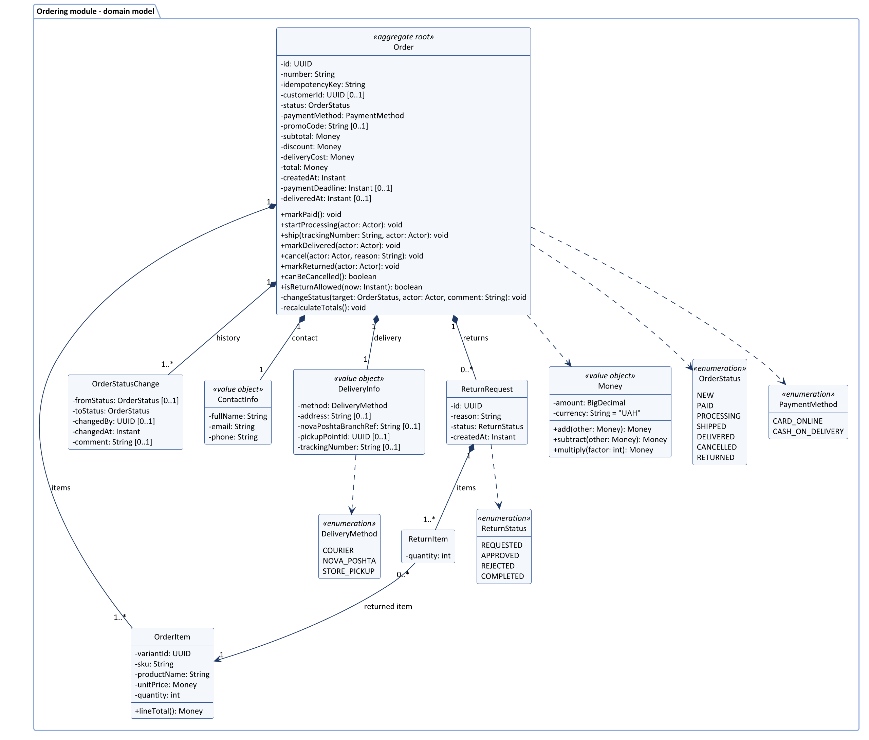
Figure 4 — UML class diagram, view 1: domain model of the Ordering module
Main design decisions in Figure 4:
- Order is an aggregate root: its state is changed only through its operations (markPaid, ship, cancel, …). Each operation checks that the transition is allowed (Figure 8) and adds an OrderStatusChange record with the author and time, as required by Order status update.
- OrderItem stores a copy of the product name, SKU and unit price at the moment of purchase, so later changes in the catalog do not change existing orders or invoices.
- Contact data (ContactInfo) is stored in every order and customerId is optional, which supports guest checkout (Checkout).
- DeliveryInfo stores the address, the Nova Poshta branch or the pickup point depending on the delivery method, and the tracking number shown to the customer.
- Money stores amounts as BigDecimal in UAH and avoids the rounding errors of floating-point numbers (Price and date format).
- ReturnRequest and ReturnItem implement Return request; isReturnAllowed checks the 14-day period after deliveredAt.
- idempotencyKey is unique, which prevents duplicate orders (Order and payment integrity).
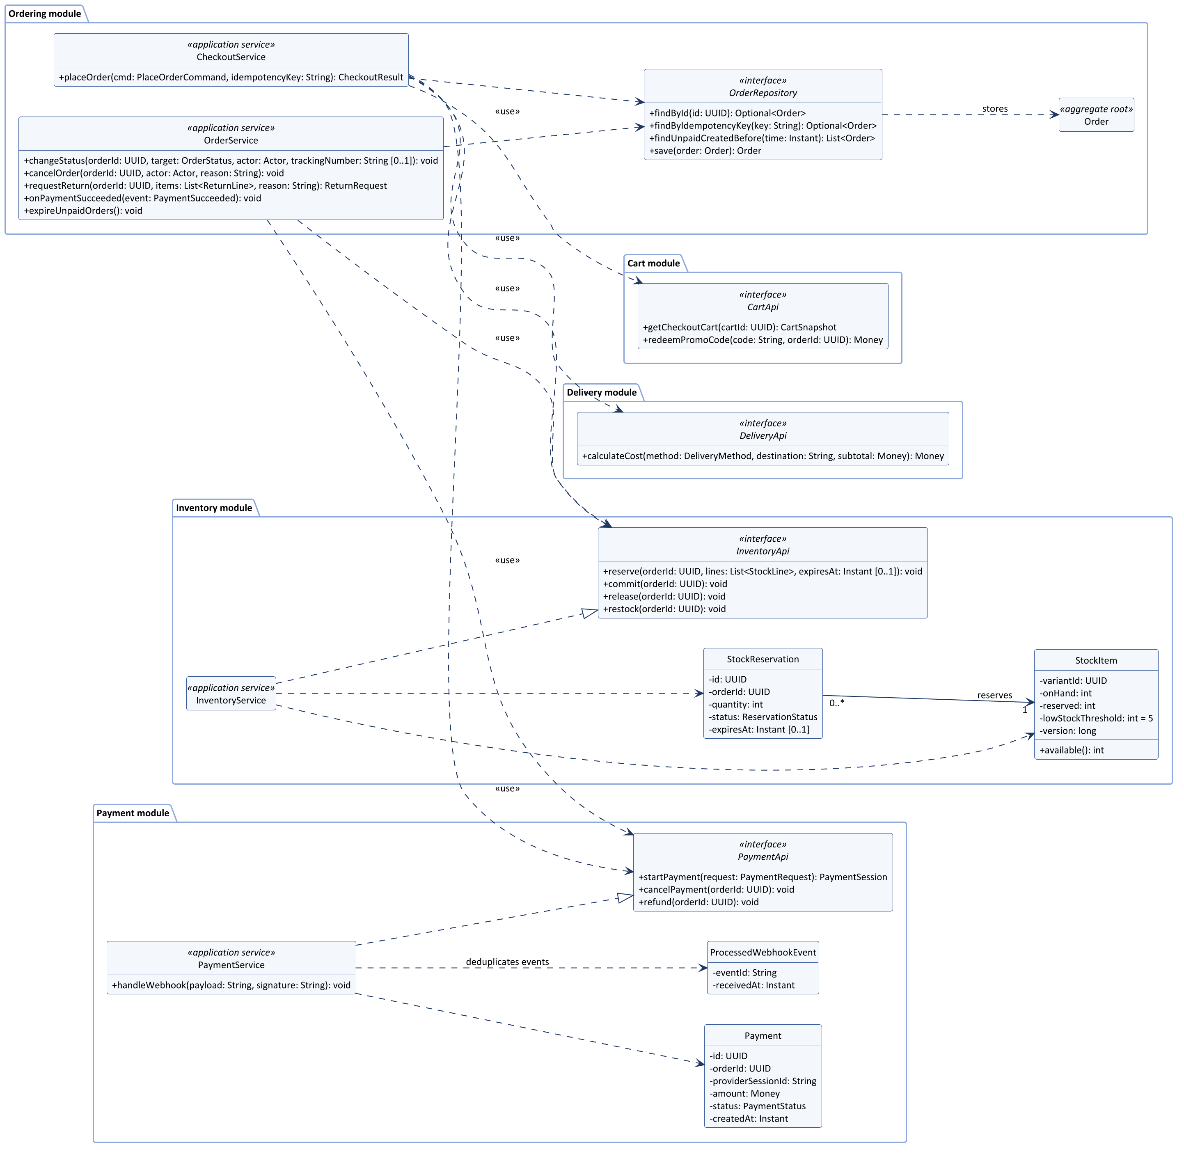
Figure 5 — UML class diagram, view 2: application services of Ordering and the collaborating modules
Main design decisions in Figure 5:
- CheckoutService and OrderService are the entry points to the Ordering module. They depend on CartApi, DeliveryApi, InventoryApi and PaymentApi — on interfaces, not on implementations — so the other modules can be replaced by test doubles in unit tests.
- StockItem keeps the onHand and reserved quantities; the available quantity shown to customers is onHand − reserved, so stock information is correct immediately after each order (goal “Provide accurate stock information”). The version attribute enables optimistic locking when managers edit stock.
- StockReservation has an expiry time for online payments and no expiry for cash on delivery.
- Payment stores only the Stripe session ID, the amount and the status — never card data (No card data stored). ProcessedWebhookEvent records processed event IDs, so repeated notifications are ignored.
- Modules refer to each other’s data by identifiers (orderId, variantId) instead of object references, so each module keeps its own tables and can be extracted later.

5.3 Sequence Diagrams of Checkout with Online Payment
Why this diagram. Checkout is the most complex and most critical interaction in the system: it involves the customer, the SPA, five modules, the database and an external payment provider, and it has transaction boundaries, asynchronous steps and error branches. A sequence diagram shows the exact order of messages and makes visible the points where Order and payment integrity could be violated — and how the design prevents it. The diagrams follow usage scenario 1 (a guest buys a product and pays by card); to keep them readable, the scenario is split into two parts.
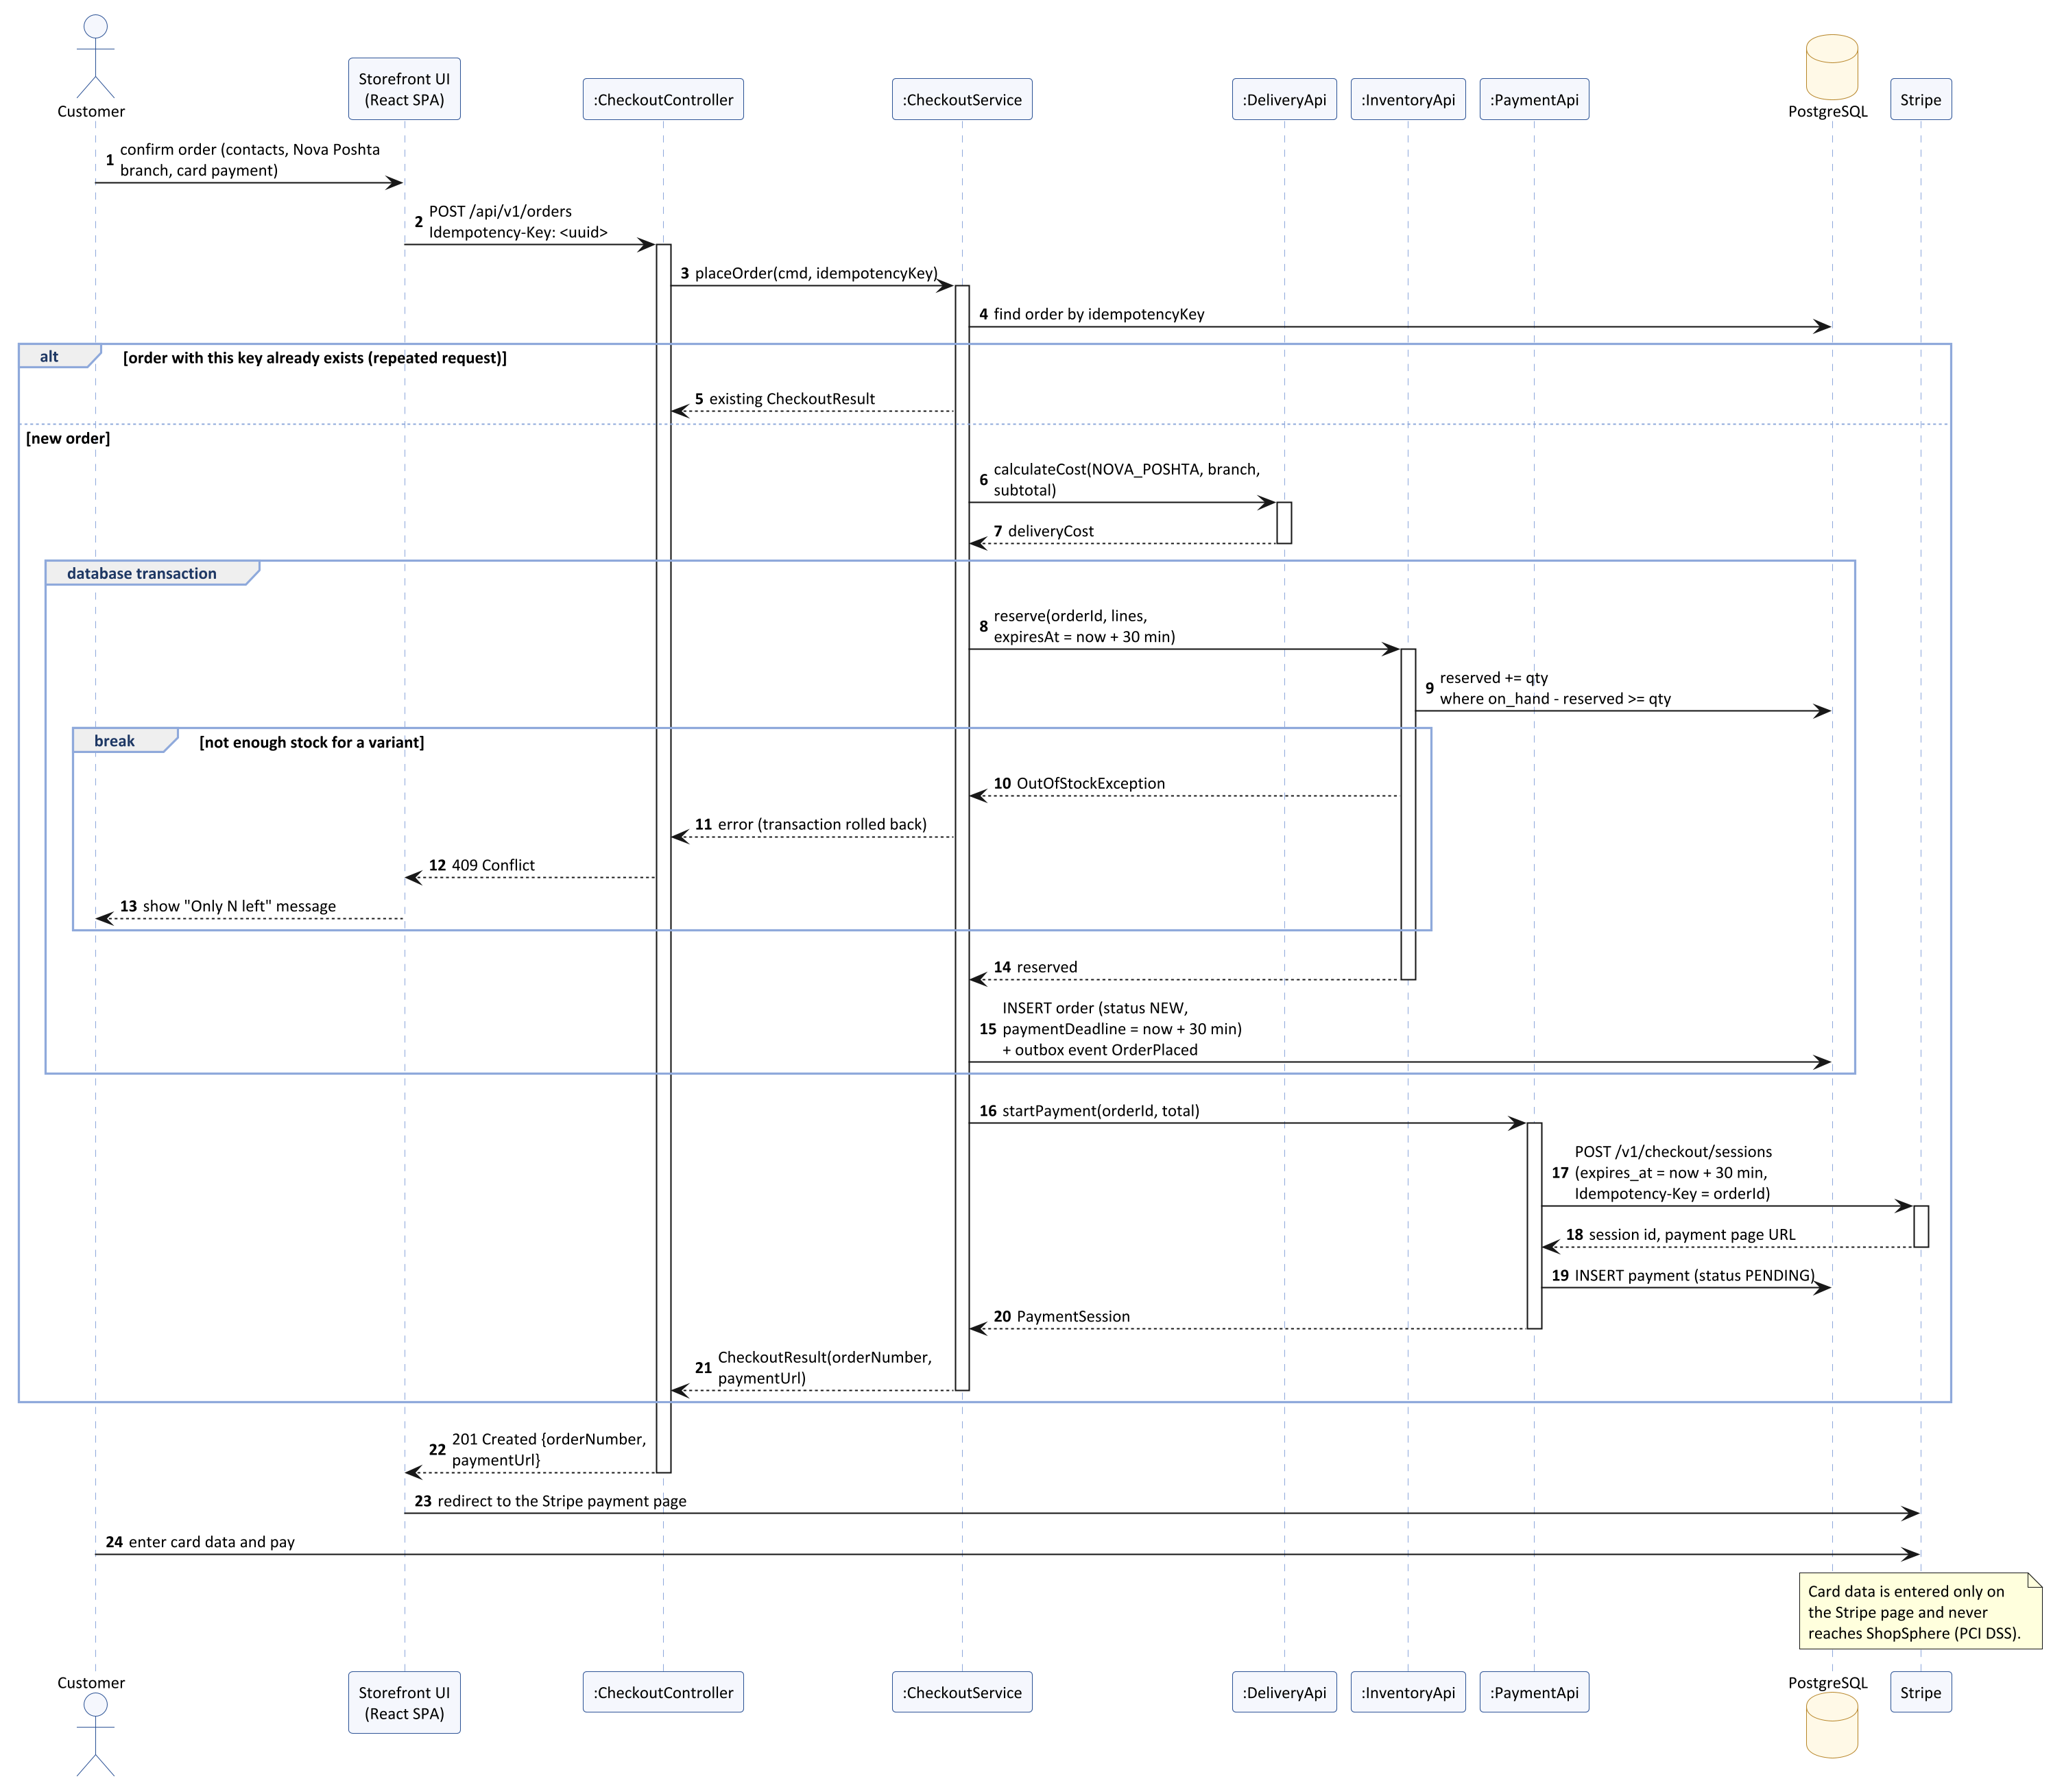
Figure 6 — UML sequence diagram, part 1: placing an order with online card payment
Part 1 (Figure 6) — placing the order:
- Steps 2–5: the request carries an Idempotency-Key; if an order with this key already exists, it is returned and no second order is created.
- Steps 6–7: the delivery cost is calculated from the delivery prices and the free-shipping threshold configured in the store settings.
- Steps 8–15: the stock reservation and saving the order with the OrderPlaced outbox event form one database transaction. If a variant does not have enough stock, the transaction is rolled back and the customer receives a clear message (break fragment).
- Steps 16–20: a Stripe Checkout Session is created with a 30-minute expiry, equal to the reservation time, and with the order ID as the idempotency key.
- Steps 22–24: the customer is redirected to the Stripe payment page and enters the card data there, so card data never reaches ShopSphere. The “order created” email is sent by the Notification module from the OrderPlaced event.
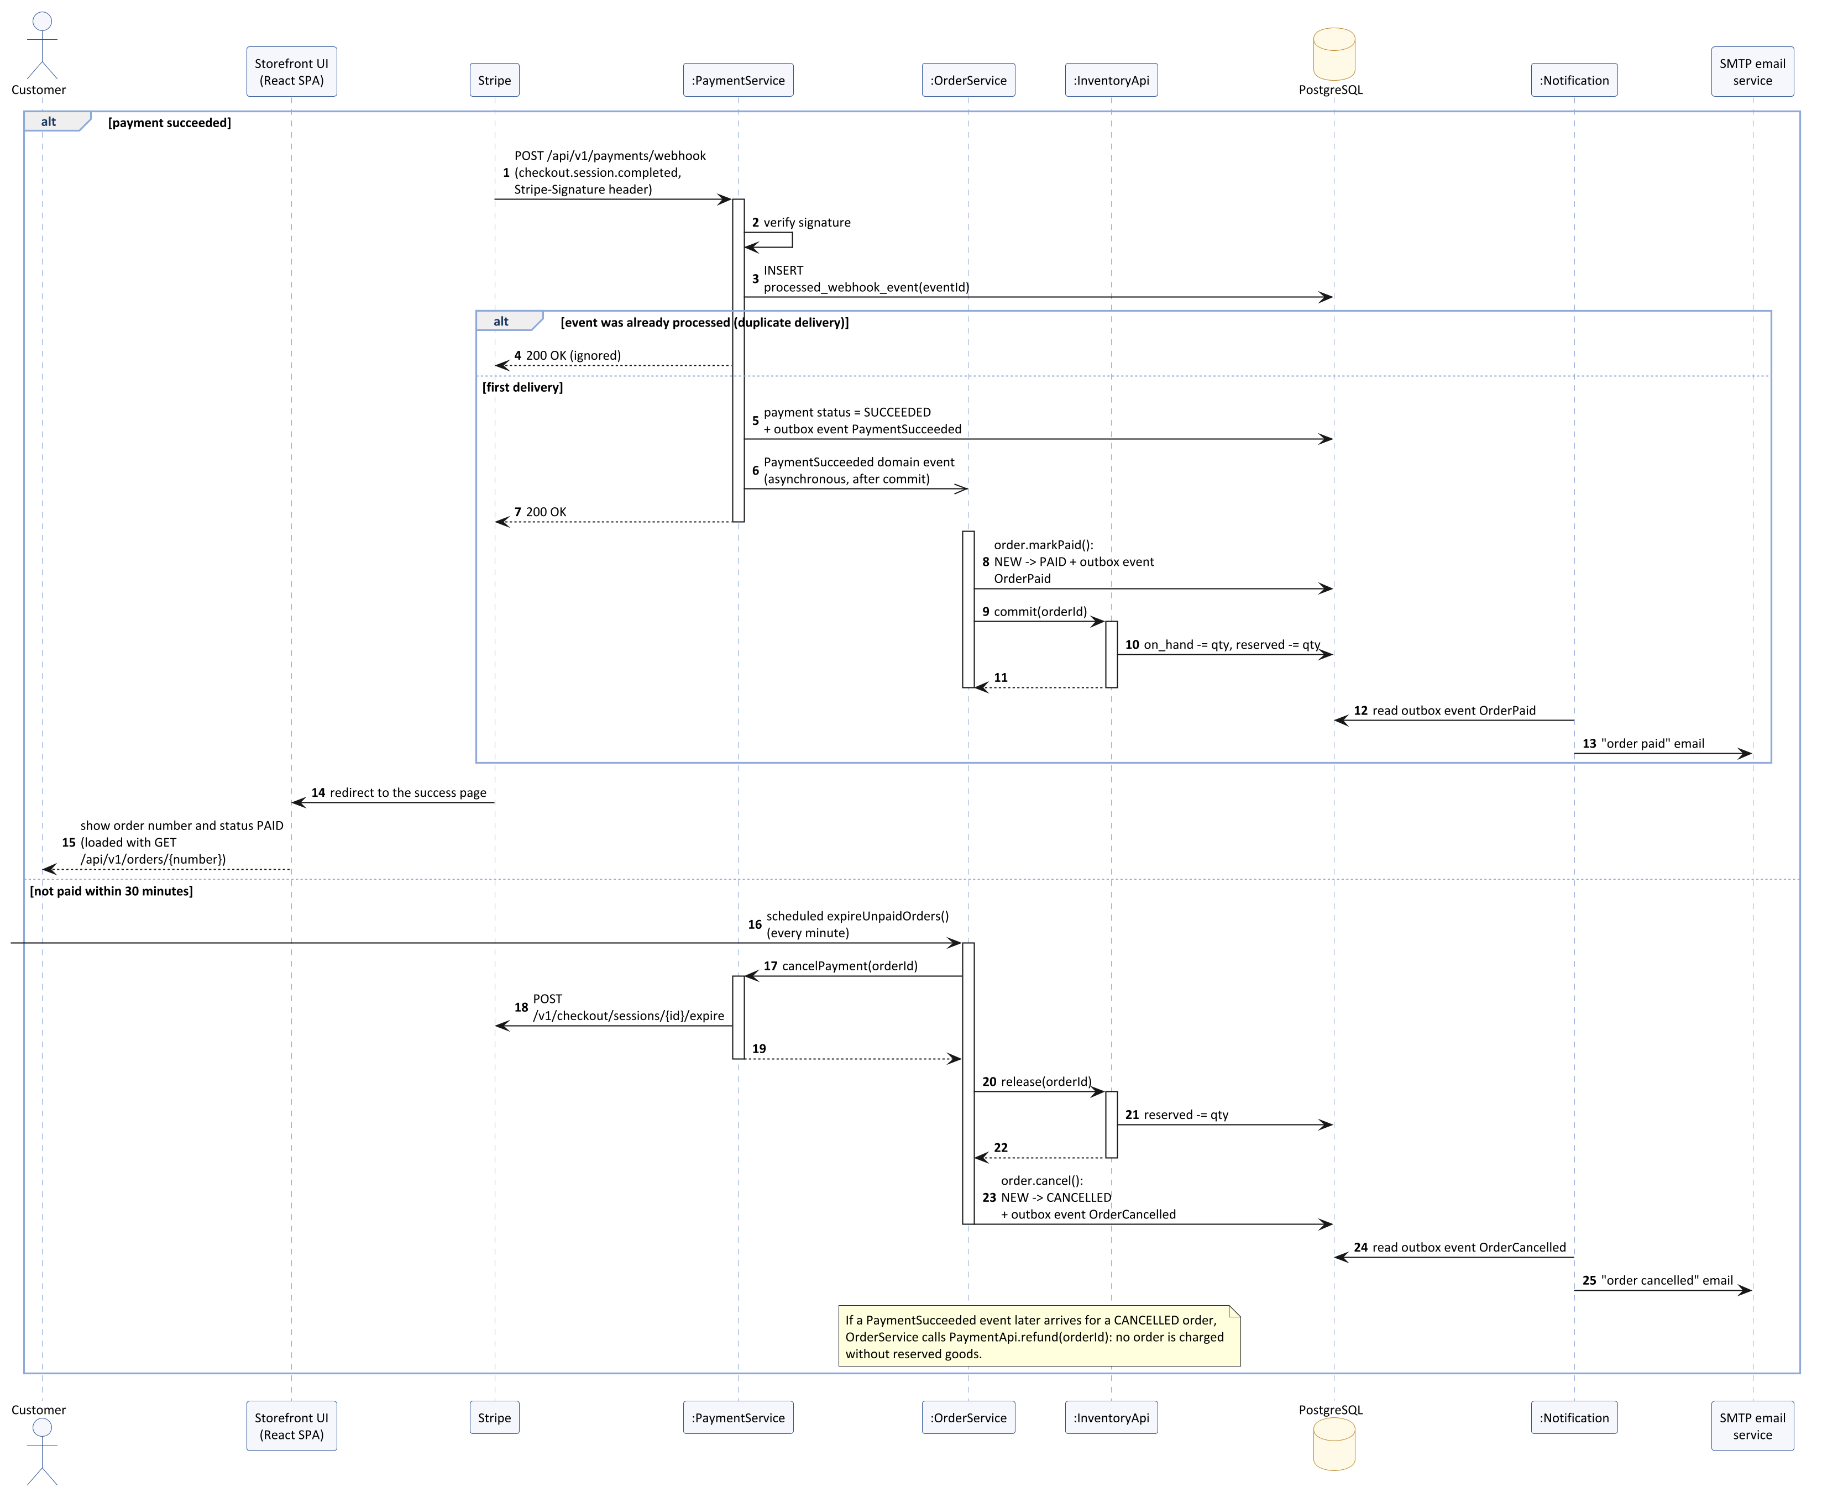
Figure 7 — UML sequence diagram, part 2: handling the payment result
Part 2 (Figure 7) — the result of the payment:
- Payment succeeded (steps 1–15): the webhook signature is verified and the event ID is recorded; a repeated event is ignored (steps 3–4). The PaymentSucceeded event is delivered to OrderService after the transaction commits; the order becomes Paid and the reservation is committed, so the stock decreases. The “order paid” email is sent from the outbox.
- Not paid within 30 minutes (steps 16–25): a scheduled job expires the Stripe session, releases the reservation and cancels the order; the customer receives an email. A late payment for a cancelled order is refunded automatically (note in the diagram).

5.4 State Machine Diagram of an Order
Why this diagram. The Specification defines seven order statuses, but the rules for moving between them are spread over several requirements: Order history and tracking, Stock reservation (automatic cancellation after 30 minutes), Order cancellation (allowed until the order is shipped, with a refund), Return request (within 14 days after delivery), Order status update and Order status emails. The state machine diagram collects these rules in one place, shows which transitions are allowed together with their triggers, guards and actions, and makes forbidden transitions (for example, cancelling a shipped order) explicit.
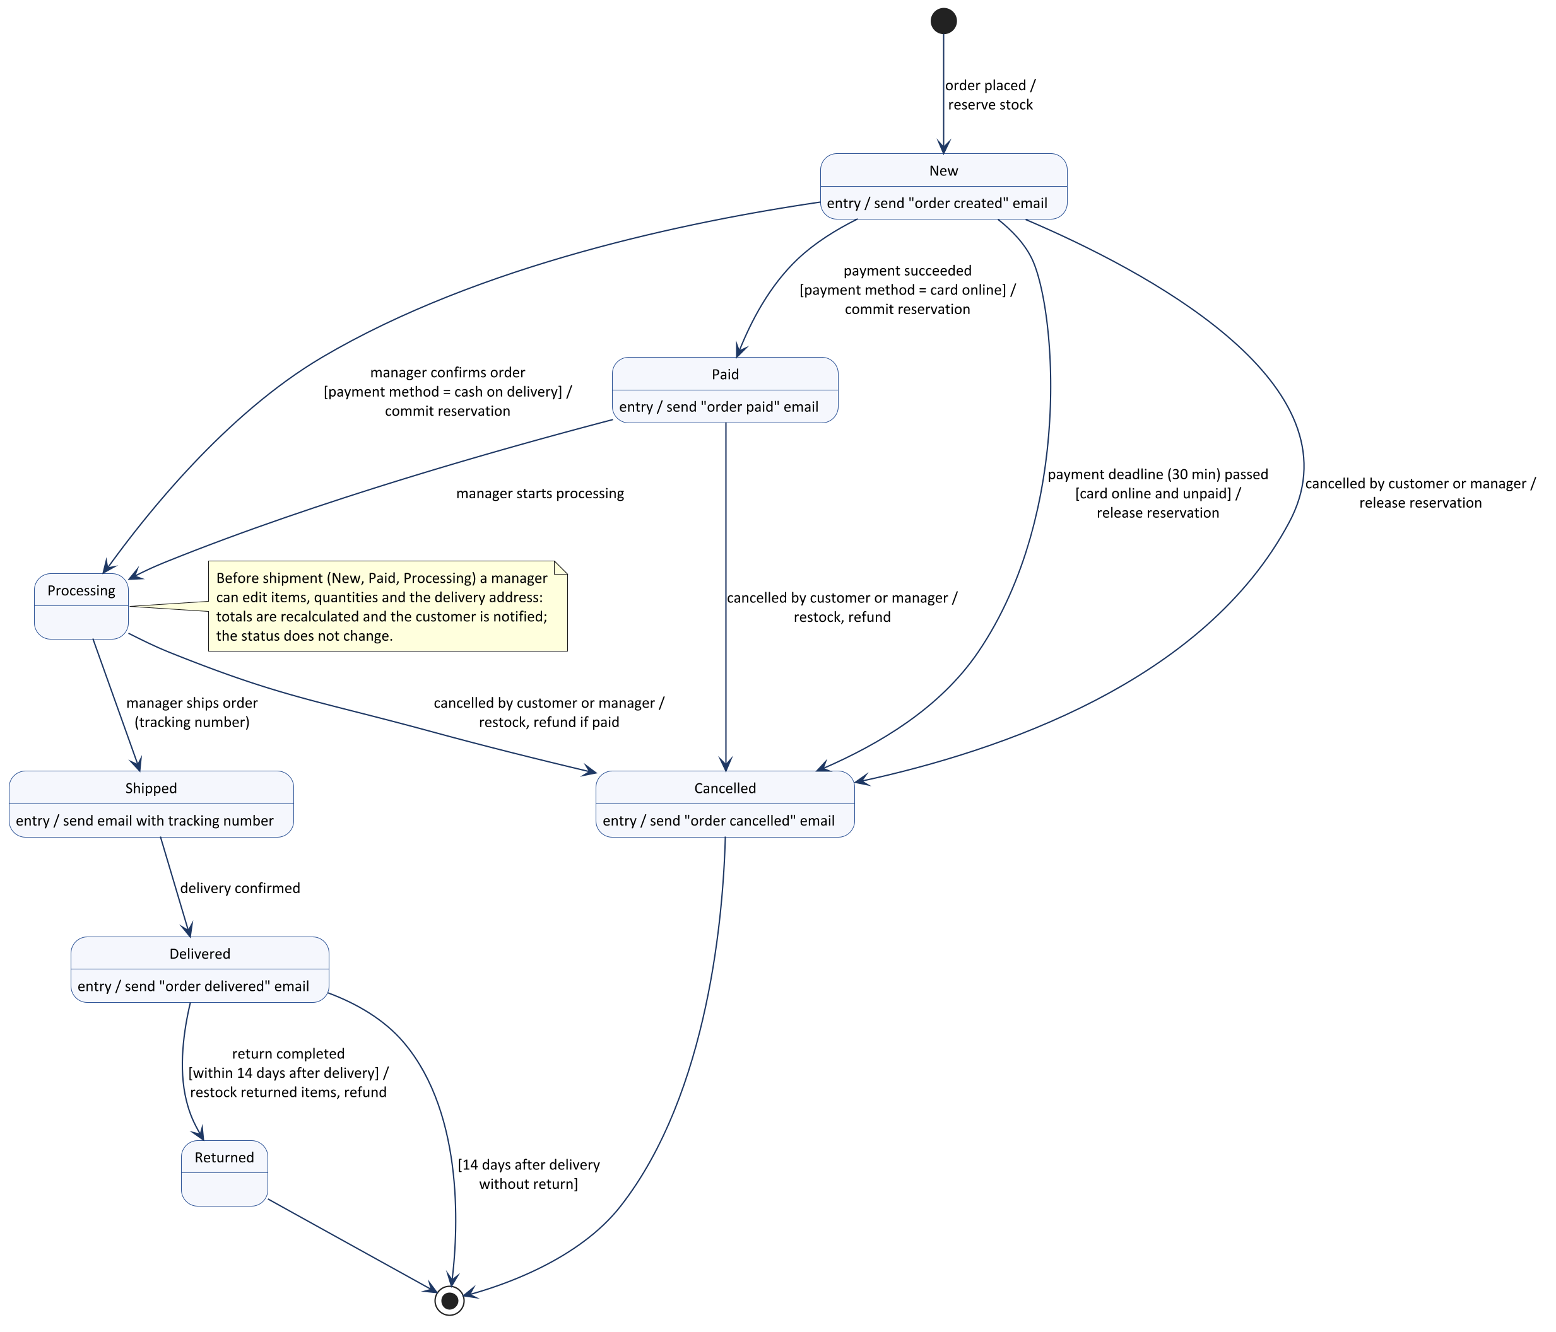
Figure 8 — UML state machine diagram of the order lifecycle
- Online card orders go New → Paid → Processing; cash-on-delivery orders go from New to Processing directly after a manager confirms them.
- Cancellation is possible from New, Paid and Processing, but not after the order has been shipped. Depending on the state, the stock reservation is released or the goods are returned to stock, and a paid order is refunded.
- A delivered order can become Returned only within 14 days after delivery.
- Entry actions send the emails required by Order status emails (created, paid, shipped, delivered, cancelled).
- The state machine is implemented as a transition table used by Order.changeStatus. Each allowed and each forbidden transition becomes an automated test case, which contributes to Test coverage 70%.

6. Diagram Selection Rationale and Relation to Non-Functional Requirements

6.1 Summary of Diagrams
Figure | UML diagram | Level | Why it was selected
1 | Component diagram (system level) | High-level | Shows the main parts of the system — client, backend, database, file storage, external services — and the protocols between them; needed to agree the overall structure with the customer and to plan the infrastructure.
2 | Component diagram (backend modules) | High-level | Shows the modules of the modular monolith and their interfaces; the main tool for keeping module boundaries and dividing work between the developers.
3 | Deployment diagram | High-level | Shows where the components run and how the nodes communicate; the only diagram that shows how availability, scalability, backups and encrypted traffic are achieved.
4, 5 | Class diagram (two views) | Detailed | Defines the structure of the key component and its dependencies; the basis for the database schema and the code.
6, 7 | Sequence diagram (two parts) | Detailed | Shows the order of interactions in the most critical scenario and where transactions, idempotency and error handling are applied.
8 | State machine diagram | Detailed | Defines the order lifecycle and all allowed status transitions in one place.

A use case diagram was not included, because the functional scope and the user roles are already defined in the Requirements Specification. An activity diagram was not needed, because the checkout workflow is fully described by the sequence diagrams.

6.2 Relation to Non-Functional Requirements
The table shows, for every non-functional requirement of the Specification, which architectural decision satisfies it and which figure shows this decision.
Requirement | Architectural decision | Figures
Performance
Server response time | Stateless instances behind a load balancer; in-process calls between modules; indexed queries; pagination; connection pool. | 1, 2, 3
Page load time | SPA and images delivered from the CloudFront CDN with browser caching; the SPA is split into parts loaded per page. | 1, 3
Search speed | PostgreSQL full-text search with GIN indexes and trigram indexes for suggestions in the Catalog module. | 2
Peak order throughput | Short checkout transaction; conditional stock update without table locks; emails sent asynchronously through the outbox; more instances added by the Auto Scaling group. | 3, 6, 7
Scalability
Adding servers | No server-side sessions (JWT), carts stored in the database, Auto Scaling group. | 3
Data volume | PostgreSQL on Amazon RDS with indexes, storage can be increased without changing the application; images stored in S3, not in the database. | 1, 3
Reliability and availability
Availability 99.5% | At least two instances in two availability zones, health checks, rolling deployments, Multi-AZ database with automatic failover. | 3
Backups and recovery | Automated daily RDS backups kept for 30 days; a backup is restored to a new database instance within the 4-hour recovery time. | 3
Order and payment integrity | One ACID transaction for the order and the reservation; idempotency key for order creation; Stripe idempotency keys; webhook deduplication; automatic refund of late payments. | 4–8
Security
Encrypted traffic | HTTPS with TLS 1.2+ on CloudFront and the load balancer; TLS to the database and to external services. | 1, 3
Password storage | BCrypt password hashing in the Identity module; passwords are never logged. | 2
No card data stored | Card data is entered only on the Stripe-hosted payment page; Payment stores only the session ID. | 5, 6
Role-based access control | Role checks in the Web & Security Layer for every endpoint; ownership checks for orders and personal data in the application services. | 2
Protection from attacks | Parameterized queries through JPA (SQL injection); output escaping in React (XSS); input validation; login and registration limited to 20 requests per minute per IP address; webhook signature verification. | 2, 7
Secrets management | Secrets stored in AWS Secrets Manager and read at startup; IAM roles instead of access keys. | 3
Usability and accessibility
Ease of ordering | Guest checkout without registration; checkout of at most three steps in the Storefront. | 1, 6
Accessibility WCAG 2.1 AA | Shared library of accessible UI components in the SPA (form labels, keyboard navigation, contrast, text alternatives for images). | 1
Responsive design | Responsive layouts with Tailwind CSS breakpoints for screens from 360 px to 1920 px. | 1
Browser support | The SPA is built by Vite for the last two versions of the supported browsers. | 1
User interface
Ukrainian and English | Translations in the SPA; email templates in both languages in the Notification module. | 1, 2
Price and date format | Money value object in UAH with two decimal places; prices and dates (DD.MM.YYYY) formatted in one place in the SPA. | 4
Clear error messages | Uniform error response with field-level errors from the Web & Security Layer, shown next to the fields in the SPA. | 2
Maintainability
Test coverage 70% | Modules with interfaces that are tested separately; the state machine and sequence diagrams define the test cases; Testcontainers for integration tests with PostgreSQL. | 2, 8
CI and code review | One repository and one GitHub Actions pipeline that builds, tests and deploys the single application. | 3
API documentation | The REST API is described in OpenAPI 3, generated from the controllers. | 1, 2
Logging and monitoring | Logs and metrics in Amazon CloudWatch; health endpoint /actuator/health checked by the load balancer. | 3

7. Conclusion
The architecture of ShopSphere has been designed on the basis of the Requirements Specification from Laboratory Work 1.
- A modular monolith with a React single-page application was selected after comparing it with a layered monolith, microservices and SOA. It gives the data consistency required for orders and payments, sufficient performance and horizontal scalability, and it is realistic for a team of two developers and the December launch.
- The high-level architecture is described by two component diagrams (system level and backend modules) and a deployment diagram. They show ten business modules, their interfaces, the protocols of all connections and the infrastructure that provides availability, scalability, security and backups.
- The key component — checkout and order processing — is described in detail by a class diagram (two views), a sequence diagram (two parts) and a state machine diagram. Together they define the data, the interactions and the lifecycle of an order and show how orders are protected from loss, duplication and double charging.
- Each of the 26 non-functional requirements is linked to an architectural decision and to a diagram (section 6.2).
Next steps: design the database schema of each module, describe the REST API in OpenAPI 3, create user interface prototypes, set up the project skeleton with the module structure and the CI/CD pipeline, and start implementing the High-priority requirements.

