PHPMyadmin

Although not recommended, you can directly manipulate the aqidb using phpmyadmin
It is accessed using the VM IP address and http://VMIPADDRESS/phpmyadmin

The username is ‘aqidb’, the password is ‘password’
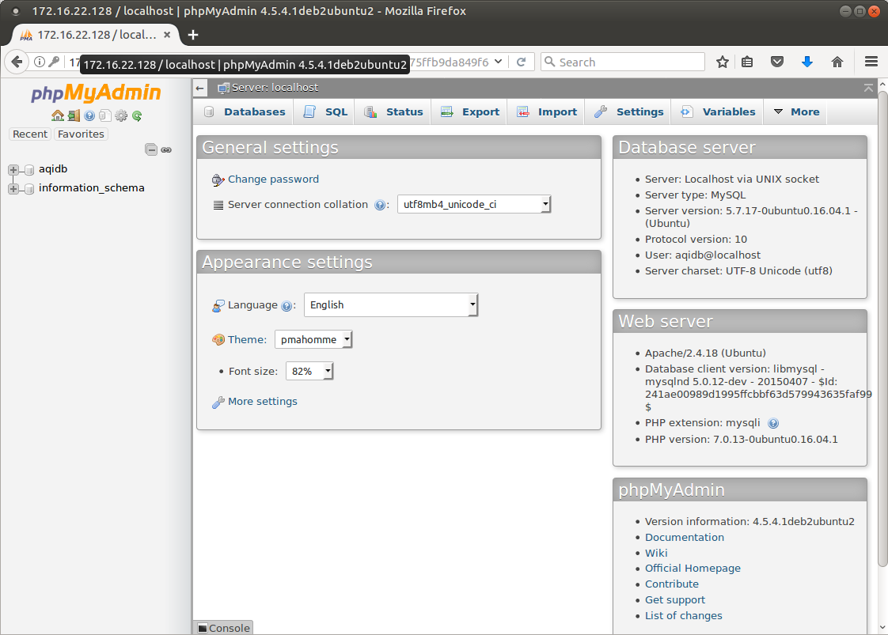

Refresh Wordpress with AQI Backups

You can access the wordpress home directory and the website directory via Windows Explorer using the \\VMIPADDRESS in the location bar of Windows Explorer.

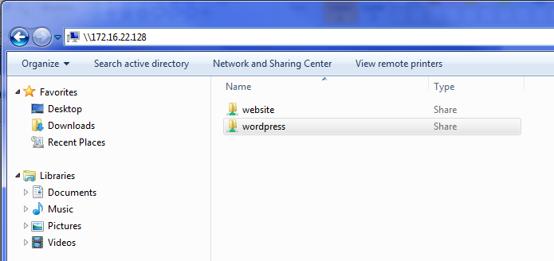

To refresh the wordpress database and website in the VM, you need to copy the two backup files to the ‘wordpress’ share in windows explorer.
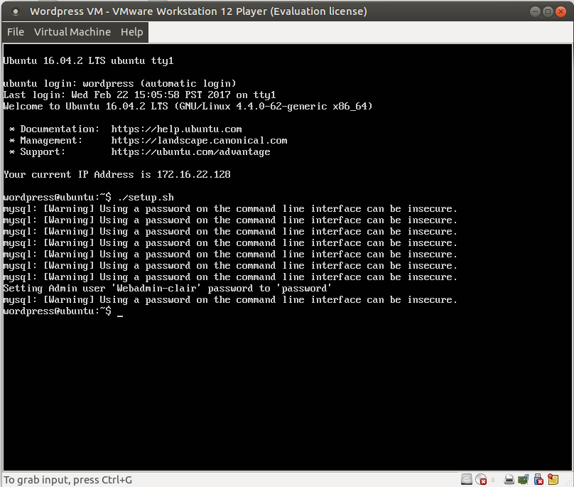
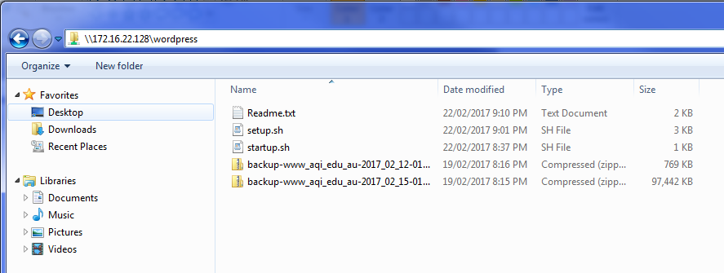

And then run the ./setup.sh script from the VM Console.

