Wordpress VM Instructions

Installation
- You will need to install VMWare Player on your Windows PC. You can download this from: http://www.vmware.com/go/downloadplayer
- Extract the AQIWordpressVM.zip to a directory on your Windows PC.
- Start VMWare Player and open the VM in the same location to which you extracted the zip file in step 2

Startup

The VM will take a while to start eventually you should see something similar to below, including the reference to your current IP address.
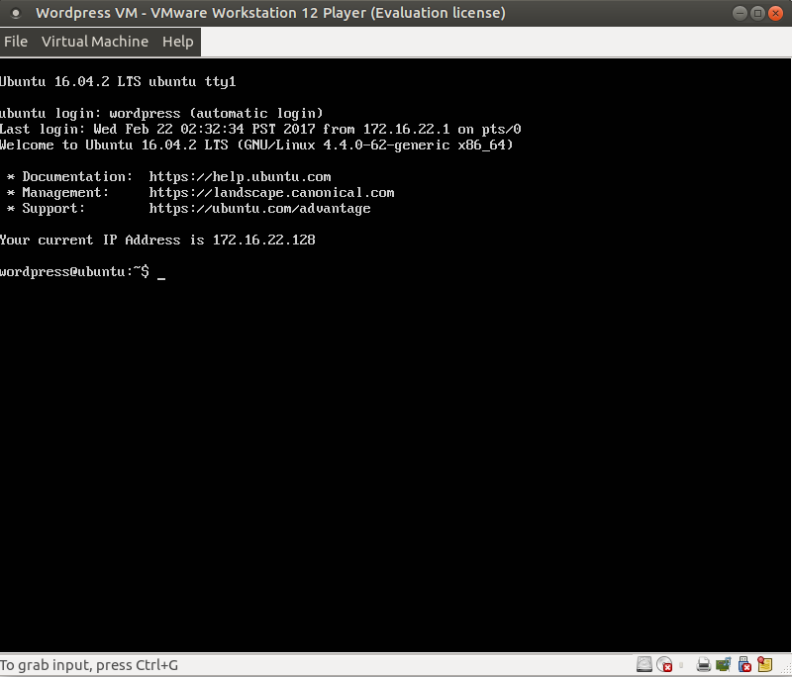
This is the IP address of the running VM and you need to take note of it because that is what you will use for windows network (samba) and in your browser. For the rest of the document we will return to the current IP Address as VMIPADDRESS.

The Web Site

You access the website using the http://VMIPADDRESS

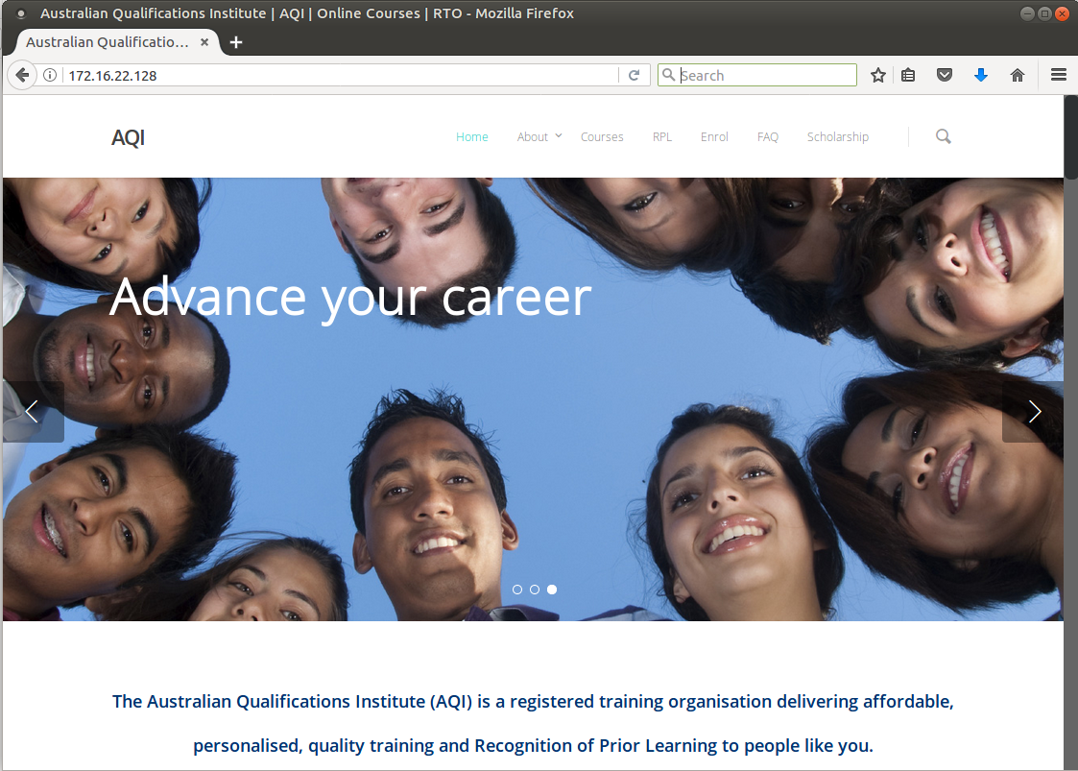

Wordpress Administration

You can access the wordpress administration section via the VM Ip address and http://VMIPADDRESS/wp-admin
The admin user is ‘admin’ and the password is ‘password’

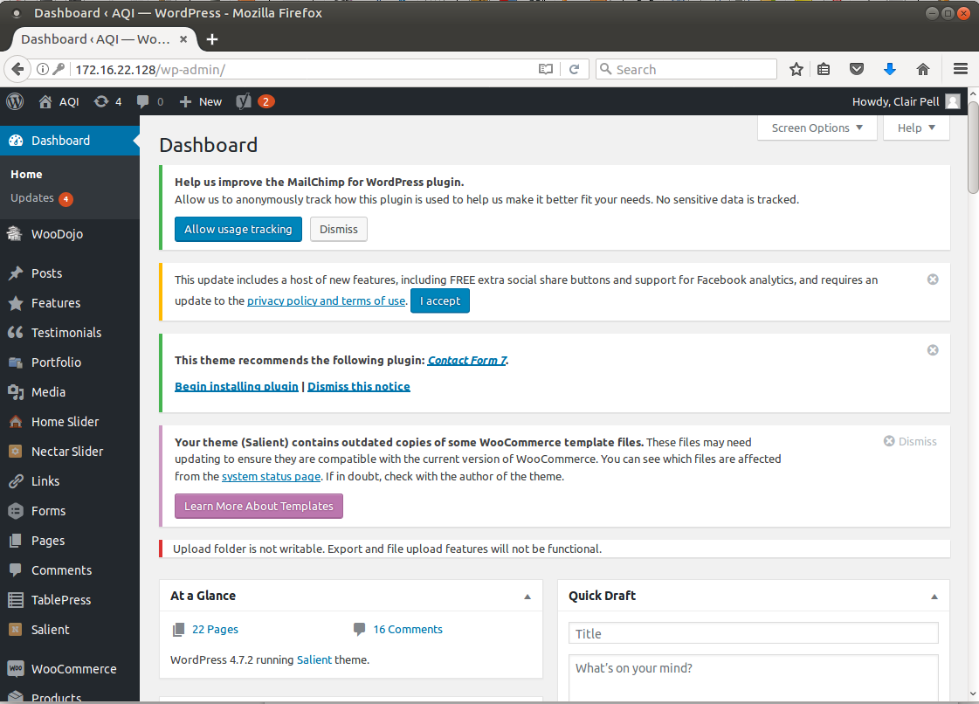

PHPMyadmin

Although not recommended, you can directly manipulate the aqidb using phpmyadmin
It is accessed using the VM IP address and http://http://VMIPADDRESS/phpmyadmin

The username is ‘aqidb’, the password is ‘password’
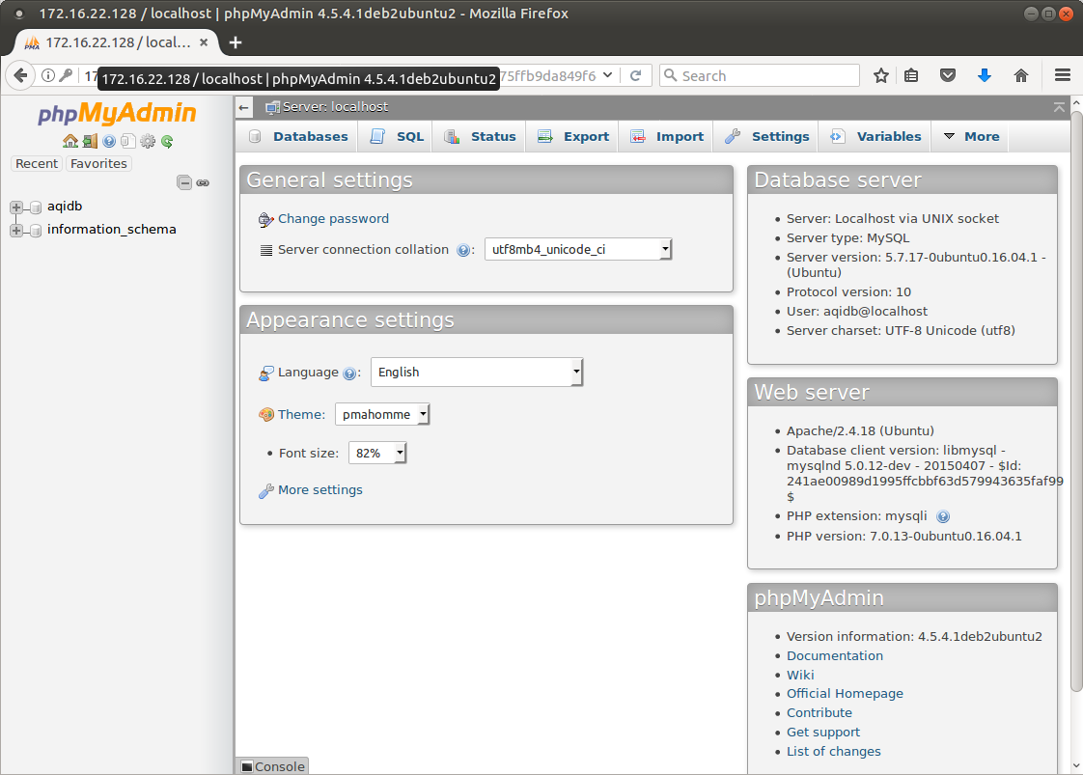

Refresh Wordpress with AQI Backups

You can access the wordpress home directory and the website directory via Windows Explorer using the \\VMIPADDRESS in the location bar of Windows Explorer.

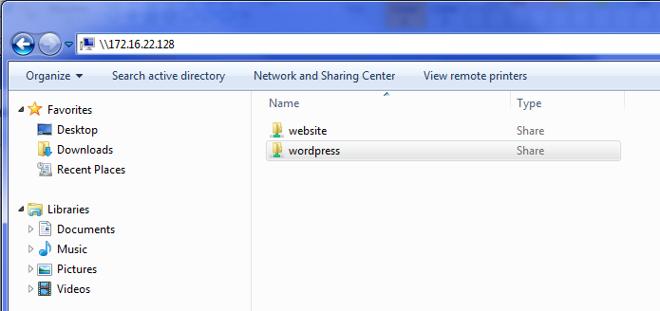

To refresh the wordpress database and website in the VM, you need to copy the two backup files to the ‘wordpress’ share in windows explorer.
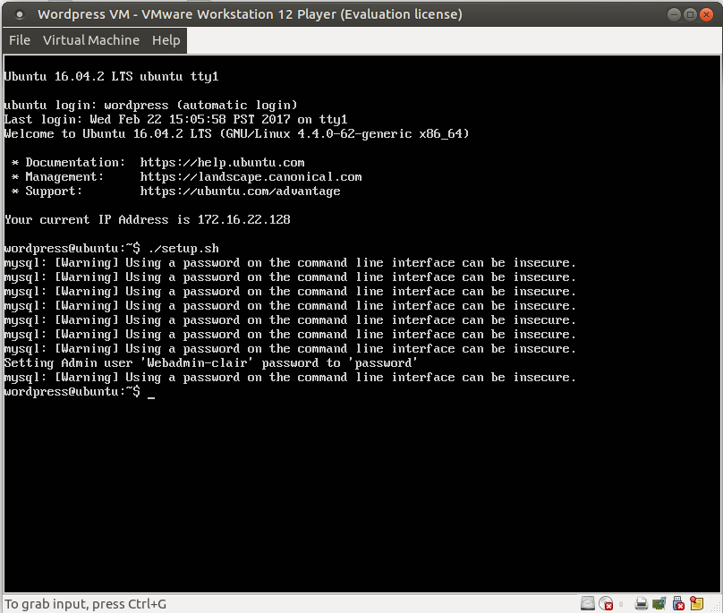
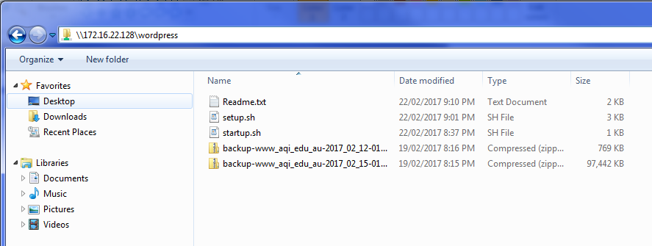

And then run the ./setup.sh script from the VM Console.

