Rigidity of the Midpoint Mean Value Property on Intervals of Fixed Length
Maksim Stepnov¹*
¹Independent Researcher; Katy, Texas, USA.
*Corresponding author. Email: mstepnov29@gmail.com
Abstract
The mean value theorem gives an interior point at which the derivative is equal to the average rate of change but it does not state where that point is. A standard converse says that if the midpoint works for every interval then the function is a polynomial of degree maximum two. This paper asks what happens when only one fixed interval length is required. The result is that parabolas are not the only solutions, there is an infinite amount of counterexamples, in the form${ e}^{at}cos\left(bt\right)$, and the smallest growth rate that occurs is $α_{1}=5.5373565660…$ This paper then proves that a solution created from a finite amount of similar models and growing more slowly than $e^{α_{1}\left|t\right|}$ must be a polynomial with degree equal or less than two, and that $α_{1}$ cannot be replaced by a larger number. The paper also gives an algebraic description of the problem using differentiation and translation operators. For every growth bound, the corresponding solution is a cyclic module over the ring created by differentiation. It can be shown with a quotient of this ring by an explicit polynomial. The rigidity result is equivalent to showing that this polynomial is $z^{3}$. Finally, it is shown that this is specific to the midpoint; if the point is moved further away from the center, the growth threshold disappears immediately.
Keywords: mean value theorem, midpoint property, functional equations, mixed-type differential equations, exponential growth, rigidity

Introduction
The mean value theorem guarantees the existence of a point where the derivative equals the average rate of change over an interval, but it does not state where that point is. If f is continuous on [a,b] and differentiable on (a,b), then there exists some ξ ∈ (a,b) such that $f'\left(b\right) = (f(b) - f(a))/ (b-a)$, A good question is, for which functions can this point always be chosen to be the midpoint $ξ=(a+b)/2$?
Every quadratic polynomial has this property, if the midpoint is a mean value point for every interval, then 𝑓 must be a polynomial of degree maximum two ((J. Aczél. Lectures on functional equations and their applications. Academic Press, 1966.)), ((H. Haruki. A property of quadratic polynomials. The American Mathematical Monthly. Vol. 86, pg. 577-579, 1979, https://doi.org/10.1080/00029890.1979.11994859.)), ((B. Richmond, T. Richmond. How to recognize a parabola. The American Mathematical Monthly. Vol. 116, pg. 910-922, 2009, https://doi.org/10.4169/000298909X477023.)), ((M. Stepnov. Localization theorem for the weighted mean value theorem. Preprint, https://github.com/MaksimStepnov228/Localization-Theorem, 2026.)).
Theorem 1. $f:R→R$ is differentiable, and satisfies $f\left(a+h\right)−f\left(a\right)=h\frac{df}{dt}\left(a+\frac{h}{2}\right)$ for every $a∈R$ and $h>0$. Then $f$ is a polynomial of degree equal or less than $2$.
Proof. Put $a=t−\frac{h}{2}$,
$f\left(t+\frac{h}{2}\right)−f\left(t−\frac{h}{2}\right)=h\frac{df}{dt}\left(t\right)$
for every $t$ and $h>0$; both sides change sign when $h$ does so (1) is correct for all real $h$. Theorem 3 shows that $f$ has derivatives of every order. Differentiating (1) twice with respect to $h$ and cancelling gives
$\frac{1}{4}\left[\frac{d^{2}f}{dt^{2}}\left(t+\frac{h}{2}\right)−\frac{d^{2}f}{dt^{2}}\left(t−\frac{h}{2}\right)\right]=0\text{ for all t }\text{and h},$
so $\frac{d^{2}f}{dt^{2}}$ has the same value everywhere and $f$ is a polynomial equal or less than $2$. However,${\left(t+\frac{h}{2}\right)}^{2}−{\left(t−\frac{h}{2}\right)}^{2}=2th=h⋅\frac{d}{dt}\left(t^{2}\right)$, so every similar polynomial works.
Question 2. Let $f:R→R$ be differentiable and assume$f\left(a+1\right)−f\left(a\right)=\frac{df}{dt}\left(a+\frac{1}{2}\right)\text{ for every a}∈R,$
so that the midpoint is a mean value point of every interval with length one. Is $f$ a polynomial of degree equal or less than $2$?
By the fundamental theorem of calculus, $f\left(a+1\right)−f\left(a\right)=\int_{a}^{a+1}{\frac{df}{dt}\left(s\right)ds}$, so writing $g := \frac{df}{dt}$, condition (2) says exactly that
$\int_{a}^{a+1}{g\left(s\right)ds=g\left(a+\frac{1}{2}\right)\text{ for every a}∈R.}$
that the midpoint rule of numerical integration with one subinterval with width $1$, is exact for $g$ on every interval with length one. Since $f\left(t\right) := \int_{0}^{t}{g\left(s\right)ds}$ recovers a solution (2) from a continuous solution (3). Theorem 1 is the fact that the midpoint rule is true for polynomials of degree equal or less than 1 and when the step size may change, the content is that one constant step size allows a lot more.
The standard theorem suggests that the answer is “parabolas,” it is not. There is an infinite amount of counterexamples.
$u_{1}\left(t\right)=e^{α_{1}t}cos\left(β_{1}t\right), α_{1}=5.5373565660…, β_{1}=14.9953525556…,$
a fast growing oscillation completing one cycle approximately every $0.419$ units. It satisfies (2) and it isn’t a parabola.
Every one of them grows at a minimum as fast as $e^{α_{1}\left|t\right|}$, so a solution that is not a polynomial cannot be small. Finding this is the main result of the paper, and the constant $α_{1}$ is actually sharp, it cannot be replaced by anything larger than it.
$α_{1}$ is not arbitrary. Trying $f\left(t\right)=e^{λt}$ in (2) collapses the problem to a single equation, and $λ=2\left(x+iy\right)$ and separating real from imaginary turns that equation into
$sinhxcosy=x, coshxsiny=y.$
Section 3 shows the possible growth rates form an increasing sequence $α_{1}<α_{2}<⋯$, and it shows $α_{1}$ is the smallest.

Methods
Note that (2) assumes $\frac{df}{dt}$ exists at every point since $a$ ranges over all of $R$. Replacing $a$ by $t−\frac{1}{2}$ changes (2) in the symmetric form used,
$\frac{df}{dt}\left(t\right)=f\left(t+\frac{1}{2}\right)−f\left(t−\frac{1}{2}\right).$
Theorem 3 Every solution of (6) has derivatives of all orders.
Proof. A differentiable function is continuous so the right side of (6) is continuous, so $\frac{df}{dt}$ is continuous and $f$ has a continuous first derivative. If $f$ has $n$ continuous derivatives then the right side also does, therefore does $\frac{df}{dt}$, giving $f$ its $\left(n+1\right)$st.
Another note is that the interval length does not matter. If $f$ has the midpoint property at $h$, meaning $f\left(a+h\right)−f\left(a\right)=h\frac{df}{dt}\left(a+\frac{h}{2}\right)$ for all $a$, then $g\left(t\right) := f\left(ht\right)$ has it at length $1$ by chain rule, and bound $\left|f\left(t\right)\right|≤Me^{c\left|t\right|}$ becomes $\left|g\left(t\right)\right|≤Me^{ch\left|t\right|}$. So every statement continues to length $h$ with each growth constant $c$ replaced by $c/h$, the threshold $α_{1}/h$, shorter intervals suggest the condition more frequently and are more rigid.
The equation as a quadrature error
Reformulation (3) is the statement that a quadrature error vanishes, and that error has a standard integral form, used twice below. Write
$L\left[f\right]\left(t\right) := f\left(t+1\right)−f\left(t\right)−\frac{df}{dt}\left(t+\frac{1}{2}\right),$
so that (2) reads $L\left[f\right]≡0$.
Theorem 4 If $g$ has two continuous derivatives then for every $m∈R$,
$\int_{m−1/2}^{m+1/2}{g\left(s\right)ds−g\left(m\right)=\int_{−1/2}^{1/2}{k\left(v\right)\frac{d^{2}g}{dt^{2}}\left(m+v\right)dv, k\left(v\right) := \frac{1}{2}{\left(\frac{1}{2}−\left|v\right|\right)}^{2},}}$
and $\int_{−1/2}^{1/2}{k\left(v\right)dv=\frac{1}{24}}$. So, for every $f$ with three continuous derivatives, $L\left[f\right]\left(t\right)=\int_{−1/2}^{1/2}{k\left(v\right)\frac{d^{3}f}{dt^{3}}\left(t+\frac{1}{2}+v\right)dv.}$
Proof. Substituting $s=m+u$ and writing $g\left(m+u\right)−g\left(m\right)=\int_{0}^{u}{\frac{dg}{dt}\left(m+w\right)dw}$ turns the left side into the double integral
$\int_{−1/2}^{1/2}{\int_{0}^{u}{\frac{dg}{dt}\left(m+w\right)dwdu,}}$
over the triangle $0≤w≤u≤\frac{1}{2}$ together with the triangle $−\frac{1}{2}≤u≤w≤0$, the second one counted negatively. Reversing the order of integration, the variable $u$ runs over $\left(w,\frac{1}{2}\right)$ in the first and over $\left(−\frac{1}{2},w\right)$ in the second, so the double integral equals
$\int_{−1/2}^{1/2}{sgn\left(w\right)\left(\frac{1}{2}−\left|w\right|\right)\frac{dg}{dt}\left(m+w\right)dw=−\int_{−1/2}^{1/2}{\frac{dk}{dv}\left(w\right)\frac{dg}{dt}\left(m+w\right)dw,}}$
since $\frac{dk}{dv}\left(w\right)=−sgn\left(w\right)\left(\frac{1}{2}−\left|w\right|\right)$. One integration by parts, with $k\left(±\frac{1}{2}\right)=0$, gives the stated identity, and $\int_{−1/2}^{1/2}{k=2\int_{0}^{1/2}{\frac{1}{2}{\left(\frac{1}{2}−v\right)}^{2}dv=\frac{1}{24}}}$. For (8) take $g=\frac{df}{dt}$ and $m=t+\frac{1}{2}$; the fundamental theorem of calculus turns the integral of $g$ into $f\left(t+1\right)−f\left(t\right)$, and $g\left(m\right)=\frac{df}{dt}\left(t+\frac{1}{2}\right)$.
Since $k>0$ on $\left(−\frac{1}{2},\frac{1}{2}\right)$, formula (8) says a solution of (2) is precisely a function whose third derivative averages to zero against $k$ at every point. Two things follow immediately. The first constrains the shape of any counterexample.
Theorem 5 If $f$ solves (2) and $\frac{d^{3}f}{dt^{3}}$ never changes sign, then $f$ is a polynomial of degree max. $2$.
Proof. By Theorem 3, the integrand in (8) is continuous and of one sign, so the integral's vanishing together with $k>0$ on the open interval forces $\frac{d^{3}f}{dt^{3}}\left(t+\frac{1}{2}+v\right)=0$ for every $t$ and every $v∈\left(−\frac{1}{2},\frac{1}{2}\right)$.
So every counterexample has a third derivative that changes sign, a first indication that the counterexamples must oscillate. The second consequence is the polynomial case. Taking $f=t^{j}$ in (8),
$L\left[t^{j}\right]=j\left(j−1\right)\left(j−2\right)\int_{−1/2}^{1/2}{k\left(v\right){\left(t+\frac{1}{2}+v\right)}^{j−3}dv=\frac{j\left(j−1\right)\left(j−2\right)}{24}t^{j−3}+⋯ \left(j≥3\right),}$
a polynomial of degree exactly $j−3$; in particular $L\left[1\right]=L\left[t\right]=L\left[t^{2}\right]=0$ and $L\left[t^{3}\right]=\frac{1}{4}$. So for a polynomial $p$ of degree $n$ we have $L\left[p\right]=0$ if and only if $n≤2$, because for $n≥3$ the leading coefficient of $L\left[p\right]$ is a nonzero multiple of that of $p$. The polynomial solutions are precisely the parabolas, exactly as in the classical case.
Counterexamples
Substituting $f\left(t\right)=e^{λt}$ for a complex number $λ$ divide by $e^{λt}$ turns (2)
$e^{λ}−1=λe^{λ/2},\text{ that is}, e^{λ/2}−e^{−λ/2}=λ.$
Writing $λ=2z$ and using $sinhz=\frac{1}{2}\left(e^{z}−e^{−z}\right)$,
$sinhz=z.$
Put $z=x+iy$ with $x,y$ real. The formula together with Euler’s formula gives $sinh\left(x+iy\right)=sinhxcosy+icoshxsiny$, so (10) is a real pair (5). Each pair $\left(x,y\right)$ gives a real solution (2), taking real and imaginary parts of $e^{2\left(x+iy\right)t}$ shows that
$e^{2xt}cos\left(2yt\right)\text{ and }e^{2xt}sin\left(2yt\right)$
both satisfy (2). These are the modes of the equation, $a=2x$ is the growth rate of the mode.
Two cases are immediate. If $y=0$ the pair becomes $sinhx=x$, which for real $x$ only at $x=0$, since $sinhx>x$ for $x>0$ and $sinh$ is odd. If $x=0$ it becomes to $siny=y$, only at $y=0$. So $\left(0,0\right)$ is the only solution on all axis, it corresponds to 0 growth rate and the solutions of growth rate $0$ are the parabolas of (9). So the question is whether (5) has any solutions with $x≠0$, it has infinite solutions.
Operators
For real number $s$ let $T_{s}$ be translation operator, $\left(T_{s}f\right)\left(t\right) := f\left(t+s\right)$ and $D := \frac{d}{dt}$ and $I := T_{0}$ for the identity. Then (7),
$L=T_{1}−I−DT_{1/2},$
and (2) is the equation $L\left[f\right]=0$. Let $A$ mean the collection of all operators from $D$ and the $T_{s}$ by taking the real linear combinations and composites. Since $T_{s}T_{u}=T_{s+u}$ and $D$ is commuted with every $T_{s}$, the collection A forms a commutative ring under addition and composition. It is commutative because differentiation commutes with every translation operator.
A ring is a collection of objects that can be added and multiplied according to the usual rules. In A, addition is the usual addition of operators, and multiplication is composition. This multiplication is commutative because differentiation commutes with translation.
An ideal is a subset of a ring that is closed under addition and remains inside the subset after multiplication by any element of the ring. For a fixed function, the operators in A that remove it form an ideal.
A module is similar to a vector space, except that its scalars come from a ring rather than a field. The solution spaces of (2) will be modules over the polynomial ring $R[D]$.
Theorem 6 There is a map $σ$ assigning to each $P∈A$ a function $σ\left(P\right)$ of a complex variable, determined by $σ\left(D\right)\left(z\right)=z, σ\left(T_{s}\right)\left(z\right)=e^{sz},$
such that $σ\left(P+Q\right)=σ\left(P\right)+σ\left(Q\right)$ and $σ\left(P∘Q\right)=σ\left(P\right)σ\left(Q\right)$. It satisfies $P\left[e^{λt}\right]=σ\left(P\right)\left(λ\right)e^{λt}\text{ for every P}∈A,\text{ every }λ∈C.$
For operator (12), $σ\left(L\right)\left(z\right)=e^{z}−1−ze^{z/2}=:Δ\left(z\right),$
the function that reappears in Theorem 11.
Proof. Both $D$ and $T_{s}$ act on $e^{λt}$ by multiplication by a number: $D\left[e^{λt}\right]=λe^{λt}$ and $T_{s}\left[e^{λt}\right]=e^{λs}e^{λt}$. Sums and composites of operators that multiply $e^{λt}$ by numbers again multiply it by the sum, respectively the product, of those numbers, so (13) holds with $σ$ defined as stated, and $σ$ converts sums into sums and composites into products. Reading (12) through $σ$ gives the stated symbol.
Three things follow at once. First, (13) says every exponential is an eigenvector of every operator in $A$ at the same time, with $σ\left(P\right)\left(λ\right)$ as the eigenvalue; so asking which exponentials solve $L\left[f\right]=0$ is the same as asking where $σ\left(L\right)$ vanishes, which is how (10) arose. Second, for a fixed function $f$ the set
$I_{f} := \left\{P∈A : P\left[f\right]=0\right\}$
is an ideal of $A$, it is closed under addition, and if $P\left[f\right]=0$ then $\left(Q∘P\right)\left[f\right]=Q\left[0\right]=0$ for every $Q$. Question 2 asks which $f$ have $L∈I_{f}$. Third, each $P∈A$ computes $P\left[f\right]\left(t\right)$ from the values of $f$ in a bounded window around $t$, and functions removed by such an operator are what Schwartz called mean-periodic ((L. Schwartz. Théorie générale des fonctions moyenne-périodiques. Annals of Mathematics. Vol. 48, pg. 857-929, 1947, https://doi.org/10.2307/1969386.)); Theorem 15 below is his description of the solution space, for our particular $L$.
Results

Results

Solving the two equations
Throughout this section $\left(x,y\right)$ is a solution of (5). In the first equation both sides are odd in $x$ and even in $y$; in the second both sides are even in $x$ and odd in $y$. So changing the sign of $x$, or of $y$, or of both, again gives a solution, and solutions come in groups of four, $\left(±x,±y\right)$. It is therefore enough to find those with $x>0$ and $y>0$.
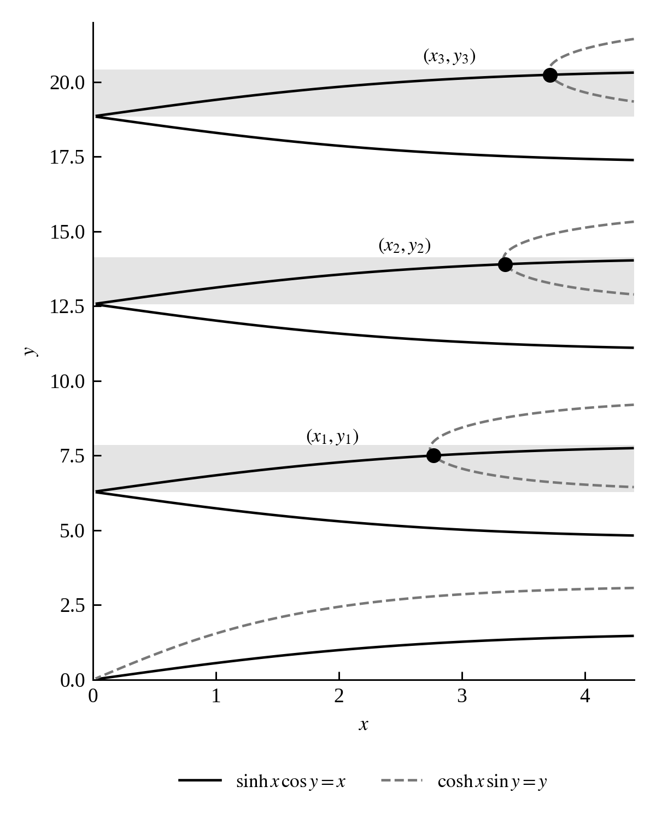
Figure 1 | The pair (5) as two families of curves in the plane. A point solves the system exactly when a solid curve meets a dashed one, and the first three crossings are marked. The shaded strips are the bands $J_{k}$ of Theorem 7; the crossings occur only there.
Each equation of (5) defines a family of curves in the $\left(x,y\right)$ plane, and a solution of the system is a point where a curve of one family meets a curve of the other; Figure 1 shows both families. The rest of this section proves that the crossings are exactly one per horizontal strip, and locates them.
Theorem 7 (Solutions) Let $\left(x,y\right)$ solve (5) with $x>0$ and $y>0$. Then $cosy>0, siny>0, \frac{tany}{y}=\frac{tanhx}{x},$
and consequently $y$ lies in one of the intervals $J_{k} := \left(2πk, 2πk+\frac{π}{2}\right)$ with $k≥1$ an integer.
Proof. Since $x>0$ we have $sinhx>x>0$, so the first equation gives $cosy=x/sinhx$, a number between $0$ and $1$. The second gives $siny=y/coshx>0$. A real number whose sine and cosine are both positive is in $\left(2πk,2πk+\frac{π}{2}\right)$ for integer $k≥0$. Dividing the second equation by the first gives $cothxtany=y/x$, which rearranges to $tany/y=tanhx/x$. Now $tanhx<x$ for every $x>0$, so the right side is less than $1$; and $tany>y$ on $\left(0,\frac{π}{2}\right)$, so if $k$ was $0$ the left side would be larger than $1$. Therefore, $k≥1$.
So no solution has $y$ below $2π$, to locate the solutions down eliminate $y$.
Theorem 8 Define $Y\left(x\right) := cothx\sqrt{\sinh^{2}x−x^{2}} \left(x>0\right).$
Then $Y$ is strictly increasing, $Y\left(x\right)→0$ as $x→0^{+}$, and $Y\left(x\right)→∞$ as $x→∞$; so $Y$ takes every positive value once.
Proof. Solve the two equations in (5) for cos y and sin y, then square and add, to get $x^{2}/\sinh^{2}x+y^{2}/\cosh^{2}x=\cos^{2}y+\sin^{2}y=1$. Solving for $y$ and using $y>0$ gives $y=coshx\sqrt{1−x^{2}/\sinh^{2}x}$, which is the labeled $Y\left(x\right)$.
For monotonicity, write $s\left(x\right) := x/sinhx$ and factor the same expression as
$Y\left(x\right)=coshx⋅\sqrt{1−s{\left(x\right)}^{2}}.$
Now $\frac{sinhx}{x}=\sum_{n≥0}{\frac{x^{2n}}{\left(2n+1\right)!}}$ is strictly increasing on $\left(0,∞\right)$, since every term is non decreasing and the term $\frac{x^{2}}{6}$ is strictly increasing. So $s$ is strictly decreasing with values in $\left(0,1\right)$, therefore $1−s^{2}$ is positive and strictly increasing, and so is its square root. Therefore, $Y$ is a product of two positive strictly increasing functions and is therefore strictly increasing.
For the limits, $s\left(x\right)→1$ and $coshx→1$ as $x→0^{+}$, so $Y\left(x\right)→0$; and $s\left(x\right)→0$ and $coshx→∞$ as $x→∞$, so $Y\left(x\right)→∞$. A strictly increasing continuous function with these limits takes every positive value exactly once.

Theorem 9. For each integer $k≥1$ there is exactly one solution $\left(x_{k},y_{k}\right)$ of (5) with $x_{k}>0$ and $y_{k}∈J_{k}$, and these, together with $\left(0,0\right)$ and the sign changes $\left(±x_{k},±y_{k}\right)$, are all the solutions. $x_{1}<x_{2}<x_{3}<⋯$ and $x_{k}→∞$, so the growth rates $α_{k} := 2x_{k}$ create a strictly increasing sequence and $α_{1}$ is the smallest one that is not zero.
Proof. Fix $k≥1$ and let $y$ range over $J_{k}$. By Theorem 8 there is exactly one $x>0$ with $Y\left(x\right)=y$; call it $X\left(y\right)$, and note $X$ is increasing because $Y$ is. We claim that $\left(X\left(y\right),y\right)$ solves (5) exactly when
$A\left(y\right) := \frac{tany}{y}\text{ equals B}\left(y\right) := \frac{tanh\left(X\left(y\right)\right)}{X\left(y\right)}.$
To see this, write $p=cosy$, $q=siny$, $P=x/sinhx$ and $Q=y/coshx$ with $x=X\left(y\right)$. The relation $y=Y\left(x\right)$ says $P^{2}+Q^{2}=1$, and $p^{2}+q^{2}=1$; and (14) says precisely $qP=pQ$. Two unit vectors in the plane with $qP−pQ=0$ are equal or opposite. Since $y∈J_{k}$ gives $p>0$ and $x>0$ gives $P>0$, they are equal, $p=P$ and $q=Q.$ The converse is Theorem 7 together with Theorem 8.
Compare the two sides of (14). On $J_{k}$,
$\frac{dA}{dy}\left(y\right)=\frac{y\sec^{2}y−tany}{y^{2}}=\frac{\sec^{2}y}{y^{2}}\left(y−\frac{1}{2}sin2y\right)>0,$
because $y>2π>\frac{1}{2}≥\frac{1}{2}sin2y$ there; and $A$ runs from $0$ at the left end of $J_{k}$ to $+∞$ at the right end. Meanwhile $t↦tanht/t$ is positive and strictly decreasing on $\left(0,∞\right)$, and $X$ is increasing, so $B$ is positive and strictly decreasing on $J_{k}$, with finite values at both ends. So $A−B$ is strictly increasing, negative near the left end and $+∞$ at the right end, and therefore vanishes at exactly one point of $J_{k}$. That gives exactly one solution per band, and Theorem 7 says there are no others with $x,y>0$.
For the ordering, $y_{k}=Y\left(x_{k}\right)$ lies in $J_{k}$, so $x_{k}$ lies in the interval $I_{k} := \left(X\left(2πk\right),X\left(2πk+\frac{π}{2}\right)\right)$. Since $2π\left(k+1\right)>2πk+\frac{π}{2}$, these intervals are disjoint and move steadily to the right, so $x_{k}$ increases with $k$. Finally the second equation of (5) gives $y_{k}≤coshx_{k}$, and $y_{k}>2πk→∞$, so $x_{k}→∞$.
The second equation of (5) can be solved for $x$ outright, and doing so pins down how the growth rates behave for large $k$.
Theorem 10 (Exact formula and growth of the rates). Every solution of (5) with $x,y>0$ satisfies $coshx=\frac{y}{siny},\text{ that is}, x=arccosh\left(\frac{y}{siny}\right).$
Moreover $cosy_{k}→0$ and $siny_{k}→1$ as $k→∞$, and $x_{k}=log\left(4πk\right)+O\left(\frac{1}{k}\right),\text{ so }α_{k}=2log\left(4πk\right)+O\left(\frac{1}{k}\right).$
Proof. Equation (15) is the second equation of (5) divided by $siny$, which is positive by Theorem 7; and $cosh$ is increasing on $x>0$, so it may be inverted.
By Theorem 9 we have $x_{k}→∞$, and the first equation of (5) gives $cosy_{k}=x_{k}/sinhx_{k}$, which tends to $0$ because $sinhx$ outgrows $x$. Since $siny_{k}>0$ and $\sin^{2}+\cos^{2}=1$, this forces $siny_{k}→1$.
For the asymptotics, we use two elementary estimates. First, for $w≥2$,
$arccoshw=log\left(w+\sqrt{w^{2}−1}\right)=log\left(2w\right)+log\frac{1+\sqrt{1−w^{−2}}}{2},$
and since $\sqrt{1−u}≥1−u$ for $0≤u≤1$, the last term lies between $−w^{−2}$ and $0$; so
$\left|arccoshw−log\left(2w\right)\right|≤w^{−2}$. Second, writing $c := cosy_{k}$, we have $siny_{k}=\sqrt{1−c^{2}}$ and hence $\left|logsiny_{k}\right|=\frac{1}{2}\left|log\left(1−c^{2}\right)\right|≤c^{2}$ once $c^{2}≤\frac{1}{2}$. Applying both to (15),
$x_{k}=log\left(2y_{k}\right)−logsiny_{k}+O\left(y_{k}^{−2}\right)=log\left(2y_{k}\right)+O\left(c^{2}\right)+O\left(k^{−2}\right).$
Now $2πk<y_{k}<2πk+\frac{π}{2}$ gives $4πk<2y_{k}<4πk+π$, so $0<log\left(2y_{k}\right)−log\left(4πk\right)<log\left(1+\frac{1}{4k}\right)<\frac{1}{4k}$. This already shows $x_{k}=log\left(4πk\right)+o\left(1\right)$, and in particular $x_{k}=O\left(logk\right)$. Feeding that back,
$coshx_{k}=y_{k}/siny_{k}$ is of size $2πk$, so $e^{x_{k}}$ is of size $4πk$ and $c=x_{k}/sinhx_{k}=O\left(logk/k\right)$, whence $c^{2}=O\left({\left(logk\right)}^{2}/k^{2}\right)$. Collecting the three error terms gives
$\left|x_{k}−log\left(4πk\right)\right|≤\frac{1}{4k}+O\left({\left(logk\right)}^{2}/k^{2}\right)$, which is the claim. Doubling gives the statement for $α_{k}$.
Numerically $k\left(x_{k}−log\left(4πk\right)\right)$ is $0.2377$ at $k=1$ and $0.2509$ at $k=1000$, so the error really is of size $\frac{1}{4k}$, exactly the bound the proof produces.
Since $y_{k}>2π$, every mode has $β_{k}=2y_{k}>4π$, so no counterexample oscillates slowly. Table 1 lists the first six solutions and Figure 2 plots them.
Table 1 | The first six solutions of $sinhxcosy=x$, $coshxsiny=y$ with $x,y>0$, and the growth rates of the corresponding modes. All digits shown are correct: the values were computed in mpmath at $50$ decimal digits, and a script in the supplement regenerates every number in this paper.
$k$ | $x_{k}$ | $y_{k}$ | growth rate $α_{k}=2x_{k}$
$1$ | $2.7686782830$ | $7.4976762778$ | $5.5373565660$
$2$ | $3.3522098849$ | $13.8999597140$ | $6.7044197697$
$3$ | $3.7167676798$ | $20.2385177078$ | $7.4335353595$
$4$ | $3.9831416403$ | $26.5545472655$ | $7.9662832807$
$5$ | $4.1932514704$ | $32.8597410051$ | $8.3865029409$
$6$ | $4.3667951177$ | $39.1588165201$ | $8.7335902353$
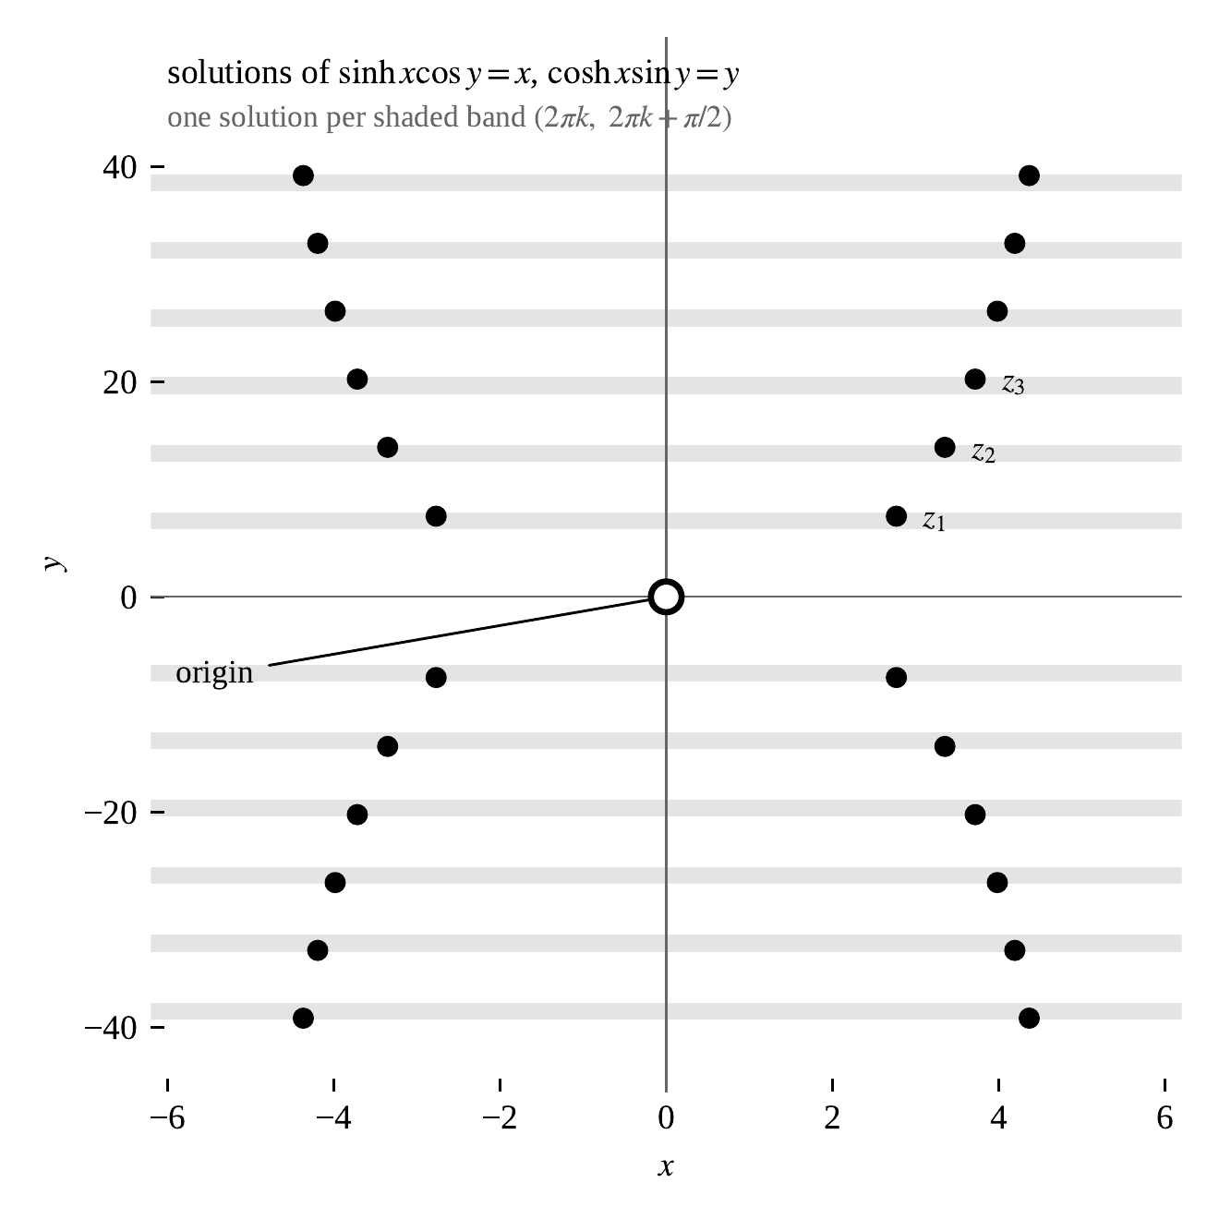
Figure 2 | Solutions $\left(x,y\right)$ of the pair (5), plotted as points $x+iy$. The origin is a solution of a special kind and accounts for $1$, $t$, $t^{2}$. Every other solution lies in one of the shaded bands $y∈\left(2πk,2πk+\frac{π}{2}\right)$, exactly one per band (Theorem 9).

Counterexample 1
Taking $k=1$ and forming the mode (11) gives
$u_{1}\left(t\right)=e^{α_{1}t}cos\left(β_{1}t\right), α_{1}=2x_{1}=5.5373565660…, β_{1}=2y_{1}=14.9953525556…,$
which is the function announced in (4). Its period is $2π/β_{1}=0.4190088418…$, so it completes more than two full oscillations per unit of length while its envelope multiplies by $e^{α_{1}}≈254$. Figure 3 shows it. It answers Question 2 in the negative, and by Theorem 9 no counterexample of this form grows more slowly.
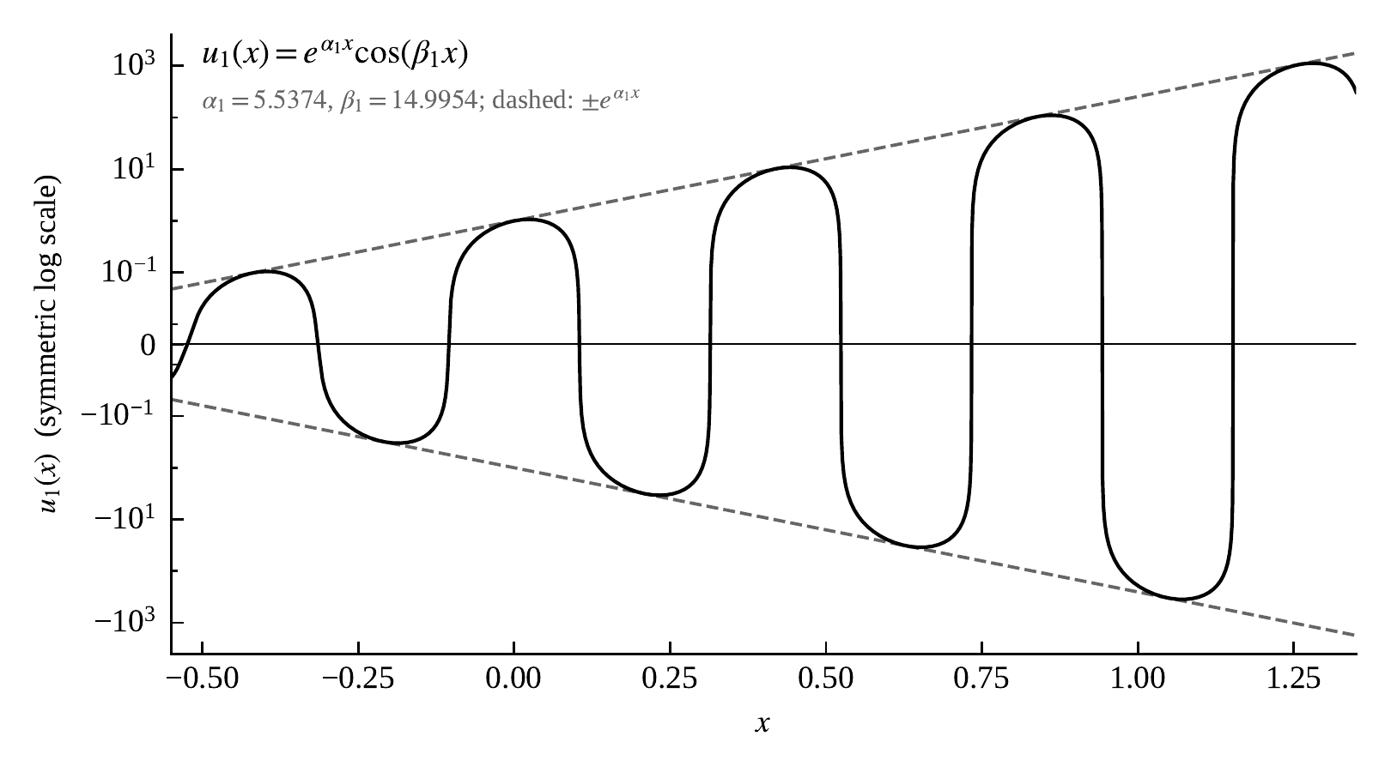
Figure 3 | The first counterexample $u_{1}\left(t\right)=e^{α_{1}t}cos\left(β_{1}t\right)$, on a symmetric logarithmic scale so that the oscillation and the growth are visible together. The dashed lines are the envelope $±e^{α_{1}t}$.

Threshold
We can now state the rigidity result. Call a function an exponential sum if it has the form
$f\left(t\right)=p\left(t\right)+\sum_{k=1}^{N}{e^{a_{k}t}\left(A_{k}cos\left(b_{k}t\right)+B_{k}sin\left(b_{k}t\right)\right),}$
with $p$ a polynomial, $N$ finite, the pairs $\left(a_{k},b_{k}\right)$ distinct, $b_{k}≥0$, and $\left(A_{k},B_{k}\right)≠\left(0,0\right)$. Every counterexample produced above is of this form, and so is every finite combination of them.
Theorem 11 (Threshold for exponential sums). Let $f$ be an exponential sum satisfying (2). Then $p$ has degree at most $2$, and each pair $\left(a_{k}/2,b_{k}/2\right)$ solves (5); in particular $\left|a_{k}\right|≥α_{1}$ for every $k$. Consequently, if in addition $\left|f\left(t\right)\right|≤Me^{c\left|t\right|}\text{ for all t},\text{ with }0≤c<α_{1}=5.5373565660…,$
then no exponential terms can occur and $f$ is a polynomial of degree at most $2$.
Proof. The operator $L$ of (7) is linear, and it sends each mode to a multiple of itself: for complex $λ$,
$L\left[e^{λt}\right]=\left(e^{λ}−1−λe^{λ/2}\right)e^{λt}=:Δ\left(λ\right)e^{λt},$
so taking real and imaginary parts, $L$ carries the two-dimensional space spanned by $e^{at}cos\left(bt\right)$ and $e^{at}sin\left(bt\right)$ into itself, and kills it exactly when $Δ\left(a+ib\right)=0$. Also $L\left[p\right]$ is a polynomial for any polynomial $p$.
The functions $1,t,…,t^{degp}$ together with the modes $e^{a_{k}t}cos\left(b_{k}t\right)$, $e^{a_{k}t}sin\left(b_{k}t\right)$ for distinct pairs $\left(a_{k},b_{k}\right)$ are linearly independent: they are solutions of a linear constant coefficient differential equation whose characteristic roots $0$ and $a_{k}±ib_{k}$ are distinct, and such solutions are independent. Applying $L$ to (16) and using $L\left[f\right]=0$, the polynomial part and each two-dimensional mode block must therefore vanish separately. So $L\left[p\right]=0$, which by (9) forces $degp≤2$; and $Δ\left(a_{k}+ib_{k}\right)=0$ for each $k$, which is exactly the statement that $\left(a_{k}/2,b_{k}/2\right)$ solves (5). By Theorem 9 a nonzero solution of (5) has $\left|x\right|≥x_{1}$, so $\left|a_{k}\right|=2\left|x\right|≥2x_{1}=α_{1}$.
For the last claim, suppose some exponential term is present and let $a := \max_{k}a_{k}$, assuming first $a>0$. Multiplying $f$ by $e^{−at}$ and letting $t→+∞$, every other term tends to $0$ and the polynomial part does too, so $e^{−at}f\left(t\right)−\left(Acos\left(bt\right)+Bsin\left(bt\right)\right)→0$ for the surviving block. The function $Acos\left(bt\right)+Bsin\left(bt\right)$ has amplitude $\sqrt{A^{2}+B^{2}}>0$, so there are arbitrarily large $t$ with $\left|f\left(t\right)\right|≥\frac{1}{2}\sqrt{A^{2}+B^{2}}e^{at}$, which is incompatible with $\left|f\left(t\right)\right|≤Me^{ct}$ once $c<a$. Hence $a≤c<α_{1}$, contradicting $\left|a_{k}\right|≥α_{1}$. If instead every $a_{k}$ is negative, the same argument applied as $t→−∞$ gives the same contradiction. So no exponential term occurs.
Remark 12. The restriction $b_{k}≥0$ and the absence of terms like $te^{at}cos\left(bt\right)$ cost nothing. A term $te^{λt}$ satisfies $L\left[te^{λt}\right]=Δ\left(λ\right)te^{λt}+\frac{dΔ}{dλ}\left(λ\right)e^{λt}$, so it can belong to a solution only if both $Δ\left(λ\right)$ and $\frac{dΔ}{dλ}\left(λ\right)$ vanish. One checks directly that $\frac{dΔ}{dλ}≠0$ at every nonzero root, so such terms never appear.
The constant in Theorem 11 cannot be improved, and the reason is simply that $u_{1}$ exists.
Theorem 13 (Sharpness). The function $u_{1}$ of (4) satisfies (2), is not a polynomial, and obeys $\left|u_{1}\left(t\right)\right|≤e^{α_{1}\left|t\right|}$ for every $t$. Hence $α_{1}$ in Theorem 11 cannot be replaced by any larger constant.
Proof. That $u_{1}$ satisfies (2) is the construction of (11). For $t≥0$ we have $\left|u_{1}\left(t\right)\right|≤e^{α_{1}t}=e^{α_{1}\left|t\right|}$, and for $t≤0$ we have $\left|u_{1}\left(t\right)\right|≤e^{α_{1}t}≤1$. Since $u_{1}$ is unbounded and changes sign infinitely often it is not a polynomial. If Theorem 11 held with some $c′>α_{1}$ in place of $α_{1}$, then $u_{1}$, which meets the growth bound with $c=α_{1}<c′$, would be forced to be a polynomial.
Figure 4 summarises the picture on a single axis.
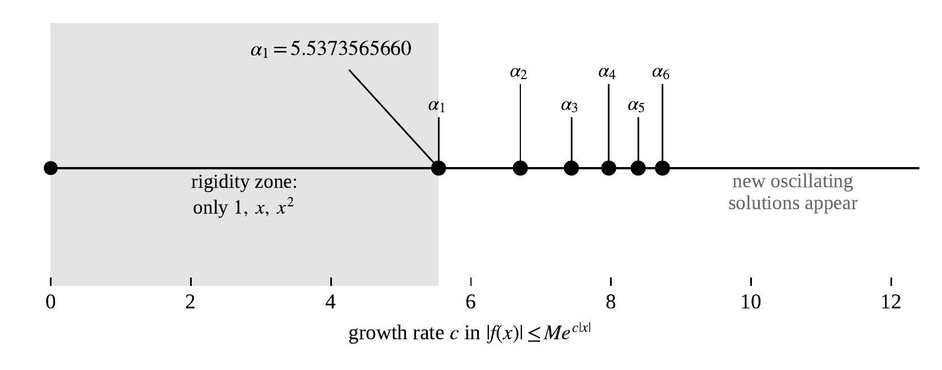
Figure 4 | The classification on one axis. Below $α_{1}=5.5373565660$ the only solutions are $1$, $t$ and $t^{2}$. Each later growth rate $α_{k}$ admits four further modes, $e^{±α_{k}t}cos\left(β_{k}t\right)$ and $e^{±α_{k}t}sin\left(β_{k}t\right)$.
Remark 14 (The bound has to be two-sided). The absolute value in $e^{c\left|t\right|}$ matters. Asking only that $f\left(t\right)=O\left(e^{ct}\right)$ as $t→+∞$ is not enough for any $c$, however small, because solutions of (5) come in $±$ pairs: alongside $u_{1}$ there is $v_{1}\left(t\right) := e^{−α_{1}t}cos\left(β_{1}t\right)$, which is bounded for $t≥0$ and is not a polynomial. The symmetry is forced, since $t↦f\left(−t\right)$ turns one solution of (2) into another.

The general case
Theorem 11 assumes the solution is built from finitely many modes. That assumption can be dropped.
Theorem 15 (General threshold; proof in ((M. Stepnov. A transform proof of the midpoint rigidity theorem. Companion preprint, https://github.com/MaksimStepnov228/Midpoint-theorem, 2026.))). Let $f:R→R$ be differentiable and satisfy (2), and suppose $\left|f\left(t\right)\right|≤Me^{c\left|t\right|}$ for all $t$ with $0≤c<α_{1}$. Then $f$ is a polynomial of degree at most $2$. More generally, for any $c≥0$, every solution obeying that bound is a finite combination of the modes whose growth rate is at most $c$ in absolute value, together with a polynomial of degree at most $2$.
We do not prove this here, because the argument is of a different kind: one takes Laplace transforms of $f$ on the two half-lines separately, observes that the two transforms are given by a single formula whose poles sit exactly at the numbers $2\left(x_{k}+iy_{k}\right)$ catalogued above, and moves a contour of integration across the strip $\left|Res\right|≤c$, picking up one residue per admissible mode. That belongs to complex analysis rather than calculus, and it is carried out in the companion preprint ((M. Stepnov. A transform proof of the midpoint rigidity theorem. Companion preprint, https://github.com/MaksimStepnov228/Midpoint-theorem, 2026.)). General theories of this type for equations that refer to both past and future values go back to Rustichini ((A. Rustichini. Functional differential equations of mixed type: the linear autonomous case. Journal of Dynamics and Differential Equations. Vol. 1, pg. 121-143, 1989, https://doi.org/10.1007/BF01047828.)) and Mallet-Paret ((J. Mallet-Paret. The Fredholm alternative for functional differential equations of mixed type. Journal of Dynamics and Differential Equations. Vol. 11, pg. 1-47, 1999, https://doi.org/10.1023/A:1021889401235.)); see also Bellman and Cooke ((R. Bellman, K. L. Cooke. Differential-difference equations. Academic Press, 1963.)) for the classical theory of equations of this shape.
What matters for the present paper is that the constant is the same in both statements. The elementary analysis of (5) is what produces $α_{1}$, and no transform can change it.
Remark 16. Some growth restriction really is needed in Theorem 15. Infinite superpositions $\sum_{k}{c_{k}e^{α_{k}t}cos\left(β_{k}t\right)}$ with rapidly shrinking coefficients converge and differentiate term by term, and they satisfy (2) while growing faster than any single exponential. So the finiteness in (16) is a genuine hypothesis, not a technicality.

The solution space as a module
The operator language of Theorem 6 lets the whole classification be packed into a single algebraic statement. Fix $c≥0$ and let $m=m\left(c\right)$ be the number of indices $k$ with $α_{k}≤c$, so $m=0$ exactly when $c<α_{1}$. Let
$M_{c} := \left\{f:R→R : f\text{ is differentiable}, L\left[f\right]=0,\text{ and }\left|f\left(t\right)\right|≤Me^{c\left|t\right|}\text{ for some M}\right\}.$
By Theorem 15 this is the span of $1,t,t^{2}$ together with the $4m$ functions $e^{±α_{k}t}cos\left(β_{k}t\right)$ and $e^{±α_{k}t}sin\left(β_{k}t\right)$ for $k≤m$, a real vector space of dimension $3+4m$. Differentiating any of these stays inside the list, so $M_{c}$ is carried into itself by $D=\frac{d}{dt}$, hence by every real polynomial in $D$. This makes $M_{c}$ a module over the polynomial ring $R\left[D\right]$, with $p⋅f := p\left(D\right)\left[f\right]$.
Theorem 17 (One function generates everything). Set
$v_{c}\left(t\right) := t^{2}+\sum_{k=1}^{m}{\left(e^{α_{k}t}+e^{−α_{k}t}\right)cos\left(β_{k}t\right),q_{c}\left(z\right) := z^{3}\prod_{k=1}^{m}{\left(z^{2}−2α_{k}z+α_{k}^{2}+β_{k}^{2}\right)\left(z^{2}+2α_{k}z+α_{k}^{2}+β_{k}^{2}\right).}}$
Then every $f∈M_{c}$ equals $p\left(D\right)\left[v_{c}\right]$ for some real polynomial $p$, and $R\left[D\right]/\left(q_{c}\left(D\right)\right) ≅ M_{c}$
as $R\left[D\right]$-modules. So $M_{c}$ is cyclic, generated by the single function $v_{c}$.
Proof. Write $f_{0} := t^{2}$ and, for $1≤k≤m$, $f_{k}^{±} := e^{±α_{k}t}cos\left(β_{k}t\right)$, so that $v_{c}=f_{0}+\sum_{k}{\left(f_{k}^{+}+f_{k}^{−}\right)}$. Put $q_{0}\left(z\right) := z^{3}$ and $q_{k}^{±}\left(z\right) := z^{2}∓2α_{k}z+α_{k}^{2}+β_{k}^{2}$.
Each summand generates one block. Since $\frac{d}{dt}t^{2}=2t$ and $\frac{d^{2}}{dt^{2}}t^{2}=2$, the smallest subspace containing $f_{0}$ and closed under $D$ is $span\{1,t,t^{2}\}$, and $q_{0}\left(D\right)\left[f_{0}\right]=0$. For real $a$ and $b≠0$,
$\frac{d}{dt}\left(e^{at}cos\left(bt\right)\right)=ae^{at}cos\left(bt\right)−be^{at}sin\left(bt\right), \frac{d}{dt}\left(e^{at}sin\left(bt\right)\right)=ae^{at}sin\left(bt\right)+be^{at}cos\left(bt\right),$
so the smallest $D$ closed subspace containing $e^{at}cos\left(bt\right)$ is the two-dimensional span of $e^{at}cos\left(bt\right)$ and $e^{at}sin\left(bt\right)$; on it $D^{2}−2aD+\left(a^{2}+b^{2}\right)$ vanishes, because $a±ib$ are the roots of $z^{2}−2az+a^{2}+b^{2}$. Taking $a=±α_{k}$ and $b=β_{k}$ gives $q_{k}^{±}\left(D\right)\left[f_{k}^{±}\right]=0$, and the blocks so obtained are exactly the ones listed above.
The polynomials $q_{0},q_{1}^{+},q_{1}^{−},…,q_{m}^{+},q_{m}^{−}$ are pairwise coprime: their complex roots are $0$ and the $4m$ numbers $±α_{k}±iβ_{k}$, all distinct because the $α_{k}$ are distinct and positive and the $β_{k}$ are positive. Their product is $q_{c}$, and $q_{c}\left(D\right)$ annihilates every summand of $v_{c}$, so $q_{c}\left(D\right)\left[v_{c}\right]=0$.
Let $N := \{p\left(D\right)\left[v_{c}\right]:p∈R\left[D\right]\}$, and let $g$ be any one of the summands, with factor $q_{g}$. The polynomial $r := q_{c}/q_{g}$ is divisible by the factor belonging to each of the other summands, so $r\left(D\right)\left[v_{c}\right]=r\left(D\right)\left[g\right]$. As $r$ and $q_{g}$ are coprime there are real polynomials $a,b$ with $ar+bq_{g}=1$, whence
$a\left(D\right)\left[r\left(D\right)\left[v_{c}\right]\right]=a\left(D\right)r\left(D\right)\left[g\right]=\left(1−b\left(D\right)q_{g}\left(D\right)\right)\left[g\right]=g.$
So every summand lies in $N$, and $N$ is closed under $D$, so $N$ contains every block and therefore $N=M_{c}$.
Finally $p↦p\left(D\right)\left[v_{c}\right]$ is a surjective map of $R\left[D\right]$-modules $R\left[D\right]→M_{c}$ whose kernel contains the ideal $\left(q_{c}\right)$, so it induces a surjection $R\left[D\right]/\left(q_{c}\right)→M_{c}$. As real vector spaces both sides have dimension $degq_{c}=3+4m$, so that surjection is an isomorphism.
Remark 18. This restates the main theorem in one line. The property of Question 2 is rigid below growth rate $c$ precisely when $q_{c}\left(z\right)=z^{3}$, and Theorem 11 says that this happens precisely for $c<α_{1}$. Each time $c$ passes an $α_{k}$, one more quartic factor is multiplied in and the module grows by four dimensions.
Remark 19. The module is over $R\left[D\right]$ and not over anything that undoes $D$: antidifferentiation does not preserve $M_{c}$, since $t^{2}$ solves (2) while $\int_{0}^{t}{s^{2}ds=\frac{t^{3}}{3}}$ does not, $L\left[t^{3}\right]$ being $\frac{1}{4}$ by (9). The failure is measured exactly. If $F$ is any antiderivative of a solution $f$, then $L$ commutes with $D$, so $\frac{d}{dt}L\left[F\right]=L\left[f\right]=0$ and $L\left[F\right]$ is some constant $κ$; since $L\left[t^{3}\right]=\frac{1}{4}$, the function $F−4κt^{3}$ is again a solution.
Remark 20 (The first two cases). For $c<α_{1}$ we have $m=0$, so $v_{c}=t^{2}$ and $q_{c}\left(z\right)=z^{3}$, giving $M_{c}≅R\left[D\right]/\left(D^{3}\right)$: the entire solution space consists of $t^{2}$ together with its first two derivatives $2t$ and $2$. For $α_{1}≤c<α_{2}$ we have $m=1$, $v_{c}\left(t\right)=t^{2}+\left(e^{α_{1}t}+e^{−α_{1}t}\right)cos\left(β_{1}t\right),$
$q_{c}\left(z\right)=z^{3}\left(z^{2}−2α_{1}z+α_{1}^{2}+β_{1}^{2}\right)\left(z^{2}+2α_{1}z+α_{1}^{2}+β_{1}^{2}\right),$
of degree $7$. The seven dimensions are $1$, $t$, $t^{2}$ and the four modes of rate $±α_{1}$, and every one of them is a real linear combination of $v_{c}$ and its first six derivatives. Adding the next band multiplies $q_{c}$ by another quartic and raises the dimension to $11$.

Moving the point off centre
Everything above is special to the midpoint, and it is easy to see how fragile that is. Fix $θ∈\left(0,1\right)$ and ask instead for $f\left(a+1\right)−f\left(a\right)=\frac{df}{dt}\left(a+θ\right)$. The same substitution $f\left(t\right)=e^{λt}$ now gives
$G_{θ}\left(λ\right) := e^{λ}−1−λe^{θλ}=\sum_{n≥2}{\left(1−nθ^{n−1}\right)\frac{λ^{n}}{n!}=0,}$
and $θ=\frac{1}{2}$ returns the equation studied above. Write $c_{*}\left(θ\right)$ for the corresponding threshold, the smallest $\left|a\right|$ over the nonzero growth rates. Then $c_{*}\left(\frac{1}{2}\right)=α_{1}$. One might expect $c_{*}$ to vary smoothly, and to guess that the midpoint, being the symmetric choice, is where it is smallest. Both guesses are wrong.
Theorem 21 (Off-centre points). For every $θ≠\frac{1}{2}$ in $\left(0,1\right)$, equation (17) has a nonzero real solution, negative if $θ<\frac{1}{2}$ and positive if $θ>\frac{1}{2}$. Moreover, writing $ε := θ−\frac{1}{2}$, there are $η>0$ and a smooth odd function $λ\left(ε\right)$ on $\left(−η,η\right)$ whose values are nonzero real solutions of (17) for $ε≠0$, with $λ\left(ε\right)=24ε+O\left(ε^{3}\right).$
Consequently $c_{*}\left(θ\right)→0$ as $θ→\frac{1}{2}$, while $c_{*}\left(\frac{1}{2}\right)=5.5373565660…$; so $c_{*}$ jumps at $θ=\frac{1}{2}$, and the midpoint is a local maximum, not a minimum.
Proof. From (17) the lowest term is $\left(\frac{1}{2}−θ\right)λ^{2}$, so for $θ<\frac{1}{2}$ the function $G_{θ}$ is strictly positive at all small nonzero $λ$. On the other hand, as $λ→−∞$ we have $e^{λ}→0$ and $λe^{θλ}→0$, since an exponential beats a linear factor, so $G_{θ}\left(λ\right)→−1$. By the intermediate value theorem $G_{θ}$ has a root at some $λ_{θ}<0$. For $θ>\frac{1}{2}$ the lowest term is negative, so $G_{θ}<0$ at small positive $λ$, while $G_{θ}\left(λ\right)→+∞$ as $λ→+∞$ because $e^{λ}$ outgrows $λe^{θλ}$ for $θ<1$; the same argument gives a root $λ_{θ}>0$.
For the behaviour near the midpoint, set $ε := θ−\frac{1}{2}$ and
$F\left(λ,ε\right) := \frac{G_{1/2+ε}\left(λ\right)}{λ^{2}}=\sum_{n≥2}{\left(1−n{\left(\frac{1}{2}+ε\right)}^{n−1}\right)\frac{λ^{n−2}}{n!},}$
the series converging for all $\left(λ,ε\right)$, so $F$ is a smooth function of two variables. Reading off the first two terms, $F\left(0,ε\right)=\frac{1}{2}−θ=−ε$ and $∂_{λ}F\left(0,0\right)=\frac{1}{6}−\frac{1}{8}=\frac{1}{24}$, so
$F\left(0,0\right)=0, ∂_{λ}F\left(0,0\right)=\frac{1}{24}≠0, ∂_{ε}F\left(0,0\right)=−1.$
The implicit function theorem therefore supplies $η>0$ and a smooth $λ\left(ε\right)$ on $\left(−η,η\right)$, unique among small solutions, with $F\left(λ\left(ε\right),ε\right)=0$, $λ\left(0\right)=0$ and
$\frac{dλ}{dε}\left(0\right)=−\frac{∂F/∂ε\left(0,0\right)}{∂F/∂λ\left(0,0\right)}=24.$
It remains to see that $λ$ is odd. A direct computation gives $G_{1−θ}(−λ)=−e^{−λ}G_{θ}(λ)$, so the root sets of $G_{1/2+ε}$ and $G_{1/2−ε}$ are negatives of one another, so $−λ\left(−ε\right)$ is also a small root for the parameter $ε$, and uniqueness gives $λ\left(ε\right)=−λ\left(−ε\right)$. An odd smooth function has no even-order terms in its Taylor expansion, so the $ε^{2}$ term is absent and $λ\left(ε\right)=24ε+O\left(ε^{3}\right)$.
Finally $e^{λ\left(ε\right)t}$ is a solution of the off-centre equation with growth rate $\left|λ\left(ε\right)\right|$ and is not a polynomial, so $c_{*}\left(θ\right)≤\left|λ\left(ε\right)\right|→0$ as $ε→0$.
The slope $24$ is not a new constant: it is $1/∫k$, the reciprocal of the weight in Theorem 4, the same number that appears in (9) and in $L\left[t^{3}\right]=\frac{1}{4}$. The numerics agree with the theorem well outside the range it covers: at $θ=0.45$ the real root is $−1.21459$ against $24ε=−1.2$, and at $θ=0.49$ it is $−0.24012$ against $−0.24$. The mechanism behind the jump is a lost symmetry. At $θ=\frac{1}{2}$ the pair (5) has no solution with $y=0$, because that would need $sinhx=x$ with $x≠0$; this is what keeps every counterexample oscillating and expensive. Break the symmetry and that obstruction disappears: a real root emerges from the origin at first order in $θ−\frac{1}{2}$, the cheapest counterexample becomes a plain exponential with no oscillation at all, and it is cheap precisely because it is a small perturbation of a constant.
What does $c_{*}\left(θ\right)$ do away from $θ=\frac{1}{2}$? This is harder to explore numerically than it looks, because the solutions for $θ≠\frac{1}{2}$ do not fall into neat bands, and a search started from the asymptotics misses some; at $θ=0.35$ such a search reports $−4.0399904$ as the smallest, while a careful count finds $3.8722154±11.6143549i$, which are smaller.

Two interval lengths
Suppose $f$ has the property at two interval lengths $h_{1}≠h_{2}$ at once, so that $L_{h_{1}}\left[f\right]=L_{h_{2}}\left[f\right]=0$ for the operators $L_{h} := T_{h}−I−hDT_{h/2}$. Then the whole ideal of $A$ generated by $L_{h_{1}}$ and $L_{h_{2}}$ annihilates $f$, and by (13) the only exponentials available to $f$ are the common zeros of the two symbols. Since $σ\left(L_{h}\right)\left(z\right)=Δ\left(hz\right)$, a nonzero common zero would mean that the scaling $z↦\left(h_{2}/h_{1}\right)z$ carries one nonzero root of $Δ$ to another, that is, that two solutions of (5) lie on one ray through the origin. Numerically the angle $arctan\left(y_{k}/x_{k}\right)$ increases strictly for $1≤k≤2000$, which would rule that out and leave $f$ a polynomial of degree at most two, but I have no proof.

Discussion
Written as (6), the equation ties $\frac{df}{dt}$ to values of $f$ both ahead of $t$ and behind it. Equations that look only backward, such as $\frac{df}{dt}=f\left(t−1\right)$, write $f$ on an interval of length one and integrate, and that data describes every solution. Here neither direction is available and there is no initial value problem at all.
For a linear differential equation of order $n$ the solutions are fixed by $n$ numbers at a single point, however here the solution space is infinite dimensional however no finite list of numbers determines a solution. Theorems 3 and 5 are the first suggestions, the equation creates derivatives of all orders and forces the third of them to change sign, so the values of $f$ on any interval are already constrained by the values elsewhere.
The classification in Theorem 11 says that the constraint takes a very clean form. Growth rate acts similarly to a “budget”. With a budget below $α_{1}$ nothing but a parabola can be afforded however if raised past $α_{1}$, then past $α_{2}$, and four new modes become available each time.
Theorem 17 says what the “budget” buys. Each time the budget is raised past an $α_{k}$ the solution space gains four dimensions, and the enlarged space is still generated by one function together with the operation of differentiating. So the growth threshold is not only a size condition on solutions, it is a condition on which factors the polynomial $q_{c}$ is allowed to have, and the rigidity statement is the single equality $q_{c}\left(z\right)=z^{3}$. This is also the reason the classification has the shape it does: quotients of $R\left[D\right]$ by a polynomial are the simplest modules there are, and the whole family of solution spaces here is of that kind.
Requiring the midpoint mean value property at a single interval length, rather than at all of them, changes the answer without destroying it. Parabolas lose their monopoly to an infinite family of growing oscillations, one for each solution of $sinhxcosy=x$, $coshxsiny=y$ (Theorem 9). What survives is a sharp threshold: among exponential sums, any solution growing more slowly than $e^{α_{1}\left|t\right|}$ with $α_{1}=5.5373565660…$ is a polynomial of degree at most two (Theorem 11), and that constant cannot be raised (Theorem 13). The same threshold governs all solutions of at most exponential growth (Theorem 15). The effect belongs to the midpoint alone: moving the evaluation point off centre by $ε$ creates a real growth rate of size about $24ε$, and the threshold collapses (Theorem 21).
Three questions remain open. First, what does $c_{*}\left(θ\right)$ do away from $θ=\frac{1}{2}$? As the end of the Results shows, even computing it numerically is delicate. Second, can a function that is not a polynomial have the property at two interval lengths at once? The Results reduce this to whether two solutions of (5) lie on one line through the origin; the numerical results suggest that they do not, but this is not proven. Third, $α_{1}$ is at present only described as $2x_{1}$ for a solution of two transcendental equations.

Acknowledgments
I thank Boris Belik for proofreading the manuscript and for suggesting the substitution used in Theorem 8. All numerical values in this paper were computed in mpmath at 50 decimal digits. This work received no external funding, and the author declares no competing interests. An AI assistant (Claude, Anthropic) was used to check the formatting of the manuscript against the journal guidelines and to apply formatting corrections.

References
1. J. Aczél. Lectures on functional equations and their applications. Academic Press, 1966.
2. H. Haruki. A property of quadratic polynomials. The American Mathematical Monthly. Vol. 86, pg. 577-579, 1979, https://doi.org/10.1080/00029890.1979.11994859.
3. B. Richmond, T. Richmond. How to recognize a parabola. The American Mathematical Monthly. Vol. 116, pg. 910-922, 2009, https://doi.org/10.4169/000298909X477023.
4. M. Stepnov. Localization theorem for the weighted mean value theorem. Preprint, https://github.com/MaksimStepnov228/Localization-Theorem, 2026.
5. L. Schwartz. Théorie générale des fonctions moyenne-périodiques. Annals of Mathematics. Vol. 48, pg. 857-929, 1947, https://doi.org/10.2307/1969386.
6. M. Stepnov. A transform proof of the midpoint rigidity theorem. Companion preprint, https://github.com/MaksimStepnov228/Midpoint-theorem, 2026.
7. A. Rustichini. Functional differential equations of mixed type: the linear autonomous case. Journal of Dynamics and Differential Equations. Vol. 1, pg. 121-143, 1989, https://doi.org/10.1007/BF01047828.
8. J. Mallet-Paret. The Fredholm alternative for functional differential equations of mixed type. Journal of Dynamics and Differential Equations. Vol. 11, pg. 1-47, 1999, https://doi.org/10.1023/A:1021889401235.
9. R. Bellman, K. L. Cooke. Differential-difference equations. Academic Press, 1963.

