**1.** **Hardware environment**

|  |  |
| --- | --- |
| mode | Device |
| CAP_SENSOR_MEM_MODE | 前端為sensor(鏡頭) |
| CAP_HDMIRX_MODE | 前端HDMI RX (IT6801) |
| CAP_MODULE_MODE | 前端ADV7180 |
| Target board:EVB977 144PIN | |

**2.Choose front-end device**

2.1 choose sensor (sensor on ,hdmi & module off)

* sensor enable

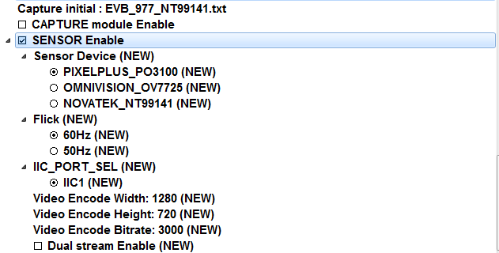

* sensor gpio

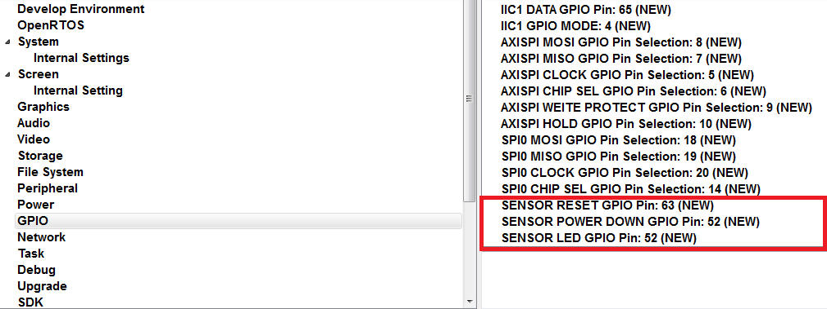

2.2 choose hdmirx(hdmi on ,sensor & module off)

* Hdmirx enable

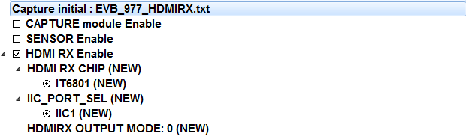

2.3 choose capture module(module on ,sensor & hdmi off)

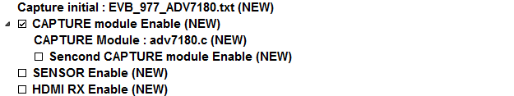

**3.Load capture init define:**

**根據**target board & source**來做設定:**

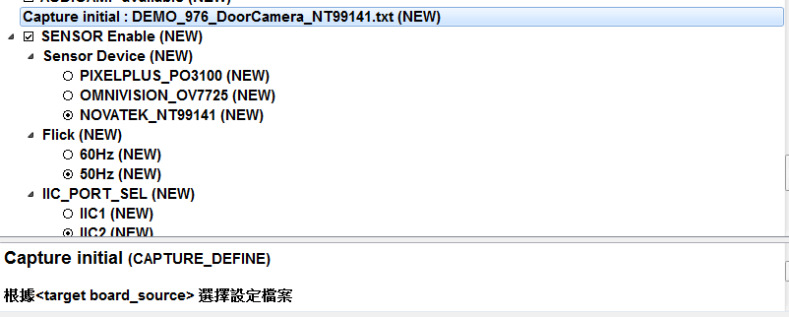

3.1如果要新增sensor就要新增一個 (xxx.txt) file 至path: sdk\target\defcap\

**4.IIC Setting**

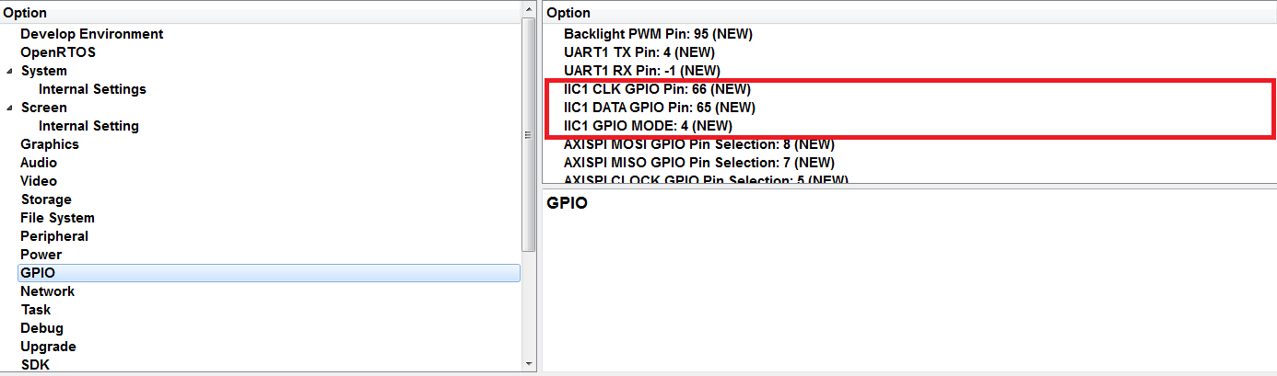

**5.Testing Result**

將收到的畫面顯示在LCD上

