1 Register an account on Azure portal (https://portal.azure.com/).
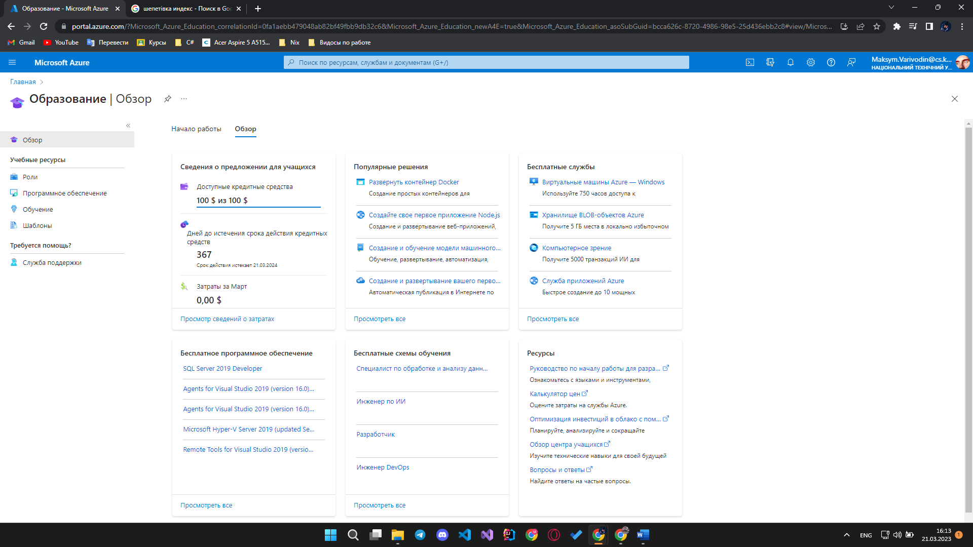2 Create Azure Blob storage account.
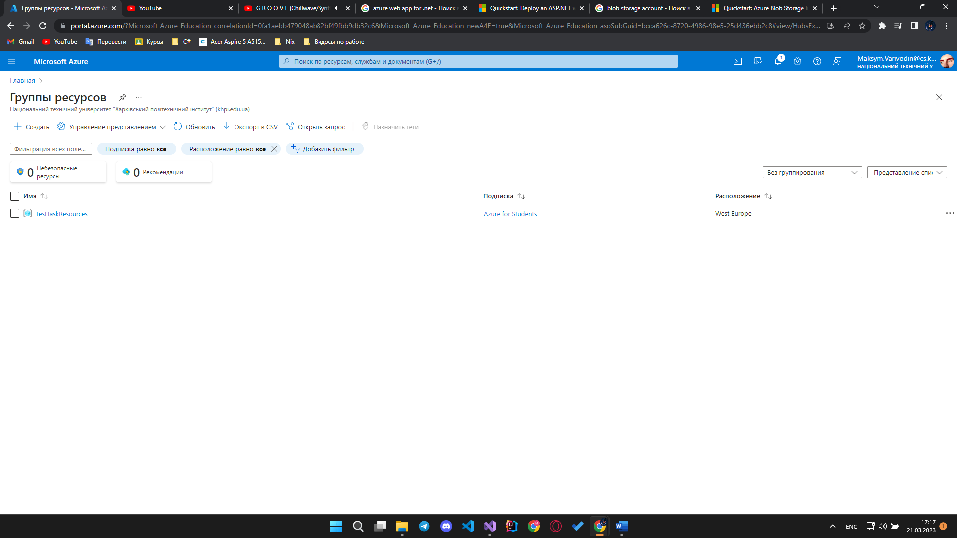
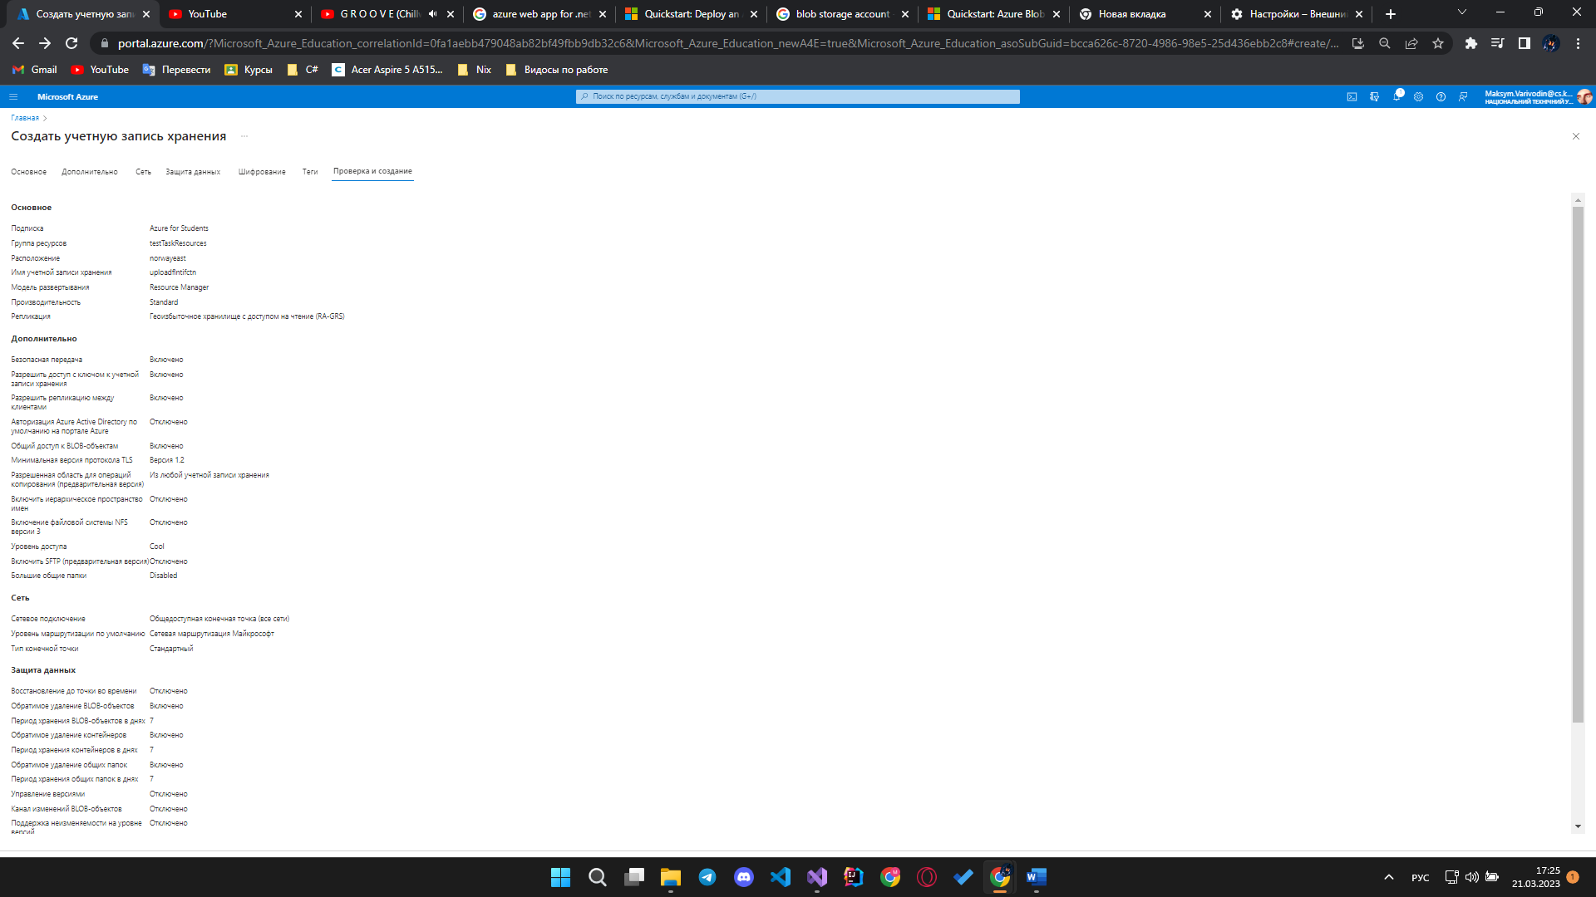
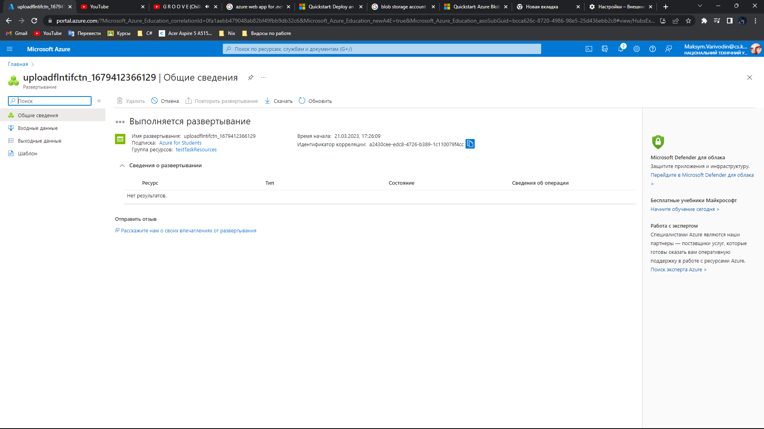
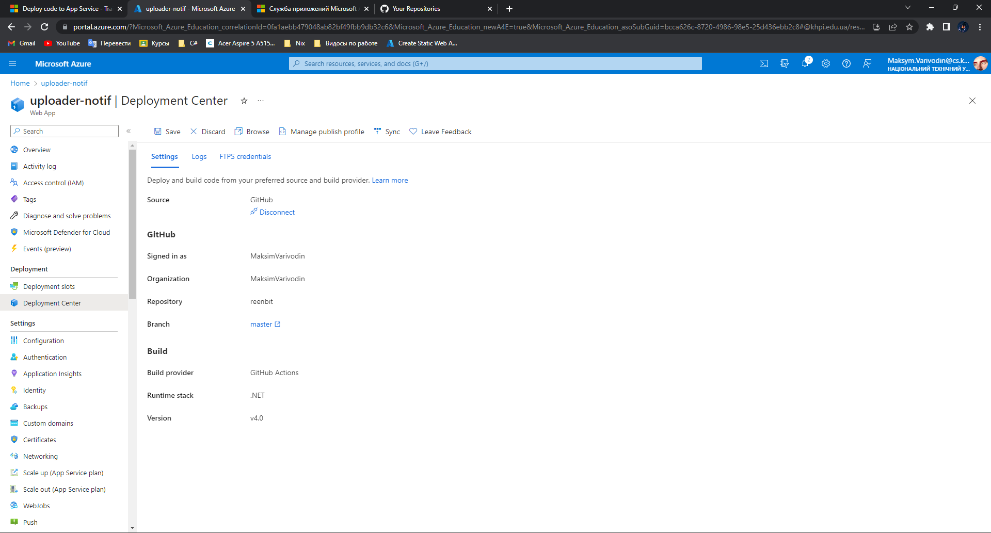
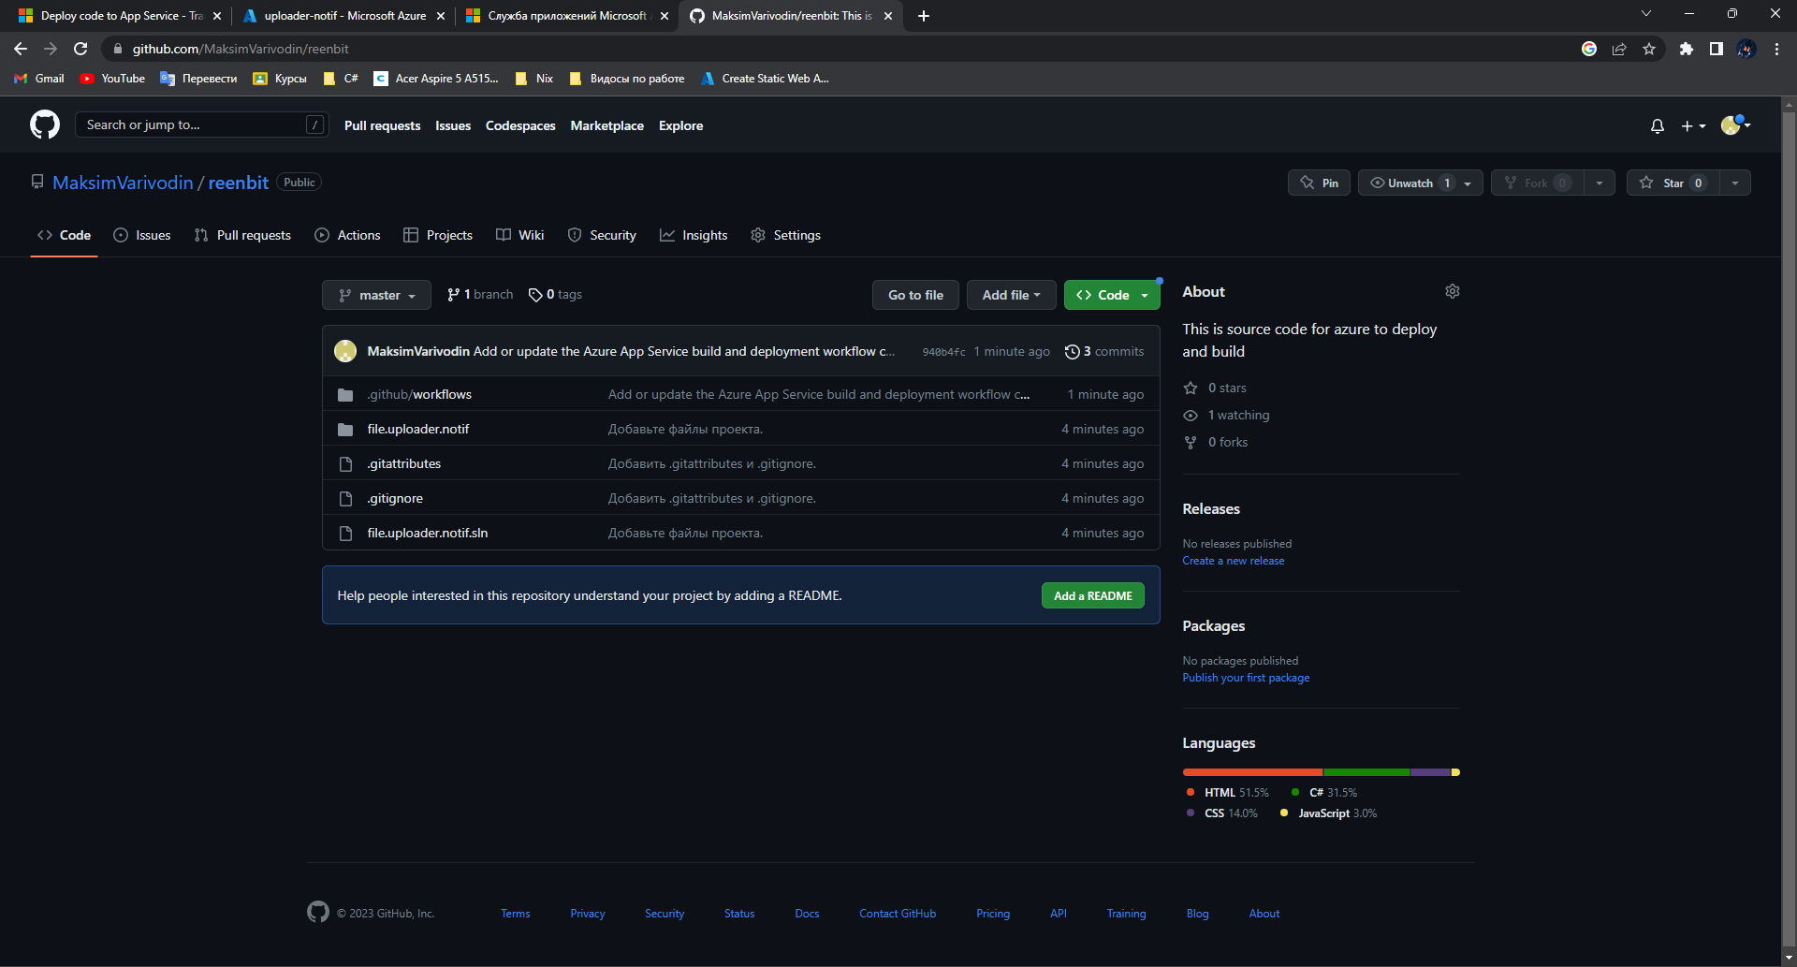
Watched course about ASP.NET
https://learn.microsoft.com/ru-ru/aspnet/web-pages/overview/getting-started/11-adding-email-to-your-web-site
https://metanit.com/sharp/aspnet5/29.1.php -ASP.NET about
https://www.aspsnippets.com/Articles/Fileupload-validation-using-Model-Data-Annotations-in-ASPNet-MVC.aspx - only DOCX
https://medium.com/nerd-for-tech/azure-blob-storage-upload-download-delete-file-s-using-net-5-0-web-api-978237a6b0e8 -how to upload the file

