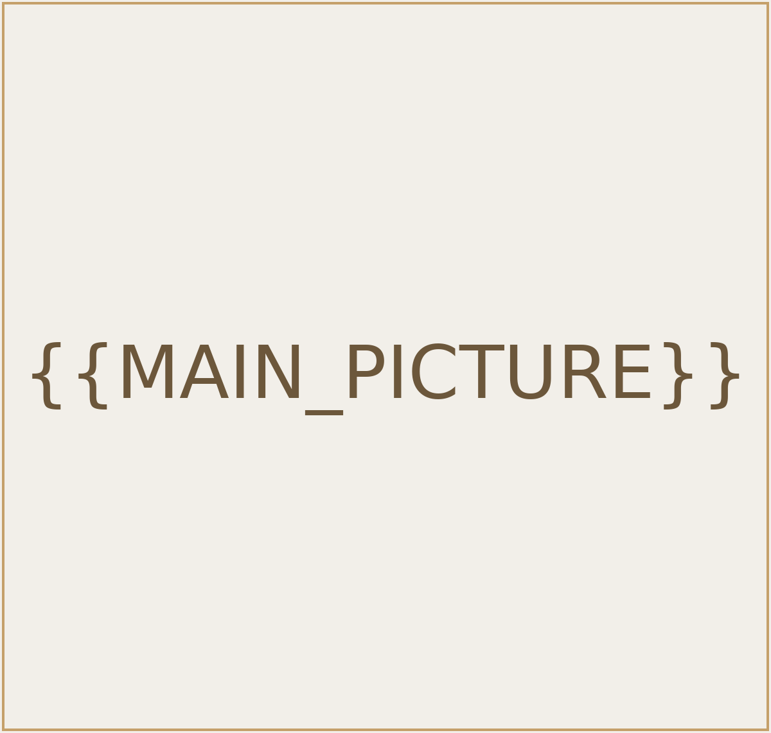
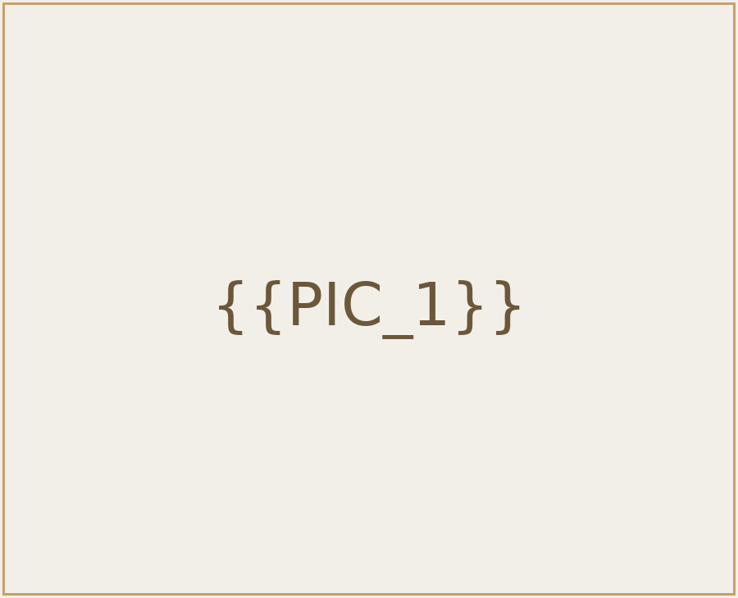
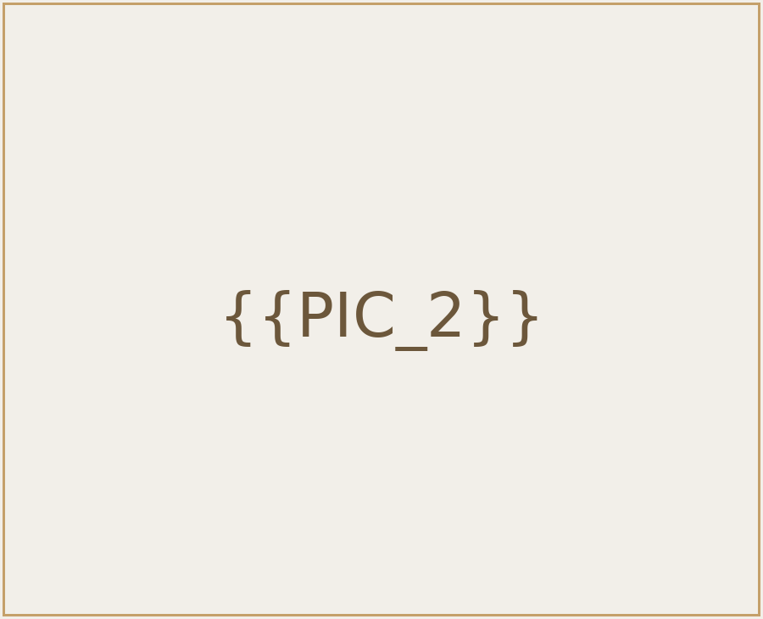





PRICE
REGION
{{REGION}}
TYPE
{{SERVICE_TYPE}}
SETTLEMENT
{{SETTLEMENT}}
LIVING AREA
{{PRICE_PRINTABLE}}
{{UNIT_AREA}}
{{Listing name for website}}


PROPERTY FEATURES
{{Ref. (ID)}} | {{PROPERTY_TYPE}} | {{COMPLEX}}
{{AGENT_NAME}}
{{AGENT_PHONE}}

{{Почта сотрудника}}
PHONE

EMAIL
Exclusive Broker
 {{BEDROOMS}} |  {{BATHROOMS}} |  {{AC_LIVING_ROOM}} |  {{A/C Bedroom}}
Bedrooms | Bathrooms | A/C Living room | A/C Bedroom
 {{Bedrooms en suite}} |  {{DISHWASHER}} |  {{WIFI}} |  {{Private Pool}}
Bedrooms en suite | Dishwasher | Wi-Fi connexion | Private Pool
 {{Gated complex}} |  {{GYM}} |  {{Parking spaces}} |  {{COMMON_POOL}}
Gated complex | Gym | Parking spaces | Common pool


STANFORD REALTY · MAURITIUS
Local Expertise. International Standards
Established in 2021

1st floor, the Prestinct, Grand Baie
www.immo.mu www.t.me/propertycloud

ROCKET VENTURES INVEST LTD | BRN C21184689 | VAT NO 27 998090 | MCB ACC. NO 000449288037

