**Typescript**

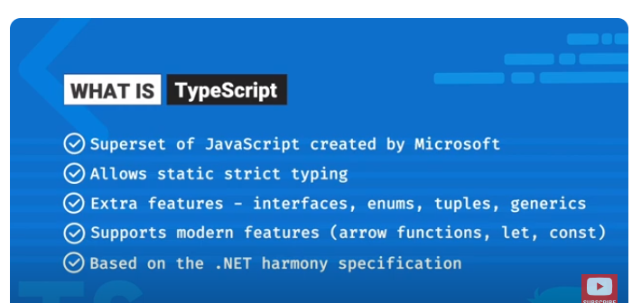

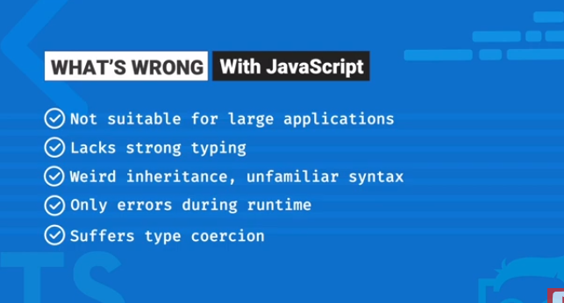

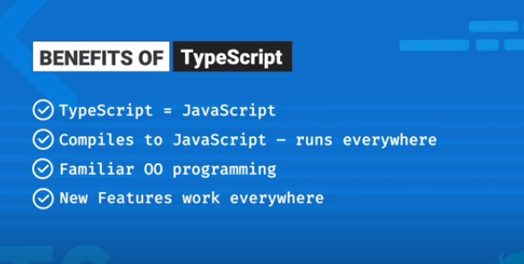

Also Compile time a error show er beboshta kore diyache

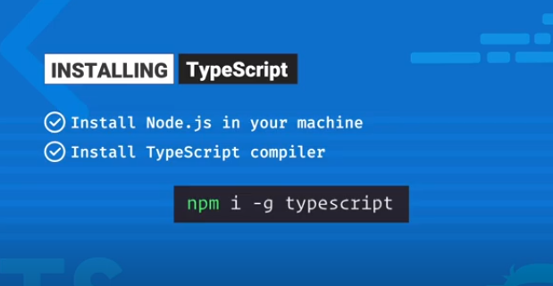

Typescript project install command: npx create-react-app my-app –template typescript

🡪 npm i react-router-dom

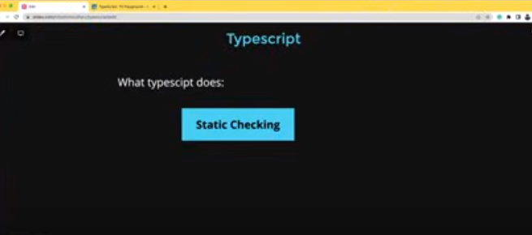

**Union:** Jokhon type 2 rokom hote pare, she khatra amra Union use korte pari.

**Any Type:** Hote pare amr application er part er type ki hobe ami akhon jani na, she khatre amra any use korte pari. Any thakle amra valu ja Khushi dite pari. Thekai na porle any use korer dorkar nai karon tahole er type use kore ki lab jodi any e use kori.

Let a: any[] = []

**How to use function type:**

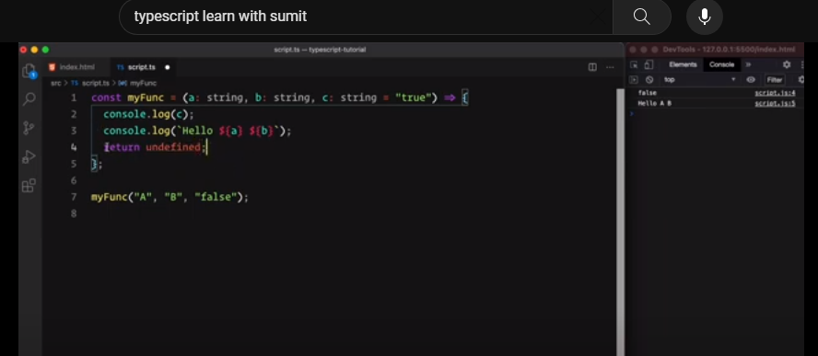

Js a function theke kono kisu return na korle undefine niya nei. But type script er khatre hoiya jai void.

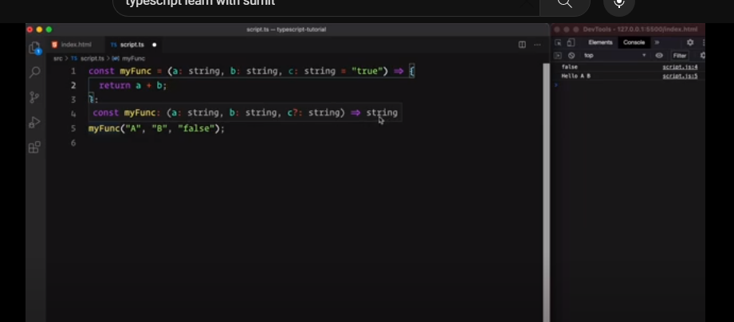

Ai khane return type ashce string.

Type Aliases

Type bitore define kora holo

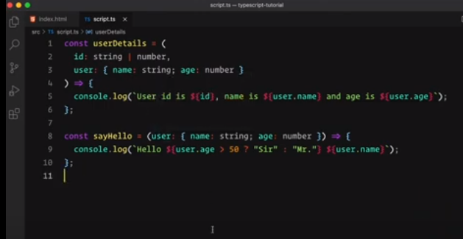

Type aghe define kore nilam tai er uporer moto bar bar likha laglo na. Amra onno ekta jaigai o type define kore function a use korte pari.

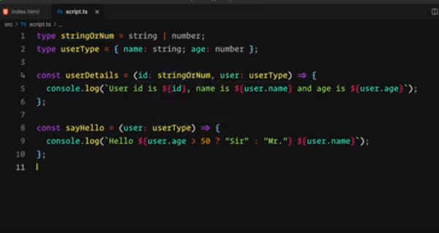

**Function in class:**

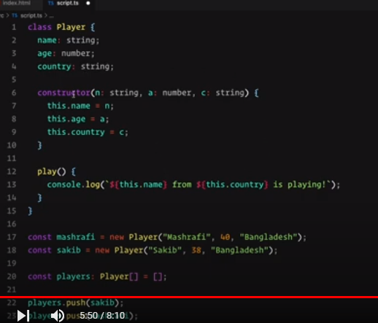

**Fig: Class code**

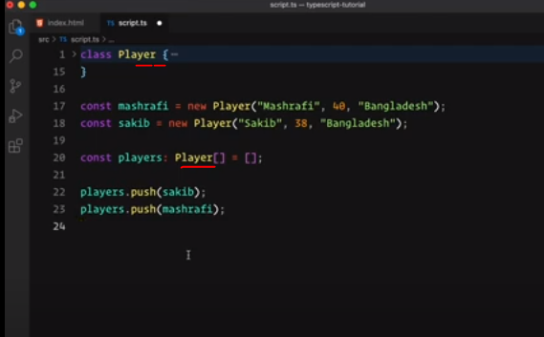

Class player ke type hishabe use korte parsi.

# **Access Modifiers**

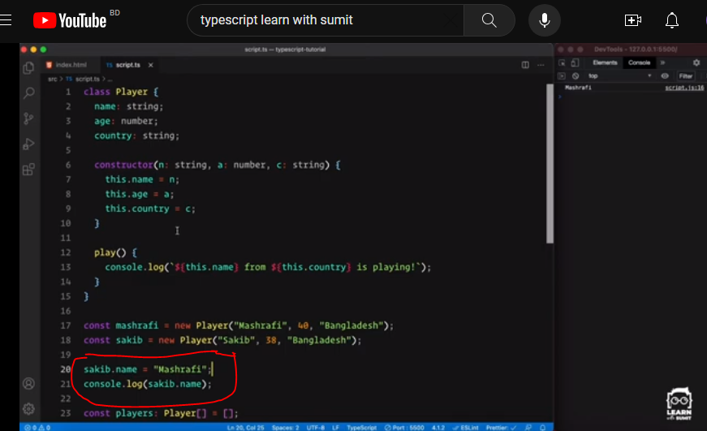

Sakib.name baire theke axcess or change korte parsi mane public ache but jeta thik na tai axcess modifier use korbo.

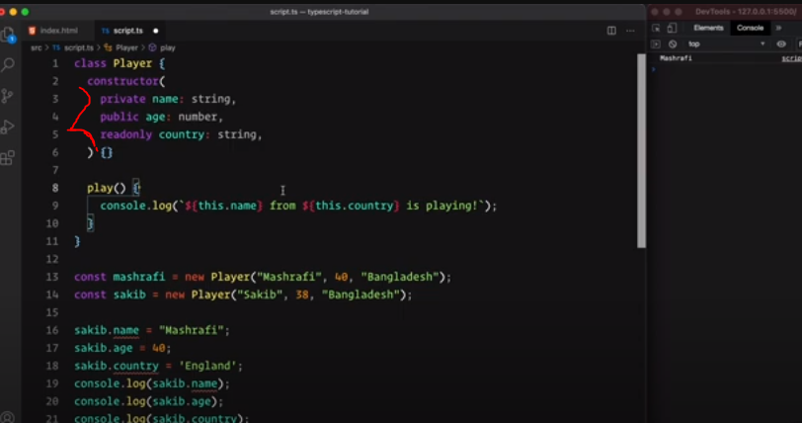

Private, public, readonly ullek kore dile uporer moto details likha lagse na.

**Module System:**

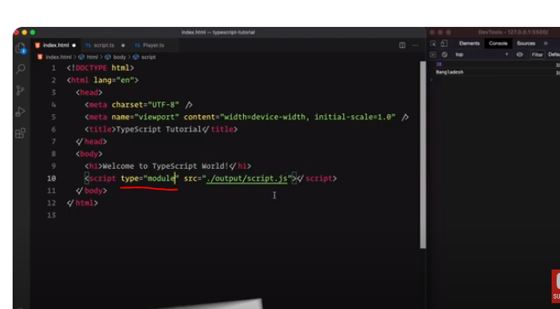

Eta typescript er kisu na.

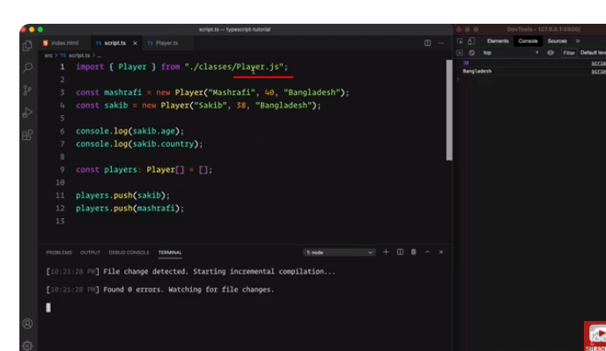

Typescrit a .js file ullek korte hoi.

Type script amder bundle korte help korse na. Eta ekta performance issue. Tai webpack use korte hobe.

**Interface:**

Interfaces hossa ekta structure. Mane kono object ba class tar ekta structure dai. Eta better programming er ekta way. Big application a interface er bebohar ache.

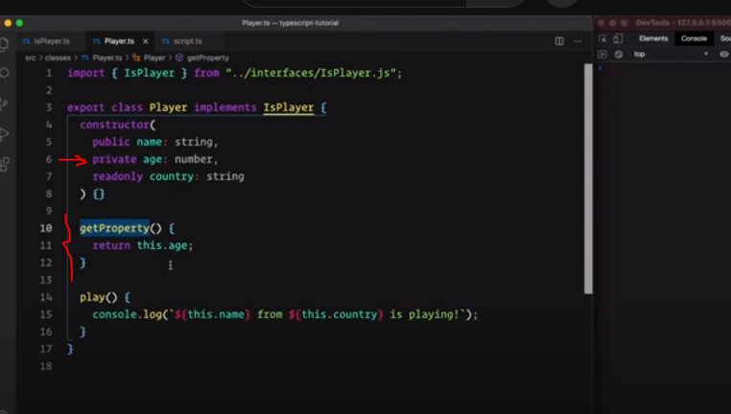

Private property use korle return kore dite hobe ai vabe. (return this.age)

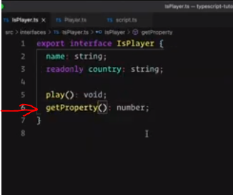

Akhon getProperty name function implement korlo.

**Generics**: Generics holo Reusable block of code jeta mainly amra type er khatre use korte pari type bole dewa er shomoi.

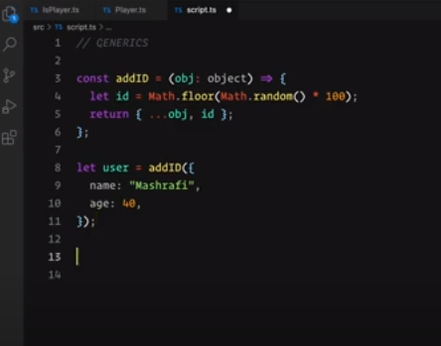

Ekhane amder shamne simply ekta fuction ache jeta object parameter akare nibe then tar shate ekta random id add kore return korbe.

Upore Object er modda ki pabe she jane na. Obj er modda user ki disse she jane na. Ai khatre e amra jeneric use korte pari.

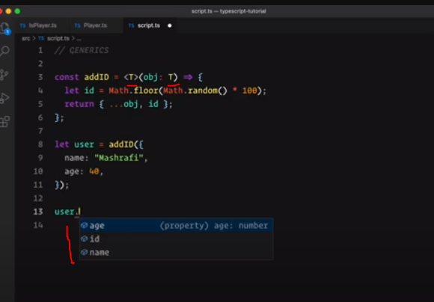

User jokhon call korbe tokhon she sheta k dorbe <T> diya. Normal convensation holo <T> diya receive kora. So akhon amra object na bole T bole dite pari. So akhon amra generic way te receive korlam mane user ja dibe tai receive korlam. So akhon amra user dot dewate age, id, name available pacchi. Muloto type take generic way te receive korece.

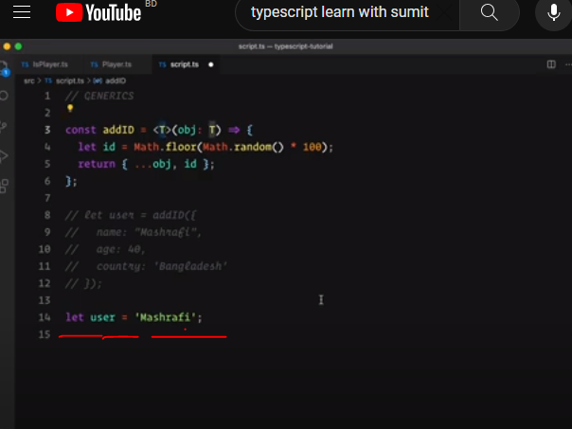Amra jodi string pathi taw she niya niche.

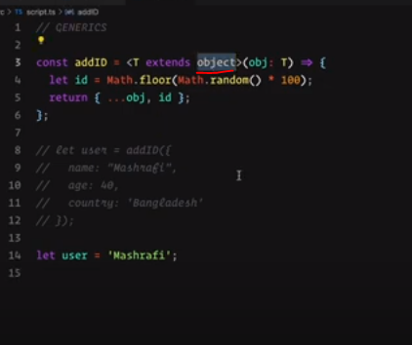

Jate string na nai she jonno amra extends object bole dibo.

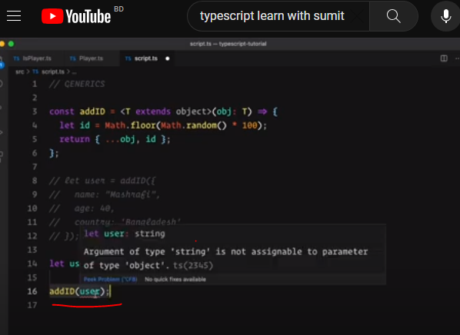

Akhon string pass korate error disse karon amra object bole diyachi.

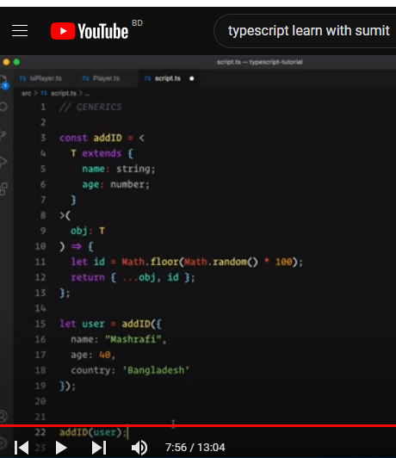

Akhon bole dilam tmi ja Khushi daw kintu shetar o ekta format thakbe.

**Interface er khatre generic er babohar:**

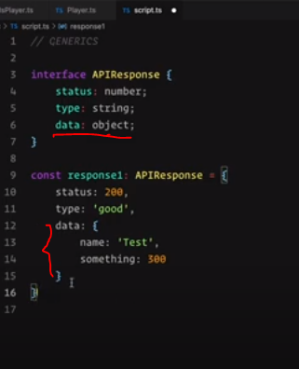

**Enum:** string or numeric value

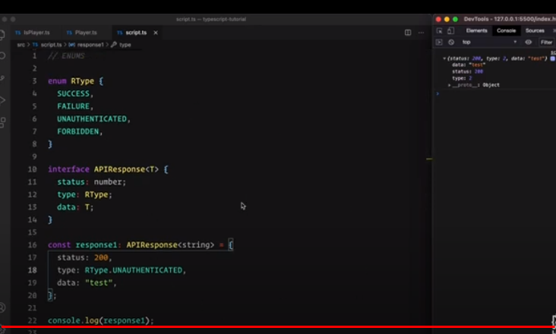

Output: 2

Tuples:

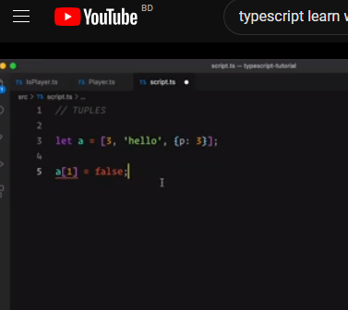

False dekhase karon amra je type gulo diyachi tar baire value dissi. Karon typescript value onujai type onuman kore nei. SO ai khane amra number, string and object er baire kisu dite parbo na. E khatre declaration order matter kore na.

But Akhon ami jodi chai Je order a ami value gulo diyachi she order a type gulo fix fix jaigai thakbe show khatre amra tuples use korbo.

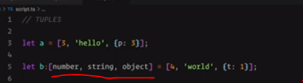

Akhon amra specific type bole dilam.

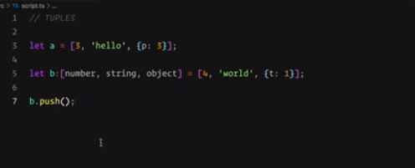

Tuple er number of elements fix ja dilam. Tuples ekta array e but ekhane amra array method gulo use korbo na. Jamon b.push korbo na karon eta unnecessary.