Download Git according to OS:
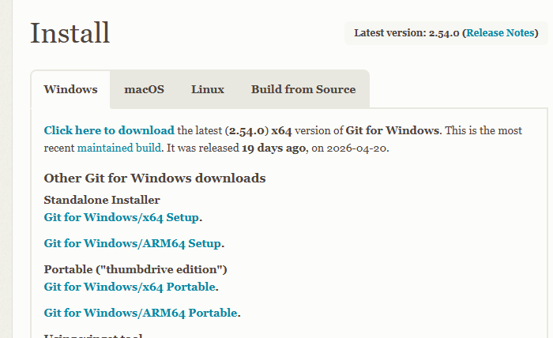

Install the Git Local device: Double click and Run as administrator
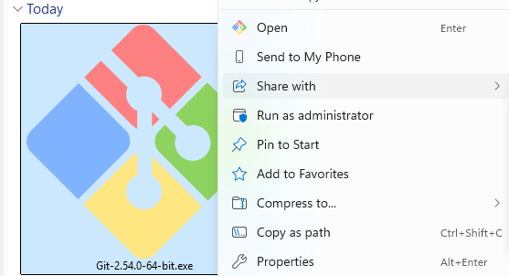

Version check from terminal using command:
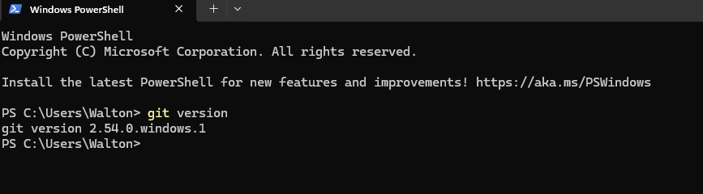

Log In Git Hub Account using Valid Credentials
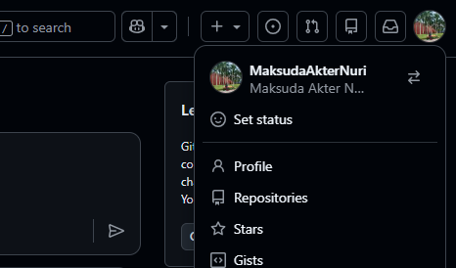

Create a repo. The repo name is “Edge-software-testing.”
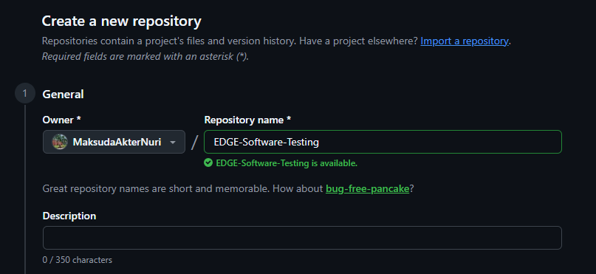

Clone the Git to local device:
Clone Done Successfully
