**ЛАБОРАТОРНА РОБОТА № 3**

**Тема**: ДОСЛІДЖЕННЯ МЕТОДІВ РЕГРЕСІЇ ТА НЕКОНТРОЬОВАНОГО НАВЧАННЯ.

**Мета**: використовуючи спеціалізовані бібліотеки і мову програмування Python дослідити методи регресії та неконтрольованої класифікації даних у машинному навчанні.

**Хід роботи:**

**Task1**



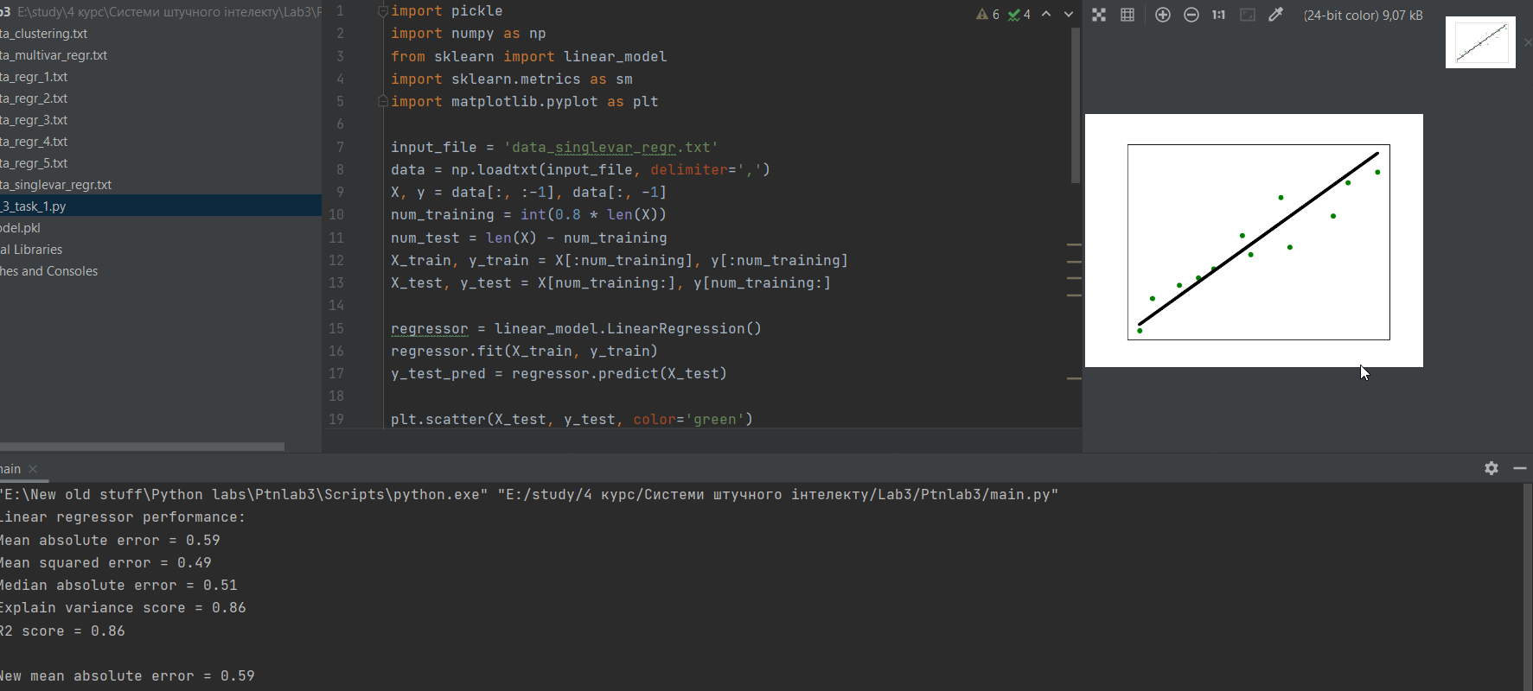

Використання лінійної регресії є простим, але неефективним через узагальненість та неточність.

import pickle  
import numpy as np  
from sklearn import linear_model  
import sklearn.metrics as sm  
import matplotlib.pyplot as plt  
  
input_file = 'data_singlevar_regr.txt'  
data = np.loadtxt(input_file, delimiter=',')  
X, y = data[:, :-1], data[:, -1]  
num_training = int(0.8 * len(X))  
num_test = len(X) - num_training  
X_train, y_train = X[:num_training], y[:num_training]  
X_test, y_test = X[num_training:], y[num_training:]  
  
regressor = linear_model.LinearRegression()  
regressor.fit(X_train, y_train)  
y_test_pred = regressor.predict(X_test)  
  
plt.scatter(X_test, y_test, color='green')  
plt.plot(X_test, y_test_pred, color='black', linewidth=4)  
plt.xticks(())  
plt.yticks(())  
plt.show()  
  
print("Linear regressor performance:")  
print("Mean absolute error =",  
round(sm.mean_absolute_error(y_test, y_test_pred), 2))  
print("Mean squared error =",  
round(sm.mean_squared_error(y_test, y_test_pred), 2))  
print("Median absolute error =",  
round(sm.median_absolute_error(y_test, y_test_pred), 2))  
print("Explain variance score =",  
round(sm.explained_variance_score(y_test, y_test_pred), 2))  
print("R2 score =", round(sm.r2_score(y_test, y_test_pred), 2))  
  
output_model_file = 'model.pkl'  
  
with open(output_model_file, 'wb') as f:  
 pickle.dump(regressor, f)  
  
y_test_pred_new = regressor.predict(X_test)  
print("\nNew mean absolute error =",  
round(sm.mean_absolute_error(y_test, y_test_pred_new), 2))

**Task2**



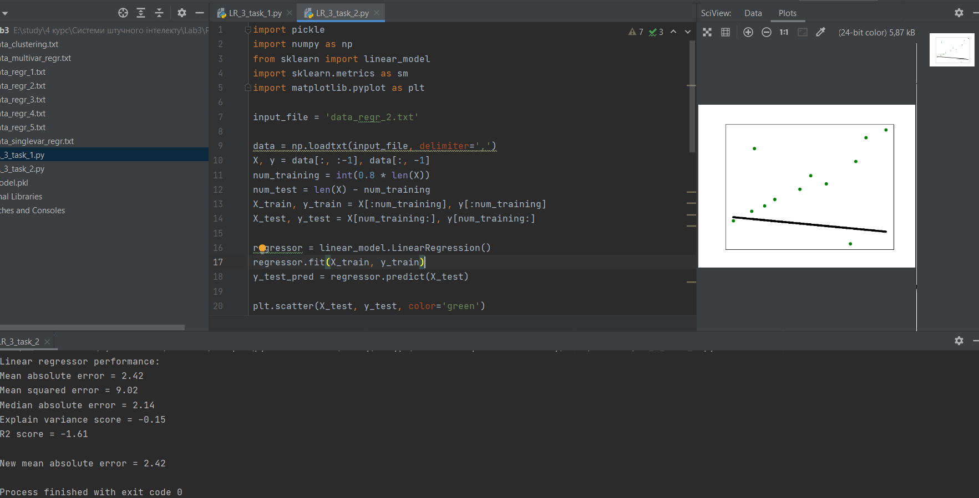

За малої кількості даних використання будь-яких алгоритмів є неефективним, особливо алгоритму лінійної регресії.

import pickle  
import numpy as np  
from sklearn import linear_model  
import sklearn.metrics as sm  
import matplotlib.pyplot as plt  
  
input_file = 'data_regr_2.txt'  
  
data = np.loadtxt(input_file, delimiter=',')  
X, y = data[:, :-1], data[:, -1]  
num_training = int(0.8 * len(X))  
num_test = len(X) - num_training  
X_train, y_train = X[:num_training], y[:num_training]  
X_test, y_test = X[num_training:], y[num_training:]  
  
regressor = linear_model.LinearRegression()  
regressor.fit(X_train, y_train)  
y_test_pred = regressor.predict(X_test)  
  
plt.scatter(X_test, y_test, color='green')  
plt.plot(X_test, y_test_pred, color='black', linewidth=4)  
plt.xticks(())  
plt.yticks(())  
plt.show()  
  
print("Linear regressor performance:")  
print("Mean absolute error =",  
round(sm.mean_absolute_error(y_test, y_test_pred), 2))  
print("Mean squared error =",  
round(sm.mean_squared_error(y_test, y_test_pred), 2))  
print("Median absolute error =",  
round(sm.median_absolute_error(y_test, y_test_pred), 2))  
print("Explain variance score =",  
round(sm.explained_variance_score(y_test, y_test_pred), 2))  
print("R2 score =", round(sm.r2_score(y_test, y_test_pred), 2))  
  
output_model_file = 'model.pkl'  
  
with open(output_model_file, 'wb') as f:  
 pickle.dump(regressor, f)  
  
y_test_pred_new = regressor.predict(X_test)  
print("\nNew mean absolute error =",  
round(sm.mean_absolute_error(y_test, y_test_pred_new), 2))

**Task3**



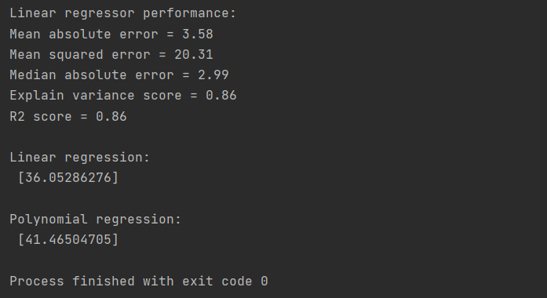

import numpy as np  
from sklearn import linear_model  
import sklearn.metrics as sm  
from sklearn.preprocessing import PolynomialFeatures  
  
input_file = 'data_multivar_regr.txt'  
data = np.loadtxt(input_file, delimiter=',')  
X, y = data[:, :-1], data[:, -1]  
  
num_training = int(0.8 * len(X))  
num_test = len(X) - num_training  
X_train, y_train = X[:num_training], y[:num_training]  
X_test, y_test = X[num_training:], y[num_training:]  
  
regressor = linear_model.LinearRegression()  
regressor.fit(X_train, y_train)  
  
y_test_pred = regressor.predict(X_test)  
  
  
print("Linear regressor performance:")  
print("Mean absolute error =",  
round(sm.mean_absolute_error(y_test, y_test_pred), 2))  
print("Mean squared error =",  
round(sm.mean_squared_error(y_test, y_test_pred), 2))  
print("Median absolute error =",  
round(sm.median_absolute_error(y_test, y_test_pred), 2))  
print("Explain variance score =",  
round(sm.explained_variance_score(y_test, y_test_pred), 2))  
print("R2 score =", round(sm.r2_score(y_test, y_test_pred), 2))  
  
polynomial = PolynomialFeatures(degree=10)  
X_train_transformed = polynomial.fit_transform(X_train)  
  
datapoint = [[7.75, 6.35, 5.56]]  
poly_datapoint = polynomial.fit_transform(datapoint)  
  
poly_linear_model = linear_model.LinearRegression()  
poly_linear_model.fit(X_train_transformed, y_train)  
print("\nLinear regression:\n", regressor.predict(datapoint))  
print("\nPolynomial regression:\n", poly_linear_model.predict(poly_datapoint))

Порівняно з лінійним регресором поліноміальний peгpecop забезпечує отримання результату, ближчого до значення 41.35. Тобто дає кращі результати

**Task4**



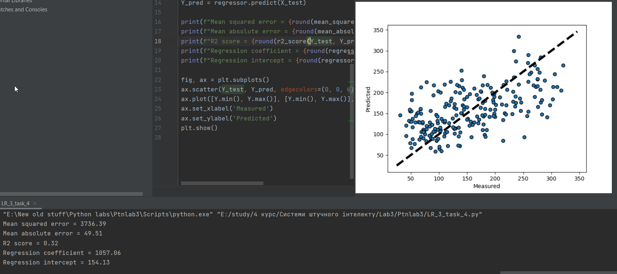

import matplotlib.pyplot as plt  
import numpy as np  
from sklearn import linear_model, datasets  
from sklearn.metrics import mean_squared_error, mean_absolute_error, r2_score  
from sklearn.model_selection import train_test_split  
  
diabetes = datasets.load_diabetes()  
X = diabetes.data[:, np.newaxis, 2]  
Y = diabetes.target  
  
X_train, X_test, Y_train, Y_test = train_test_split(X, Y, test_size=0.5, random_state=0)  
regressor = linear_model.LinearRegression()  
regressor.fit(X_train, Y_train)  
Y_pred = regressor.predict(X_test)  
  
print(f"Mean squared error = {round(mean_squared_error(Y_test, Y_pred), 2)}")  
print(f"Mean absolute error = {round(mean_absolute_error(Y_test, Y_pred), 2)}")  
print(f"R2 score = {round(r2_score(Y_test, Y_pred), 2)}")  
print(f"Regression coefficient = {round(regressor.coef_[0], 2)}")  
print(f"Regression intercept = {round(regressor.intercept_, 2)}")  
  
fig, ax = plt.subplots()  
ax.scatter(Y_test, Y_pred, edgecolors=(0, 0, 0))  
ax.plot([Y.min(), Y.max()], [Y.min(), Y.max()], 'k--', lw=4)  
ax.set_xlabel('Measured')  
ax.set_ylabel('Predicted')  
plt.show()

Використання лінійної регресії в даному випадку не є ефективним через велике розповсюдження даних.

**Task5**



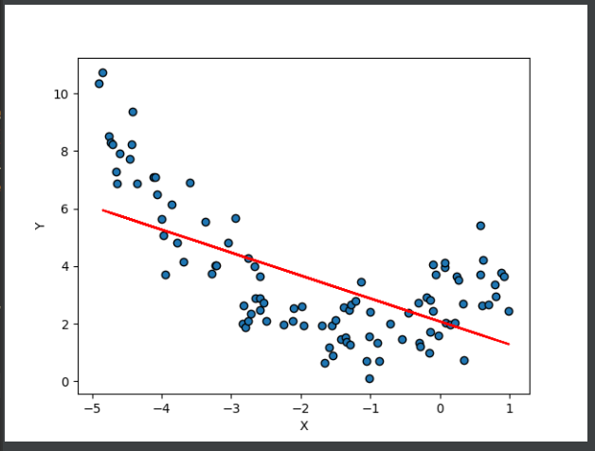

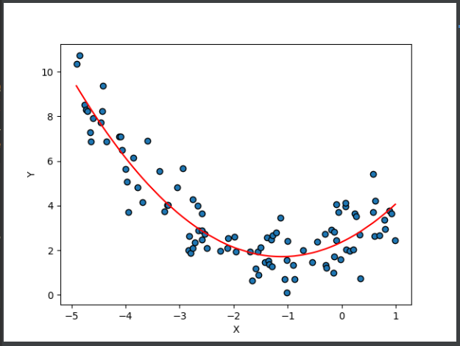

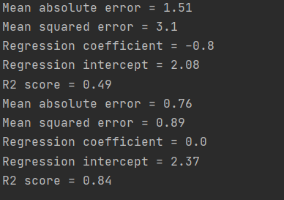

import matplotlib.pyplot as plt  
import numpy as np  
from sklearn import linear_model  
from sklearn.preprocessing import PolynomialFeatures  
from sklearn.metrics import mean_squared_error, mean_absolute_error, r2_score  
from sklearn.model_selection import train_test_split  
  
m = 100  
X = 6 * np.random.rand(m, 1) - 5  
Y = 0.5 * X**2 + X + 2 + np.random.randn(m, 1)  
  
indices = np.argsort(X, axis=0)  
X = X[indices].reshape(-1, 1)  
Y = Y[indices].reshape(-1, 1)  
  
X_train, X_test, Y_train, Y_test = train_test_split(X, Y, test_size=0.5, random_state=0)  
regressor = linear_model.LinearRegression()  
regressor.fit(X_train, Y_train)  
Y_pred = regressor.predict(X_test)  
  
print(f"Mean absolute error = {round(mean_absolute_error(Y_test, Y_pred), 2)}")  
print(f"Mean squared error = {round(mean_squared_error(Y_test, Y_pred), 2)}")  
print(f"Regression coefficient = {round(regressor.coef_[0][0], 2)}")  
print(f"Regression intercept = {round(regressor.intercept_[0], 2)}")  
print(f"R2 score = {round(r2_score(Y_test, Y_pred), 2)}")  
  
plt.scatter(X, Y, edgecolors=(0, 0, 0))  
plt.plot(X_test, Y_pred, color="red")  
plt.xlabel('X')  
plt.ylabel('Y')  
plt.show()  
  
poly = PolynomialFeatures(degree=2)  
X_poly = poly.fit_transform(X)  
regressor = linear_model.LinearRegression()  
regressor.fit(X_poly, Y)  
Y_pred = regressor.predict(X_poly)  
  
print(f"Mean absolute error = {round(mean_absolute_error(Y, Y_pred), 2)}")  
print(f"Mean squared error = {round(mean_squared_error(Y, Y_pred), 2)}")  
print(f"Regression coefficient = {round(regressor.coef_[0][0], 2)}")  
print(f"Regression intercept = {round(regressor.intercept_[0], 2)}")  
print(f"R2 score = {round(r2_score(Y, Y_pred), 2)}")  
  
plt.scatter(X, Y, edgecolors=(0, 0, 0))  
plt.plot(X, Y_pred, color="red")  
plt.xlabel('X')  
plt.ylabel('Y')  
plt.show()

**Task6**

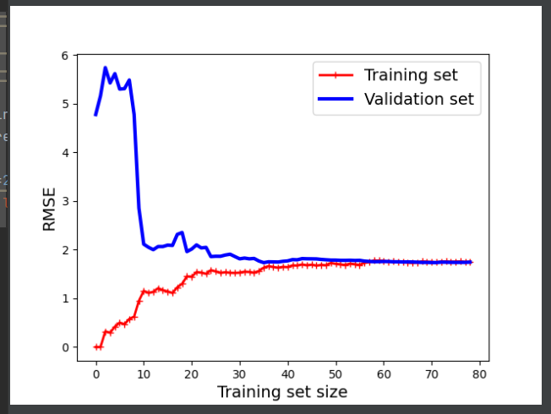

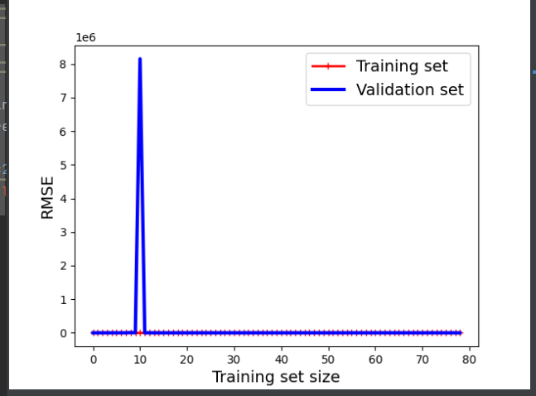

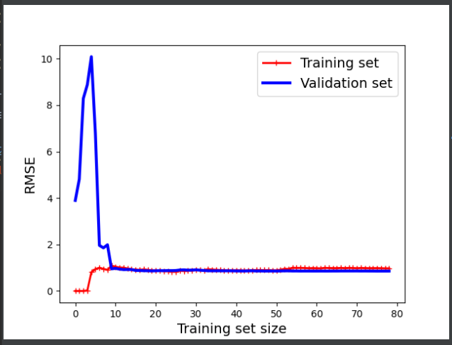

**Task7**



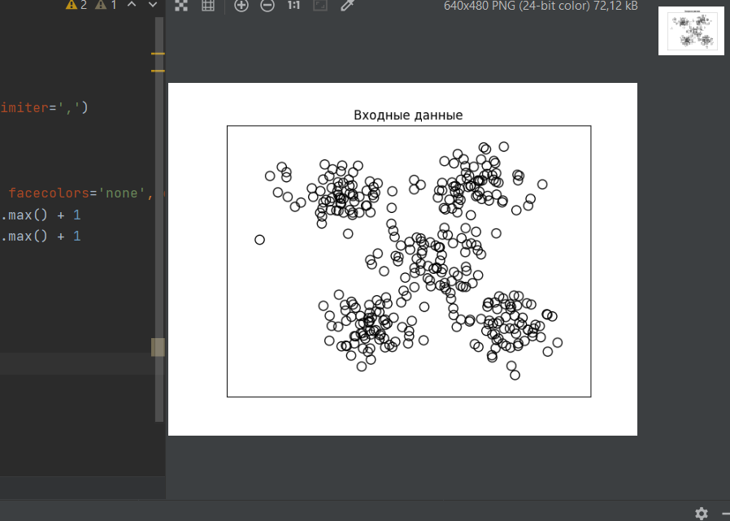

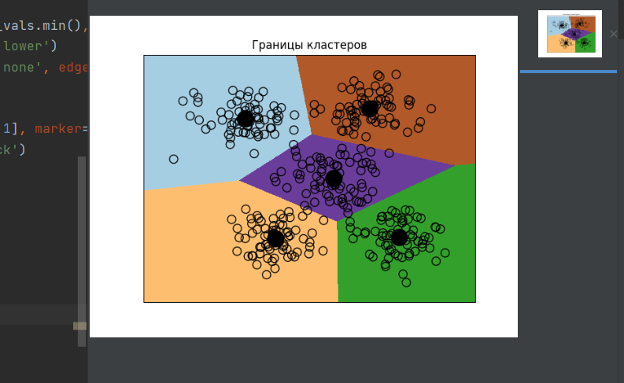

import numpy as np  
import matplotlib.pyplot as plt  
from sklearn.cluster import KMeans  
from sklearn import metrics  
  
X = np.loadtxt('data_clustering.txt', delimiter=',')  
num_clusters = 5  
  
plt.figure()  
plt.scatter(X[:, 0], X[:, 1], marker='o', facecolors='none', edgecolors='black', s=80)  
x_min, x_max = X[:, 0].min() - 1, X[:, 0].max() + 1  
y_min, y_max = X[:, 1].min() - 1, X[:, 1].max() + 1  
plt.title('Входные данные')  
plt.xlim(x_min, x_max)  
plt.ylim(y_min, y_max)  
plt.xticks(())  
plt.yticks(())  
plt.show()  
  
kmeans = KMeans(init='k-means++', n_clusters=num_clusters, n_init=10)  
kmeans.fit(X)  
step_size = 0.01  
x_min, x_max = X[:, 0].min() - 1, X[:, 0].max() + 1  
y_min, y_max = X[:, 1].min() - 1, X[:, 1].max() + 1  
x_vals, y_vals = np.meshgrid(np.arange(x_min, x_max, step_size), np.arange(y_min, y_max, step_size))  
  
output = kmeans.predict(np.c_[x_vals.ravel(), y_vals.ravel()])  
output = output.reshape(x_vals.shape)  
plt.figure()  
plt.clf()  
plt.imshow(output, interpolation='nearest', extent=(x_vals.min(), x_vals.max(), y_vals.min(), y_vals.max()),  
 cmap=plt.cm.Paired, aspect='auto', origin='lower')  
plt.scatter(X[:, 0], X[:, 1], marker='o', facecolors='none', edgecolors='black', s=80)  
  
cluster_centers = kmeans.cluster_centers_  
plt.scatter(cluster_centers[:, 0], cluster_centers[:, 1], marker='o', s=210, linewidths=4,  
 color='black', zorder=12, facecolors='black')  
x_min, x_max = X[:, 0].min() - 1, X[:, 0].max() + 1  
y_min, y_max = X[:, 1].min() - 1, X[:, 1].max() + 1  
plt.title('Границы кластеров')  
plt.xlim(x_min, x_max)  
plt.ylim(y_min, y_max)  
plt.xticks(())  
plt.yticks(())  
plt.show()

Використання методу K-середніх дозволяє ефективно класифікувати дані без допомоги вчителя, а за використання K-середніх++ знаходження центрів залишається за алгоритмом.

**Task8**



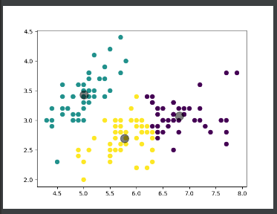

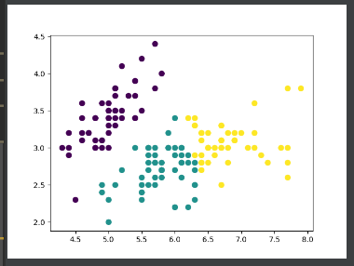

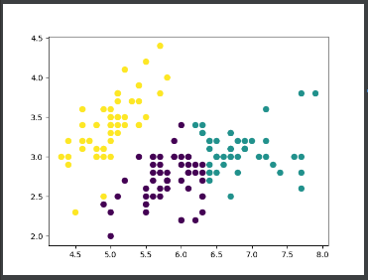

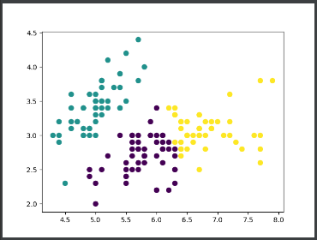

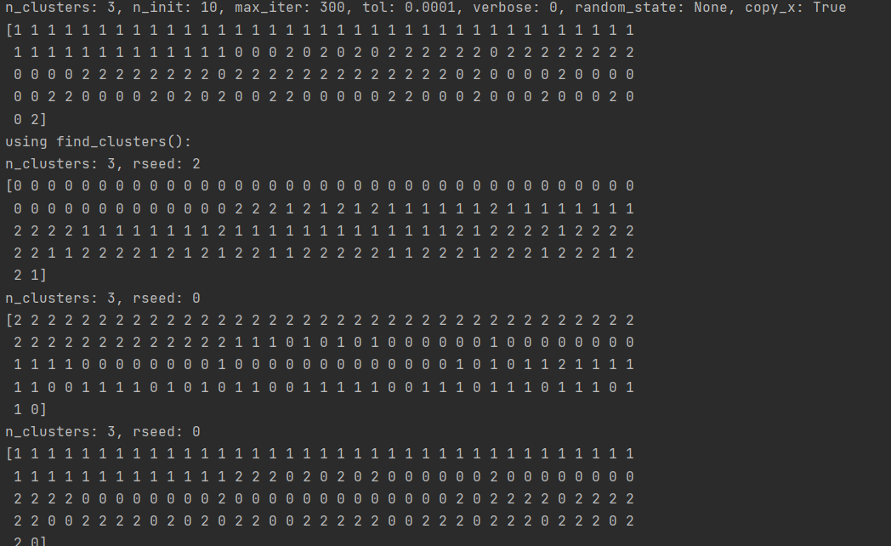

import matplotlib.pyplot as plt  
from sklearn import datasets  
from sklearn.svm import SVC  
from sklearn.cluster import KMeans  
from sklearn.metrics import pairwise_distances_argmin  
import numpy as np  
  
iris = datasets.load_iris()  
X = iris.data[:, :2]  
Y = iris.target  
  
kmeans = KMeans(n_clusters=Y.max() + 1, init='k-means++', n_init=10, max_iter=300,  
 tol=0.0001, verbose=0, random_state=None, copy_x=True)  
kmeans.fit(X)  
y_pred = kmeans.predict(X)  
  
print(f"n_clusters: {Y.max() + 1}, n_init: 10, max_iter: 300, tol: 0.0001, verbose: 0, random_state: None, copy_x: True")  
print(y_pred)  
plt.figure()  
plt.scatter(X[:, 0], X[:, 1], c=y_pred, s=50, cmap='viridis')  
centers = kmeans.cluster_centers_  
plt.scatter(centers[:, 0], centers[:, 1], c='black', s=200, alpha=0.5)  
plt.show()  
  
def find_clusters(X, n_clusters, rseed=2):  
 rng = np.random.RandomState(rseed)  
 i = rng.permutation(X.shape[0])[:n_clusters]  
 centers = X[i]  
  
 while True:  
 labels = pairwise_distances_argmin(X, centers)  
 new_centers = np.array([X[labels == i].mean(0) for i in range(n_clusters)])  
 if np.all(centers == new_centers):  
 break  
 centers = new_centers  
 return centers, labels  
  
  
print("using find_clusters():")  
centers, labels = find_clusters(X, 3)  
print(f"n_clusters: {3}, rseed: {2}")  
print(labels)  
plt.scatter(X[:, 0], X[:, 1], c=labels, s=50, cmap='viridis')  
plt.show()  
  
centers, labels = find_clusters(X, 3, rseed=0)  
print(f"n_clusters: {3}, rseed: {0}")  
print(labels)  
plt.scatter(X[:, 0], X[:, 1], c=labels, s=50, cmap='viridis')  
plt.show()  
  
labels = KMeans(3, random_state=0).fit_predict(X)  
print(f"n_clusters: {3}, rseed: {0}")  
print(labels)  
plt.scatter(X[:, 0], X[:, 1], c=labels, s=50, cmap='viridis')  
plt.show()

**Task9**



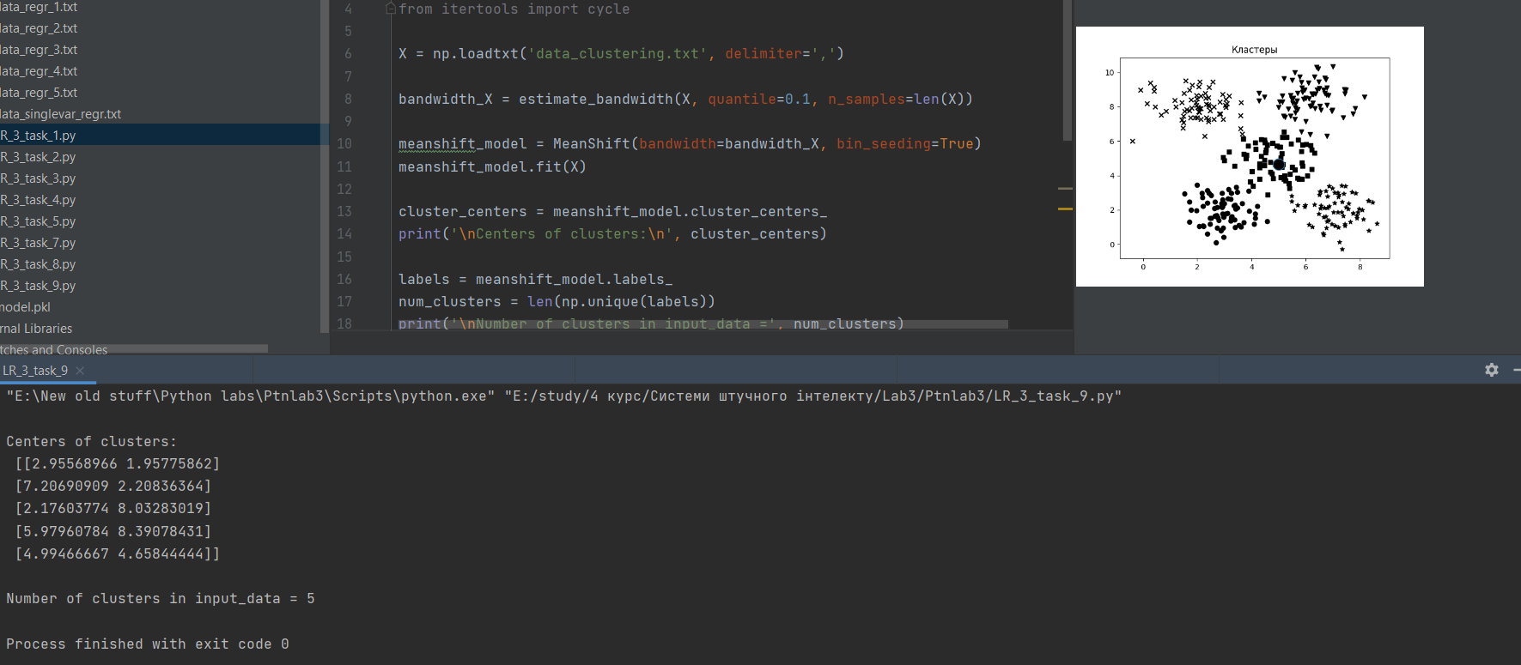

import numpy as np  
import matplotlib.pyplot as plt  
from sklearn.cluster import MeanShift, estimate_bandwidth  
from itertools import cycle  
  
X = np.loadtxt('data_clustering.txt', delimiter=',')  
  
bandwidth_X = estimate_bandwidth(X, quantile=0.1, n_samples=len(X))  
  
meanshift_model = MeanShift(bandwidth=bandwidth_X, bin_seeding=True)  
meanshift_model.fit(X)  
  
cluster_centers = meanshift_model.cluster_centers_  
print('\nCenters of clusters:\n', cluster_centers)  
  
labels = meanshift_model.labels_  
num_clusters = len(np.unique(labels))  
print('\nNumber of clusters in input_data =', num_clusters)  
  
plt.figure()  
markers = 'o*xvs'  
for i, marker in zip(range(num_clusters), markers):  
 plt.scatter(X[labels==i, 0], X[labels==i, 1], marker=marker, color='black')  
  
cluster_center = cluster_centers[i]  
plt.plot(cluster_center[0], cluster_center[1], marker='o',  
 markerfacecolor='black', markersize=15)  
plt.title('Кластеры')  
plt.show()

**Task10**

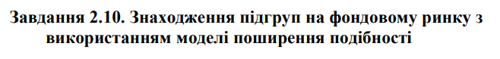

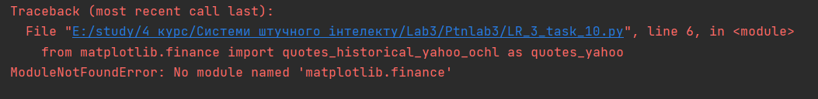

import datetime  
import json  
import numpy as np  
import matplotlib.pyplot as plt  
from sklearn import covariance, cluster  
from matplotlib.finance import quotes_historical_yahoo_ochl as quotes_yahoo  
  
input_file = ‘company_symbol_mapping.json’  
  
with open (input_file, ‘r’) as f:  
 company_symbols_map = json.loads(f.read())  
  
symbols, names = np.array(list(company_symbols_map.items())).T  
  
start_date = datetime.datetime(2003, 7, 3)  
end_date = datetime.datetime(2007, 5, 4)  
quotes = [quotes_yahoo(symbol, start_date, end_date, asobject=True) for symbol in symbols]  
  
opening_quotes = np.array([quote.open for quote in quotes]).astype(np.float)  
closing_quotes = np.array([quote.close for quote in quotes]).astype(np.float)  
  
quotes_diff = closing_quotes – opening_quotes  
  
X = quotes_diff.copy().T  
X /= X.std(axis=0)  
  
edge_model = covariance.GraphicalLassoCV()  
  
with np.errstate(invalid=’ignore’):  
 edge_model.fit(X)  
  
_, labels = cluster.affinity_propagation(edge_model.covariance_)  
num_labels = labels.max()  
  
for I in range(num_labels + 1):  
 print(“Cluster”, i+1, “🡺”, ‘,’.join(names[labels == i]))

**Під час виконання коду сталася помилка. Модуля matplotlib.finance не було знайдено.**

**https://gitlab.com/2019-2023/ipz19-3/lysovyi-maksym/AI**

**Висновок:** використовуючи спеціалізовані бібліотеки і мову програмування Python дослідив методи регресії та неконтрольованої класифікації даних у машинному навчанні.