**ЛАБОРАТОРНА РОБОТА № 4**

**Тема**: ДОСЛІДЖЕННЯ МЕТОДІВ АНСАМБЛЕВОГО НАВЧАННЯ ТА СТВОРЕННЯ РЕКОМЕНДАЦІЙНИХ СИСТЕМ

**Мета**: використовуючи спеціалізовані бібліотеки та мову програмування Python дослідити методи ансамблів у машинному навчанні та створити рекомендаційні системи.

**Хід роботи:**

**Task1**

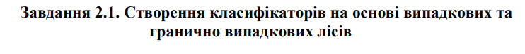

**--classifier-type erf**

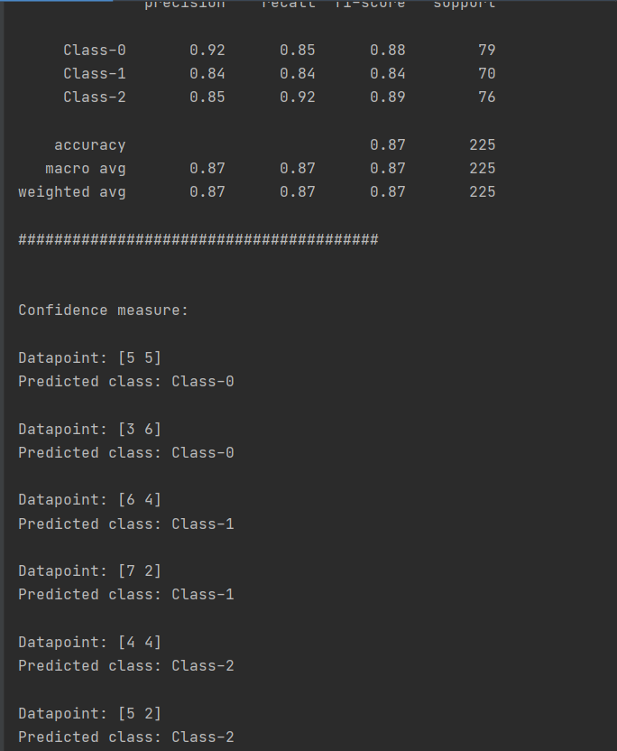

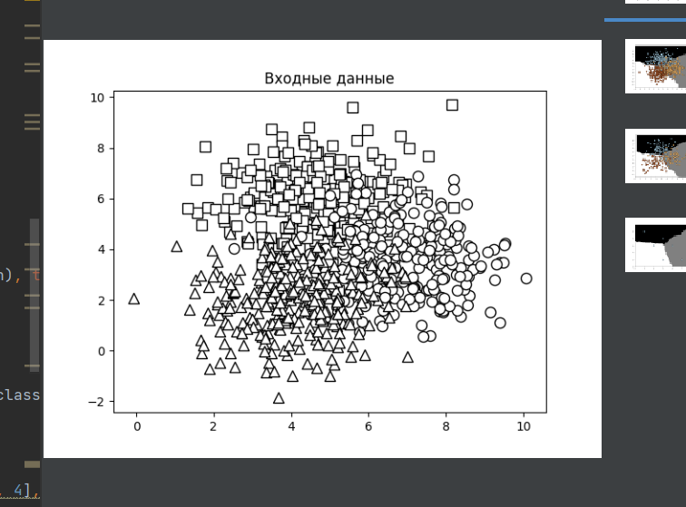

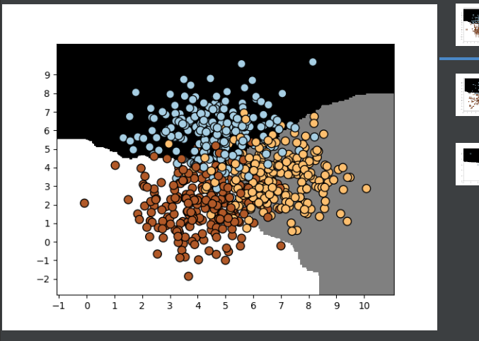

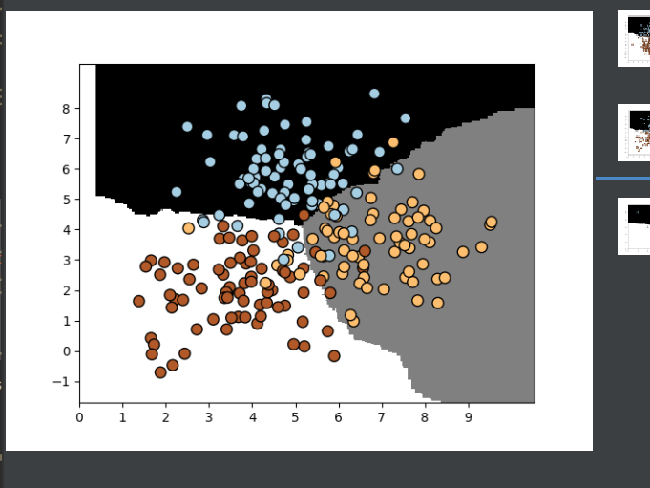

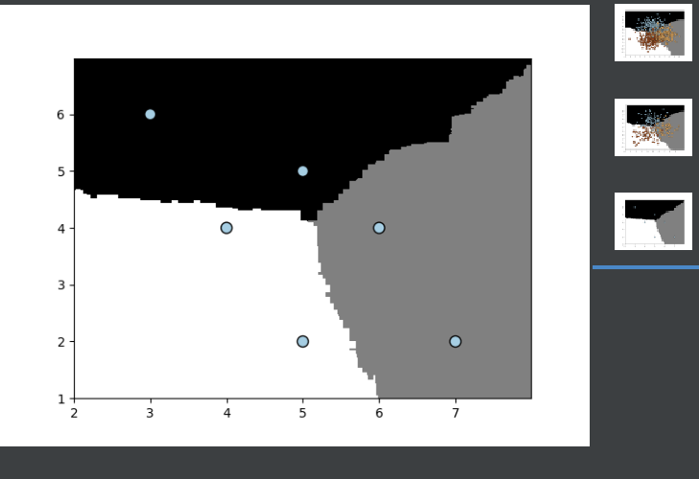

import argparse  
import numpy as np  
import matplotlib.pyplot as plt  
from sklearn.metrics import classification_report  
from sklearn.model_selection import train_test_split  
from sklearn.ensemble import RandomForestClassifier, ExtraTreesClassifier  
from sklearn.metrics import classification_report,confusion_matrix  
  
from utilities import visualize_classifier  
  
def build_arg_parser():  
 parser = argparse.ArgumentParser(description='Classify data using Ensemble Learning techniques')  
 parser.add_argument('--classifier-type', dest='classifier_type', required=True, choices=['rf', 'erf'], help="Type of classifier to use; can be either 'rf' of 'erf'")  
 return parser  
  
  
if __name__=='__main__':  
 args = build_arg_parser().parse_args()  
 classifier_type = args.classifier_type  
  
 input_file = 'data_random_forests.txt'  
 data = np.loadtxt(input_file, delimiter=',')  
 X, y = data[:, :-1], data[:, -1]  
  
 class_0 = np.array(X[y==0])  
 class_1 = np.array(X[y==1])  
 class_2 = np.array(X[y==2])  
  
 plt.figure()  
 plt.scatter(class_0[:, 0], class_0[:, 1], s=75, facecolors='white', edgecolors='black', linewidths=1, marker='s')  
 plt.scatter(class_1[:, 0], class_1[:, 1], s=75, facecolors='white', edgecolors='black', linewidths=1, marker='o')  
 plt.scatter(class_2[:, 0], class_2[:, 1], s=75, facecolors='white', edgecolors='black', linewidths=1, marker='^')  
 plt.title('Входные данные')  
  
 X_train, X_test, y_train, y_test = train_test_split(X, y, test_size=0.25, random_state=5)  
  
 params = {'n_estimators': 100, 'max_depth': 4, 'random_state': 0}  
  
 if classifier_type == 'rf':  
 classifier = RandomForestClassifier(**params)  
 else:  
 classifier = ExtraTreesClassifier(**params)  
  
  
 classifier.fit(X_train, y_train)  
 visualize_classifier(classifier, X_train, y_train)  
  
  
 y_test_pred = classifier.predict(X_test)  
 visualize_classifier(classifier, X_test, y_test)  
  
 class_names = ['Class-0', 'Class-1', 'Class-2']  
 print('\n' + '#'*40)  
 print('\nClassifier performance on training dataset\n')  
 print(classification_report(y_train, classifier.predict(X_train), target_names = class_names))  
 print('#'*40 + '\n')  
  
 print('#'*40)  
 print('\nClassifier performance on test dataset\n')  
 print(classification_report(y_test, y_test_pred, target_names=class_names))  
 print('#'*40 + '\n')  
  
  
 test_datapoints = np.array([[5, 5], [3, 6], [6, 4], [7, 2], [4, 4], [5, 2]])  
  
 print("\nConfidence measure:")  
 for datapoint in test_datapoints:  
 probabilities = classifier.predict_proba([datapoint])[0]  
 predicted_class = 'Class-' + str(np.argmax(probabilities))  
 print('\nDatapoint:', datapoint)  
 print('Predicted class:', predicted_class)  
  
 # Visualize the datapoints  
 visualize_classifier(classifier, test_datapoints, [0]*len(test_datapoints))  
  
 plt.show()

Використання випадкових дерев та граничних випадкових дерев дозволяє ефективно класифікувати дані, з двох методів останній має кращий результат.

**Task2**



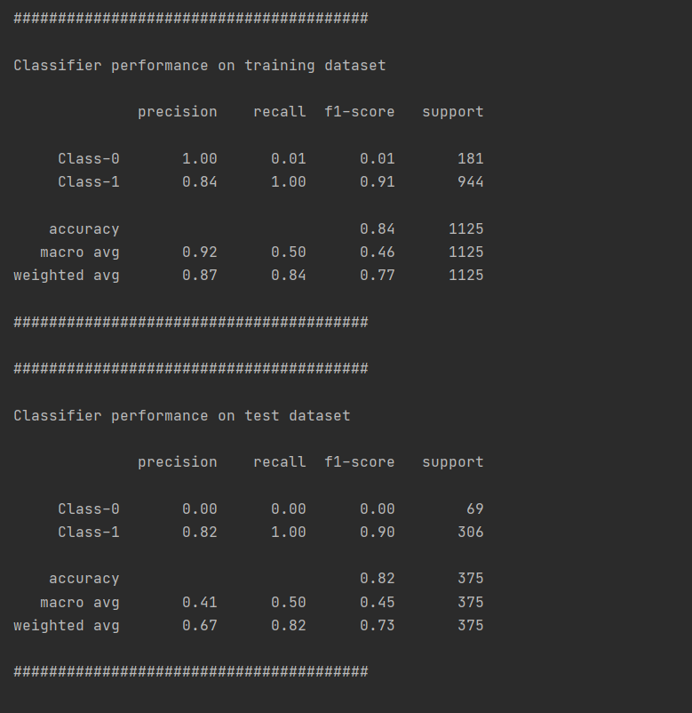

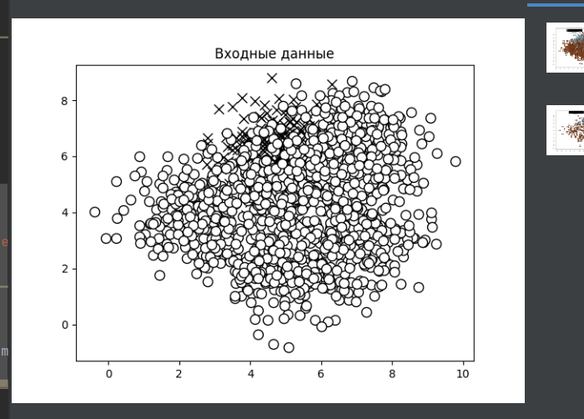

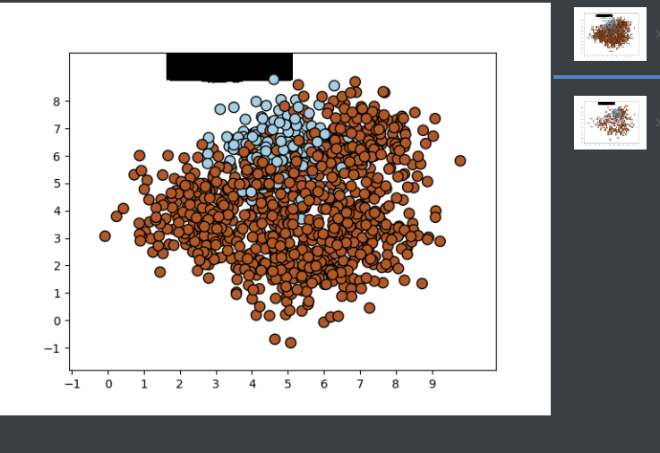

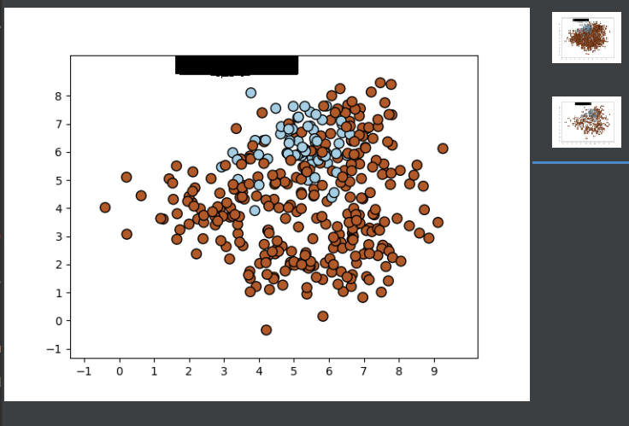

import sys  
import numpy as np  
import matplotlib.pyplot as plt  
from sklearn.ensemble import RandomForestClassifier, ExtraTreesClassifier  
from sklearn.model_selection import train_test_split  
from sklearn.metrics import classification_report,confusion_matrix  
  
from utilities import visualize_classifier  
  
input_file = 'data_imbalance.txt'  
data = np.loadtxt(input_file, delimiter=',')  
X, y = data[:, :-1], data[:, -1]  
  
class_0 = np.array(X[y == 0])  
class_1 = np.array(X[y == 1])  
  
plt.figure()  
plt.scatter(class_0[:, 0], class_0[:, 1], s=75, facecolors='black', edgecolors='black', linewidths=1, marker='x')  
plt.scatter(class_1[:, 0], class_1[:, 1], s=75, facecolors='white', edgecolors='black', linewidths=1, marker='o')  
plt.title('Входные данные')  
  
X_train, X_test, y_train, y_test = train_test_split(X, y, test_size=0.25, random_state=5)  
  
params = {'n_estimators': 100, 'max_depth': 4, 'random_state': 0}  
  
if len(sys.argv) > 1:  
 if sys.argv[1] == 'balance':  
 params = {'n_estimators': 100, 'max_depth': 4, 'random_state': 0, 'class_weight': 'balanced'}  
 else:  
 raise TypeError("Invalid input argument; should be 'balance'")  
  
classifier = ExtraTreesClassifier(**params)  
classifier.fit(X_train, y_train)  
  
visualize_classifier(classifier, X_train, y_train)  
y_test_pred = classifier.predict(X_test)  
visualize_classifier(classifier, X_test, y_test)  
  
class_names = ['Class-0', 'Class-1']  
print('\n' + '#' * 40)  
print('\nClassifier performance on training dataset\n')  
print(classification_report(y_train, classifier.predict(X_train), target_names=class_names))  
print('#' * 40 + '\n')  
  
print('#' * 40)  
print('\nClassifier performance on test dataset\n')  
print(classification_report(y_test, y_test_pred, target_names=class_names))  
print('#' * 40 + '\n')  
  
plt.show()

Завдяки балансуванню даних було отримано коректні результати та ефективно класифіковано дані

**Task3**

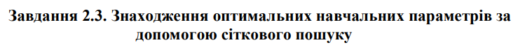

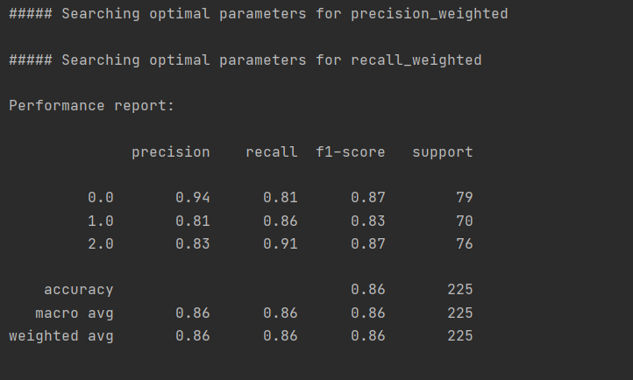

**Не працює**

# print("\nGrid scores for the parameter grid:")  
# for params, avg_score, in classifier.cv_results_:  
# print(params, '-->', round(avg_score, 3))  
# print("\nBest parameters:", classifier.best_params_)

import numpy as np  
import matplotlib.pyplot as plt  
from sklearn.ensemble import RandomForestClassifier, ExtraTreesClassifier  
from sklearn.model_selection import train_test_split  
from sklearn.model_selection import GridSearchCV  
from sklearn.metrics import classification_report,confusion_matrix  
  
from utilities import visualize_classifier  
  
  
input_file = 'data_random_forests.txt'  
data = np.loadtxt(input_file, delimiter=',')  
X, y = data[:, :-1], data[:, -1]  
  
class_0 = np.array(X[y == 0])  
class_1 = np.array(X[y == 1])  
class_2 = np.array(X[y == 2])  
X_train, X_test, y_train, y_test = train_test_split(X, y, test_size=0.25, random_state=5)  
  
parameter_grid = [{'n_estimators': [100], 'max_depth': [2, 4, 7, 12, 16]}, {'max_depth': [4], 'n_estimators': [25, 50, 100, 250]}]  
metrics = ['precision_weighted', 'recall_weighted']  
  
for metric in metrics:  
 print("\n##### Searching optimal parameters for", metric)  
  
classifier = GridSearchCV(ExtraTreesClassifier(random_state=0), parameter_grid, cv=5, scoring=metric)  
classifier.fit(X_train, y_train)  
  
# print("\nGrid scores for the parameter grid:")  
# for params, avg_score, in classifier.cv_results_:  
# print(params, '-->', round(avg_score, 3))  
# print("\nBest parameters:", classifier.best_params_)  
  
y_pred = classifier.predict(X_test)  
print("\nPerformance report:\n")  
print(classification_report(y_test, y_pred))

**Task4**



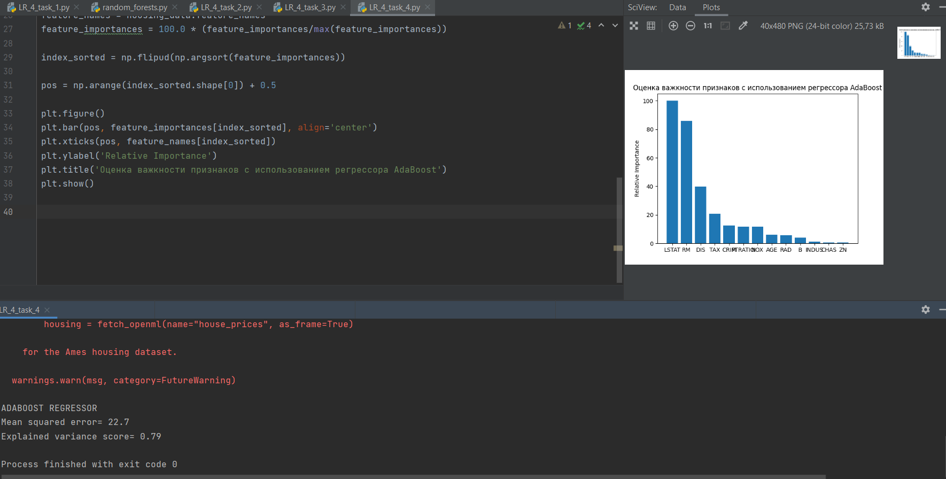

import numpy as np  
import matplotlib.pyplot as plt  
from sklearn.tree import DecisionTreeRegressor  
from sklearn.ensemble import AdaBoostRegressor  
from sklearn import datasets  
from sklearn.metrics import mean_squared_error, explained_variance_score  
from sklearn.model_selection import train_test_split  
from sklearn.utils import shuffle  
  
housing_data = datasets.load_boston()  
  
X, y = shuffle(housing_data.data, housing_data.target, random_state=7)  
X_train, X_test, y_train, y_test = train_test_split(X, y, test_size=0.2, random_state=7)  
  
regressor = AdaBoostRegressor(DecisionTreeRegressor(max_depth=4), n_estimators=400, random_state=7)  
regressor.fit(X_train, y_train)  
  
y_pred = regressor.predict(X_test)  
mse = mean_squared_error(y_test, y_pred)  
evs = explained_variance_score(y_test, y_pred)  
print("\nADABOOST REGRESSOR")  
print("Mean squared error=", round(mse, 2))  
print("Explained variance score=", round(evs, 2))  
  
feature_importances = regressor.feature_importances_  
feature_names = housing_data.feature_names  
feature_importances = 100.0 * (feature_importances/max(feature_importances))  
  
index_sorted = np.flipud(np.argsort(feature_importances))  
  
pos = np.arange(index_sorted.shape[0]) + 0.5  
  
plt.figure()  
plt.bar(pos, feature_importances[index_sorted], align='center')  
plt.xticks(pos, feature_names[index_sorted])  
plt.ylabel('Relative Importance')  
plt.title('Оценка важкности признаков с использованием регрессора AdaBoost')  
plt.show()

**Task5**

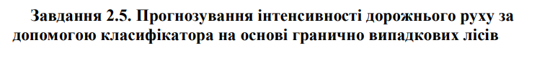

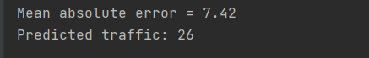

import numpy as np  
import matplotlib.pyplot as plt  
from sklearn.metrics import classification_report, mean_absolute_error  
from sklearn.model_selection import train_test_split, cross_val_score  
from sklearn.ensemble import ExtraTreesRegressor  
from sklearn import preprocessing  
  
input_file = 'traffic_data.txt'  
data = []  
with open(input_file, 'r') as f:  
 for line in f.readlines():  
 items = line[:-1].split(',')  
 data.append(items)  
  
data = np.array(data)  
  
label_encoder = []  
X_encoded = np.empty(data.shape)  
for i, item in enumerate(data[0]):  
 if item.isdigit():  
 X_encoded[:, i] = data[:, i]  
 else:  
 label_encoder.append(preprocessing.LabelEncoder())  
 X_encoded[:, i] = label_encoder[-1].fit_transform(data[:, i])  
  
X = X_encoded[:, :-1].astype(int)  
Y = X_encoded[:, -1].astype(int)  
  
X_train, X_test, Y_train, Y_test = train_test_split(X, Y, test_size=0.25, random_state=5)  
params = {'n_estimators': 100, 'max_depth': 4, 'random_state': 0}  
regressor = ExtraTreesRegressor(**params)  
regressor.fit(X_train, Y_train)  
  
Y_pred = regressor.predict(X_test)  
print("Mean absolute error =", round(mean_absolute_error(Y_test, Y_pred), 2))  
  
test_datapoint = ['Saturday', '10:20', 'Atlanta', 'no']  
test_datapoint_encoded = [-1] * len(test_datapoint)  
count = 0  
  
for i, item in enumerate(test_datapoint):  
 if item.isdigit():  
 test_datapoint_encoded[i] = int(test_datapoint[i])  
 else:  
 test_datapoint_encoded[i] = int(label_encoder[count].transform([test_datapoint[i]]))  
 count = count + 1  
  
test_datapoint_encoded = np.array(test_datapoint_encoded)  
  
print("Predicted traffic:", int(regressor.predict([test_datapoint_encoded])[0]))

**Task6**

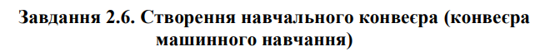

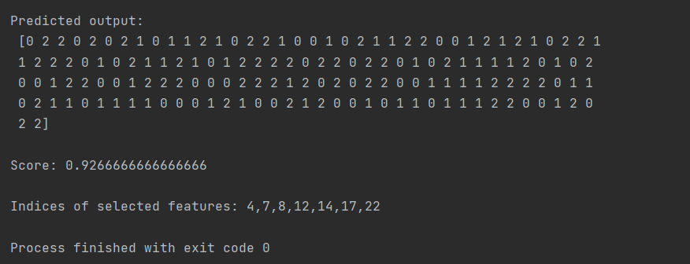

from sklearn.datasets import _samples_generator  
from sklearn.feature_selection import SelectKBest, f_regression  
from sklearn.pipeline import Pipeline  
from sklearn.ensemble import ExtraTreesClassifier  
  
X, y = _samples_generator.make_classification(n_samples=150, n_features=25, n_classes=3, n_informative=6, n_redundant=0, random_state=7)  
  
k_best_selector = SelectKBest(f_regression, k=9)  
classifier = ExtraTreesClassifier(n_estimators=60, max_depth=4)  
  
processor_pipeline = Pipeline([('selector', k_best_selector), ('erf', classifier)])  
processor_pipeline.set_params(selector__k=7, erf__n_estimators=30)  
processor_pipeline.fit(X, y)  
  
output = processor_pipeline.predict(X)  
print("\nPredicted output:\n", output)  
  
print("\nScore:", processor_pipeline.score(X, y))  
status = processor_pipeline.named_steps['selector'].get_support()  
selected = [i for i, x in enumerate(status) if x]  
print("\nIndices of selected features:", ','.join([str(x) for x in selected]))

**Predicted output – спрогнозовані результати для всіх вхідних даних**

**Score – обчислення оцінки з використанням маркованих тренувальних даних**

**Indices of selected features – індекси обраних ознак**

**Task7**



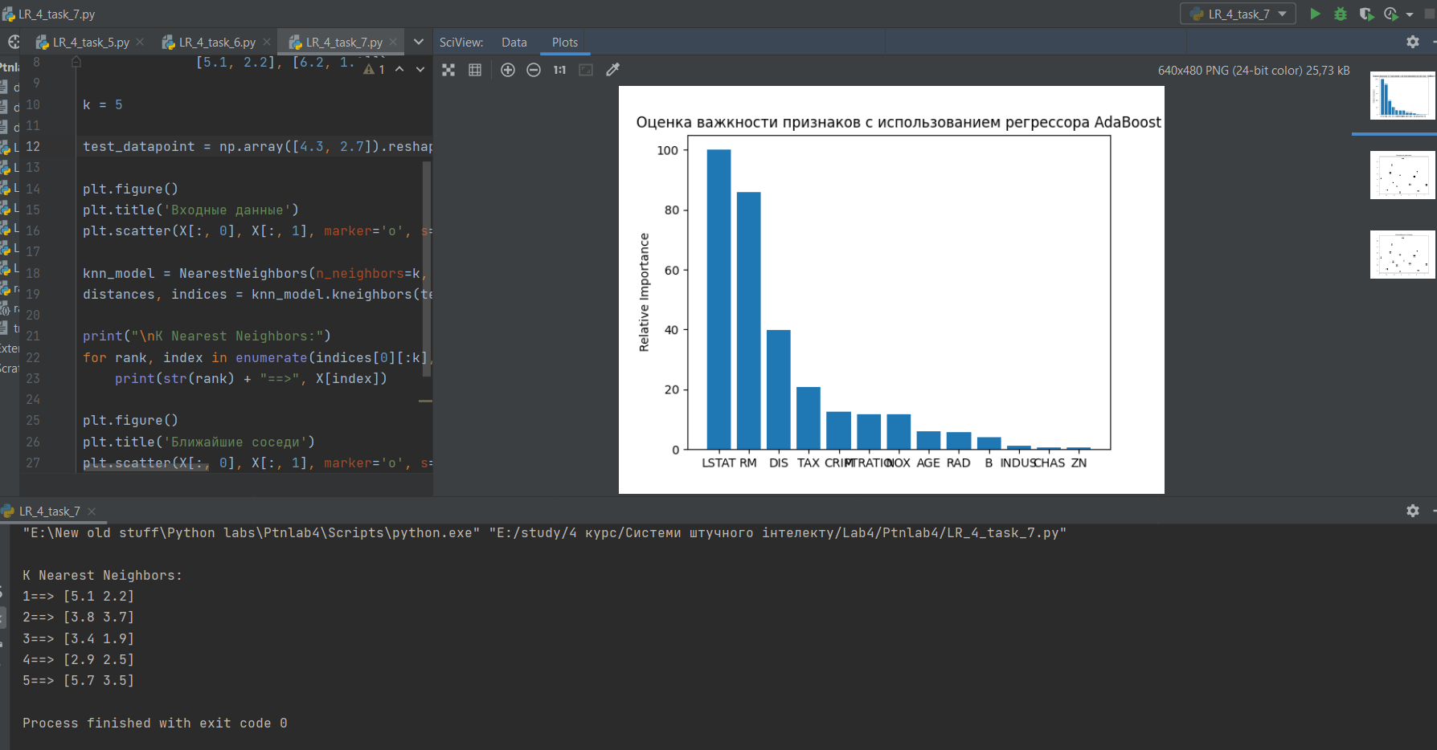

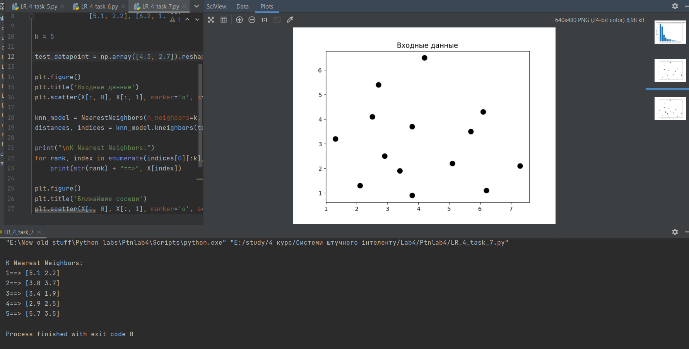

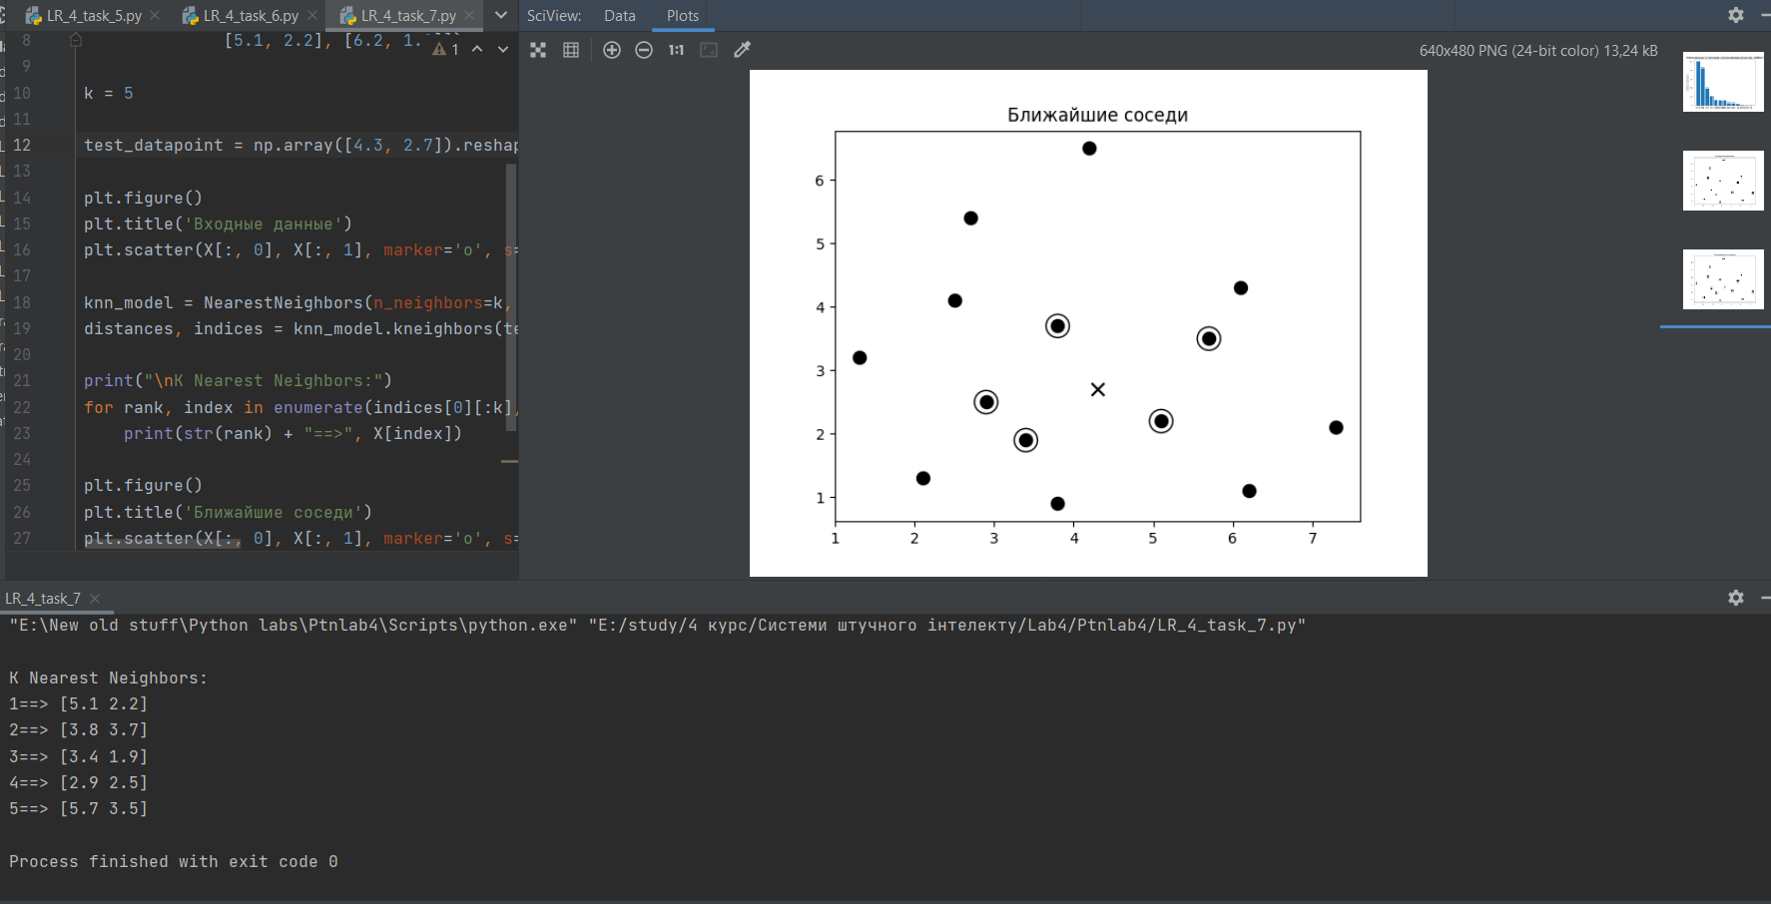

import numpy as np  
import matplotlib.pyplot as plt  
from sklearn.neighbors import NearestNeighbors  
  
X = np.array([[2.1, 1.3], [1.3, 3.2], [2.9, 2.5], [2.7, 5.4],  
 [3.8, 0.9], [7.3, 2.1], [4.2, 6.5], [3.8, 3.7],  
 [2.5, 4.1], [3.4, 1.9], [5.7, 3.5], [6.1, 4.3],  
 [5.1, 2.2], [6.2, 1.1]])  
  
k = 5  
  
test_datapoint = np.array([4.3, 2.7]).reshape(1, -1)  
  
plt.figure()  
plt.title('Входные данные')  
plt.scatter(X[:, 0], X[:, 1], marker='o', s=75, color='black')  
  
knn_model = NearestNeighbors(n_neighbors=k, algorithm='ball_tree').fit(X)  
distances, indices = knn_model.kneighbors(test_datapoint)  
  
print("\nK Nearest Neighbors:")  
for rank, index in enumerate(indices[0][:k], start=1):  
 print(str(rank) + "==>", X[index])  
  
plt.figure()  
plt.title('Ближайшие соседи')  
plt.scatter(X[:, 0], X[:, 1], marker='o', s=75, color='k')  
plt.scatter(X[indices][0][:][:, 0], X[indices][0][:][:, 1], marker='o', s=250, color='k', facecolors='none')  
plt.scatter(test_datapoint[0][0], test_datapoint[0][1], marker='x', s=75, color='k')  
plt.show()

**Task8**



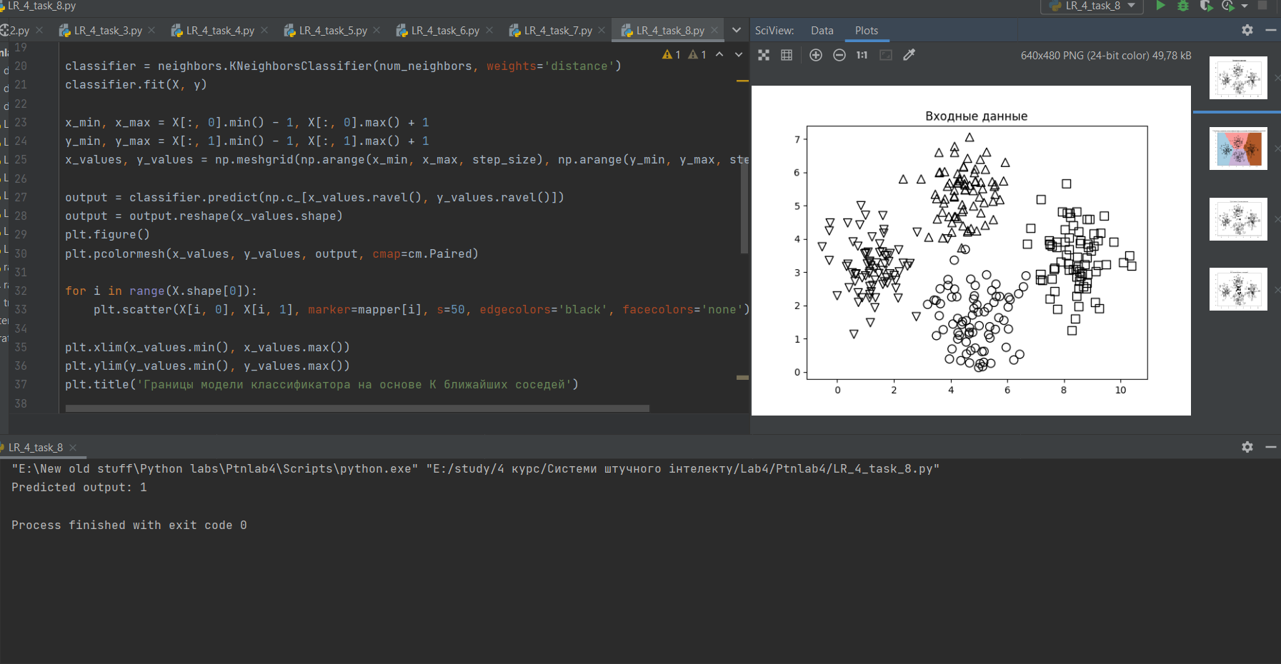

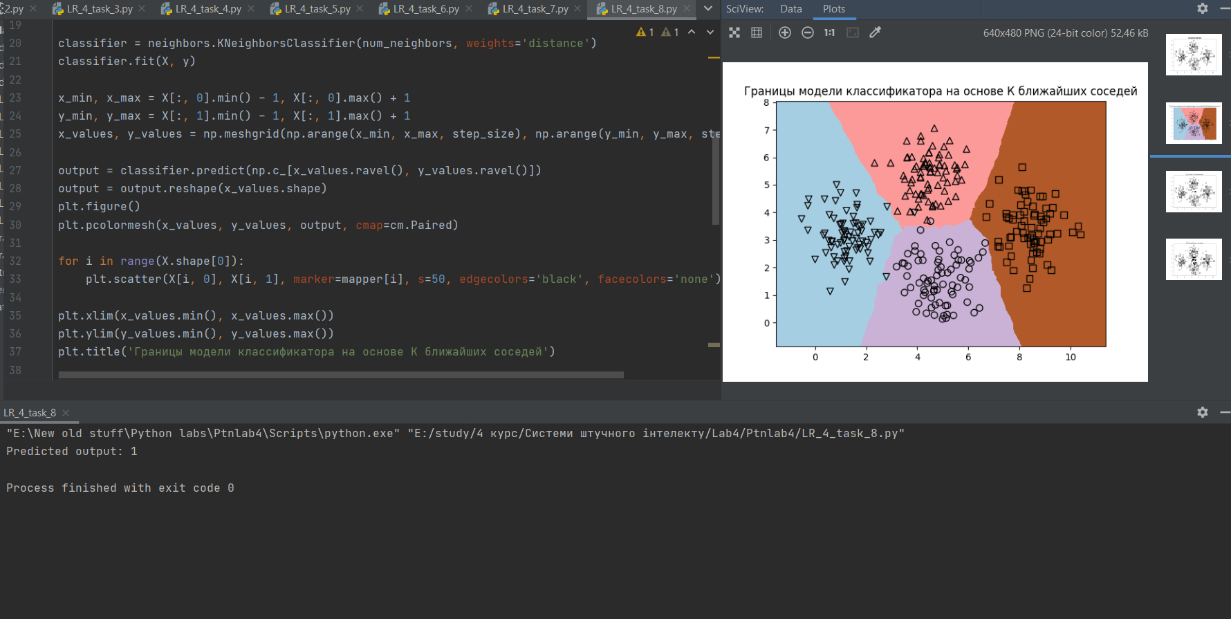

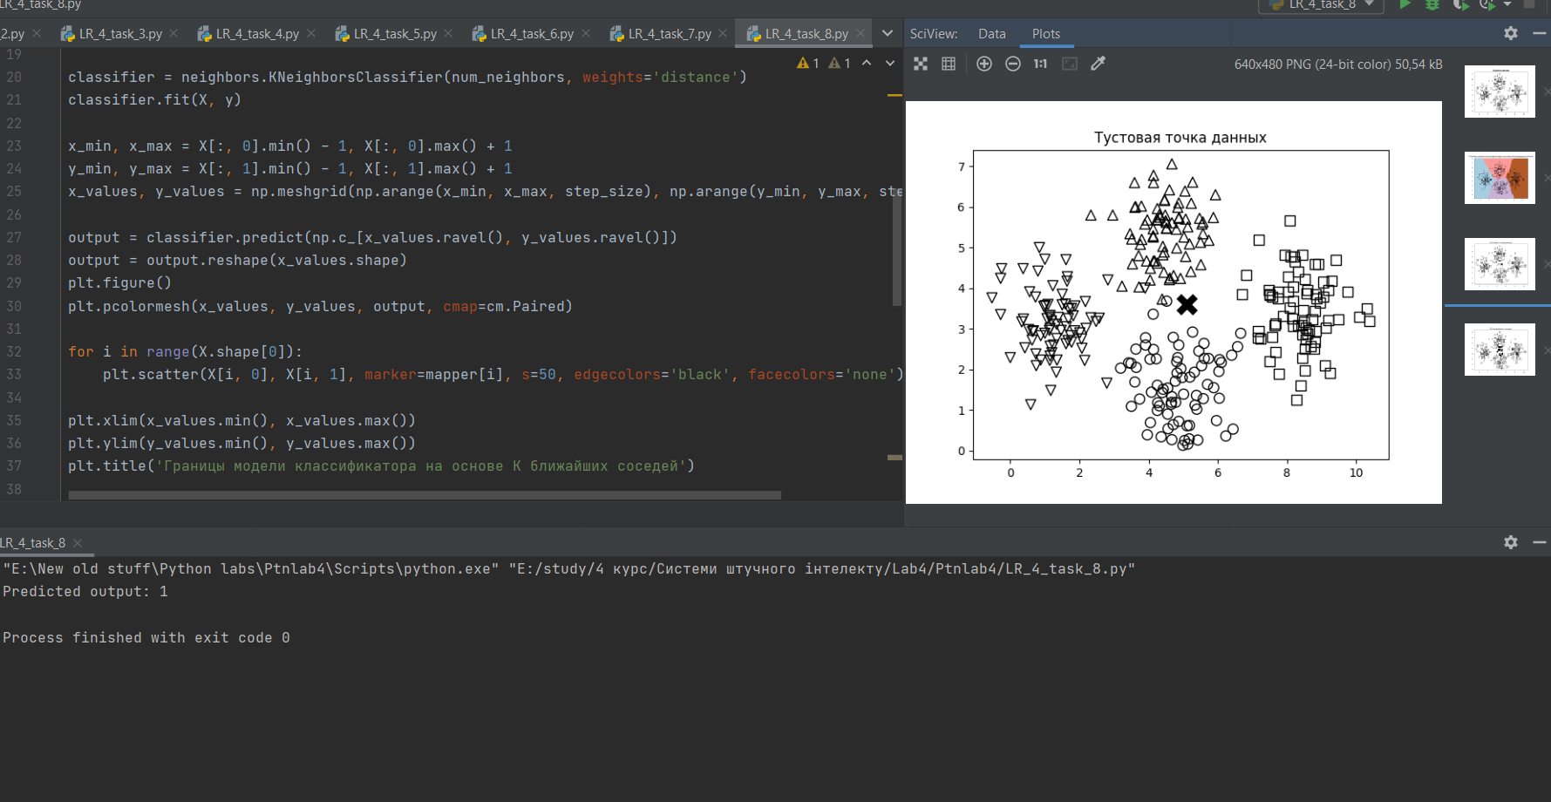

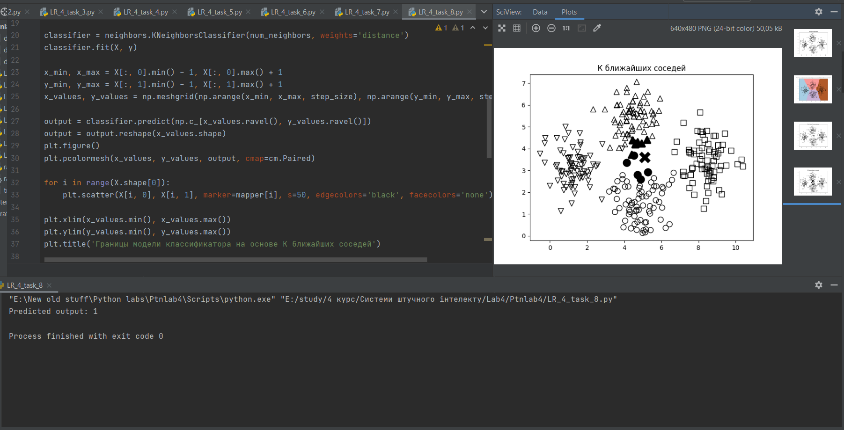

import numpy as np  
import matplotlib.pyplot as plt  
import matplotlib.cm as cm  
from sklearn import neighbors, datasets  
  
input_file = 'data.txt'  
data = np.loadtxt(input_file, delimiter=',')  
X, y = data[:, :-1], data[:, -1].astype(int)  
  
plt.figure()  
plt.title('Входные данные')  
marker_shapes = 'v^os'  
mapper = [marker_shapes[i] for i in y]  
for i in range(X.shape[0]):  
 plt.scatter(X[i, 0], X[i, 1], marker=mapper[i], s=75, edgecolors='black', facecolor='none')  
  
num_neighbors = 12  
step_size = 0.01  
  
classifier = neighbors.KNeighborsClassifier(num_neighbors, weights='distance')  
classifier.fit(X, y)  
  
x_min, x_max = X[:, 0].min() - 1, X[:, 0].max() + 1  
y_min, y_max = X[:, 1].min() - 1, X[:, 1].max() + 1  
x_values, y_values = np.meshgrid(np.arange(x_min, x_max, step_size), np.arange(y_min, y_max, step_size))  
  
output = classifier.predict(np.c_[x_values.ravel(), y_values.ravel()])  
output = output.reshape(x_values.shape)  
plt.figure()  
plt.pcolormesh(x_values, y_values, output, cmap=cm.Paired)  
  
for i in range(X.shape[0]):  
 plt.scatter(X[i, 0], X[i, 1], marker=mapper[i], s=50, edgecolors='black', facecolors='none')  
  
plt.xlim(x_values.min(), x_values.max())  
plt.ylim(y_values.min(), y_values.max())  
plt.title('Границы модели классификатора на основе К ближайших соседей')  
  
test_datapoint = [5.1, 3.6]  
plt.figure()  
plt.title('Тустовая точка данных')  
for i in range(X.shape[0]):  
 plt.scatter(X[i, 0], X[i, 1], marker=mapper[i], s=75, edgecolors='black', facecolors='none')  
  
plt.scatter(test_datapoint[0], test_datapoint[1], marker='x', linewidths=6, s=200, facecolors='black')  
  
_, indices = classifier.kneighbors([test_datapoint])  
indices = indices.astype(int)[0]  
  
plt.figure()  
plt.title('К ближайших соседей')  
for i in indices:  
 plt.scatter(X[i, 0], X[i, 1], marker=mapper[y[i]], linewidths=3, s=100, facecolors='black')  
  
plt.scatter(test_datapoint[0], test_datapoint[1], marker='x', linewidths=6, s=200, facecolors='black')  
  
for i in range(X.shape[0]):  
 plt.scatter(X[i, 0], X[i, 1], marker=mapper[i], s=75, edgecolors='black', facecolors='none')  
  
print("Predicted output:", classifier.predict([test_datapoint])[0])  
plt.show()

**Task9**

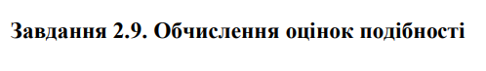

David Smith та Brenda Peterson Euclidean

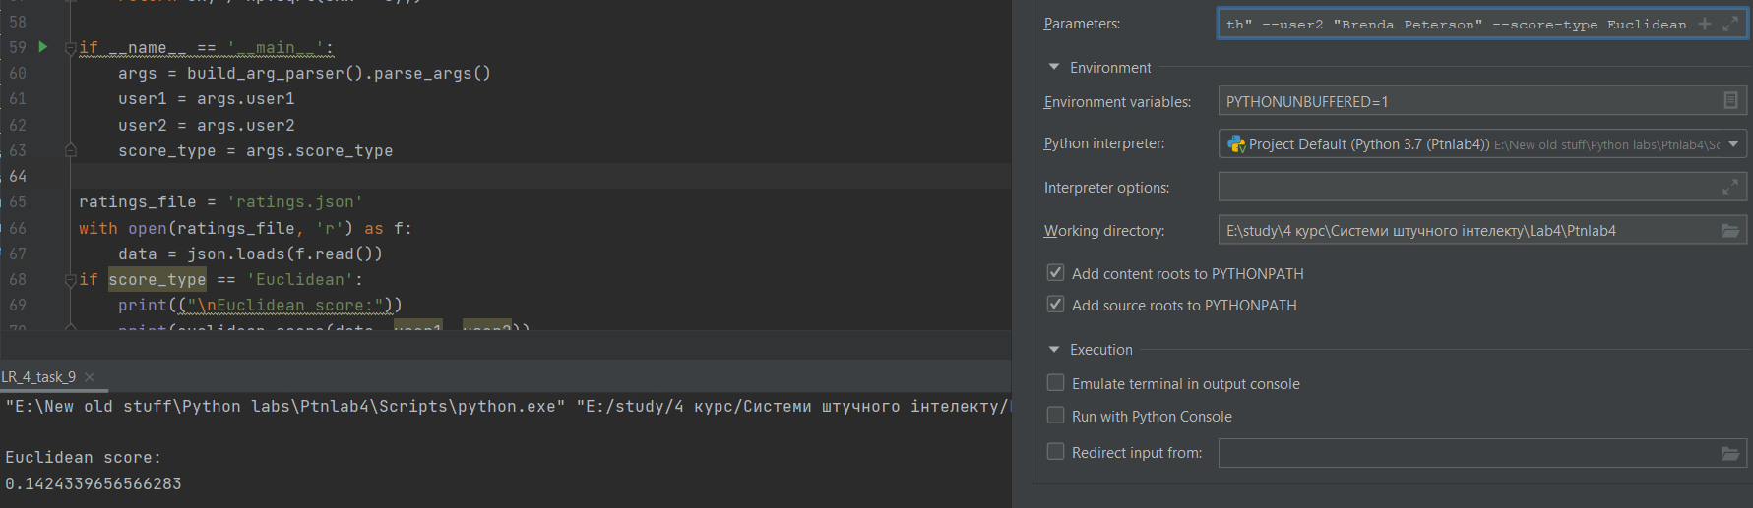

David Smith та Brenda Peterson Pearson

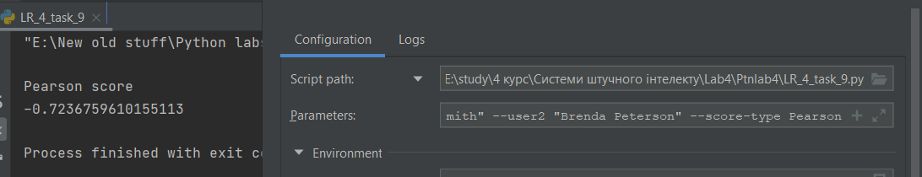

David Smith та Samuel Miller Euclidean

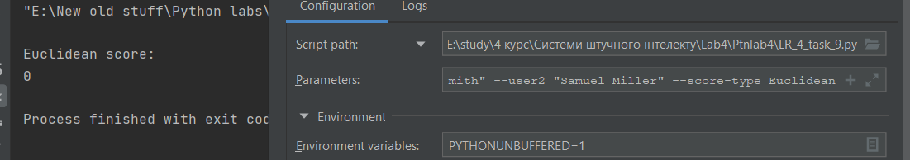

David Smith та Samuel Miller Pearson

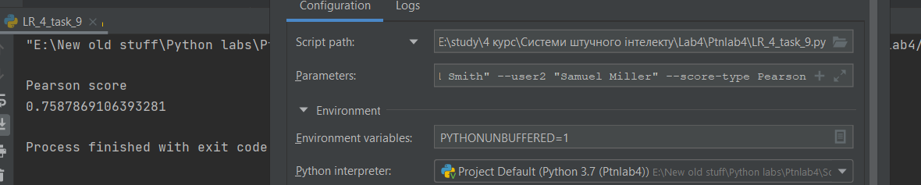

David Smith та Julie Hammel Euclidean

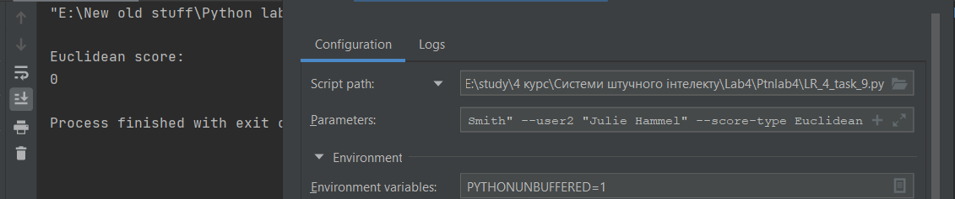

David Smith та Julie Hammel Pearson

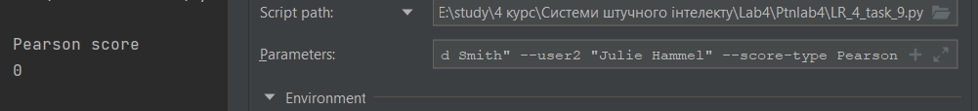

David Smith та Clarissa Jackson Euclidean



David Smith та Clarissa Jackson Pearson

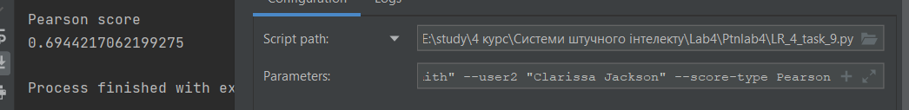

David Smith та Adam Cohen Euclidean



David Smith та Adam Cohen Pearson

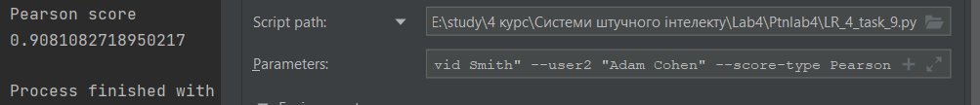

David Smith та Chris Duncan Euclidean



David Smith та Chris Duncan Pearson

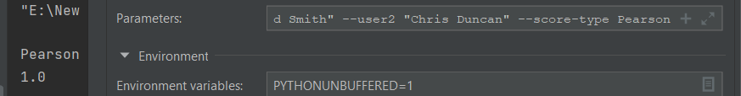

import argparse  
import json  
import numpy as np  
  
def build_arg_parser():  
 parser = argparse.ArgumentParser(description='Compute similarity score')  
 parser.add_argument('--user1', dest='user1', required=True, help='First user')  
 parser.add_argument('--user2', dest='user2', required=True, help='Second user')  
 parser.add_argument('--score-type', dest='score_type', required=True, choices=['Euclidean', 'Pearson'], help='Similarity metric to be used')  
 return parser  
  
  
def euclidean_score(dataset, user1, user2):  
 if user1 not in dataset:  
 raise TypeError('Cannot find' + user1 + 'in the dataset')  
 if user2 not in dataset:  
 raise TypeError('Cannot find' + user2 + 'in the dataset')  
 common_movies = {}  
 for item in dataset[user1]:  
 if item in dataset[user2]:  
 common_movies[item] = 1  
 if len(common_movies) == 0:  
 return 0  
 squared_diff = []  
 for item in dataset[user1]:  
 if item in dataset[user2]:  
 squared_diff.append(np.square(dataset[user1][item] - dataset[user2][item]))  
 return 1/(1 + np.sqrt(np.sum(squared_diff)))  
  
  
def pearson_score(dataset, user1, user2):  
 if user1 not in dataset:  
 raise TypeError('Cannot find' + user1 + 'in the dataset')  
 if user2 not in dataset:  
 raise TypeError('Cannot find' + user2 + 'in the dataset')  
 common_movies = {}  
 for item in dataset[user1]:  
 if item in dataset[user2]:  
 common_movies[item] = 1  
 num_ratings = len(common_movies)  
 if num_ratings == 0:  
 return 0  
 user1_sum = np.sum([dataset[user1][item] for item in common_movies])  
 user2_sum = np.sum([dataset[user2][item] for item in common_movies])  
  
 user1_squared_sum = np.sum([np.square(dataset[user1][item]) for item in common_movies])  
 user2_squared_sum = np.sum([np.square(dataset[user2][item]) for item in common_movies])  
 sum_of_products = np.sum([dataset[user1][item] * dataset[user2][item] for item in common_movies])  
  
 Sxy = sum_of_products - (user1_sum * user2_sum / num_ratings)  
 Sxx = user1_squared_sum - np.square(user1_sum) / num_ratings  
 Syy = user2_squared_sum - np.square(user2_sum) / num_ratings  
  
 if Sxx * Syy == 0:  
 return 0  
  
 return Sxy / np.sqrt(Sxx * Syy)  
  
if __name__ == '__main__':  
 args = build_arg_parser().parse_args()  
 user1 = args.user1  
 user2 = args.user2  
 score_type = args.score_type  
  
ratings_file = 'ratings.json'  
with open(ratings_file, 'r') as f:  
 data = json.loads(f.read())  
if score_type == 'Euclidean':  
 print(("\nEuclidean score:"))  
 print(euclidean_score(data, user1, user2))  
else:  
 print("\nPearson score")  
 print(pearson_score(data, user1, user2))

**Task10**



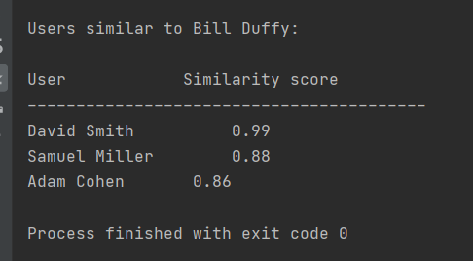

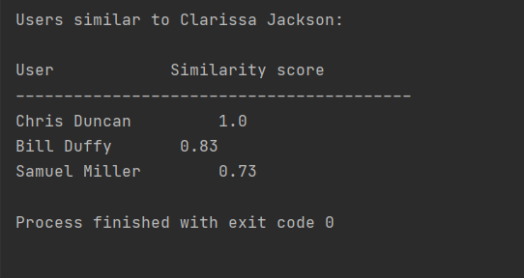

import argparse  
import json  
import numpy as np  
from compute_scores import pearson_score  
  
  
def build_arg_parser():  
 parser = argparse.ArgumentParser(description='Find users who are similar to the input user ')  
 parser.add_argument('--user', dest='user', required=True, help='Input user')  
 return parser  
  
  
def find_similar_users(dataset, user, num_users):  
 if user not in dataset:  
 raise TypeError('Cannot find' + user + ' in the dataset')  
 scores = np.array([[x, pearson_score(dataset, user, x)] for x in dataset if x != user])  
 scores_sorted = np.argsort(scores[:, 1])[::-1]  
 top_users = scores_sorted[:num_users]  
 return scores[top_users]  
  
  
if __name__ == '__main__':  
 args = build_arg_parser().parse_args()  
 user = args.user  
 ratings_file = 'ratings.json'  
  
with open(ratings_file, 'r') as f:  
 data = json.loads(f.read())  
  
print('\nUsers similar to ' + user + ':\n')  
similar_users = find_similar_users(data, user, 3)  
print('User\t\t\tSimilarity score')  
print('-'*41)  
for item in similar_users:  
 print(item[0], '\t\t', round(float(item[1]), 2))

**Task11**



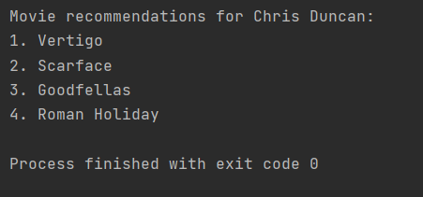

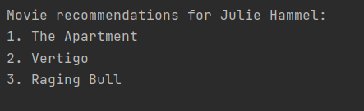

import argparse  
import json  
import numpy as np  
  
from compute_scores import pearson_score  
from collaborative_filtering import find_similar_users  
  
  
def build_arg_parser():  
 parser = argparse.ArgumentParser(description='Find the movie recommendations for the given user')  
 parser.add_argument('--user', dest='user', required=True,  
 help='Input user')  
 return parser  
  
  
def get_recommendations(dataset, input_user):  
 if input_user not in dataset:  
 raise TypeError('Cannot find ' + input_user + ' in the dataset')  
  
 overall_scores = {}  
 similarity_scores = {}  
  
 for user in [x for x in dataset if x != input_user]:  
 similarity_score = pearson_score(dataset, input_user, user)  
  
 if similarity_score <= 0:  
 continue  
  
 filtered_list = [x for x in dataset[user] if x not in \  
 dataset[input_user] or dataset[input_user][x] == 0]  
  
 for item in filtered_list:  
 overall_scores.update({item: dataset[user][item] * similarity_score})  
 similarity_scores.update({item: similarity_score})  
  
 if len(overall_scores) == 0:  
 return ['No recommendations possible']  
  
 movie_scores = np.array([[score / similarity_scores[item], item]  
 for item, score in overall_scores.items()])  
  
 movie_scores = movie_scores[np.argsort(movie_scores[:, 0])[::-1]]  
  
 movie_recommendations = [movie for _, movie in movie_scores]  
  
 return movie_recommendations  
  
  
if __name__ == '__main__':  
 args = build_arg_parser().parse_args()  
 user = args.user  
  
 ratings_file = 'ratings.json'  
  
 with open(ratings_file, 'r') as f:  
 data = json.loads(f.read())  
  
 print("\nMovie recommendations for " + user + ":")  
 movies = get_recommendations(data, user)  
 for i, movie in enumerate(movies):  
 print(str(i + 1) + '. ' + movie)

**https://gitlab.com/2019-2023/ipz19-3/lysovyi-maksym/AI**

**Висновок:** використовуючи спеціалізовані бібліотеки та мову програмування Python дослідив методи ансамблів у машинному навчанні та створив рекомендаційні системи.