**ЛАБОРАТОРНА РОБОТА № 7**

**Тема**: ДОСЛІДЖЕННЯ МУРАШИНИХ АЛГОРИТМІВ

**Мета**: використовуючи спеціалізовані бібліотеки та мову програмування Python навчитися дослідити метод мурашиних колоній.

**Хід роботи:**

**Task1**

Дослідження мурашиного алгоритму на прикладі рішення задачі комівояжера

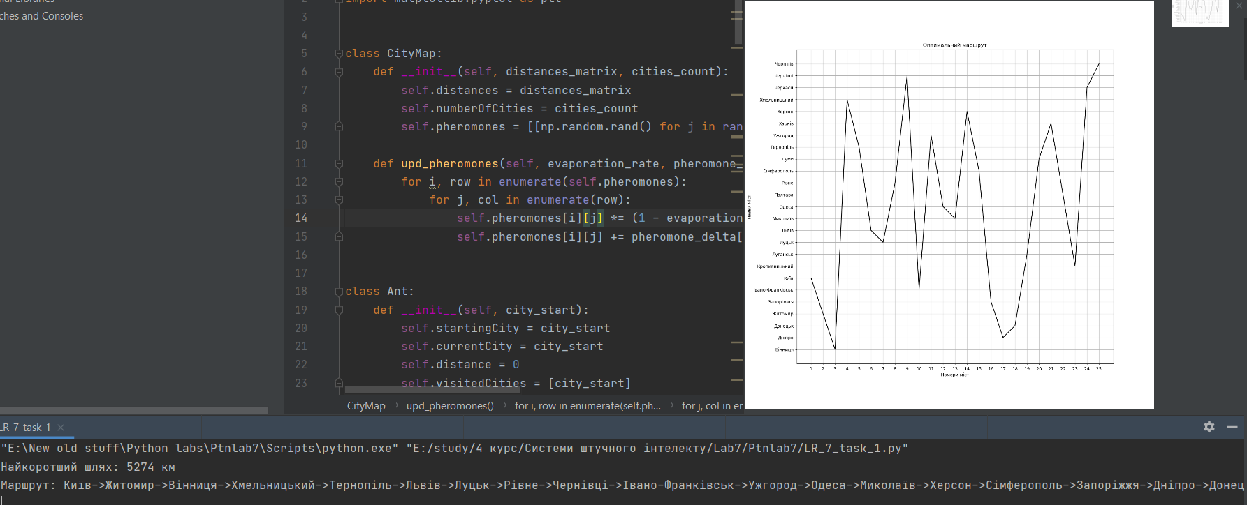

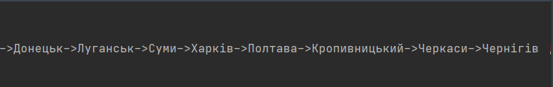

import numpy as np  
import matplotlib.pyplot as plt  
  
  
class CityMap:  
 def __init__(self, distances_matrix, cities_count):  
 self.distances = distances_matrix  
 self.numberOfCities = cities_count  
 self.pheromones = [[np.random.rand() for j in range(cities_count)] for i in range(cities_count)]  
  
 def upd_pheromones(self, evaporation_rate, pheromone_delta):  
 for i, row in enumerate(self.pheromones):  
 for j, col in enumerate(row):  
 self.pheromones[i][j] *= (1 - evaporation_rate)  
 self.pheromones[i][j] += pheromone_delta[i][j]  
  
  
class Ant:  
 def __init__(self, city_start):  
 self.startingCity = city_start  
 self.currentCity = city_start  
 self.distance = 0  
 self.visitedCities = [city_start]  
  
 def move(self, city_new, distance):  
 self.currentCity = city_new  
 self.visitedCities.append(city_new)  
 self.distance += distance  
  
  
class Colony:  
 maxColonyCycles = 50  
 pheromoneAddition = 0.0005  
 pheromoneEvaporationRate = 0.2  
 pheromoneImportance = 0.01  
 distanceImportance = 9.5  
 antCanVisitPreviousCities = False  
  
 def __init__(self, ants_num):  
 self.numberOfAnts = ants_num  
  
 def find_route(self, city_map, city_num):  
 min_dist = float('inf')  
 route = []  
 for cycle in range(self.maxColonyCycles):  
 pheromones_delta = [[0.0 for i in range(city_map.numberOfCities)] for j in range(city_map.numberOfCities)]  
 for antNumber in range(self.numberOfAnts):  
 ant = Ant(city_num)  
 while len(ant.visitedCities) < city_map.numberOfCities:  
 next_city = self.get_next_city(ant, city_map)  
 ant.move(next_city, city_map.distances[ant.currentCity][next_city])  
 ant_dist = ant.distance + city_map.distances[ant.currentCity][ant.startingCity]  
 if ant_dist < min_dist:  
 min_dist = ant_dist  
 route = ant.visitedCities  
 for city in range(len(ant.visitedCities) - 1):  
 pheromones_delta[ant.visitedCities[city]][  
 ant.visitedCities[city + 1]] += self.pheromoneAddition / ant_dist  
 city_map.upd_pheromones(self.pheromoneEvaporationRate, pheromones_delta)  
  
 return min_dist, route  
  
  
 def get_probabilities(self, ant, city_map):  
 result = [0 for i in range(city_map.numberOfCities)]  
 total_probability = 0  
 for newCity in range(city_map.numberOfCities):  
 if (newCity != ant.currentCity) and (self.antCanVisitPreviousCities or newCity not in ant.visitedCities):  
 probability = pow(city_map.pheromones[ant.currentCity][newCity], self.pheromoneImportance) * pow(  
 1 / city_map.distances[ant.currentCity][newCity], self.distanceImportance)  
 result[newCity] = probability  
 total_probability += probability  
 result = [result[i] / total_probability for i in range(city_map.numberOfCities)]  
 return result  
  
  
 def get_next_city(self, ant, city_map):  
 probabilities = self.get_probabilities(ant, city_map)  
 random_value = np.random.rand()  
 for i in range(city_map.numberOfCities):  
 if probabilities[i] > random_value:  
 return i  
 else:  
 random_value -= probabilities[i]  
 return -1  
  
  
  
distance = [  
 [0, 645, 868, 125, 748, 366, 256, 316, 1057, 382, 360, 471, 428, 593, 311, 844, 602, 232, 575, 734, 521, 120,  
 343, 312, 396],  
 [645, 0, 252, 664, 81, 901, 533, 294, 394, 805, 975, 343, 468, 196, 957, 446, 430, 877, 1130, 213, 376, 765,  
 324, 891, 672],  
 [868, 252, 0, 858, 217, 1171, 727, 520, 148, 1111, 1221, 611, 731, 390, 1045, 591, 706, 1100, 1391, 335, 560,  
 988, 547, 1141, 867],  
 [125, 664, 858, 0, 738, 431, 131, 407, 1182, 257, 423, 677, 557, 468, 187, 803, 477, 298, 671, 690, 624, 185,  
 321, 389, 271],  
 [748, 81, 217, 738, 0, 1119, 607, 303, 365, 681, 833, 377, 497, 270, 925, 365, 477, 977, 1488, 287, 297, 875,  
 405, 957, 747],  
 [366, 901, 1171, 431, 1119, 0, 561, 618, 1402, 328, 135, 747, 627, 898, 296, 1070, 908, 134, 280, 1040, 798,  
 246, 709, 143, 701],  
 [256, 533, 727, 131, 607, 561, 0, 298, 811, 388, 550, 490, 489, 337, 318, 972, 346, 427, 806, 478, 551, 315,  
 190, 538, 149],  
 [316, 294, 520, 407, 303, 618, 298, 0, 668, 664, 710, 174, 294, 246, 627, 570, 506, 547, 883, 387, 225, 435,  
 126, 637, 363],  
 [1057, 394, 148, 1182, 365, 1402, 811, 668, 0, 1199, 1379, 857, 977, 474, 1129, 739, 253, 1289, 1539, 333, 806,  
 1177, 706, 1292, 951],  
 [382, 805, 1111, 257, 681, 328, 388, 664, 1199, 0, 152, 780, 856, 725, 70, 1052, 734, 159, 413, 866, 869, 263,  
 578, 336, 949],  
 [360, 975, 1221, 423, 833, 135, 550, 710, 1379, 152, 0, 850, 970, 891, 232, 1173, 896, 128, 261, 1028, 1141,  
 240, 740, 278, 690],  
 [471, 343, 611, 677, 377, 747, 490, 174, 857, 780, 850, 0, 120, 420, 864, 282, 681, 754, 999, 556, 51, 590, 300,  
 642, 640],  
 [428, 468, 731, 557, 497, 627, 489, 294, 977, 856, 970, 120, 0, 540, 741, 392, 800, 660, 1009, 831, 171, 548,  
 420, 515, 529],  
 [593, 196, 390, 468, 270, 898, 337, 246, 474, 725, 891, 420, 540, 0, 665, 635, 261, 825, 1149, 141, 471, 653,  
 279, 892, 477],  
 [311, 957, 1045, 187, 925, 296, 318, 627, 1129, 70, 232, 864, 741, 665, 0, 1157, 664, 162, 484, 805, 834, 193,  
 508, 331, 458],  
 [844, 446, 591, 803, 365, 1070, 972, 570, 739, 1052, 1173, 282, 392, 635, 1157, 0, 896, 1097, 1363, 652, 221,  
 964, 696, 981, 1112],  
 [602, 430, 706, 477, 477, 908, 346, 506, 253, 734, 896, 681, 800, 261, 664, 896, 0, 774, 1138, 190, 732, 662,  
 540, 883, 350],  
 [232, 877, 1100, 298, 977, 134, 427, 547, 1289, 159, 128, 754, 660, 825, 162, 1097, 774, 0, 338, 987, 831, 112,  
 575, 176, 568],  
 [575, 1130, 1391, 671, 1488, 280, 806, 883, 1539, 413, 261, 999, 1009, 1149, 484, 1363, 1138, 338, 0, 1299,  
 1065, 455, 984, 444, 951],  
 [734, 213, 335, 690, 287, 1040, 478, 387, 333, 866, 1028, 556, 831, 141, 805, 652, 190, 987, 1299, 0, 576, 854,  
 420, 1036, 608],  
 [521, 376, 560, 624, 297, 798, 551, 225, 806, 869, 1141, 51, 171, 471, 834, 221, 732, 831, 1065, 576, 0, 641,  
 351, 713, 691],  
 [120, 765, 988, 185, 875, 246, 315, 435, 1177, 263, 240, 590, 548, 653, 193, 964, 662, 112, 455, 854, 641, 0,  
 463, 190, 455],  
 [343, 324, 547, 321, 405, 709, 190, 126, 706, 578, 740, 300, 420, 279, 508, 696, 540, 575, 984, 420, 351, 463,  
 0, 660, 330],  
 [312, 891, 1141, 389, 957, 143, 538, 637, 1292, 336, 278, 642, 515, 892, 331, 981, 883, 176, 444, 1036, 713,  
 190, 660, 0, 695],  
 [396, 672, 867, 271, 747, 701, 149, 363, 951, 949, 690, 640, 529, 477, 458, 1112, 350, 568, 951, 608, 691, 455,  
 330, 695, 0]  
]  
  
  
cities = [  
 'Вінниця', 'Дніпро', 'Донецьк', 'Житомир', 'Запоріжжя', 'Івано-Франківськ', 'Київ', 'Кропивницький',  
 'Луганськ', 'Луцьк', 'Львів', 'Миколаїв', 'Одеса', 'Полтава', 'Рівне', 'Сімферополь', 'Суми', 'Тернопіль',  
 'Ужгород', 'Харків', 'Херсон', 'Хмельницький', 'Черкаси', 'Чернівці', 'Чернігів'  
]  
  
if __name__ == '__main__':  
 cityMap = CityMap(distance, len(distance[0]))  
 colony = Colony(len(distance[0]))  
 result = colony.find_route(cityMap, 6)  
 print(f"Найкоротший шлях: {result[0]} км")  
  
  
 cityRoutes = "Маршрут: "  
 for i in result[1]:  
 cityRoutes += cities[i]  
 if i != result[1][-1]:  
 cityRoutes += "->"  
 print(cityRoutes)  
  
  
 fig = plt.figure(figsize=(13, 13))  
 plt.xticks([i + 1 for i in range(25)])  
 plt.yticks([i for i in range(25)], cities)  
 plt.xlabel("Номери міст")  
 plt.ylabel("Назви міст")  
 plt.title("Оптимальний маршрут")  
 plt.plot([i + 1 for i in range(25)], result[1], ms=12, mfc='r',  
 mec='black', mew=2, color='black')  
 plt.grid()  
 plt.show()

**Висновок:** використовуючи спеціалізовані бібліотеки та мову програмування Python навчивя досліджувати метод мурашиних колоній.