**ACIT 3640 - Cloud Computing with AWS**

**(Lab 3)**

**Bootstrap Linux and Windows Instances**

**Student Number: _________________________________ Set: ________**

**First Name: ___________________ Last Name: _________________________**

Part I

1. Create an HTML file on your computer called “index.html.”
2. Open the index.html file with a text editor, like Notepad, and type the following line:

“Hello World from <your name>”

1. Log into the AWS Console.
2. Under “Storage”, select S3.
3. Create a bucket. The bucket name should be in all lower case letters. Make sure the Region matches your default region for your root AWS account.

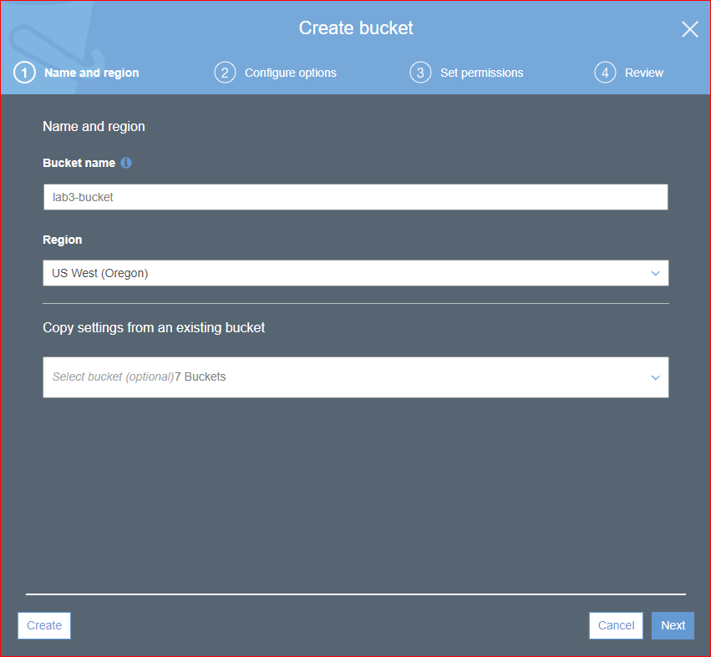

1. Upload the index.html file to this bucket.
   1. Click on the bucket and select the upload button at the top of the screen.
   2. Upload file and write down the bucket name for later reference.
2. Create an IAM Role to allow access to S3 buckets.
   1. From your account name in the top right corner of the AWS console, select Security Credentials.
   2. On the left hand side menu, select Roles
   3. Create a new role.
   4. From the list of AWS Service Roles, select the first role “ EC2.” Click next.

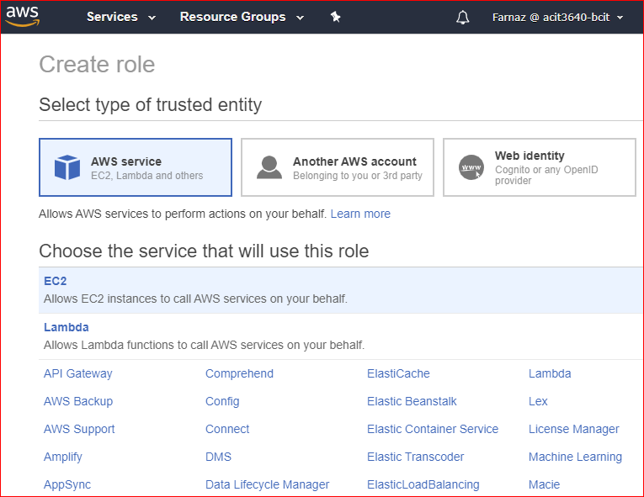

* 1. From the list of policies, select “AmazonS3FullAccess” and click next.

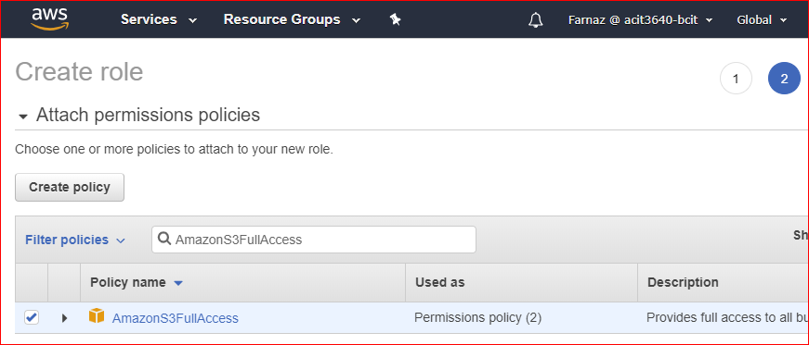

* 1. Name the role “S3-Admin-Access.” And create role

1. Navigate to the EC2 area of AWS.
   1. Launch an Amazon Linux AMI.
   2. On Step 3, change the IAM Role to “S3-Admin-Access.”
   3. In Step 3, click “Advanced Details”

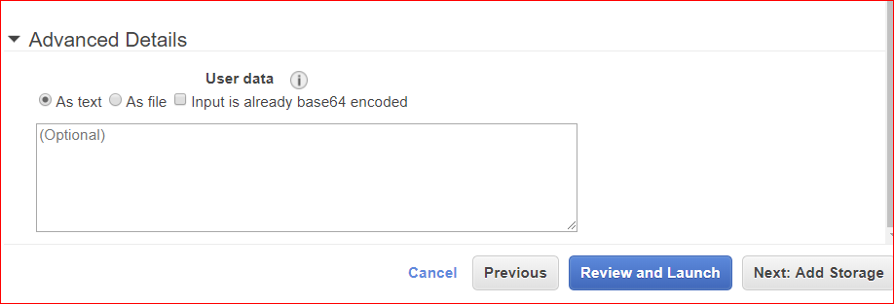

* 1. In the “User data” area, enter the following bash (shell) script:

#!/bin/bash

yum install httpd -y

yum update -y

aws s3 cp s3://YOUR-BUCKET-NAME-HERE/index.html /var/www/html/

service httpd start

chkconfig httpd on

* 1. What does this script do?
  2. When setting up the Security Group, make sure you add HTTP (port 80) for inbound HTTP traffic.

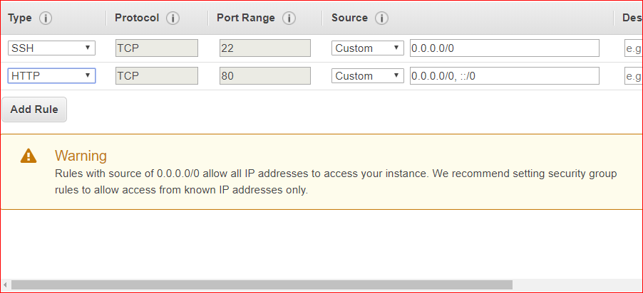

* 1. Tag your instance and launch it.

1. Once the instance is up and running, copy the Public IP address to the browser on your workstation or laptop.

**Instructor’s initials: ________**

Part II

1. Now, let’s bootstrap a Windows instance.
2. Launch an EC2 and select **Microsoft Windows Server 2019 Base.**
3. Do NOT use the IAM role from Part I, above. Leave the role as None.
4. In the Advanced Details area (Step 3), enter the following code:

<powershell>

Install-WindowsFeature Web-Server -IncludeManagementTools –IncludeAllSubFeature

</powershell>

1. What does this code do?
2. When setting up the Security Group, make sure you open port 80 for inbound HTTP traffic.
3. Tag the instance and launch it.
4. After the instance has passed the Status Checks, RDP into the instance.
5. Launch the Server Manager Dashboard.
6. On the left, you should see that IIS has been installed (it may take 2-3 minutes).

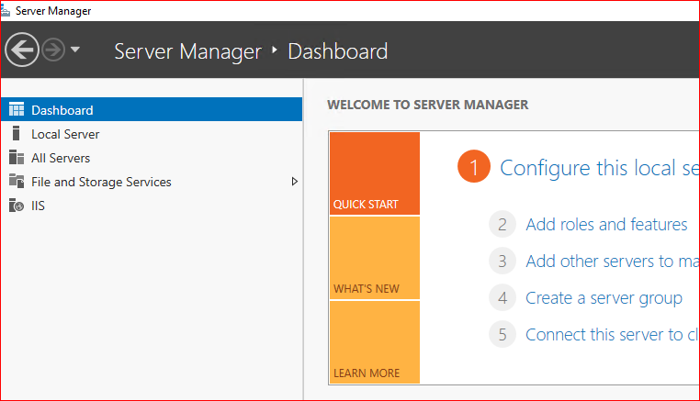

1. Minimize the Server Manager screen.
2. From a web browser on your workstation or lab top, enter the Public IP address of the instance. Is IIS running?
3. Go back to the Windows instance.
4. Open the Windows File Explorer and navigate to the directory C:\inetpub\wwwroot.
5. Open the iisstart.htm file with a text editor, like Notepad.
6. Remove the <style> tag and all its contents, up through </style>.
7. Go the tag <div id=”container”>
8. Enter the following code after that tag line, replacing what is currently there:

<a href="http://169.254.169.254/latest/meta-data/">Instance Metadata</a>  
<a href="http://169.254.169.254/latest/meta-data/hostname">Instance Hostname</a>  
<a href="http://169.254.169.254/latest/meta-data/placement/availability-zone">Instance Availability Zone</a>   
<a href="http://169.254.169.254/latest/user-data">Instance Userdata</a>

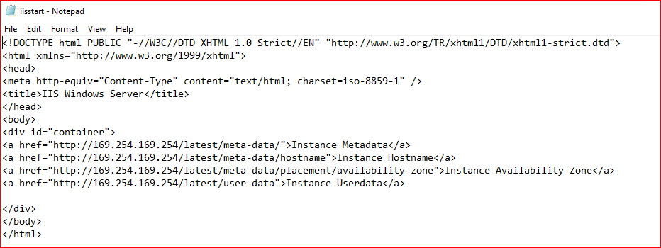

1. Launch Internet Explorer from within the instance.
2. Enter the URL http://127.0.0.1/
3. Click on the hyperlinks.

**Instructor’s initials: ________**

Part III

1. Create another Amazon Linux instance.
2. Enter the following bootstrap code in the Advanced Details area:

#!/bin/sh  
yum -y install httpd php  
chkconfig httpd on  
systemctl start httpd

1. What does this do?
2. When setting up the Security Group, make sure you add HTTP (port 80) for inbound HTTP traffic.
3. SSH into the instance.
4. Create a PHP web page by entering following code in Git terminal:

cd /var/www/html/.  
sudo nano index.php  
<?php  
 $url = "http://169.254.169.254/latest/meta-data/instance-id";  
 $instance_id = file_get_contents($url);  
 echo "Instance ID: <b>" . $instance_id . "</b><br/>";  
 $url = "http://169.254.169.254/latest/meta-data/placement/availability-zone";  
 $zone = file_get_contents($url);  
 echo "Zone: <b>" . $zone . "</b><br/>";  
?>

1. From a browser on your workstation or laptop, enter the Public IP address of this instance.

**Instructor’s initials: ________**

Clean Up

1. Terminate all of your running instances.
2. **Important**: Delete the S3 bucket containing the index.html file.