**ACIT3640 – Lab 3 – Part B**

**Cloud Formation Template**

In this part of the lab, you will use a CloudFormation template that creates an EC2 Linux instance.

1. Download, save and read the JSON CloudFormation template called “Lab_3_Part_B_Linux_CloudFormation_Template.json.” in D2L.
2. Search cloud formation in the search bar in AWS console.

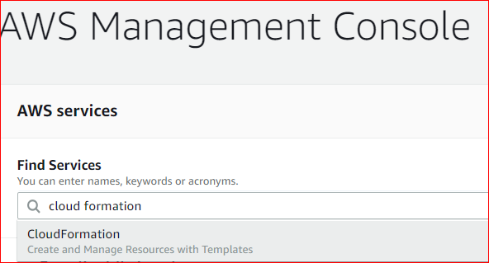

1. Click on create stack on top of the page.
2. Since we have a template, select “Template is ready” and “upload a template file.”
3. Upload your template.

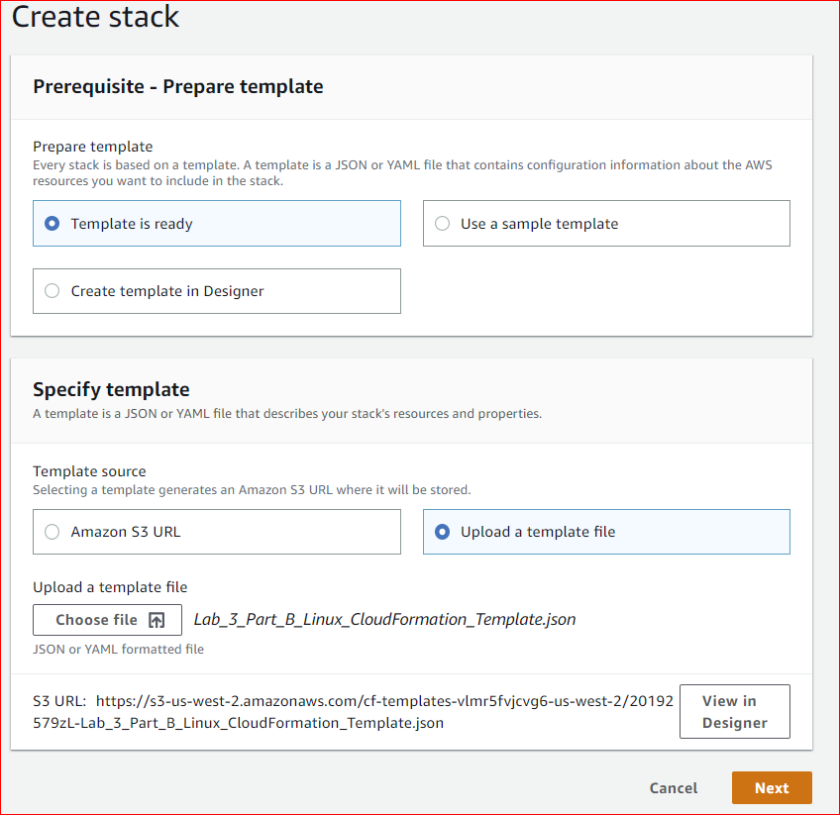

1. Click next and provide a name like “lab3”.
2. Make sure to select your key in kayName textbox.

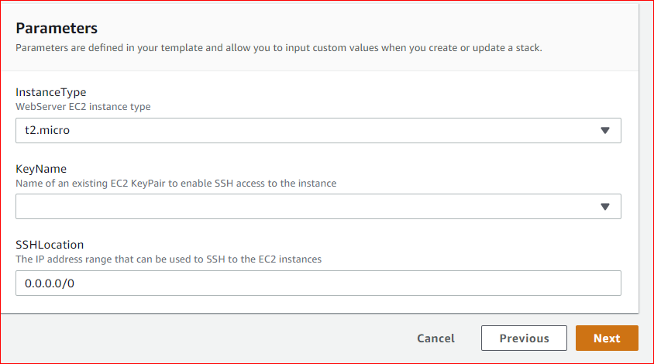

1. Click on next, review and create stack
2. Go to EC2 dashboard. Is there any running instance?
3. After the instance has launched, connect to it.
4. **Instructor’s initials: ________**
5. Make sure to terminate your instance and delete your stack.

This part of the lab is optional.

1. Using the provided template as a guide, write a new CloudFormation template that launches a Windows Server 2012 R2 instance. The template must be written in YAML, not JSON.
2. After the instance has launched, connect to it using RDP.
3. Name the template:

A00123456-Lab3-PartB.yml

1. Upload the template to the Dropbox on D2L lab3.