**ACIT 3640 – Lab 7**

**Route 53 and Elastic IPs**

1. Purchase a domain name, e.g., bcitcloud.ca, from an Internet domain registrar. There are many Internet domain registries. Here are some of them:
   1. godaddy.com
   2. fatcow.com
   3. freedns.afraid.org
   4. ca.cart.web.com

* 1. namecheap.com
  2. hover.com

1. Log into your AWS Console.
2. Launch an Amazon Linux instance.
3. Enter the following bootstrap code in the Advanced Details area:
4. #!/bin/sh  
   yum -y install httpd php  
   chkconfig httpd on  
   systemctl start httpd
5. For the inbound traffic for you security group, set the type to “All traffic” and the source “Anywhere.”
6. Launch your instance.
7. SSH into the instance after it is running.

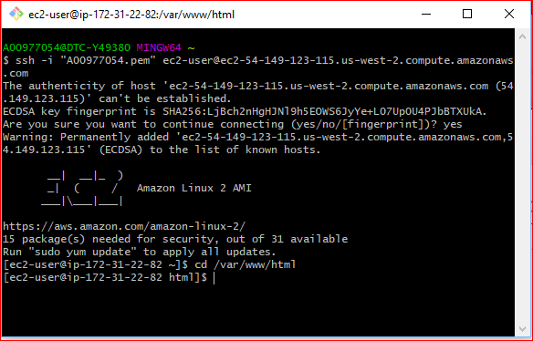

1. Create a PHP web page:
2. cd /var/www/html/.  
   sudo nano index.php  
   <?php  
    $url = "http://169.254.169.254/latest/meta-data/instance-id";  
    $instance_id = file_get_contents($url);  
    echo "Instance ID: <b>" . $instance_id . "</b><br/>";  
    $url = "http://169.254.169.254/latest/meta-data/placement/availability-zone";  
    $zone = file_get_contents($url);  
    echo "Zone: <b>" . $zone . "</b><br/>";  
   ?>
3. Verify the website is working. From a browser on your workstation or laptop, enter the Public IP address of this instance. Don’t forget to add “/index.php” at the end of the IP address. This webpage should display the Instance ID and Public IP address of your instance. Record your Public IP address here because you will need it later: __________________
4. Now, you are going to associate your domain name with this website/instance.
5. From the AWS Services menu, click on Route 53 under Networking & Content Delivery.
6. Click on Get Started Now under DNS management and then Create Hosted Zone.
7. Click on create hosted zone button, on the right hand side, enter the Domain Name that you have purchased in the Domain Name field.
   1. Select “Public Hosted Zone” from the Type field. Click Create.

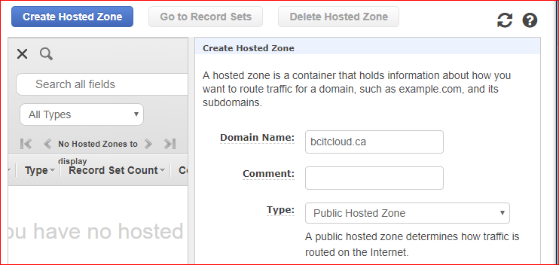

* 1. You will now see one SOA (Start of Authority) record and four NS (Name Server) record. Notice the values associated with the NS records

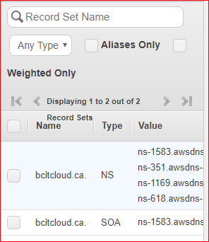

1. Log into your Internet domain registrar, e.g., GoDaddy.com.
   1. Find you domain name.
   2. Go to the Name Server settings. I purchased my domain (bcitcloud.ca) from GoDaddy. In GoDaddy, go to my products, click on DNS Manage.

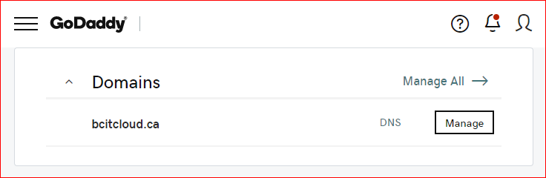

1. Change name servers from default to Custom.

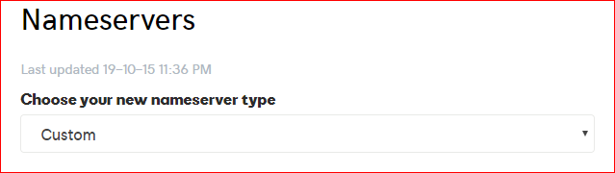

1. Eneter *four* NS records, one for each value in your AWS NS records set in Route 53 and save.

This is a sample from GoDadday:

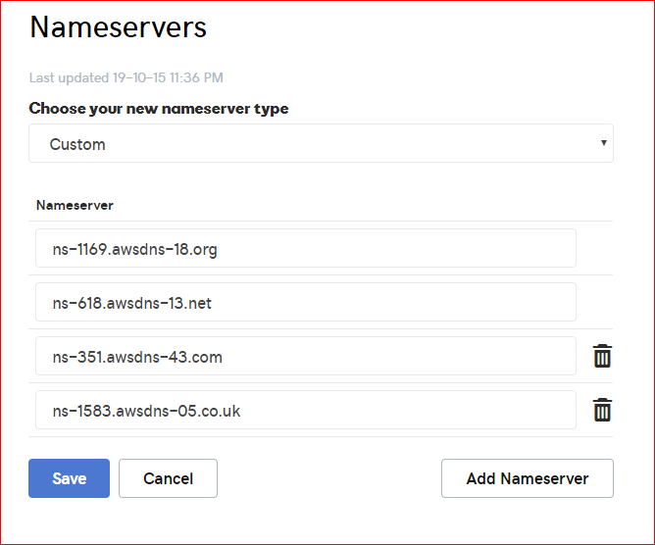

When you are finished, you should have four new NS records listed. This change may take up to 12 hours to propagate to internet.

1. In AWS, configure your naked domain name or your zone apex record. This will tell your domain name where to go.
2. Go back to Route 53, select Hosted Zones and click on your Domain Name.
3. Click Create Record Set. On the right side of the screen:
   1. Enter “www” to prefix you domain name.
   2. For Type, select “A – IPv4 address”
   3. For Alias, select No.
   4. In TTL (Seconds) field, enter 60.
   5. In the Value field, enter the Public IP address of your instance.
   6. For the Routing Policy, accept the default of “Simple.”

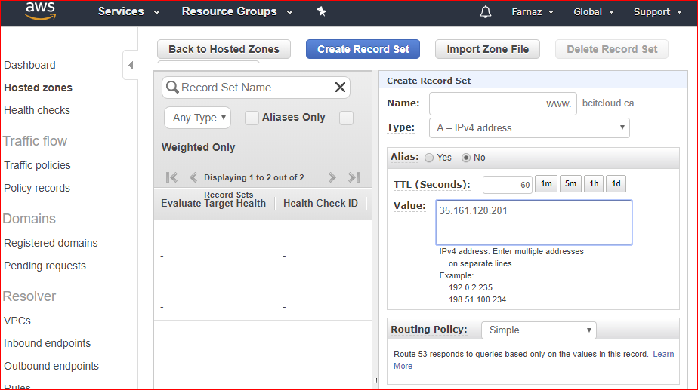

* + 1. Examine the other routing policies. Descriptions of the different routing policies can be found here: <http://docs.aws.amazon.com/Route53/latest/DeveloperGuide/routing-policy.html>

1. You should now see that an A record has been created.

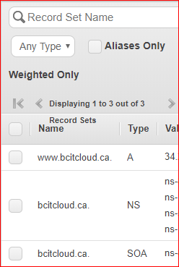

1. Create an Alias record, without the “www”
   1. Click Create Record Set.
   2. Do not enter a prefix in the Name field.
   3. For Type, select “A – IPv4 address”
   4. For Alias, select Yes.
   5. In the Alias Target field, enter your full domain name, e.g., [www.bcitcloud.ca](http://www.bcitcloud.ca).
   6. Click create.

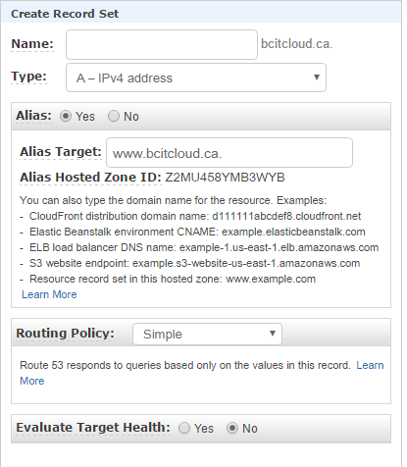

1. All of your Route 53 records should now be listed:

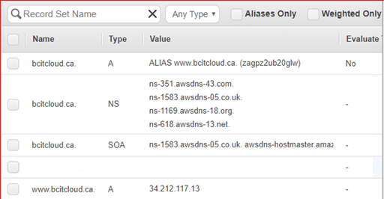

1. Go to your browser and verify all of your possible domain names, e.g., bcitcloud.ca and www.bcitcloud.ca. If your webpage doesn’t appear, it probably means that your domain name has not been propagated to the root level domain servers. Wait around 1 to 4 hours and try again.
2. Once your domain names are resolving correctly, *stop* and then restart your instance.
   1. Can you still get to your website? If not, why not?
   2. Check the Public IP address. Is it the same as the when the instance was created?
   3. What do I have to do to get my domain working again?
3. Now, let’s create a permanent fix to the problem of stopping and restarting instances by using an Elastic IP (EIP) address.
4. Go to this webpage: <http://docs.aws.amazon.com/AWSEC2/latest/UserGuide/elastic-ip-addresses-eip.html#working-with-eips>
5. Read the first two paragraphs and then go to the section titled “Associating an Elastic IP Address with a Running Instance.”
6. Add an Elastic IP address to your instance.
7. Go into Route 53 and change the value (IP address) for you’re A record to the EIP.
8. Wait a few minutes and refresh your browser. You should still be able to get to your website. Notice that your webpage will now display the EIP.
9. Add a Route 53 Health Check to you web server.
10. On the left hand side of the Route 53 dashboard, select Health checks.

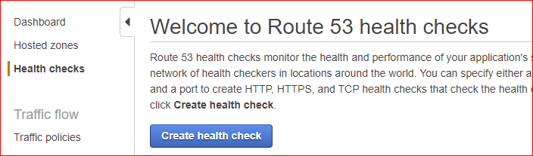

1. Click the “Create health check” button.
2. Enter a name, like “Lab-HC.”
3. Accept the default value for “What to monitor.”
4. Accept the default value for “Specify endpoint by” (IP address).
5. The Protocol should be HTTP.
6. In the IP Address field, enter your Elastic IP.
7. The Port should be set to 80.
8. Click Next.
9. On the next screen, click “Yes” to “Create an alarm.”
10. For “Send notification,” click “New SNS topic.”
11. Enter a Topic name, like “WebServerFailed.”
12. Enter your email address and click “Create health check.”
13. Check your email. You should receive an AWS subscription notification.
14. Test your website again.
15. Once the Alarm status has changed from “Insufficient data” to green, “1 of 1 in OK,” you can *delete* the health check.

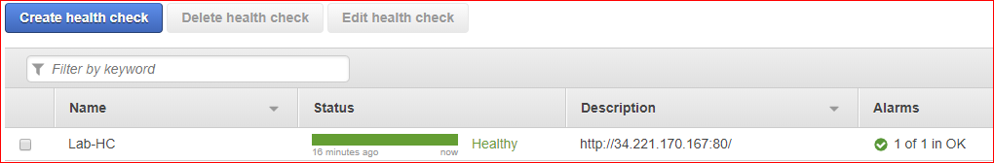

1. Go back to the Elastic IPs screen.
2. Select your EIP and Disassociate Address it from your instance (Actions -> Dissociate address)
3. Then, the release addresses. (Actions -> Release addresses)
4. Go to the EC2 Dashboard. Under Images, select the Ubuntu AMI you created in Lab 4. Launch another (second) EC2 instance from this AMI. Make sure the instance is in the same Availability Zone as the first instance. If you don’t have your image there, Launch instance by doing lab4- part1.
5. Once this instance is running, enter the Public IP address followed by “/index.php” to make sure it is working.
6. Create a classic Load Balancer in EC2 dashboard.
7. On “Step 2: Assign Security Group,” make sure to add rule for HTTP and SSH.
8. On “Step 4: Configure Health Check,” go to the Ping Path field. Remove “/index.html” and enter “/index.php” Set the Response Timeout to 2 and the Health Check Interval to 5.
9. Attach your two running instances to the load balancer. Attach the same security group you used for your two instances.
10. Click the Description tab on your load balancer screen. Note the **Status: 0 of 2 instances in service.** Click on the hyperlink. You will see your instances listed. The status of the instances is probably “OutOfService.” You can hover over the status with your mouse.
11. Click on the Description tab again. When the status reads **Status: 2 of 2 instances in service**, your load balancer is running.
12. Test the load balancer. Copy that DNS Name of the load browser – without the “A Record” -- and use it as the URL in your web browser. Then, add “/index.php” at the end of the URL. Click the Refresh button on your browser, you should see your pages. If it doesn’t work fix it. Here are my screenshots:

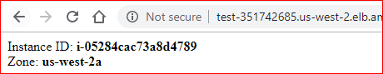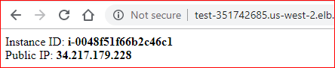

1. Now, you need to point your domain name to the DNS Name of the load balancer. So, go back into Route 53.
2. For the existing Alias record, change the value of the Alias Target to be the DNS Name for the load balancer.
3. Change the “www” A record to be an Alias record and enter the DNS Name for the load balancer in the Alias Target field.
4. In your browser, verify that your domain is still accessible. Refresh the browser and notice the values changing.
5. If you see default page of Apache server in your browser, you may need to add /index.php at the end of your domain.
6. To fix this problem you can delete default page of Apache in Ubuntu as shown in below screen shot.

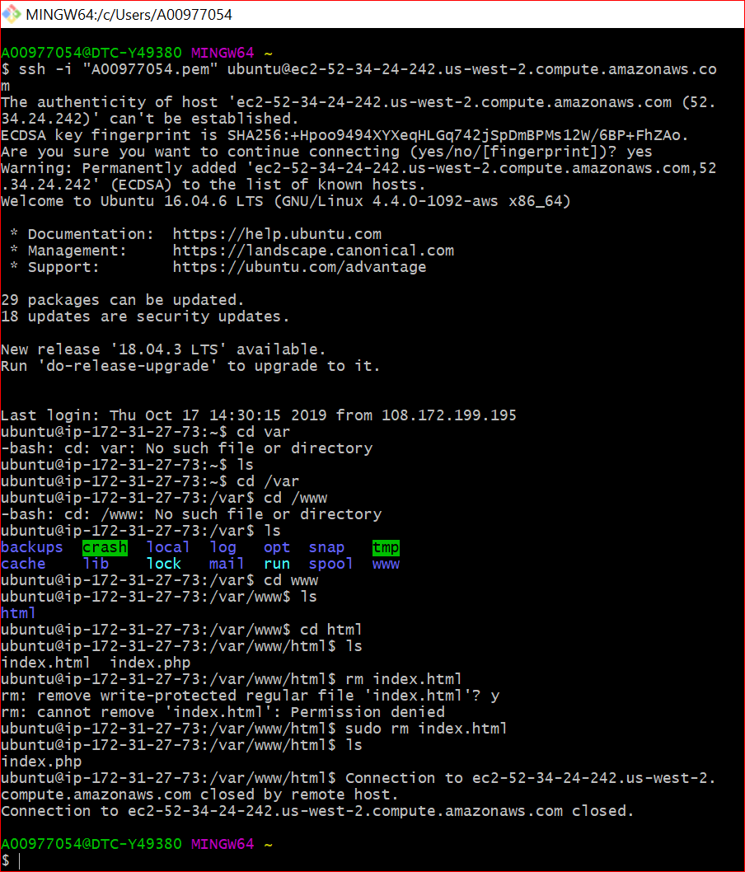

1. If you have done the lab outside class please stop your two instances and show your work to your instructor in class by starting your instances. Show your website using your domain name.
2. Don’t do the next step until you get your mark from the instructor.

**Instructor’s initials**: ______

Clean Up

1. Delete the load balancer.
2. Terminate all of your running instances.
3. You can leave your Hosted Zone in Route 53 for now. We will use it again in the future. You pay only for the hosted zones you configure and the number of queries that Amazon Route 53 answers.