# GIT

Git is a [free and open source](https://git-scm.com/about/free-and-open-source) distributed version control system designed to handle everything from small to very large projects with speed and efficiency.

### **The Remote Git Repository**

Each developer will work in their local repository but eventually, they will push the code into a remote repository. Once the code is in the remote repository, other developers can see and modify that code.

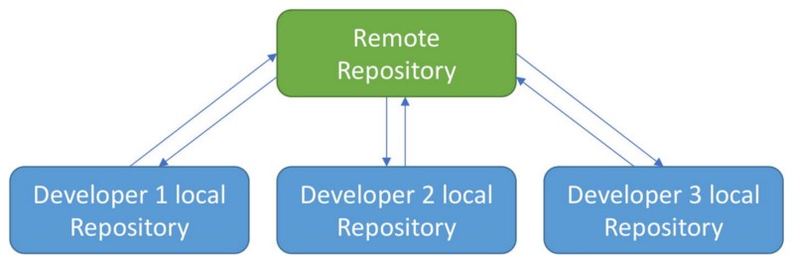

**Git Push**

In order to push all the code from the local repository into the remote repository, use the following command:

git push -u origin master

This pushes the code from the master branch in the local repository to the master branch in the remote repository.

**Git Pull**

git pull is used to pull the latest changes from the remote repository into the local repository. The remote repository code is updated continuously by various developers, hence git pull is necessary:

git pull origin master

**Git Clone**

git clone is used to clone an existing remote repository into your computer. The command for this is:

git clone [repository url]

**Git Commit**

Use the following command to commit the file/changes:

git commit -m "Initial Commit"

“Initial Commit” is the commit message here. Enter a relevant commit message to indicate what code changes were done in that particular commit.