**МІНІСТЕРСТВО ОСВІТИ І НАУКИ УКРАЇНИ**

**НАЦІОНАЛЬНИЙ УНІВЕРСИТЕТ «ЛЬВІВСЬКА ПОЛІТЕХНІКА»**

**Інститут комп’ютерних технологій, автоматики та метрології**

**кафедра “Електронних обчислювальних машин”**



Звіт

до лабораторної роботи № 1

з дисципліни «Моделювання комп’ютерних систем»

на тему:

«Інсталяція та ознайомлення з середовищем розробки Xilinx ISE. Ознайомлення зі стендом Elbert V2 – Spartan 3A FPGA»

**Варіант 25**

**Виконав:**

ст. гр. КІ-202

Федина М. А.

**Прийняв:**

Козак Н. Б.

**Львів 2024**

**Завдання згідно мого варіанту:**

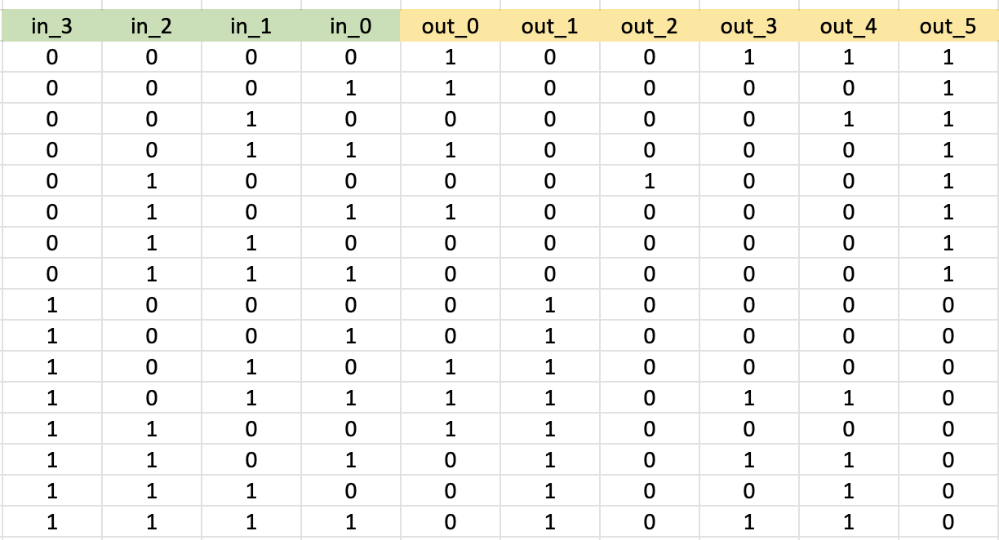

Згідно мого варіанту я сформував схему, яка працює за заданою логікою:

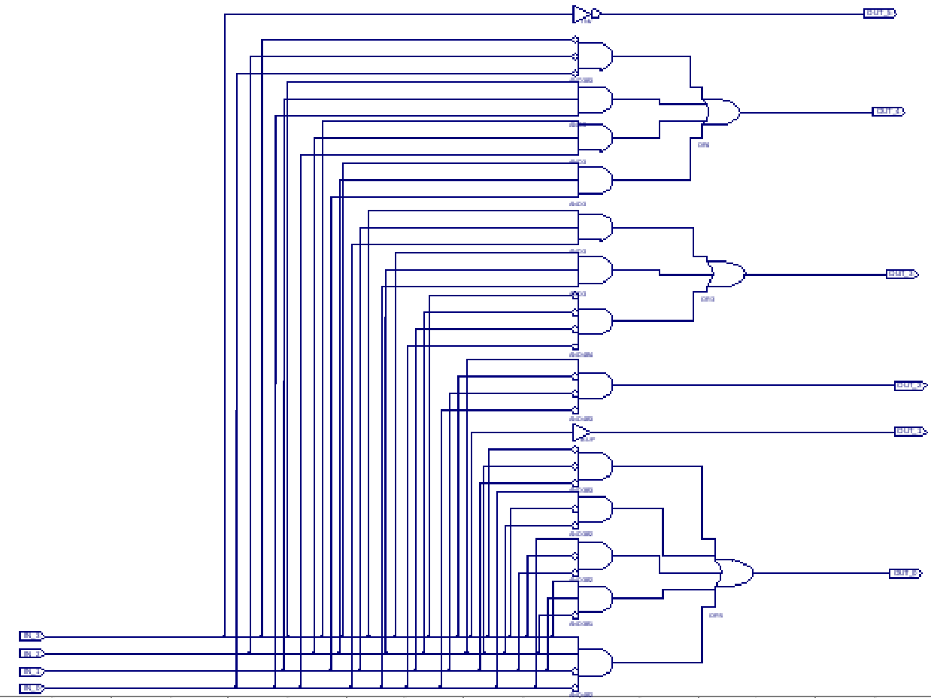

Після цього створив файл з розширенням .ucf, в якому міститься даний код:

#+++++++++++++++++++++++++++++++++++++++++++++++++++++++++++++++++++++++++++++++++++++++++++++++++++++#

# This file is a .ucf for ElbertV2 Development Board #

# To use it in your project : #

# * Remove or comment the lines corresponding to unused pins in the project #

# * Rename the used signals according to the your project #

#+++++++++++++++++++++++++++++++++++++++++++++++++++++++++++++++++++++++++++++++++++++++++++++++++++++#

#**************************************************************************************************************************************************#

# UCF for ElbertV2 Development Board #

#**************************************************************************************************************************************************#

CONFIG VCCAUX = "3.3" ;

# Clock 12 MHz

# NET "Clk" LOC = P129 | IOSTANDARD = LVCMOS33 | PERIOD = 12MHz;

####################################################################################################

# VGA

####################################################################################################

# NET "HSync" LOC = P93 | IOSTANDARD = LVCMOS33 | SLEW = SLOW | DRIVE = 12;

# NET "VSync" LOC = P92 | IOSTANDARD = LVCMOS33 | SLEW = SLOW | DRIVE = 12;

# NET "Blue[2]" LOC = P98 | IOSTANDARD = LVCMOS33 | SLEW = SLOW | DRIVE = 12;

# NET "Blue[1]" LOC = P96 | IOSTANDARD = LVCMOS33 | SLEW = SLOW | DRIVE = 12;

# NET "Green[2]" LOC = P102 | IOSTANDARD = LVCMOS33 | SLEW = SLOW | DRIVE = 12;

# NET "Green[1]" LOC = P101 | IOSTANDARD = LVCMOS33 | SLEW = SLOW | DRIVE = 12;

# NET "Green[0]" LOC = P99 | IOSTANDARD = LVCMOS33 | SLEW = SLOW | DRIVE = 12;

# NET "Red[2]" LOC = P105 | IOSTANDARD = LVCMOS33 | SLEW = SLOW | DRIVE = 12;

# NET "Red[1]" LOC = P104 | IOSTANDARD = LVCMOS33 | SLEW = SLOW | DRIVE = 12;

# NET "Red[0]" LOC = P103 | IOSTANDARD = LVCMOS33 | SLEW = SLOW | DRIVE = 12;

####################################################################################################

# Micro SD Card

####################################################################################################

# NET "CLK" LOC = P57 | IOSTANDARD = LVCMOS33 | SLEW = SLOW | DRIVE = 12;

# NET "DAT0" LOC = P83 | IOSTANDARD = LVCMOS33 | SLEW = SLOW | DRIVE = 12;

# NET "DAT1" LOC = P82 | IOSTANDARD = LVCMOS33 | SLEW = SLOW | DRIVE = 12;

# NET "DAT2" LOC = P90 | IOSTANDARD = LVCMOS33 | SLEW = SLOW | DRIVE = 12;

# NET "DAT3" LOC = P85 | IOSTANDARD = LVCMOS33 | SLEW = SLOW | DRIVE = 12;

# NET "CMD" LOC = P84 | IOSTANDARD = LVCMOS33 | SLEW = SLOW | DRIVE = 12;

####################################################################################################

# Audio

####################################################################################################

# NET "AUDIO_L" LOC = P88 | IOSTANDARD = LVCMOS33 | SLEW = SLOW | DRIVE = 12;

# NET "AUDIO_R" LOC = P87 | IOSTANDARD = LVCMOS33 | SLEW = SLOW | DRIVE = 12;

####################################################################################################

# Seven Segment Display

####################################################################################################

# NET "SevenSegment[7]" LOC = P117 | IOSTANDARD = LVCMOS33 | SLEW = SLOW | DRIVE = 12;

# NET "SevenSegment[6]" LOC = P116 | IOSTANDARD = LVCMOS33 | SLEW = SLOW | DRIVE = 12;

# NET "SevenSegment[5]" LOC = P115 | IOSTANDARD = LVCMOS33 | SLEW = SLOW | DRIVE = 12;

# NET "SevenSegment[4]" LOC = P113 | IOSTANDARD = LVCMOS33 | SLEW = SLOW | DRIVE = 12;

# NET "SevenSegment[3]" LOC = P112 | IOSTANDARD = LVCMOS33 | SLEW = SLOW | DRIVE = 12;

# NET "SevenSegment[2]" LOC = P111 | IOSTANDARD = LVCMOS33 | SLEW = SLOW | DRIVE = 12;

# NET "SevenSegment[1]" LOC = P110 | IOSTANDARD = LVCMOS33 | SLEW = SLOW | DRIVE = 12;

# NET "SevenSegment[0]" LOC = P114 | IOSTANDARD = LVCMOS33 | SLEW = SLOW | DRIVE = 12;

# NET "Enable[2]" LOC = P124 | IOSTANDARD = LVCMOS33 | SLEW = SLOW | DRIVE = 12;

# NET "Enable[1]" LOC = P121 | IOSTANDARD = LVCMOS33 | SLEW = SLOW | DRIVE = 12;

# NET "Enable[0]" LOC = P120 | IOSTANDARD = LVCMOS33 | SLEW = SLOW | DRIVE = 12;

####################################################################################################

# LED

####################################################################################################

NET "OUT_0" LOC = P46 | IOSTANDARD = LVCMOS33 | SLEW = SLOW | DRIVE = 12;

NET "OUT_1" LOC = P47 | IOSTANDARD = LVCMOS33 | SLEW = SLOW | DRIVE = 12;

NET "OUT_2" LOC = P48 | IOSTANDARD = LVCMOS33 | SLEW = SLOW | DRIVE = 12;

NET "OUT_3" LOC = P49 | IOSTANDARD = LVCMOS33 | SLEW = SLOW | DRIVE = 12;

NET "OUT_4" LOC = P50 | IOSTANDARD = LVCMOS33 | SLEW = SLOW | DRIVE = 12;

NET "OUT_5" LOC = P51 | IOSTANDARD = LVCMOS33 | SLEW = SLOW | DRIVE = 12;

# NET "LED[6]" LOC = P54 | IOSTANDARD = LVCMOS33 | SLEW = SLOW | DRIVE = 12;

# NET "LED[7]" LOC = P55 | IOSTANDARD = LVCMOS33 | SLEW = SLOW | DRIVE = 12;

####################################################################################################

# DP Switches

####################################################################################################

NET "IN_0" LOC = P70 | PULLUP | IOSTANDARD = LVCMOS33 | SLEW = SLOW | DRIVE = 12;

NET "IN_1" LOC = P69 | PULLUP | IOSTANDARD = LVCMOS33 | SLEW = SLOW | DRIVE = 12;

NET "IN_2" LOC = P68 | PULLUP | IOSTANDARD = LVCMOS33 | SLEW = SLOW | DRIVE = 12;

NET "IN_3" LOC = P64 | PULLUP | IOSTANDARD = LVCMOS33 | SLEW = SLOW | DRIVE = 12;

# NET "DPSwitch[4]" LOC = P63 | PULLUP | IOSTANDARD = LVCMOS33 | SLEW = SLOW | DRIVE = 12;

# NET "DPSwitch[5]" LOC = P60 | PULLUP | IOSTANDARD = LVCMOS33 | SLEW = SLOW | DRIVE = 12;

# NET "DPSwitch[6]" LOC = P59 | PULLUP | IOSTANDARD = LVCMOS33 | SLEW = SLOW | DRIVE = 12;

# NET "DPSwitch[7]" LOC = P58 | PULLUP | IOSTANDARD = LVCMOS33 | SLEW = SLOW | DRIVE = 12;

####################################################################################################

# Switches

####################################################################################################

# NET "Switch[0]" LOC = P80 | PULLUP | IOSTANDARD = LVCMOS33 | SLEW = SLOW | DRIVE = 12;

# NET "Switch[1]" LOC = P79 | PULLUP | IOSTANDARD = LVCMOS33 | SLEW = SLOW | DRIVE = 12;

# NET "Switch[2]" LOC = P78 | PULLUP | IOSTANDARD = LVCMOS33 | SLEW = SLOW | DRIVE = 12;

# NET "Switch[3]" LOC = P77 | PULLUP | IOSTANDARD = LVCMOS33 | SLEW = SLOW | DRIVE = 12;

# NET "Switch[4]" LOC = P76 | PULLUP | IOSTANDARD = LVCMOS33 | SLEW = SLOW | DRIVE = 12;

# NET "Switch[5]" LOC = P75 | PULLUP | IOSTANDARD = LVCMOS33 | SLEW = SLOW | DRIVE = 12;

####################################################################################################

# GPIO

####################################################################################################

####################################################################################################

# HEADER P1

####################################################################################################

# NET "IO_P1[0]" LOC = P31 | IOSTANDARD = LVCMOS33 | SLEW = SLOW | DRIVE = 12;

# NET "IO_P1[1]" LOC = P32 | IOSTANDARD = LVCMOS33 | SLEW = SLOW | DRIVE = 12;

# NET "IO_P1[2]" LOC = P28 | IOSTANDARD = LVCMOS33 | SLEW = SLOW | DRIVE = 12;

# NET "IO_P1[3]" LOC = P30 | IOSTANDARD = LVCMOS33 | SLEW = SLOW | DRIVE = 12;

# NET "IO_P1[4]" LOC = P27 | IOSTANDARD = LVCMOS33 | SLEW = SLOW | DRIVE = 12;

# NET "IO_P1[5]" LOC = P29 | IOSTANDARD = LVCMOS33 | SLEW = SLOW | DRIVE = 12;

# NET "IO_P1[6]" LOC = P24 | IOSTANDARD = LVCMOS33 | SLEW = SLOW | DRIVE = 12;

# NET "IO_P1[7]" LOC = P25 | IOSTANDARD = LVCMOS33 | SLEW = SLOW | DRIVE = 12;

####################################################################################################

# HEADER P6

####################################################################################################

# NET "IO_P6[0]" LOC = P19 | IOSTANDARD = LVCMOS33 | SLEW = SLOW | DRIVE = 12;

# NET "IO_P6[1]" LOC = P21 | IOSTANDARD = LVCMOS33 | SLEW = SLOW | DRIVE = 12;

# NET "IO_P6[2]" LOC = P18 | IOSTANDARD = LVCMOS33 | SLEW = SLOW | DRIVE = 12;

# NET "IO_P6[3]" LOC = P20 | IOSTANDARD = LVCMOS33 | SLEW = SLOW | DRIVE = 12;

# NET "IO_P6[4]" LOC = P15 | IOSTANDARD = LVCMOS33 | SLEW = SLOW | DRIVE = 12;

# NET "IO_P6[5]" LOC = P16 | IOSTANDARD = LVCMOS33 | SLEW = SLOW | DRIVE = 12;

# NET "IO_P6[6]" LOC = P12 | IOSTANDARD = LVCMOS33 | SLEW = SLOW | DRIVE = 12;

# NET "IO_P6[7]" LOC = P13 | IOSTANDARD = LVCMOS33 | SLEW = SLOW | DRIVE = 12;

####################################################################################################

# HEADER P2

####################################################################################################

# NET "IO_P2[0]" LOC = P10 | IOSTANDARD = LVCMOS33 | SLEW = SLOW | DRIVE = 12;

# NET "IO_P2[1]" LOC = P11 | IOSTANDARD = LVCMOS33 | SLEW = SLOW | DRIVE = 12;

# NET "IO_P2[2]" LOC = P7 | IOSTANDARD = LVCMOS33 | SLEW = SLOW | DRIVE = 12;

# NET "IO_P2[3]" LOC = P8 | IOSTANDARD = LVCMOS33 | SLEW = SLOW | DRIVE = 12;

# NET "IO_P2[4]" LOC = P3 | IOSTANDARD = LVCMOS33 | SLEW = SLOW | DRIVE = 12;

# NET "IO_P2[5]" LOC = P5 | IOSTANDARD = LVCMOS33 | SLEW = SLOW | DRIVE = 12;

# NET "IO_P2[6]" LOC = P4 | IOSTANDARD = LVCMOS33 | SLEW = SLOW | DRIVE = 12;

# NET "IO_P2[7]" LOC = P6 | IOSTANDARD = LVCMOS33 | SLEW = SLOW | DRIVE = 12;

####################################################################################################

# HEADER P4

####################################################################################################

# NET "IO_P4[0]" LOC = P141 | IOSTANDARD = LVCMOS33 | SLEW = SLOW | DRIVE = 12;

# NET "IO_P4[1]" LOC = P143 | IOSTANDARD = LVCMOS33 | SLEW = SLOW | DRIVE = 12;

# NET "IO_P4[2]" LOC = P138 | IOSTANDARD = LVCMOS33 | SLEW = SLOW | DRIVE = 12;

# NET "IO_P4[3]" LOC = P139 | IOSTANDARD = LVCMOS33 | SLEW = SLOW | DRIVE = 12;

# NET "IO_P4[4]" LOC = P134 | IOSTANDARD = LVCMOS33 | SLEW = SLOW | DRIVE = 12;

# NET "IO_P4[5]" LOC = P135 | IOSTANDARD = LVCMOS33 | SLEW = SLOW | DRIVE = 12;

# NET "IO_P4[6]" LOC = P130 | IOSTANDARD = LVCMOS33 | SLEW = SLOW | DRIVE = 12;

# NET "IO_P4[7]" LOC = P132 | IOSTANDARD = LVCMOS33 | SLEW = SLOW | DRIVE = 12;

####################################################################################################

# HEADER P5

####################################################################################################

# Two input PINs of P5 Header IO_P5[1] and IO_P5[7].

# NET "IO_P5[0]" LOC = P125 | IOSTANDARD = LVCMOS33 | SLEW = SLOW | DRIVE = 12;

# NET "IO_P5[1]" LOC = P123 | IOSTANDARD = LVCMOS33 | SLEW = SLOW | DRIVE = 12 | PULLUP;

# NET "IO_P5[2]" LOC = P127 | IOSTANDARD = LVCMOS33 | SLEW = SLOW | DRIVE = 12;

# NET "IO_P5[3]" LOC = P126 | IOSTANDARD = LVCMOS33 | SLEW = SLOW | DRIVE = 12;

# NET "IO_P5[4]" LOC = P131 | IOSTANDARD = LVCMOS33 | SLEW = SLOW | DRIVE = 12;

# NET "IO_P5[5]" LOC = P91 | IOSTANDARD = LVCMOS33 | SLEW = SLOW | DRIVE = 12;

# NET "IO_P5[6]" LOC = P142 | IOSTANDARD = LVCMOS33 | SLEW = SLOW | DRIVE = 12;

# NET "IO_P5[7]" LOC = P140 | IOSTANDARD = LVCMOS33 | SLEW = SLOW | DRIVE = 12 | PULLUP;

Рядки коду, що не використовуються під час виконання лабораторної роботи закоментував, та вніс зміни до LED і DB SWITCHES.

Після запуску в режимі симуляції ми отримали такий графік:

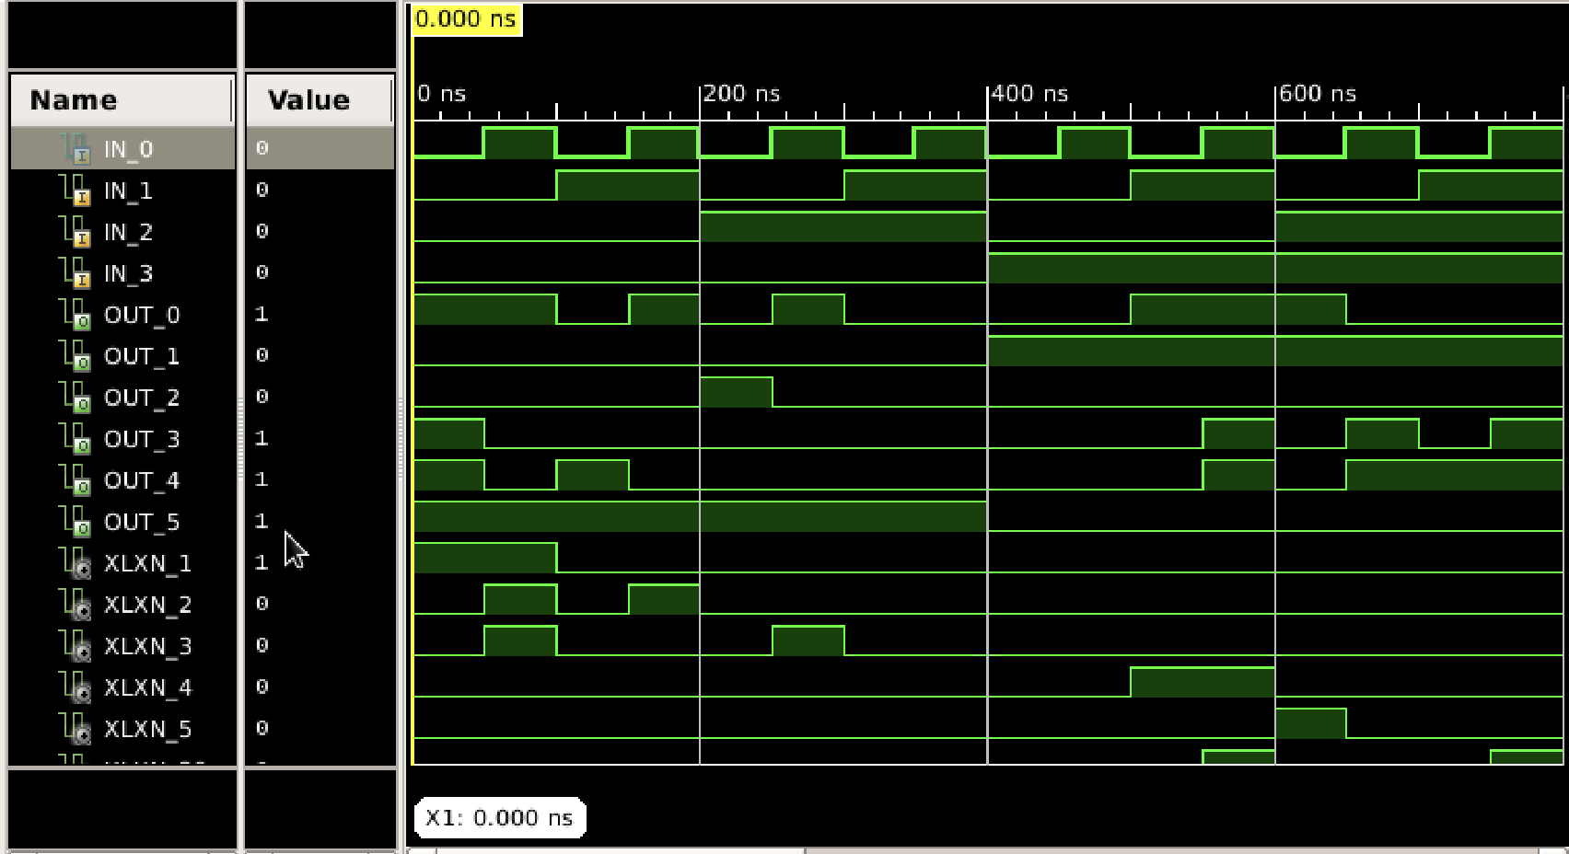

На ньому ми можемо побачити, що всі задані варіантом комбінації збігаються.

**Висновок:** в результаті виконання лабораторної роботи №1 інсталював та ознайомився із середовищем розробки Xilinx ISE 14.7. Виконав усі задані в лабораторній роботі завдання. Дослідив задану варіантом комбінацію. В результаті симуляції роботи схеми отримали вірні значення, що збігаються із вхідними даними згідно мого варіанту.