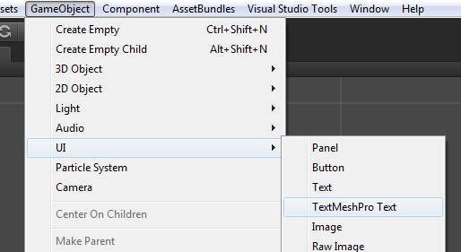
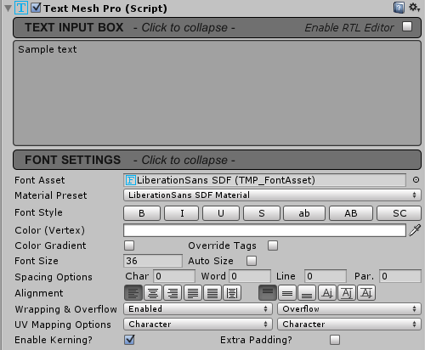
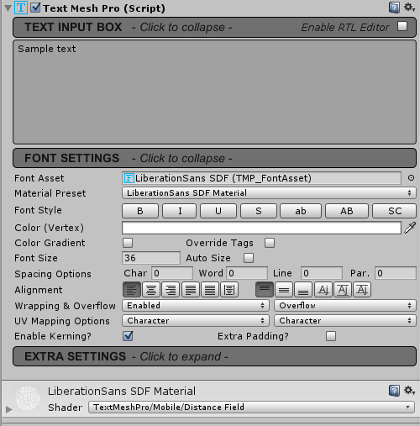
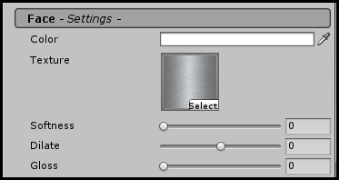
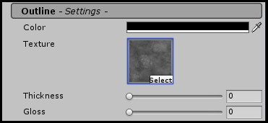
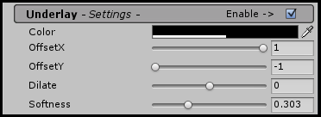
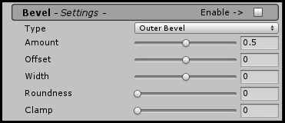
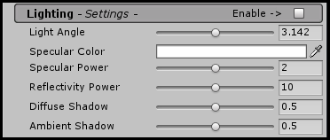
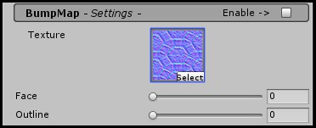
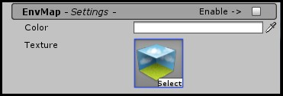
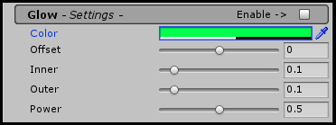
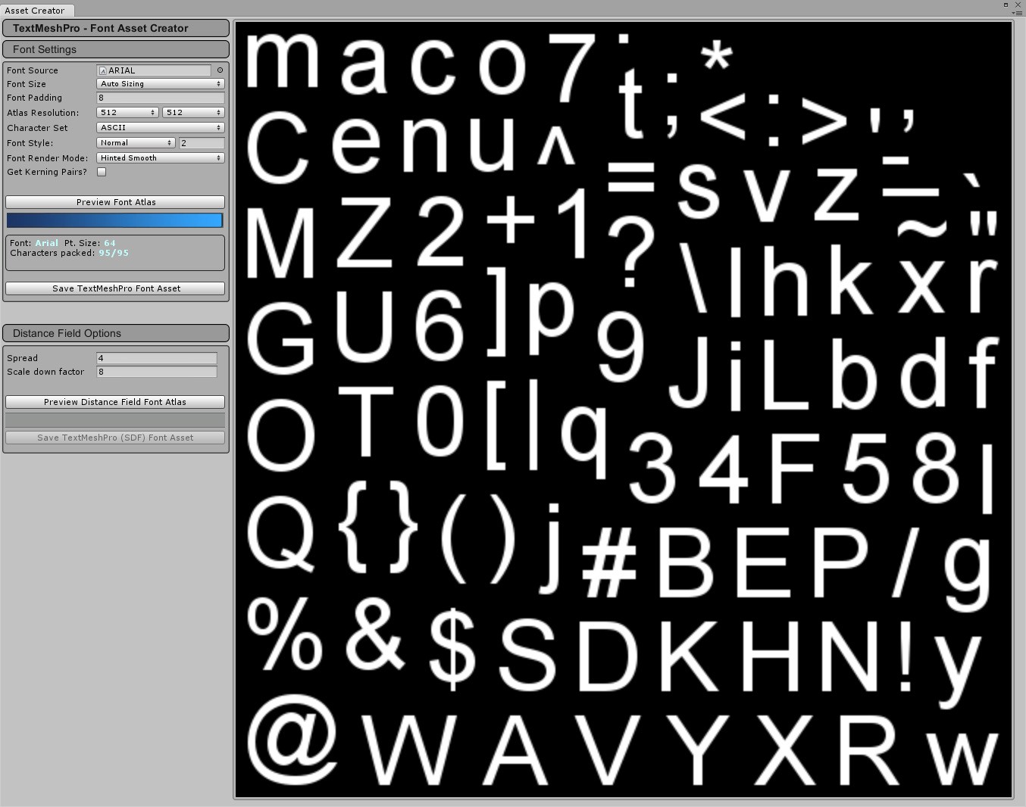
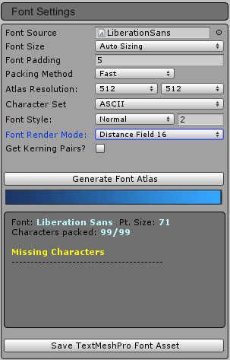
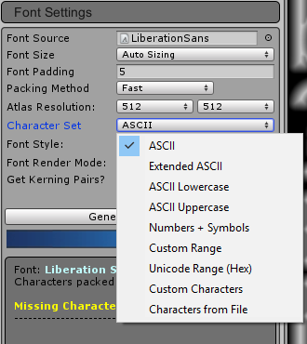
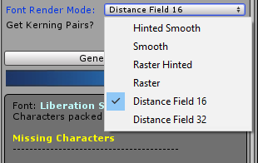
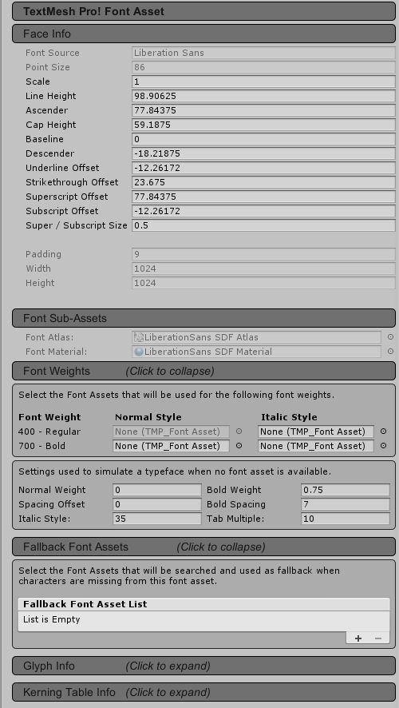
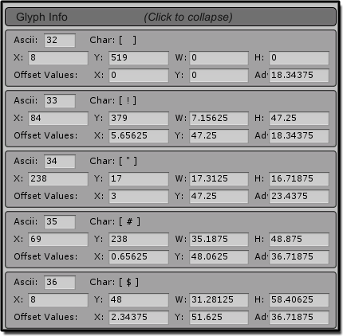
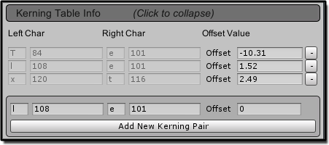

^{Auto Translate}

for Unity Localization

USER GUIDE
Release 0.2.5
Feb 2022

Copyright (C) 2022 Hernets Maksym - All Rights Reserved

Getting Started
Overview 4
Installation 4
Quick Start 4
Requirement 4
Warning 4

Overview
This User Guide was designed to provide AutoTranslate users with a basic overview of the features and functionality of the tool.

Installation
Once you have downloaded AutoTranslate from Unity’s Asset Store, go to: “Assets->Import Package->Custom Package...”. In the Import Asset window, find and select the AutoTranslate. unitypackage file. After the “Importing package” window appears in Unity, verify that all items to import are selected and then click the Import button in the bottom right of the window.

You can get the plugin through the unity package manager using the "https://github.com/MaksymHernets/AutoTranslateForUnityLocalization.git?path=/Assets" link.

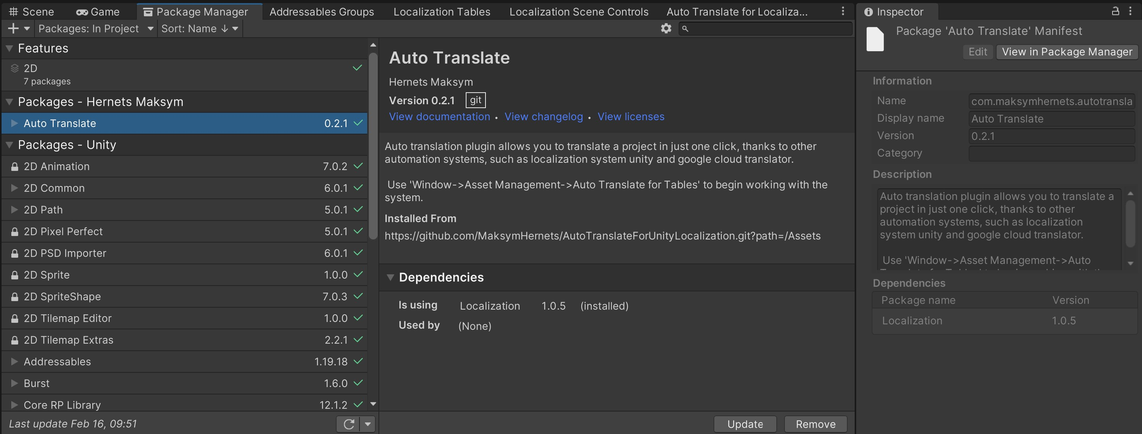

Quick Start
Use 'Window->Asset Management->Auto Translate for Tables' to begin working with the system.
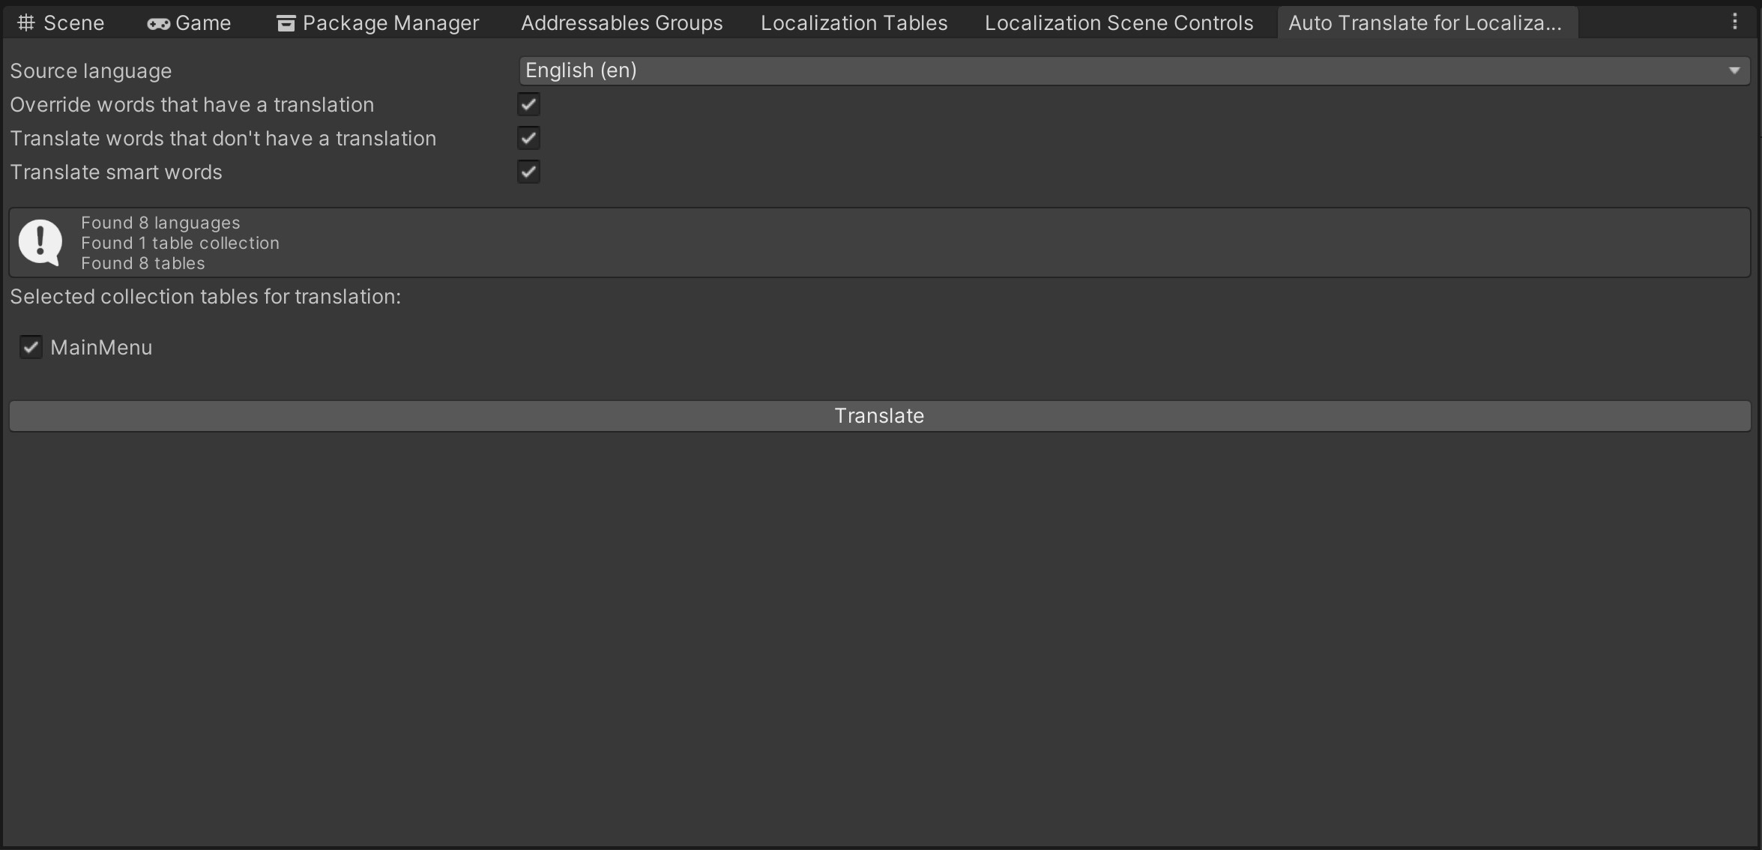

Requirement
This plugin is designed for the fact that your project has already implemented such packages as addressable and localization from unity.

Warning

The plugin is at the release version and does not contain unit tests, so you may encounter errors in the plugin.

