Адміністратор Контроллери

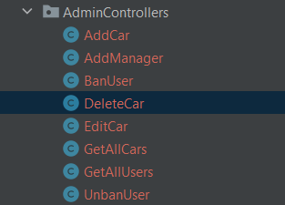

Фільтри

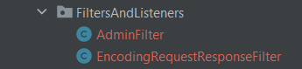

DAO, імплементація ДАО, Connection Pool, Сутності, Фабрики дао

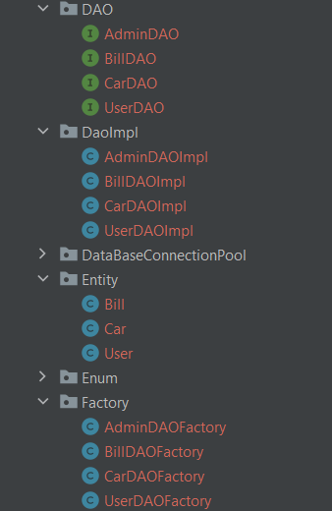

JSP – сторінки, css, js, Junit

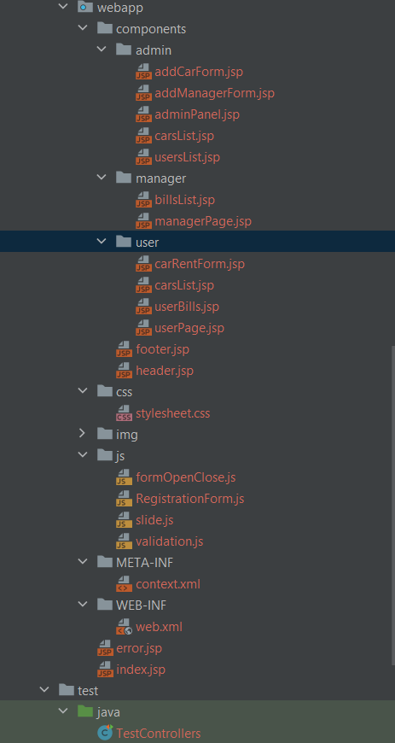

Діаграма прецидентів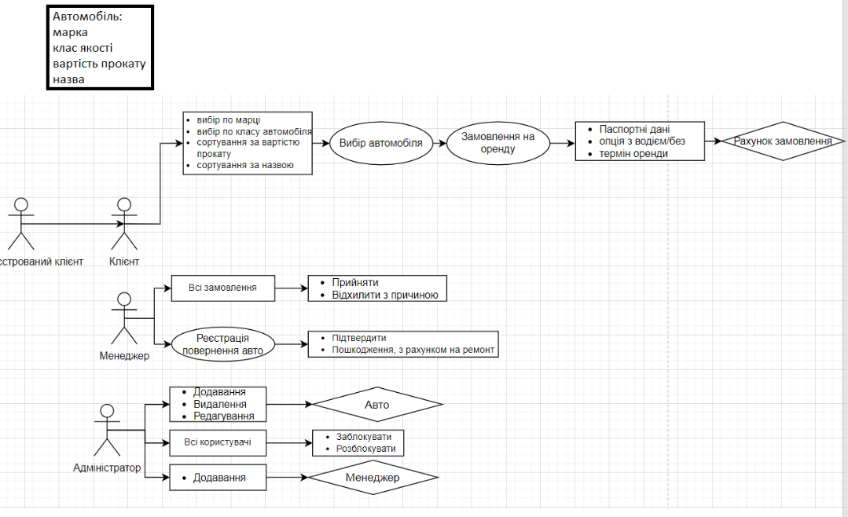

Приклад роботи Edit/Delete Car

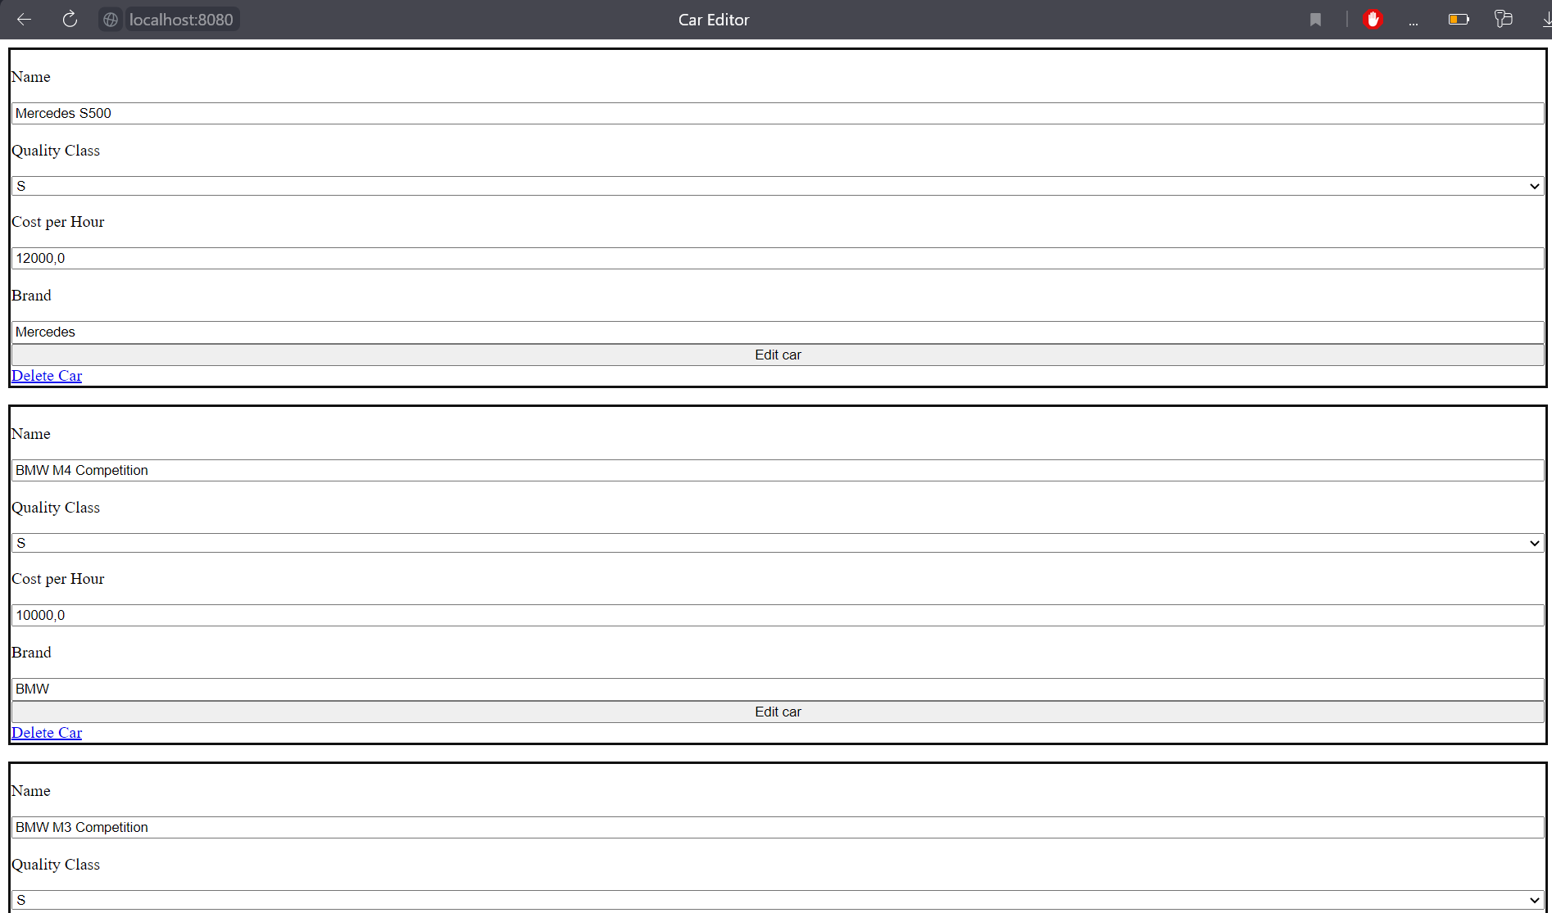

<%@ **page** contentType="text/html;charset=UTF-8" language="java" %>  
<html>  
<head>  
 <title>Car Editor</title>  
</head>  
<body>  
<**c:forEach** items="${carsList}" var="car">  
 <form action="/EditCar" method="post" style="display:flex;flex-direction: column; border: #111111 3px solid">  
 <input type="hidden" name="idCar" value="${car.getIdCar()}">  
 <p>Name</p>  
 <input type="text" name="name" required value="${car.getName()}">  
 <p>Quality Class</p>  
 <select name="qualityClass" required>  
 <option value="S" <**c:if** test="${car.getQualityClass()=='S'}">selected</**c:if**> >S</option>  
 <option value="A" <**c:if** test="${car.getQualityClass()=='A'}">selected</**c:if**>>A</option>  
 <option value="B" <**c:if** test="${car.getQualityClass()=='B'}">selected</**c:if**>>B</option>  
 <option value="C" <**c:if** test="${car.getQualityClass()=='C'}">selected</**c:if**>>C</option>  
 <option value="D" <**c:if** test="${car.getQualityClass()=='D'}">selected</**c:if**>>D</option>  
 </select>  
 <p>Cost per Hour</p>  
 <input type="number" value="${car.getCostPerHour()}" name="costPerHour" step="any" min="0" required>  
 <p>Brand</p>  
 <input type="text" name="brand" value="${car.getBrand()}">  
 <button type="submit">Edit car</button>  
 <a href="/DeleteCar?idCar=${car.getIdCar()}">Delete Car</a>  
 </form>  
</**c:forEach**>  
  
</body>  
</html>

@WebServlet(name = "DeleteCar", value = "/DeleteCar")  
public class DeleteCar extends HttpServlet {  
 @Override  
 protected void doGet(HttpServletRequest request, HttpServletResponse response) throws ServletException, IOException {  
 int idCar = Integer.*parseInt*(request.getParameter("idCar"));  
 AdminDAO adminDAO = AdminDAOFactory.*getInstance*();  
 boolean status = adminDAO.deleteCar(idCar);  
 if (status){  
 response.sendRedirect("components/admin/adminPanel.jsp");  
 }else  
 response.sendRedirect("error.jsp");  
 }  
}

@WebServlet(name = "EditCar", value = "/EditCar")  
public class EditCar extends HttpServlet {  
  
 @Override  
 protected void doPost(HttpServletRequest request, HttpServletResponse response) throws ServletException, IOException {  
 int idCar = Integer.*parseInt*(request.getParameter("idCar"));  
 String name = request.getParameter("name");  
 String qualityClass = request.getParameter("qualityClass");  
 double costPerHour = Double.*parseDouble*(request.getParameter("costPerHour"));  
 String brand = request.getParameter("brand");  
 Car car = new Car(idCar, name, qualityClass, costPerHour, brand);  
 AdminDAO adminDAO = AdminDAOFactory.*getInstance*();  
 boolean status = adminDAO.editCar(car);  
 if (status){  
 response.sendRedirect("components/admin/adminPanel.jsp");  
 }else  
 response.sendRedirect("error.jsp");  
 }  
}

Приклад роботи Add car

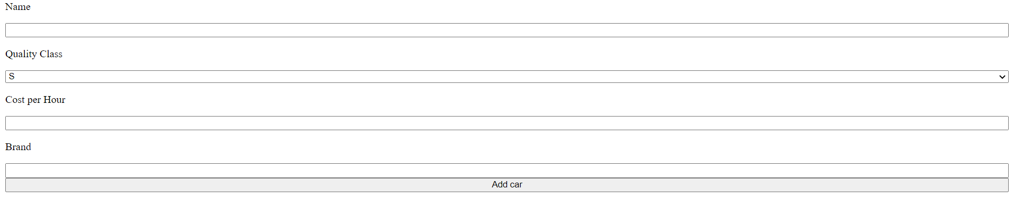

@WebServlet(name = "AddCar", value = "/AddCar")  
public class AddCar extends HttpServlet {  
  
 @Override  
 protected void doPost(HttpServletRequest request, HttpServletResponse response) throws ServletException, IOException {  
 String name = request.getParameter("name");  
 String qualityClass = request.getParameter("qualityClass");  
 double costPerHour = Double.*parseDouble*(request.getParameter("costPerHour"));  
 String brand = request.getParameter("brand");  
 Car car = new Car(name, qualityClass, costPerHour, brand);  
 AdminDAO adminDAO = AdminDAOFactory.*getInstance*();  
 boolean status = adminDAO.addCar(car);  
 if (status) {  
 response.sendRedirect("components/admin/addCarForm.jsp");  
 } else  
 response.sendRedirect("error.jsp");  
 }  
}

<html>  
<head>  
 <title>Add Car</title>  
</head>  
<body>  
<**jsp:include** page="../header.jsp"></**jsp:include**>  
<form action="/AddCar" method="post" style="display:flex;flex-direction: column">  
 <p>Name</p>  
 <input type="text" name="name" required>  
 <p>Quality Class</p>  
 <select name="qualityClass" required>  
 <option value="S">S</option>  
 <option value="A">A</option>  
 <option value="B">B</option>  
 <option value="C">C</option>  
 <option value="D">D</option>  
 </select>  
 <p>Cost per Hour</p>  
 <input type="number" name="costPerHour" step="any" min="0" required>  
 <p>Brand</p>  
 <input type="text" name="brand">  
 <button type="submit">Add car</button>  
</form>  
</body>  
</html>

Приклад роботи js валідації даних

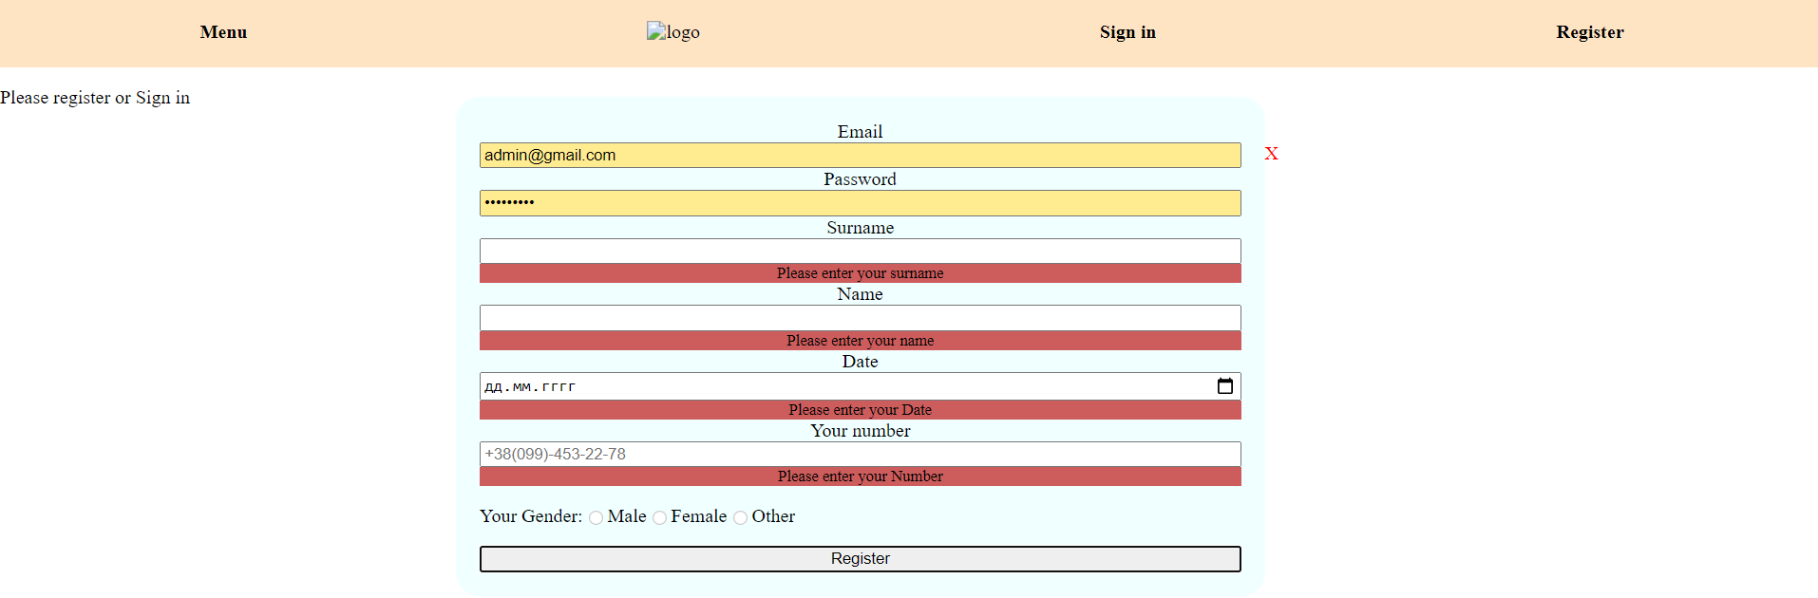

function phoneMask() {  
 var mask = "+38(0__)-___-__-__";  
 var phoneNumber = ***document***.getElementById("phone").value;  
 var numbersInPhoneNumber = phoneNumber.toString().replace(/\D+/g, "");  
 numbersInPhoneNumber = numbersInPhoneNumber.slice(0, 12);  
 if (numbersInPhoneNumber.length == 1) {  
 mask = mask.replace("_", numbersInPhoneNumber.charAt(0));  
 }  
 for (let i = 3; i < numbersInPhoneNumber.length; i++) {  
 mask = mask.replace("_", numbersInPhoneNumber.charAt(i));  
 }  
 var cursorPosition = mask.search("_");  
 ***document***.getElementById("phone").value = mask;  
 document.getElementById("phone").setSelectionRange(cursorPosition, cursorPosition);  
}  
  
function validateDate(element, DATE_REQUIRED) {  
 const currentDate = new Date();  
 const d = new Date(element.value);  
 if (d instanceof Date && !isNaN(d) && d.getFullYear() > 1900 && d<currentDate) {  
 return true;  
 }  
 return showError(element, DATE_REQUIRED);  
}  
  
function submitRegisterForm() {  
 const form = document.getElementById("register");  
 const EMAIL_INVALID = "Please enter a correct email address format";  
 const EMAIL_REQUIRED = "Please enter your email";  
 let emailValid = validateEmail(form.elements["email"], EMAIL_REQUIRED, EMAIL_INVALID);  
 const PASS_REQUIRED = "Please enter your pass";  
 let passValid = hasValue(form.elements["password"], PASS_REQUIRED);  
 const SURNAME_REQUIRED = "Please enter your surname";  
 let surnameValid = hasValue(form.elements["surname"], SURNAME_REQUIRED);  
 const NAME_REQUIRED = "Please enter your name";  
 let nameValid = hasValue(form.elements["name"], NAME_REQUIRED);  
 const DATE_REQUIRED = "Please enter your Date";  
 let dateValid = validateDate(form.elements["date"], DATE_REQUIRED);  
 const NUMBER_REQUIRED = "Please enter your Number";  
 let numberValid = validateNumber(form.elements["phoneNumber"], NUMBER_REQUIRED);  
 if (emailValid && passValid && surnameValid && nameValid && dateValid && numberValid) {  
 form.submit();  
 }  
}  
  
function submitLoginForm() {  
 const form = document.getElementById("signIn");  
 const EMAIL_INVALID = "Please enter a correct email address format";  
 const EMAIL_REQUIRED = "Please enter your email";  
 let emailValid = validateEmail(form.elements["email"], EMAIL_REQUIRED, EMAIL_INVALID);  
 const PASS_REQUIRED = "Please enter your pass";  
 let passValid = hasValue(form.elements["password"], PASS_REQUIRED);  
 if (emailValid && passValid) {  
 form.submit();  
 }  
}  
  
function showMessage(input, message, type) {  
 const msg = input.parentNode.querySelector("small");  
 msg.innerText = message;  
 input.className = type ? "success" : "error";  
 return type;  
}  
  
function showError(input, message) {  
 return showMessage(input, message, false);  
}  
  
function showSuccess(input) {  
 return showMessage(input, "", true);  
}  
  
function hasValue(input, message) {  
 if (input.value.trim() === "") {  
 return showError(input, message);  
 }  
 return showSuccess(input);  
}  
  
function validateEmail(input, requiredMsg, invalidMsg) {  
 if (!hasValue(input, requiredMsg)) {  
 return false;  
 }  
 const emailRegex =  
 /^(([^<>()\[\]\\.,;:\s@"]+(\.[^<>()\[\]\\.,;:\s@"]+)*)|(".+"))@((\[[0**-**9]{1,3}\.[0**-**9]{1,3}\.[0**-**9]{1,3}\.[0**-**9]{1,3}\])|(([a**-**zA**-**Z\-0**-**9]+\.)+[a**-**zA**-**Z]{2,}))$/;  
 const email = input.value.trim();  
 if (!emailRegex.test(email)) {  
 return showError(input, invalidMsg);  
 }  
 return true;  
}  
  
function validateNumber(input, requiredMsg) {  
 if (!hasValue(input, requiredMsg)) {  
 return false;  
 }  
 var phoneNumber = input.value;  
 var numbersInPhoneNumber = phoneNumber.toString().replace(/\D+/g, "");  
 if (numbersInPhoneNumber.length != 12) {  
 return showError(input, requiredMsg);  
 }  
 return true;  
}

Приклад роботи Слайдера меню

function showForm(elementId) {  
 ***document***.getElementById('signIn').parentElement.classList.remove('show');  
 ***document***.getElementById('register').parentElement.classList.remove('show');  
 ***document***.getElementById(elementId).parentElement.classList.add('show');  
}  
  
function closeForm(elementId) {  
 ***document***.getElementById(elementId).parentElement.classList.remove('show');  
}  
function openSlideBar() {  
 ***document***.getElementById("slideBarMenu").classList.add('slideBarMenuOpen');  
}  
  
function closeSlideBar() {  
 ***document***.getElementById("slideBarMenu").classList.remove('slideBarMenuOpen');  
}

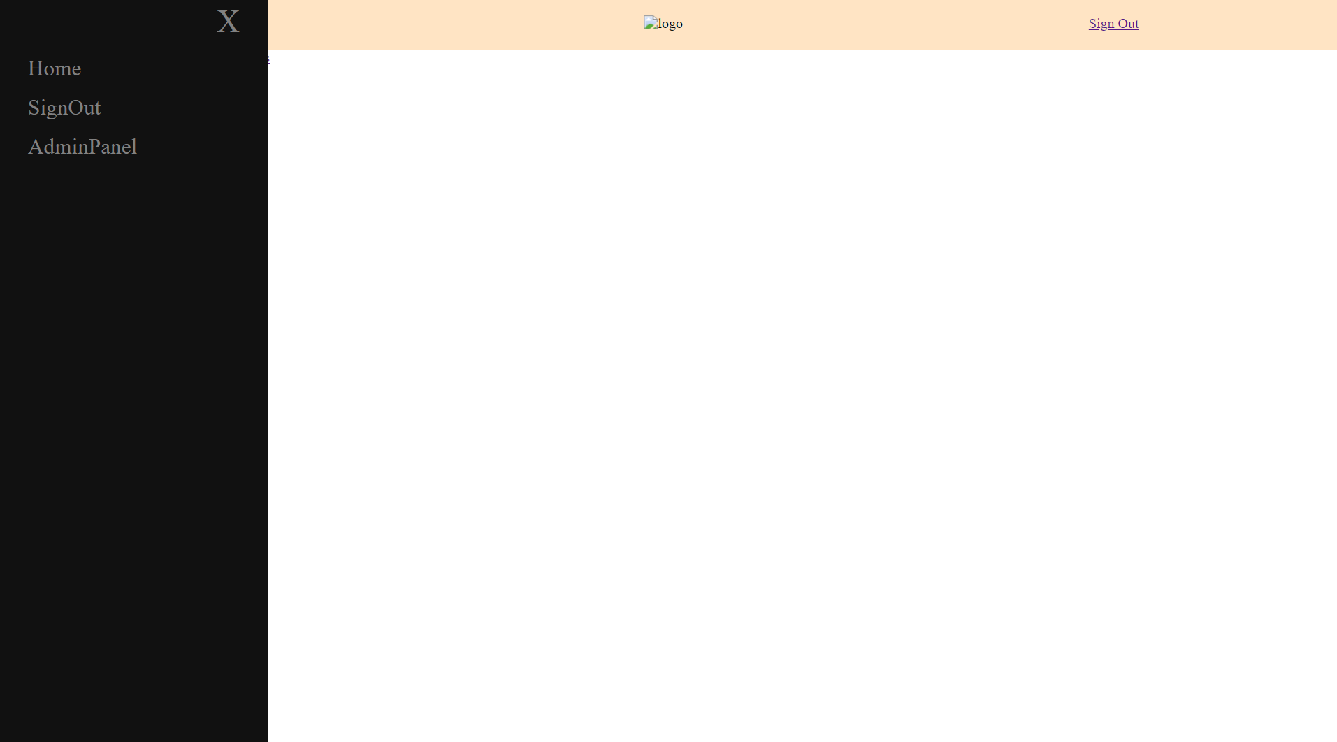

Додавання менеджера

<html>  
<head>  
 <title>Add Manager</title>  
</head>  
<body>  
<form action="/AddManager" method="post" style="display:flex;flex-direction: column">  
 <p>Name</p>  
 <input type="text" name="name">  
 <p>Surname</p>  
 <input type="text" name="surname">  
 <p>Gender</p>  
 <input type="text" name="gender">  
 <p>Email</p>  
 <input type="text" name="email">  
 <p>Password</p>  
 <input type="text" name="password">  
 <p>Phone number</p>  
 <input type="text" name="phoneNumber">  
 <p>Date of Birthday</p>  
 <input type="date" name="dateOfBirthday" min="01.01.1900" max="01.01.2004">  
 <button type="submit">Add Manager</button>  
</form>  
</body>  
</html>

@WebServlet(name = "AddManager", value = "/AddManager")  
public class AddManager extends HttpServlet {  
  
 @Override  
 protected void doPost(HttpServletRequest request, HttpServletResponse response) throws ServletException, IOException {  
 String name = request.getParameter("name");  
 String surname= request.getParameter("surname");  
 String gender= request.getParameter("gender");  
 String email= request.getParameter("email");  
 String password= request.getParameter("password");  
 String phoneNumber= request.getParameter("phoneNumber");  
 Date dateOfBirthday= Date.*valueOf*(request.getParameter("dateOfBirthday"));  
 User user = new User(name, surname, gender, email, password, phoneNumber, dateOfBirthday);  
 AdminDAO adminDAO = AdminDAOFactory.getInstance();  
 boolean status = adminDAO.addManager(user);  
 if (status){  
 response.sendRedirect("components/admin/adminPanel.jsp");  
 }else  
 response.sendRedirect("error.jsp");  
 }  
}

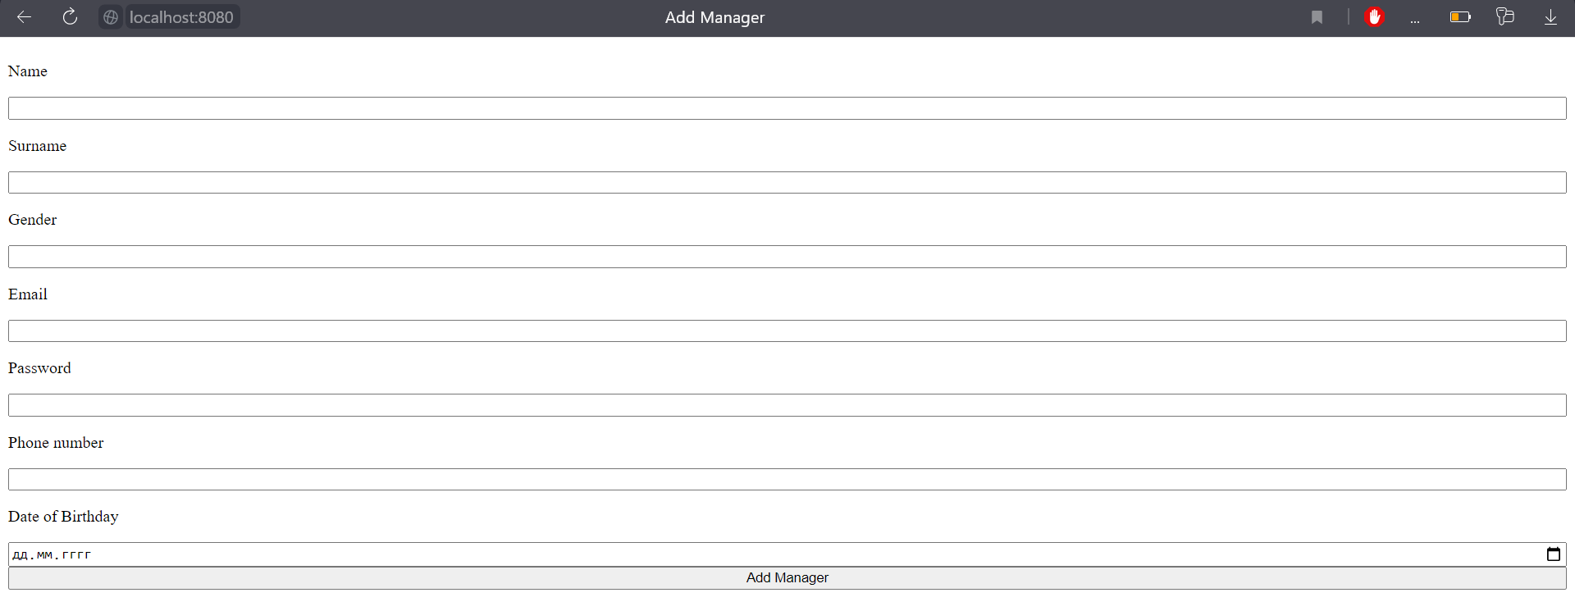

Отримання користувачів, та управління баном користувачів, змінює статус бана на протилежний

@WebServlet(name = "UnbanUser", value = "/UnbanUser")  
public class UnbanUser extends HttpServlet {  
 @Override  
 protected void doGet(HttpServletRequest request, HttpServletResponse response) throws ServletException, IOException {  
 int idUser = Integer.*parseInt*(request.getParameter("idUser"));  
 AdminDAO adminDAO = AdminDAOFactory.*getInstance*();  
 boolean status = adminDAO.unbanUser(idUser);  
 if (status){  
 response.sendRedirect("components/admin/carsList.jsp");  
 }else  
 response.sendRedirect("error.jsp");  
 }  
}

@WebServlet(name = "BanUser", value = "/BanUser")  
public class BanUser extends HttpServlet {  
 @Override  
 protected void doGet(HttpServletRequest request, HttpServletResponse response) throws ServletException, IOException {  
 int idUser = Integer.*parseInt*(request.getParameter("idUser"));  
 AdminDAO adminDAO = AdminDAOFactory.*getInstance*();  
 boolean status = adminDAO.banUser(idUser);  
 if (status){  
 response.sendRedirect("components/admin/carsList.jsp");  
 }else  
 response.sendRedirect("error.jsp");  
 }  
}

<html>  
<head>  
 <title>Users</title>  
</head>  
<body>  
<**c:forEach** items="${usersList}" var="user">  
 <form action="  
<**c:choose**>  
<**c:when** test="${user.getBanStatus()}">  
/UnbanUser  
</**c:when**>  
<**c:otherwise**>  
/BanUser  
</**c:otherwise**>  
</**c:choose**>"  
 method="get">  
 <div style="border: #111111 3px solid">  
 <p>Id User: ${user.getIduser()}</p>  
 <input type="hidden" name="idUser" value="${user.getIduser()}">  
 <p>Name: ${user.getName()}</p>  
 <p>Surname: ${user.getSurname()}</p>  
 <p>Email: ${user.getEmail()}</p>  
 </div>  
 <button type="submit">Change BAN status</button>  
 </form>  
</**c:forEach**>  
</body>  
</html>

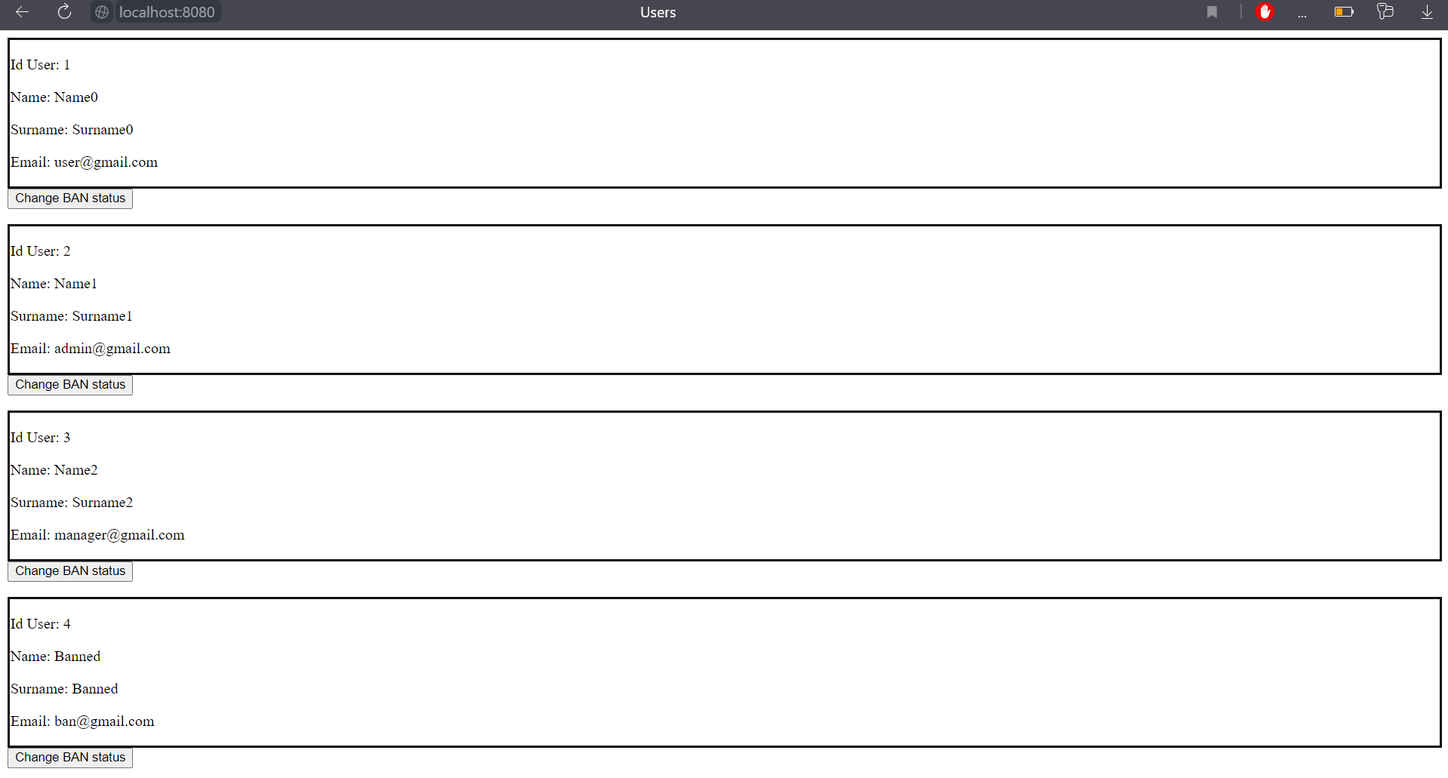

Header

<%@ **taglib** prefix="c" uri="http://java.sun.com/jsp/jstl/core" %>  
<header>  
 <script src="../js/slide.js"></script>  
 <script src="../js/formOpenClose.js"></script>  
 <script src="../js/RegistrationForm.js"></script>  
 <link rel="stylesheet" href="../css/stylesheet.css">  
 <h4 style="cursor:pointer"><a onclick="openSlideBar()">Menu</a></h4>  
 <img class="logo_small" src="../img/logo.jpg" alt="logo">  
 <**c:if** test="${user==null}">  
 <h4 style="cursor:pointer"><a onclick="showForm('signIn')">Sign in</a>  
 </h4>  
 <h4 style="cursor:pointer"><a onclick="showForm('register')">Register</a>  
 </h4>  
 <div class="hidden">  
 <a class="closeButtonForm" onclick="closeForm('signIn')">X</a>  
 <form action="/SignIn" method="post" class="openForm" id="signIn">  
 <div class="formElement">  
 <label>Email</label>  
 <input type="text" name="email" required>  
 <small></small>  
 </div>  
 <div class="formElement">  
 <label>Password</label>  
 <input type="password" name="password" minlength="8" required>  
 <small></small>  
 </div>  
 <button type="button" onclick="submitLoginForm()">Sign In</button>  
 </form>  
 </div>  
 <div class="hidden">  
 <a class="closeButtonForm" onclick="closeForm('register')">X</a>  
 <form action="/RegisterServlet" method="post" class="openForm" id="register">  
 <div class="formElement">  
 <label>Email</label>  
 <input type="text" name="email" minlength="5" required>  
 <small></small>  
 </div>  
 <div class="formElement">  
 <label>Password</label>  
 <input type="password" name="password" minlength="8" required>  
 <small></small>  
 </div>  
 <div class="formElement">  
 <label>Surname</label>  
 <input type="text" name="surname" required>  
 <small></small></div>  
 <div class="formElement">  
 <label>Name</label>  
 <input type="text" name="name" required>  
 <small></small>  
 </div>  
 <div class="formElement">  
 <label>Date</label>  
 <input type="date" name="date" min="1900-01-01" max="2023-01-01" required>  
 <small></small>  
 </div>  
 <div class="formElement">  
 <label>Your number</label>  
 <input type="tel" id="phone" onkeyup="phoneMask()" name="phoneNumber"  
 pattern="\+[0-9]{2}\([0-9]{3}\)-[0-9]{3}-[0-9]{2}-[0-9]{2}"  
 placeholder="+38(099)-453-22-78" required>  
 <small></small>  
 </div>  
 <div class="gender"><p>Your Gender:</p>  
 <input type="radio" name="gender" value="Male" required>  
 <label>Male</label>  
 <input type="radio" name="gender" value="Female">  
 <label>Female</label>  
 <input type="radio" name="gender" value="Other">  
 <label>Other</label>  
 <small></small>  
 </div>  
  
 <button type="button" onclick="submitRegisterForm()">  
 Register</button>  
 </form>  
 </div>  
 </**c:if**>  
 <**c:if** test="${user!=null}">  
 <a href="/SignOut">Sign Out</a>  
 </**c:if**>  
 <div id="slideBarMenu" class="slideBar">  
 <a href="javascript:void(0)" class="closeButton" onclick="closeSlideBar()">X</a>  
 <a href="index.jsp">Home</a>  
 <**c:if** test="${user!=null}">  
 <a href="/SignOut">SignOut</a>  
 </**c:if**>  
 <**c:if** test="${user.getRole()=='admin'}">  
 <a href="index.jsp">AdminPanel</a>  
 </**c:if**>  
 </div>  
</header>

Logger

<?xml version="1.0" encoding="UTF-8"?>  
<Configuration status="WARN">  
 <Appenders>  
 <Console name="LogToConsole" target="SYSTEM_OUT">  
 <PatternLayout pattern="%highlight{%d{HH:mm:ss.SSS} [%t] %-5level %logger{36} - %msg%n}{TRACE=magenta}" disableAnsi="false"/>  
 </Console>  
 </Appenders>  
 <Loggers>  
  
 <Logger name="com.example.autoRent" level="info" additivity="false">  
 <AppenderRef ref="LogToConsole"/>  
 </Logger>  
  
 <Root level="error">  
 <AppenderRef ref="LogToConsole"/>  
 </Root>  
 </Loggers>  
</Configuration>

Connection pool

package com.example.autoRent.Model.DataBaseConnectionPool;  
  
import org.slf4j.Logger;  
import org.slf4j.LoggerFactory;  
  
import javax.naming.Context;  
import javax.naming.InitialContext;  
import javax.naming.NamingException;  
import javax.sql.DataSource;  
  
public class ConnectionPool {  
  
 private static final Logger *LOG* = LoggerFactory.*getLogger*(ConnectionPool.class);  
  
 private ConnectionPool() {  
 }  
  
 private static DataSource *dataSource*;  
  
 public static synchronized DataSource getDataSource() {  
 if (*dataSource* == null) {  
 try {  
 Context ctx = new InitialContext();  
 *dataSource* = (DataSource) ctx.lookup("java:comp/env/jdbc/ConnectionPool");  
 } catch (NamingException e) {  
 e.printStackTrace();  
 *LOG*.error("Connection pool .getDataSource error," +  
 " Context lookup environment doesn't exist" +  
 " java:comp/env/jdbc/ConnectionPool", e);  
 }  
 }  
 return *dataSource*;  
 }  
  
}

.EncodingRequestResponseFilter - Encoding UTF-8

14:58:33.650 [http-nio-8080-exec-5] INFO com.example.autoRent.Controller.FiltersAndListeners.EncodingRequestResponseFilter - Encoding UTF-8

14:58:33.662 [http-nio-8080-exec-9] INFO com.example.autoRent.Controller.FiltersAndListeners.EncodingRequestResponseFilter - Encoding UTF-8

14:58:33.673 [http-nio-8080-exec-1] INFO com.example.autoRent.Controller.FiltersAndListeners.EncodingRequestResponseFilter - Encoding UTF-8

14:58:33.683 [http-nio-8080-exec-10] INFO com.example.autoRent.Controller.FiltersAndListeners.EncodingRequestResponseFilter - Encoding UTF-8

14:58:46.643 [http-nio-8080-exec-6] INFO com.example.autoRent.Controller.FiltersAndListeners.EncodingRequestResponseFilter - Encoding UTF-8

14:58:46.741 [http-nio-8080-exec-2] INFO com.example.autoRent.Controller.FiltersAndListeners.EncodingRequestResponseFilter - Encoding UTF-8

14:58:49.719 [http-nio-8080-exec-3] INFO com.example.autoRent.Controller.FiltersAndListeners.EncodingRequestResponseFilter - Encoding UTF-8

14:58:49.727 [http-nio-8080-exec-4] INFO com.example.autoRent.Controller.FiltersAndListeners.EncodingRequestResponseFilter - Encoding UTF-8

14:58:49.828 [http-nio-8080-exec-8] INFO com.example.autoRent.Controller.FiltersAndListeners.EncodingRequestResponseFilter - Encoding UTF-8

14:59:22.692 [http-nio-8080-exec-6] INFO com.example.autoRent.Controller.FiltersAndListeners.EncodingRequestResponseFilter - Encoding UTF-8

14:59:22.710 [http-nio-8080-exec-2] INFO com.example.autoRent.Controller.FiltersAndListeners.EncodingRequestResponseFilter - Encoding UTF-8

14:59:22.796 [http-nio-8080-exec-3] INFO com.example.autoRent.Controller.FiltersAndListeners.EncodingRequestResponseFilter - Encoding UTF-8

14:59:45.049 [http-nio-8080-exec-5] INFO com.example.autoRent.Controller.FiltersAndListeners.EncodingRequestResponseFilter - Encoding UTF-8

14:59:45.160 [http-nio-8080-exec-9] INFO com.example.autoRent.Controller.FiltersAndListeners.EncodingRequestResponseFilter - Encoding UTF-8

14:59:47.394 [http-nio-8080-exec-1] INFO com.example.autoRent.Controller.FiltersAndListeners.EncodingRequestResponseFilter - Encoding UTF-8

15:00:11.241 [http-nio-8080-exec-6] INFO com.example.autoRent.Controller.FiltersAndListeners.EncodingRequestResponseFilter - Encoding UTF-8

15:00:11.338 [http-nio-8080-exec-2] INFO com.example.autoRent.Controller.FiltersAndListeners.EncodingRequestResponseFilter - Encoding UTF-8

15:00:12.631 [http-nio-8080-exec-3] INFO com.example.autoRent.Controller.FiltersAndListeners.EncodingRequestResponseFilter - Encoding UTF-8

15:00:15.660 [http-nio-8080-exec-4] INFO com.example.autoRent.Controller.FiltersAndListeners.EncodingRequestResponseFilter - Encoding UTF-8

15:00:15.758 [http-nio-8080-exec-8] INFO com.example.autoRent.Controller.FiltersAndListeners.EncodingRequestResponseFilter - Encoding UTF-8

15:00:26.791 [http-nio-8080-exec-5] INFO com.example.autoRent.Controller.FiltersAndListeners.EncodingRequestResponseFilter - Encoding UTF-8

15:01:18.943 [http-nio-8080-exec-7] INFO com.example.autoRent.Controller.FiltersAndListeners.EncodingRequestResponseFilter - Encoding UTF-8

15:01:19.071 [http-nio-8080-exec-10] INFO com.example.autoRent.Controller.FiltersAndListeners.EncodingRequestResponseFilter - Encoding UTF-8

15:01:21.286 [http-nio-8080-exec-6] INFO com.example.autoRent.Controller.FiltersAndListeners.EncodingRequestResponseFilter - Encoding UTF-8

15:01:21.301 [http-nio-8080-exec-2] INFO com.example.autoRent.Controller.FiltersAndListeners.EncodingRequestResponseFilter - Encoding UTF-8

15:01:21.437 [http-nio-8080-exec-3] INFO com.example.autoRent.Controller.FiltersAndListeners.EncodingRequestResponseFilter - Encoding UTF-8

15:01:29.315 [http-nio-8080-exec-4] INFO com.example.autoRent.Controller.FiltersAndListeners.EncodingRequestResponseFilter - Encoding UTF-8

15:01:29.333 [http-nio-8080-exec-8] INFO com.example.autoRent.Controller.FiltersAndListeners.EncodingRequestResponseFilter - Encoding UTF-8

15:01:29.494 [http-nio-8080-exec-5] INFO com.example.autoRent.Controller.FiltersAndListeners.EncodingRequestResponseFilter - Encoding UTF-8

User Bills

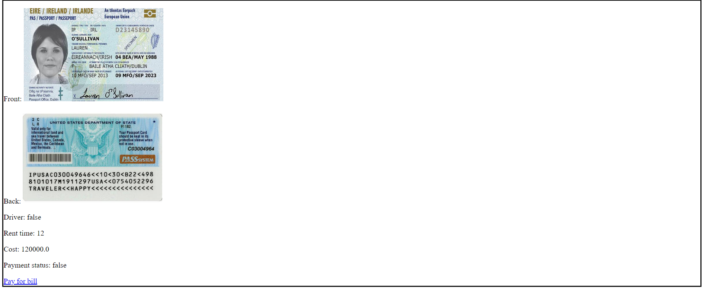

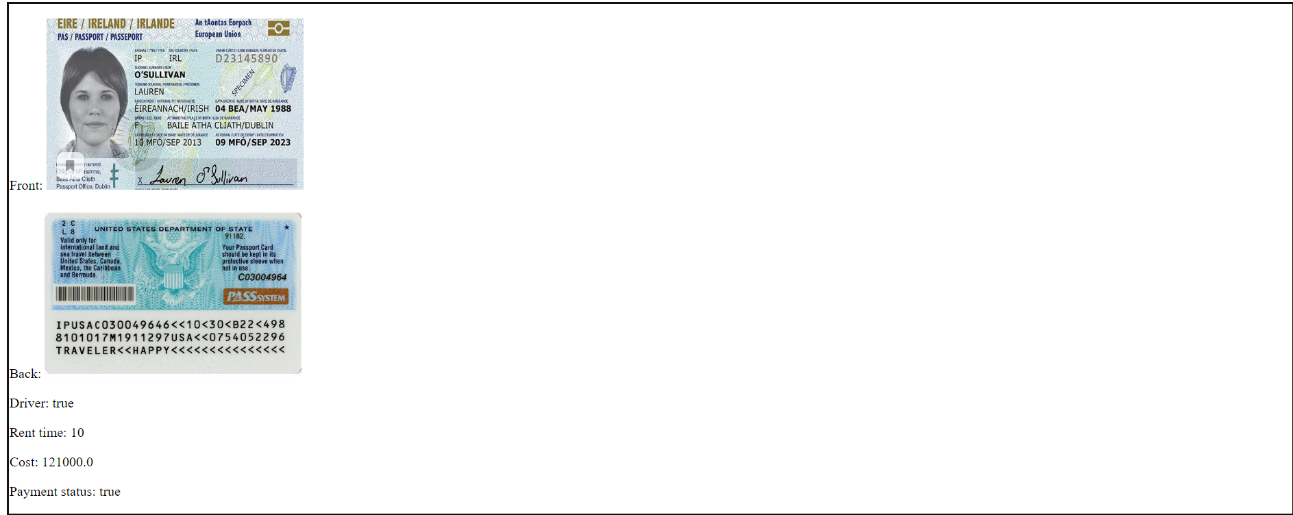

<html>  
<head>  
 <title>Bills</title>  
</head>  
<body>  
<div>  
 <**c:forEach** items="${billsList}" var="bill">  
 <div style="border: #111111 3px solid">  
 <p>Front: <img width="300px" height="200px" src="${bill.getFrontPassport()}"></p>  
 <p>Back: <img width="300px" height="200px" src="${bill.getBackPassport()}"></p>  
 <p>Driver: ${bill.isDriver()}</p>  
 <p>Rent time: ${bill.getRentTime()}</p>  
 <p>Cost: ${bill.getCost()}</p>  
 <p>Payment status: ${bill.isPaymentStatus()}</p>  
 <**c:if** test="${!bill.isPaymentStatus()}">  
 <a href="/PayForBill?idBill=${bill.getIdbill()}">Pay for bill</a>  
 </**c:if**>  
 <**c:if** test="${bill.isPaymentStatus()}">  
 <p>${bill.getRentStatus()}</p>  
 <p>${bill.getReturnStatus()}</p>  
 </**c:if**>  
 </div>  
 </**c:forEach**>  
</div>  
</body>  
</html>

User get cars

<html>  
<head>  
 <title>User Page</title>  
</head>  
<body>  
<div style="display: flex;flex-direction: column">  
 <a href="/AllCars">All cars</a>  
 <a href="/AllCarsSortedByName">All cars sorted by name</a>  
 <a href="/AllCarsSortedByNameDESC">All cars sorted by name desc</a>  
 <a href="/AllCarsSortedByPrice">All cars sorted by price</a>  
 <a href="/AllCarsSortedByPriceDESC">All cars sorted by price desc</a>  
 <form action="/CarsByBrand" method="post">  
 <p>Brand</p>  
 <input type="text" name="brand">  
 <button type="submit">Search</button>  
 </form>  
 <form action="/CarsByQualityClass" method="post">  
 <p>Quality class</p>  
 <select name="qualityClass">  
 <option value="S">S</option>  
 <option value="A">A</option>  
 <option value="B">B</option>  
 <option value="C">C</option>  
 <option value="D">D</option>  
 </select>  
 <button type="submit">Search</button>  
 </form>  
</div>  
<div>  
 <**jsp:include** page="carsList.jsp"></**jsp:include**>  
</div>  
</body>  
</html>

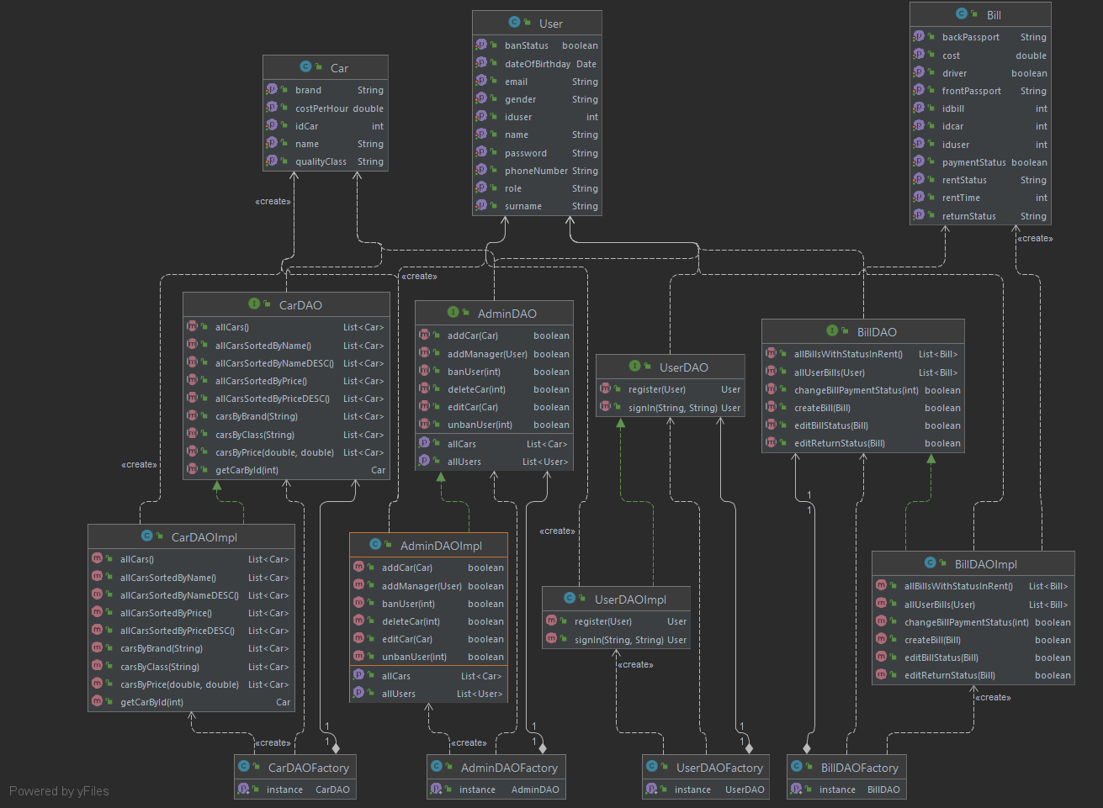

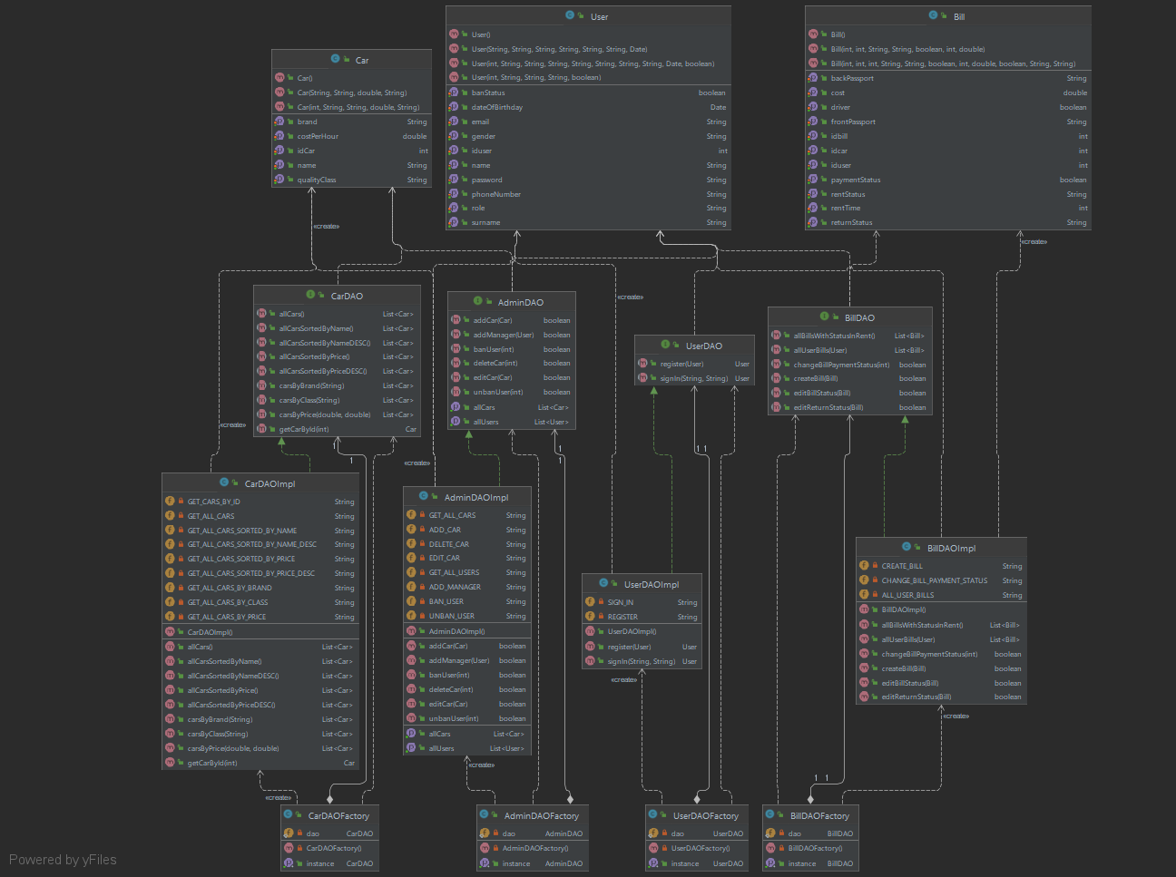

Менеджер

