IRISH-NER Documentation
1. Project overview
This project is focused on AI extraction of address related entities from ICU notes. In this project 5 entities were outlined: street name, which can include number. GPE or geopolitical entity, this can be a city, village, district of a city e.t.c. County – one of Irish counties. Eircode or Postcode for the Northern Ireland. Facility – can be pharmacy, hospital, special accommodation e.t.c.
This project was developed to be run in CPU only trusted environments. It requires no internet connection to extract the outlined entities.
2. Environment and Infrastructure
During the project development the main tools that were used are JypiterHub running on NUIG server and LM studio which was running on the server as well.
To setup the LM Studio on the server:
Install llmster
The Jupyter shell may omit system administration directories from PATH, so add them before installation:
export PATH="$PATH:/usr/sbin:/sbin"
curl -fsSL https://lmstudio.ai/install.sh | bash
export PATH="$HOME/.lmstudio/bin:$PATH"
Optional: persist the LM Studio CLI path for future shells:
echo 'export PATH="$HOME/.lmstudio/bin:$PATH"' >> ~/.bashrc
Start llmster
lms daemon up
lms daemon status
Download and load a CPU model
lms get google/gemma-4-e2b
lms load google/gemma-4-e2b --gpu 0.0 --context-length 8192
lms ps
The context length can also be set to a lower value to reduce memory usage, though this has not been tested for its effect on token generation speed.
Start the local API
The service is kept on loopback in a secured environment:
lms server start --bind 127.0.0.1 --port 1234
lms server status
curl http://127.0.0.1:1234/v1/models
Note: do not bind to 0.0.0.0 unless access is protected by an approved authenticated TLS proxy. As this is a Trusted Research Environment, LM Studio’s LM Link feature (lms login, lms link enable) must not be used — inference stays local to the TRE through 127.0.0.1.
Test inference
CLI test with performance statistics:
lms chat google/gemma-4-e2b --stats -p "Explain ICU data in two sentences."
Python test with explicit thinking mode:
import json
from urllib.request import Request, urlopen

payload = {
"model": "google/gemma-4-e2b",
"input": "Explain ICU data in two sentences.",
"reasoning": "on",
"max_output_tokens": 512,
}

request = Request(
"http://127.0.0.1:1234/api/v1/chat",
data=json.dumps(payload).encode(),
headers={"Content-Type": "application/json"},
method="POST",
)

with urlopen(request, timeout=180) as response:
result = json.load(response)

for item in result.get("output", []):
print(f"[{item['type']}]\n{item.get('content', '')}\n")

print(result.get("stats"))
The native /api/v1/chat endpoint returns reasoning and final-message items separately. Model downloads and catalogue searches require internet access; inference against 127.0.0.1 remains local.
3. Data sources and preparation
Address data used for training and validation was sourced from the Property Price Register, the CRO open data portal, and OpenStreetMap/Geofabrik. These three sources were unified into one csv file. Then duplicates and non-valid values like empty street names, eircodes consisting of numbers only e.t.c were removed
The ICU type notes were generated with the help of unifying AI and the mentioned CSV file. The ICU notes were generated with empty labels like <STREET_LABLEL>, <GPE_LABEL>, <COUNTY_LABEL>, <EIRCODE_LABEL> and were replaced using python script with corresponding real values from the csv file.
Its worth to note some notes were generated with pure use of AI.
4. Architecture evolution
Phase 1: spaCy v3 model
An initial spaCy v3 model was trained with STREET, GPE, COUNTY, and EIRCODE labels. Synthetic training data was generated using diversified templates, with disjoint train/dev splits to avoid leakage. Hard-negative examples were injected to correct false positives on names and dates, and data was converted into spaCy’s DocBin format for training.
Phase 2: Hybrid regex and statistical NER
A hybrid architecture combining regex-based extraction with statistical NER was established, adding a regex-based Eircode component to complement the model’s predictions.
However due to unability to access real data that the model could be trained on, and problems of AI generated notes such as simillar semantic structure, same seed and after consultation with professor Michael Madden I have decided to go with more modern and flexible approach.
Phase 3: LM Studio local inference (current approach)
The current approach uses batched LM Studio local inference (Gemma-4-e2b/e4b variants) with structured prompt engineering for entity extraction. Supporting scripts handle postcode filtering and parsing of verbose model responses.
5. Recurring issues
Several recurring issues were addressed throughout development: train/dev leakage, model overfitting on uniform synthetic templates, LM Studio catalogue and connectivity problems, and output post-processing for inconsistent model responses.
LM studios answers can be inconsistent, so for the same output in different trials the result would be different. LM studio also tends to duplicate its answers sometimes. To get the perfect result we would require very powerful hardware.
6. Repository and access
Github: https://github.com/MaksymLuhinTCD/IRISH-NER.git
6. Measure accuracy
To measure the accuracy of the model I am going to use the following indicators:
- Precision: Of all the entities the model extracted, what percentage were correct?
- Recall: Of all the actual entities in the text, what percentage did the model successfully find?
- F1-Score: The harmonic mean of precision and recall; it provides a balanced view of model performance.
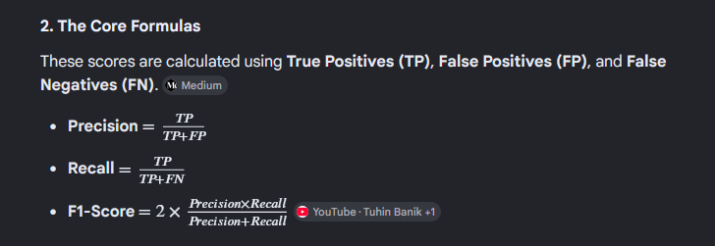

7. Future work
Open items include further evaluation of extraction accuracy across entity types, and continued refinement of prompt engineering and output parsing for the LM Studio inference pipeline.
+
Finishing the documentation

