# AUDIO INTERFACES:

**BEHRINGER U-PHORIA UMC404HD**

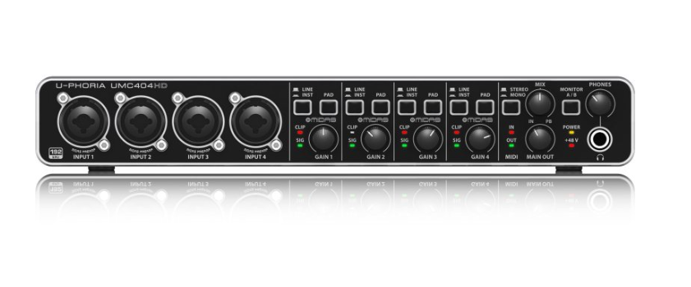

Characteristics:

24bit/192 kHz frequency

Compatible with such audio tools: Avid Pro Tools, Ableton Live, Steinberg Cubase

4 XLR Inputs

MIDI I/O

799 Zlotys (403 Zlotys on AliExpress)

<https://www.czakmusic.pl/behringer-u-phoria-umc404hd-interfejs-usb-midi-z,3,9165,24343>

<https://pl.aliexpress.com/item/1005008769388043.html?src=google&pdp_npi=4%40dis!PLN!997.49!403.04!!!!!%40!12000046592159736!ppc!!!&snps=y&snpsid=1&src=google&albch=shopping&acnt=752-015-9270&isdl=y&slnk=&plac=&mtctp=&albbt=Google_7_shopping&aff_platform=google&aff_short_key=_oDeeeiG&gclsrc=aw.ds&&albagn=888888&&ds_e_adid=775633110645&ds_e_matchtype=search&ds_e_device=c&ds_e_network=g&ds_e_product_group_id=2442123901331&ds_e_product_id=pl1005008769388043&ds_e_product_merchant_id=5551326180&ds_e_product_country=PL&ds_e_product_language=pl&ds_e_product_channel=online&ds_e_product_store_id=&ds_url_v=2&albcp=23052422285&albag=185983060716&isSmbAutoCall=false&needSmbHouyi=false&gad_source=1&gad_campaignid=23052422285&gbraid=0AAAAA_eFwRCXGMcbBXwnj-AVpP2UfHAOs&gclid=Cj0KCQjwjL3HBhCgARIsAPUg7a7r8pClXs97FL-SS5EgnTSCSOiHb7Ty2a5AAUozgY4wpqLVUo1n8VkaAv3vEALw_wcB>

**Professional 3rd Gen 4×4 USB PC 4- XLR microphone input computer audio interface 24-Bit 192 kHz with 48V phantom power**

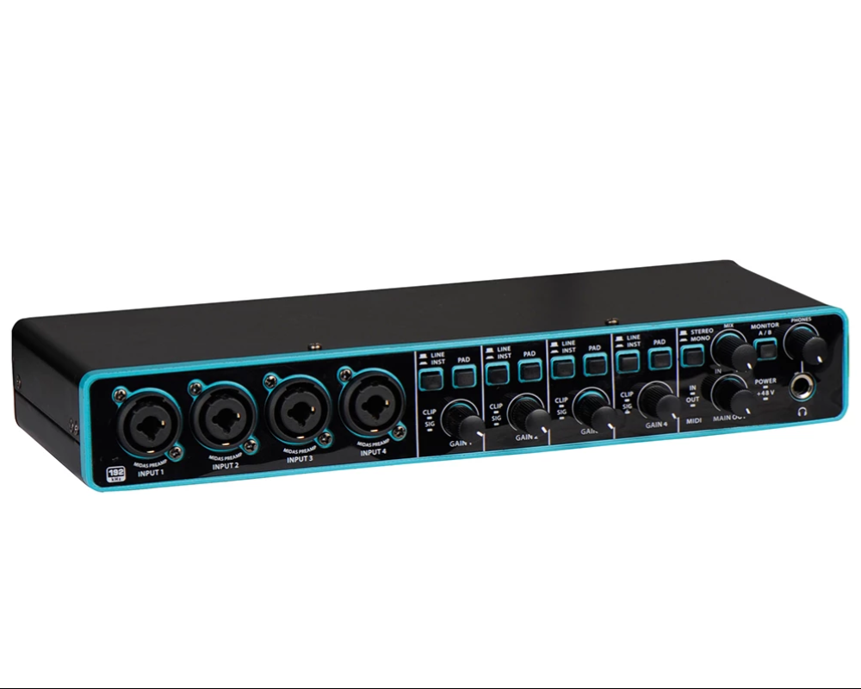

Characteristics:

24bit/192 kHz frequency

4 XLR Inputs

Price: 100 dollars (180 dollars without discount)

<https://soundprofessionals.com/product/SP-PRO-INTERFACE-4-XLR/?srsltid=AfmBOorRurGDFNTEwhFUWadc2CElvQzROHIesSKd2ih4BH1u9SRzMX44>

**MD44 24 bit/192 kHZ Audio Interface Studio 4 Channel Sound Table Audio 4 in 4 out USB Sound Card Electric Guitar Live Recording**

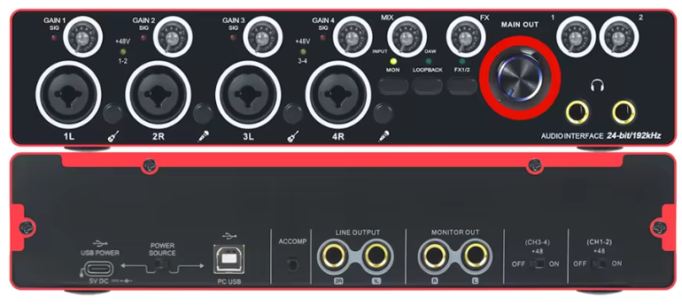

4 XLR Inputs

USB connection

Price: 220,48 Zlotys  
<https://pl.aliexpress.com/item/1005008535382205.html>