DEVICE:

Microphone array - set of microphones (with frequencies 100 – 10000 Hz) (drone sound – 100 Hz – several KHz)

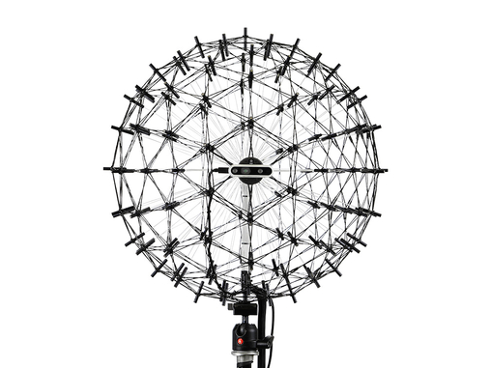

Source: <https://www.google.com/url?sa=i&url=https%3A%2F%2Fwww.gfaitech.com%2Fproducts%2Facoustic-camera%2Fmicrophone-arrays%3Fgad_campaignid%3D17498805991%26cHash%3Da9df60a836ac25b8c2f64362c61f6db1&psig=AOvVaw3WR6ezzPBm0QYeCUP0JWDc&ust=1760094692278000&source=images&cd=vfe&opi=89978449&ved=0CBUQjRxqFwoTCJC2yun9lpADFQAAAAAdAAAAABAE>

The computer will receive the data from microphone array and then process it (data can also be stored in the database).  
  
Algorithm to use: beamforming.