BIG REFINED SEARCH

OPTIONS:

First option: Preset (preconstructed) microphone array connected to computer via USB.

Hardware needed:

1. Microphone array  
   Microphone array options:

miniDSP UMA-16 USB Mic Array (16 microphones MEMS Knowles SPH1668LM4H in rectangular form, comes with 1,5 meter mini-usb - usb cabel) (price: 1600 zlotys) ([link](https://blackdotaudio.eu/minidsp-uma-16-usb-mic-array,236,3146124.html?srsltid=AfmBOoorIIpsIopLZSs0oeYNIHo5n1qa4zdJBJn4dVJQYIb3tIj0GMszHcs));

8 Array Directional Microphone Array (8 microphones) (price: 269 zlotys) ([link](https://www.fruugo.pl/8-array-directional-microphone-array-usb-linear-180-degree-sound-pickup-suppression/p-421488677-887768366?language=en&ac=google&gad_source=1&gad_campaignid=22764412488&gbraid=0AAAAADpXug0n_qHMJzWgDLDVJeCDRQYTG&gclid=CjwKCAjwr8LHBhBKEiwAy47uUsZaN_lFHoPzpPL2MqYtC2qO4noTi7zQ5e-PHXSQeb4OaWz8qXUAiRoC36UQAvD_BwE));

Mic6 Microphone Array (7 MEMS microphones) (price: 149 zlotys) ([link](https://www.fruugo.pl/mic6-microphone-array-zrod%C5%82o-dzwieku-modu%C5%82-sledzenia-lokalizacji-expansion-board-msm261s4030h0-ai-z-1/p-139477907-294677739?language=pl&ac=google&asc=pmax&gad_source=1&gad_campaignid=19640376884&gbraid=0AAAAADpXug1VWfSmrk0Y0TW9jRS7m7Mk_&gclid=CjwKCAjwr8LHBhBKEiwAy47uUp9hHLQsBkqYi7uDrYoMrnhcRMe01p84Rrj3Ove-A85wgoPQgX6iehoCYMIQAvD_BwE));

1. Mini-USB - USB cable (or USB-C - USB depending on the model of array) (if not present in the kit) (1m Mini-USB – USB cable – 20-30 zlotys) (1m USB-C – USB cable – 10-20 zlotys).
2. Laptop.

(Alternative suboption): Number of Microphone Array devices can be extended to 3,4 or 5 separate array devices using USB extension hub. It is recommended to use active (self-powered) USB hubs as the unpowered USB hubs will spend more energy from the laptop and will be less efficient when it comes to device communication, although powered USB hubs may require external source of electricity.

Powered USB hubs options:

# Active Hub USB 3.0 - 5 ports with switches and power supply (price: 139 zlotys) ([link](https://kamami.pl/en/usb-splitters/586791-active-hub-usb-30-5-ports-with-switches-and-power-supply-5906623463220.html));

# RSHTECH Powered USB Hub Aluminum 4-port USB 3.0 Hub (price: 82 zlotys) ([link](https://www.amazon.co.uk/Powered-RSHTECH-Aluminum-4-port-Individual-Black/dp/B08ZKSK6MB?th=1));

Unpowered USB hubs options:

# Anker Ultra Slim Extra Light 4 Port USB 3.0 Hub (price: 79 zlotys) ([link](https://www.amazon.pl/Anker-koncentrator-przej%C5%9Bci%C3%B3wka-MacBook-Surface/dp/B07L32B9C2/ref=asc_df_B07L32B9C2?mcid=4d56ad3bc03e3cfe899704ff82a934b9&tag=plshogostdde-21&linkCode=df0&hvadid=719815623536&hvpos=&hvnetw=g&hvrand=2774989261251109746&hvpone=&hvptwo=&hvqmt=&hvdev=c&hvdvcmdl=&hvlocint=&hvlocphy=9067408&hvtargid=pla-621842602315&psc=1&language=pl_PL&gad_source=1));

# ORICO 4-portowy rozdzielacz USB 3.0 HUB USB (price: 50 (33) zlotys) ([link](https://www.aliexpress.com/p/tesla-landing/index.html?_immersiveMode=true&scenario=c_ppc_item_bridge_gmv&productId=1005008203620700&src=google&aff_short_key=_c3iN9Lxl&withMainCard=true&aff_platform=true&isdl=y&traffic_server_nav=true&key=_3in1&src=google&albch=shopping&acnt=752-015-9270&isdl=y&slnk=&plac=&mtctp=&albbt=Google_7_shopping&aff_platform=google&gclsrc=aw.ds&&albagn=888888&&ds_e_adid=776050366943&ds_e_matchtype=search&ds_e_device=c&ds_e_network=g&ds_e_product_group_id=2441362952347&ds_e_product_id=pl1005008203620700&ds_e_product_merchant_id=5660123851&ds_e_product_country=PL&ds_e_product_language=pl&ds_e_product_channel=online&ds_e_product_store_id=&ds_url_v=2&albcp=23052457359&albag=188859667111&isSmbAutoCall=false&needSmbHouyi=false&gad_source=1&gad_campaignid=23052457359&gbraid=0AAAAA_eFwRAVYOltIkFRr1Illzpdnn6Bk&gclid=CjwKCAjwgeLHBhBuEiwAL5gNEQdfBuLuIl3PjGdkp0MZOIw9SerxorEa9kwUGf60af0BTjLGiD98UxoCRV8QAvD_BwE));

Software needed:

1. Sound processing software.

Examples:

1. ODAS Library ([link](https://github.com/introlab/odas.git)) – open-source, written in C. Dedicated to perform sound source localization, tracking, separation and post-filtering.

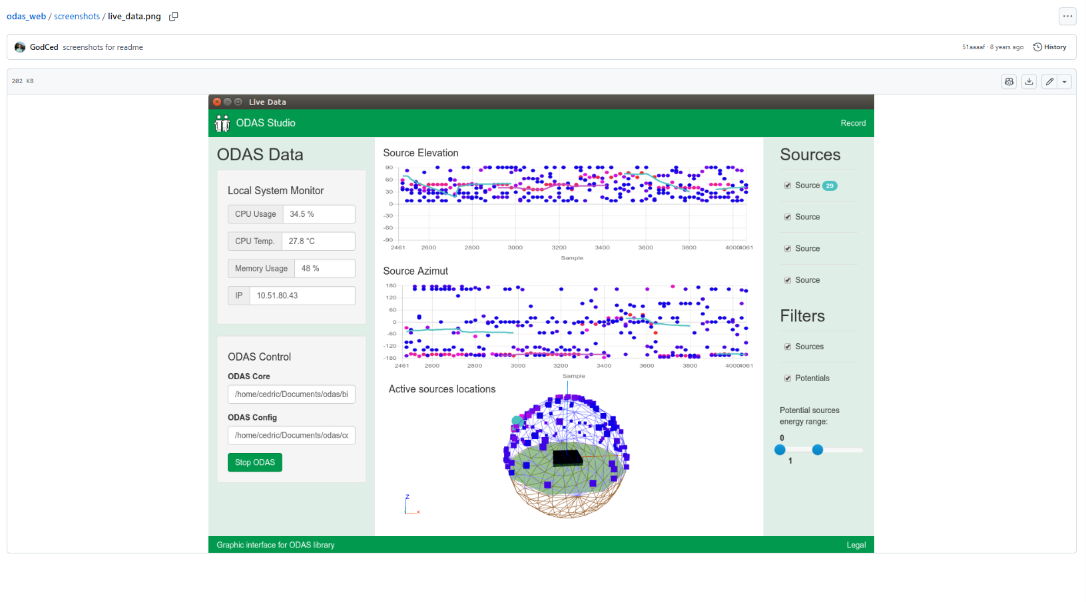

GUI of the ODAS Studio.

1. pyAudioAnalysis ([link](https://github.com/tyiannak/pyAudioAnalysis.git)) – written in Python. Dedicated to audio extraction, detection and classification.
2. Maixpy IDE, Platformio IDE (C, C++ languages) ([link to Maxipy](https://github.com/sipeed/MaixPy.git)) ([link to Platformio](https://platformio.org/platformio-ide)). Dedicated to work with embedded systems.

Algorithm of sound source location determination: TDOA (Time Difference of Arrival) which will be based on true-range (or pseudorange) miltilateration that will require distance measurements in order for microphones to pick the signal from sound source up.

Scientific article on similar topic: [link](http://psasir.upm.edu.my/id/eprint/111185/1/Performance%20of%20DOA%20Estimation%20Algorithms%20for%20Acoustic%20Localization%20of%20Indoor%20Flying%20Drones%20Using%20Art.pdf)

Exemplary video: [link](https://youtu.be/n7y2rLAnd5I?si=fKkS3OkO_SMpUJYI)

In the video the XMOS xCore 7 array microphone array (with 7 microphones) was shown and ODAS library was utilized. It was shown that the array, using software with ODAS library was able to determine the location of sound source in 3-dimensional space. In video it was also shown that there is possibility to filter the sound as well as determine the location of sound source in real time.

Construction scheme (with one array):

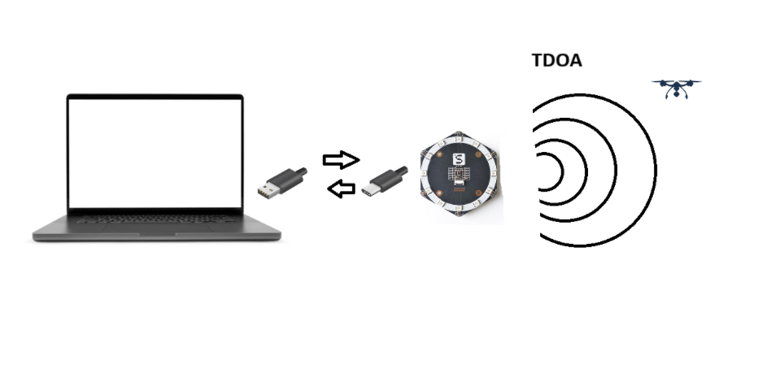

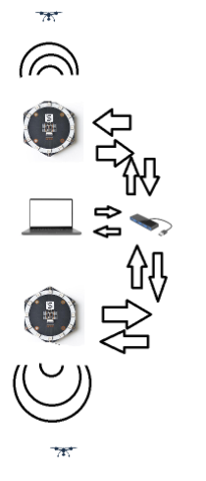Sketch for option with 2 MEMS Array with the use of USB hub.

Distances from the Laptop to the Hub/Arrays – 1 meter.  
  
Advantages:

* Simplicity of construction. Such microphone arrays can be connected via USB to the computer (as shown on the video) and does not require any audio interfaces.
* Portability. Such construction (configuration) does not require a lot of space and can be placed even in very tight places.
* Small cost. Such configuration does not require very big amount of funds as the hardware that it consists of is not very demanding yet still able to efficiently perform sound localization techniques.
* Greater performance of MEMS microphones over Electric-based (see graph) that results in better signal-to-noise ratio.

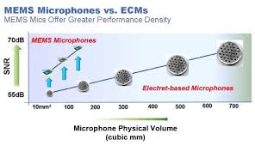

Disadvantages:

* Complexity of the software. This type of hardware requires the code of the software to be written in the programming language that will manage hardware efficiently. The process of coding may also require external libraries such as ODAS to be used.
* Relatively short range of MEMS microphone for source detection – up to only 20 meters (for arrays).

Conclusion: this option is relatively cheap and simple to construct and position yet still is complex from the software point of view. Even though it has relatively short range of its effectiveness it has better greater performance in terms of sound localization.