Distance between microphones and how to set them appropriately:
(view from above)
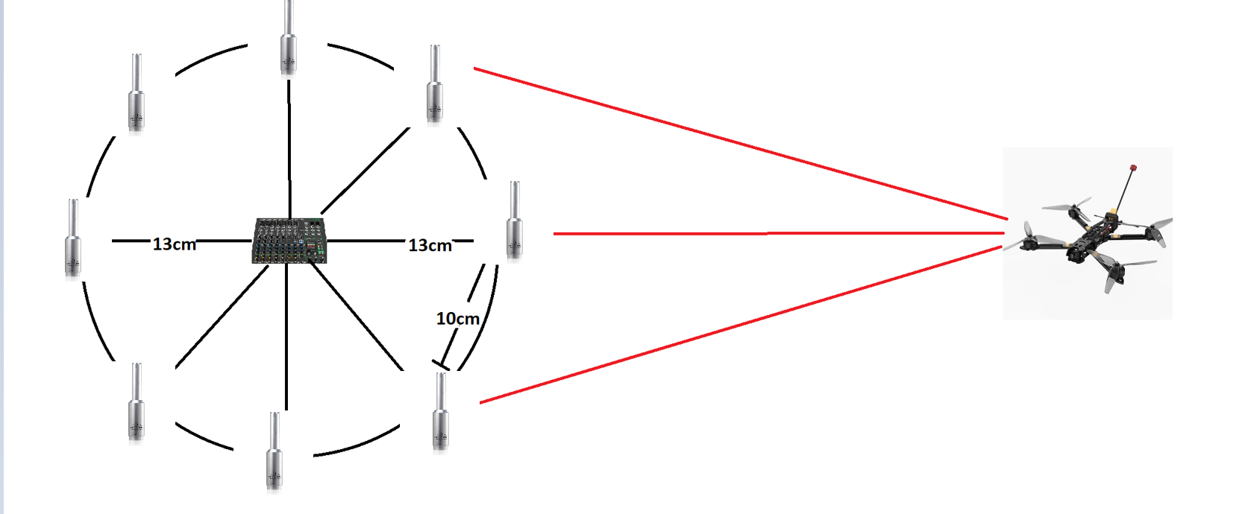
Calculated distance between microphones is 10cm, because:
λ=f/c
the most common frequency (f) we want to hear from drone is 1,5kHz
speed of sound (c) is 343 m/s
so wave (λ) will be about 23cm
to prevent aliasing (error or distortion in a signal or image that makes it appear different from its original form) distance between microfones should be half of wavelength (11,5cm)
Because d=2Rsin(π/8) the radius of this array should be 13 cm.
(of course we can scale this whole setup but when we make radius bigger we need to for radius of 26 cm use 16 microphones and the range of detecting microphones would increase by 41%)
Angle of microphones:
Mount all microphones vertically, with the capsule (the little grille end) pointing straight upward. This way, each mic “sees” the sound field the same way in the horizontal plane (where you estimate azimuth). You avoid one mic’s body casting an “acoustic shadow” on another.
Optionally tilt each mic slightly outward and upward (~10–15°). That helps reduce ground reflections. It also improves sensitivity to drones flying above the array instead of level with it.

Range:
(Radius for 8 microphones in different environments)
Quiet (30dB) | Medium (45dB) | City (55dB)
90 m | 40 m | 12 m

Setup:
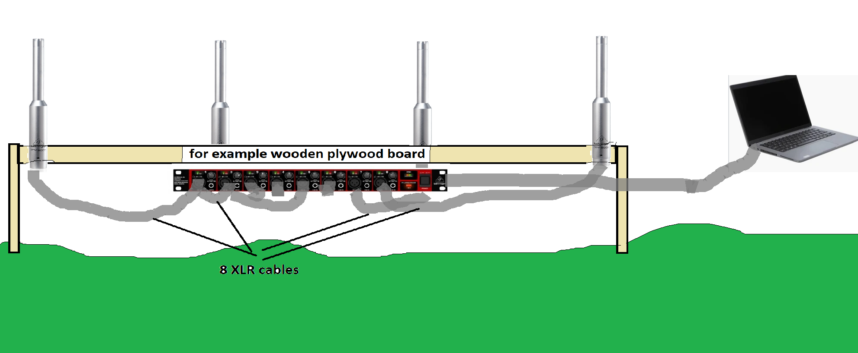
Costs:
For 8 microphones array:
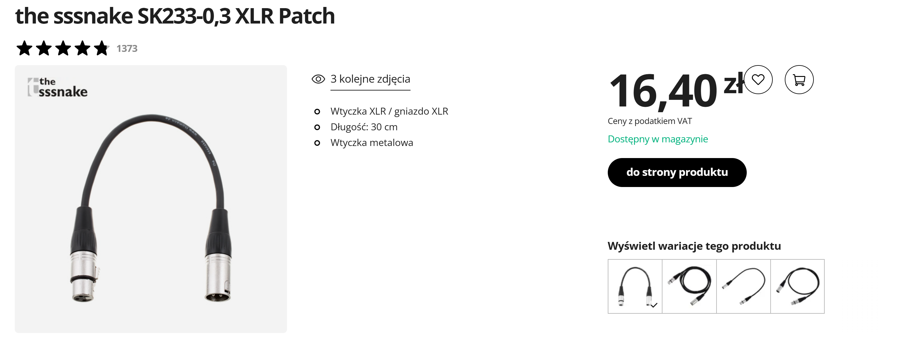
- 8*XLR cable of about 30cm because we need reserve to connect it to the audio interface.
8*17pln = 136 PLN
- 8*Behringer ECM8000 = about 800pln
- 1* Behringer UMC1820 (for example) = about 800 pln
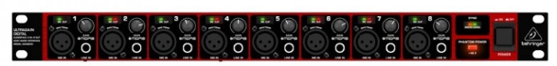

So the estimated cost is about 1800 PLN
Measuring vertical and horizontal distance:
Because ring array will only give as information about on which angle from our setup the drone is we need to add 2 microphones on a mast to calculate the difference in the sound between upper and lower microphone will give us height of a drone and overall intensity will give us how far the drone is.
If we want to add this the costs will rise to about 2000 PLN or higher if we decide for this 2 microphones use microphones with better range.
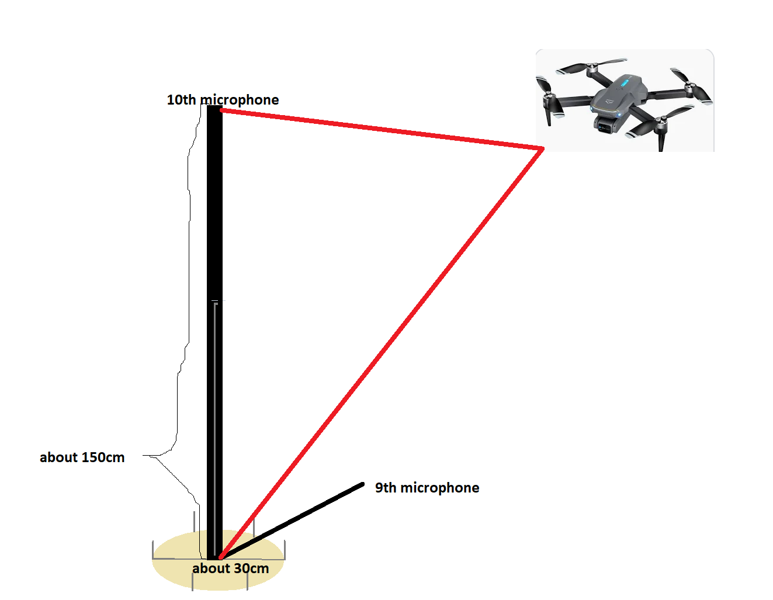

Analyzing the signal:
When the signal finally go to the computer from the audio interface it can be managed by ASIO (Audio Stream Input Output) drivers for example:
-Native ASIO driver from your audio interface manufacturer
- ASIO4ALL
- FlexASIO
Then we can connect to our ASIO by program we will write for purpose of this project.
For example when writing our code in python we can use libraries like:
pyaudio https://github.com/respeaker/mic_array/blob/master/mic_array.py
sounddevice https://python-sounddevice.readthedocs.io/en/0.5.3/usage.html
Example of code finding the angle from where the sounds come:
https://github.com/respeaker/mic_array/blob/master/mic_array.py
In our program we can use TDOA (Time Difference of Arival). It measures small time delay between when a sound wave reaches different microphones.
For a pair of microphones spaced by a known distance, the time delay is given by:
Δt = dcosinus(angle)/c
Where c is a speed of sound.
By calculating difference of arival time between several microphone pairs in a circular array, the system can estimate the azimuth angle — the direction from which the sound source (e.g., a drone) is arriving.
This is achieved using the GCC-PHAT algorithm (Generalized Cross-Correlation with Phase Transform), which provides robust estimation of small time delays even in noisy environments.
To extend the system into three-dimensional localization, two additional microphones can be placed vertically — one above and one below the main circular array.
By computing the TDOA between these two vertical microphones, the system can estimate the elevation angle, indicating how high above the horizon the drone is located:
angle=arcsin(c Δt/H)
Where H is vertical distance between the microphones.
Furthermore, since the sound intensity decreases with distance, the combination of beamformed signal power and calibrated sound pressure levels can be used to approximate the range (distance) of the drone.
Another proposition:
https://www.sciencedirect.com/topics/engineering/microphone-array
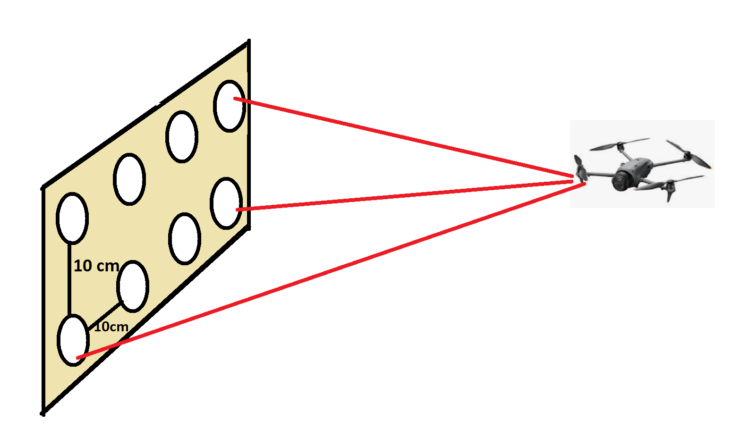

Quiet (30dB) | Medium (45dB) | City (55dB)
110 m | 42 m | 14 m
Angle of detection 60–85°
Propositions for Microphones:
-Behringer C-2
cost: about 160 PLN
range:
quiet environment (30dB) -> 50 m
medium (45dB) -> 30 m
city (55dB) -> 5-10 m
+ Captures full drone frequency spectrum for analysis and RPM estimation.
– Not very directional, so localization accuracy is limited.
-Behringer ECM8000
cost: about 100 PLN
range:
quiet environment (30dB) -> 40 m
medium (45dB) -> 15 m
city (55dB) -> 5 m
+ Flat frequency response ideal for acoustic spectrum measurement.
– Omnidirectional pickup makes direction finding difficult.
-Superlux PRA383D XLR
cost: about 250PLN
range:
quiet environment (30 dB) → 60 m
medium (45 dB) → 25 m
city (55 dB) → 8 m
+ Good balance between price and directionality.
– Still limited range and higher self-noise than premium models.
Propositions for Audio Interface:
-Behringer UMC1820 + ADA8200+ADAT optical cable
Cost about 1830 PLN (800 + 800 + 30)
Connection to computer by USB-B
16 XLR inputs (8+8)
Fully supports ASIO drivers on Windows
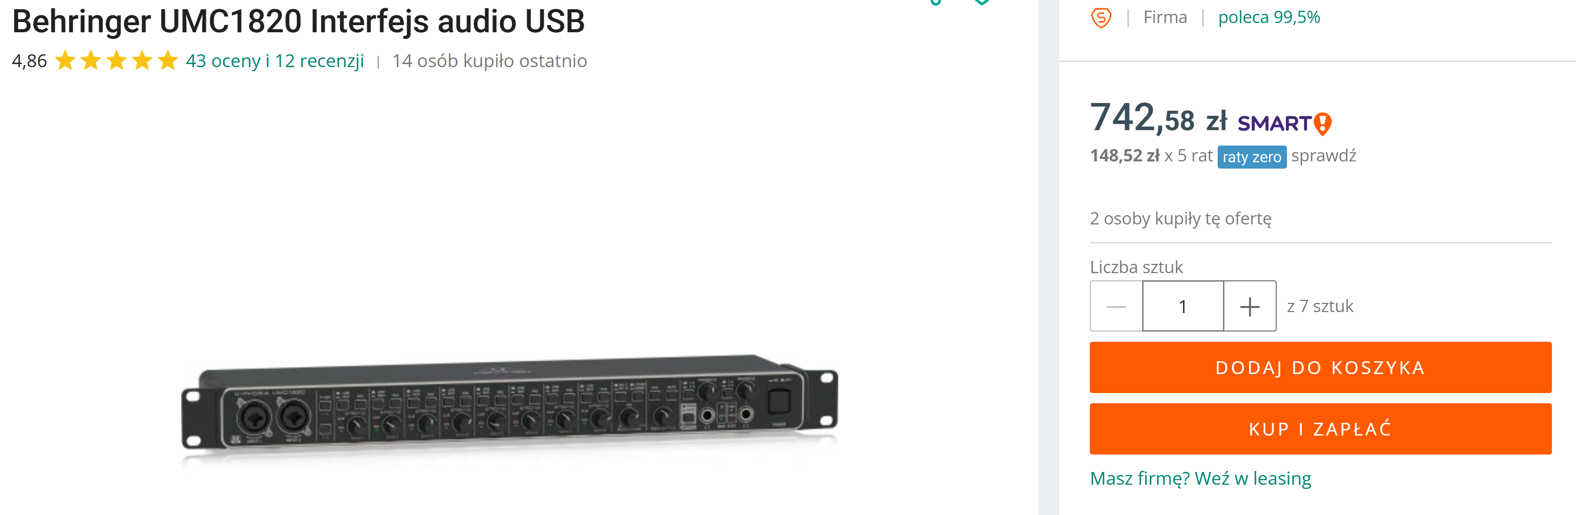
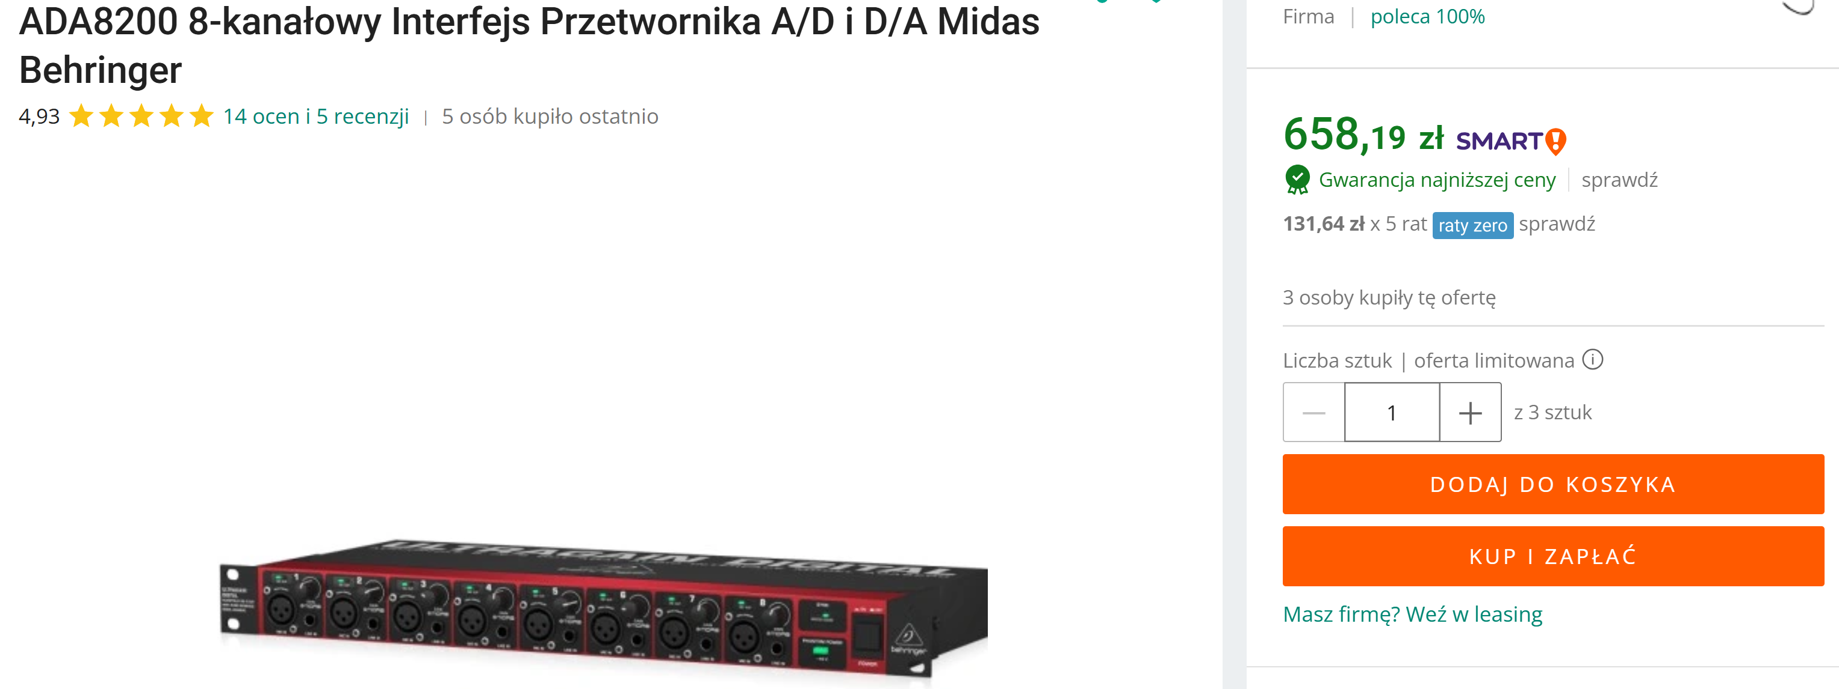
- PreSonus Studio 1824c + ADA8200+ ADAT optical cable
Cost about 1500 + 800 + 30 PLN
Connection to computer by USB-C
8 XLR so need to be extended by for example ADA8200
Very clean preamps and solid Windows drivers
